Supporting Information for:

Cu/Cu₂O interface-modulated two-stage reduction of Cu₂O under methanol
Meng Li¹, Matthew T. Curnan^{1,2,3}, Hao Chi¹, Stephen D. House^{1,4}, Christopher M. Andolina¹, Jeong Woo Han³, Wissam A. Saidi², Götz Veser^{1, 5}, Judith C. Yang^{1, 4,6}

¹ Department of Chemical and Petroleum Engineering, University of Pittsburgh, Pittsburgh, PA 15261, USA
² Department of Mechanical Engineering & Materials Science, University of Pittsburgh, Pittsburgh, PA 15261, USA
³ Department of Chemical Engineering, Pohang University of Science and Technology (POSTECH), Pohang, Gyeongbuk 37673, Republic of Korea
⁴ Environmental TEM Catalysis Consortium (ECC), University of Pittsburgh, Pittsburgh, PA 15261, USA
⁵ Center for Energy, University of Pittsburgh, PA 15261, USA
⁶ Department of Physics, University of Pittsburgh, Pittsburgh, PA 15261, USA

Table of Contents
Movie Captions 4
Note 1: Data Analysis 5
Figure S1| Cu₂O islands grown on Cu(110) surface after in situ oxidation at 300 °C under 0.03 Pa O₂. 8
Figure S2| Measurement of island size evolution. 9
Figure S3| Additional plots of the measured island size evolution in Movie S1. 10
Figure S4| Fitting of measured size and projection area. 11
Figure S5| Monolayer-by-monolayer reduction of Cu₂O nano-island #2 shown in Movie S2. 12
Figure S6| Cu₂OCu interfacial transformation along Cu|Cu₂O(100) interface in Movie S2. 12
Figure S7| Isotropic reduction of Cu₂O island #3 for Cu||Cu₂O(110) interface observed in Movie S3. 13
Figure S8| Isotropic reduction of Cu₂O island #4 for Cu||Cu₂O(110) interface observed in Movie S4. 14
Note 2: e-beam Effect 15
Figure S9| e-beam induced reduction of Cu₂O island. 16
Note 3: Statistical and Machine Learning Analysis of Cu₂O Island Shrinking 17
Figure S10| Bai-Perron breakpoint test analysis completed on the {110} side facets of the Cu₂O(110) island over all tested time. 19
Figure S11| Bai-Perron breakpoint test analysis completed on the depth, height and tilt angle of the Cu₂O(110) island over all tested time. 20
Table S1| Summary of all calculated breakpoints (BP) in sequence over time from Figures S10-S11. 21
Figure S12| Summary of all BPs from complete, calculated univariate time series. 21
Figure S13| Bai-Perron breakpoint test analysis completed on the sizes of the Cu₂O(110) island between the start and end of island depth shrinking. 23
Table S2| Summary of all calculated breakpoints (BP) in sequence over time. 24
Figure S14| Summary of all calculated Bai-Perron breakpoints (BP) during the R-D anisotropic to R-H isotropic transition regime. 24
Figure S15| Individual radius (R), depth (D), and height (H) breakpoints (BP) over a common time interval within the temporal boundaries imposed by island depth shrinking (left). 26
Figure S16| Fitting of R-H measurements using calculated breakpoints. 30
Note 4: DFT Simulation of MeOH Adsorption Energies on Stepped Cu₂O(110){110} Surface 32
Figure S17| Cu₂O(110){110} side facet structure investigated for Figure 4a. 32
Note 5: DFT Simulation of MeOH Adsorption Energies on Cu(110)||Cu₂O(110){110} Interfaces 33
Figure S18| DFT calculation results on MeOH adsorption energies on Cu(110)||Cu₂O(110){110} interfacial structure without defects investigated via Figure 4b. 33
Table S3| Summary of DFT calculation results on MeOH E_{ads} – with unstable (red), stable (green), and most stable (blue) structures – on Cu(110)||Cu₂O(110){110} interfaces. 34
Note 6: DFT Simulation of MeOH Adsorption Energies on Cu(110)||Cu₂O(110){010} Interfaces 35
Figure S19| Cu(110)||Cu₂O(110){010} interfacial structure investigated to complement Figure 4c. 35
Table S4| Summary of DFT calculation results on MeOH E_{ads} – with stable (green) and most stable (blue) structures – on Cu(110)||Cu₂O(110){010} interfaces with a Cu(100)-Cu₂O(100) channel, which better represents the experimental triple point. 36
Note 7: DFT Simulation of MeOH Adsorption Energies on Cu(110)||Cu₂O(110){010} Interfaces (Cu-O Terminated) with Cu and O Defects 37
Figure S20| Cu(110)||Cu₂O(110){010} interfacial structure with Cu-O terminated {010} interface and Cu and O defects investigated via Figure 4d. 37
Table S5| Summary of DFT calculation results on MeOH E_{ads} on Cu(110)||Cu₂O(110){010} with a Cu(100)-Cu₂O(100) channel interface, which represents the experimental triple point. 38
Note 8: DFT Simulation of MeOH Adsorption Energies on Cu(110)||Cu₂O(110){010} Interfaces (Cu Terminated) with Cu Defects 39
Figure S21| Cu(110)||Cu₂O(110){010} interfacial structure with Cu-terminated (100) interface and Cu defects investigated via Figure 4e. 39
Table S6| Summary of DFT calculation results on MeOH E_{ads} on Cu(110)||Cu₂O(110){010}. 40
Note 9: Experimental Verification of Defects Near (100) Junction 41
Figure S22| HRTEM simulation results depicting vacancy induced effects on image intensity. 42
Figure S23| Change of relative intensity near junction from anisotropic stage to isotropic stage. 43
Supporting References 44

Movie Captions
Movie S1: (a) Atomic resolution HRTEM movie of full reduction process of epitaxial Cu₂O island #1 grown on Cu(110) surface at 300 °C under 0.1 mTorr MeOH vapor. (b) Corresponding enhanced FFT movie of the sample showing the island tilting during the isotropic stage. (c) Measured island size and tilt angle evolution during the reduction.
Movie S2: Atomic resolution HRTEM movie of Cu₂O island #2 showing the anisotropic reduction dynamics on side layer of Cu₂O(110) surface at 300 °C under 0.1 mTorr MeOH vapor.
Movie S3: Atomic resolution HRTEM movie of Cu₂O island #3 showing the isotropic reduction stage on flat Cu(110) surface at 300 °C under 0.1 mTorr MeOH vapor.
Movie S4: Atomic resolution HRTEM movie of Cu₂O island #4 showing the isotropic reduction stage at 300 °C under 0.1 mTorr MeOH vapor.
Movie S5: Atomic resolution HRTEM movie of electron beam induced reduction of Cu₂O island #5 at 300 °C under vacuum at high e-beam dosage (3×10⁶ e/nm²·s).

Note 1: Data Analysis
Movie alignment. The as recorded in situ Transmission Electron Microscopy (TEM) movie is significantly affected by drift during experiments, such as sample drift due to heating and gas injection. Although there are multiple existing movie drift-correction methods, most of them are developed for purposes such as shaky video footage in camera videos recording daily life. These methods usually require unchanging templates, such as corners, for alignment to perform image stabilization. However, for TEM movies, especially HRTEM movies, finding such unchanging markers is usually difficult. In this work, we improved upon a former movie alignment algorithm based on template matching to align in situ TEM movies^{1, 2}. Instead of a constant unchanging template, the template for alignment changes over time to meet the requirements of in situ TEM movies, in which samples themselves have varying shapes over time. Furthermore, since blurry frames, which are caused by movement of the TEM stage or adjusting its focus, induce significant defects in alignment results, the blurry frames were deleted before alignment using an automated blur detection algorithm. The timestamp of the original movie is maintained to avoid the blurry frame deletion induced error in rate measurement. Hence, this method is suitable for aligning most in situ movies in which drift only impacts a small portion of the sample from frame to frame.
Movie enhancement. After alignment, movies were cropped, rotated, and accelerated for easier observation using a combination of ImageJ and Python codes. To enhance image quality and increase Signal-to-Noise Ratios (SNR), movie frames were batch-enhanced by a home-made filtering code in ImageJ. This code used a combination of Inverse Fast Fourier Transform (IFFT) and Wiener filtering to enhance the contrast of each image. Each frame of the movie was first Wiener filtered and then FFT filtered, while subsequent mask addition enhanced Cu₂O diffraction spots and reduced FFT noise signals. This mask addition formed IFFTs that yielded enhanced frames, which – when recombined with filtered frames – developed a new movie.
Measure size evolution dynamics. The overall size evolution plotted in Figure 1e and Figure S3 is measured using a kymograph, which is taken at the center of the island shown in Figure S2 from the aligned and enhanced movie. Height (H) is defined as the distance from the top Cu₂O(110) surface to the Cu(110) surface intersecting the center of the Cu₂O island. Radius (R) is defined as half of the width of the Cu₂O island, while buried island depth (D) is defined as the distance from the lower edge of the Cu₂O island to the Cu(110) planar surface threshold imposed by H. Note there is a deviation in time when R and H became 0, which resulted from measuring R from the horizontal line two atomic layers above the Cu surface instead of directly on the Cu surface shown in Figure S2. This was done to avoid errors caused by processes inducing defects in the Cu surface, such as surface reconstruction and cluster accumulation (Figure 1c).
Measure island tilt dynamics. The tilt angle evolution plotted in Figure S3 and Figure 3 is measured from the FFT movie displayed in HRTEM Movie S1. For each frame in each analyzed HRTEM movie, an FFT image was generated. Subsequent image processing enhances contrast and reduces noise in FFT images. Cu₂O diffraction spots in processed FFT images are discerned using blob detection³. This detection method is more accurate for images with low signal-to-noise ratios, such as the FFT images yielded during the collapse of the island. As shown in Figure S3b, measured tilt angles resolved over time – namely at each spatial point used for detection – are in good agreement. At each measured time, the average tilt angle of such detected points is the effective tilt angle measurement applied to subsequent analyses. The corresponding standard deviation of such detected point measurements forms each error bar. This tilt angle quantification method is automated using our homemade Python code, and can be extended to benefit data analyses across many other in situ experiments.
Measure island projection area. Projection area of the Cu₂O island is measured using a convolutional neural network (CNN). The network is trained using 50% of the frames that comprise the movie visualizing island area (selected randomly). Trained samples are labeled by first resolving FFT images of frames, then filtering FFTs via IFFT using Cu₂O diffraction spots. IFFT images are then filtered and resolved using the blob detection method. Atomic positions detected from IFFT images are then compared with raw images for verification. Verified positions are then transferred into filled mask files, which serve as a ground truth for training. This CNN network approach is adopted from the UIUC Neural network software package⁴, and is trained on our data. Predicted island area is compared with raw and IFFT filtered frames, preferring consistency with IFFT results to maximize accuracy. Nevertheless, this method only works on Cu₂O islands with well-defined crystalline lattices. Hence, it is not applied after islands lose their lattice fringes or contrast after extensive reduction such as island tilting and collapsing. Projection area is plotted in Figure S4. Fitting of measured projection area data shows a transition from linear to isotropic shrinking near 123.6 s, consistent with the individual measurement fitting results.
Statistical analysis and atomic model visualization. Statistical analysis is performed on measured size evolution to reveal changes in kinetic reaction mechanisms. This analysis is detailed in Note 2. All atomic visualizations of surfaces, interfaces, and adsorbates were made using VESTA⁵.

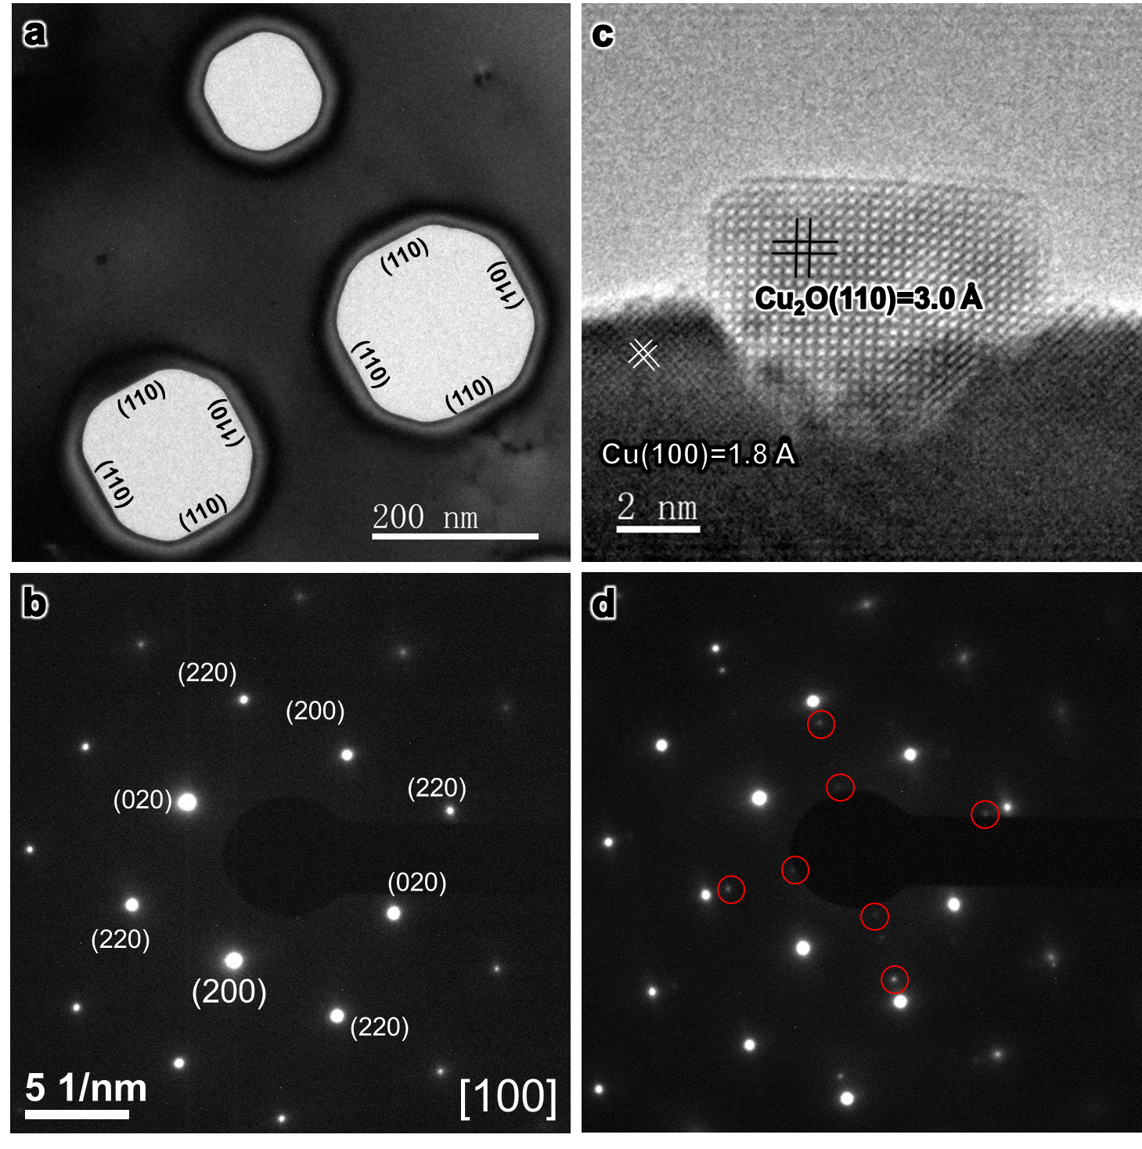
Figure S1| Cu₂O islands grown on Cu(110) surface after in situ oxidation at 300 °C under 0.03 Pa O₂.
(a-b) Before oxidation, the Cu film was reduced in H₂ to remove native oxides. (a) Clean contrast in the bright-field TEM image and (b) clean diffraction pattern with only Cu diffraction spots indicates the reduced film is oxide-free. (c-d) After in situ oxidation, a Cu₂O island with a cube-on-cube epitaxial relationship to the Cu substrate was formed, as was confirmed by an (c) HRTEM image and a (d) diffraction pattern. Spots representing Cu₂O islands are circled in red. 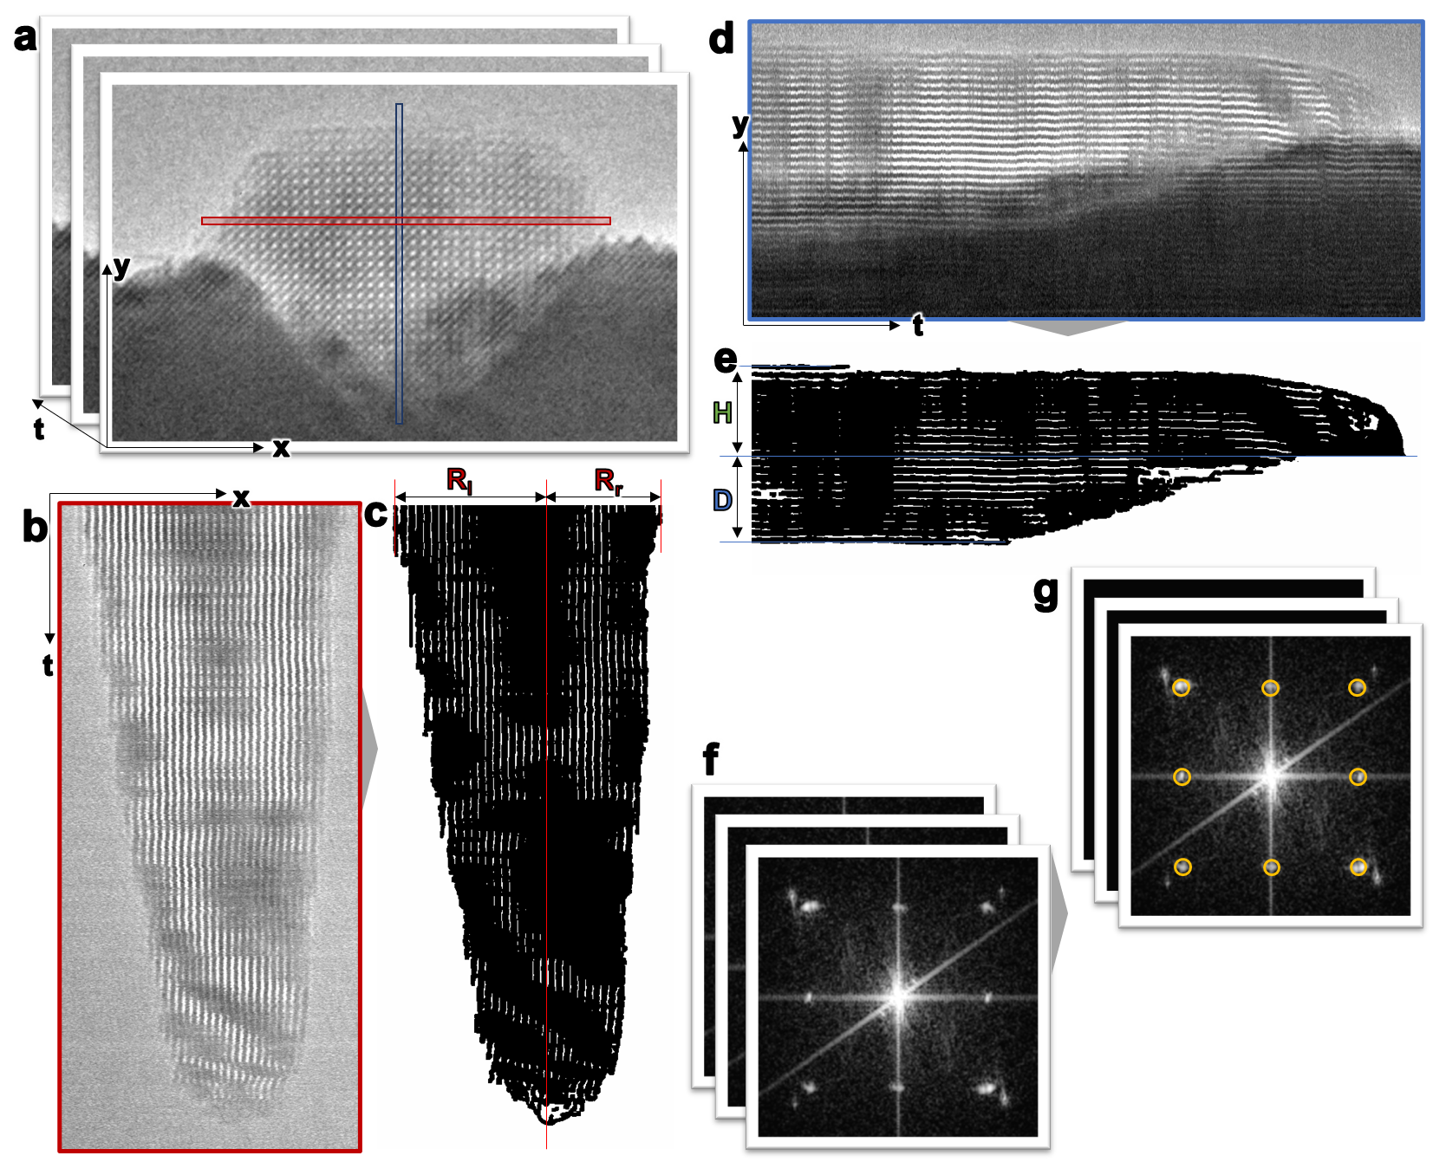
Figure S2| Measurement of island size evolution.
(a) Time series HRTEM images taken from Movie S1. (b,d) Kymograph of Cu₂O island x and y dimension sizes taken over time from the boxed area in (a) colored correspondingly. (c) Segmented binarized image of (b) for the measurement of left radius (R_{l}) and right radius (R_{r}). The overall radius R is the average of R_{l} and R_{r}. (e) Segmented binarized image of (d) for the measurement of island height (H) and buried depth (D). (f) Corresponding FFT time series from (a). (g) Identified diffraction spot center positions from (f) for island tilt angle measurement. The island tilt angle is taken from the average of the relative rotation of the circled diffraction spots.

Figure S3| Additional plots of the measured island size evolution in Movie S1.
(a) The leftward (R_{l}, red line) and rightward (R_{r}, yellow line) side widths of a Cu₂O island are measured relative to the location where the island disappears from the kymograph, as is shown in Figure S2b-c. The average radius (R, orange line) is the average of R_{l} and R_{r}. The height (H, green line) and buried depth (D, blue line) are measured relative to the location where the island disappears from the kymograph shown in Figure S2d-e. (b) The island tilt angle (θ, purple line) is measured using the relative rotation angle from the FFT movie shown in Figure S2f-g. Sampled time series, labelled 1-8 (leftward plot), correspond to diffraction spots (rightward figure) at which tilt angle variations were detected and measured. Analyzed tilt angle data (purple) is the average of these 8 sampled tilt angle measurements, while error bars are the standard deviations of such measurements at each unit of time.
Figure S4| Fitting of measured size and projection area.
(a) Fitted sizes of island measurements R, D, and H using the breakpoint calculated in Note 3. Size evolution follows linear and parabolic trends before and after the breakpoint, respectively. (b) Fitting of measured island projection area using a CNN approach.

Figure S5| Monolayer-by-monolayer reduction of Cu₂O nano-island #2 shown in Movie S2.
(a-d) HRTEM observation of the dynamics of fully reducing a single Cu₂O(110) monolayer under 7.6×10⁻⁶ Torr MeOH vapor and at 300 °C. The colored markers highlight the transition of removing the outermost side monolayer of the Cu₂O island (red), and replacing it with the formerly second outermost layer (blue). (e-f) Snapshots of the same island before and after reduction over a longer time period, during which a Cu(110)|Cu₂O(110){100} triple junction configuration is maintained over time. (g) Measured, averaged shrinking of 20 side layers indicates their relatively constant reduction rate. Initial first (1st) and last (20th) layer locations over time are labelled accordingly in (e-f). Error bars are standard deviations of each measurement.

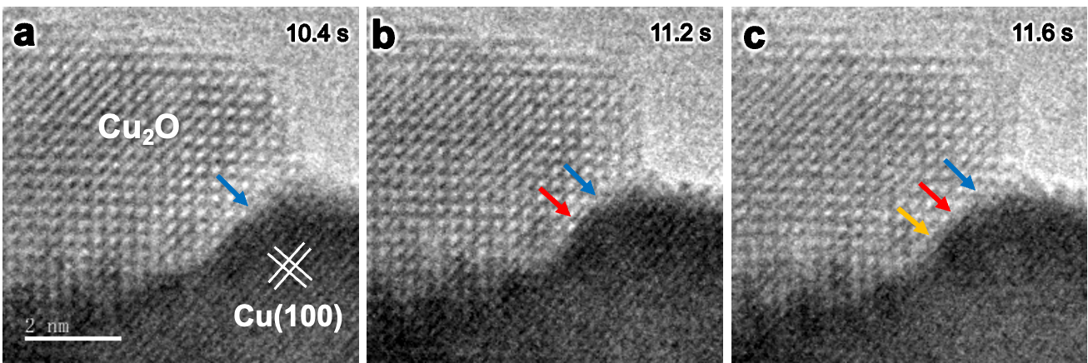

Figure S6| Cu₂OCu interfacial transformation along Cu|Cu₂O(100) interface in Movie S2.
(a-c) HRTEM snapshots showing the Cu₂OCu transformation at the Cu₂O||Cu(100) interface under 7.6×10⁻⁶ Torr MeOH vapor and at 300 °C. Blue, red, and yellow arrows point to the Cu₂O/Cu interface step edge at (a) 10.4 s, (b) 11.2 s, and (c) 11.6 s, respectively.
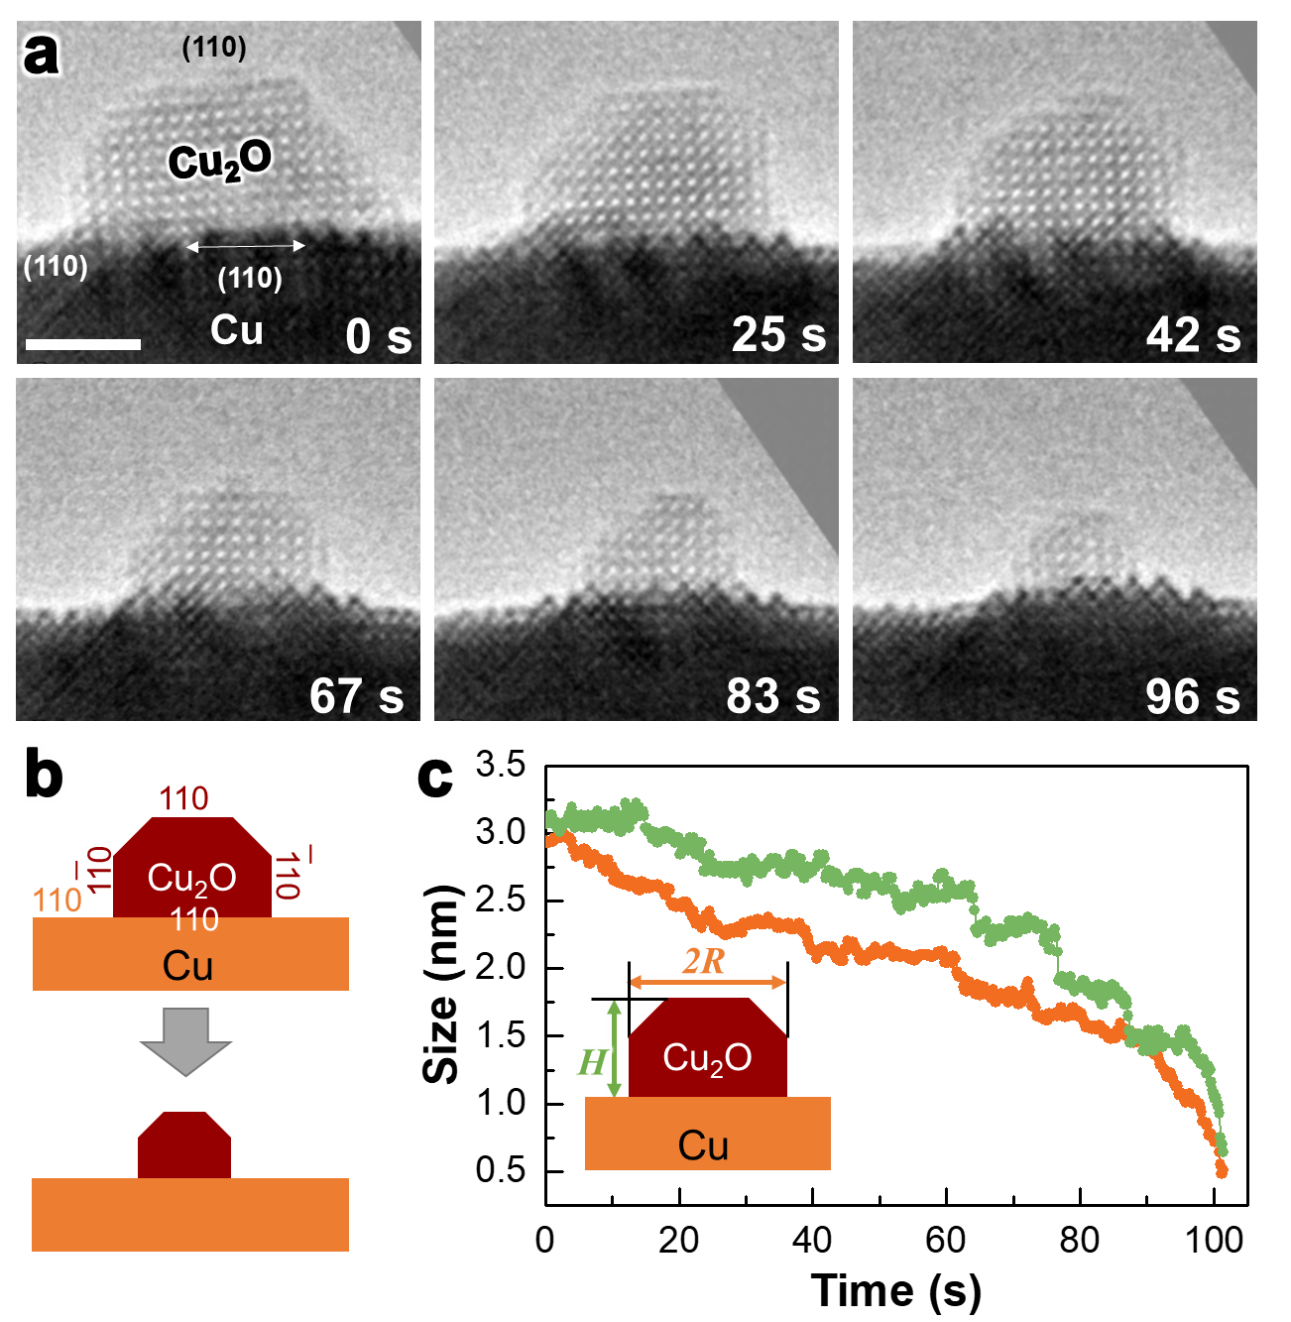
Figure S7| Isotropic reduction of Cu₂O island #3 for Cu||Cu₂O(110) interface observed in Movie S3.
(a) HRTEM snapshots showing the anisotropic reduction of the Cu₂O island on both the top and side of the Cu₂O island at 1×10⁻² Pa MeOH vapor at 300 °C. Scale bar: 2 nm. (b) Schematic illustration showing the reduction process. Note both sides of the Cu₂O island are flat, so no Cu pile or Cu₂O island tilting was observed. (c) Corresponding island size evolution measured from the movie.
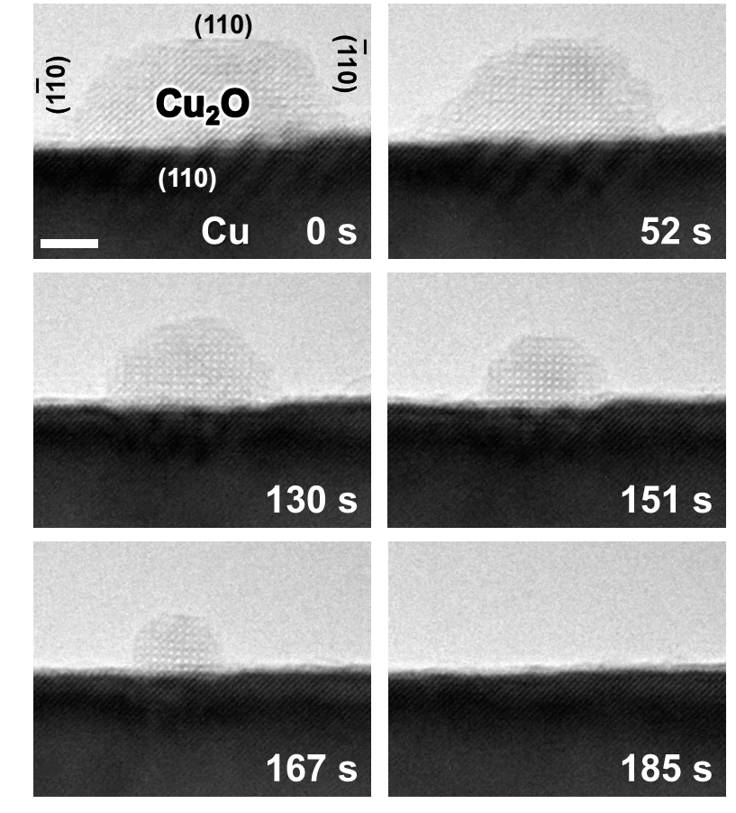
Figure S8| Isotropic reduction of Cu₂O island #4 for Cu||Cu₂O(110) interface observed in Movie S4.
HRTEM snapshots showing the anisotropic reduction of the Cu₂O island on both the top and side of the Cu₂O island at 1×10⁻² Pa MeOH vapor at 300 °C. Note both sides of the Cu₂O island are flat, so no Cu pile or Cu₂O island tilting was observed. Scale bar: 2 nm.

Note 2: e-beam Effect
Effects resulting from e-beam exposure constitute a general issue for in situ TEM studies. For oxides such as Cu₂O, strong electron beams have been reported capable of reducing oxides beyond the scope of studied reactions^{6, 7}. To avoid this effect, the variable impact of e-beam dosage has been tested experimentally. Applying an acceleration voltage of 300 keV and an emission current of 2 μA, an e-beam dosage – measured without its sample – of ~125 nA/um² (7.8×10⁵ e/nm²·s) was initially tested as a control. Note that this dosage is lower than that typically used for HRTEM imaging, as shown in literature reports (~1-5×10⁶ e/nm²·s)⁸. Under this e-beam dosage, no obvious change in Cu₂O island size was observed in vacuum over 3~5 minutes of e-beam exposure. In contrast, Cu₂O islands were reduced within 3 min after MeOH was injected. Beyond the e-beam illuminated sample area, Cu₂O islands on other sample areas were also reduced, corroborating this reduction behavior. Higher e-beam dosages (1.5-3×10⁶ e/nm²·s) were also tested, confirming that e-beams can induce reduction of studied samples under sufficient conditions (Figure S9). However, this e-beam induced reduction in vacuum is uniform, or isotropic, across the top and side facets of Cu₂O islands. Such results further confirm that our experimentally observed two-stage reduction – which is discerned by a transition away from anisotropic island shrinking – is due to MeOH involved reactions, instead of the e-beam effect. Since low e-beam dosage decreases the signal-to-noise ratio of studied images, Supporting Movies and corresponding extracted images are constructed by averaging together every two adjacent frames of raw recorded movie footage after image alignment and signal enhancement.
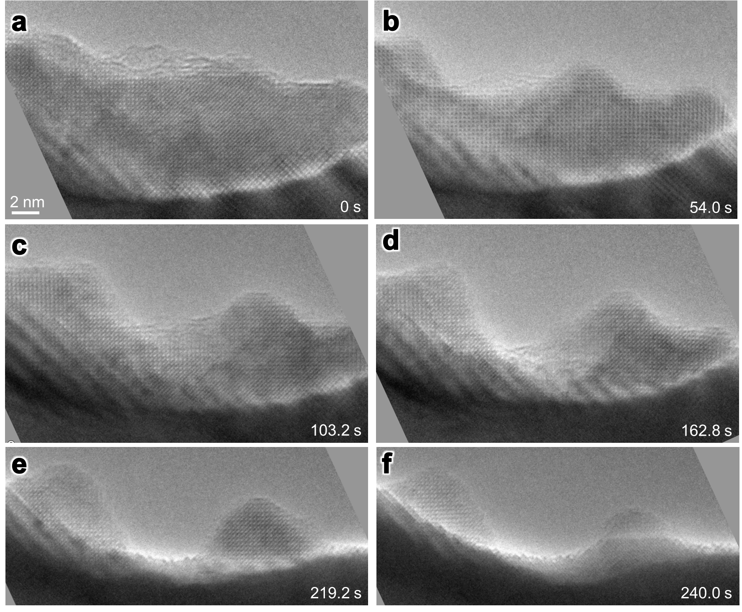
Figure S9| e-beam induced reduction of Cu₂O island.
(a-f) HRTEM snapshots taken over 4 minutes, showing the e-beam induced reduction of a Cu₂O island happens on both its top and side facets under higher e-beam intensity (1.5×10⁶ e/nm²·s) at 300 °C in vacuum.

Note 3: Statistical and Machine Learning Analysis of Cu₂O Island Shrinking
In previous work, in situ Transmission Electron Microscopy (TEM) observations of Cu₂O island shrinking and reduction dynamics over time were characterized by deterministic trends⁹. Diffusive flux measured during related chemical reactions and mass transport events was modeled via continuous and deterministic relationships, as well as changes or breaks in those fitted relationships.^{2, 9} Such characterization of island dimension shrinking was possible for experimentally observable, well-defined, and distinct reaction phenomena. These phenomena can be easily discerned from individual atomic oscillations or small particle movements resulting from temperature, pressure, and reaction conditions. However, atomic-scale ETEM observations may feature highly discretized reactive processes. Such processes can consist of complicated reduction dynamics comprised of multiple dimensional measurements, or networks of interconnected but distinct reaction events. As previously demonstrated on related diffusion and nucleation mechanisms involving catalytic active sites, stochastic – rather than deterministic – kinetic modeling can characterize such reactive dynamics a priori.^{10, 11, 12} In this work, the changing stages of underlying discretized atomic processes – such as changes in reaction sites – can be expected to impact resultant size kinetics trends. Therefore, distinct kinetic regimes – as well as the dynamic structural transition points (breakpoints) delineating them – are identified, characterized, and correlated with ETEM observations via statistical and machine learning approaches that employ stochastic kinetic modeling.
Referenced statistical and machine learning techniques were implemented via the R software platform.¹³ After being introduced in the first subsection of this note, the Bai-Perron approach then evaluates structural breaks corresponding to discrete changes in island shrinking dynamics over full and transitional univariate time series segments. After completing this subsection, sup-F testing was performed on transitional series in a subsequent subsection to identify a concerted multivariate break across multiple series. All of these statistical evaluations were completed with the strucchange package in R.¹⁴ Upon identifying this multivariate structural break, Auto-Regressive Integrated Moving Average (ARIMA) models were fitted to such transitional segments delineated by that break using the forecast package in R.^{15, 16} After fitting kinetically substantiated ARIMA terms to these delineated structural dynamics, one-to-one correspondences of concerted atomic oscillations over paired time series were evaluated via cointegration tests (Schmidt-Phillips unit root tests) using the urca package.¹⁷
- Introducing Univariate Time Series Breakpoint Analysis
Bai-Perron testing first fits linear trends to time series segments formed by possible combinations of starting (ST) and ending (ET) times of a tested univariate series. ST-ET combinations are limited by a minimum segment size or fraction of total time series size (h), which determines the maximum number of detected breaks within a tested series. The residual sums of squares (RSS) of each segment is calculated and tabulated, yielding an upper triangular matrix formed from all possible ST (rows) and ET (columns) of these segments.^{14, 18, 19} From this matrix, the total RSS of any combination of data segments formed from a iteratively specified number of breaks (k) is optimized using the Bellman principle.^{18, 20} Per iteration of a subset routine, optimization first balances incremented k values with removed fractions of sequential time series data specified by a single h value. Via a superset routine, h is initialized to 0.2, then subsequently incrementally decreased until convergence of an optimal k. For k that yield small data segment lengths given limits imposed by h, multiple apparent and closely spaced breaks may only be detected as single breaks due to sampling limitations. This recursive optimization methodology, which is usually characterized as a dynamic programming problem,^{18, 19, 21} effectively learns from initially tabulated RSS to minimize optimized RSS at specified k values. Thus, this approach can be understood as the machine learning, or reinforcement learning, of time series breakpoints from RSS values.^{22, 23}
A priori, this technique was applied to entire time series modeling the left Cu₂O(110){110} island side facet radius (R_{l}; Figure S10a), the matching right side facet radius (R_{r}; Figure S10b), the average of those radii (R; Figure S10c), island depth (D; Figure S11a), corresponding height (H; Figure S11b), and island tilt angle (T; Figure S11c). Bai-Perron breakpoint tests are completed over whole time series, as well as time series filtered to focus on only series components adjacent to anisotropic-to-isotropic kinetic transitions. Plots and summaries of whole and transitional time series analyses are respectively presented in Figures S10-S12 and Table S1, as well as Figures S13-S14 and Table S2. Table S1 and summarize the times to which all per-series breakpoints were fitted via Bai-Perron testing. Optimal numbers of breakpoints were determined via the Bayesian Information Crierion (BIC) for model selection, in which the trade-off between k and the total RSS of fitted segments at a given k were compared.^{14, 19, 24}

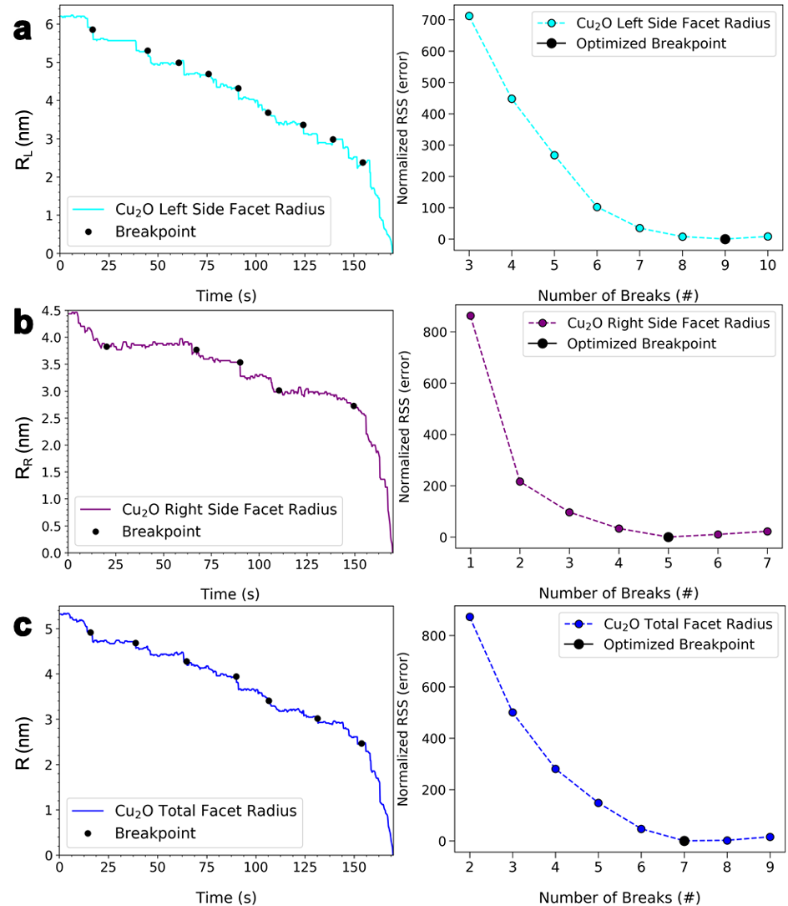
Figure S10| Bai-Perron breakpoint test analysis completed on the {110} side facets of the Cu₂O(110) island over all tested time.
(a) Left (110) side facet (R_{l}; cyan), (b) right (110) side facet (R_{r}; purple), and (c) average of R_{l} and R_{r} (R; blue). The left panel shows resolved time series breakpoints (black points), while the right panel shows optimized model selection plots. The optimal number of breakpoints for each time series is highlighted via a black point in each rightward plot, while all measured BIC per plot are normalized relative to the BIC calculated at each optimal point.
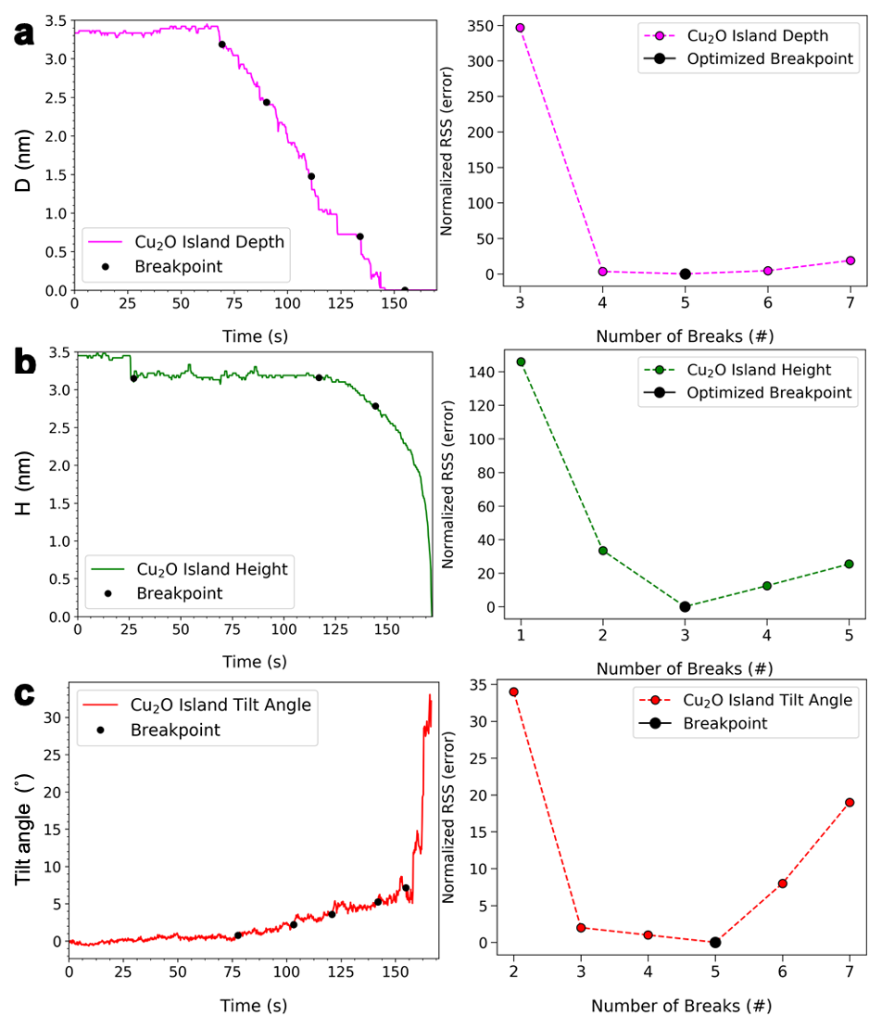
Figure S11| Bai-Perron breakpoint test analysis completed on the depth, height and tilt angle of the Cu₂O(110) island over all tested time.
(a) Buried depth (D; pink), (b) island height (H; green), and (c) tilt angle (T, red). The left panel shows resolved time series breakpoints (black points), while the right panel shows optimized model selection plots. The optimal number of breakpoints for each time series is highlighted via a black point in each rightward plot, while all measured BIC per plot are normalized relative to the BIC calculated at each optimal point.

Table S1| Summary of all calculated breakpoints (BP) in sequence over time from Figures S10-S11.
Breakpoints | R, Left (nm) | R, Right (nm) | R, Mean (nm) | D (nm) | H (nm) | Tilt Angle (°)
BP 1 (s) | 16.6 | 20.2 | 15.8 | 69.2 | 27.2 | 77.6
BP 2 (s) | 44.8 | 67.2 | 38.8 | 90.2 | 117.0 | 103.2
BP 3 (s) | 60.6 | 90.0 | 64.8 | 111.2 | 144.4 | 120.8
BP 4 (s) | 75.8 | 110.4 | 90.0 | 134.0 |  | 142.0
BP 5 (s) | 91.0 | 149.4 | 106.6 | 155.0 |  | 154.8
BP 6 (s) | 106.2 |  | 131.4
BP 7 (s) | 124.2 |  | 153.8
BP 8 (s) | 139.4
BP 9 (s) | 154.6

Figure S12| Summary of all BPs from complete, calculated univariate time series.
Breakpoints (BP) of R_{l}, R_{r}, R, H, D, and tilt angle are respectively marked by leftward triangles, rightward triangles, circles, upward triangles, downward triangles, and diamonds colored to correspond to their constituent time series. Background colors distinguish approximate transitions between the anisotropic stage – including the R linear stage (light blue background), the R-D linear stage (darker blue background), and the isotropic stage (R-H isotropic stage, orange background). A roughly simultaneous breakpoint (filled BPs with corresponding color, marked by a dashed circle) is observed in radius-related (R_{l},R_{r}, R), H, and tilt series near the R-D to R-H transition.

- Univariate Bai-Perron Breakpoint Analysis of R, D, and H
Though anisotropic radial island shrinking occurs throughout studied time series, specific temporal domains are directly connected to anisotropic-to-isotropic kinetic transitions and associated dynamics. These domains and transitions are predicated on embedded island interfaces transforming from trapezoidal to triangular shapes, namely due to buried interfacial Cu₂O reduction (Figure 1b). Such structural transformations decrease island depth (D), yielding Cu₂O||Cu interfaces that further shrink (100) radial (R) interfaces. Thus, anisotropic shrinking is studied over whole time series, as well as domain-specific reaction mechanisms characterized by concerted R-D dynamics. The subsequent transition to isotropic radius (R) and height (H) reduction results from depletion of buried Cu₂O, and thus Cu sourcing from the Cu₂O(110){100} interface. Such depletion transforms this {100} channel into a {110} interface, which induces more uniform interaction with MeOH across R and H island dimensions. Thus, isotropic R-H shrinking should be characterized by distinctly different – but also concerted – diffusive flux and structural dynamics versus anisotropic R-D shrinking. In conjunction with experimental observations, a two-stage reaction mechanism is statistically validated, deriving shared structural breakpoints across series and transitions from concerted R-D anisotropic to R-H isotropic shrinking dynamics.
Bai-Perron optimizations (Figures S10-S11) and summarized structural breaks (Figure S12, Table S1) were first performed over whole univariate entire time series, revealing multiple overlapping island radius (R), height (H), and buried depth (D) breakpoints. Such breaks estimated the initial time (69.2 s, Figure 1e) at which island depth D began to decrease linearly and consistently. This break (70 s) coincides with the start of gradual island shrinking that results from tapering of its embedded component, which occurs during Cu₂O→Cu transformation but while the island maintains its trapezoidal or rectangular shape (Figure 1b). Applying this lower limit, a second set of Bai-Perron optimizations (Figures S13-S15) and summarized structural breaks (Table S2) were completed on this temporal domain. Break prediction generally improved for R, D, and H measures while specifically refining the upper limit for any depth decreases (144.2 s), as well as linear and consistent depth decreases (134.2 s). The latter of these corresponds to the trapezoidal-to-triangular embedded island transformation and associated reaction processes (Figure 1c). The former of these defines the temporal domain used to resolve a single concerted R-D-H breakpoint corresponding to an anisotropic-to-isotropic transition.
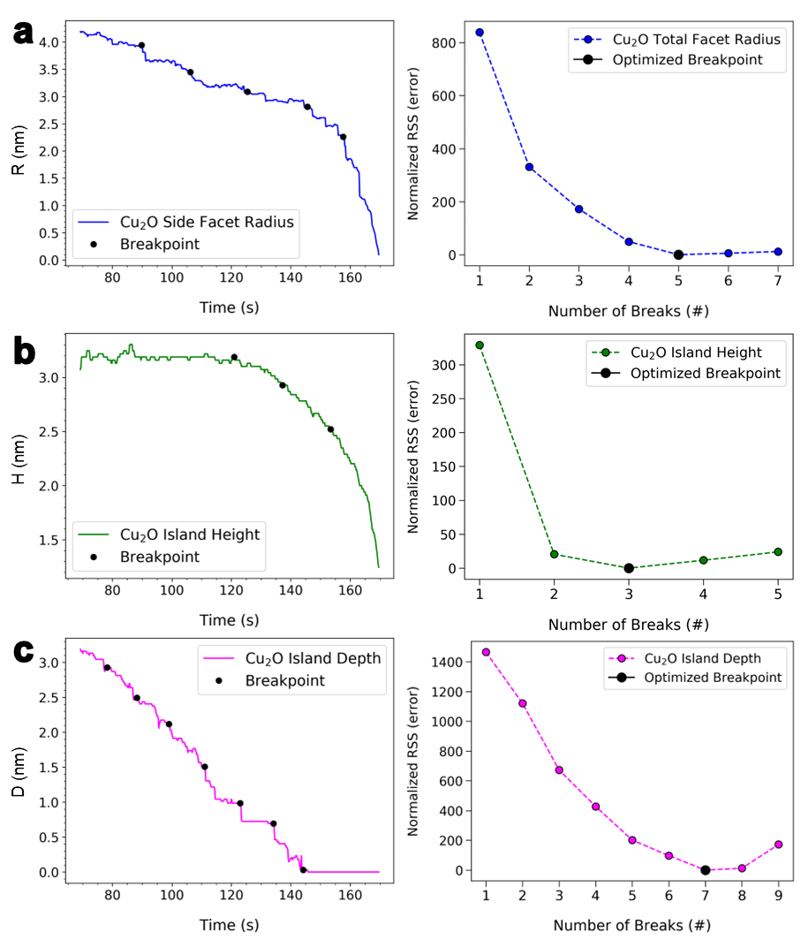
Figure S13| Bai-Perron breakpoint test analysis completed on the sizes of the Cu₂O(110) island between the start and end of island depth shrinking.
(a) Radius (R, blue), (b) height (H, green), and (c) depth (D, pink). The left panel shows resolved time series breakpoints (black points), while the right panel shows optimized model selection plots. The optimal number of breakpoints for each time series is highlighted via a black point in each rightward plot, while all measured BIC per plot are normalized relative to the BIC calculated at each optimal point.

Table S2| Summary of all calculated breakpoints (BP) in sequence over time.
BPs were adapted from left to right, or from before to after, according to plots from Figures S12-S13. BP times corresponding to the transition from R-D anisotropic to R-H linear isotropic kinetic regimes are highlighted in white, indicating when the transformation of buried Cu₂O via reduction is no longer approximately continuous (reaches a second discontinuity). Italicized red times (D = 134.2 s, H = 137.2 s) represent the threshold at which even discontinuous reduction is no longer consistent, and isotropic linear reduction of H becomes observable. BPs characterizing the transition between R-H linear and parabolic isotropic regimes (R = 157.6 s, H = 153.4 s) are bolded.
Breakpoints | R, average (nm) | D (nm) | H (nm)
BP 1 (s) | 89.8 | 78.2 | 121.0
BP 2 (s) | 106.2 | 88.2 | 137.2
BP 3 (s) | 125.4 | 99.0 | 153.4
BP 4 (s) | 145.6 | 111.0
BP 5 (s) | 157.6 | 123.0
BP 6 (s) |  | 134.2
BP 7 (s) |  | 144.2

Figure S14| Summary of all calculated Bai-Perron breakpoints (BP) during the R-D anisotropic to R-H isotropic transition regime.
BPs are marked by hollow symbols defined in Fig. S12. Half-filled BPs at ~123 s correspond to the transition from R-D anisotropic to R-H linear isotropic kinetics, indicating when the transformation of buried Cu₂O via reduction is no longer approximately continuous (reaches a second discontinuity). Semi-filled BPs (D = 134.2 s, H = 137.2 s) represent the threshold at which discontinuous reduction is no longer consistent, and isotropic linear reduction of H becomes observable. Solid-filled BPs (R = 157.6 s, H = 153.4 s) show the transition between R-H linear and parabolic isotropic regimes.

- Concerted Breakpoints: Multivariate R-D-H and Beyond
To identify when structural dynamics signal a transition from R-D anisotropic to R-H isotropic kinetics, an initial screening shows a single possible shared R-D-H breakpoint via Table S2 (H=121.0, D=123.0, R =125.4 s). To verify this break, a sup-F test evaluates a multivariate linear model (slopes=dl/dt, intercepts=l_{t=t0}) over enumerated (h) R, D, and H series (length l) versus time (t) with time-specific errors (𝜀_{i,t}).² The statistical significance of imparting a single break (k=1) uniformly across R, D, and H is evaluated via an F-test statistic (F). F is calculated from the linear fitting errors, or RSS per segment summed over all segments, of data segments (a, b; respective sample sizes N_{a}, N_{b}) shared across all series. Per possible shared breakpoint tested, null (H₀) and alternate (H_{A}) hypotheses are evaluated, finding whether breaks in shared linear intercept or slope terms are significant. Such tests are performed over a temporal window (j₁ < j < j₂), over which single breakpoint placement across R, D, and H is varied. Over this window, the breakpoint with a “maximized” (supremum, sup) F is taken and compared to a significance threshold (L~15-20). If this breakpoint is significant, then a concerted transition across dynamic regimes is evidenced. The formalisms used to complete sup-F testing are presented below:^{2, 14}
$$l_{h,t}={\left(\frac{dl}{dt}\right)}_{h}t+l_{h,t=t_{0}}+ε_{h,t}$$
$$F=\frac{\left[{RSS}_{b+a}-\left({RSS}_{b}+{RSS}_{a}\right)\right]/k}{({RSS}_{b}+{RSS}_{a})/(N_{b}+N_{a}-2k)}$$
$$Per breakpoint-H_{0}: l_{t=0,b}=l_{t=0,a} AND {\left({dl}/{dt}\right)}_{b}={\left({dl}/{dt}\right)}_{a}$$
$$Per breakpoint-H_{A}:l_{t=0,b}≠l_{t=0,a} AND/OR {\left({dl}/{dt}\right)}_{b}≠{\left({dl}/{dt}\right)}_{a}$$
$$Over range-H_{0}: \sup{F}<L \left| H_{A}: \sup{F}≥L \right| \sup{F}=\sup_{j_{1}≤j<j_{2}}{F_{j}}$$
As shown in Figure S15, a concerted R-D-H breakpoint at 123.6 s is estimated for this two-stage dynamics transition within a sampling window of 93.8 < j < 144.6 s. The sup-F test statistic (F=1101) and the neighborhood of its optimization are strongly significant, statistically evidencing the experimentally observed two-stage transition and its resolved time. This point marks an estimated threshold for several experimentally observed phenomena, including the loss of approximately continuous island depth sinking, the transition from anisotropic to isotropic reduction of R and H island dimensions, and the coarsening of the Cu||Cu₂O junction that coincides with its interfacial transformation between (100) and (110) orientations.
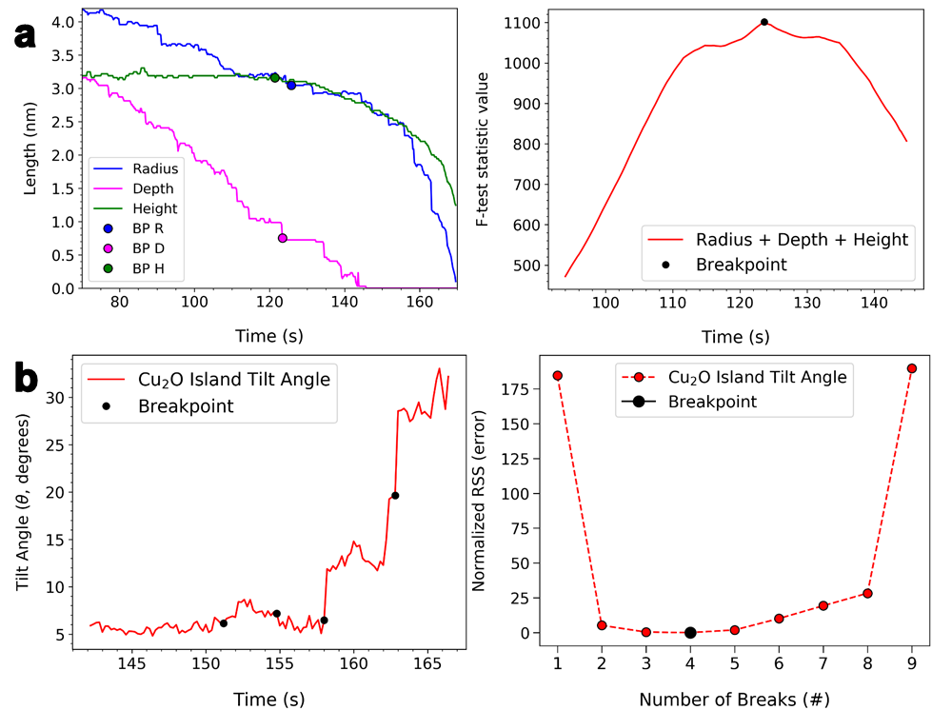
Figure S15| Individual radius (R), depth (D), and height (H) breakpoints (BP) over a common time interval within the temporal boundaries imposed by island depth shrinking (left).
(a) Optimized combined R-D-H sup-F test results indicate that a single BP for all three measures can be estimated to occur at t = 123.6 s (F = 1101) within the studied 93.8 < j < 144.6 s window. (b) Bai-Perron breakpoint test analysis completed on Cu₂O island tilt angle after the end of island depth shrinking.
At subsequent D breaks of 134.2 s and 144.2 (Table S2), discontinuous decreases in D persist. This former breakpoint correlates with the experimental observation of nearly complete buried Cu₂O reduction at approximately 135 s (Figure 1c), and approximately coincides with an H breakpoint (137.2 s, Table S2). Different island dimension breakpoints are linked via tilt angle breaks. Figure S11c indicates an initial tilt angle breakpoint at 77.6 s, which is near the start of island depth loss (~70 s) and coincides with the first D breakpoint following such loss (78.2 s, Table S2). Tables S1-S2 show tilt angle breaks slightly (103.2 s) near a discrete radial mass transport event (106.2 s), albeit a more prominent tilt angle breakpoint (120.8 s) occurs adjacent to the two-stage transition threshold (123.6 s). The final loss of island depth during buried Cu₂O reduction (144.2 s, Figure 1c), and the second experimentally observed tilting oscillation induced by Cu accumulation (153 s, Figure 3c), are also detected by respective tilt angle breakpoints (142.0, 154.8 s; Table S1). Focusing on tilt angle after full buried Cu₂O reduction (t>144.2 s), Figure S15b detects an initial experimentally observed tilting oscillation with a breakpoint (151.2 s), reaffirms the first breakpoint derived during full tilt angle trend analysis (154.8 s), and correlates both subsequent sudden losses in island radius with two breakpoints (158.0, 162.8 s).

- Stochastic Trend Fitting of Island Size Evolution with ARIMA Models
Applying the detected breakpoints, stochastic trend analyses were performed on experimentally measured island kinetics, implicitly resolving various types of diffusive Cu flux accompanying island transformations with different Auto-Regressive Integrated Moving Average (ARIMA) terms. Such flux corresponds to island shrinking, which is distinguished from white noise caused by measurement errors. Cu diffusion along island dimensions during the anisotropic regime can be exclusively characterized via first-order linear diffusive decay (I=1) away from a studied oxide island (ARIMA(0,1,0) model). In contrast, matching Cu atomic flux during isotropic regimes is best described as second-order parabolic decay (I=2), accompanied by equilibrated stationary Cu diffusion (Cu↔Cu, MA=1) over island dimensions (ARIMA(0,2,1) model). Physically, the anisotropic R-D fit characterizes linear diffusive decay over a 2-D radial surface area. Correspondingly, the isotropic R-H fit depicts some concerted oscillatory Cu diffusion, with parabolic diffusive decay, over a 3-D island volume. This deduction is further proved by island projection area measurements (Figure S4b), which reveal linear decay in the anisotropic stage and parabolic decay in the isotropic stage. Hence, the two-stage fitting of the island size further suggests the change of reaction mechanism in the two stages.
Whether R-D and R-H structural dynamics and diffusional flux are respectively correlated between 69.2-123.6 s and 123.6-144.2 s is determined by first characterizing those domain specified dynamics. Discrete atomic dynamics spanning R, D, and H time series are fitted via ARIMA models. Such models are fitted to each individual series (generalized as Y) assessing island shrinking over time (t):²⁵
$$Y_{t}=μ+\sum_{a=1}^{A}{φ_{a}Y_{t-a}}+\sum_{i=1}^{I}{iY_{t-i}}+\sum_{m=1}^{M}{θ_{m}ε_{t-m}}+ε_{t}$$
Stochastic trends dynamics are fitted via three variable types summed in series, which are classified as autoregressive (AR), drift (or integrated, I), and moving average (MA) terms. These terms are undergirded by an effective ARIMA(0, 0, 0) reference model, which represents the Brownian motion or Langevin dynamics of reducing Cu₂O at studied interfaces.^{26, 27} In ARIMA models, current Y values in stochastic trends are fitted to previous instances of themselves (AR, I), are grouped into residual white noise at the current time (𝜀_{t}), or are fitted to the residuals of previously fitted instances of themselves (MA).²⁵ In stochastic kinetics, AR and MA terms of differencing orders a and m fit atomic dynamics originating from forward reactions of matching reaction orders.¹⁰ AR and MA terms both represent diffusion within thermodynamically isolated systems that conserve system mass. However, AR terms characterize the kinetics, and transport dynamics, of perturbative reaction processes returning systems to thermodynamic equilibrium. MA terms account for mass conserving (stationary) kinetics and dynamics of non-perturbative reactions, such as equilibrated diffusive flux.^{10, 12, 28} Integrated terms of differencing order i accommodate mass diffusing out of locally isolated systems (nonstationarity).^{12, 26, 27} During island shrinking or growth, i can represent the number of spatial dimensions over which Cu is transported, or Cu flux across an isolated thermodynamic system barrier.²⁹ Time-averaged fitted constants (μ) account for non-normalized trend contributions, which are unrelated to oscillatory (stationary) or diffusive (integrated) structural dynamics. AR, I, and MA terms describing previous reaction events are connected to Y (Y_{t}) at the present time (t), namely by the number of time units (Δt = 0.2 s) by which they are lagged. Such terms are incremented by a (total of A), i (total of I), and m (total of M) to yield general ARIMA(a, i, m) fitted models.²⁵
AR and MA coefficients fit stationary atomic oscillations, while I coefficients are integers and account for mass transport to or from an isolated system. When two integration (I) terms are correlated, such that the transportation events they characterize constitute a concerted reaction process, they are called cointegrated. Statistical cointegration tests determine whether corresponding I terms from paired ARIMA models are correlated or not, comparing the shrinking of paired measures (R-D or R-H) over specific temporal domains (anisotropic or isotropic, respectively). These tests evaluate finite differencing between ARIMA model fits to find whether differences in paired I coefficients (𝜏) are statistically significant.²⁵ The null (H₀) hypotheses of such tests affirm paired coefficient or unit root (𝜏) significance, while their alternative (H_{A}) hypotheses permit cointegration:¹⁷
$$H_{0}: τ≠0; H_{A}: τ=0$$
ARIMA models can be fitted to stochastic processes by manual selection, in which information criteria (for example, BIC) results of different ARIMA parameter sets are compared. Automated procedures, such as the Hyndman-Khandakar algorithm, apply related criteria to select parameters.^{13, 16} This work applies the Hyndman-Khandakar algorithm to R-D anisotropic (temporal domain over 69.2-123.6 s) and R-H (123.6-144.2 s) paired trends separately. Individual anisotropic R and D processes were both fitted to ARIMA(0, 1, 0) models with non-zero μ, while individual isotropic R and H processes were fitted to ARIMA(0, 2, 1) models with non-zero μ. In a physical context, the anisotropic R-D fit characterizes Brownian dynamics with linear diffusive decay over a 2-D radial surface area. Correspondingly, the isotropic R-H fit depicts Brownian dynamics with parabolic diffusive decay over a 3-D island volume. Both dynamics form interfaces with gaseous environments.^{25, 26, 29, 30}
Figure S16| Fitting of R-H measurements using calculated breakpoints.
Fitting curves for R and H are plotted in black dashed and dot-dashed lines, respectively. Their parameters are listed in the figure. Anisotropic and isotropic stages are colored with blue and orange backgrounds, respectively. Fitting parameters and residuals (res) are listed on corresponding curves. (a) Linear + parabolic fitting using the concerted breakpoint (Figure S15, BP=123.6 s). (b) Linear + parabolic fitting using separately calculated R (145.6 s) and H (137.2 s) breakpoints (Table S2). (c) Linear + linear + parabolic fitting combining the concerted (123.6 s) breakpoint with separately calculated R (157.6 s) and H (153.4 s) breakpoints (Table S2).

- Correlating Oscillatory Structural Dynamics via Cointegration Testing
Concerted R-D and R-H diffusive flux is evidenced by evaluating cointegration between differenced, paired trends using Schmidt-Phillips unit root testing. For anisotropic shrinking within the transitional domain, R and D dynamics – produced by diffusion events – were fitted to I(1) terms or ARIMA(0,1,0) models. Cointegration is tested on such processes using the following length measurement (l) differencing equation (ΔY_{t}):
$$ΔY_{t}=l_{R}-l_{D}=\left(μ_{R}-μ_{D}\right)+\left(l_{R,t-1}-\left[τ_{1}l_{D,t-1}\right]\right)+\left(ε_{R,t}-ε_{D,t}\right)=Δμ+[τ_{1}Δl_{t-1}]+Δε_{t}$$
Fixing μ and current time error (𝜀_{t}) differences, linear I(1) coefficient (𝜏₁) unit root significance is evaluated via the Schmidt-Phillips (SP) test.^{17, 31} The resulting overall test statistic (SP=-3.53) is between the critical values for 5% (-3.04) and 1% (-3.61) significance, indicating moderate cointegration or shared R-D dynamics before the anisotropic-to-isotropic transition. Given also R²=0.98 for this ΔY_{t}, R and D shrinking over respective Cu₂O facets and Cu₂O||Cu junction interfaces are partially correlated. While diffusive flux over these interfaces originates from a shared step flow mechanism, many reaction processes – which are not controlled by ΔY_{t} – are likely impacting its SP value. For R-H isotropic processes, both I(1) and I(2) unit roots (respectively 𝜏₁ and 𝜏₂) are initially tested using the ΔY_{t} below, given they were both fitted to ARIMA(0, 2, 1) models:
$$ΔY_{t}=l_{R}-l_{H}=Δμ+\left[τ_{1}Δl_{t-1}\right]+\left(2l_{R,t-2}-2\left[τ_{2}l_{H,t-2}\right]\right)+Δε_{t}=Δμ+\left[τ_{1}Δl_{t-1}\right]+\left[τ_{2}Δl_{t-2}\right]+Δε_{t}$$
Naïvely differencing respective linear and quadratic 𝜏₁ and 𝜏₂ unit root terms simultaneously, SP = -1.09, which is not significant under a 10% critical value (-3.28). However, this cointegration test fitted R and H series to not only I(1) and I(2) terms, but also MA(1) terms. Thus, ΔY_{t} is rearranged to account for such MA(1) terms:
$$ΔY_{t}=l_{R}-l_{H}=Δμ+τ_{1}Δl_{t-1}+τ_{2}Δl_{t-2}+Σε_{t}+\left(θ_{R}ε_{R,t-1}-θ_{H}ε_{H,t-1}\right)$$
Differencing now isolated 𝜏₁ and 𝜏₂ terms simultaneously, SP = -76.57, which greatly supersedes its 1% critical value (-4.08). These results strongly imply that isolated atomic diffusive flux across R and H measures, which does not result from concerted stationary reactions, is induced by isotropic MeOH dissociation. Such results also directly indicate that Cu mass transport across corresponding top and side Cu₂O island facets, which results from island shrinking, is uniform.

Note 4: DFT Simulation of MeOH Adsorption Energies on Stepped Cu₂O(110){110} Surface
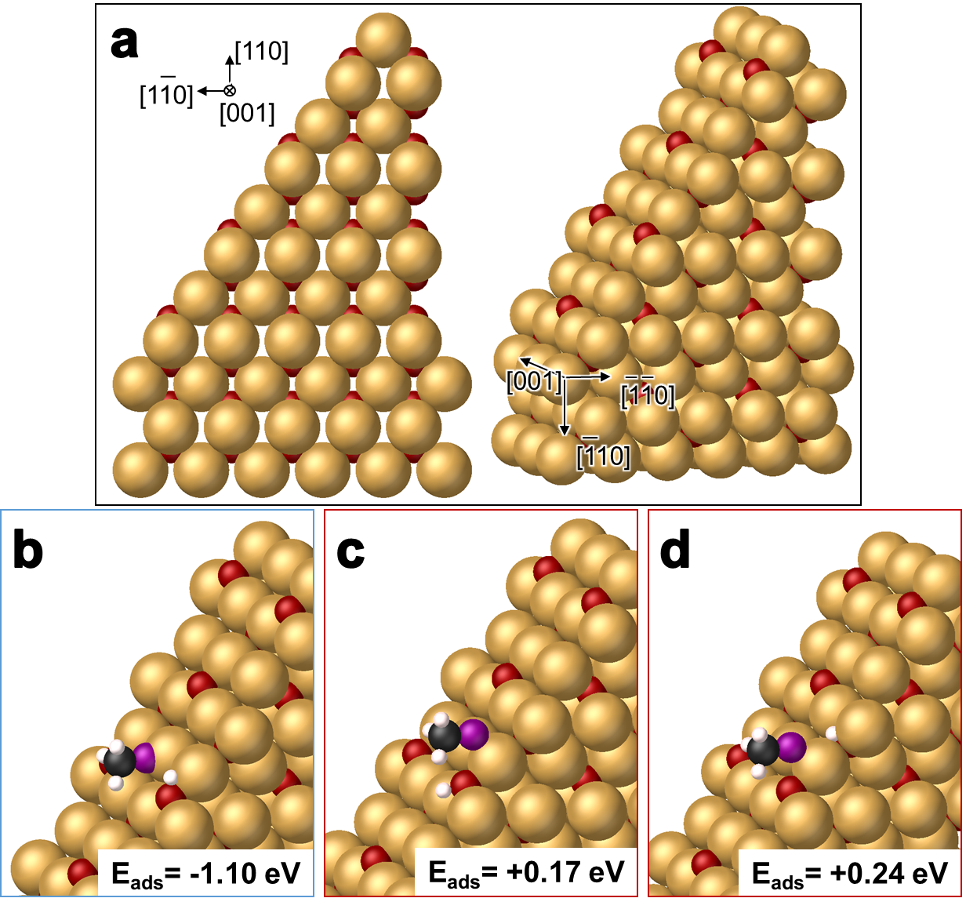
Figure S17| Cu₂O(110){110} side facet structure investigated for Figure 4a.
(a) Reference structure without adsorbates used for dissociative adsorption calculations in this figure. (b) Structure with a MeO adsorbate on an under-coordinated (two-fold) Cu atom and a H adsorbate on a fully coordinated (three-fold) O atom. This is the most favorable Cu₂O(110){110} adsorbate candidate (E_{ads} = -1.10 eV). (c) Structure with a MeO adsorbate between two fully coordinated (three-fold) Cu atoms and a H adsorbate on a fully coordinated surface (three-fold) O atom (E_{ads} = +0.17 eV). (d) Structure with a MeO adsorbate between two fully coordinated (three-fold) Cu atoms and a H adsorbate on a fully coordinated subsurface (four-fold) O atom (E_{ads} = +0.24 eV). Unstable structures (positive E_{ads}) are outlined in red, while the most favorable structure is outlined in blue. Cu (light brown), O (red), C (black), and H (white) atoms are generally colored accordingly, while O comprising MeO adsorbates are colored purple to distinguish them.

Note 5: DFT Simulation of MeOH Adsorption Energies on Cu(110)||Cu₂O(110){110} Interfaces
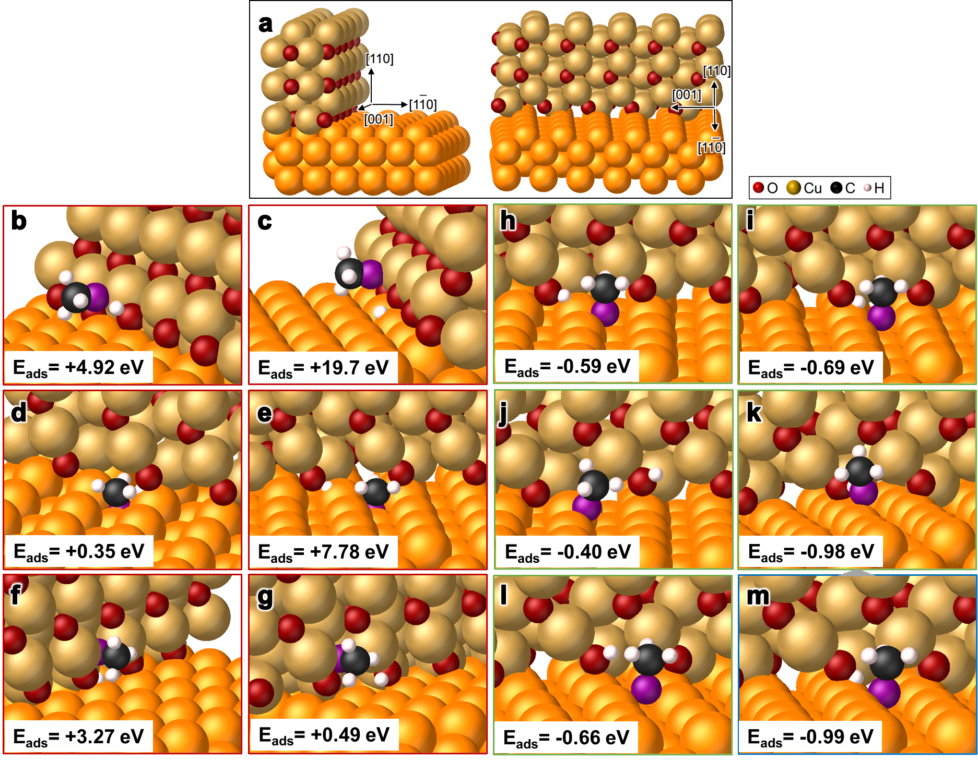
Figure S18| DFT calculation results on MeOH adsorption energies on Cu(110)||Cu₂O(110){110} interfacial structure without defects investigated via Figure 4b.
(a) Reference structure with no adsorbates used for dissociative adsorption calculations in this figure. (b-m) Dissociatively absorbed MeOH described in Table S3. Unstable structures (positive E_{ads}) are outlined in red, stable structures (negative E_{ads}) are outlined in green, and the most favorable structure (m) is outlined in blue. Cu forming Cu₂O interfaces (light brown), O (red), C (black), and H (white) atoms are generally colored accordingly, while O comprising MeO adsorbates are colored purple and Cu atoms forming Cu surfaces are colored orange to distinguish them from other Cu.

Table S3| Summary of DFT calculation results on MeOH E_{ads} – with unstable (red), stable (green), and most stable (blue) structures – on Cu(110)||Cu₂O(110){110} interfaces.
All atoms adsorbed to Cu₂O(110){110} are adsorbed at its lowest layer and are fully coordinated (no defects). Overall, MeO is most favorably adsorbed to two Cu(110) Cu sites in the same channel with one at the triple point, while matching cross-channel results are somewhat less favorable but still stable. H is then most favorably adsorbed to the O site on Cu₂O(110){110} nearest to MeO in both cases. The most favorable adsorption structure from this set is nearly, but not quite, as favorable as the most favorable Cu(110) site facet adsorption configuration (E_{ads} = -1.10 eV).
Figure S18 | Description | E_{ads} (eV)
b | MeO: 1 surface Cu site on Cu₂O(110){110}  H: On O of Cu₂O(110){110}, O site nearest to MeO | +4.92
c | MeO: 1 surface Cu site on Cu₂O(110){110}  H: On Cu of Cu(110), Cu site nearest to MeO | +19.70
d | MeO: Between 2 subsurface sites on Cu(110)  H: On O of Cu₂O(110){110}, O site nearest to MeO | +0.35
e | MeO: Between 2 subsurface sites on Cu(110)  H: On O of Cu₂O(110){110}, O site not nearest to MeO | +7.78
f | MeO: 1 subsurface Cu site on Cu₂O(110){110}  H: On O of Cu₂O(110){110}, O site nearest to MeO | +3.27
g | MeO: 1 subsurface Cu site on Cu₂O(110){110}  H: On O of Cu₂O(110){110}, O site not nearest to MeO | +0.49
h | MeO: 2 cross-channel Cu(110) sites (both initialized at triple point, relaxed accordingly)  H: On O of Cu₂O(110){110}, O site not nearest to MeO | -0.59
i | MeO: 2 cross-channel Cu(110) sites (both initialized at triple point, relaxed accordingly)  H: On O of Cu₂O(110){110}, O site nearest to MeO | -0.69
j | MeO: 2 in-channel sites on Cu(110) (1 at triple point)  H: On O of Cu₂O(110){110}, O site not nearest to MeO | -0.40
k | MeO: 2 in-channel sites on Cu(110) (1 at triple point)  H: On O of Cu₂O(110){110}, O site nearest to MeO | -0.98
l | MeO: 2 cross-channel Cu(110) sites (none at triple point)  H: On O of Cu₂O(110){110}, O site nearest to MeO | -0.66
m | MeO: Initially 2 cross-channel Cu(110) sites (both at triple point), relaxed into k  H: On O of Cu₂O(110){110}, O site nearest to MeO | -0.99

Note 6: DFT Simulation of MeOH Adsorption Energies on Cu(110)||Cu₂O(110){010} Interfaces
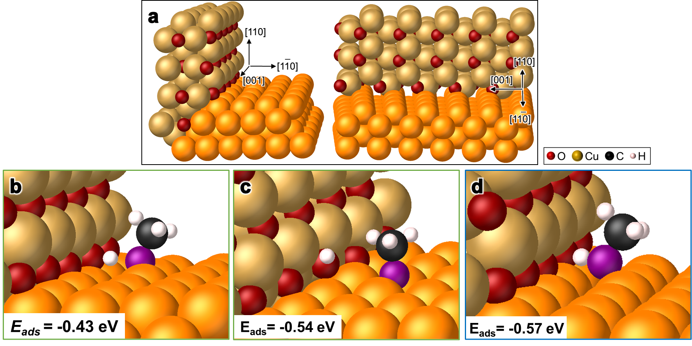
Figure S19| Cu(110)||Cu₂O(110){010} interfacial structure investigated to complement Figure 4c.
(a) Reference structure with no adsorbates used for adsorbate calculations in this figure. This structure applies a Cu(100)-Cu₂O(100) channel, an O-termination of the Cu₂O(100) surface, and no defects. (b) MeO and H adsorbate configurations rendered to resemble the most favorable structure derived in Note 5 as closely as is possible (Figure S18k,m). Beyond Figure S18k, this structure features an O-termination of its Cu₂O(110){110} surface and is stable (E_{ads} = -0.43 eV). (c) MeO and H adsorbate configurations resembling favorable cross-channel structures from Note 5 (Figure S18k,m). Beyond Figure S18j, this structure features an O-termination of its Cu₂O(110){110} surface and is stable (E_{ads} = -0.54 eV). (d) MeO and H adsorbate configuration resembling the most favorable structure derived in Note 5, except for H being adsorbed not next to MeO (Figure S18m). Beyond Figure S18m, this structure features an O-termination of its Cu₂O(110){110} surface, and is the most stable structure tested in Note 6 (E_{ads} = -0.57 eV).

Table S4| Summary of DFT calculation results on MeOH E_{ads} – with stable (green) and most stable (blue) structures – on Cu(110)||Cu₂O(110){010} interfaces with a Cu(100)-Cu₂O(100) channel, which better represents the experimental triple point.
All atoms adsorbed to Cu₂O(110){010} are located at the lowest layer of this interface, and are fully coordinated (no defects). Evaluated adsorption configurations are made to represent an ensemble of stable structures from the set tested in Note 5. Overall, MeO is most favorably adsorbed to two Cu sites in the same channel, while one of these Cu is located at the triple point. H is adsorbed to an O on Cu₂O(110){010} that is not as close as is possible to that MeO (mirrors Figure S18j). Matching cross-channel adsorption (represents Figure S18i) and MeO-H adjacent in-channel adsorption (represents Figure S18m) results are somewhat less favorable, but are still stable. All structures are distinctly less favorable than the most favorable Cu(110) site facet adsorption configuration (E_{ads} = -1.10 eV).
Figure S19 | Description | E_{ads} (eV)
b | MeO: 2 in-channel sites on Cu(110) (1 at triple point)  H: On O of Cu₂O(110){010}, O site nearest to MeO | -0.43
c | MeO: 2 cross-channel sites on Cu(110) (none at triple point)  H: On O of Cu₂O(110){010}, O site not nearest to MeO | -0.54
d | MeO: 2 in-channel sites on Cu(110) (1 at triple point)  H: On O of Cu₂O(110){010}, O site not nearest to MeO | -0.57

Note 7: DFT Simulation of MeOH Adsorption Energies on Cu(110)||Cu₂O(110){010} Interfaces (Cu-O Terminated) with Cu and O Defects
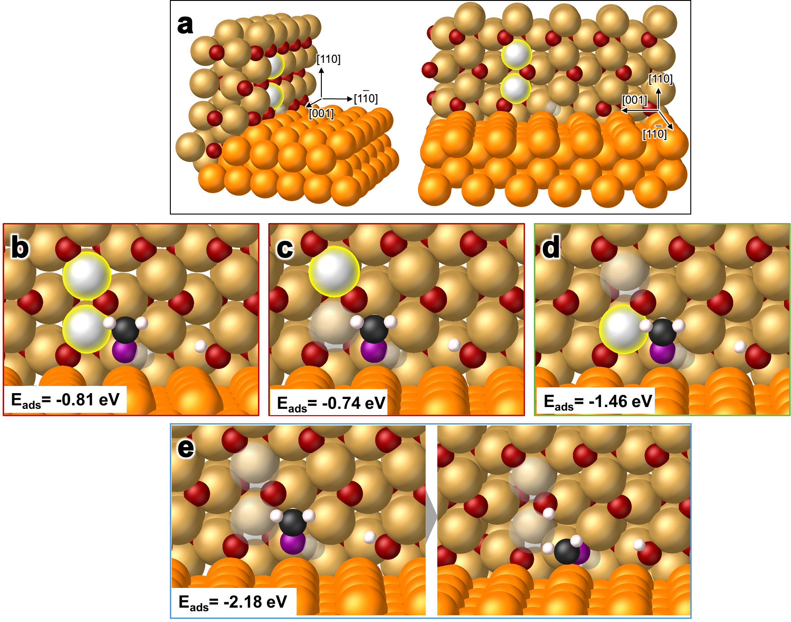
Figure S20| Cu(110)||Cu₂O(110){010} interfacial structure with Cu-O terminated {010} interface and Cu and O defects investigated via Figure 4d.
(a) The reference state without adsorbates features an O-termination of the Cu₂O(110){010} interface and one O site defect on the lowermost layer of that surface (grey hollow atom). Such features are maintained over all structures in Note 7. Two Cu on the lowermost and second lowermost Cu layers of Cu₂O(110){010}, which are highlighted in yellow, variably serve as sites for defects in simulations performed in Note 7. (b) Structure with MeO embedded within an O vacancy on the lowermost Cu₂O(110){010} layer and H adsorbed to an O on that layer next to the vacant O site. Other than its adsorbates, this structure matches its reference (a), as both possible Cu defect sites (highlighted in yellow) on the lowermost and second lowermost Cu layers of Cu₂O(110){010} are not defects (are not vacant). This structure is stable (E_{ads} = -0.81 eV). (c) Structure with MeO embedded within an O vacancy on the lowermost Cu₂O(110){010} layer and H adsorbed to an O on that layer next to the vacant O site. Other than its adsorbates, this structure matches its reference (a) but with the lower highlighted Cu removed, as the Cu site on the lowermost layer is vacant (is a defect site). In contrast, the matching Cu defect site (highlighted in yellow) on the second lowermost Cu₂O(110){010} Cu layer is not vacant. This structure is stable (E_{ads} = -0.74 eV). (d) Structure with MeO embedded within an O vacancy on the lowermost Cu₂O(110){010} layer and H adsorbed to an O on that layer next to the vacant O site. Other than its adsorbates, this structure matches its reference (a) but with the upper highlighted Cu removed, as the Cu site on the second lowermost layer is vacant (is a defect site). In contrast, the matching Cu defect site (highlighted in yellow) on the lowermost Cu₂O(110){010} Cu layer is not vacant. This structure is stable (E_{ads} = -1.46 eV). (e) Structure initialized with MeO embedded within an O vacancy on the lowermost Cu₂O(110){010} layer and H adsorbed to an O on that layer next to the vacant O site (left panel). This structure with an adsorbate is referenced relative to (a), but with both highlighted Cu removed (vacancies). After relaxation, one H is transferred from MeO to an undercoordinated O on Cu₂O(110){010} that resulted from Cu defects (right panel). This structure is stable (E_{ads} = -2.18 eV).

Table S5| Summary of DFT calculation results on MeOH E_{ads} on Cu(110)||Cu₂O(110){010} with a Cu(100)-Cu₂O(100) channel interface, which represents the experimental triple point.
Relative to the most favorable Cu(110) site facet adsorption configuration (E_{ads} = -1.10 eV), structures that are less favorable (red), more favorable (green), and the most favorable (blue) of all tested structures in Note 7 are highlighted accordingly below. All atoms adsorbed to Cu₂O(110){010} are located at its lowest layer. Given that the experimental process by which Cu₂O side layers are removed requires exposure of both terminations (Cu-O and Cu) of the Cu₂O interface, these structures represent Cu-O terminated structures. Adsorption configurations are selected to best improve proximity of MeO-based adsorbates to the triple point, possibly available sites at which H can be adsorbed after dissociation, and possible Cu defects on Cu₂O(110){010}. Consistently, MeO is more favorably adsorbed to this structure than the side facet against which it competes in experiment when the Cu site nearest MeO is vacant (or a defect site). Favorability is even further improved when Cu defects lead to O undercoordination, such that more H can be dissociated from MeO and transferred to such nearby O. All studied structures were stable.
Figure S20 | Description | E_{ads} (eV)
b | O: 1 defect, lowest Cu₂O(110){110} layer  Cu: No defects  Cu site nearest to MeO is not a defect site | -0.81
c | O: 1 defect, lowest Cu₂O(110){110} layer  Cu: 1 defect, second lowest Cu₂O(110){110} layer  Cu site nearest to MeO is not a defect site | -0.74
d | O: 1 defect, lowest Cu₂O(110){110} layer  Cu: 1 defect, lowest Cu₂O(110){110} layer  Cu site nearest to MeO is a defect site | -1.46
e | O: 1 defect, lowest Cu₂O(110){110} layer  Cu: 2 defects, both Cu₂O(110){110} layers  Cu site nearest to MeO is a defect site  Relaxes to separate MeO from an additional H | -2.18

Note 8: DFT Simulation of MeOH Adsorption Energies on Cu(110)||Cu₂O(110){010} Interfaces (Cu Terminated) with Cu Defects
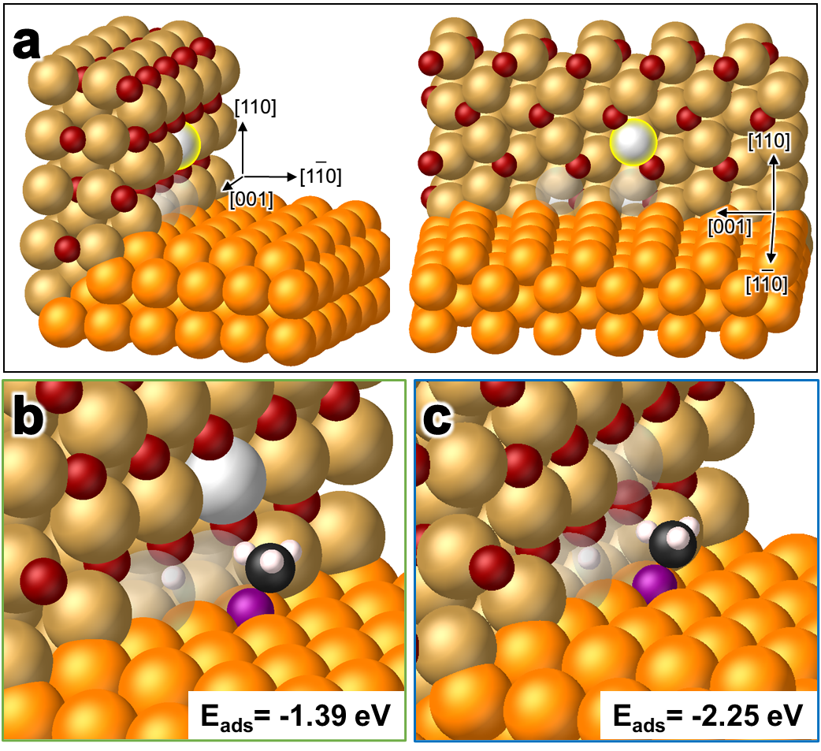
Figure S21| Cu(110)||Cu₂O(110){010} interfacial structure with Cu-terminated (100) interface and Cu defects investigated via Figure 4e.
(a) The reference structure without adsorbates features a Cu-termination of the Cu₂O(110){010} interface, and two Cu defect sites (grey hollow atoms) on the lowermost layer of that surface. This is the adsorbate-free reference structure for (b). Adding another Cu defect on the second lowermost layer of Cu₂O(110){110} (highlighted, solid grey) forms the adsorbate-free reference for (c). (b) Structure with MeO and H adsorbate configurations adapted from Figure S20c, but shifted down to the Cu(110) surface. This structure is stable (E_{ads} = -1.39 eV). (c) Structure with MeO and H adsorbate configurations adapted from Figure S20e, but shifted down to the Cu(110) surface. This structure is stable (E_{ads} = -2.25 eV).

Table S6| Summary of DFT calculation results on MeOH E_{ads} on Cu(110)||Cu₂O(110){010}.
Structures that are more favorable (green) than the most favorable Cu(110) site facet adsorption configuration (-1.10 eV), as well as the most favorable (blue) of all tested structures in Note 8, are highlighted accordingly below. All atoms adsorbed to Cu₂O(110){010} are located at its lowest layer. Given that the experimental process by which Cu₂O side layers are removed requires exposure of both terminations (Cu-O and Cu) of the Cu₂O interface, these structures represent Cu terminated structures. Adsorption configurations are selected to most closely mirror those tested in Note 7 as is possible, given that the iterative removal of Cu₂O side layers (at the triple point) in experiment would require transition between Cu and Cu-O terminations of Cu₂O(110). Thus, the structures and configurations shown in Note 8 are designed to readily transition between those featured in Note 7. Particularly, the lowermost Cu layer of Cu₂O(110) in Note 7 would diffuse onto Cu(110), while MeO and H would maintain their configurations while adsorbing onto Cu(110) and Cu₂O(110), respectively. Consistently, MeO is more favorably adsorbed to this structure than the side facet against which it competes in experiment when the Cu sites nearest MeO are vacant (or are defect sites). Favorability is even further improved when more Cu defects are introduced. In conjunction with Notes 5, 6, and 7, these results indicate that regardless of the orientations of particular interfaces featuring reactions, the terminations of such interfaces, or the configurations of dissociated MeO and H adsorbates, the overarching cause of favorability inducing anisotropic island shrinking is the introduction of Cu and O defects on vertical Cu₂O(110) side layers. All structures studied in Note 8 were stable.
Figure S21 | Description | E_{ads} (eV)
b | Lower layer: 2 Cu defects  Upper layer: No Cu defects | -1.39
c | Lower layer: 2 Cu defects  Upper layer: 1 Cu defect | -2.25

Note 9: Experimental Verification of Defects Near (100) Junction
Our DFT simulations suggest that for the (100) junction, Cu and O vacancies near the junction could significantly lower dissociative adsorption energies. Although direct observation of individual site vacancies in TEM is still a very challenging task, the relative TEM intensity changes caused by inducing multiple vacancies can substantiate claims of single site vacancy existence.³²
Using the most favorable vacancy configuration from DFT simulated structures shown in Figure 4, an atomic model of a Cu₂O island grown on Cu(110) with a (100) junction is built (Figure S22a). This Cu||Cu₂O interface adopts the (6×7) Coincident Site Lattice (CSL) structure observed in our experiments and previous papers.³³ HRTEM image simulation is performed using this model with and without vacancies, fitting simulation parameters to best match experimental images (Figure S22b). Such parameters are then adopted to compare TEM image intensities before and after site vacancies are induced. Both Cu and O vacancies are found to lead to increases in intensity.
To verify described effects in experiments, HRTEM movies are pseudo-colored to show intensity changes, as shown in Figure S23. As shown in Figure S23a-c, the junction region in the anisotropic stage shows brighter contrast in comparison with referenced Cu₂O bulk. However, this relative increase in intensity disappeared in corresponding images depicting reduction during the isotropic stage. Further, atomic column positions of the Cu₂O island were detected using our data analysis method. Using the detected column positions, the average intensity of each atomic column is calculated and plotted in panels beneath TEM images. During the entire anisotropic stage, the junction area shows much higher intensity (red) than all other regions of the island. In contrast, more uniform TEM image intensity is observed across studied islands during the isotropic stage. The experimentally observed intensity increases near junctions are caused by vacancies, as is confirmed by our HRTEM simulations.

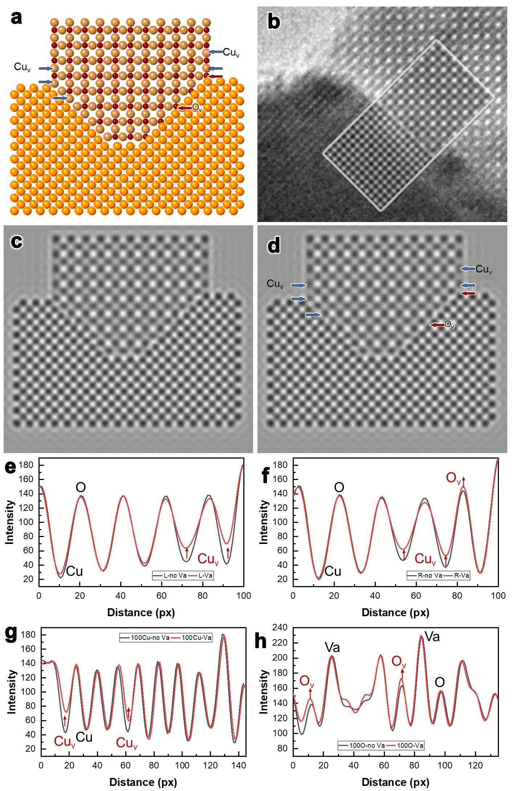
Figure S22| HRTEM simulation results depicting vacancy induced effects on image intensity.
(a) Atomic model for HRTEM simulation with defect sites on Cu₂O(110) surfaces and Cu||Cu₂O interfaces; vacancy configurations at junctions are adopted from the most favorable simulated configurations in Figure 4. (b) Simulated HRTEM image (inset) is in good agreement with the experimental image. (c) Simulated HRTEM image without defects. (d) Simulated HRTEM image with defects. (e) Intensity profiles of Cu₂O(110) surface with (red) and without (grey) Cu vacancy (Cu_{v}) marked by arrows. (f) Intensity profiles of Cu₂O(110) surface with (red) and without (grey) Cu and O vacancies marked by arrows. (g) Intensity profiles of Cu-terminated Cu||Cu₂O(100) interface with (red) and without (grey) Cu vacancies marked by arrows. (h) Intensity profiles of O-terminated Cu||Cu₂O(100) interface with (red) and without (grey) O vacancies marked by arrows.

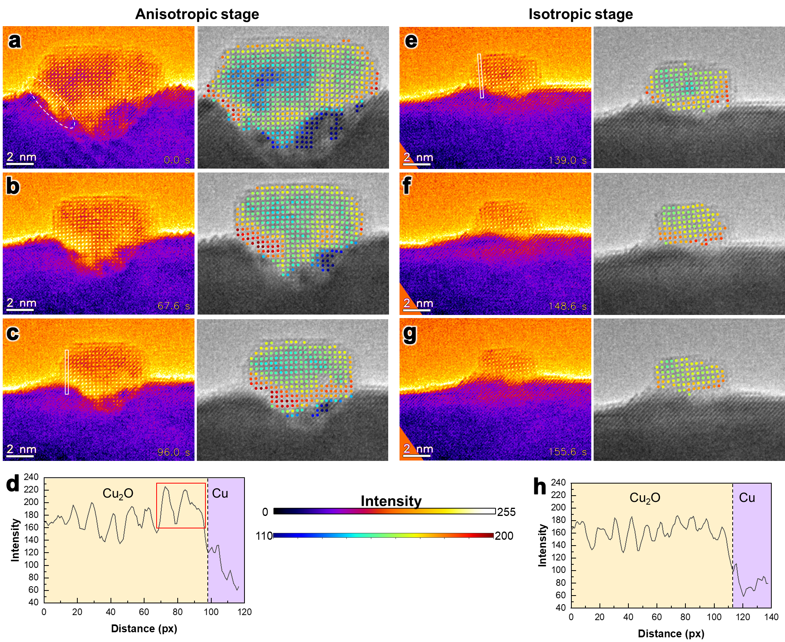
Figure S23| Change of relative intensity near junction from anisotropic stage to isotropic stage.
(a-c) Pseudo-colored HRTEM images of the anisotropic stage highlight intensity differences (left), while corrresponding plots of atomic column intensity are depicted in atom-resolved images (right). The intensity near the junction is brighter than that of the Cu₂O bulk throughout this stage; the junction is marked by the dashed circle in (a). (d) Representative intensity profile of the junction region marked in (c). The atomic columns near the Cu||Cu₂O interface (boxed region) show increased intensity. (e-g) Pseudo-colored HRTEM images of the isotropic stage highlight intensity differences (left), while corresponding plots of atomic column intensity are depicted in atom-resolved images (right). The intensity near the junction is similar to that of the Cu₂O bulk throughout this stage. (h) Representative intensity profile of the junction region marked in (e) showing uniform intensity across the Cu₂O island. Upper and lower intensity (heatmap) color bars between (d) and (h) apply to leftward pseudo-colored HRTEM images and rightward columnar atom-resolved images, respectively.

Supporting References
1. Li M, Curnan MT, Saidi WA, Yang JC. Uneven Oxidation and Surface Reconstructions on Stepped Cu(100) and Cu(110). Nano Lett 2022, 22(3): 1075-1082.

2. Li M, Curnan MT, Gresh-Sill MA, House SD, Saidi WA, Yang JC. Unusual layer-by-layer growth of epitaxial oxide islands during Cu oxidation. Nat Commun 2021, 12(1): 2781.

3. Ziatdinov M, Dyck O, Maksov A, Li X, Sang X, Xiao K, et al. Deep Learning of Atomically Resolved Scanning Transmission Electron Microscopy Images: Chemical Identification and Tracking Local Transformations. ACS Nano 2017, 11(12): 12742-12752.

4. Yao L, Ou Z, Luo B, Xu C, Chen Q. Machine Learning to Reveal Nanoparticle Dynamics from Liquid-Phase TEM Videos. ACS Cent Sci 2020, 6(8): 1421-1430.

5. Momma K, Izumi F. VESTA 3for three-dimensional visualization of crystal, volumetric and morphology data. Journal of Applied Crystallography 2011, 44(6): 1272-1276.

6. Sheng H, Zheng H, Jia S, Chan MKY, Rajh T, Wang J, et al. Atomistic manipulation of reversible oxidation and reduction in Ag with an electron beam. Nanoscale 2019, 11(22): 10756-10762.

7. Egerton RF, Li P, Malac M. Radiation damage in the TEM and SEM. Micron 2004, 35(6): 399-409.

8. Song M, Zhou G, Lu N, Lee J, Nakouzi E, Wang H, et al. Oriented attachment induces fivefold twins by forming and decomposing high-energy grain boundaries. Science 2020, 367(6473): 40-45.

9. Chi H, Curnan MT, Li M, Andolina CM, Saidi WA, Veser G, et al. In situ environmental TEM observation of two-stage shrinking of Cu2O islands on Cu(100) during methanol reduction. Phys Chem Chem Phys 2020, 22(5): 2738-2742.

10. McQuarrie DA. Stochastic approach to chemical kinetics. Journal of Applied Probability 2016, 4(3): 413-478.

11. Luo L, Nian Y, Wang S, Dong Z, He Y, Han Y, et al. Real-Time Atomic-Scale Visualization of Reversible Copper Surface Activation during the CO Oxidation Reaction. Angewandte Chemie International Edition 2020, 59(6): 2505-2509.

12. Zhang K, Apley DW, Chen W. Nonstationarity Analysis of Materials Microstructures via Fisher Score Vectors. Acta Materialia 2021, 211: 116818.

13. Team RC. R: A language and environment for statistical computing. 2013.

14. Zeileis A, Leisch F, Hornik K, Kleiber C. strucchange. An R package for testing for structural change in linear regression models. 2001.

15. Hyndman RJ, Athanasopoulos G, Bergmeir C, Caceres G, Chhay L, O'Hara-Wild M, et al. Package ‘forecast’. https://cran.r-project.org/web/packages/forecast/forecast.pdf 2020.

16. Hyndman RJ, Khandakar Y. Automatic Time Series Forecasting: The forecast Package for R. Journal of Statistical Software 2008, 27(3): 1-22.

17. Pfaff B, Zivot E, Stigler M, Pfaff MB. Package ‘urca’. Unit root and cointegration tests for time series data R package version 2016: 1.2-6.

18. Zeileis A, Kleiber C, Krämer W, Hornik K. Testing and dating of structural changes in practice. Computational Statistics & Data Analysis 2003, 44(1): 109-123.

19. Bai J, Perron P. Computation and analysis of multiple structural change models. Journal of Applied Econometrics 2003, 18(1): 1-22.

20. Hawkins DM. Fitting multiple change-point models to data. Computational Statistics & Data Analysis 2001, 37(3): 323-341.

21. Wang B, Sun J, Motter AE. Detecting structural breaks in seasonal time series by regularized optimization. arXiv preprint arXiv:150504305 2015.

22. Eisenegger C, Naef M, Linssen A, Clark L, Gandamaneni PK, Müller U, et al. Role of Dopamine D2 Receptors in Human Reinforcement Learning. Neuropsychopharmacology 2014, 39(10): 2366-2375.

23. Jocham G, Klein TA, Ullsperger M. Differential Modulation of Reinforcement Learning by D2 Dopamine and NMDA Glutamate Receptor Antagonism. The Journal of Neuroscience 2014, 34(39): 13151.

24. Schwarz G. Estimating the dimension of a model. The annals of statistics 1978: 461-464.

25. Diebold FX. Elements of forecasting. Citeseer, 1998.

26. Stojkoski V, Sandev T, Kocarev L, Pal A. Geometric Brownian motion under stochastic resetting: A stationary yet nonergodic process. Physical Review E 2021, 104(1): 014121.

27. Peters O, Klein W. Ergodicity Breaking in Geometric Brownian Motion. Physical Review Letters 2013, 110(10): 100603.

28. Zwanzig R. Time-correlation functions and transport coefficients in statistical mechanics. Annual Review of Physical Chemistry 1965, 16(1): 67-102.

29. Zhou G, Yang JC. Formation of Quasi-One-Dimensional Cu2O Structures by in situ Oxidation of Cu(100). Physical Review Letters 2002, 89(10): 106101.

30. Zhou G, Yang JC. Reduction of Cu2O islands grown on a Cu(100) surface through vacuum annealing. Phys Rev Lett 2004, 93(22): 226101.

31. Phillips PCB, Perron P. Testing for a unit root in time series regression. Biometrika 1988, 75(2): 335-346.

32. Sun X, Zhu W, Wu D, Li C, Wang J, Zhu Y, et al. Surface-reaction induced structural oscillations in the subsurface. Nature Communications 2020, 11(1): 305.

33. Zhou G. Metal-oxide interfaces at the nanoscale. Applied Physics Letters 2009, 94(23).

