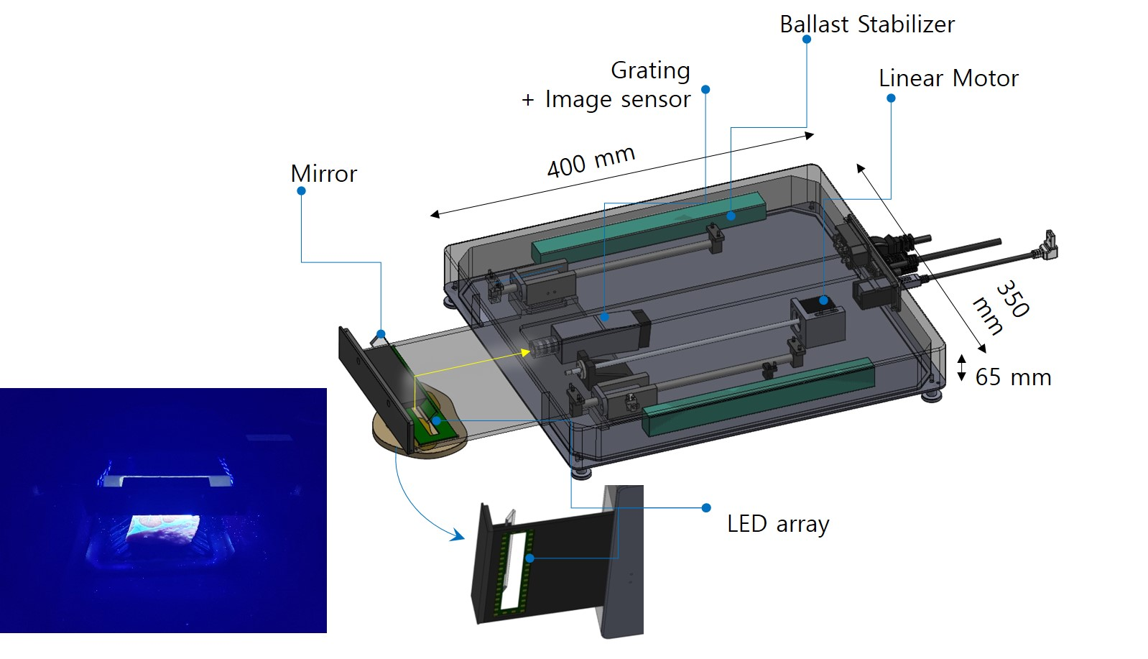

Extended Data Fig. 1 | Schematic of line-scan type HIS. The schematic shows the details of line-scan-type HIS. A moving optical element composed of linear 365 nm LED arrays with a rectangular window and a mirror scan linearly to illuminate and collect fluorescence from the meat surface. The fluorescence signals are transported to a conventional spectrometer composed of grating and an image sensor from Ximea Corporation. An actual photograph of elements in motion to illuminate the LED and collect the fluorescence spectrum from the meat specimen is displayed in the left corner.

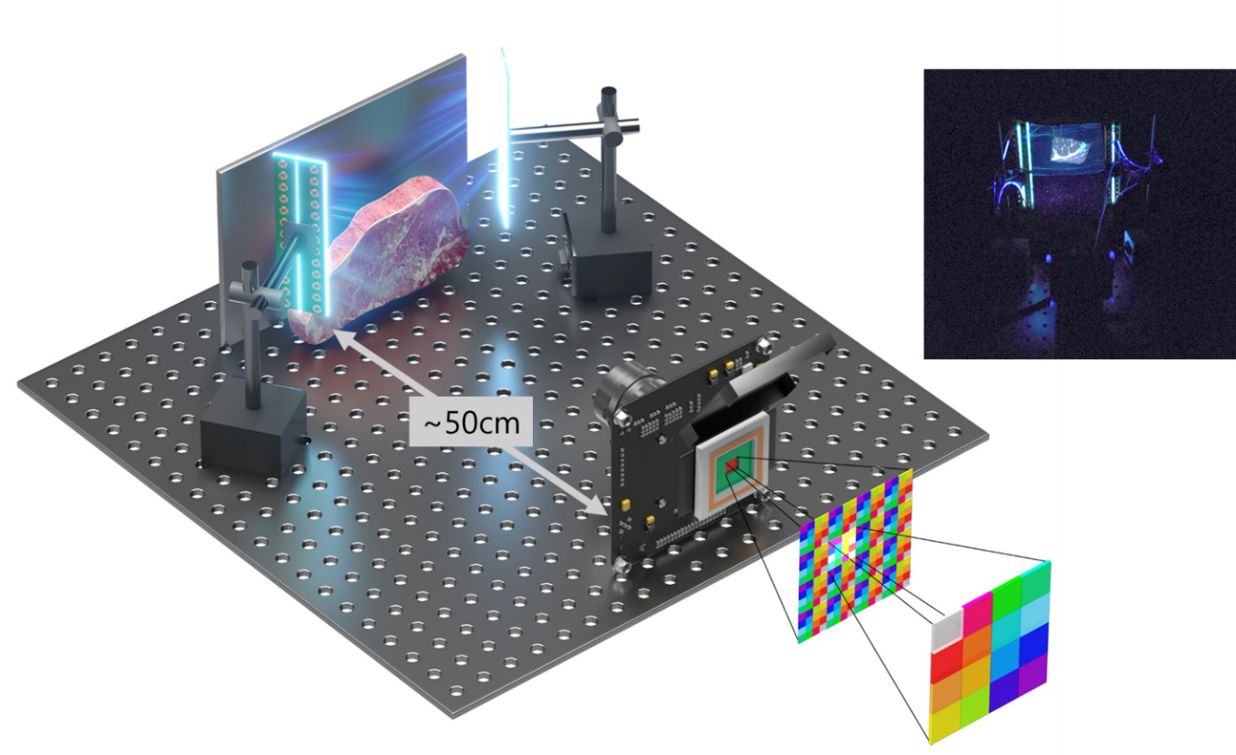
Extended Data Fig. 2 | Schematic of snapshot-type HIS. The schematic shows the details of snapshot-type HIS. The meat specimen is illuminated by 365 nm LED vertical arrays, and the hyperspectral images of the fluorescence signal generated from the meat specimen are taken by the snapshot-type HIS, positioned ~50 cm away. A photograph of the snap-shot-type HIS used in the experiment is displayed on the upper right.

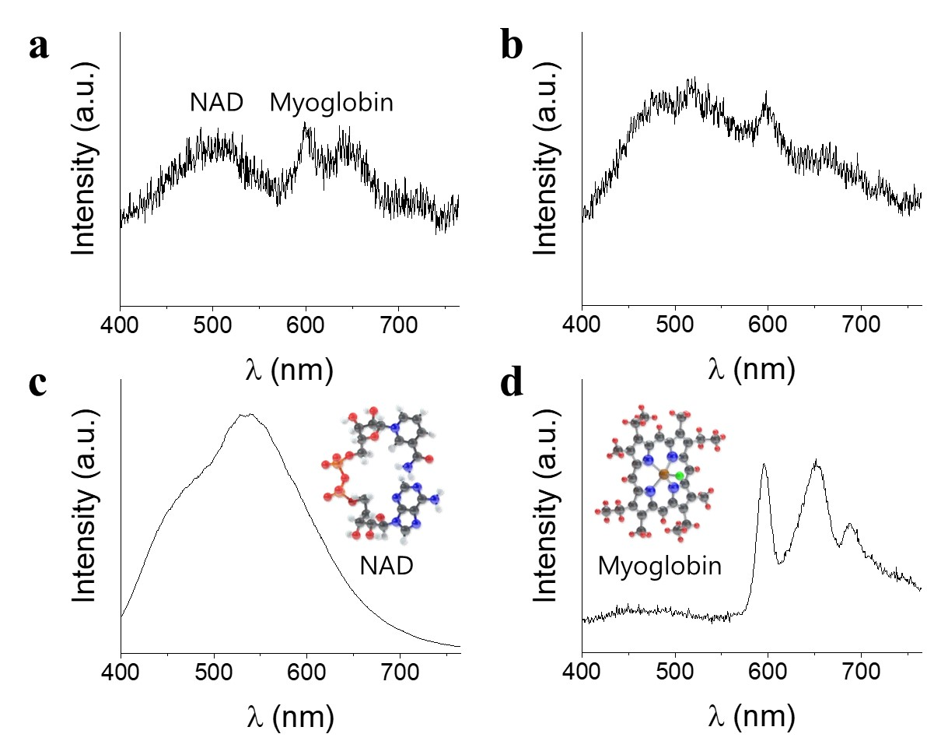
Extended Data Fig. 3 | Fluorescence spectrum of the meat specimen, NAD and myoglobin. The fluorescence spectrum of (A) fresh and (B) rotten meat specimen excited by 365 nm LED arrays. Fluorescence spectrum of (C) NAD and (D) myoglobin purchased from Aldrich. Inc. and excited by 365 nm LED. Molecular structures are shown as insets. The characteristic features in the spectrum of meat are very similar to that of the NAD and myoglobin.

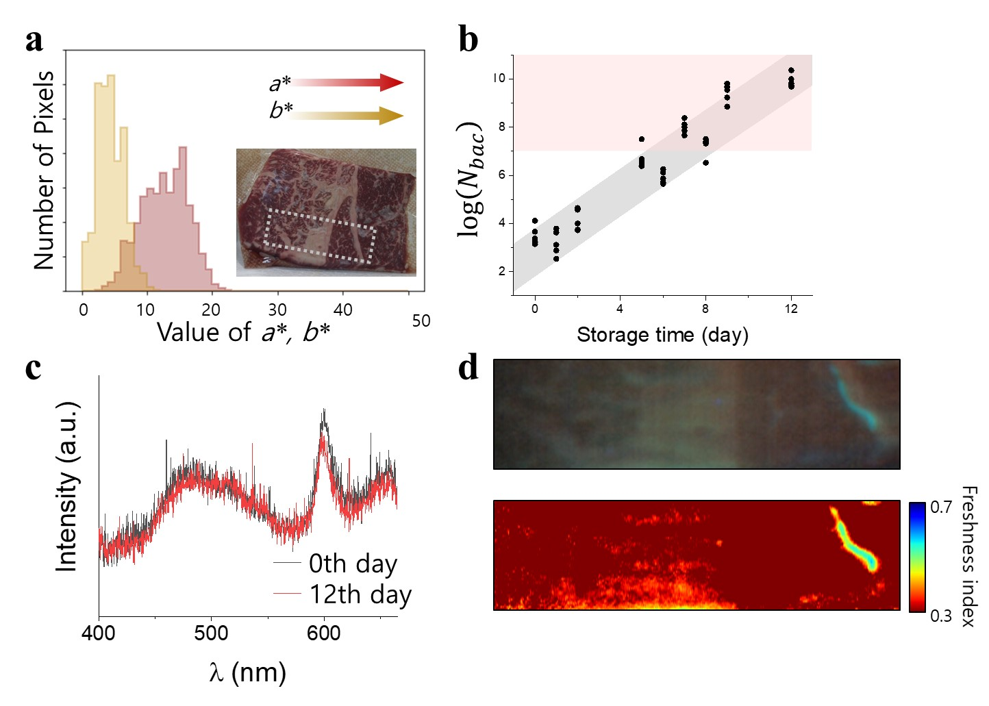

Extended Data Fig. 4 | Freshness of vacuum packaged meat specimen on the 12th day. (A) Distribution of a* and b* values of the RGB image as an inset. (B) Bacterial density ($N_{bac}$) of the PE wrap packaged sample prepared on the same day with vacuum packaged sample as a function of storage time. The reddish-shaded area in the figure indicates the inedible state. (C) Two representative fluorescence spectra on the 0th and 12th day of the vacuum-packaged meat specimen. (D) Hyperspectral image of meat fluorescence and its F. I. indicated by the white dotted rectangular area in the inset of (A).

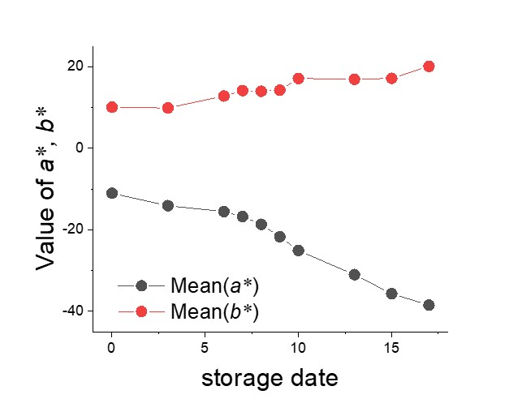

Extended Data Fig. 5 | Storage time dependence of RGB^{hyper}. Time dependence of mean a* and b* values of the RGB images constructed from the fluorescence hyperspectral images (RGB^{hyper}) of the PE-packaged meat specimen. Values of a* and b* provide limited information to estimate meat freshness in the early stages.

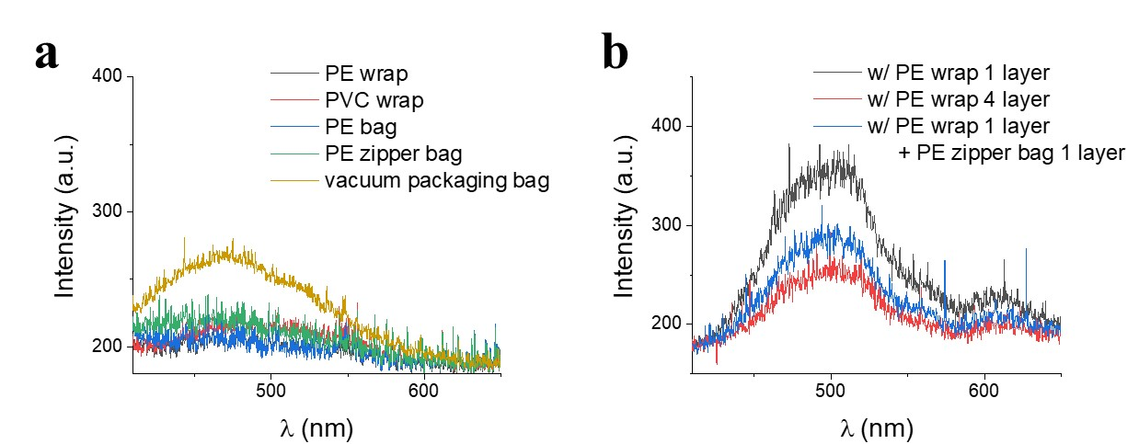

Extended Data Fig. 6 | Influence of the packaging material on the final fluorescence spectrum. (A) Fluorescence spectrum of each packaging material. To amplify the fluorescence effect of the packing material, a spectrum of two layers with 5 s integration time is taken, which is longer than 10 times the actual experimental condition. Roughly, the effect gets amplified more than 20 times. (B) Fluorescence spectrum of the meat specimen packaged in a PE wrap, where black represents one time and red represents four times wrapping, and PE-wrap one time and PE zipper back (blue), respectively.

Type | PE wrap | PVC wrap | PE zipper bag | Vacuum packing bag
Chemical  component | High density polyethylene  (HDPE) | Polyvinyl  chloride  (PVC) | Low density  polyethylene  (LDPE) | Polyamide

Extended Table 1 | List of packaging materials and their chemical components.

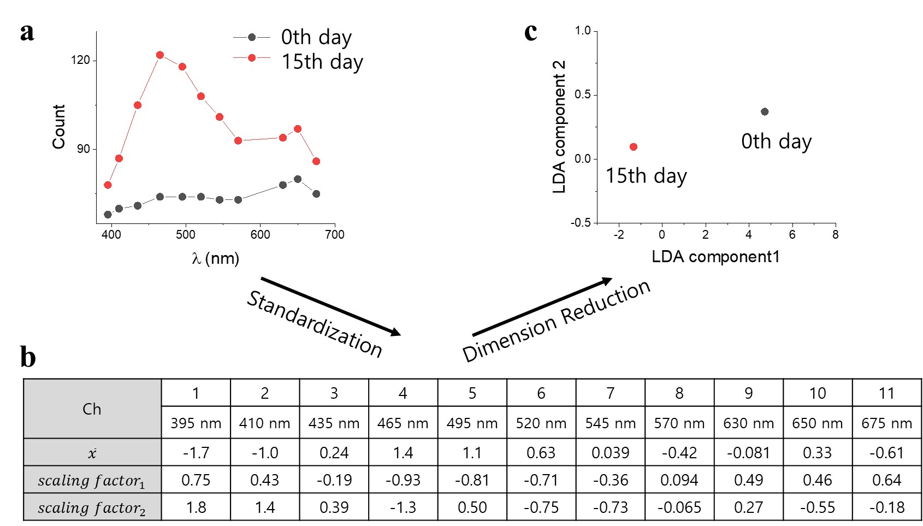

Extended Data Fig. 7| Dimensionality reduction from 11 to 2 dimensions in the hyperspectral data cube by LDA. The process of dimensionality reduction of hyperspectral images has been illustrated. (A) Two representative data of 11 dimensions on the 0th and the 15th day of the PE-packaged meat specimen. (B) Wavelength-dependent $\overline{x}$ and two scaling factors determined by LDA. The table shows the reduced dimension of the two representative data.

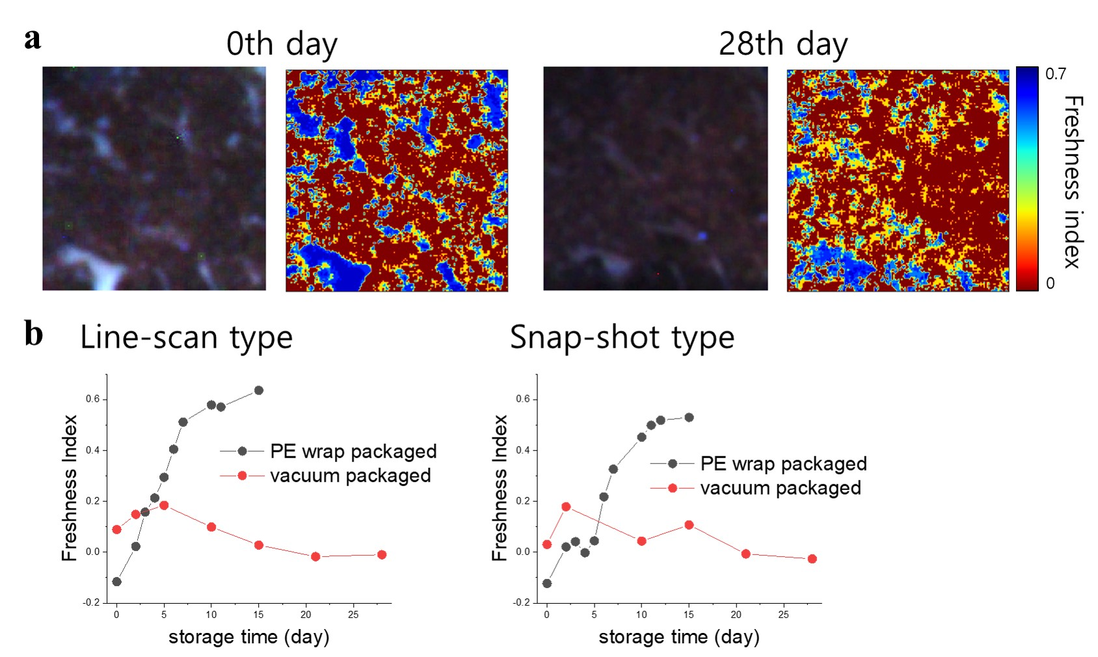
Extended Data Fig. 8| Storage time dependent F. I. of the PE and vacuum-packaged meat specimens. (A) Hyperspectral images and F. I. values on the 0th and the 28th day, obtained by snapshot-type HIS. (B) Comparison of F. I. values as a function of storage time of the PE-wrap-packaged (black) and vacuum-packaged (red) meat specimens, obtained by line-scan-type and snapshot-type HIS.

