SUPPLEMENTAL TABLES

Supplemental Table 1 – CMR patterns of LV hypertrophy as previously defined by Dweck et al; normal values for CMR according to Kawel-Boehm et al [18].
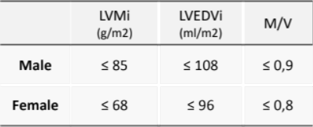
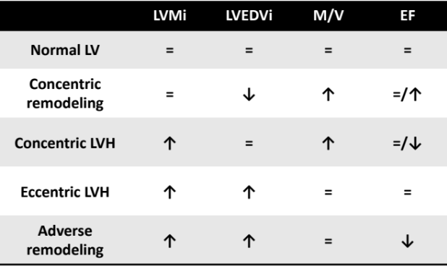

Supplemental Table 2 – Comparative analyses between asymmetric and non-asymmetric LV patterns before surgery.
 | Asymmetric LV hypertrophy | Non-asymmetric LV hypertrophy | p-value
Number of patients | 71 | 59 | -
Hypertension, n (%) | 56 (86) | 52 (91) | 0.380
ACE inhibitors/ARBs, n (%) | 44 (62) | 40 (68) | 0.489
Diuretics, n (%) | 25 (35) | 22 (37) | 0.808
Beta-blockers, n (%) | 18 (25) | 20(34) | 0.286
MRAs, n (%) | 1 (1) | 2 (3.4) | 0.592
Diabetes mellitus, n (%) | 21 (48) | 13 (22) | 0.808
Creatinine Clearance, ml/min | 71.8 ± 24.8 | 72.2± 20.8 | 0.907
NT-pro BNP, pg/mL | 790 (303 - 2119.5) | 437 (145-1190) | 0.043
Echocardiography
Indexed Aortic Valve Area, cm² | 0.39 ± 0.10 | 0.41 ± 0.08 | 0.434
Mean Aortic gradient, mmHg | 64.2 ± 18.4 | 57.4 ± 16.1 | 0.028
LV indexed mass, g/m2 | 167.8 ± 56 | 146.9 ± 47.6 | 0.025
LVEDV, mL | 89.8 ± 37.7 | 83.4 ± 28.6 | 0.148
LV ejection fraction, % | 57.1 ± 10 | 59.1 ± 8.3 | 0.247
GLS, % | -13.8 ± 3.6 | -15.8 ± 3.8 | 0.005
Cardiac Magnetic Resonance
Ejection Fraction, % | 57.9 ± 10 | 61.8 ± 9.8 | 0.028
LV mass index, g/m² | 90.6 ± 27.8 | 71.2 ± 21.1 | <0.001
Indexed LVEDV, mL/m² | 89.5 ± 24.6 | 81.2 ± 20.4 | 0.042
Geometric remodeling, g/m² | 1.1 (0.88 – 1.14) | 0.8 (0.77 – 0.97) | <0.001
LGE, g | 4.2 (0 – 11.75) | 1.9 (0 – 5.94) | 0.036
Values are median (interquartile range), mean±standard deviation, ACE inhibitors - Angiotensin-converting-enzyme inhibitors, ARBs - Angiotensin receptor blockers, MRAs - Mineralocorticoid receptor antagonists, GLS – Global longitudinal strain, LV – left ventricle, LVEDV – left ventricle end diastolic volume, LGE – late gadolinium enhancement; Bold P-values are statistically significant; Patients with exclusive junctional LGE were excluded from the analyses of LGE.

Supplemental Table 3 - Comparative analyses between imaging data: TTE and CMR in patients with severe symptomatic AS before and after AVR.
 | Before AVR  n=130 | After AVR  n=116 | p-value
Echocardiography
Maximum Aortic gradient, mmHg | 98.6 ± 27.2 | 23.1± 8.7 | <0.001
Mean Aortic gradient, mmHg | 61.1 ± 17.6 | 12.7 ± 5.2 | <0.001
DVI | 0.20 ± 0.05 | 0.49 ± 0.10 | <0.001
Relative wall thickness | 0.51 ± 0.13 | 0.46 ± 0.14 | 0.001
LV indexed mass, g/m² | 158.3 ± 53.2 | 128.9 ± 44.2 | <0.001
LVEDV, mL | 86.9 ± 33.9 | 85.5 ± 32.7 | 0.607
LV ejection fraction, % | 57.9 ± 9.3 | 59.7± 7.9 | 0.095
Global Longitudinal strain, % | -14.7 ± 3.8 | -16.2 ± 3.2 | <0.001
Cardiac Magnetic Resonance
LV indexed mass, g/m² | 81.8 ± 26.7 | 62.7 ± 15.1 | <0.001
LVEDV, mL | 155.1 ± 47.4 | 141 ± 44.2 | <0.001
Geometric remodeling, g/mL | 0.96 (0.82-1.08) | 0.84 (0.71-0.93) | <0.001
LV ejection fraction, % | 59.7 ± 10.1 | 58 ± 8.8 | 0.034
Values are median (interquartile range), mean±standard deviation, LV – left ventricle, LVEDV – left ventricle end diastolic volume; Bold P-values are statistically significant. Comparative sensitivity analysis was performed only for patients who complete post-operative study with TTE and CMR at the 3rd to 6th month post-AVR.

