Supplementary Information
Environmental footprints of the SHIFTPHONE show resources and CO₂ savings through modular smartphone design
Anna C. Schomberg^{1*}, Clemens Mostert¹, Stefan Bringezu¹, Thomas Krause², Leon von Zepelin²
- Center for Environmental Systems Research, Kassel Institute for Sustainability, University of Kassel, Germany
- SHIFT GmbH, Falkenberg, Germany
* Corresponding author, anna.schomberg@uni-kassel.de

Supplementary Table 1: Inputs of M2x2.5 and M5. The type and quantity of replaced modules are taken from the SHIFT GmbH repair statistics for the SHIFT6m. Camera lenses exchanged and audioports exchanged are not incorporated here due to data shortages. Values are given as items and, if available, also in other units as applied in the LCA models.
 |  | Per functional unit  (use for one year) |  |  | Per lifetime  (use for five years)
Use case | Input | Item | Value | Unit | Item | Value | Unit
M2x2.5 | electricity |  | 1.86 | kWh |  | 9.32 | kWh
 | SHIFT6m, 2 smartphones, 5 years | 0.40 |  |  | 1.00
M5 | electricity |  | 1.86 | kWh |  | 9.32 | kWh
 | SHIFT6m, 1 smartphone, 5 years | 0.20 |  |  | 1.00
 | displays exchanged, per SHIFT6m
 |  | 0.06 | 2.52E-03 | kg | 0.32 | 0.01 | kg
 | batteries, exchanged, per SHIFT6m
 |  | 0.05 | 3.30E-03 | kg | 0.25 | 0.02 | kg
 | backcameras exchanged, per SHIFT6m
 |  | 0.02 |  |  | 0.09
 | earpieces exchanged, per SHIFT6m
 |  | 4.57E-03 | 5.76E-08 | kg | 0.02 | 2.88E-07 | kg
 | frames (incl. backcover) exchanged, per SHIFT6m
 |  | 4.37E-03 | 1.31E-04 | kg | 0.02 | 6.55E-04 | kg
 | frontcameras exchanged, per SHIFT6m
 |  | 2.90E-03 |  |  | 0.01
 | sub-PCB (incl. speaker) exchanged, per SHIFT6m
 |  | 2.33E-03 | 5.78E-06 | m² | 0.01 | 2.89E-05 | m²
 | mainboards, PCBAs exchanged, per SHIFT6m
 |  | 3.83E-04 | 9.49E-07 | m² | 1.92E-03 | 4.74E-06 | m²

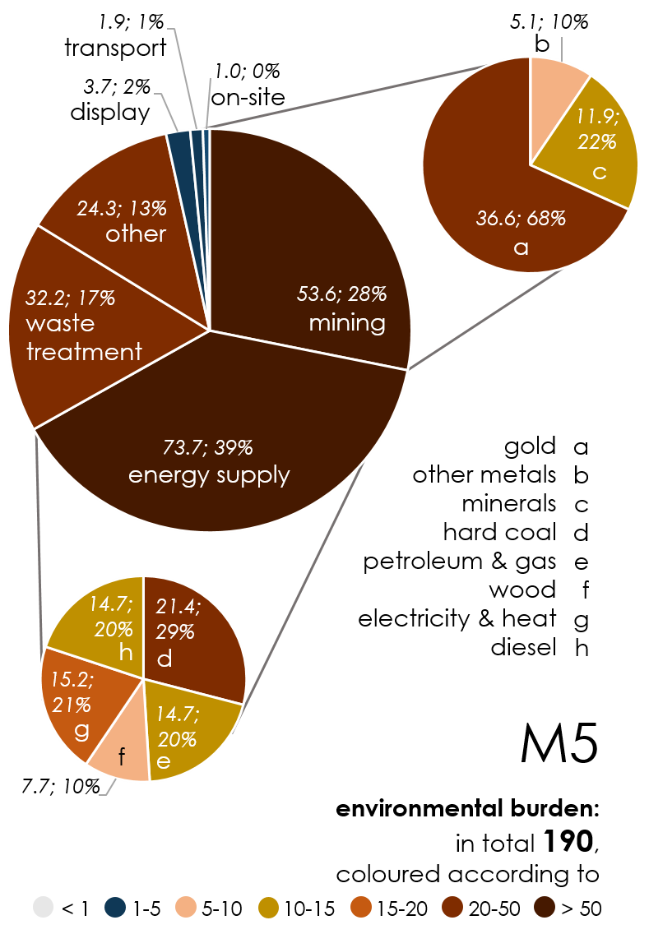
Supplementary Figure 1: Composition of the environmental burden by activity categories of M5. Details see caption of Figure 3 and Supplementary Table 1.

Supplementary Table 2: Environmental burden (env. burden) of the activity categories (categ.) and shares of M2x2.5 and M5 as well as differences between the two models. The environmental burden is a dimensionless index which sums the normalised results of all footprints by activity categories.
 | M2x2.5 |  | M5 |  | Difference of M5 to M2x2.5
Activity category | env. burden of categ. | share of categ. | env. burden of categ. | share of categ. | absolute | relative [%]
gold mining | 64.3 | 22 | 36.6 | 19 | -27.8 | -12
other metal mining | 10.4 | 4 | 5.1 | 3 | -5.3 | -24
non-metal mining | 16.7 | 6 | 11.9 | 6 | -4.8 | 11
hard coal mining | 34.5 | 11 | 21.4 | 11 | -13.1 | -1
petroleum and (natural) gas production | 20.7 | 7 | 14.7 | 8 | -6.0 | 10
forestry (wood chips) | 13.0 | 4 | 7.7 | 4 | -5.3 | -9
electricitiy and heat production | 26.1 | 9 | 15.2 | 8 | -10.9 | -10
diesel use | 19.3 | 7 | 14.7 | 8 | -4.6 | 18
waste treatment | 53.3 | 18 | 32.2 | 17 | -21.1 | -6
other activities | 25.5 | 9 | 24.3 | 13 | -1.2 | 47
display production | 5.6 | 2 | 3.7 | 2 | -1.9 | 2
transport | 3.3 | 1 | 1.9 | 1 | -1.4 | -11
on-site activities | 2.1 | 1 | 1.0 | 1 | -1.0 | -23
sum | 294.8 | 100 | 190.4 | 100 | -104.4

Supplementary Table 3: *Raw values with different unit according to indicator. Norm.: Normalised. Hotspot values are the sum of all normalised activity values belonging to one location, i.e. the environmental burden which is a dimensionless index. M2x2.5 referred to as M2.5 here. Locations: AU Australia, CA Canada, CA-QC Canada Québec, CH Switzerland, CN China, CN-HB Hebei, CN-HE Henan, CN-JS Jiangsu, CN-NM Inner Mongol, CN-SD Shandong, CN-SX Shanxi, CO Colombia, DE Germany, DZ Algeria, FALK Falkenberg, IN India, MX Mexico, RER Europe, RME Middle East, RNA Northern America, RU Russia, SE Sweden, US United States, ZA South Africa. Indicators: tmr total material requirement, rmi raw material input, wsf-qual water scarcity footprint qualitative, wsf-quan water scarcity footprint quantitative, occu Land occupation, ced cumulative energy demand, gwi global warming impact.
Model | Indi-cator | Activity | Location | Quali-ty | Raw value* | Median | Norm. Value | Hot-spot value
m2.5 | rmi | gold production | AU | 2 | 1.72 | 0.58 | 2.97 | 6.56
m2.5 | tmr | gold production | AU | 2 | 0.56 | 0.23 | 2.40
m2.5 | wsf-qual | treatment of sulfidic tailings, from gold mine operation, tailings impoundment | AU | 2 | 165.86 | 138.66 | 1.20
m2.5 | rmi | gold production | CA | 2 | 1.06 | 0.58 | 1.83 | 4.06
m2.5 | tmr | gold production | CA | 2 | 0.34 | 0.23 | 1.48
m2.5 | wsf-qual | treatment of sulfidic tailings, from gold mine operation, tailings impoundment | CA | 2 | 104.52 | 138.66 | 0.75
m2.5 | occu | softwood forestry, mixed species, boreal forest | CA-QC | 2 | 0.01 | 0.01 | 1.05 | 1.74
m2.5 | occu | electricity production, hydro, reservoir, non-alpine region | CA-QC | 2 | 0.01 | 0.01 | 0.68
m2.5 | occu | softwood forestry, mixed species, sustainable forest management | CH | 2 | 0.01 | 0.01 | 1.13 | 1.13
m2.5 | wsf-qual | treatment of sulfidic tailings, from gold mine operation, tailings impoundment | CN | 2 | 1052.85 | 138.66 | 7.59 | 11.62
m2.5 | wsf-quan | water production, decarbonised | CN | 2 | 0.21 | 0.05 | 4.03
m2.5 | ced | lignite mine operation | CN, Jinxin | 1 | 1.87 | 2.04 | 0.92 | 2.15
m2.5 | rmi | lignite mine operation | CN, Jinxin | 1 | 0.19 | 0.23 | 0.81
m2.5 | tmr | lignite mine operation | CN, Jinxin | 1 | 0.25 | 0.58 | 0.42
m2.5 | ced | hard coal mine operation and hard coal preparation | CN, Muli | 1 | 4.52 | 2.04 | 2.22 | 5.75
m2.5 | rmi | hard coal mine operation and hard coal preparation | CN, Muli | 1 | 0.23 | 0.23 | 1.00
m2.5 | wsf-quan | hard coal mine operation and hard coal preparation | CN, Muli | 1 | 0.04 | 0.05 | 0.85
m2.5 | gwi | hard coal mine operation and hard coal preparation | CN, Muli | 1 | 0.08 | 0.11 | 0.80
m2.5 | tmr | hard coal mine operation and hard coal preparation | CN, Muli | 1 | 0.28 | 0.58 | 0.48
m2.5 | occu | hard coal mine operation and hard coal preparation | CN, Muli | 1 | 0.00 | 0.01 | 0.40
m2.5 | ced | hard coal mine operation and hard coal preparation | CN, Quanshuigou | 1 | 18.10 | 2.04 | 8.87 | 22.88
m2.5 | rmi | hard coal mine operation and hard coal preparation | CN, Quanshuigou | 1 | 0.93 | 0.23 | 4.00
m2.5 | tmr | hard coal mine operation and hard coal preparation | CN, Quanshuigou | 1 | 0.17 | 0.05 | 3.30
m2.5 | gwi | hard coal mine operation and hard coal preparation | CN, Quanshuigou | 1 | 0.34 | 0.11 | 3.20
m2.5 | occu | hard coal mine operation and hard coal preparation | CN, Quanshuigou | 1 | 1.12 | 0.58 | 1.93
m2.5 | wsf-quan | hard coal mine operation and hard coal preparation | CN, Quanshuigou | 1 | 0.02 | 0.01 | 1.59
m2.5 | gwi | electricity production, hard coal | CN-HB | 2 | 0.11 | 0.11 | 1.06 | 1.06
m2.5 | gwi | electricity production, hard coal | CN-HE | 2 | 0.13 | 0.11 | 1.22 | 1.22
m2.5 | gwi | electricity production, hard coal | CN-JS | 2 | 0.17 | 0.11 | 1.64 | 1.64
m2.5 | gwi | electricity production, hard coal | CN-NM | 2 | 0.23 | 0.11 | 2.19 | 2.19
m2.5 | gwi | electricity production, hard coal | CN-SD | 2 | 0.17 | 0.11 | 1.64 | 1.64
m2.5 | gwi | electricity production, hard coal | CN-SX | 2 | 0.13 | 0.11 | 1.25 | 1.25
m2.5 | occu | electricity production, hydro, reservoir, tropical region | CO | 2 | 0.01 | 0.01 | 1.13 | 1.13
m2.5 | gwi | electricity production, lignite | DE | 2 | 0.22 | 0.11 | 2.06 | 4.04
m2.5 | occu | hardwood forestry, beech, sustainable forest management | DE | 2 | 0.01 | 0.01 | 1.08
m2.5 | occu | hardwood forestry, beech, sustainable forest management | DE | 2 | 0.01 | 0.01 | 0.91
m2.5 | ced | natural gas production | DZ | 2 | 2.98 | 2.04 | 1.46 | 1.46
m2.5 | occu | LP:SHIFT6m | FALK | 1 | 0.02 | 0.01 | 2.07 | 2.07
m2.5 | wsf-quan | tap water production, conventional treatment | IN | 2 | 0.04 | 0.05 | 0.75 | 1.36
m2.5 | wsf-quan | water production, decarbonised | IN | 2 | 0.03 | 0.05 | 0.62
m2.5 | wsf-qual | treatment of sulfidic tailings, from silver mine operation, tailings impoundment | MX | 2 | 883.34 | 138.66 | 6.37 | 8.10
m2.5 | wsf-qual | treatment of sulfidic tailings, from gold mine operation, tailings impoundment | MX | 2 | 240.48 | 138.66 | 1.73
m2.5 | ced | lignite mine operation | RER | 3 | 4.43 | 2.04 | 2.17 | 5.09
m2.5 | rmi | lignite mine operation | RER | 3 | 0.45 | 0.23 | 1.92
m2.5 | tmr | lignite mine operation | RER | 3 | 0.58 | 0.58 | 1.00
m2.5 | ced | petroleum production | RME | 3 | 10.00 | 2.04 | 4.90 | 6.28
m2.5 | rmi | petroleum production | RME | 3 | 0.22 | 0.23 | 0.93
m2.5 | tmr | petroleum production | RME | 3 | 0.26 | 0.58 | 0.45
m2.5 | ced | uranium mine operation, underground | RNA | 3 | 3.70 | 2.04 | 1.81 | 1.81
m2.5 | rmi | copper mine operation and beneficiation, sulfide ore | RU | 2 | 4.94 | 2.04 | 2.42 | 14.59
m2.5 | ced | natural gas production | RU | 2 | 4.36 | 2.04 | 2.14
m2.5 | ced | petroleum production, onshore | RU | 2 | 0.95 | 0.23 | 4.05
m2.5 | wsf-qual | treatment of sulfidic tailings, from copper mine operation, tailings impoundment | RU | 2 | 1.10 | 0.58 | 1.89
m2.5 | tmr | copper mine operation and beneficiation, sulfide ore | copper concentrate, sulfide ore | Cutoff, U | RU | 2 | 427.94 | 138.66 | 3.09
m2.5 | wsf-qual | treatment of sulfidic tailings, from gold mine operation, tailings impoundment | RU | 2 | 139.24 | 138.66 | 1.00
m2.5 | occu | hardwood forestry, birch, sustainable forest management | SE | 2 | 0.02 | 0.01 | 1.84 | 4.61
m2.5 | occu | softwood forestry, pine, sustainable forest management | SE | 2 | 0.01 | 0.01 | 1.40
m2.5 | occu | softwood forestry, spruce, sustainable forest management | SE | 2 | 0.01 | 0.01 | 1.36
m2.5 | wsf-qual | treatment of sulfidic tailings, from gold mine operation | US | 2 | 1029.81 | 138.66 | 7.43 | 13.40
m2.5 | tmr | gold production | US | 2 | 1.38 | 0.58 | 2.38
m2.5 | rmi | gold production | US | 2 | 0.45 | 0.23 | 1.92
m2.5 | ced | natural gas production | US | 2 | 2.10 | 2.04 | 1.03
m2.5 | wsf-qual | treatment of sulfidic tailings, from silver mine operation | US | 2 | 90.10 | 138.66 | 0.65
m2.5 | tmr | gold mine operation and gold production | ZA | 2 | 1.01 | 0.58 | 1.74 | 7.39
m2.5 | rmi | hard coal mine operation | ZA | 2 | 0.33 | 0.23 | 1.41
m2.5 | rmi | gold mine operation and gold production | ZA | 2 | 0.33 | 0.23 | 1.40
m2.5 | rmi | hard coal mine operation | ZA | 2 | 0.24 | 0.23 | 1.04
m2.5 | gwi | electricity production | ZA | 2 | 0.08 | 0.11 | 0.78
m2.5 | tmr | hard coal mine operation | ZA | 2 | 0.34 | 0.58 | 0.58
m2.5 | tmr | hard coal mine operation | ZA | 2 | 0.25 | 0.58 | 0.43
m5 | tmr | gold production | AU | 2 | 0.99 | 0.58 | 1.70 | 3.77
m5 | rmi | gold production | AU | 2 | 0.32 | 0.23 | 1.38
m5 | wsf-qual | treatment of sulfidic tailings, from gold mine operation, tailings impoundment | AU | 2 | 95.23 | 138.66 | 0.69
m5 | tmr | gold production | CA | 2 | 0.61 | 0.58 | 1.05 | 2.33
m5 | rmi | gold production | CA | 2 | 0.20 | 0.23 | 0.85
m5 | wsf-qual | treatment of sulfidic tailings, from gold mine operation, tailings impoundment | CA | 2 | 60.01 | 138.66 | 0.43
m5 | occu | softwood forestry, mixed species, boreal forest | CA-QC | 2 | 0.01 | 0.01 | 0.65 | 1.03
m5 | occu | electricity production, hydro, reservoir, non-alpine region | CA-QC | 2 | 0.00 | 0.01 | 0.38
m5 | wsf-qual | treatment of sulfidic tailings, from gold mine operation, tailings impoundment | CN | 2 | 604.51 | 138.66 | 4.36 | 6.87
m5 | wsf-quan | water production, decarbonised | CN | 2 | 0.13 | 0.05 | 2.51
m5 | ced | lignite mine operation | CN, Jinxin | 1 | 1.09 | 2.04 | 0.54 | 1.01
m5 | rmi | lignite mine operation | CN, Jinxin | 1 | 0.11 | 0.23 | 0.47
m5 | ced | hard coal mine operation and hard coal preparation | CN, Muli | 1 | 2.82 | 2.04 | 1.38 | 3.28
m5 | rmi | hard coal mine operation and hard coal preparation | CN, Muli | 1 | 0.15 | 0.23 | 0.62
m5 | wsf-quan | hard coal mine operation and hard coal preparation | CN, Muli | 1 | 0.03 | 0.05 | 0.53
m5 | gwi | hard coal mine operation and hard coal preparation | CN, Muli | 1 | 0.05 | 0.11 | 0.50
m5 | occu | hard coal mine operation and hard coal preparation | CN, Muli | 1 | 0.00 | 0.01 | 0.25
m5 | ced | hard coal mine operation and hard coal preparation | CN, Quanshuigou | 1 | 11.27 | 2.04 | 5.52 | 14.24
m5 | rmi | hard coal mine operation and hard coal preparation | CN, Quanshuigou | 1 | 0.58 | 0.23 | 2.49
m5 | wsf-quan | hard coal mine operation and hard coal preparation | CN, Quanshuigou | 1 | 0.11 | 0.05 | 2.05
m5 | gwi | hard coal mine operation and hard coal preparation | CN, Quanshuigou | 1 | 0.21 | 0.11 | 1.99
m5 | tmr | hard coal mine operation and hard coal preparation | CN, Quanshuigou | 1 | 0.70 | 0.58 | 1.20
m5 | occu | hard coal mine operation and hard coal preparation | CN, Quanshuigou | 1 | 0.01 | 0.01 | 0.99
m5 | gwi | electricity production, hard coal | CN-JS | 2 | 0.11 | 0.11 | 1.02 | 1.02
m5 | gwi | electricity production, hard coal | CN-NM | 2 | 0.14 | 0.11 | 1.37 | 1.37
m5 | gwi | electricity production, hard coal | CN-SD | 2 | 0.11 | 0.11 | 1.02 | 1.02
m5 | gwi | electricity production, lignite | DE | 2 | 0.16 | 0.11 | 1.48 | 4.05
m5 | occu | hardwood forestry, beech, sustainable forest management | DE | 2 | 0.01 | 0.01 | 0.75
m5 | occu | hardwood forestry, beech, sustainable forest management | DE | 2 | 0.01 | 0.01 | 0.69
m5 | gwi | electricity production, hard coal | DE | 2 | 0.06 | 0.11 | 0.55
m5 | occu | softwood forestry, spruce, sustainable forest management | DE | 2 | 0.00 | 0.01 | 0.31
m5 | occu | softwood forestry, pine, sustainable forest management | DE | 2 | 0.00 | 0.01 | 0.26
m5 | occu | LP:SHIFT6m | FALK | 1 | 0.01 | 0.01 | 1.04 | 1.04
m5 | wsf-qual | treatment of sulfidic tailings, from silver mine operation, tailings impoundment | MX | 2 | 500.39 | 138.66 | 3.61 | 4.60
m5 | wsf-qual | treatment of sulfidic tailings, from gold mine operation, tailings impoundment | MX | 2 | 138.07 | 138.66 | 1.00
m5 | ced | petroleum and gas production | NO | 2 | 1.38 | 2.04 | 0.68 | 1.03
m5 | wsf-quan | electricity production, hydro, reservoir, alpine region | NO | 2 | 0.02 | 0.05 | 0.35
m5 | ced | lignite mine operation | RER | 3 | 3.49 | 2.04 | 1.71 | 4.01
m5 | rmi | lignite mine operation | RER | 3 | 0.35 | 0.23 | 1.51
m5 | tmr | lignite mine operation | RER | 3 | 0.46 | 0.58 | 0.79
m5 | ced | petroleum production, onshore | RME | 3 | 5.92 | 2.04 | 2.90 | 3.46
m5 | rmi | petroleum production, onshore | RME | 3 | 0.13 | 0.23 | 0.55
m5 | ced | uranium mine operation, underground | RNA | 3 | 2.83 | 2.04 | 1.39 | 1.75
m5 | ced | uranium mine operation, open cast | RNA | 3 | 0.74 | 2.04 | 0.36
m5 | rmi | copper mine operation and beneficiation, sulfide ore | RU | 2 | 0.60 | 0.23 | 2.58 | 9.15
m5 | wsf-qual | treatment of sulfidic tailings, from copper mine operation | RU | 2 | 272.23 | 138.66 | 1.96
m5 | ced | natural gas production | RU | 2 | 3.20 | 2.04 | 1.57
m5 | ced | petroleum production, onshore | RU | 2 | 2.59 | 2.04 | 1.27
m5 | tmr | copper mine operation and beneficiation, sulfide ore | RU | 2 | 0.70 | 0.58 | 1.20
m5 | wsf-qual | treatment of sulfidic tailings, from gold mine operation | RU | 2 | 79.95 | 138.66 | 0.58
m5 | occu | hardwood forestry, birch, sustainable forest management | SE | 2 | 0.02 | 0.01 | 1.53 | 3.82
m5 | occu | softwood forestry, pine, sustainable forest management | SE | 2 | 0.01 | 0.01 | 1.16
m5 | occu | softwood forestry, spruce, sustainable forest management | SE | 2 | 0.01 | 0.01 | 1.13
m5 | wsf-qual | treatment of sulfidic tailings, from gold mine operation, tailings impoundment | US | 2 | 591.29 | 138.66 | 4.26 | 7.68
m5 | tmr | gold production | US | 2 | 0.79 | 0.58 | 1.36
m5 | rmi | gold production | US | 2 | 0.26 | 0.23 | 1.10
m5 | ced | natural gas production | US | 2 | 1.19 | 2.04 | 0.58
m5 | wsf-qual | treatment of sulfidic tailings, from silver mine operation, tailings impoundment | US | 2 | 51.04 | 138.66 | 0.37
m5 | tmr | gold mine operation and gold production | ZA | 2 | 0.58 | 0.58 | 1.00 | 3.74
m5 | rmi | hard coal mine operation | ZA | 2 | 0.21 | 0.23 | 0.90
m5 | rmi | gold mine operation and gold production | ZA | 2 | 0.19 | 0.23 | 0.81
m5 | rmi | hard coal mine operation | ZA | 2 | 0.15 | 0.23 | 0.66
m5 | tmr | hard coal mine operation | ZA | 2 | 0.22 | 0.58 | 0.37

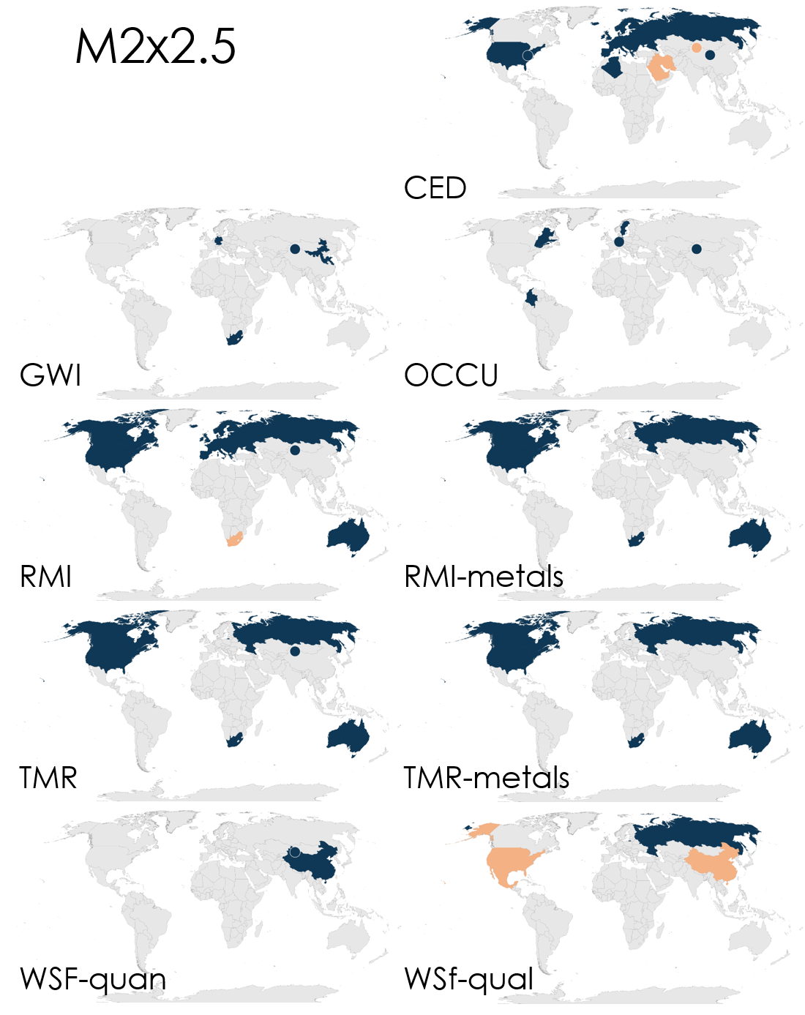
Supplementary Figure 2: Hotspots of M2x2.5 according to contributions of single environmental impacts. Legend see Figure 4 in the main text. Indicator: CED cumulative energy demand, GWI global warming impact, OCCU land occupation, RMI raw material input, RMI-metals raw material input only for the impact category metals (included in RMI, presented here to provide additional information), TMR total material requirement, TMR-metals total material requirement only for the impact category metals (included in TMR, presented here to provide additional information), WSF-quan water scarcity footprint quantitative, WSF-qual water scarcity footprint qualitative.

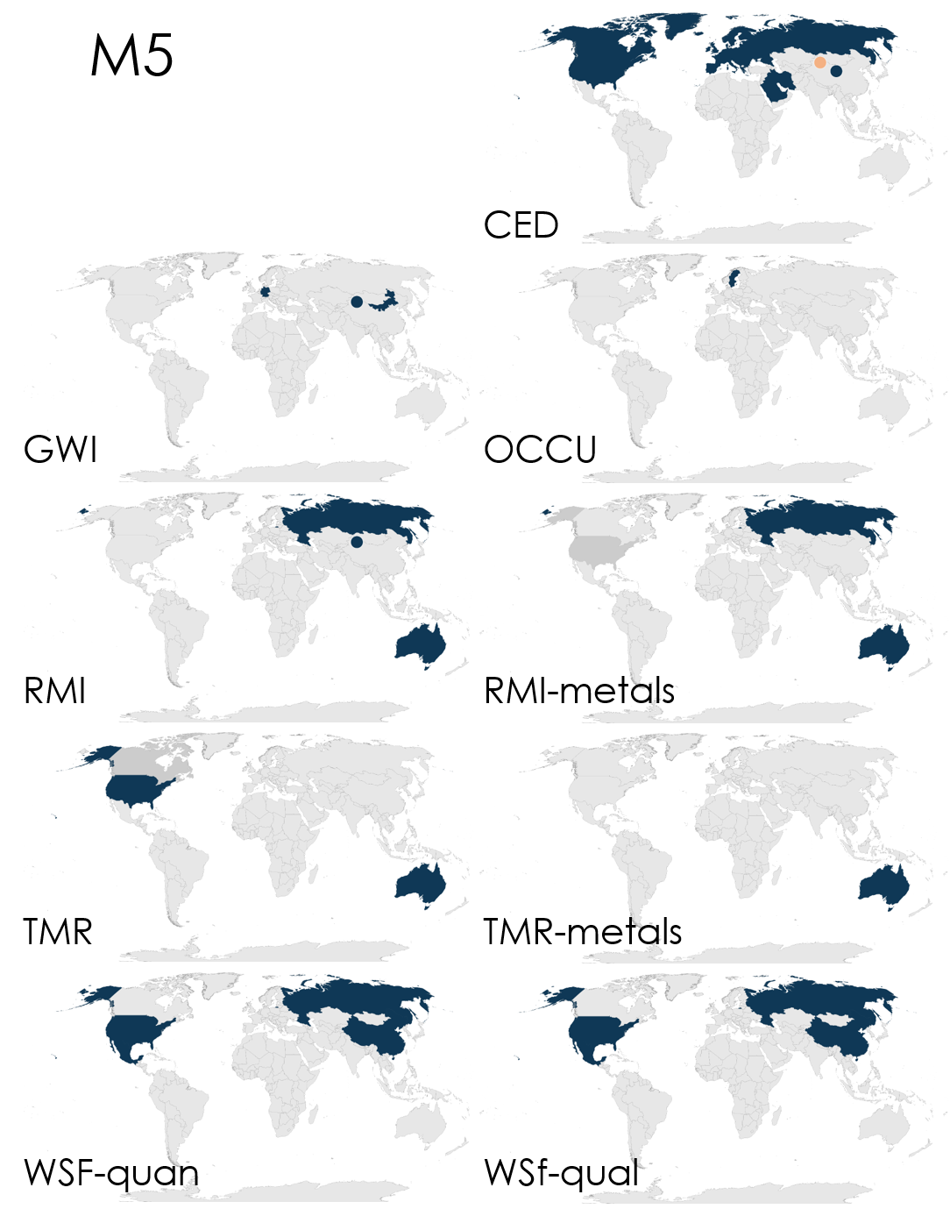
Supplementary Figure 3: Hotspots of M5 according to contributions of single environmental impacts. Legend see Figure 4 in the main text. Indicator: CED cumulative energy demand , GWI global warming impact, OCCU land occupation, RMI raw material input, RMI-metals raw material input only for the impact category metals (included in RMI, presented here to provide additional information), TMR total material requirement, TMR-metals total material requirement only for the impact category metals (included in TMR, presented here to provide additional information), WSF-quan water scarcity footprint quantitative, WSF-qual water scarcity footprint qualitative.

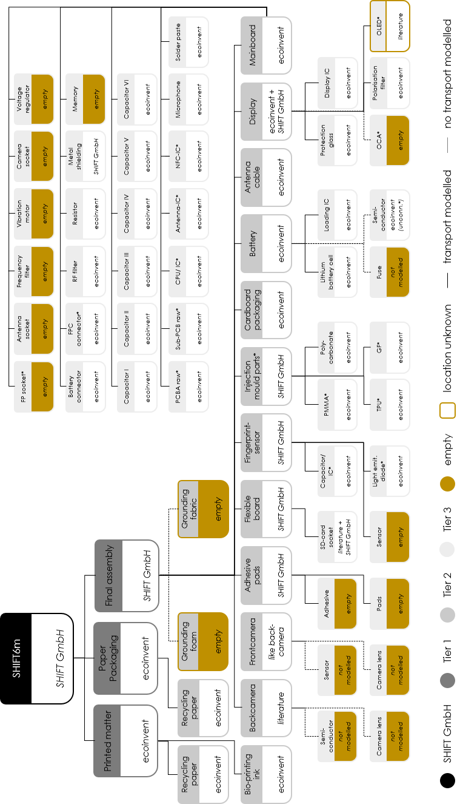
Supplementary Figure 4: Supply chain of the SHIFTPHONE as analysed by SHIFT GmbH and modelled in this study. Abbreviations: FP socket: socket for memory; FPC connector; RF filter: radiofrequency filter; PCBA raw: mainboard, raw dataset (unmounted); Sub-PCB raw: small mainboard, raw dataset (unmounted); IC: integrated circuit; NFC-IC: near field communication integrated circuit; Injection mould. Parts: injection moulded parts; Light emit. diode: light emitting diode; PMMA: polymethyl methacrylate; TPU: polyurethane; GF: glass fibre reinforced plastic; OCA: optically clear adhesive; OLED: organic light emitting diode.

Supplementary Table 4: Share of analysed activities per footprint on the total footprint result. Activities enter the hotspot analysis if they contribute at least 1 % to the total footprint result. 44 % is identified as outlier and not included in the “average without outlier”.
 |  | coverage [%]
Footprint | unit, per smartphone  use for one year | M2x2.5 | M5
climate FP | kg CO₂-Eqv. | 44 | 44
energy FP | kWh-Eqv. | 81 | 81
land FP | m²*a land occupation | 71 | 73
material FP (RMI) | kg raw material | 73 | 71
material FP (RMI, metal) | kg raw material | 93 | 93
material FP (TMR) | kg primary material | 79 | 78
material FP (TMR, metal) | kg primary material | 91 | 93
water FP (quant.) | m³ water | 61 | 58
water FP (qual.) | m³ virtual dilution water | 89 | 89
average |  | 76 | 75
average without outlier |  | 80 | 79

Supplementary Table 5: LCA-data quality scheme.
 | Reliability | Completeness | Temporal correlation | Geographical correlation | Further technological correlation
1 | Verified data based on measurements | Representative data from all sites relevant for the market considered, over and adequate period to even out normal fluctuations | Less than 3 years of difference to the time period of the data set | Data from area under study | Data from enterprises, processes and materials under study
2 | Verified data partly based on assumptions or non-verified data based on measurements | Representative data from > 50% of the sites relevant for the market considered, over an adequate period to even out normal fluctuations | Less than 6 years of difference to the time period of the data set | Average data from larger area in which the area under study is included | Data from processes and materials under study (i.e. identical technology) but from different enterprises
3 | Non-verified data partly based on qualified estimates | Representative data from only some sites (<< 50%) relevant for the market considered or > 50% of sites but from shorter periods | Less than 10 years of difference to the time period of the data set | Data from area with similar production conditions | Data from processes and materials under study but from different technology
4 | Qualified estimate (e.g. by industrial expert) | Representative data from only one site relevant for the market considered or some sites but from shorter periods | Less than 15 years of difference to the time period of the data set | Data from area with slightly similar production conditions | Data on related processes or materials
5 | Non-qualified estimates | Representativeness unknown or data from a small number of sites and from shorter periods | Age of data unknown or more than 15 years of difference to the time period of the data set | Data from unknown or distinctly different area (North America instead of Middle East, OECD-Europe instead of Russia) | Data on related processes on laboratory scale or from different technology

Supplementary Table 6: Data quality. Abbrevations see Supplementary Table 2 and 4.
Impact category | R | C | T | G | F
CED_fossil | 2 | 2 | 4 | 3 | 2
CED_nuclear | 1 | 1 | 5 | 2 | 1
CED_primary forest | n.a | n.a. | n.a. | n.a. | n.a.
GWI_GWP 100a | 2 | 3 | 5 | 4 | 2
OCCU_Land Occupation | 2 | 3 | 4 | 3 | 1
RMI | 2 | 2 | 4 | 3 | 1
RMI, metal ores | 2 | 2 | 4 | 3 | 1
TMR | 2 | 2 | 4 | 4 | 1
TMR, metal ores | 2 | 2 | 4 | 4 | 1
WSFquan | 3 | 3 | 5 | 3 | 3
WSFqual | 1 | 1 | 2 | 1 | 1

