Supplementary materials
Supplement to: Salikhov SI, Abdurakhmonov IY, Ziyavitdinov JF, et al. Repurposing of Rutan showed effective treatment for COVID-19 disease, submitted.

Supplementary Table 1. Main results of preclinical safety studies of Rutan substance conducted in adult animals
Study | Dose, type of administration, animals, group size | Conclusion
General toxicology
Single dose toxicity | 2000, 5000 mg/kg once, IG*, mice and rats, 5 per group | Mice LD₅₀ > 5000 mg/kg (toxicity class VI);  rats LD₅₀ = 4800 mg/kg (toxicity class V)
Single dose toxicity | 30, 50, 70, 80, 100 mg/kg, IV**,  mice, 5 per group | LD₅₀ = 73 mg/kg (toxicity class IV)
Cumulation | IG, mice, rats, 10 per group | No cumulative properties
Repeated dose toxicity | IG within 30 days:  25, 50, 100 mg/kg/day, rats, 5 per group;  10, 20, 40 mg/kg/day, rabbits, 3 per group, recovery period one month after the last injection | No toxic effect on the condition of peripheral blood, kidney, and liver function, as well as specific changes in the internal organs of animals
Specific toxicology
Genotoxicity | 0,5; 1,0; 2.0 mg; 4.0 mg/mL, culture medium | Absence of genotoxic properties (in vitro method of chromosomal aberrations in human peripheral blood lymphocytes)
Reproductive and ontogenetic toxicity | 25, 100 mg/kg, IG,  rats, 20 females and 10 males in groups | Absence of gonadotoxicity, embryotoxicity, or teratogenic effect
Local tolerance
Local irritant effect | 0.5 and 5% solution, rabbits intraconjuctivally once, rats subcutaneously for 10 days in a group of 3 rabbits and 5 rats | No local irritant effect
Allergic properties | 25 mg/kg, IG, 0.5% and 5% solution cutaneously,  guinea pigs 6 per group | No allergic properties
Immunotoxicity | 25, 50, and 100 mg/kg once, IG, mice 5 per group | Immunomodulatory effect
General pharmacology
Effect on the cardiovascular system and arterial pressure | 1, 10 and 50 mg/kg, IV  Cats, 3 per group | at a dose of 50 mg/kg - inhibition of contractility of the heart muscle
Impact on the CNS | 50, 100 and 200 mg/kg, IG  Mice, 5-10 per group | No effect on the orienting response, spontaneous motor activity, anticonvulsant action
*IG – intragastric administration, **IV – intravenous administration, CNS-Central nervous system

Supplementary Table 2. Main results of preclinical studies on the safety of the Rutan substance in developing animals
Study | Dose, type of administration, animals, group size | Conclusion
General toxicology
Acute Toxicity | 5000 mg/kg, once IG*;  80, 100, 120, 160, 180 mg/kg, once IP**, baby rats, 6 per group | IG: LD₅₀> 5000 mg/kg (toxicity class VI);  IP: LD₅₀ = 137 (112÷165) mg/kg (toxicity class IV)
Cumulation | IG, baby rats, 10 per group | No cumulative properties
Chronic toxicity | 10, 20, and 40 mg/kg/day, IG for 30 days, baby rats, 5 per group, recovery period 1 month after the last injection, 5 per group | No toxic effect on peripheral blood, kidney and liver function, or behavioral reactions. Histology: full-blooded arteries of parenchymal organs, hyperplasia of immune cells in primary and secondary immune organs
* IG – intragastric administration, **IP – intraperitoneal administration

Supplementary Table 3. The frequency of occurrence of several clinical symptoms in patients of the main and control groups upon admission to the hospital and before discharge with a mild course of the disease
Clinical symptoms | Main group (n=38) |  |  |  | Control group (n=22) |  |  |  | Chi²-test
Clinical symptoms | Before treatment |  | After treatment |  | Before treatment |  | After treatment |  | р
Clinical symptoms | n | % | n | % | n | % | n | %
Weakness | 38 | 100 | 0 | 0 | 22 | 100 | 11 | 50 | <0,01
Lethargy | 38 | 100 | 0 | 0 | 22 | 100 | 18 | 81 | <0,01
Headache | 12 | 31.5 | 0 | 0 | 10 | 45.5 | 18 | 81 | <0,01
Dizziness | 25 | 67.8 | 0 | 0 | 9 | 40.9 | 15 | 68.18 | <0,01
Temperature | 18 | 47.36 | 0 | 0 | 12 | 54.5 | 13 | 59 | <0,01
Chills | 34 | 89.5 | 0 | 0 | 14 | 63.6 | 0 | 0 | >0.05
Irritability | 12 | 31.57 | 0 | 0 | 1 | 4.7 | 0 | 0 | >0.05
Anxiety | 1 | 2.6 | 0 | 0 | 0 | 0 | 0 | 0 | >0.05
Sweating | 12 | 31.57 | 0 | 0 | 1 | 4.7 | 0 | 0 | >0.05
Itchy throat | 30 | 78.9 | 0 | 0 | 18 | 81.8 | 18 | 81 | <0,01
Sore throat | 37 | 97.3 | 0 | 0 | 18 | 81.8 | 0 | 0 | >0.05
Nasal congestion | 37 | 97.3 | 0 | 0 | 18 | 81.8 | 0 | 0 | >0.05
Cough (dry, with phlegm) | 37 | 97.3 | 0 | 0 | 18 | 81.8 | 0 | 0 | >0.05
Rhinitis | 14 | 36.8 | 0 | 0 | 9 | 40.9 | 0 | 0 | >0.05
Dyspnea | 13 | 52 | 0 | 0 | 4 | 18.18 | 0 | 0 | >0.05
Chest pain | 1 | 2.6 | 0 | 0 | 0 | 0 | 0 | 0 | >0.05
Lack of air | 13 | 34.2 | 0 | 0 | 2 | 9 | 0 | 0 | >0.05
Labored breathing | 2 | 5.5 | 0 | 0 | 0 | 0 | 0 | 0 | >0.05
Anosmia | 37 | 97.3 | 0 | 0 | 20 | 52.63 | 10 | 45.45 | <0,01
Ageusia | 38 | 100 | 0 | 0 | 20 | 52.63 | 10 | 45.45 | <0,01
Anorexia | 0 | 0 | 0 | 0 | 0 | 0 | 0 | 0 | >0.05
Dry mouth | 28 | 73.7 | 0 | 0 | 6 | 15.78 | 0 | 0 | >0.05
Lower appetite | 35 | 92.1 | 0 | 0 | 21 | 95.45 | 0 | 0 | >0.05
Nausea | 2 | 5.2 | 0 | 0 | 6 | 27.27 | 13 | 59 | <0,01
Vomiting | 0 | 0 | 0 | 0 | 3 | 13.63 | 0 | 0 | >0.05
Diarrhea | 0 | 0 | 0 | 0 | 0 | 0 | 0 | 0 | >0.05
Myalgia | 13 | 34.2 | 0 | 0 | 5 | 22.72 | 6 | 27.27 | <0,01
n-number of samples

Supplementary Table 4. The frequency of occurrence of several clinical symptoms in patients of the main and control groups upon admission to the hospital and before discharge with a moderate course of the disease with parenchymal damage up to 30%
Clinical symptoms | Main group (n=38) |  |  |  | Control group (n=23) |  |  |  | Χ²-test
Clinical symptoms | Before treatment |  | After treatment |  | Before treatment |  | After treatment |  | р
Clinical symptoms | n | % | n | % | n | % | n | %
 | 38 | 100 | 0 | 0 | 23 | 100 | 11 | 47.8 | <0.01
Weakness | 38 | 100 | 0 | 0 | 23 | 100 | 19 | 82.6 | <0.01
Lethargy | 35 | 92.1 | 0 | 0 | 8 | 34.78 | 19 | 82.6 | <0.01
Headache | 18 | 47.4 | 0 | 0 | 11 | 47.8 | 15 | 65.21 | <0.01
Dizziness | 33 | 86.8 | 0 | 0 | 15 | 65.2 | 15 | 65.21 | <0.01
Temperature | 30 | 78.9 | 0 | 0 | 18 | 78.3 | 0 | 0 | >0.05
Chills | 4 | 10.52 | 0 | 0 | 5 | 21.7 | 0 | 0 | >0.05
Irritability | 1 | 97.3 | 0 | 0 | 0 | 0 | 0 | 0 | >0.05
Anxiety | 22 | 57.89 | 0 | 0 | 12 | 52.2 | 18 | 78.2 | <0.01
Sweating | 36 | 94.7 | 0 | 0 | 22 | 95.6 | 19 | 82.6 | <0.01
Itchy throat | 36 | 94.7 | 0 | 0 | 22 | 95.6 | 0 | 0 | >0.05
Sore throat | 34 | 89.5 | 0 | 0 | 18 | 78.3 | 0 | 0 | >0.05
Nasal congestion | 34 | 89.5 | 0 | 0 | 17 | 73.9 | 0 | 0 | >0.05
Cough (dry. with phlegm) | 20 | 52.63 | 0 | 0 | 12 | 52.2 | 0 | 0 | >0.05
Rhinitis | 20 | 52.63 | 0 | 0 | 0 | 100 | 0 | 0 | >0.05
Dyspnea | 16 | 42.1 | 0 | 0 | 0 | 100 | 0 | 0 | >0.05
Chest pain | 20 | 89.5 | 0 | 0 | 5 | 21.7 | 0 | 0 | >0.05
Lack of air | 10 | 26.3 | 0 | 0 | 5 | 21.7 | 0 | 0 | >0.05
Labored breathing | 37 | 97.3 | 0 | 0 | 20 | 86.9 | 10 | 43.47 | <0.01
Anosmia | 38 | 100 | 0 | 0 | 23 | 100 | 10 | 43.47 | <0.01
Ageusia | 0 | 0 | 0 | 0 | 0 | 0 | 0 | 0 | >0.05
Anorexia | 34 | 89,47 | 0 | 0 | 18 | 78,3 | 0 | 0 | >0.05
Dry mouth | 32 | 84,2 | 0 | 0 | 23 | 100 | 0 | 0 | >0.05
Low appetite | 5 | 13,2 | 0 | 0 | 15 | 65,2 | 13 | 56,52 | <0.01
Nausea | 0 | 0 | 0 | 0 | 0 | 0 | 0 | 0 | >0.05
Vomiting | 0 | 0 | 0 | 0 | 0 | 0 | 0 | 0 | >0.05
Diarrhea | 25 | 65,78 | 0 | 0 | 11 | 47,8 | 6 | 26 | <0.01
n-number of samples

Supplementary Table 5. Dynamics of the virus content in the nasal secretion in patients of the main and control groups with a mild course of the disease
Virological study | Main group (n=38) |  |  | Chi2-test | Control group (n=22) |  |  | Χ²-test
Virological study | On admission | (+) After 5 days | (+) At discharge | p | On admission | (+) After 5 days | (+) At discharge | p
PCR test for COVID-19 | 38  (100%) | 8  (21%) | 0 | <0,001 | 22  (100%) | 19  (86,4%) | 12  (54.5%) | <0.001

Supplementary Table 6. Dynamics of the virus content in the nasal secretion in patients of the main and control groups with a moderate course of the disease with parenchymal damage up to 30%
Virological study | Main group (n=38) |  |  | Chi2-test | Control group (n=23) |  |  | Χ²-test
Virological study | On admission | (+) After 5 days | (+) At discharge | p | On admission | (+) After 5 days | (+) At discharge | p
PCR test for COVID-19 | 38  (100%) | 6  (15.8%) | 0  (0%) | <0,001 | 23  (100%) | 21  (91%) | 9  (39.2%) | <0.001

Supplementary Table 7. The frequency of occurrence of several clinical symptoms in children aged 6-18 years of the main and control groups upon admission to the hospital and before discharge
Clinical symptoms | Main group (n=101) |  |  |  | Control group (n=100)
Clinical symptoms | Before treatment |  | After treatment |  | Before treatment |  | After treatment |  | Χ²-test
Clinical symptoms | n | % | n | % | n | % | n | % | p
 | 101 | 100.0 | 101 | 100.0 | 100 | 100.0 | 100 | 100.0 | > 0.05
Weakness, lethargy | 101 | 100.0 | 91 | 90.2 | 100 | 100.0 | 96 | 96.0 | > 0.05
Dry/ cough wet | 101 | 100.0 | 95 | 94.1 | 100 | 100.0 | 95 | 95.0 | > 0.05
Hyperthermia | 98 | 97.0 | 5 | 4.9 | 95 | 95.0 | 22 | 22.0 | < 0.001
Malaise | 101 | 100.0 | 15 | 14.8 | 100 | 100.0 | 22 | 22.0 | > 0.05
Dizziness | 39 | 38.6 | 15 | 14.8 | 44 | 44.0 | 18 | 18.0 | > 0.05
Pain when swallowing | 69 | 68.3 | 5 | 4.9 | 68 | 68.0 | 17 | 17.0 | < 0,01
Pharynx, redness, grainy | 81 | 80.2 | 29 | 28.7 | 90 | 90.0 | 42 | 42.0 | > 0.05
Pronounced sweating | 101 | 100.0 | 44 | 43.6 | 100 | 100.0 | 45 | 45.0 | > 0.05
Pain with deep inhalation/exhalation | 42 | 15.0 | 0 | 0 | 15 | 15.0 | 8 | 8.0 | < 0.001
Headache | 89 | 88.1 | 2 | 2.0 | 76 | 76.0 | 8 | 8.0 | < 0.05
Loss of appetite | 91 | 90.1 | 8 | 7.9 | 83 | 83.0 | 7 | 7.0 | > 0.05
Diarrhea | 12 | 11.9 | 0 | 0 | 2 | 2.0 | 0 | 0 | > 0.05
Nausea, vomiting | 15 | 14.8 | 0 | 0 | 12 | 12.0 | 2 | 2.0 | > 0.05
Pain in muscles and bones | 89 | 88.1 | 2 | 2.0 | 83 | 83.0 | 1 | 1.0 | > 0.05
Pain in the right hypochondrium | 5 | 4.9 | 0 | 0 | 5 | 5.0 | 0 | 0 | > 0.05
Loss of taste and smell | 17 | 6.8 | 33 | 32.7 | 2 | 2.0 | 33 | 33.0 | < 0.01
n-number of samples

Supplementary Table 8 Distribution of patients in the catamnestic study by age group.
Groups/ age in years | 6-10 | 11-14 | 15-18 | Total
Control Count  Row % | 28  43.08 | 17  26.15 | 20  30.77 | 65
Basic Count  Row % | 18  29.03 | 25  40.32 | 19  30.65 | 62
Total | 46 | 42 | 39 | 127

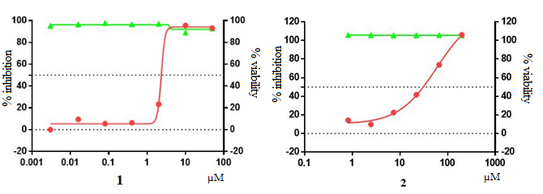Supplementary Figure 1. Rutan (1) and Favipiravir (2) activity against H1N1 influenza virus in MDCK cells.

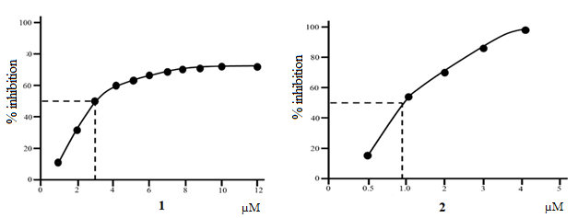
Supplementary Figure 2. Inhibition of SARS-CoV-2 3CL^{pro} by Rutan (1) and Baicalein (2)

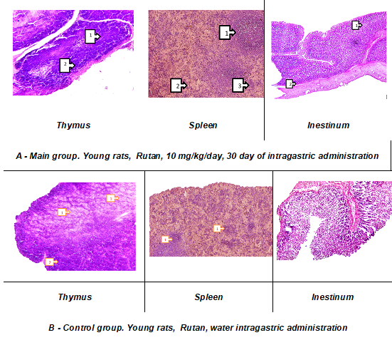
Supplementary Figure 3. Histological picture of the immune organs after the application of Rutan

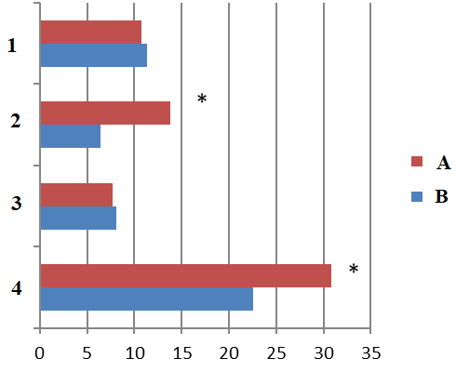
Supplementary Figure 4. The frequency of detection of post-COVID syndromes (1) - other manifestations, (2) - inflammatory-pain syndrome, (3) - catarrhal respiratory syndrome, (4) - astheno-vegetative syndromes in children aged 6-18 years of the main (В) and control (А) groups (n=127). Note: * - reliability of differences in indicators (P<0.05).

