Supplement 1

Does exposure to nature make children more intelligent? Analysis in Polish children with and without ADHD

Dorota Buczyłowska^{1*}, Clemens Baumbach¹, Jakub Bratkowski², Yarema Mysak¹, Maja Wierzba-Łukaszyk¹, Krzysztof Skotak², Katarzyna Sitnik-Warchulska³, Małgorzata Lipowska^{3,4}, Bernadetta Izydorczyk¹, Marcin Szwed¹, Iana Markevych^{1,5}

¹ Institute of Psychology, Jagiellonian University, Krakow, Poland
² Institute of Environmental Protection-National Research Institute, Warsaw, Poland
³ Faculty of Management and Social Communication, Institute of Applied Psychology, Jagiellonian University, Krakow, Poland
⁴ Institute of Psychology, University of Gdansk, Gdansk, Poland
⁵ Medical University of Plovdiv, Plovdiv, Bulgaria

*Correspondence:
Dr Dorota Buczyłowska
Institute of Psychology, Jagiellonian University
Ingardena 6, 30-060 Krakow, Poland
dorota.buczylowska@uj.edu.pl

Contents
Figure S1. Flowchart of the study sample……………………………………………………………...3
Figure S2. BDOT10k land cover layers cropped to the study area: tree cover (A), grass/shrub cover (B), water cover (C)……………………………………………………………………………………………………………………………………4
Figure S3. Directed Acyclic Graph (DAG) for the association between exposure to greenspace/
bluespace and IQ………………………………………………………………………………………...5
Figure S4. B coefficients and their corresponding 95% confidence intervals for the associations between greenspace and bluespace exposure and performance on SB5 individual subtests from the nonverbal and verbal domain for cases and controls.…………………………………………………………………………………………………..6
Figure S5. B coefficients and their corresponding 95% confidence intervals for the associations between greenspace and bluespace single exposures, perceived greenspace and bluespace scores and SB5 composite scores in cases and controls..……………………………………………………………………………………………….7
Table S1. B Descriptive statistics for Stanford-Binet Intelligence Scales, Fifth Edition (SB5)…………8
Table S2. Residential greenspace and bluespace exposure data …………………………………………………………..9
Table S3. Estimated path coefficients in the structural equation model linking greenspace to physical activity and Full Scale Intelligence Quotient (FSIQ), Nonverbal Intelligence Quotient (NVIQ), and Verbal Intelligence Quotient (VIQ)…………………………………………………………………………………….10

Originally recruited: cases (n = 216) and controls (n = 524)

Without outliers: cases (n = 215) and controls (n = 524)

With SB5 data: cases (n = 212) and controls (n = 521)

With green/bluespace data: cases (n = 210) and controls (n = 518)

With confounder data: cases (n = 206) and controls (n = 508)

With physical activity data: cases (n = 206) and controls (n = 508)

Figure S1. Flowchart of the study sample.
Note. SB5 = the Stanford-Binet Intelligence Scales, Fifth Edition. Confounders include sex, minimum parental education, and urbanicity.

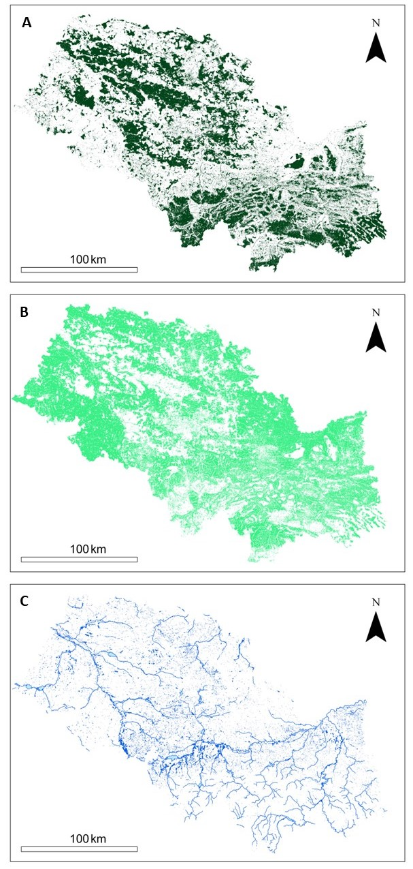

Figure S2. BDOT10k land cover layers cropped to the study area: tree cover (A), grass/shrub cover (B), water cover (C).
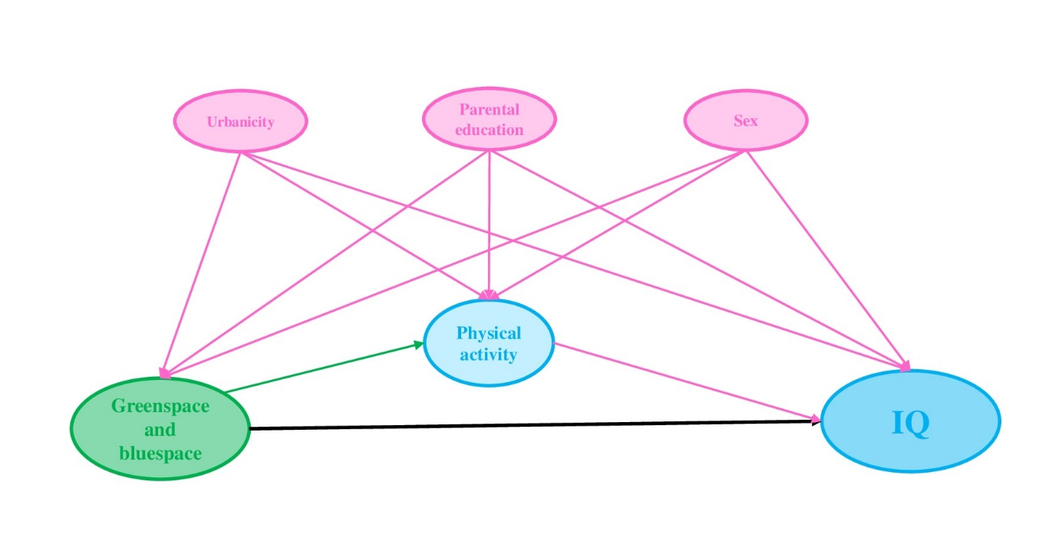

Figure S3. Directed Acyclic Graph (DAG) for the association between exposure to greenspace/ bluespace and IQ.
Note. The thick black line depicts the association of interest. Pink arrows mark confounding paths, while the green arrow marks mediation pathway. Identified minimal sufficient adjustment set included sex, parental education, and urbanicity (pink ovals). Physical activity is identified as mediator.

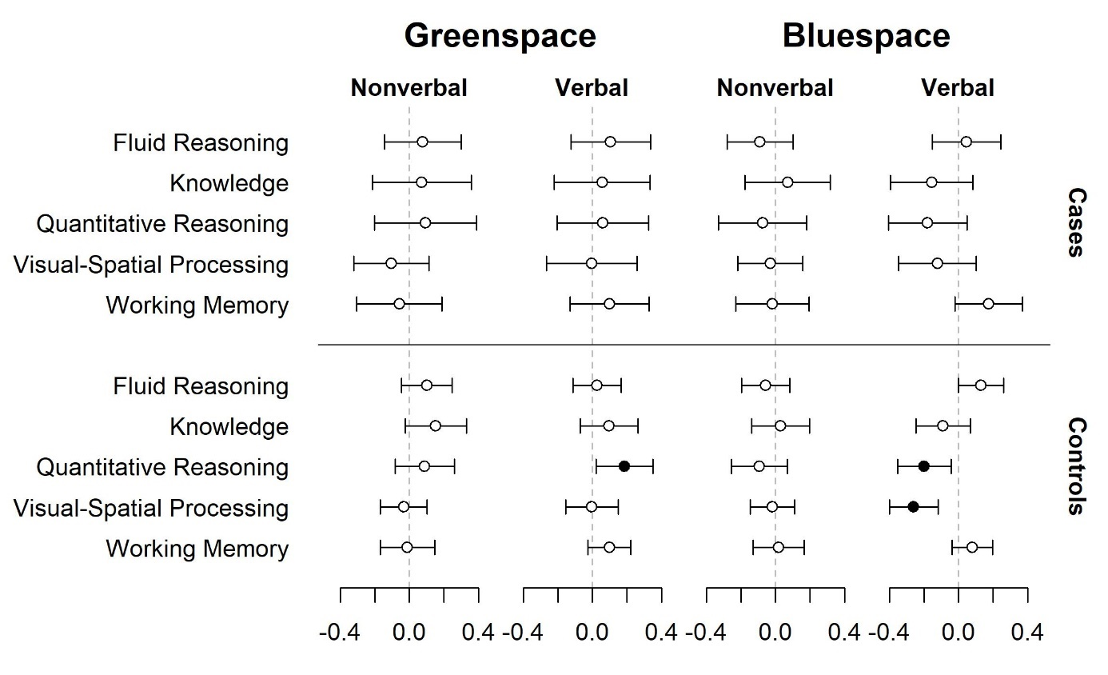
Figure S4. B coefficients and their corresponding 95% confidence intervals for the associations between greenspace and bluespace exposure and performance on SB5 individual subtests from the nonverbal and verbal domain for cases and controls.
Note. Statistically significant results are indicated by filled circles.

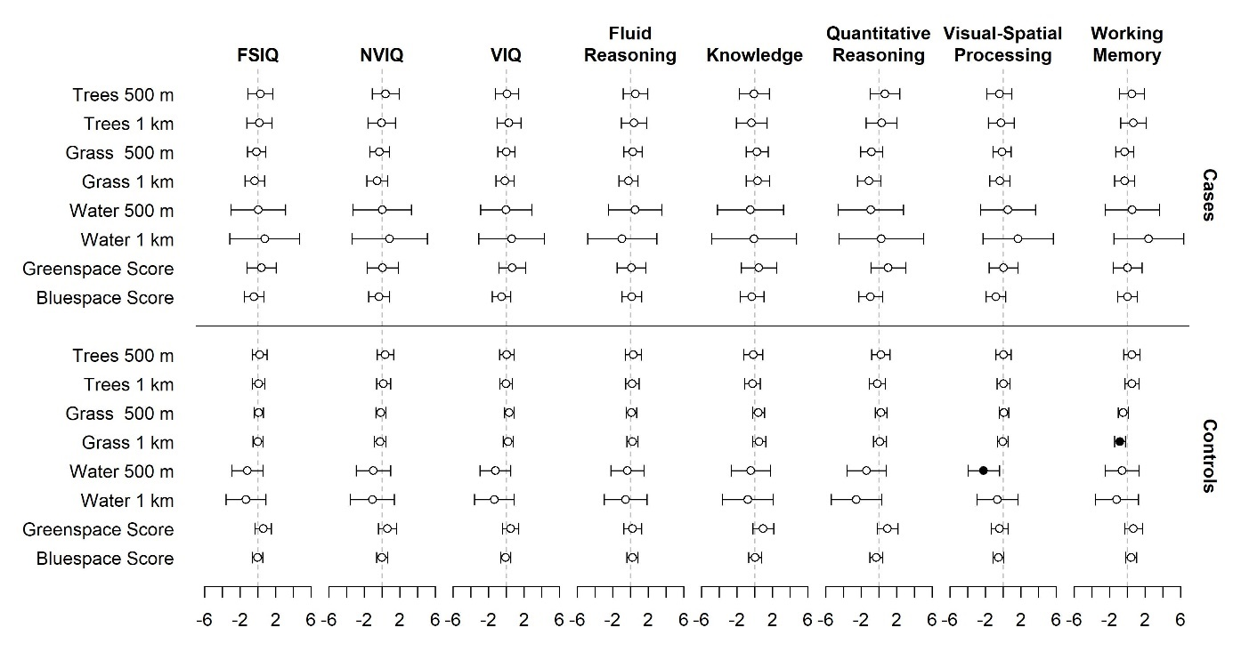
Figure S5. B coefficients and their corresponding 95% confidence intervals for the associations between greenspace and bluespace single exposures, perceived greenspace and bluespace scores and SB5 composite scores in cases and controls.
Note. FSIQ = Full Scale Intelligence Quotient, NVIQ = Nonverbal Intelligence Quotient, VIQ = Verbal Intelligence Quotient. Statistically significant results are indicated by filled circles.

Table S1.
Descriptive statistics for Stanford-Binet Intelligence Scales, Fifth Edition (SB5)
Composite IQ and factor scores | Variable: mean ± SD (min. – max.) | Cases (with ADHD) | Controls (without ADHD)
Composite IQ and factor scores | Full Scale IQ | 100.27 ± 11.5 (69-132) | 104.95 ± 10.25 (68-136)
Composite IQ and factor scores | Nonverbal IQ | 100.34 ± 11.98 (69-130) | 104.81 ± 11.04 ( 58-141)
Composite IQ and factor scores | Verbal IQ | 100.17 ± 11.15 (71-130) | 104.45 ± 10.21 (70-135)
Composite IQ and factor scores | Fluid Reasoning | 101.39 ± 11.03 (58-131) | 104.09 ± 10.76 (65-134)
Composite IQ and factor scores | Knowledge | 101.18 ± 13.81 (66-177) | 105.5 ± 12.73 (60-146)
Composite IQ and factor scores | Quantitative Reasoning | 98.68 ± 13.69 (65-139) | 103.22 ± 12.66 (68-142)
Composite IQ and factor scores | Visual-Spatial Reasoning | 99.83 ± 11.48 (67-141) | 103.67 ± 10.24 (73-138)
Composite IQ and factor scores | Working Memory | 100.14 ± 11.19 (69-127) | 104.22 ± 10.93 (66-152)
Subtest scores | Nonverbal Fluid Reasoning | 10.20 ± 2.13 (2-15) | 10.56 ± 2.29 (1-17)
Subtest scores | Nonverbal Knowledge | 10.27 ± 2.81 (3-18) | 10.99 ± 2.81 (4-19)
Subtest scores | Nonverbal Quantitative Reasoning | 9.95 ± 2.85 (4-18) | 10.78- ± 2.67 (3-18)
Subtest scores | Nonverbal Visual-Spatial Reasoning | 10.05 ± 2.09 (4-18) | 10.66 ± 2.10 (4-17)
Subtest scores | Nonverbal Working Memory | 10.12 ± 2.36 (3-16) | 10.9 ± 2.44 (2-19)
Subtest scores | Verbal Fluid Reasoning | 10.22 ± 2.26 (2-17) | 10.74 ± 2.21 (4-18)
Subtest scores | Verbal Knowledge | 10.15 ± 2.72 (3-19) | 10.94 ± 2.63 (2-19)
Subtest scores | Verbal Quantitative Reasoning | 9.84 ± 2.66 (4-18) | 10.6 ± 2.61 (4-19)
Subtest scores | Verbal Visual-Spatial Reasoning | 10.01 ± 2.66 (4-17) | 10.72 ± 2.42 (3-17)
Subtest scores | Verbal Working Memory | 10.04 ± 2.22 (2-16) | 10.57 ± 1.98 (1-18)
Note. Composite score scale (100 ± 15); subtest score scale (10 ± 3); IQ = intelligence quotient.

Table S2.
Residential greenspace and bluespace exposure data
Variable: mean ± SD (min. – max.) or n (%) | Cases (with ADHD) | Controls (without ADHD)
Green (z-standardized) | -0,22 ± 1,83 (-5,31-6,16) | 0,07 ± 1,74 (-6,87-5)
Blue (z-standardized) | 0,13 ± 1,54 (-2,21-8,42) | -0,09 ± 1,44 (-2,21-7.54)
Greenspace score (Likert scale) | 5,74 ± 0,96 (2-7) | 5,88 ± 0,94 (1-7)
Bluespace score (Likert scale) | 3,59 ± 1,37 (1-7) | 3,42 ± 1,49 (1-6.8)
Grass/shrub 500m buffer, % | 31,15 ± 19,13 (1,22-88,36) | 33,76 ± 19.56 (1.78-92.84)
Grass/shrub 1km buffer, % | 35,09 ± 17,78 (5,55 - 84,57) | 37,6 ± 17,82 (2,92 - 91,13)
Trees 500m buffer, % | 9,85 ± 11,48 (0-74,66) | 9,88 ± 10.86 (0-75.63)
Trees 1km buffer, % | 12,56 ± 11,4 (0,8-61,88) | 12,97 ± 12,9 (0,41 - 67,84)
Water 500m buffer | 0,81 ± 1,78 (0-12,73) | 0,76 ± 1.86 (0-17.29)
Water 1km buffer | 1,11 ± 1,9 (0-14,92) | 0,91 ± 1,5 (0-14,53)
Water 500m  Absence  Presence | 85 (41.3)  121 (58.7) | 240 (47.3)  267 (52.7)

Table S3.
Estimated path coefficients in the structural equation model linking greenspace to physical activity and Full Scale Intelligence Quotient (FSIQ), Nonverbal Intelligence Quotient (NVIQ), and Verbal Intelligence Quotient (VIQ)
 | Cases |  |  |  | Controls
 | Estimate | p-value | 95% CI |  | Estimate | p-value | 95% CI
Regressions: |  |  | Lower | Upper |  |  | Lower | Upper
FSIQ ~
Sex | 1.170 | 0.522 | -2.416 | 4.757 | 1.473 | 0.095 | -0.257 | 3.203
Parental education | 4.372 | 0.000 | 2.335 | 6.408 | 4.322 | 0.000 | 3.179 | 5.465
Urbanicity | 0.176 | 0.037 | 0.010 | 0.343 | 0.084 | 0.090 | -0.013 | 0.182
Greenspace | 0.280 | 0.635 | -0.874 | 1.433 | 0.475 | 0.148 | -0.168 | 1.118
Physical activity | 0.641 | 0.356 | -0.722 | 2.004 | 0.325 | 0.458 | -0.534 | 1.184
NVIQ ~
Sex | 0.566 | 0.769 | -3.205 | 4.336 | 0.276 | 0.781 | -1.669 | 2.220
Parental education | 2.902 | 0.009 | 0.738 | 5.067 | 3.660 | 0.000 | 2.353 | 4.967
Urbanicity | 0.127 | 0.149 | -0.046 | 0.300 | 0.075 | 0.175 | -0.033 | 0.182
Greenspace | 0.108 | 0.855 | -1.048 | 1.264 | 0.366 | 0.298 | -0.324 | 1.057
Physical activity | 0.520 | 0.489 | -0.953 | 1.993 | 0.415 | 0.386 | -0.523 | 1.353
VIQ ~
Sex | 1.650 | 0.358 | -1.871 | 5.172 | 2.420 | 0.005 | 0.729 | 4.112
Parental education | 5.156 | 0.000 | 3.265 | 7.048 | 4.386 | 0.000 | 3.272 | 5.501
Urbanicity | 0.200 | 0.012 | 0.043 | 0.356 | 0.085 | 0.082 | -0.011 | 0.180
Greenspace | 0.368 | 0.516 | -0.743 | 1.479 | 0.503 | 0.124 | -0.137 | 1.143
Physical activity | 0.683 | 0.323 | -0.670 | 2.035 | 0.194 | 0.656 | -0.659 | 1.046
Physical activity ~
Sex | 0.041 | 0.808 | -0.290 | 0.372 | 0.204 | 0.031 | 0.019 | 0.390
Parental education | 0.164 | 0.089 | -0.025 | 0.353 | 0.106 | 0.110 | -0.024 | 0.235
Urbanicity | -0.002 | 0.840 | -0.017 | 0.014 | 0.003 | 0.567 | -0.007 | 0.013
Greenspace | 0.023 | 0.627 | -0.071 | 0.117 | 0.079 | 0.014 | 0.016 | 0.141
Greenspace ~
Sex | -0.147 | 0.490 | -0.565 | 0.271 | 0.152 | 0.208 | -0.084 | 0.388
Parental education | -0.138 | 0.249 | -0.373 | 0.097 | 0.123 | 0.141 | -0.041 | 0.288
Urbanicity | -0.097 | 0.000 | -0.109 | -0.085 | -0.097 | 0.000 | -0.108 | -0.087
Indirect and total effects:
Greenspace → physical activity → FSIQ | 0.051 | 0.087 | -0.002 | 0.114 | 0.026 | 0.469 | -0.044 | 0.095
Total effect of greenspace on FSIQ | 0.037 | 0.118 | -0.012 | 0.085 | 0.500 | 0.121 | -0.132 | 1.133
Greenspace → physical activity → NVIQ | 0.012 | 0.689 | -0.047 | 0.071 | -0.084 | 0.406 | -0.044 | 0.110
Total effect of greenspace on NVIQ | 0.120 | 0.839 | -1.034 | 1.273 | -0.041 | 0.249 | -0.280 | 1.078
Greenspace → physical activity → VIQ | 0.016 | 0.657 | -0.054 | 0.086 | 0.015 | 0.657 | -0.052 | 0.082
Total effect of greenspace on VIQ | 0.384 | 0.497 | -0.724 | 1.492 | 0.518 | 0.107 | -0.112 | 1.148
Note. Unstandardized regression weights with their significance level and confidence interval are given for each path. Significant coefficients are shown in bold.

