EZH2 inhibition sensitizes retinoic acid-driven senescence in Synovial Sarcoma
Muhammad Mushtaq ^{1,2,#,*}, Judit Liaño-Pons^{1,*}, Ye Yuan¹, María Victoria Ruiz-Pérez¹, Elena Kashuba ¹, Bertha Brodin ³, and Marie Arsenian-Henriksson ^{1,#}.

¹Department of Microbiology, Tumor and Cell Biology (MTC), Biomedicum, Karolinska
Institutet, SE-171 65, Stockholm, Sweden

³Department of Applied Physics, Biomedical and X-Ray Physics, KTH Royal Institute of
Technology, SE-10691 Stockholm, Sweden.

²Present address: Department of Biotechnology, Faculty of Life Sciences and Informatics. Balochistan University of Information Technology, Engineering and Management Sciences (BUITEMS), 87300, Quetta, Pakistan.

* Authors contributed equally
# Corresponding authors:
muhammad.mushtaq1@buitms.edu.pk
marie.arsenian.henriksson@ki.se

Table of contents

Figure S1. Expression analysis of PRAME and EZH2 in soft tissue sarcoma cells. The Figure corresponds to Figure 1B in main text.
Figure S2. KEGG pathway analysis. KEGG enrichment analysis of the DEGs presented in Figure 2A-B.
Figure S3. GSEA Enrichment plots of PRAME high versus moderate. The Figure is related to Figure 2 and additional data is presented in Table S1.
Figure S4. SS18-SSX siRNA transfections of SYO-1 and MoJo cells. Original blots from the Western blot shown in Figure 3B.
Figure S5. Overexpression of SS18-SSX in SW982 cells. The data is presented in main Figure 3D.
Figure S6. Colony formation assay in SS cells after treatment with GSK343 and ATRA. Figure corresponds to Figure 4.
Figure S7. Expression of EZH2 in SS cells following treatment with GSK343. Figure corresponds to Figure 5C.
Figure S8. Treatment of SYO-1 cells with GSK343 and ATRA. This Figure corresponds to main Figure 6A.
Figure S9. Expression level of p16 in SS cells. This Figure corresponds to main Figure 7D.
Figure S10. Effects of PRAME knock down on PRAME and p21 expression in SYO-1 cells. Original scan corresponding to Figure 8A.
Figure S11. Schematic presentation of the proposed model.
Table S1. Detailed Enrichment Results of the gene sets. Data corresponds to the GSEA graphs shown in Figure 2 and Figure S3.
Table S2. List of Antibodies used in Western blot assays.
Table S3. List of Antibodies used in immunofluorescence (IF) and Proximity Ligation Assays (PLA).
Supplementary Material and Methods

A

55

130
100

B

Figure S1: Expression analysis of PRAME and EZH2 in soft tissue sarcoma cells.
(A) A panel of STS was tested for the expression of PRAME and EZH2 using Western blot analysis. The membranes were cut and incubated with antibodies against PRAME (upper left blot) or EZH2 (upper right blot). The lower blot showed expression of β-Actin as loading control. Molecular weight markers are indicated in red to the left of each blot. (B) The expression level of PRAME and EZH2 relative to expression of β-Actin was quantified and presented in graphs. Notably, TP-SS represents expression of PRAME and EZH2 in all three SS18-SSX- translocation positive SS cells (SYO-1, MoJo, and HSSY-II) while TN-SS refers to the translocation negative SS SW982 cell line. The Figure corresponds to Figure 1B in main text.

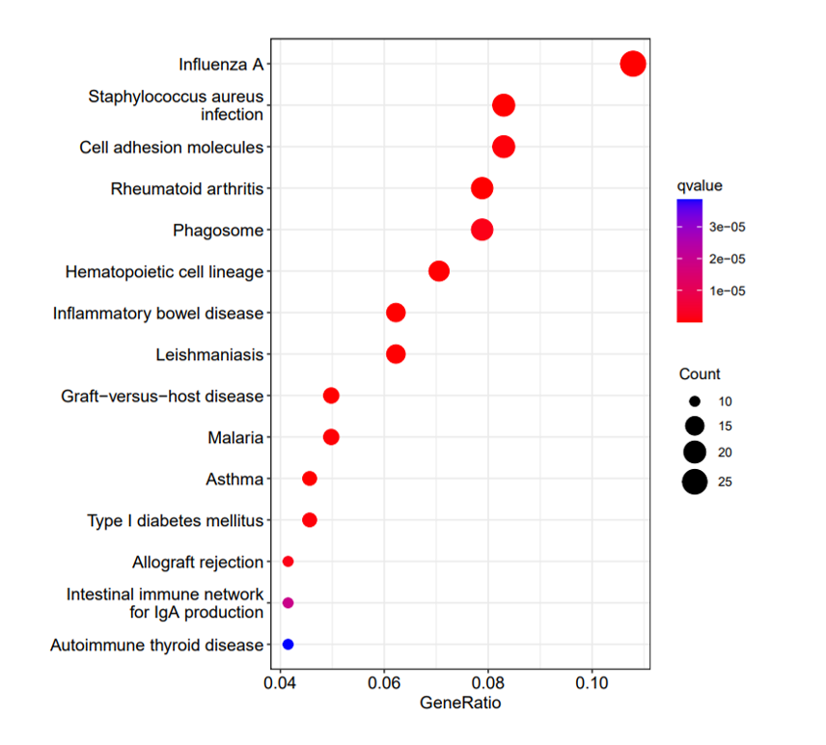
Figure S2: KEGG pathway analysis. KEGG enrichment analysis of the DEGs presented in Figure 2A-B. The y-axis shows clustered KEGG pathways. The GeneRatio on the x-axis represents the ratio of the number of genes enriched in one KEGG pathway to the number of upregulated or downregulated DEGs. The indicator bar indicates significance as q-value and the black circles represent number of counts. The Figure is related to Figure 2.

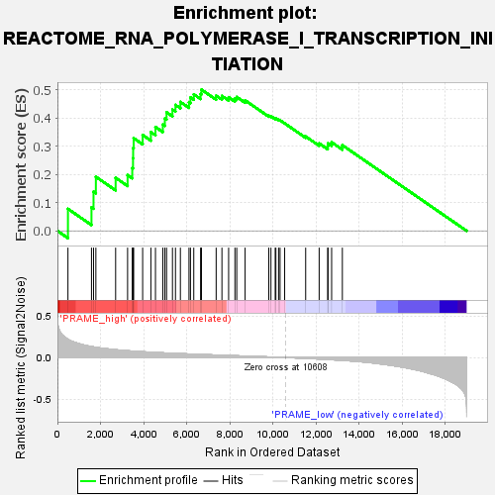
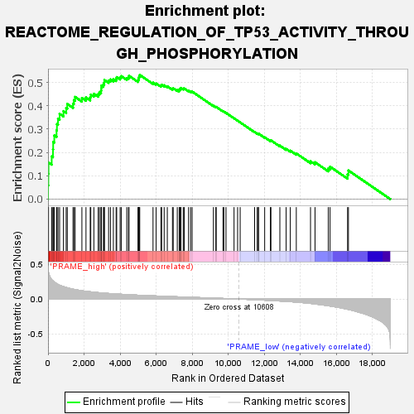
A B
NES: 2.009
p-value: 0.0039
NES: 1.811
p-value: 0.0010

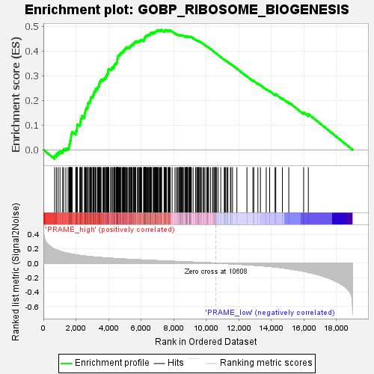
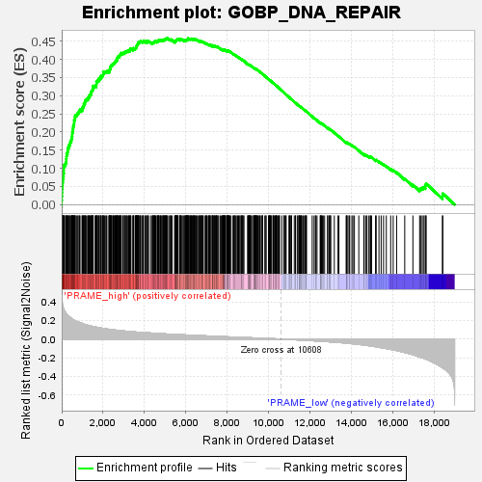
C D
NES: 2.027
p-value: 0.0019
NES: 2.003
p-value: 0.0020

Figure S3: GSEA Enrichment plots of PRAME high versus moderate. Gene set enrichment analysis (GSEA) was performed for (A) RNA Polymerase transcription initiation transcriptome, (B) Regulation of TP53 regulation through phosphorylation (C) DNA repair, and (D) Ribosome biogenesis, using gene sets in the GSEA Molecular Signatures Database. “Signal-to-Noise” ratio (SNR) statistics was used to rank the genes per their correlation with PRAME high (red) or PRAME moderate (blue) expression. The green curves correspond to the enrichment score (ES) curve, which is the running sum of the weighted enrichment score obtained from GSEA software, while the normalized enrichment score (NES) and the p-value presented in each gene set are shown in each graph. The Figure is related to Figure 2 and additional data is presented in Table S1.

A B
55

35

55

35

70
55

Figure S4: SS18-SSX siRNA transfections of SYO-1 and MoJo cells. Original blots from the Western blot shown in Figure 3B. (A) Expression of SS18-SSX (upper blots) and the corresponding expression of GAPDH (lower blots). The bands in blue boxes were cropped and presented in main Figure 3B. (B) Expression of PRAME in SYO-1 (upper left) and MoJo (upper right) cells and GAPDH in corresponding blots (lower blots). Molecular weight markers are indicated in red to the left of each blot.

Figure S5: Overexpression of SS18-SSX in SW982 cells. Expression of PRAME (upper blot), SS18-SSX (middle blot), and GAPDH (lower blot) in SW982 cells after transfection with the SS18-SSX1 expression plasmid. GAPDH was used as loading control. Molecular weight markers are presented in red to the right of each blot. The data is presented in main Figure 3D.

Figure S6. Colony formation assay in SS cells after treatment with GSK343 and ATRA. Translocation positive HSSY-II SS cells and translocation negative SW982 SS cells were treated with DMSO, GSK343 (GSK), or ATRA individually as well as in combination (Combo). Colonies were stained with crystal violet after four weeks. Representative plates from three individual experiments are shown. Figure corresponds to Figure 4.

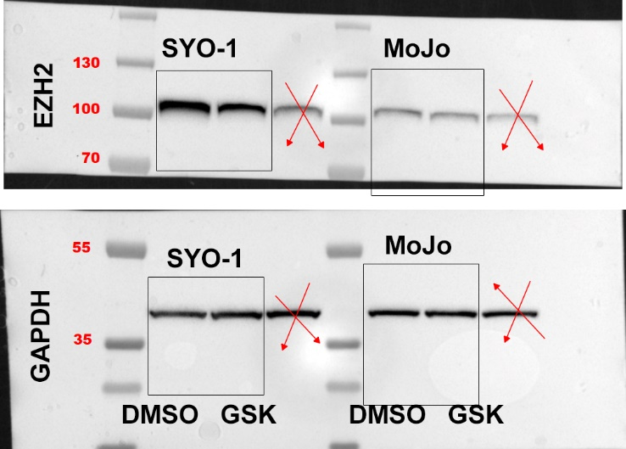
Figure S7: Expression of EZH2 in SS cells following treatment with GSK343. SYO-1 and MoJo cells were treated with DMSO or GSK343 (GSK) as indicated. Western blot analysis for EZH2 (upper panel) and GAPDH as loading control (lower panel). Molecular weight markers are indicated in red to the left of each blot. The bands in the four boxes were cropped and presented in Figure 5C. Note that the third and sixth bands, which are crossed over, were excluded in Figure 5C as they are from control and treated extracts respectively, loaded in duplicate.

Figure S8: Treatment of SYO-1 cells with GSK343 and ATRA. Cells were treated with DMSO, GSK343, ATRA, or GSK343+ATRA as indicated. Expression of Tubulin BIII (black box, upper blot), p21 (black box, lower blot), SOX9 (red box, upper blot), PPARγ (blue box, upper blot), and MYC (green box, upper blot). The blots in the lower panel represent expression of β-Actin used as loading control for the corresponding blots shown in the upper panel. Molecular weight markers are shown in red to the left or to the right of the blots. This Figure corresponds to main Figure 6A.

Figure S9: Expression level of p16 in SS cells. SYO-1 and MoJo cells were treated with 1) DMSO; 2) GSK343, 3) ATRA, and 4) GSK343+ATRA as indicated and expression of the senescence marker p16 was analyzed using Western blot. β-Actin was used as loading control. Molecular weight markers are shown in red to the left of the blots. This Figure corresponds to main Figure 7D.

Figure S10: Effects of PRAME knock down on PRAME and p21 expression in SYO-1 cells. Cells were transduced with lentiviral particles loaded with either control vector or vectors carrying PRAME shRNAs. Expression of PRAME (left panel) and p21 (right panel) in stable cell lines. Lanes 1-2) shControl; lanes 3-4) shPRAME1; and lanes 5-6) shPRAME2 after treatment with DMSO (lanes 1, 3, 5) or 5 µM ATRA (lanes 2, 4, 6) for three days. $β$-Actin was used as loading control. Molecular weight markers are shown in red to the left of each blot. Original scan corresponding to Figure 8A.

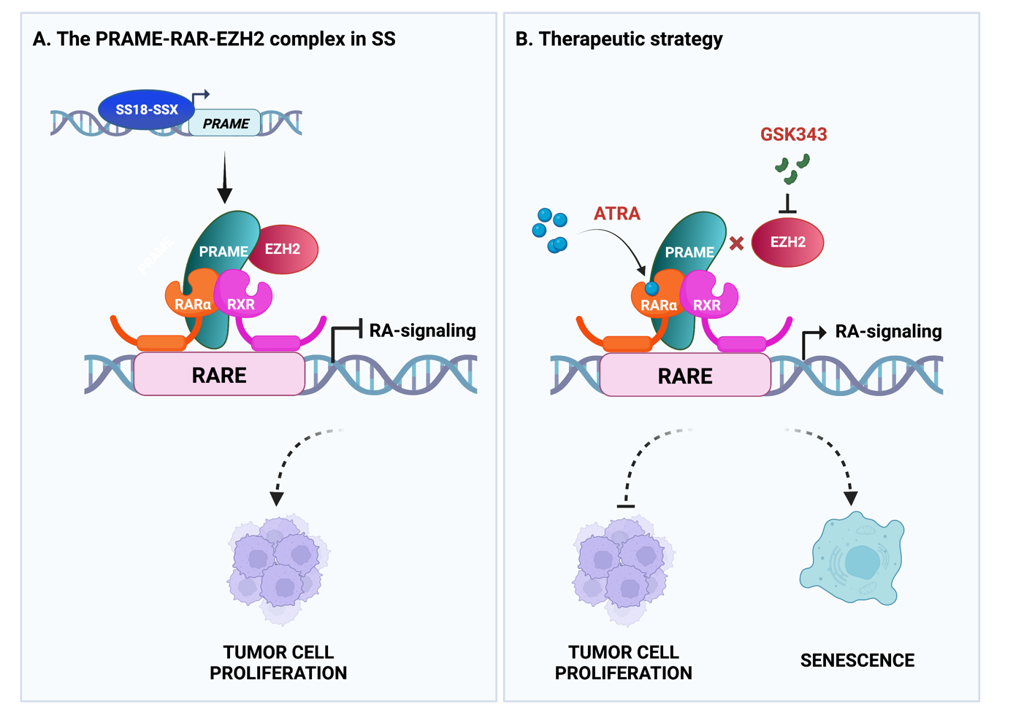
Figure S11: Schematic presentation of the proposed model. (A) The PRAME-RAR-EZH2 complex in SS. The fusion oncoprotein SS18-SSX binds to the PRAME promoter and activates gene expression. PRAME in turn forms a complex with RARα-RXR heterodimers as well as with EZH2, which binds to retinoic acid response elements (RAREs). This results in transcriptional repression of retinoic acid (RA) responsive genes and inhibition of RA-signaling, allowing tumor cell proliferation. (B) Therapeutic strategy. Combination treatment with an inhibitor of EZH2, GSK343, together with all-trans retinoic acid (ATRA) disrupts the PRAME-RAR-EZH2 complex and restores RA-signaling. Consequently, tumor cell proliferation is blocked with subsequent induction of cellular senescence. The Figure was created with Biorender.com.

Table S1: Detailed Enrichment Results of the gene sets. Enrichment results for the gene sets used. Size: Number of genes in the gene set; ES: Enrichment score for the gene set; NES: Normalized enrichment score; NOM p-value: Nominal p-value, i.e. the statistical significance of the enrichment score; FDR q-value: False discovery rate; FWER p-value: Familywise-error rate; RANK AT MAX: rank at which the maximum enrichment score was observed in the list; LEADING EDGE: the three statistical parameters which define the leading edge subset i.e. tag, list, and signal. Data corresponds to the GSEA graphs shown in Figure 2 and Figure S3.

Table S2: List of Antibodies used in Western blot assays.
Antibody | Dilution | Catalog Number | Manufacturer
Rabbit anti SS18-SSX | 1:1000 | 70929 | Cell Signaling Technology, Leiden, Netherlands
Mouse anti PRAME | 1:500 | sc-137188 | Santa Cruz Biotechnology, Dallas, TX, USA
Mouse anti Tubulin β-III (2G10) | 1:2000 | ab78078 | Abcam, Cambridge, UK
Rabbit anti SOX9 | 1:1500 | sc-20095 | Santa Cruz Biotechnology, Dallas, TX, USA
Mouse anti c-MYC (9E10) | 1:1000 | sc-40 | Santa Cruz Biotechnology, Dallas, TX, USA
Rabbit anti p21 | 1:3000 | 12D1 | Cell Signaling Technology, Leiden, Netherlands
Rabbit anti p21 | 1:1000 | sc-397 | Santa Cruz Biotechnology, Dallas, TX, USA
Rabbit anti Retinoic acid Receptor α | 1:1000 | PA1-810A | Thermo Fisher Scientific, Waltham, MA, USA
Mouse anti β-Actin | 1:3000 | sc-47778 | Santa Cruz Biotechnology, Dallas, TX, USA
Mouse anti GAPDH | 1:3000 | sc-32233 | Santa Cruz Biotechnology, Dallas, TX, USA
Rabbit anti EZH2 (D2C9) | 1:2000 | 5246S | Cell Signaling Technology, Leiden, Netherlands
Mouse anti PPARγ | 1:1000 | sc-7273 | Santa Cruz Biotechnology, Dallas, TX, USA

Table S3: List of Antibodies used in immunofluorescence (IF) and Proximity Ligation Assays (PLA). Only one dilution specified when the antibody was diluted the same manner in both assays.
Antibody | Dilution | Catalog Number | Manufacturer
Mouse anti PRAME | 1:200 | sc-137188 | Santa Cruz Biotechnology, Dallas, TX, USA
Mouse anti Tubulin β-III (2G10) | 1:2000 | ab78078 | Abcam, Cambridge, UK
Rabbit anti Retinoic acid Receptor alpha | 1:200/1:250 | PA1-810A | Thermo Fisher Scientific, Waltham, MA, USA
Rabbit anti EZH2 (D2C9) | 1:200 | 5246S | Cell Signaling Technology, Leiden, Netherlands

Supplementary Material and Methods
Cell Culture
The SS and RD-ES cell lines were cultured in DMEM medium, RH30 and SW872 in RPMI, while SK-UT-1 cells in MEM medium. All cell lines were maintained in 10% fetal bovine serum (FBS) (Life Technologies, Waltham, MA, USA), except MoJo cells, which were cultured in 15% FBS. All media were supplemented with 100 units/ml penicillin and 100 μg/ml streptomycin (Merck/Sigma-Aldrich, St. Louis, MO, USA). Cells were cultured at +37°C in humified conditions with 5% CO2.
Lentiviral transduction for PRAME knockdown.
SYO-1 cells were seeded at a confluence of 25,000 cells/well in 6-well plates the day before transduction. Complete medium was then replaced by 1 ml of medium without FBS containing lentiviral particles at MOI = 3 with 4 µg/ml of polybrene (VectorBuilder GmbH, Neu-Isenburg, Germany) to increase efficiency. After 12 h, 1 ml of complete medium was added to each well and was refreshed after 24 h. Forty-eight hours post transduction, cells were selected with 1 µg/ml puromycin (Merck/Sigma-Aldrich, St. Louis, MO, USA) for two days and then maintained with 0.5 µg/ml puromycin.
In silico gene expression analysis
Gene expression analysis was performed using Microarray expression data from the GSE40018 and GSE40021 datasets. GSE40018 included 34 SS samples from the GPL13497 platform (Agilent-026652 Whole Human Genome Microarray 4 × 44K v2). The GSE40021 dataset contained 58 SS samples from the GPL6480 platform (Agilent-014850 Whole Human Genome Microarray 4 × 44K G4112F). The information from these two data sets was combined for analysis using the Robuse Multi-Array Average algorithm and combat function of the “sva” package in R (v4.1.3) for preprocessing and removal of batch effects. Noteworthy, previous studies have shown that all SS samples expressed PRAME at certain levels (1), hence we grouped the samples only into PRAME moderate and high groups. The median PRAME expression was used as the cutoff value to make the division into the high and moderate PRAME expressing groups, respectively.

Expression Analysis of PRAME in STS
The R2 Genomic Platform (http://r2platform.com) was used to study the expression pattern of PRAME in STS. We combined data from the Boshoff (2) and the Filion (3) cohorts for analysis of PRAME expression in a panel of STS clinical samples. Briefly, SS (n=56), rhabdomyosarcoma (n=30), Ewing Sarcoma (n=33), and leiomyosarcoma (n=8) patient data were examined. Log2 values of RNA expression levels were extracted and subjected to statistical analysis using GraphPad Prism 6 software (La Jolla, CA, USA). One-way ANOVA test was applied for statistical analysis. We also analyzed the mutational status of PRAME in SS tumors using the COSMIC database (4). The query was generated as follows: (https://cancer.sanger.ac.uk/cosmic/gene/analysis?all_data=&coords=AA%3AAA&dr=&gd=&hn=synovial_sarcoma&id=202519&ln=PRAME_ENST00000398743&res_type=AA&seqlen=510&sn=soft_tissue&ss=fibrous_tissue_and_uncertain_origin&export=html&start=487&end=undefined#variants).
Differential Gene Expression and Gene Set Enrichment Analysis
Differentially expressed genes (DEGs) were analyzed using the limma package in R (5). Next, gene ontology (GO) and Kyoto Encyclopedia of Genes and Genomes (KEGG) enrichment analyses were performed using clusterProfiler packages in R (6) to identify the pathways in which the DEGs are involved. To analyze the involvement of PRAME in RA signaling in SS, the RA-target gene set “DELACROIX_RAR_BOUND_ES.gmt” was downloaded from the Molecular Signatures Database (MSigDB) (7) and gene set enrichment analysis (GSEA) was performed using the GSEA software (Broad Institute, v4.2.3) (Table S1). The molecular profile data of PRAME expression in SS as described above was used for GSEA.

Details of the siRNA pool used for knockdown of SS18-SSX
- ON-TARGETplus Human SSX2 (6757) siRNA - SMARTpool, L-017245-01-0005
5´-UUGAUGAUAUUGCCACAUA-3´
5´-CAGCAGAGGACGAAAAUGA-3´,
5´-CCUUAUAAUUGAUGAGCAA-3´,
5´-ACAGAAUCAUCCCGAAGAU-3´
- ON-TARGETplus Human SSX1 (6756) siRNA - SMARTpool, L-019194-00-0005
5´-UCUGCAUGGAACAGCAUUA-3´,
5´-AAGAGAAAGUAUGAGGCUA-3´,
5´-GUUCGAUGUUAGCGUUUAC-3´,
5´-ACUGUGUCAUUCUGUUAGA-3´
- ON-TARGETplus Non-targeting Pool
5´-UGGUUUACAUGUCGACUAA-3´,
5´-UGGUUUACAUGUUGUGUGA-3´,
5´-UGGUUUACAUGUUUUCUGA-3´,
5´-UGGUUUACAUGUUUUCCUA-3´

SS18-SSX Plasmid and Overexpression
The cDNA of SS18-SSX1 was cloned in the eukaryotic expression vector pTargeT (Promega, Madison, Wis, USA) as previously described (8). The SW982 cells were transfected using Lipofectamine 3000 transfection reagent (Cat No. L3000008, Invitrogen, Thermo Fisher Scientific, Waltham, MA, USA). Cells were harvested after three days and ten days for expression analysis at mRNA and protein, respectively.

Chromatin Immunoprecipitation Assay
The EZ-Magna ChIP™ G - Chromatin Immunoprecipitation kit (Cat No. 17-409) was purchased from EMD Millipore (Burlington, MA, USA). Briefly, SYO-1 cells were grown in 10 cm culture dishes. When the culture was 90% confluent, cells were fixed at room temperature for 10 min in a medium containing 1% methanol-free formaldehyde (Cat No. 28908, Thermo Fisher Scientific, Waltham, MA, USA) and then the manufacturer’s protocol was followed. The extracted nuclei were sheared using 20 cycles of Misonix Ultrasonic Liquid Processor (S-4000) set to 30 s “on” and 30 s “off” per cycle with an amplitude of 50%. For each ChIP reaction, 120 µg of sheared DNA was used. After overnight incubation with an anti-SS18-SSX antibody (Cat No. 70929, Cell Signaling Technology, Leiden, Netherlands) or an isotype control IgG antibody (rabbit IgG, polyclonal ab171870; Abcam, Cambridge, UK), protein G beads (EMD Millipore, Burlington, MA, USA), and the DNA-protein complex, reverse cross linking was performed using a Thermomixer (Invitrogen, Thermo Fisher Scientific, Waltham, MA, USA) at +67°C for 2 hours, then 4 µL of 20 mg/mL proteinase K (MD Millipore, Burlington, MA, USA) was added and the mixture was incubated at +57°C for another 2 hours.
Quantitative PCR was performed on Step One Real-Time PCR Systems (Applied Biosystems, Van Allen Way, CA, USA). Nucleotides -195 to -97 of the EGR1 promoter were amplified as a positive control while the region spanning -1015 to -823 bp upstream of the EGR1 transcription start site was used as a negative control. The -66 to +35 bp sequence in relation to the PRAME transcription start site was used for analysis.
The fold enrichment method was applied to detect the binding of SS18-SSX to the promoter regions of the PRAME or EGR1 genes. Unpaired t-test with Welch’s correction was applied to calculate the p-values of four independent experiments using GraphPad Prism 6.0 software (La Jolla, CA, USA).
Sequences of primers used for ChIP-qPCR:
EGR1^{-195/-97} _Forward: 5´-TAGGGTGCAGGATGGAGGT-3´
EGR1^{-195/-97} _Reverse: 5´ -AAGCAGGAAGCCCTAATATGGCAG-3´
PRAME^{-66/+35} _Forward: 5´-GGGGAGCTGTACCCTGAAG-3´
PRAME^{-66/+35} _Reverse: 5´-CTGGGAGGAAGTGGGTTTT-3´
EGR1^{-1015/-823} _Forward: 5´-AATCAGCTTCCCCACTTCGG-3´
EGR1^{-1015/-823} _Reverse: 5´-GGATAGGAAGTCACGGCCAC-3´

Cell Viability assay
The 3-(4,5-dimethylthiazol-2-yl)-2,5-diphenyltetrazolium bromide (MTT) based cell viability assay was performed. 1,500 SYO-1, MoJo, or HSSY-II cells were seeded per well in 96 well plates and cultured overnight. Next day, the cells were exposed to 2.5 µM GSK343 and 5 µM ATRA both individually and in combination using DMSO as a vehicle.
Briefly, at the end of each treatment period, 0.5 mg/mL of MTT (Merck/Sigma-Aldrich, St. Louis, MO, USA) was added to each well and incubated at +37°C for 1 hour. Medium was then replaced with DMSO followed by incubation on a shaker at room temperature for 30 min. The OD was measured at 570 nm using a ﻿LUMIstar Omega plate reader (BMG Labtech, Ortenberg, Germany). Three independent experiments with each cell line were performed and unpaired t-test was used for statistical analysis.
IncuCyte Live-Cell Imaging for Cell Proliferation
Stable shControl, shPRAME1, and shPRAME2 SYO-1 cell lines were seeded in 96-well plates in triplicates and treated for seven days with ATRA or DMSO. Medium plus ATRA or DMSO was changed once in the middle of the treatment period. Cell proliferation was assessed by measuring confluence in an Incucyte® S3 Live-Cell imaging system (Sartorius, Goettingen, Germany). Four bright-field images per well were taken every six hours. Confluence was normalized versus the first time-point (0 h) and presented as the mean of three independent experiments. Statistical significance was determined with unpaired t-test.

RT-qPCR for gene expression analysis.
Total RNA was extracted using RNeasy Plus Mini Kit (Qiagen, Germantown, MD, USA) following the manufacturer’s protocol. RNA was used to synthesize cDNA using First Strand Synthesis Kit (Thermo Fisher Scientific, Waltham, MA, USA) following the manufacturer’s protocol. RT-qPCR was performed using StepOne™ Real-Time PCR System (Applied Biosystems, Van Allen Way, CA, USA). The primer concentration was adjusted to a final concentration of 3 μM and the total reaction volume in all RT-qPCR experiments was 20 μL, using a SYBR Green master mix (Thermo Fisher Scientific, Waltham, MA, USA). The primers sequences (5′ to 3′) were as follows.
KLF4_Forward: 5´-CCCACATGAAGCGACTTCCC-3´
KLF4_Reverse: 5´-CAGGTCCAGGAGATCGTTGAA-3´
OCT4_Forward: 5´-CTGGGTTGATCCTCGGACCT-3´
OCT4_Reverse: 5´-CCATCGGAGTTGCTCTCCA-3´
SOX2_Forward: 5´-GCCGAGTGGAAACTTTTGTC-3´
SOX2_Reverse: 5´-GGCAGCGTGTACTTATCCTTCT-3´
NANOG_Forward: 5´-TTTGTGGGCCTGAAGAAAACT-3´
NANOG_Reverse: 5´-AGGGCTGTCCTGAATAAGCAG-3´
TBP_Forward: 5´-GAGAGTTCTGGGATTGTACCG-3´
TBP_Reverse: 5´-ATCCTCATGATTACCGCAGC-3´
β−Actin_Forward: 5´-CACCATTGGCAATGAGCGGTTC-3´
β−Actin_Reverse: 5´-AGGTCTTT GCGGATGTCCACGT-3´
GAPDH_Forward: 5´-ACCACCCTGTTGCTGTAGCCAA-3´
GAPDH_Reverse: 5´-GTCTCCTCT GACTTCAACAGCG-3´

Relative gene expression was normalized to that of the transcript from the genes encoding the TATA-binding protein (TBP), GAPDH, and β−Actin, which served as endogenous controls. All experiments were performed independently at least three times and two-way ANOVA analysis was performed for statistical analysis.

Proximity Ligation assay
SYO-1 cells were seeded in six well plates containing glass coverslips. The following day, they were treated with DMSO, 5 µM ATRA, 2.5 µM GSK343, or the combination of ATRA and GSK343 for three days. Cells were washed twice with PBS, fixed with 4% formaldehyde, and permeabilized with 0.1% Triton X-100. Next, slides were blocked with blocking buffer and incubated overnight at +4°C with primary antibodies against PRAME together either with a RARα or an EZH2 antibody (1:200). Proximity ligation was performed utilizing the Duolink® In Situ Green Starter Kit Mouse/Rabbit (Merck/Sigma-Aldrich (St. Louis, MO, USA) according to the manufacturer’s protocol. Co-localization fluorescence signal intensity was detected using a Zeiss Axiovert 200 M microscope with the Zen 2 blue edition software. Three independent PLA experiments were performed, the signal intensity was quantified using Image J (NIH, Bethesda, MD, USA), and represented as relative to the number of nuclei. Unpaired t-test was used for statistical analysis.

Senescence Assay
10,000 cells/well for the control and 20,000 cells/well for the treatments were seeded and incubated for ten days with DMSO, 5 µM ATRA, 2.5 µM GSK343, or the combination of ATRA and GSK343. The proportion of senescent cells was measured using the Senescence β-galactosidase (β-gal) staining Assay Kit (Millipore KAA002, Burlington, MA, USA). For quantification, the number of β-gal positive cells was counted in each culture under the microscope and representative images were captured. The assay was performed at least four independent times and after quantification of β-gal staining, unpaired t-test was applied for statistical significance.

Colony Formation Assay
200 cells were seeded in each well of a 6 well plate and treated after 24 h with DMSO, 5 µM ATRA, 2.5 µM GSK343, or the combination of ATRA and GSK343 at +37°C. Treatments were maintained for two weeks for SYO-1 and four weeks for MoJo cells, with medium plus compounds being changed every three days. Next, cells were fixed in 4% PFA (Merck/Sigma-Aldrich, St. Louis, MO, USA) and stained with 0.2% crystal violet solution (Merck/Sigma-Aldrich, St. Louis, MO, USA), followed by several washes with water to remove excess of dye. Images were taken using a ChemiDoc XRS+ System (Bio-Rad, Hercules, CA, USA). Experiments were repeated at least three times for each cell line and unpaired t-test was performed for statistical analysis.

Western Blot Analysis
Western blot analysis was performed as described in (9). Briefly, whole-cell lysates were prepared using RIPA lysis buffer containing protease inhibitor cocktail (Roche, Basel, Switzerland). Samples were boiled in 1× Laemmli buffer at +95°C for 10 min and separated by sodium dodecyl sulfate-polyacrylamide gel electrophoresis (SDS-PAGE) (BoltTM 4-12% Bis-Tris Plus, Invitrogen, CA, USA). After gel electrophoresis, separated proteins were transferred to nitrocellulose membranes (Trans-Blot Turbo Transfer Pack, Cat No. 1704159, Bio-Rad, Hercules, CA, USA). Membranes were blocked with 5% non-fat milk (AppliChem GmbH, Darmstadt, Germany) and probed with primary antibodies overnight at +4°C. Horseradish peroxidase tagged anti-mouse or anti-rabbit secondary antibodies (dilution 1:3000; Agilent Technologies, Santa Clara, CA, USA) were added followed by incubation for 1 h and development using SuperSignal™ West Dura (Cat No. 34076, Thermo Fisher Scientific, Waltham, MA, USA). Immunoblots were imaged using a ChemiDoc XRS+ System (Bio-Rad, Hercules, CA, USA) and analyzed with Image Lab software (Bio-Rad, Hercules, CA, USA). GAPDH or β-Actin antibodies were used as loading controls. The PageRuler™ Plus Prestained protein ladder was purchased from Thermo Fisher Scientific (Cat No. 26620, Thermo Fisher Scientific, Waltham, MA, USA). All Western blot experiments were performed at least three times.

Immunofluorescence
Synovial sarcoma cells were treated with DMSO, ATRA, GSK343, or the combination of ATRA and GSK343, for ten days. Immunofluorescence staining was performed for analysis of Tubulin-βIII and RARα. Two different protocols were used.
Synovial sarcoma cells (3,000) were cultured per well of six well plates containing glass coverslips. Next day the culture was treated with DMSO, 5 µM ATRA, 2.5 µM GSK343, or the combination of ATRA and GSK343, and incubated at +37°C for ten days. Next, cells were fixed in a 1:1 solution of methanol and acetone and stored at -20°C. Cells on coverslips were rehydrated for 30 min in PBS and incubated with mouse anti-Tubulin-βIII antibody (1:2000) for 1 hour at room temperature. After three washes with PBS, the coverslips were incubated with rabbit anti-mouse FITC-conjugated secondary antibody (1:700; Invitrogen, Waltham, MA, USA) and Hoechst (Merck/Sigma-Aldrich, St. Louis, MO, USA) was added to stain cell nuclei.
For RARα immunofluorescence, following treatment SYO-1 and MoJo cells were fixed with 4% paraformaldehyde solution (Merck/Sigma-Aldrich, St. Louis, MO, USA) for 15 min and incubated with blocking solution (3% BSA and 0.25% Triton X-100 in PBS) for 1 h at room temperature. Coverslips were incubated with anti-RARα in blocking solution (1:250, PA1-810A, Thermo Fisher Scientific, Waltham, MA, USA) overnight at +4ºC. Next day, samples were washed three times with PBS and incubated with AlexaFluor 488-conjugated goat anti-rabbit secondary antibody (1:700, Invitrogen, Waltham, MA, USA), and Phalloidin Dylight TM 554 (1:800, 13054S, Cell Signaling, Danvers, MA, USA) for 45 min at room temperature. After three washes with PBS, DAPI (1:10,000; Merck/Sigma-Aldrich, St. Louis, MO, USA) was added to stain nuclei. Following five min incubation, coverslips were washed three times in PBS and mounted on slides with ProLong™ Diamond Antifade Mountant (P36961, Thermo Fisher Scientific, Waltham, MA, USA). Images were captured with a Zeiss Axiovert 200M microscope with the Zen 2 blue edition software and edited using ImageJ (NIH, Bethesda, MD, USA). All immunofluorescence experiments were independently performed three times with each cell line.

References
1. Roszik J, Wang W-L, Ravi V, Hwu P, Yee C, Futreal A, et al. Expression and clinical correlations of PRAME in sarcoma subtypes. Journal of Clinical Oncology. 2016;34(15_suppl):11067-.
2. Henderson SR, Guiliano D, Presneau N, McLean S, Frow R, Vujovic S, et al. A molecular map of mesenchymal tumors. Genome Biol. 2005;6(9):R76.
3. Filion C, Motoi T, Olshen AB, Lae M, Emnett RJ, Gutmann DH, et al. The EWSR1/NR4A3 fusion protein of extraskeletal myxoid chondrosarcoma activates the PPARG nuclear receptor gene. J Pathol. 2009;217(1):83-93.
4. Tate JG, Bamford S, Jubb HC, Sondka Z, Beare DM, Bindal N, et al. COSMIC: the Catalogue Of Somatic Mutations In Cancer. Nucleic Acids Research. 2018;47(D1):D941-D7.
5. Ritchie ME, Phipson B, Wu D, Hu Y, Law CW, Shi W, et al. limma powers differential expression analyses for RNA-sequencing and microarray studies. Nucleic Acids Research. 2015;43(7):e47-e.
6. Yu G, Wang LG, Han Y, He QY. clusterProfiler: an R package for comparing biological themes among gene clusters. OMICS. 2012;16(5):284-7.
7. Liberzon A, Birger C, Thorvaldsdóttir H, Ghandi M, Mesirov JP, Tamayo P. The Molecular Signatures Database (MSigDB) hallmark gene set collection. Cell Syst. 2015;1(6):417-25.
8. Brodin B, Haslam K, Yang K, Bartolazzi A, Xie Y, Starborg M, et al. Cloning and characterization of spliced fusion transcript variants of synovial sarcoma: SYT/SSX4, SYT/SSX4v, and SYT/SSX2v. Possible regulatory role of the fusion gene product in wild type SYT expression. Gene. 2001;268(1-2):173-82.
9. Mushtaq M, Kovalevska L, Darekar S, Abramsson A, Zetterberg H, Kashuba V, et al. Cell stemness is maintained upon concurrent expression of RB and the mitochondrial ribosomal protein S18-2. Proceedings of the National Academy of Sciences. 2020;117(27):15673.

