Supplementary information I
Insights on mercury and energy consumption from in-situ measurements of artisanal and small-scale gold mining in Brazil
Authors: Benjamin Fritzª, Bernhard Peregovich^{b}, Lorena da Silva Tenório^{b}, Adria Cristina da Silva Alves^{b}, Mario Schmidtª
ª Institute for Industrial Ecology, Pforzheim University, Tiefenbronner Str. 65, 75175 Pforzheim, Germany
^{b} Universidade Federal do Oeste do Pará, Rua Vera Paz Av. Vera Paz, s/n, Bairro Salé, 1 Pavimento, Bloco Modular Tapajós, Unidade Tapajós, Santarém 68035-110, Brazil

Energy intensity for transportation of goods in ASGM
In LCA of gold mining, the transport process from and to the mine usually is neglectable small e.g., ecoinvent v.3.9.1 less than 1 % in market for gold, unrefined and market for gold-silver-ingot¹. Note, that this does not include the transport of the ore within the mine with conveyors or hauling trucks. In the Garimpos it could be more relevant, because of the remote character of the mines and smaller economy of scales, compared to industrial mining. To estimate the diesel consumption and its associated climate impacts the following information were mainly used:
- vehicle specific data as well as statistical annual data for diesel consumption
- data on diesel demand for gold from our own study
- satellite data
- secondary data for regional gold production volumes².
In general, there are three modes of transport for providing auxiliary materials like food, mercury, machine parts and diesel. Because this whole transport topic is bound to a lot of uncertainty and because on an average weight basis diesel is the heaviest good transported, this study focuses on the transport of diesel. The logistics of diesel in the garimpos will be split in three major modes of transport: by car, by boat and by airplanes.
To calculate average distances between the important fuel stations and Currutelas in our study Google Earth® (https://earth.google.com) was used (see Figure 1).
We assume that transporting diesel into big cities in the area like Santarém, Belém and Marabá is comparable to the transport assumptions included in the average market for diesel in Brazil based on ecoinvent v.3.9.1¹. A detailed life cycle inventory analysis of this dataset revealed, that 99 % of the transports involved in the production of 1 kg of diesel in Brazil are by ship, lorry and train. The diesel consumed for transporting the diesel freight or in other words the associated diesel footprint is 25 g_{diesel}/kg_{diesel}.
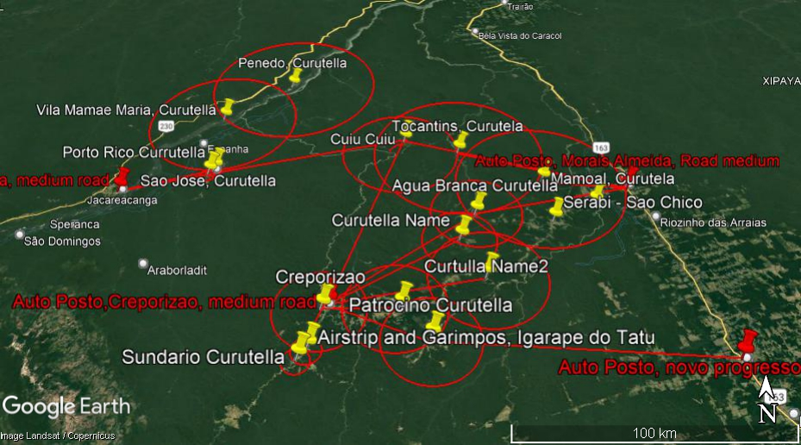
Figure 1: Map of the infrastructure for diesel in the study area distances between currutelas (radius in red) and to the fuel stations (yellow lines).

Road transport
From the bigger cities the diesel is transported to fuel stations in the area like Jacareacanga, Itaituba, Jardim do Ouro and Creporizão by medium-sized (45,000 L_{load}) tanker lorries. The fuel consumption of these tanker lorries is around 0.7 L/km or 0.58 kg_{Diesel}/km at an average diesel density of 0.83 kg/L³. The average distance between the big cities and the fuel stations is 1,160 km. This leads to 1,160 km * 0.58 kg_{Diesel}/km / 37,575 kg_{load} =18.1 g_{diesel}/kg_{diesel}. For the empty runs back, the consumption is around 0.33 kg_{Diesel}/km and therefore the diesel footprint for the big tankers is around 28 g_{diesel}/kg_{diesel}
From here the diesel gets transported either by small tanker lorries, pickups, boats or airplanes. The average distance from the fuel stations to the closer lying Currutelas is 70.6 km beeline. Although the driving distance in the amazon rain forest on often temporary roads is far from beeline, we use the beeline distances, since the distances are also varying great and it is almost impossible to know the real distances as the often-temporary roads are not shown on the maps. We assume the utilization of small tankers (5,000 L) with an average consumption of 0.58 kg_{Diesel}/km. This leads to 70.6 km * 0.58 kg_{diesel}/km / 4,150 kg_{load} =9.87 g_{diesel}/kg_{diesel}. For the empty runs back, the consumption is around 0.33 kg_{Diesel}/km and therefore the diesel footprint for the small tankers is around 16 g_{diesel}/kg_{diesel}
A common pickup used for the transportation of goods on the last mile that we observed is the Toyota Hilux 7Th Gen®. This auto model has a load capacity of 1,000 kg and a diesel consumption between 0.08 – 0.12 L/km. As the general speed in the Amazon rainforest is low but the load for transporting diesel is high, we assume 0.08 kg_{Diesel}/km. The distance between the Currutelas, based on the radii (see Figure 2) is on average 24.1 km beeline. If we assume, that diesel is transported with a Hilux from the currutela to the garimpo and further assume, that the maximum distance of a garimpo from a currutela is halfway of the distance between the average distance of currutelas to each other, we can assume that the last mile is around 12.1 km beeline. This leads to 12.1 km * 0.08 kg_{diesel}/km / 1,000 kg_{load} = 1 g_{diesel}/kg_{diesel}. Wherever a simple option can be found in the garimpos to raise cost efficiency, from our observation it was done. Therefore, the pickups almost never drive around empty, but carry other goods or passengers on their way back. Since these routes in the end also mainly serve the purpose of gold mining, we assumed that the same diesel consumption is needed for the route back, doubling the total diesel consumption. Hence the diesel footprint for the last mile is 2 g_{diesel}/kg_{diesel}.

River transport
In the Amazon River Basin, it is common to travel by boat for centuries. One common type of canoe used, with a very long shaft that extends the propeller of the motor is called Voadeira (or in Spanish speaking areas Peque-Peque). There is a very wide network of rivers and creeks in the study area, and most of the Garimpos are close to waterbeds. From satellite data it is known, that more than half of the Garimpos in 2012 could be found within a distance of 1 km from a river ⁴. We assume, that the connection between the currutelas on rivers is similar to those on temporary roads. The consumption of the boats is varying great depending on going up- or downstream, as well as speed and load. We assume, that a boat with a load of 900 kg of diesel at 20 km/h consumes on average 4.2 kg_{Diesel}/h. We further assume, that the distance of the currutelas to the fuel stations of 70.6 km described under section I.Ialso applies for boats. Meaning it would take around 3.5 h at a cruising speed of 20 km/h to transport the 900 kg of diesel. The boats also transport other goods or passengers on their way back which is why we assume a similar consumption there and back. The error we make by this assumption could be counterbalanced by the difference between going up or down the river. The result would therefore be 4.2 kg-Diesel/h * 7 h/ 900 kg_{load} = 33 g_{Diesel} /kg_{Diesel}.

Air transport
Within the study area, there are lots of temporary air strips that are used for the transportation of diesel. To estimate the amount of diesel needed for the transportation we use another approach, that is based on total per year estimates (statistical) instead of specific fuel consumption and distances (process-based). We have gathered data from interviews of around 46 very small airplanes of the type Cessna Centurion® and Skylane® as well as of four Cessna Caravan® to find out their weekly kerosene consumption as well as the number of weeks that they are actually flying (~ 10 month). The total kerosene consumption in the area is about 2,540,000 L kerosene. Additionally, we assume, that the total gold production in Para for the years 2019 and 2020 is ~28 tons accumulated² and we therefore used a value of ~14 tons per year. Dividing the 2,540,000 L_{kerosene} by the 14,000 kg_{Au} results in 181 L_{kerosene}/ kg_{Au}. With an average density of 0.8 kg/L_{kerosene} this means 145 kg_{kerosene}/kg_{Au}. Hence the density and the heating value of kerosene and diesel is very similar, we treat the kerosene as it was diesel in order to unify the nomenclature and raise the comparability. It is important to note, that because the diesel footprint for aviation is derived from total data per year and not process specific, it already includes a share of the total transports with planes. For the process specific calculation for boat (section I.II) and road transport (section I.I) on the other hand, it was always assumed that 100 % of diesel needed in the Garimpo is transported by either road or boat.

Total fuel consumption for transportation
From our surveys we know, that the gold production from secondary deposits with the use of excavators is the most common method in the Tapajos area and has a specific diesel consumption of ~4,500 kg diesel/kg Au (see main article). This is assumed to be the mass that needs to be transported per kg of gold by a mixture of planes, boats and trucks. To apply the diesel footprints calculated in the sections I.I, I.II and I.III a share between these three modes of transport must be found. Because our data gathered on the fuel consumption of airplanes is based on an annual statistical method, it can be used to determine such a share for the transportation by planes. With the total number of flights per year of 27,700, the total load that could be transported based on the max load of the airplane types can be calculated. This results in 19,000 t maximum freight transported by aircraft – or 950 kg_{load}/kg_{Au}. Hence the aviation has a share of around ~ 20 %. The remaining 80 % have to be distributed between road and river. In the rainy season, the roads are harder to use, but the water level of the rivers is higher and makes it easier to navigate and vice-versa. The rainy season is from January to May, with little variations from year to year ⁵. We therefore assume the share between road and river transportation to be 50-50.
Route | Diesel-Footprint [g_{diesel}/kg_{load}]
From well to medium cities in the region (applies for all routes)
Market for diesel, Brazil (ecoinvent) | 25
From big cities to medium cities by 45,000 L tankers with an average distance of 1,160 km | 28
From medium cities to garimpos via road (4500 kg_{load}* 0.4)
From medium cities to currutelas by 5,000 L tankers with an average distance of 70.6 km | 16
From Currutelas to garimpos with pickup trucks over a distance of 12.1 km | 2
From medium cities to garimpos via river (4500 kg_{load}*0.4)
From Currutelas to Garimpos with Voadeiras over 70.6 km | 33
From medium cities to garimpos via airplanes (4500 kg_{load}*0.2)
Annual fuel consumption by 50 different planes in the region divided by the annual gold production of 20 t of Au | 145 kg
Applying the distribution between the modes of transport
(25+28)*4500+(16+2)*4500*0.4+33*4500*0.4+145
Total diesel consumption for logistics per kg of fine gold | 330 kg_{diesel}/kg_{diesel}

References
1. Wernet, G. et al. The ecoinvent database version 3 (part I): overview and methodology. ecoinvent v.3.9.1. Int J Life Cycle Assess 21, 1218–1230; 10.1007/s11367-016-1087-8 (2016).
2. Manzolli, B., Rajao, R., Braganca, A. C. H. & Oliveira, P. d. T. M. Legalidade da producao de ouro no brasil (Editora IGC/UFMG, Belo Horizonte, Brasil, 2021).
3. DIN. Automotive fuels – Diesel – Requirements and test methods (Beuth, Berlin, 2022).
4. Felipe De Lucia Lobo. Spatial and Temporal Analysis of Water Siltation Caused by Artisanal Small-scale Gold Mining in the Tapajós Water Basin, Brazilian Amazon: An Optics and Remote Sensing Approach, 2015.
5. Climate-Data.org. Climate Marituba. Available at https://climate-data.org/suedamerika/brasilien/para/marituba-26634/.

