APPENDIX I
- English version of the adapted SOC-13 and SOC-29 scale based on our recommendations.
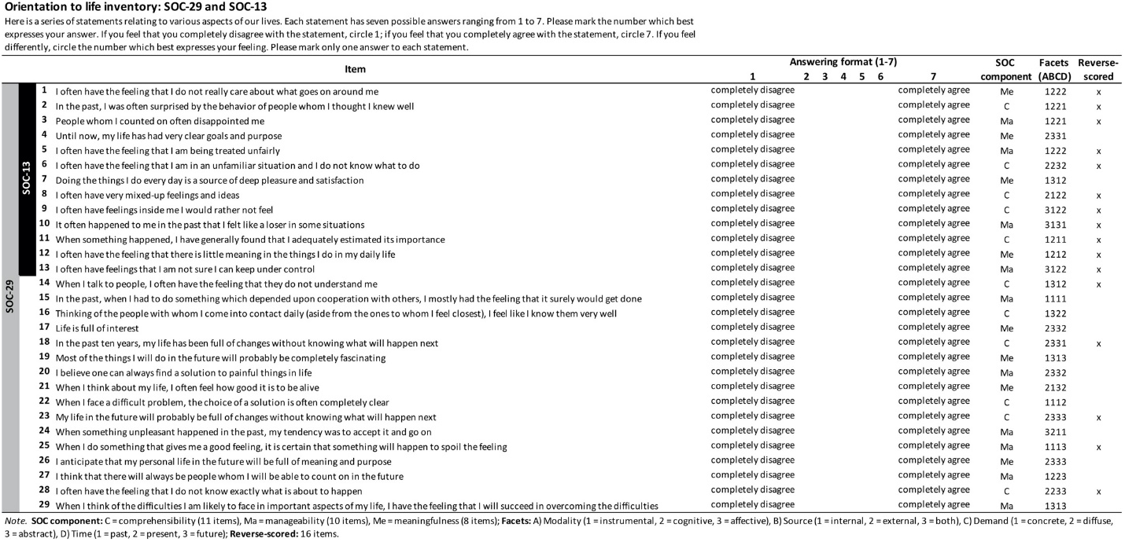

APPENDIX II
- Czech version of the adapted SOC-13 and SOC-29 scale based on our recommendations.
