Supplementary Information

Iron oxide nanozymes stabilize stannous fluoride for targeted biofilm killing and synergistic oral disease prevention

Yue Huang et al.

*Corresponding authors. Email: koohy@upenn.edu & david.cormode@pennmedicine.upenn.edu

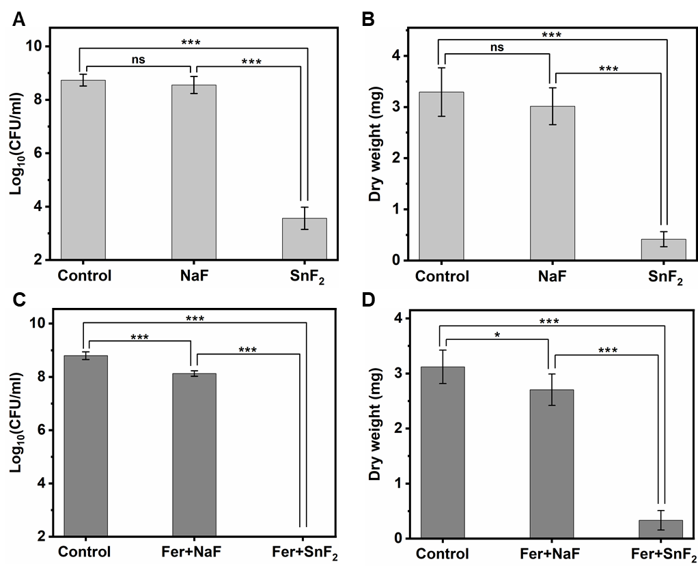
Fig. S1. (A and B) The bacterial viability (A) and the mass of biofilm (B) after treatment with NaF or SnF₂ at 1000 ppm of F. (C and D) The bacterial viability (C) and the mass of biofilm (D) after treatment with Fer+NaF or Fer+SnF₂ at 1 mg of Fe/ml, 1000 ppm of F, and 1% (v/v) of H₂O₂. The data are presented as mean ± standard deviation. *, p < 0.05, ***, p < 0.001; ns, nonsignificant; one-way ANOVA followed by Tukey test.

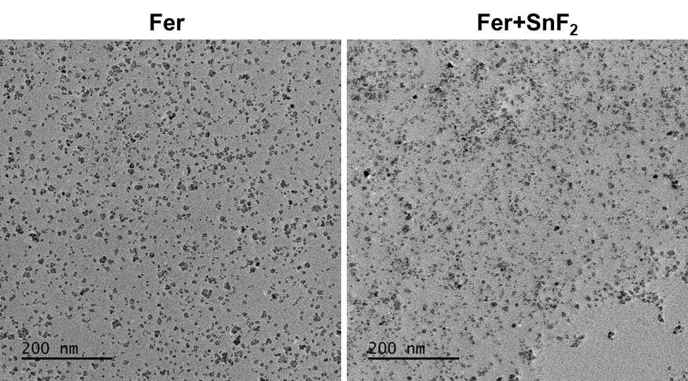

Fig. S2. Representative TEM images of Fer and Fer+SnF₂ after 1 h incubation in 0.1 M sodium acetate buffer (pH 4.5).

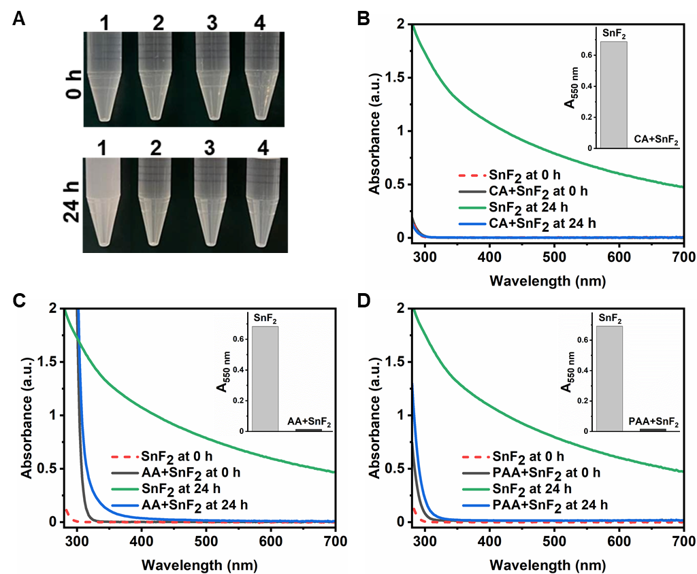

Fig. S3. (A) Photographs of SnF₂ in different conditions at pH 4.5 (0.1 M sodium acetate buffer). The samples are: 1. SnF₂ alone, 2. SnF₂+citric acid (CA), 3. SnF₂+L-ascorbic acid (AA), and 4. SnF₂+poly(acrylic acid) (PAA). Top: 0 h; bottom: after 24 h. (B to D) UV-visible absorption spectra of SnF₂ (250 ppm of F) at pH 4.5 (0.1 M sodium acetate buffer) with or without CA (1 mg/ml) (B), AA (1 mg/ml) (C), and PAA (1 mg/ml) (D) at the time points indicated. Insets show the absorbance of SnF₂ with or without CA (B), AA (C), and PAA (D) at 550 nm after 24 h incubation as a measure of turbidity.

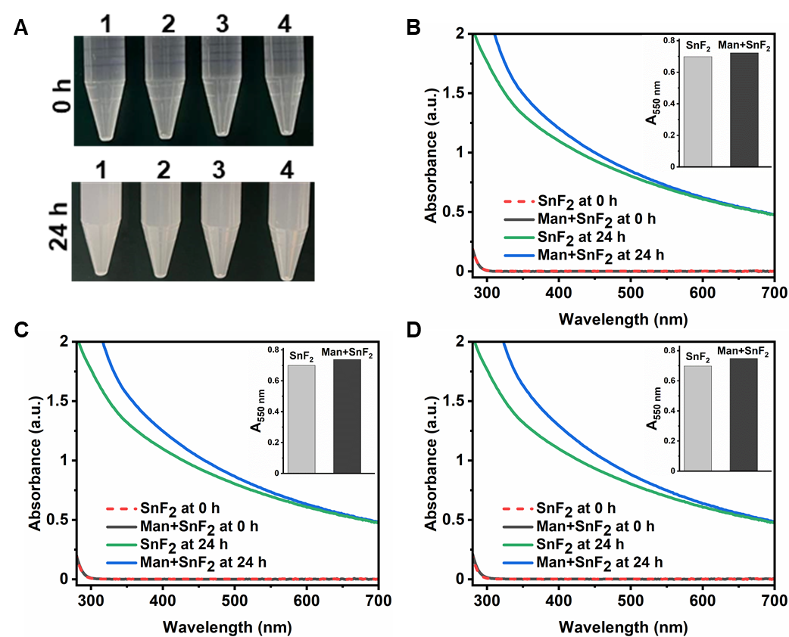
Fig. S4. (A) Photographs of SnF₂ with various amounts of mannitol (Man) at pH 4.5 (0.1 M sodium acetate buffer) after 0 or 24 h incubation. The samples are: 1. SnF₂ alone, 2. SnF₂+1 mg/ml of Man, 3. SnF₂+2 mg/ml of Man, and 4. SnF₂+10 mg/ml of Man. The concentration of SnF₂ was 250 ppm of F. Top: 0 h; bottom: after 24 h. (B to D) UV-visible absorption spectra of SnF₂ at pH 4.5 (0.1 M sodium acetate buffer) with or without 1 mg/ml (B), 2 mg/ml (C), and 10 mg/ml (D) of Man at the time points indicated. Insets show the absorbance of SnF₂ with or without 1 mg/ml (B), 2 mg/ml (C), and 10 mg/ml (D) of Man at 550 nm after 24 h incubation as a measure of turbidity.

Fig. S5. Effect of various amounts of SnF₂ (0-80 µg/ml) on the catalytic activity of Fer (20 µg of Fe/ml) in 0.1 M sodium acetate buffer (pH 4.5), as assessed by TMB colorimetric assay. The data are presented as mean ± standard deviation.

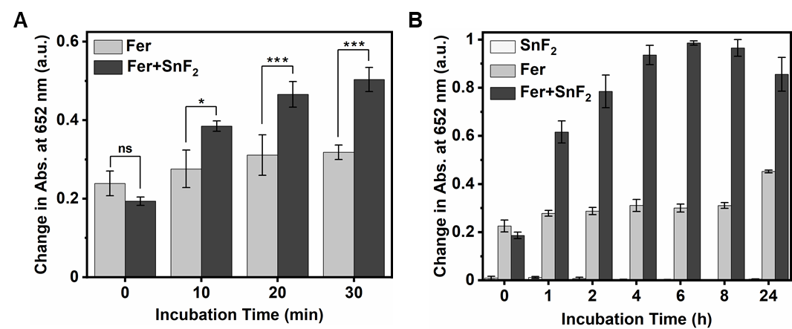
Fig. S6. (A and B) Effect of incubation time on the catalytic activity of Fer (20 µg of Fe/ml) with or without SnF₂ (20 µg/ml) in 0.1 M sodium acetate buffer (pH 4.5), as assessed by TMB colorimetric assay. The increase in absorption at 652 nm shows ROS production. The data are presented as mean ± standard deviation. *, p < 0.05, ***, p < 0.001; ns, nonsignificant; one-way ANOVA followed by Tukey test.
Fig. S7. The change in PL intensity of 7-hydroxycoumarin at 452 nm as a function of time with or without SnF₂ (20 µg/ml). The data are presented as mean ± standard deviation.

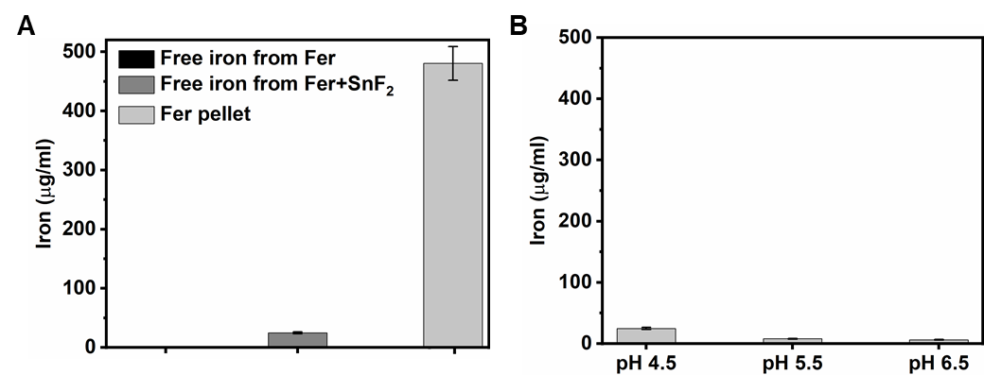
Fig. S8. (A) Concentration of iron released from Fer (0.5 mg of Fe/ml) at pH 4.5 after 1 h incubation in the absence of SnF₂, presence of SnF₂ (0.5 mg/ml), and after the dissolution of the pellet in a volume equal to the volume of the filtrate, as determined by ICP-OES. (B) Concentration of iron released from Fer (0.5 mg of Fe/ml) in the presence of SnF₂ (0.5 mg/ml) during incubation at the indicated pH for 1 h. The data are presented as mean ± standard deviation.

Fig. S9. Effect of the combined treatment of Fer (1 mg of Fe/ml) and SnF₂ (250 ppm of F) on the cell viability of human gingival keratinocytes (HGK). The data are presented as mean ± standard deviation. ns, nonsignificant; one-way ANOVA followed by Tukey test.

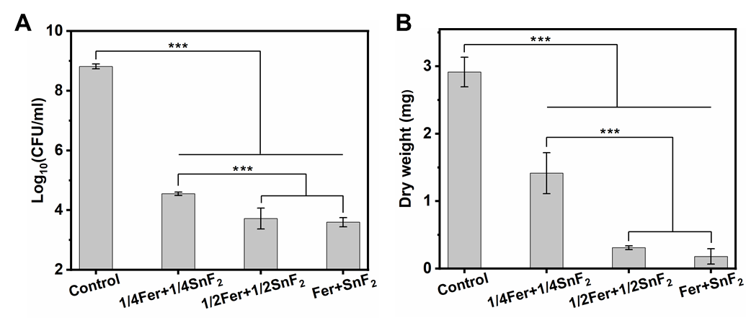

Fig. S10. (A and B) The bacterial viability (A) and biofilm mass (B) with the varied concentration of Fer (0-1 mg of Fe/ml) and SnF₂ (0-250 ppm of F). 1/4Fer, 1/2Fer, and Fer stand for 0.25 mg of Fe/ml, 0.5 mg of Fe/ml, and 1 mg of Fe/ml, respectively. Similarly,1/4SnF₂, 1/2SnF₂, and SnF₂ stand for 62.5 ppm of F, 125 ppm of F, and 250 ppm of F, respectively. The data are presented as mean ± standard deviation. ***, p < 0.001; one-way ANOVA followed by Tukey test.

Fig. S11. Workflow for lift-out and thinning of lamellae from M1 rat molars for analysis by STEM-EDS and STEM-EELS. (A) Buccal aspect of whole M1 molar. (B) SEM image of the middle cusp of molar in (A). (C) SEM image of enamel surface after deposition of a protective strap of FIB-Pt. (D and E) SEM images of enamel surface with lamella attached to micro-manipulator after lift-out. (F) SEM image of lamella after thinning.
Fig. S12. Elemental composition of the surface of rat molars as assessed by STEM-EELS. (A-F) Plots of mole fractions of Ca, and of the sum of mole fractions of Fe, Sn, and F (A), and plots of mole fractions of Ca (B), O (C), F (D), Fe (E), and Sn (F) vs. distance in the direction normal to the EES for M1 rat molars from rates treated with Fer+SnF₂ and untreated controls. The distance axis is referenced to the approximate position of the interface between the Fe/Sn/F-rich layer and the underlying enamel.

Fig. S13. Example XPS spectra of mature rat molar enamel. (A) Survey spectra of teeth from Fer+SnF₂-treated (blue, after a sputtering time of t_{s} = 1000 s) and untreated (orange, t_{s} = 0 s) animals. Colored bands indicate binding energy ranges for selected elements. (B to G) Detailed, background-corrected spectra for the P 2p (B), Ca 2p (C), Sn 3d (D), O 1s (E), F 1s (F), and Fe 2p (G) spectral lines recorded on opposite sides of a maxillary molar of a Fer+SnF₂-treated animal (Pos 1, dark blue; Pos 2, light blue; t_{s} = 1000 s), and at the surface of a tooth from an untreated animal (untreated, orange). Note that the feature at ~496 keV in the untreated sample in (D) likely corresponds to the NaKL1 line (asterisk) and that the Sn 3d and Fe 2p lines overlap (G). For quantification, the contribution of the Fe 2p line was isolated by fitting both lines.

Fig. S14. HRTEM analysis of coating on treated rat molars. (A) HRTEM image. Note that likely some beam damage is apparent in the Fe/Sn/F-rich layer (asterisks). (B to D) Magnitude of 2D Fast Fourier Transforms (FFTs) of areas indicated in (A). (E-G) Plots of radial integrals of FFTs (E) in (B), (F) in (C), and (G) in (D). Spatial frequencies consistent with d-spacing for the $\{002\}$, $\{3\overline{2}1\}$, and $\left\{3\overline{3}0\right\}$ sets of planes of hydroxylapatite are indicated in (E), and those consistent with d-spacing for the $\{001\}$ and $\{111\}$ sets of planes in Pt are indicated in (G).
Table S1. The hydrodynamic diameter (in nm) of Fer and Fer+SnF₂ in DI water at various incubation times. The data are presented as mean ± standard deviation. The mean and standard deviation were calculated from the three means.
Incubation Time (h) | Fer | Fer+SnF₂
0 | 35.0 ± 0.16 | 26.0 ± 5.3
1 | 34.4 ± 1.3 | 28.7 ± 1.4
2 | 32.9 ± 0.42 | 41.0 ± 2.7
4 | 35.0 ± 3.3 | 33.9 ± 2.0
6 | 34.1 ± 1.7 | 38.3 ± 1.3
24 | 31.9 ± 0.43 | 34.1 ± 0.11

Table S2. The zeta potential (in mV) of Fer and Fer+SnF₂ in DI water at various incubation times. The data are presented as mean ± standard deviation. The mean and standard deviation were calculated from three means.
Incubation Time (h) | Fer | Fer+SnF₂
0 | -48.5 ± 1.4 | -10.5 ± 0.84
1 | -42.0 ± 4.1 | -11.0 ± 1.1
2 | -42.8 ± 7.3 | -10.6 ± 0.92
4 | -45.7 ± 2.1 | -10.6 ± 0.73
6 | -41.1 ± 5.0 | -10.1 ± 0.61
24 | -39.4 ± 2.5 | -11.8 ± 1.2

Scheme S1. Formation of 7-hydroxycoumarin (a highly fluorescent molecule) as a result of the reaction of coumarin with hydroxyl radical (•OH).

