Supporting Information

Pac-Man bacteria eat nanoprobes for aggregation-enhanced imaging and killing diverse microorganisms

Yunmin Yang,‡ Binbin Chu,‡ Jiayi Cheng, Jiali Tang, Bin Song, Houyu Wang* & Yao He*

Laboratory of Nanoscale Biochemical Analysis, Institute of Functional Nano and Soft Materials (FUNSOM), and Collaborative Innovation Center of Suzhou Nano Science and Technology, Soochow University, Suzhou 215123, China

* Corresponding authors. Email: houyuwang@suda.edu.cn; yaohe@suda.edu.cn

‡ These authors contributed equally.

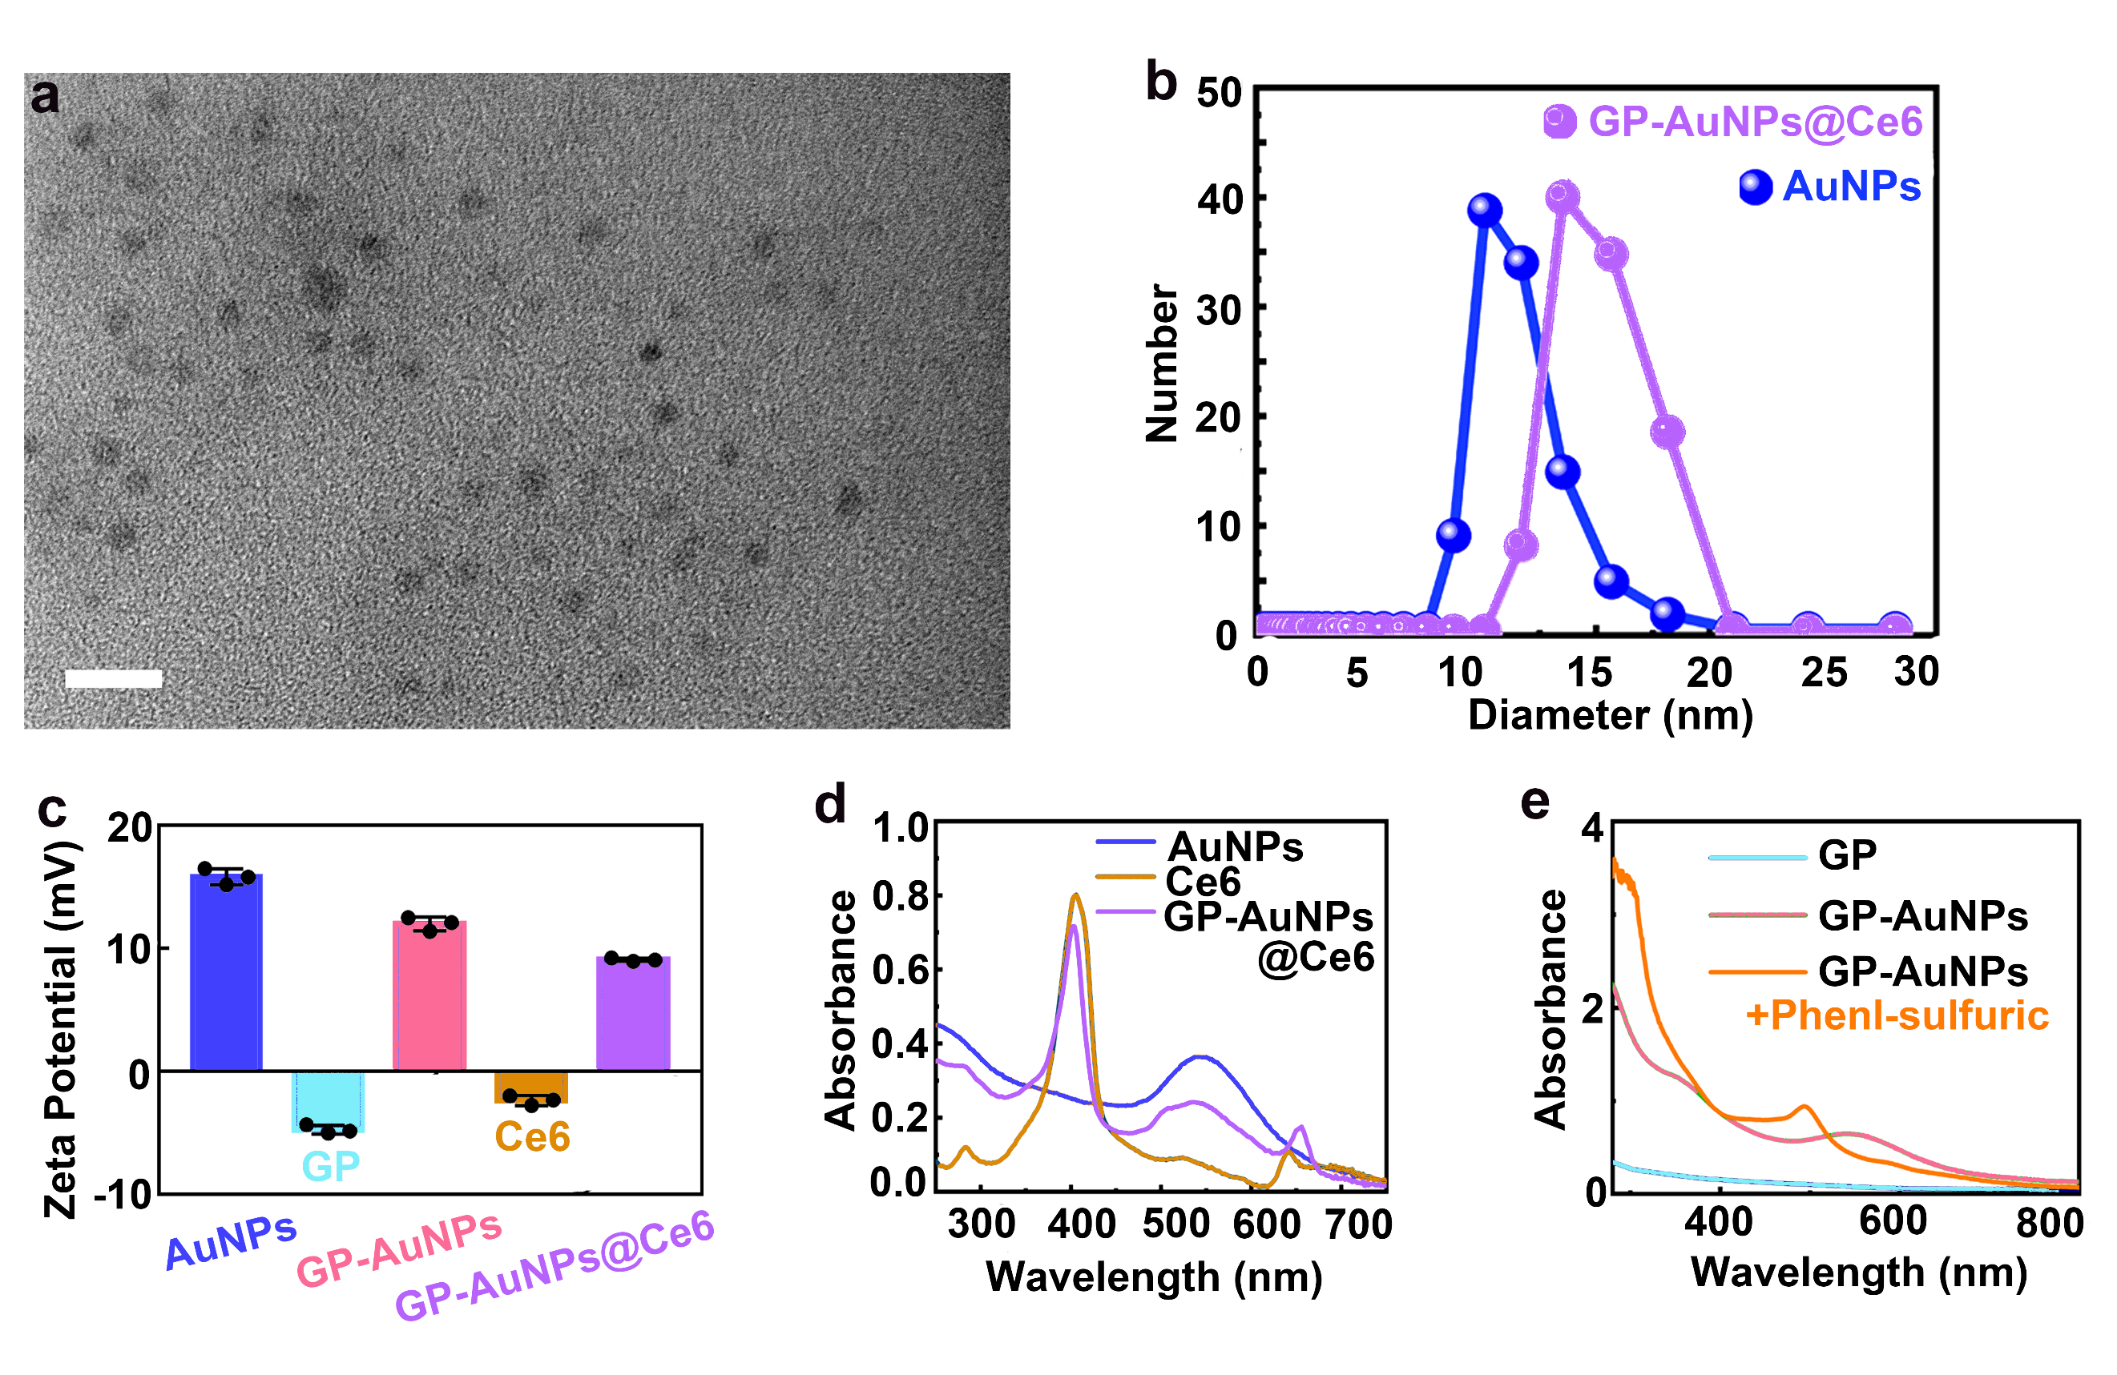
Supplementary Fig. 1. Characterization of GP-AuNPs and GP-AuNPs@Ce6. a, TEM images of GP-AuNPs@Ce6. Scale bar, 20 nm. b, The DLS analysis of GP-AuNPs@Ce6 and AuNPs. c, Zeta Potentials of pure GP, Ce6, AuNPs, GP-AuNPs, and GP-AuNPs@Ce6. d, Absorption spectra of Ce6, AuNPs, and GP-AuNPs@Ce6. e, Absorption spectra of GP, GP-AuNPs and GP-AuNPs reacted with phenl-sulfuric. Error bars represent the standard deviation obtained from three independent measurements. Source data are provided as a Source Data file.

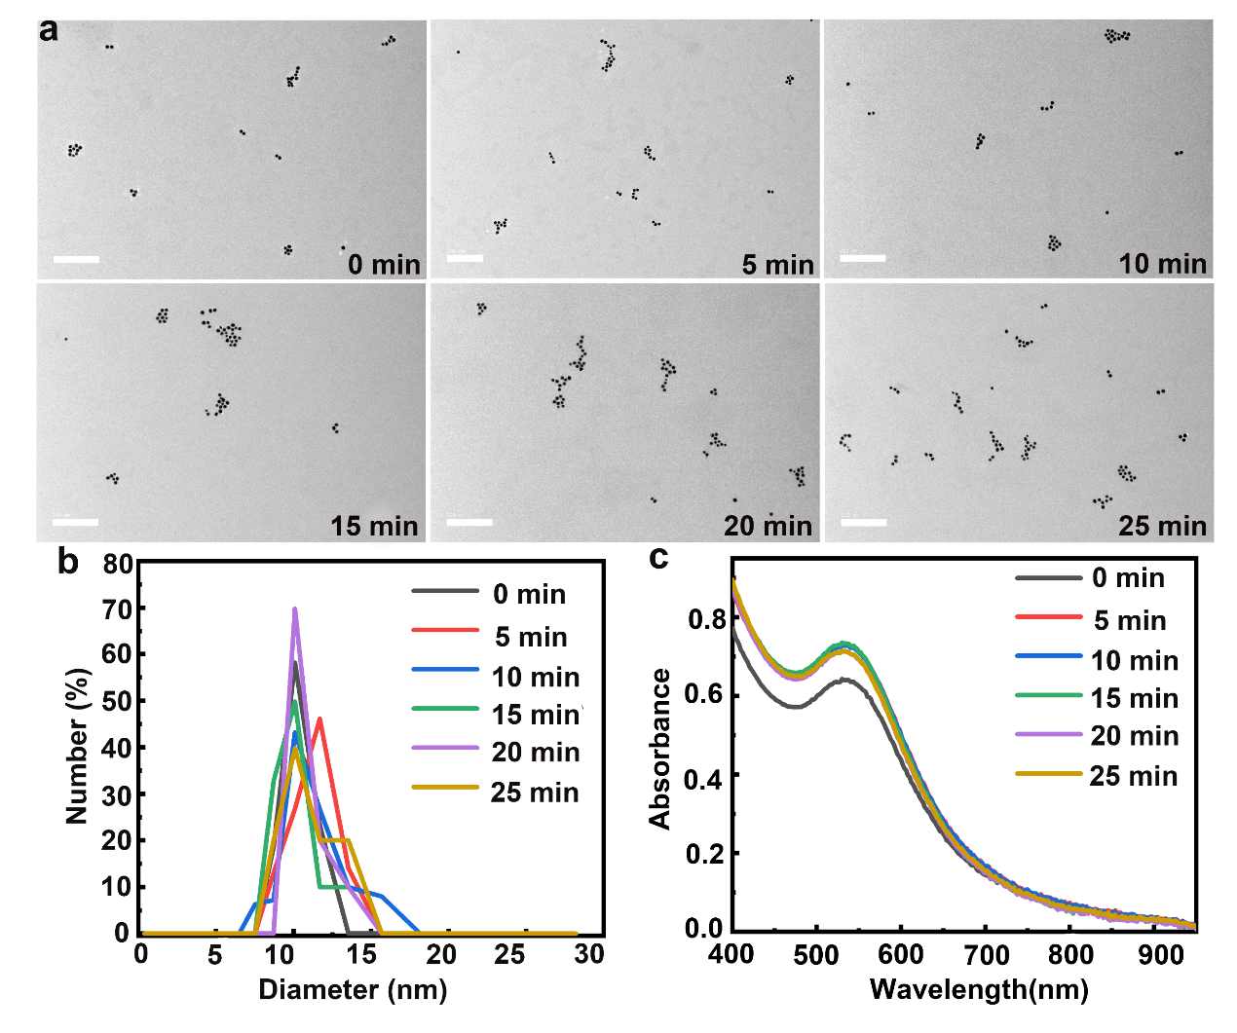
Supplementary Fig. 2. Characterization of AuNPs treated with 405-nm laser irradiation. a, Irradiation time-dependent TEM images of AuNPs. Scale bars, 200 nm. b, Corresponding irradiation time-dependent hydrodynamic size profiles of AuNPs. c, Corresponding irradiation time-dependent absorption spectra of AuNPs. Laser: 405 nm, 1.0 W cm⁻². Source data are provided as a Source Data file.

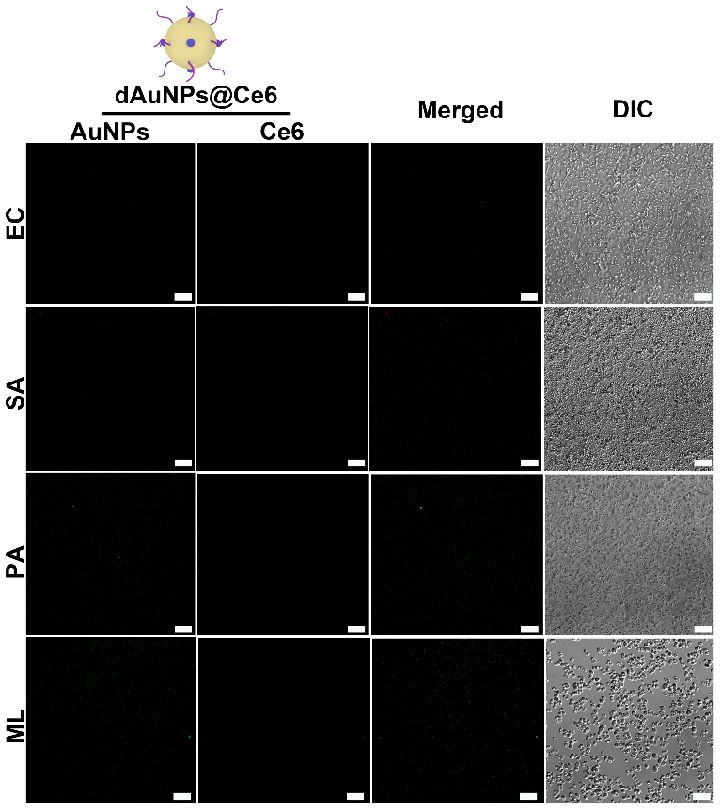
Supplementary Fig. 3. CLSM images of dAuNPs@Ce6-treated bacteria. Confocal images of four kinds of bacteria (e.g., S. aureus (SA), E. coli (EC), M. luteus (ML), P. aeruginosa (PA)) after the incubation with 1.0 mg mL⁻¹ dAuNPs@Ce6. After incubation, the treated bacteria were rinsed with PBS buffer for several times. The bacterial cell concentration is ~10⁷ CFU. Scale bars, 10 μm.

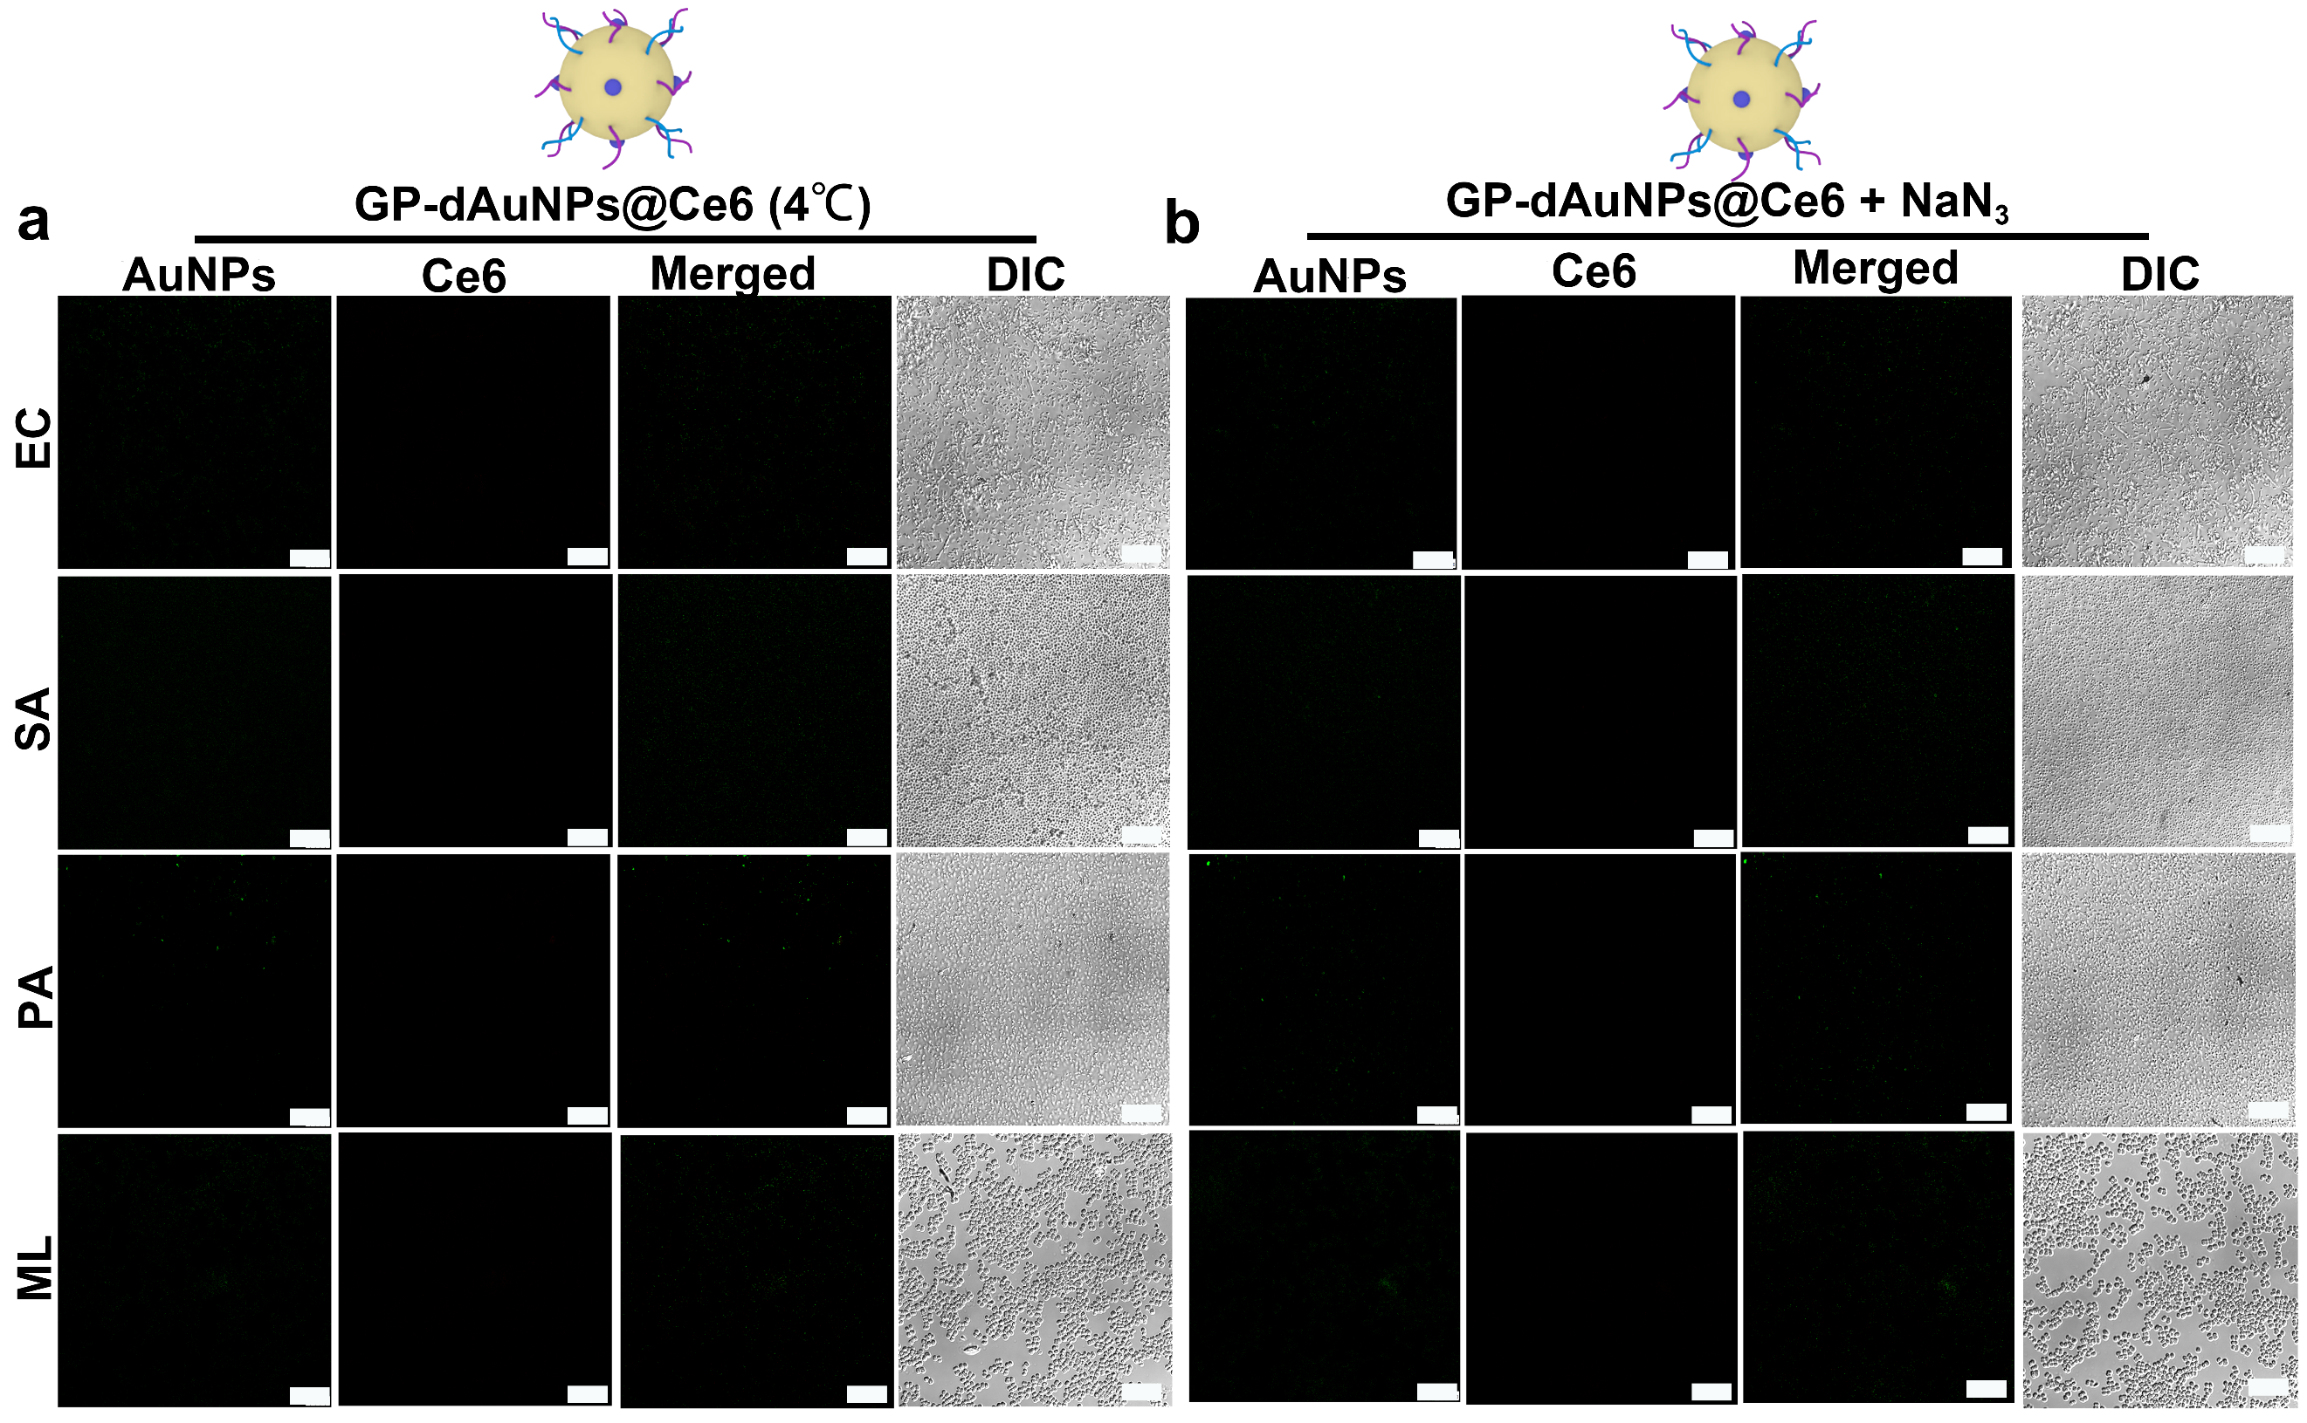
Supplementary Fig. 4. CLSM images of GP-dAuNPs@Ce6-treated bacteria in different conditions. a, Confocal images of four kinds of bacteria (e.g., S. aureus (SA), E. coli (EC), M. luteus (ML), P. aeruginosa (PA)) treated by 1.0 mg mL⁻¹ GP-dAuNPs@Ce6 at 4 ºC. b, Confocal images of four kinds of bacteria (e.g., S. aureus (SA), E. coli (EC), M. luteus (ML), P. aeruginosa (PA)) treated by 1.0 mg mL⁻¹ GP-dAuNPs@Ce6 after the treatment of NaN₃. After incubation, the treated bacteria were rinsed with PBS buffer for several times. The bacterial cell concentration is ~10⁷ CFU. Scale bars, 10 μm.

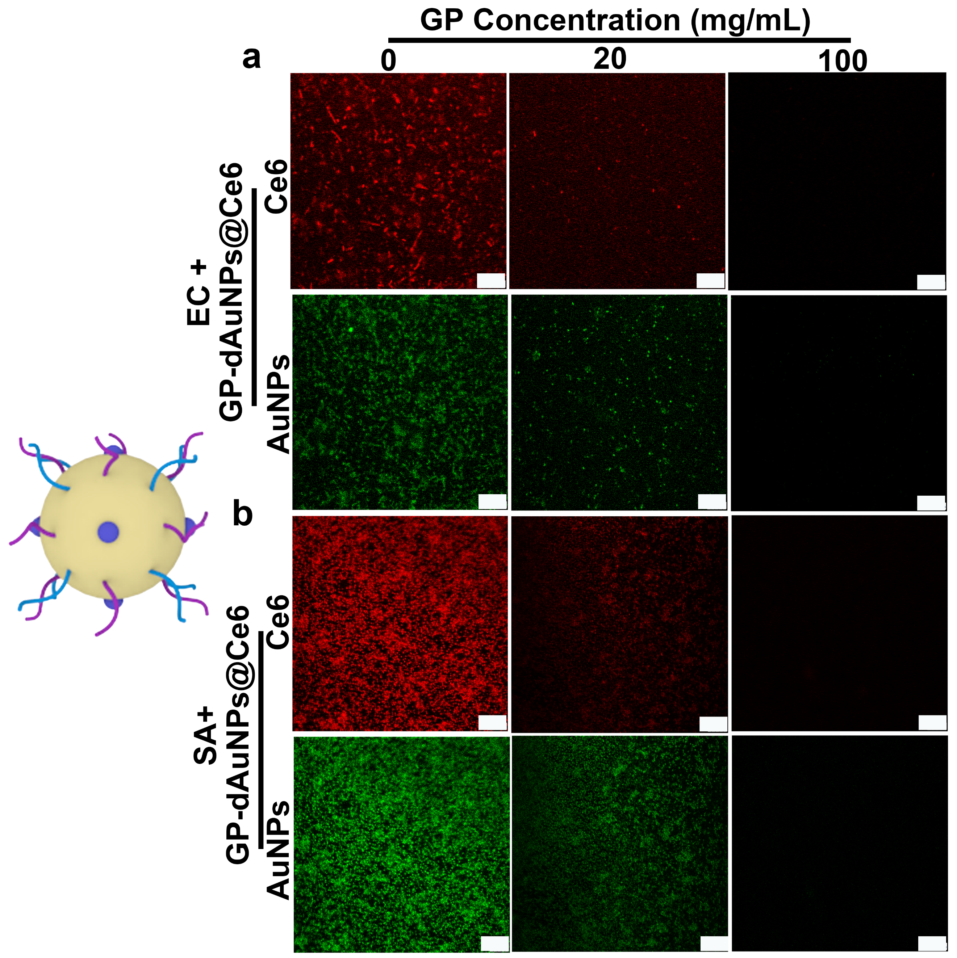
Supplementary Fig. 5. CLSM images of the GP-dAuNPs@Ce6-treated bacteria after treatments of pure GP with different concentrations. Confocal fluorescence images of EC and SA incubated with GP with different concentrations (e.g., 0, 20, 100 mg mL⁻¹) for 5 min and then incubated with 1.0 mg mL⁻¹ GP-dAuNPs@Ce6 for another 2 h. After incubation, the treated bacteria were rinsed with PBS buffer for several times. The bacterial cell concentration is ~10⁷ CFU. Scale bars, 10 μm.

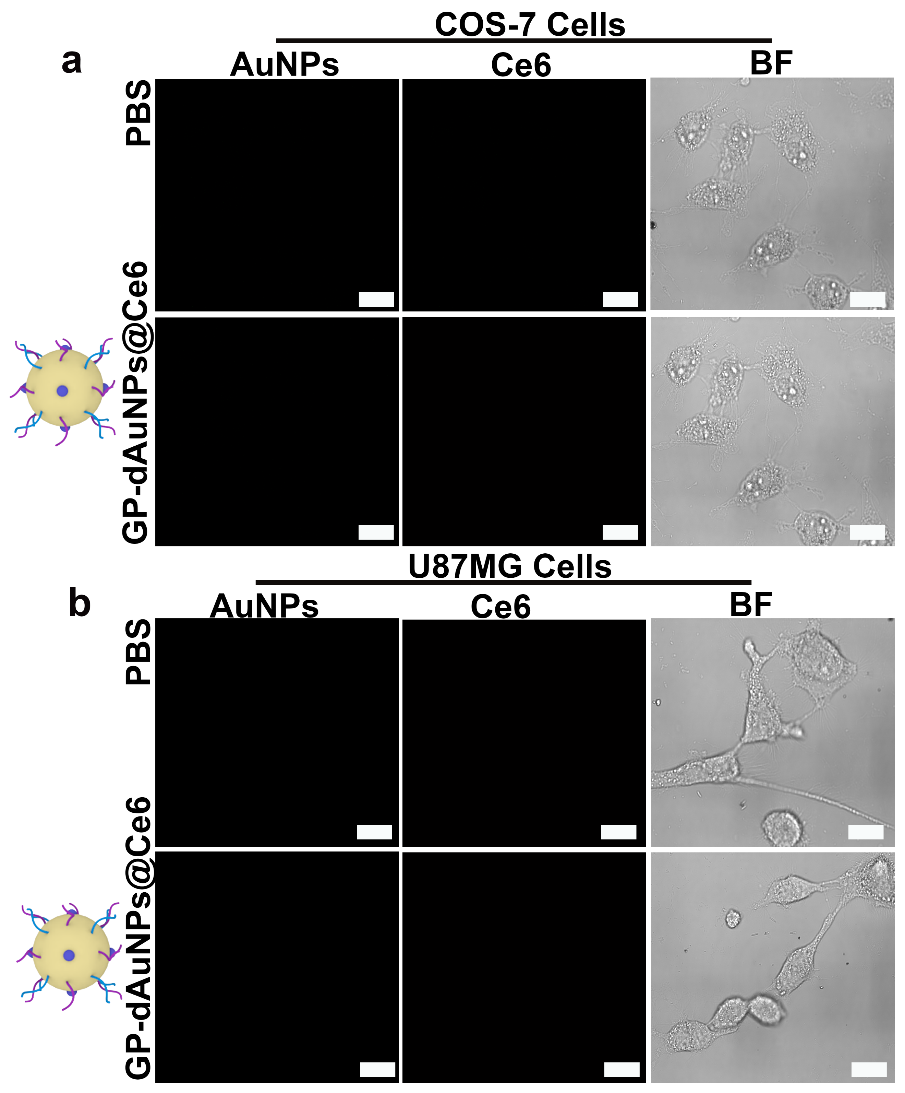
Supplementary Fig. 6. CLSM images of GP-dAuNPs@Ce6-treated cells. Confocal fluorescence images of (a) COS-7 cells and (b) U87MG cells after co-incubation with 1.0 mg mL⁻¹ GP-dAuNPs@Ce6 for 2h. After incubation, the treated cells were rinsed with PBS buffer for several times. Scale bars, 25 μm.

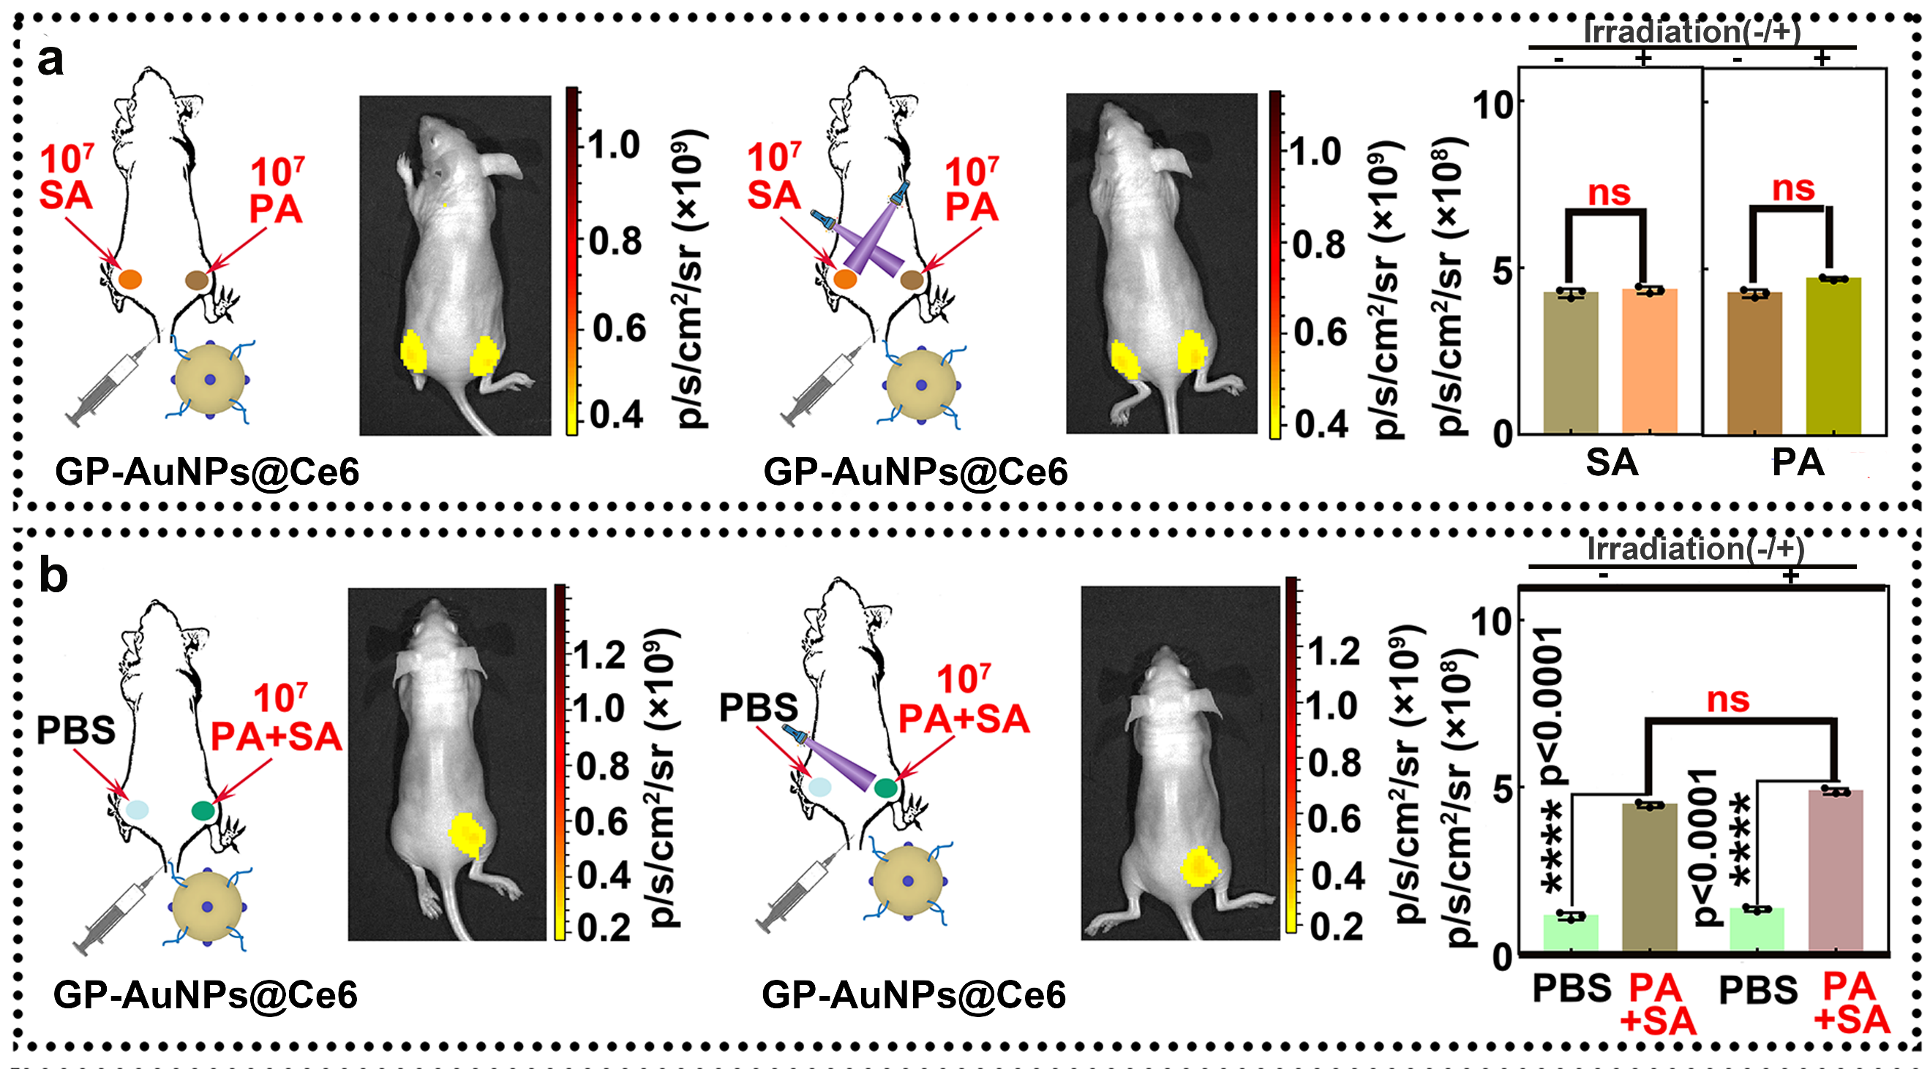
Supplementary Fig. 7. In vivo imaging of bacteria in superficial tissues of mice treated with GP-AuNPs@Ce6. a, In vivo imaging of PA (right side) and SA (left side)-infected sites of mice treated with 1.0 mg mL⁻¹ GP-AuNPs@Ce6 with and without 405-nm laser irradiation and corresponding histograms of mean fluorescence intensity at two sites. The bacterial cell concentration during imaging is ~10⁷ CFU. b, In vivo imaging of mixture of PA and SA (PA + SA, right side) and PBS (left side)-treated sites of mice injected with GP-AuNPs@Ce6 with and without 405-nm laser irradiation and corresponding histograms of mean fluorescence intensity at two sites. The bacterial cell concentration during imaging is ~10⁷ CFU. Statistical analysis is performed using a one-way ANOVA analysis. Error bars represent the standard deviation obtained from three independent measurements (**** means p< 0.0001, ns means no significance, n = 3). The cartoons are created by Dr. Houyu Wang. Source data are provided as a Source Data file.

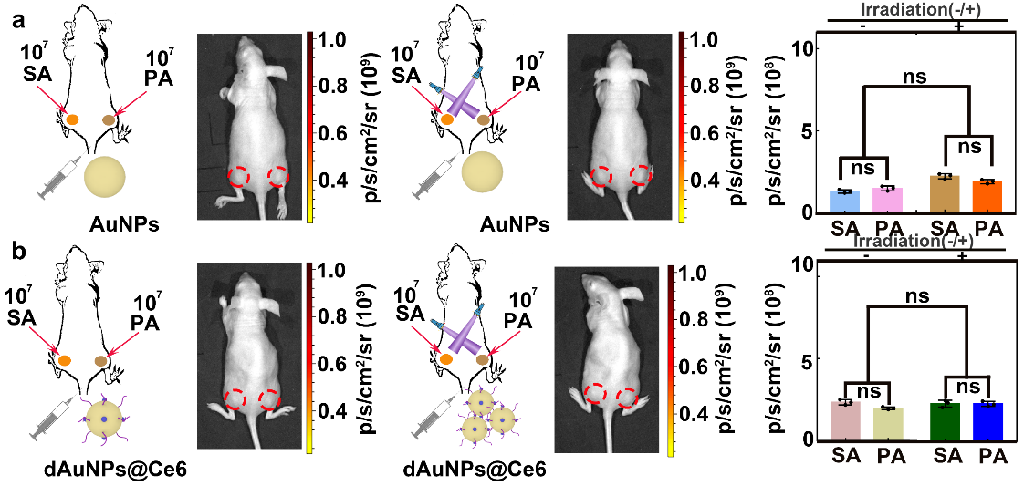
Supplementary Fig. 8. In vivo imaging of bacteria in superficial tissues of mice treated by AuNPs or dAuNPs@Ce6. a, In vivo imaging of PA (right side) and SA (left side)-infected sites of mice treated with 1.0 mg mL⁻¹ AuNPs with and without 405-nm laser irradiation and corresponding histograms of mean fluorescence intensity at two sites. The bacterial cell concentration during imaging is ~10⁷ CFU. b, In vivo imaging of PA (right side) and SA (left side)-infected sites of mice treated with 1.0 mg mL⁻¹ dAuNPs@Ce6 with and without 405-nm laser irradiation and corresponding histograms of mean fluorescence intensity at two sites. The bacterial cell concentration during imaging is ~10⁷ CFU. Statistical analysis is performed using a one-way ANOVA analysis. Error bars represent the standard deviation obtained from three independent measurements (ns means no significance, n = 3). Source data are provided as a Source Data file.

Cytotoxicity of the GP-dAuNPs@Ce6.
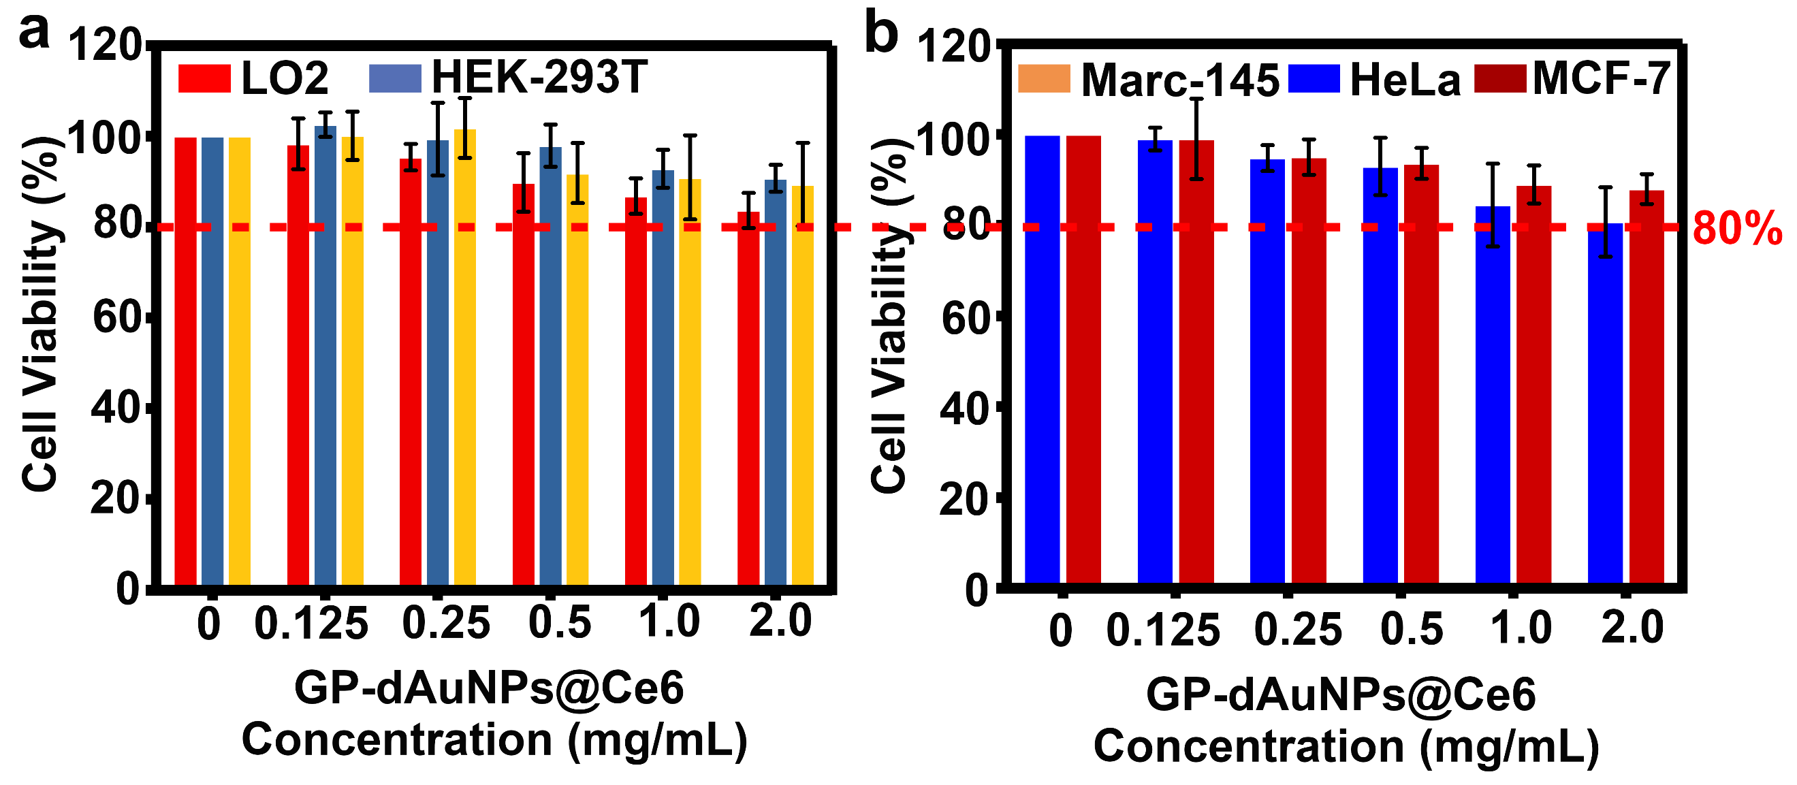
Supplementary Fig. 9. Cytotoxicity of the prepared GP-dAuNPs@Ce6. Cell viability of LO2, HEK-293T, Marc-145, HeLa and MCF-7 cells treated with different dosages of the resultant GP-dAuNPs@Ce6 for 24 h. Error bars represent the standard deviation obtained from three independent measurements. Source data are provided as a Source Data file.

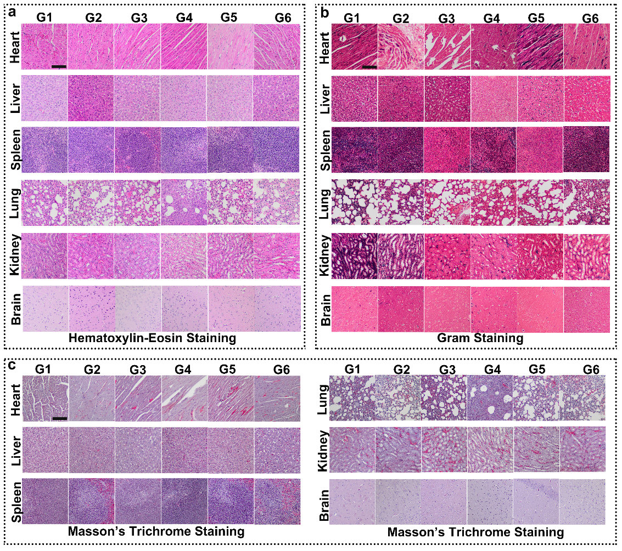
Supplementary Fig. 10. In vivo toxicity assessments of GP-dAuNPs@Ce6. a，H & E staining of histological evaluation of different organs (heart, liver, spleen, lung, kidney, and brain) harvested from treated mice for 30 days. Scale bars, 50 μm. b, Gram staining of different organs (heart, liver, spleen, lung, kidney, and brain) harvested from treated mice for 30 days. Scale bars, 50 μm. c, Masson’s trichrome staining of different organs (heart, liver, spleen, lung, kidney, and brain) harvested from treated mice for 30 days. The mice in group 1 (G1) are treated with GP-dAuNPs@Ce6+660-nm laser (12 mW cm⁻², 5 min); The mice in group 2 (G2) are treated with GP-dAuNPs@Ce6+808-nm laser (1.0 W cm⁻², 5 min); the mice in group 3 (G3) are treated by GP-dAuNPs@Ce6+660-nm laser (12 mW cm⁻², 5 min)+ 808-nm laser (1.0 W cm⁻², 5 min); the mice in group 4 (G4) are treated by GP-dAuNPs@Ce6+405-nm laser (1.0 W cm⁻², 25 min)+ 660-nm laser (12 mW cm⁻², 5 min); the mice in group 5 (G5) are treated by GP-dAuNPs@Ce6+405-nm laser (1.0 W cm⁻², 25 min)+ 808-nm laser (1.0 W cm⁻², 5 min); the mice in group 6 (G6) are treated by the GP-dAuNPs@Ce6+405-nm laser (1.0 W cm⁻², 25 min)+ 660-nm laser (12 mW cm⁻², 5 min)+ 808-nm laser (1.0 W cm⁻², 5 min). Scale bars, 50 μm.

