Appendix I : Appraisal instruments MAStARI Appraisal instrument.

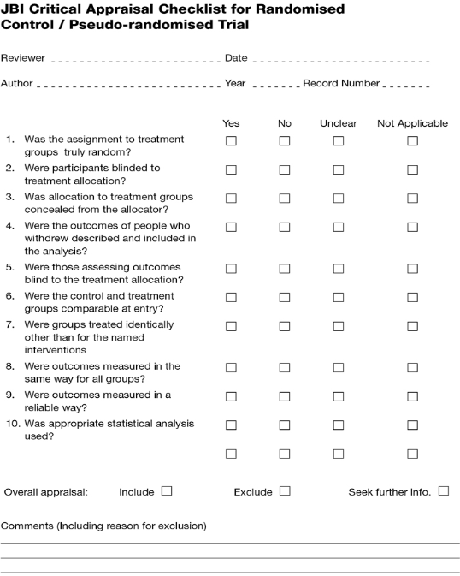

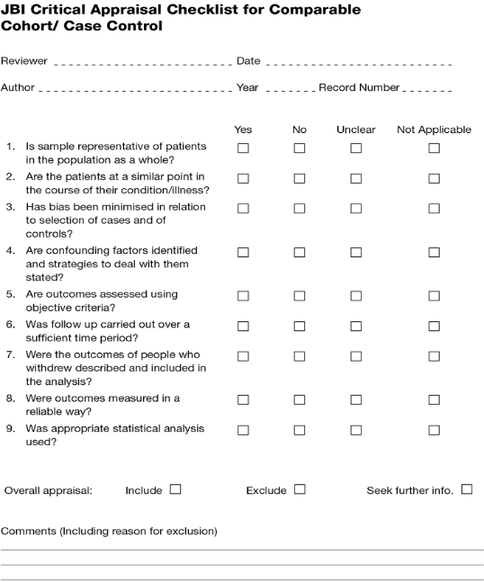

Appendix 2
Data Extraction Tools

JBI Data Extraction Form for Experimental/Observational Studies

Reviewer Author Journal
Date Year Record number

Study method | RCT | Quasi-RCT | Longitudinal
 | Retrospective | Observational | Other
Participants
Setting
Population
Sample size

Intervention 1
Interventions
Intervention 2
Intervention 3

Intervention 1

Intervention 2

Intervention 3

Appendix 3

Clinical outcome measures

Outcome description | Scale/measure

Study results
- Dichotomous data

Outcome | Intervention ( ) number/total number | Intervention ( ) number/total number

- Continuous data

Outcome | Intervention ( ) mean & SD (number) | Intervention ( ) mean & SD (number)

Authors’ conclusions

Comments

Data Extraction Tools 185

JBI QARI Data Extraction Form for Interpretive and Critical Research

Reviewer Author Journal
Date Year Record number

Study description
Methodology Method Intervention Setting Geographical Cultural Participants Data analysis

Authors’ conclusions
Comments

Findings | Illustration from publication (page number) | Evidence
Findings | Illustration from publication (page number) | Unequivocal | Credible | Unsupported

186 Appendix 3

JBI NOTARI Data Extraction Form

Reviewer Author Journal
Date Year Record number

Study description
Type of text Stated Allegiance/position Intervention Setting Geographical Cultural Logic of argument Data analysis

Authors’ conclusions

Comments

Findings | Illustration from Publication (page number) | Evidence
Findings | Illustration from Publication (page number) | Unequivocal | Credible | Unsupported

