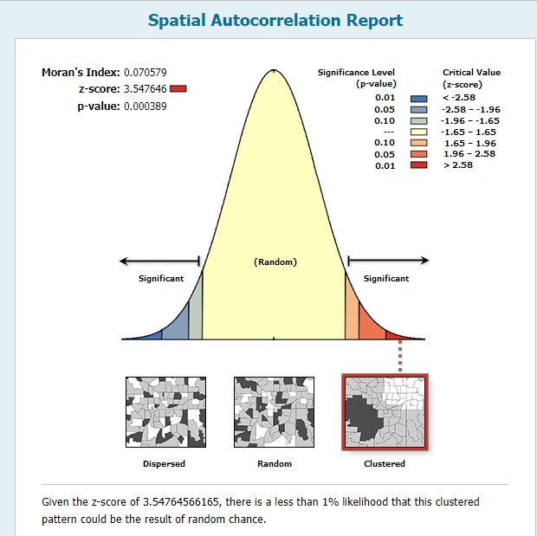
Supplementary file 2.b figure: Autocorrelation report of intimate partner violence among married women in Ethiopia, 2016 EDHS.

