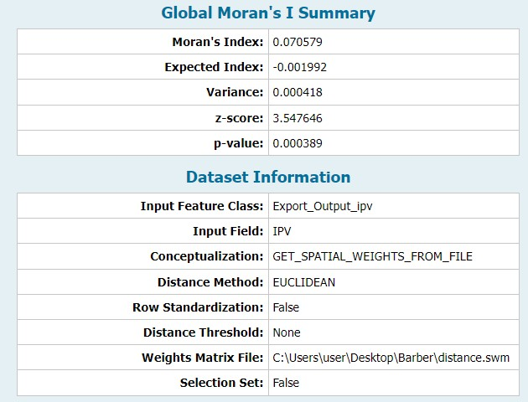
Supplementary file 2.a figure: Global Moran's I Summary and dataset information of intimate partner violence among married women in Ethiopia, 2016 EDHS.

