Supplementary Information
Identifying life-history patterns along the fast-slow continuum of mammalian viral carriers
Andrea Tonelli*, Hernan Caceres-Escobar, Marcus S. C. Blagrove, Maya Wardeh, Moreno Di Marco*
*Andrea Tonelli <andrea.tonelli@uniroma1.it>, Moreno Di Marco <moreno.dimarco@uniroma1.it>
SI. Content:
Appendix S1: Supplementary methods…………….…………………………………………………2
Table S1………………………………………...….……………….………………………………...4
Table S2……………………………………….……...……………………………………………....5
Table S3……………………………………………………………………………………………....6
Table S4……………………………………………………………………………………………....7
Figure S1………...…………….……………………………………………………………………...8
Figure S2……………………………………………………………………………………………...9
Figure S3…………………………………………………………………………………………….10
Figure S4…………………………………………………………………………………………….11
Figure S5…………………………………………………………………………………………….12
Figure S6…………………………………………………………………………………………….13
Tables S5 and S6 are available as separate .csv files.

Appendix S1: Supplementary methods
We adopted an ecological classification based on viral traits that have implications for viral ecology such as evolvability and interaction with the host and the environment. We chose three recognisable binary viral traits at the family level, and then identified eight unique mutually exclusive ecological groups. The selected traits accounted for i) genomic organization (i.e., linear or circular), ii) genomic partition (i.e., monopartite or segmented), iii) pericapsidic envelop (i.e., presence or absence). These viral characteristics were chosen as they proved to be relatively important predictors of virus host-range in previous work¹, thus able to capture meaningful elements of the interaction between viruses and their carriers.
A circular genome implies, both in RNA and DNA viruses, a peculiar synthesis via the rolling circle replication mode that results in production of viral progeny at high rate². Genome organization also affects the engagement of the host enzymatic machinery during replication³. The viral pericapsidic envelop consists of a lipid bilayer that surrounds the protein capsid. The exterior face of the bilayer is studded with virus-coded membrane proteins, thus enveloped viruses often exhibit a fringe of glycoprotein spikes or knobs that are responsible for the primary interaction with the host cell. Host-cell receptor recognition is crucial in determining the host range of the virus and its infectiousness⁴. Due to the biological properties of the lipid bilayer, enveloped viruses deactivate quickly in the external environment, often requiring direct transfer⁵. Genome segmentation affects virus evolvability, as recombination is greatly facilitated by genome segments reassortment⁶. Indeed, reassortment between viruses of the same subtype can be an important source of diversity, promoting adaptation and immune escape⁶. As an example, inter-strain reassortment between swine, avian and/or human influenza A viruses has been recognized as the underlying mechanism at the origin of several pandemics, such as the 2009 “swine” flu⁷.
Out of the eight possible combinations of the aforementioned traits, we obtained seven observed ecological groups. An insufficient number of susceptible mammal species on two of these groups did not allow their inclusion in the analysis: viruses with a linear, unsegmented genome and a pericapsidic envelope; viruses with a circular, segmented genome and without an envelope. For the five remaining groups we could make assumptions on viral ecology, based on the specific traits’ combination (Table S2).

Supplementary References
1. Wardeh, M., Blagrove, M. S. C., Sharkey, K. J. & Baylis, M. Divide-and-conquer: machine-learning integrates mammalian and viral traits with network features to predict virus-mammal associations. Nat Commun 12, (2021).
2. Kusumoto-Matsuo, R., Kanda, T. & Kukimoto, I. Rolling circle replication of human papillomavirus type 16 DNA in epithelial cell extracts. Genes to Cells 16, (2011).
3. Wawrzyniak, P., Plucienniczak, G. & Bartosik, D. The different faces of rolling-circle replication and its multifunctional initiator proteins. Frontiers in Microbiology vol. 8 Preprint at https://doi.org/10.3389/fmicb.2017.02353 (2017).
4. Gelderblom, H., R. Structure and Classification of Viruses. 1996. Chapter 41. Medical Microbiology. (1996).
5. Lowen, A. C. & Steel, J. Roles of Humidity and Temperature in Shaping Influenza Seasonality. J Virol 88, (2014).
6. Sanjuán, R. & Domingo-Calap, P. Genetic Diversity and Evolution of Viral Populations. in Encyclopedia of Virology (2021). doi:10.1016/b978-0-12-809633-8.20958-8.
7. Mena, I. et al. Origins of the 2009 H1N1 influenza pandemic in swine in Mexico. Elife 5, (2016).
8. IUCN. 2021. The IUCN Red List of Threatened Species. Version 2021-3. https://www.iucnredlist.org. Accessed on [21/10/2021]. (2021).
9. Soria, C. D., Pacifici, M., Di Marco, M., Stephen, S. M. & Rondinini, C. COMBINE: a coalesced mammal database of intrinsic and extrinsic traits. Ecology 102, (2021).
10. Fick, S. E. & Hijmans, R. J. WorldClim 2: new 1-km spatial resolution climate surfaces for global land areas. International Journal of Climatology 37, (2017).
11. Faurby, S. et al. PHYLACINE 1.2: The Phylogenetic Atlas of Mammal Macroecology. Ecology vol. 99, (2018).

Supplementary Tables
Table S1. Names and description of the 23 variables used as predictors of carrier status and zoonotic carrier status in the analysis.
Variable | Type | Description | Source
order | Order | Species’ taxonomic order | IUCN⁸
adult_mass_g | Life-history | Body mass of an adult individual in grams | COMBINE⁹
max_longevity_d | Life-history | Maximum reported age at death for the species in days | COMBINE⁹
gestation_length_d | Life-history | Length of time of fetal growth in days | COMBINE⁹
interbirth_interval_d | Life-history | Time between reproduction events in days | COMBINE⁹
range_size | Ecology | Species’ Extent of occurrence (EOO) in Km² | IUCN⁸
annual_mean_temp | Ecology | Annual mean temperature within the species range | WorldClim2¹⁰
temp_wettest_q | Ecology | Mean temperature of wettest quarter within the species range | WorldClim2¹⁰
temp_driest_q | Ecology | Mean temperature of driest quarter within the species range | WorldClim2¹⁰
temp_warmest_q | Ecology | Mean temperature of warmest quarter within the species range | WorldClim2¹⁰
prec_wettest_q | Ecology | Precipitation of wettest quarter within the species range | WorldClim2¹⁰
prec_driest_q | Ecology | Precipitation of driest quarter within the species range | WorldClim2¹⁰
prec_warmest_q | Ecology | Precipitation of warmest quarter within the species range | WorldClim2¹⁰
prec_coldest_q | Ecology | Precipitation of coldest quarter within the species range | WorldClim2¹⁰
eigenV_c1- eigenV_c10 | Phylogeny | Ten phylogenetic eigenvectors extracted from PHYLACINE v. 1.2’s phylogeny | PHYLACINE v. 1.2¹¹

 | Traits | Families | Ecological properties
Group 1 | non-enveloped, linear, non-segmented | Adenoviridae, Astroviridae, Caliciviridae,  Motetraviridae, Dicistroviridae, Hepeviridae,  Parvoviridae, Picornaviridae | Directly (fecal-oral, respiratory droplets, ingestion) or indirectly transmitted, high persistence in the environment, no reassortment
Group 2 | enveloped, linear,  non-segmented | Arteviridae, Bornaviridae, Coronaviridae,  Filoviridae, Flaviviridae, Herpesviridae,  Matonaviridae, Mesoniviridae, Paramyxoviridae,  Pneumoviridae, Poxviridae, Retroviridae,  Rhabdoviridae, Tobaniviridae | Low environmental persistence, many trasmission routes, no reassortment
Group 3 | non-enveloped, circular, non-segmented | Anelloviridae, Circoviridae, Genomoviridae,  Hepadnaviridae, Papillomaviridae, Polyomaviridae | Directly or indirectly transmitted, high persistence in the environment,  higher replication rate, no reassortment, sometimes chronic infections and latency
Group 4 | non-enveloped, linear, segmented | Nodaviridae, Partitiviridae, Picobirnaviridae,  Reoviridae | Often directly transmitted (fecal-oral), high persistence in the environment,  fast evolving, broader host spectrum
Group 6 | enveloped, linear, segmented | Arenaviridae, Hantaviridae, Nairoviridae,  Orthomyxoviridae, Peribunyaviridae, Phenuiviridae | Low environmental persistence (sometimes vector-borne), fast evolving, broader host spectrum
Table S2. The five ecological groups resulted from the ecological classification based on unique combinations of three ecologically relevant viral traits, and corresponding ecological properties.

Table S3. Performance metrics of general models resulting from the cross-validation.

Model | TSS | Specificity | Sensitivity
I | 0.40 | 0.74 | 0.66
V | 0.24 | 0.35 | 0.89
IV | 0.41 | 0.57 | 0.84
II | 0.40 | 0.94 | 0.46
VII | 0.15 | 1.00 | 0.15
III | 0.53 | 0.93 | 0.60
VI | 0.46 | 0.95 | 0.51
eco 1 | 0.38 | 0.81 | 0.57
eco 3 | 0.38 | 0.88 | 0.50
eco 6 | 0.34 | 0.77 | 0.57
eco 2 | 0.32 | 0.37 | 0.96
eco 4 | 0.53 | 0.93 | 0.60
Preplasmiviricota | 0.20 | 0.89 | 0.30
Negarnaviricota | 0.24 | 0.35 | 0.89
Pisuviricota | 0.41 | 0.80 | 0.61
Nucleocytoviricota | 0.34 | 0.94 | 0.40
Cressdnaviricota | 0.31 | 0.97 | 0.33
Kitrinoviricota | 0.29 | 0.75 | 0.53
Artverviricota | 0.49 | 0.96 | 0.53
Peploviricota | 0.50 | 0.90 | 0.61
Cossaviricota | 0.47 | 0.93 | 0.54
Duplornaviricota | 0.52 | 0.94 | 0.58

Table S4. Performance metrics of zoonotic models resulting from the cross-validation.

Model | TSS | Specificity | Sensitivity
I | 0.40 | 0.93 | 0.47
V | 0.23 | 0.37 | 0.87
IV | 0.41 | 0.57 | 0.84
II | 0.32 | 0.98 | 0.33
VII | 0.44 | 1.00 | 0.44
III | 0.35 | 0.97 | 0.39
VI | 0.74 | 0.89 | 0.85
eco 1 | 0.43 | 0.89 | 0.54
eco 3 | 0.50 | 0.96 | 0.54
eco 6 | 0.47 | 0.82 | 0.65
eco 2 | 0.34 | 0.38 | 0.96
eco 4 | 0.35 | 0.97 | 0.39
Negarnaviricota | 0.23 | 0.37 | 0.87
Pisuviricota | 0.46 | 0.85 | 0.62
Kitrinoviricota | 0.45 | 0.73 | 0.72
Artverviricota | 0.58 | 0.88 | 0.69
Peploviricota | 0.34 | 0.90 | 0.44
Cossaviricota | 0.22 | 1.00 | 0.22
Nucleocytoviricota | 0.35 | 0.93 | 0.42
Duplornaviricota | 0.39 | 0.97 | 0.43

Table S5. Performance metrics of general models resulting from the taxonomic block validation. Uploaded as a separate file.
Table S6. Performance metrics of zoonotic models resulting from the taxonomic block validation. Uploaded as a separate file.

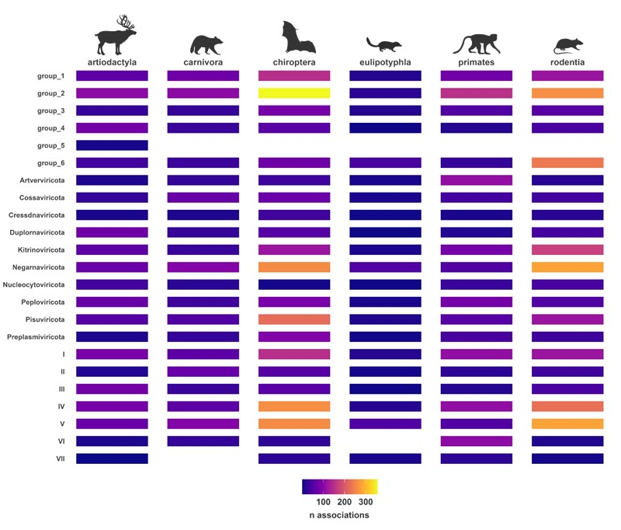
Supplementary Figures:

Figure S1. Number of mammal-virus associations per viral group across the six most represented mammalian orders in the dataset.

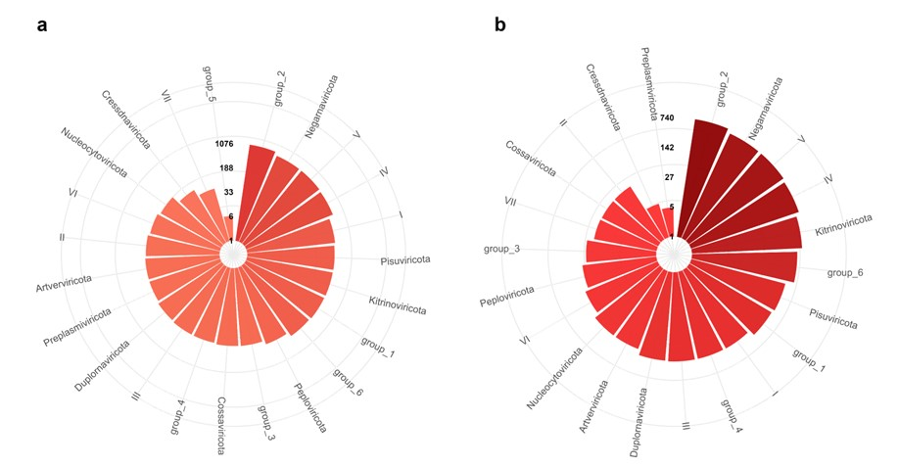

Figure S2. Distribution of mammal-carrier associations across eco-evolutionary viral groups. a) Number of unique carrier-virus associations per viral group. b) Number of unique zoonotic carrier-virus associations per viral group. Radial axes are log scaled for representation purposes.

Figure S3 Probability density functions (PDFs) of life-history traits of a) general carriers, and b) zoonotic carriers compared to those of all mammals. PDFs show the relative likelihood of a variable falling within a particular range of values. Here, we used PDFs to infer the probability that the values of life-history variables from our subsample (general carriers and zoonotic carriers) fell short of the range of variation of the main sample (all mammals). This probability is shown as the non-overlapping red areas and resulted to be negligible.

Figure S4. Distribution of virus families across classification schemes. Each tile represents a viral family, with size corresponding to the number of associations and color indicating the proportion of zoonotic associations. Families that accounted for less than 40 interactions are not shown. Groups within each classification are outlined in black. Viral families are abbreviated as follows: Papi = Papillomaviridae, Poxv = Poxviridae, Poly = Polyomaviridae, Hepe = Hepeviridae, Toga = Togaviridae, Cali = Caliciviridae, Hepa = Hepadnaviridae, Pico = Picobirnaviridae, Reov = Reoviridae, Parv = Parvoviridae, Phen = Phenuiviridae, Aren = Arenaviridae, Nair = Nairoviridae, Peri = Peribunyaviridae, Circ = Circoviridae, Geno = Genomoviridae, Orth = Orthomyxoviridae, Hant = Hantaviridae, Rhab = Rhabdoviridae, Pico = Picornaviridae, Retr = Retroviridae, Aden = Adenoviridae.

Figure S5. Variable importance for the predictors of general carrier status across ecological, evoutionary and structural viral classification schemes. The importance of each variable is quantified as the mean decrease accuracy of random forest models’ predictions caused by variable permutation. Variables’ importance obtained from each model were rescaled, so that the most influential variable took a value of 1.

Figure S6. Variable importance for the predictors of zoonotic carrier status across ecological, evoutionary and structural viral classification schemes. The importance of each variable is quantified as the mean decrease accuracy of random forest models’ predictions caused by variable permutation. Variables’ importance obtained from each model were rescaled, so that the most influential variable took a value of 1.

