Supplementary Materials for
Nitrate radicals suppress biogenic new particle formation from monoterpene oxidation

Dandan Li, Wei Huang, Dongyu Wang, Mingyi Wang, Joel A. Thornton, Lucía Caudillo, Birte Rörup, Ruby Marten, Wiebke Scholz, Henning Finkenzeller, Guillaume Marie, Urs Baltensperger, David M. Bell, Zoé Brasseur, Joachim Curtius, Lubna Dada, Jonathan Duplissy, Xianda Gong, Armin Hansel, Xu-Cheng He, Victoria Hofbauer, Heikki Junninen, Jordan E. Krechmer, Andreas Kürten, Houssni Lamkaddam, Katrianne Lehtipalo, Brandon Lopez, Yingge Ma, Naser G. A. Mahfouz, Hanna E. Manninen, Bernhard Mentler, Sebastien Perrier, Tuukka Petäjä, Joschka Pfeifer, Maxim Philippov, Meredith Schervish, Siegfried Schobesberger, Jiali Shen, Mihnea Surdu, Sophie Tomaz, Rainer Volkamer, Xinke Wang, Stefan K. Weber, André Welti, Douglas R. Worsnop, YushengWu, Chao Yan, Marcel Zauner-Wieczorek, Markku Kulmala, Jasper Kirkby, Neil M. Donahue, Christian George, Imad El-Haddad*, Federico Bianchi*, Matthieu Riva*

*Corresponding author. Email: federico.bianchi@helsinki.fi
imad.el-haddad@psi.ch
matthieu.riva@ircelyon.univ-lyon1.fr

This PDF file includes:

Supplementary Figs. S1 to S21
References
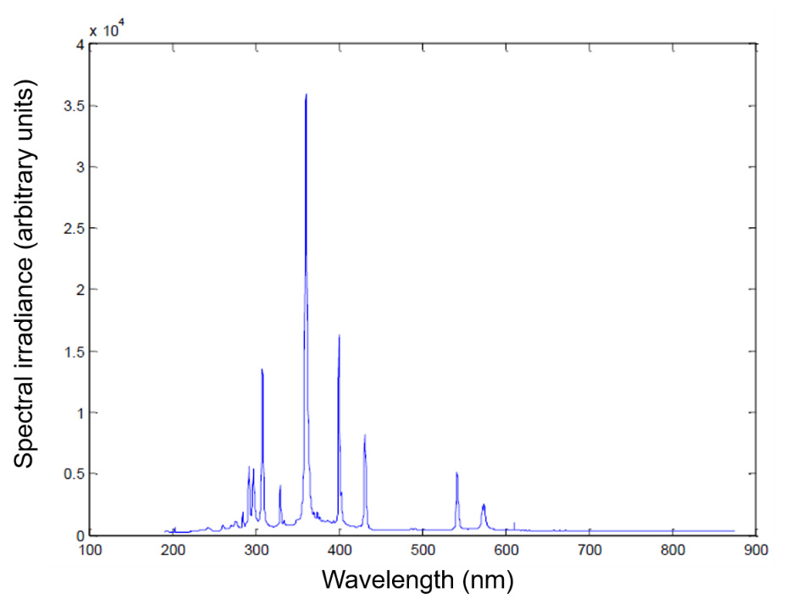
Supplementary Figure 1. Spectrum of mercury-doped xenon arc lamps (UVH) in the CLOUD chamber. Four 200 W Hamamatsu Hg-Xe lamps (UVH) provide light across the entire UV-Vis spectral range and illuminate the chamber homogeneously.
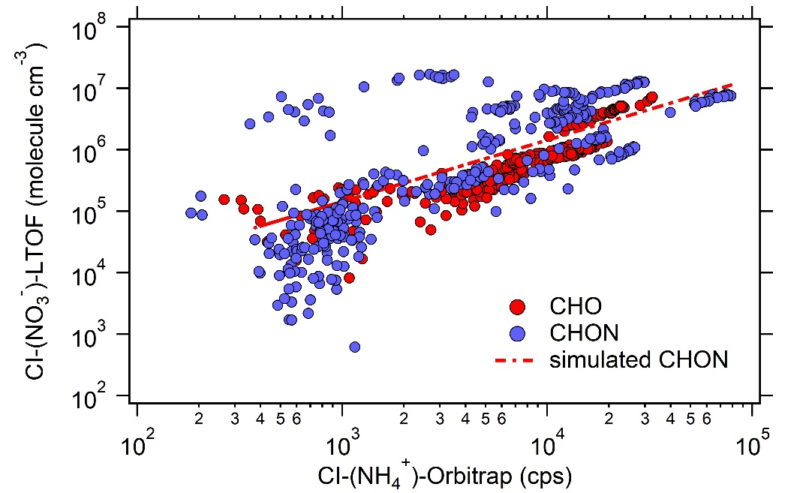
Supplementary Figure 2. Sensitivity of CI-(NH₄⁺)-Orbitrap for the detection of CHO and CHON in the CLOUD chamber. Time evolution intercomparison of CHO (red marker) and CHON (blue marker) measured by CI-(NH₄⁺)-Orbitrap and CI-(NO₃–)-LTOF. Time evolution of CHO species with correlation coefficients R² > 0.9 between NH₄⁺-Orbitrap (cps in unit) and NO₃–-LTOF (molecule cm⁻³ in unit) are used to obtain the calibration factor applied to estimate the concentration of CHON measured by NH₄⁺-Orbitrap (red dashed line). The outliers for CHON measured by CI-(NO₃–)-LTOF is the time evolution of one compound (C₁₀H₁₅NO₁₀).
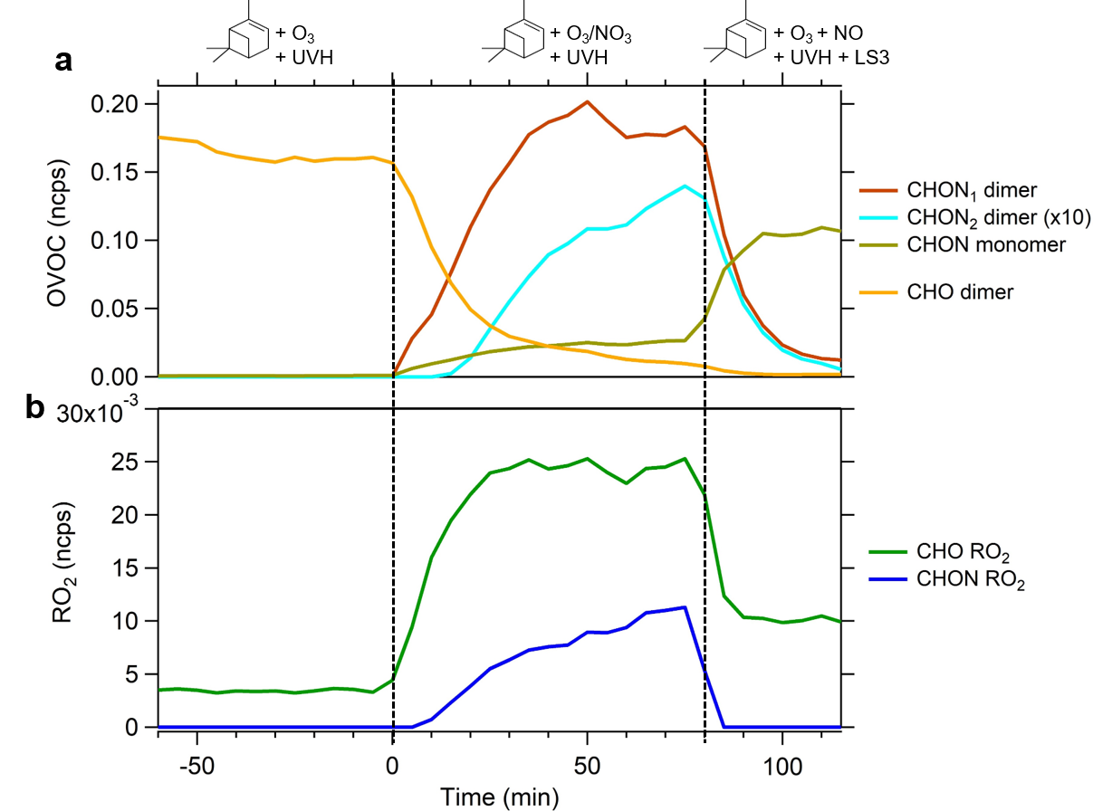
Supplementary Figure 3. Effect of NO₃ radicals and NO on OVOC in CLOUD. Evolution of 1 N-containing dimers (CHON₁ dimer), 2 N-containing dimers (CHON₂ dimer), N-containing monomers (CHON monomer) and non-N containing dimer (CHO dimer) (a) and N-containing RO₂ radicals (CHON RO₂) and non-N containing RO₂ radicals (CHO RO₂) (b).
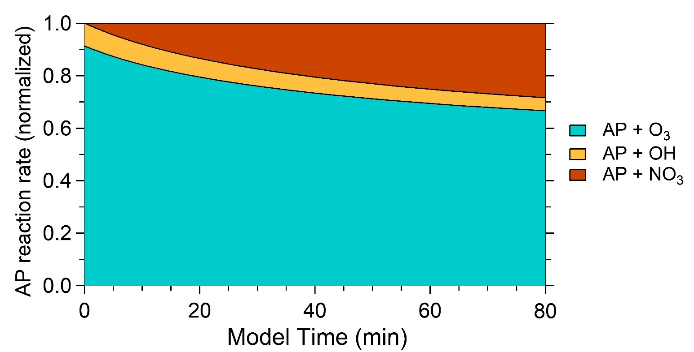
Supplementary Figure 4. Evolution of normalized α-pinene reaction rate during the NO₃ perturbed ozonolysis stage in CLOUD chamber. The contributions of different oxidants to the reacted α-pinene were simulated using F0AM model when NO₃ was present in the chamber during t = 0-80 mins.
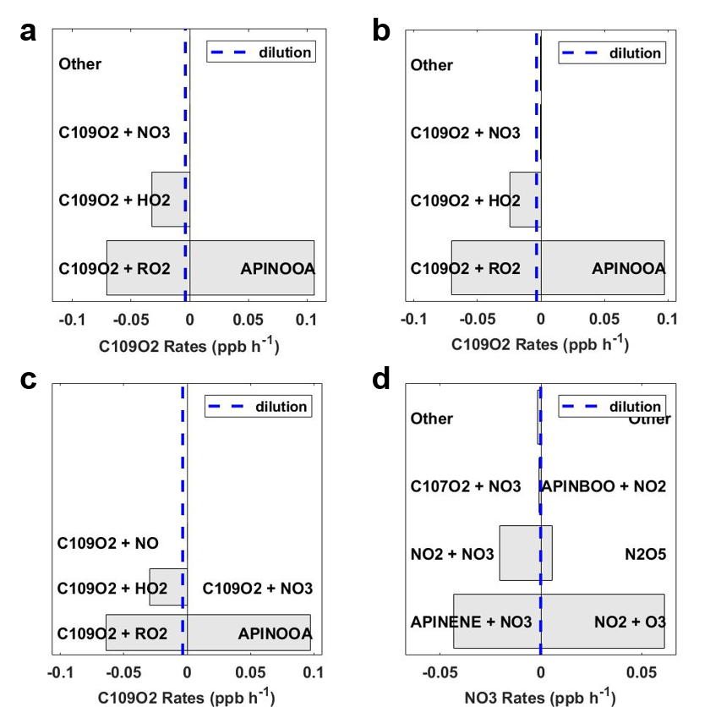
Supplementary Figure 5. Fate of C₁₀H₁₅O₄ and NO₃ radicals simulated in CLOUD chamber. Production and loss rates of C₁₀H₁₅O₄ (C109O2) radical during pure ozonolysis (a), during ozonolysis perturbed by NO₃ (b), and during ozonolysis perturbed by NO_{x} (c). Production and loss rates of formed NO₃ radical during NO₂ injected into the chamber at t = 0-80 min (d). APINOOA, C107O2 and APINBOO in the figure refer to Criegee Intermediate, C₁₀H₁₅O₄ and C₁₀H₁₇O₃, respectively.

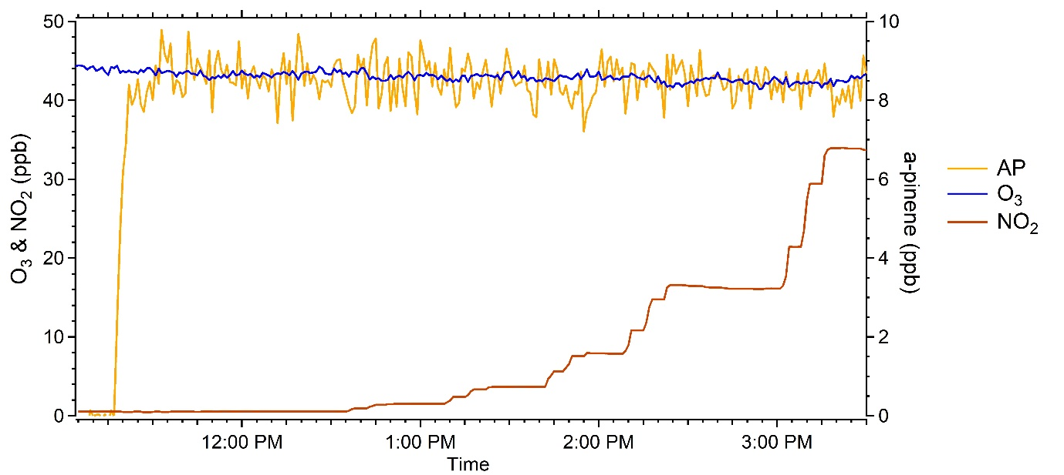
Supplementary Figure 6. Precursors for oxidation flow reactor (OFR) experiments. A run of the evolution of trace gas α-pinene, O₃, and NO₂ in the OFR outflow. Constant α-pinene and O₃ were injected to the OFR. The concentration of NO₂ in the OFR varied from 0–75 ppbv. Experiments were conducted at 296 K and RH < 1%.
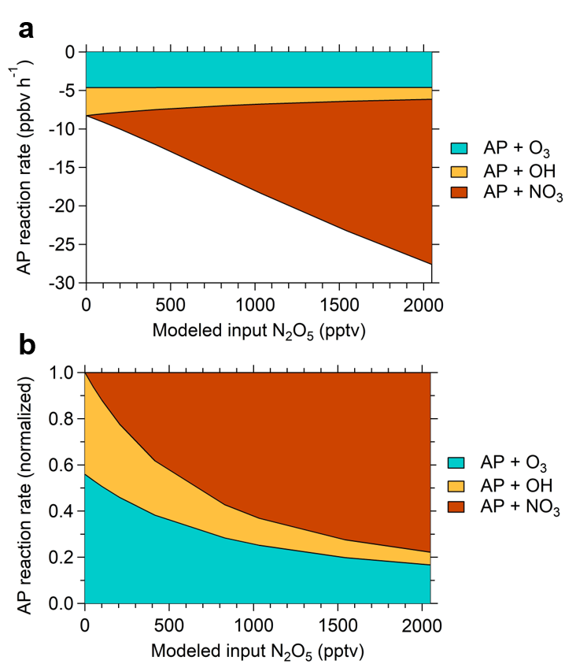
Supplementary Figure 7. Simulated reactivity of α-pinene at different NO₃ levels in OFR experiments. Absolute reaction rate of α-pinene (a) and normalized reaction rate of α-pinene (b) as a function of modeled input N₂O₅ concentration. The contributions of different oxidants to the reacted α-pinene at nine NO₃ concentrations were simulated using F0AM model.
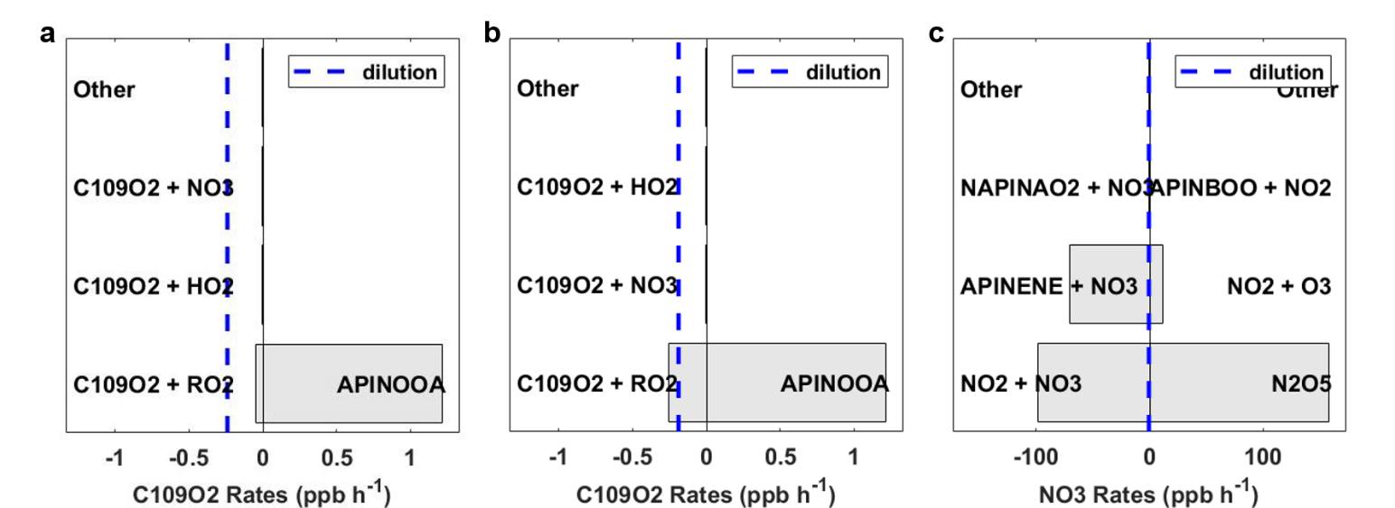
Supplementary Figure 8. Fate of NO₃ and C₁₀H₁₅O₄ radicals simulated in OFR experiments. Production and loss rates of C₁₀H₁₅O₄ (C109O2) radicals in O₃/OH chemistry (a), and at highest NO₂:O₃ (b). Production and loss rates of NO₃ at highest NO₂:O₃ (c). The concentration of α-pinene + O₃ were used as input in (a), α-pinene + O₃ + NO₂ in (b) and O₃ + NO₂ in (c). The input concentration of α-pinene, O₃, and NO₂ were 10 ppbv, 50 ppbv, and 75 ppbv, respectively. APINOOA, NAPINAO2 and APINBOO in the figure refer to Criegee Intermediate, C₁₀H₁₆NO₅ and C₁₀H₁₇O₃, respectively.
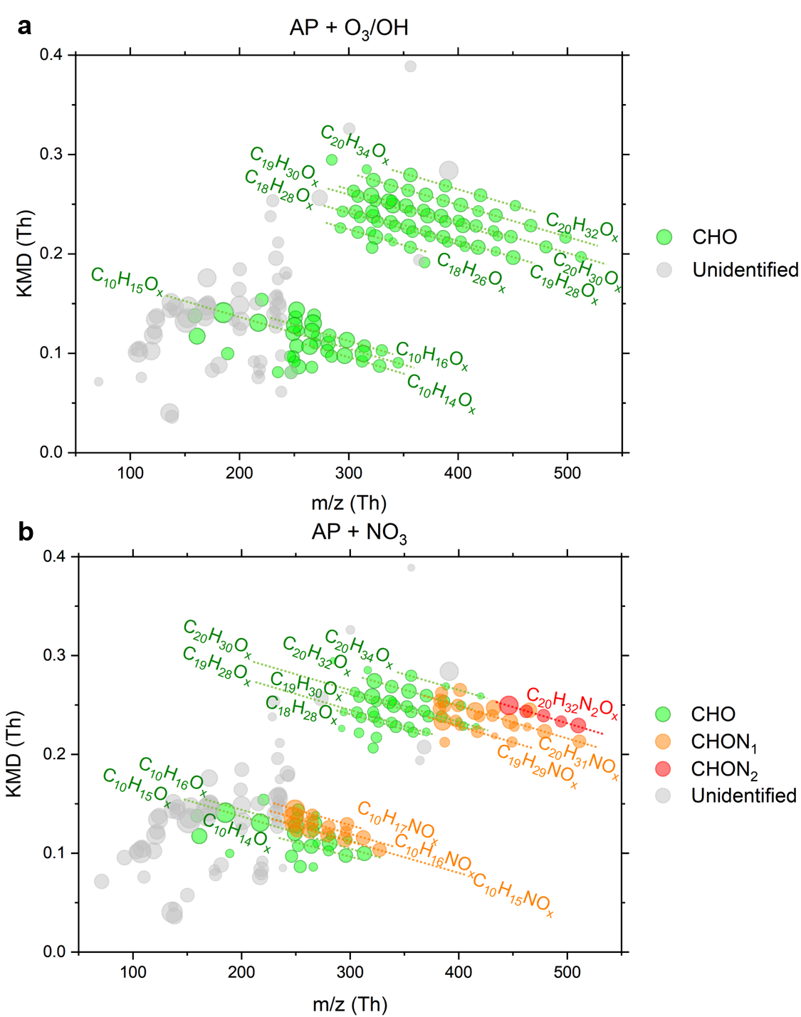
Supplementary Figure 9. Kendrick mass defect plots of OVOCs in OFR experiments measured by CI-(NH₄⁺)- Orbitrap. Kendrick mass defect plots of gaseous compounds observed in the reactions of α-pinene with O₃/OH (a) and NO₃ radical at highest NO₂:O₃ (b). The circles are the measured ions colored by groups: CHO, CHON₁, CHON₂, and unidentified compounds, the sizes of which correspond to their logarithmic intensities. The unidentified compounds represent products with apparent evolution but unassigned molecular formulae.
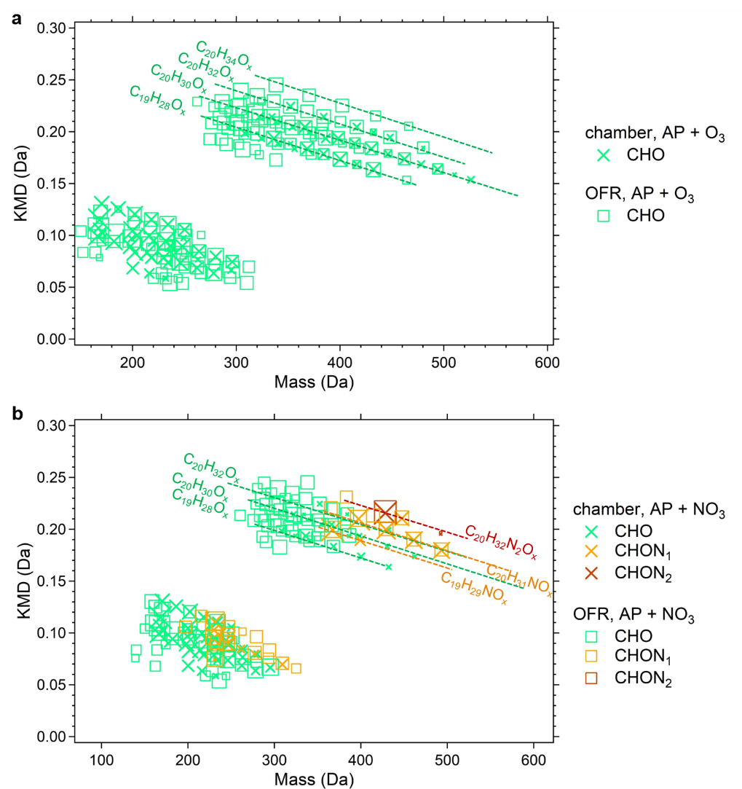
Supplementary Figure 10. Kendrick mass defect plots of OVOCs observed in the CLOUD chamber and OFR experiments. Mass defect plots for C₉₋₁₀ monomers and C₁₉₋₂₀ dimers from pure ozonolysis in the chamber versus from O₃/OH chemistry in OFR experiments (a). Mass defect plots for C₉₋₁₀ monomers and C₁₉₋₂₀ dimers from ozonolysis perturbed by NO₃ in the chamber versus from OFR at lowest NO₂:O₃ (b). Data at which about 30% of α-pinene was oxidized by NO₃ radicals were used for comparison between CLOUD and OFR experiments. The circles are the measured molecules colored by groups: CHO, CHON₁, and CHON₂, the sizes of which correspond to their logarithmic intensities. Cross and square markers correspond to chamber and OFR data measured by CI-(NH₄⁺)-Orbitrap, respectively. The abscissa represents the measured mass of the compounds which has subtracted the reagent ions.
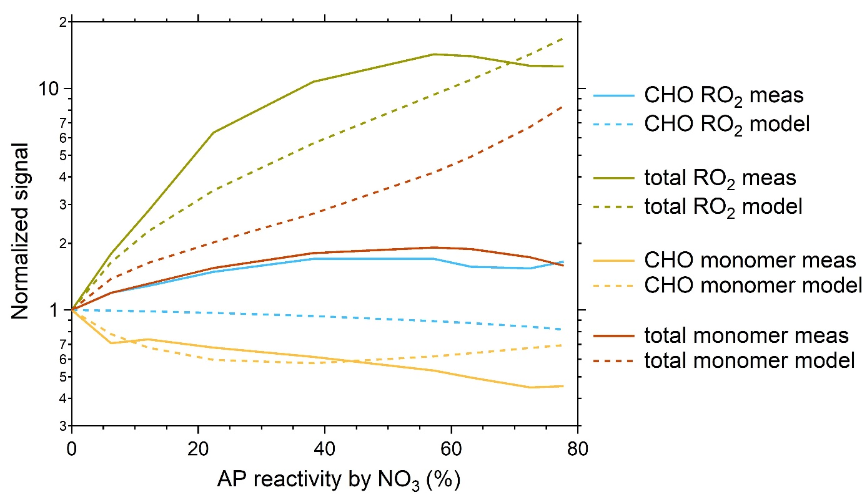
Supplementary Figure 11. Low oxygenated OVOCs measured by CI-(NH₄⁺)-Orbitrap and simulated in OFR experiments. Normalized signals of low oxygenated CHO RO₂ (i.e., C₁₀H₁₅O₄ from O₃), total RO₂ (CHO RO₂ and C₁₀H₁₆NO₅ from NO₃), CHO monomers (C₁₀H₁₄O₃, C₁₀H₁₆O₂₋₄, and C₁₀H₁₈O₃), and total monomer (CHO monomers, C₁₀H₁₅NO₄, and C₁₀H₁₇NO_{4,5}) as a function of α-pinene reactivity by NO₃ radicals. Results measured by CI-(NH₄⁺)-Orbitrap are given in solid lines and those simulated by F0AM in dashed lines.
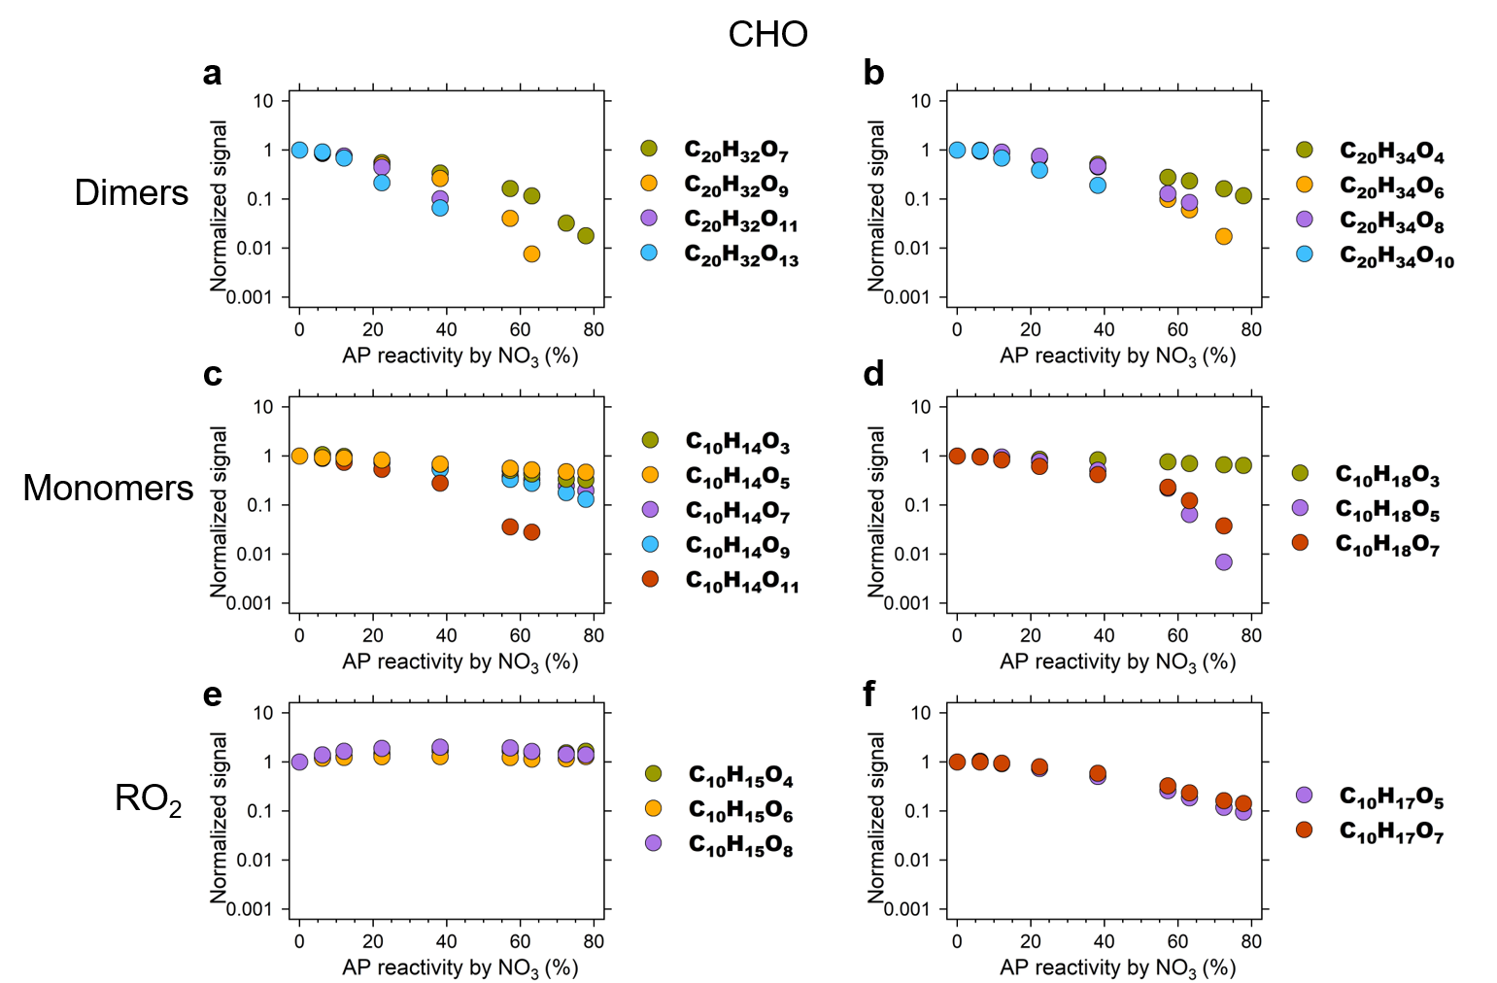
Supplementary Figure 12. CHO in OFR experiments measured by CI-(NH₄⁺)-Orbitrap. Normalized signals of dimers C₂₀H₃₂O_{x} (a) and C₂₀H₃₄O_{x} (b), monomers C₁₀H₁₄O_{x} (c) and C₁₀H₁₈O_{x} (d), peroxy radicals C₁₀H₁₅O_{x} (e) and C₁₀H₁₇O_{x} (f) derived from O₃/OH chemistry as a function of α-pinene reactivity by NO₃ radicals.
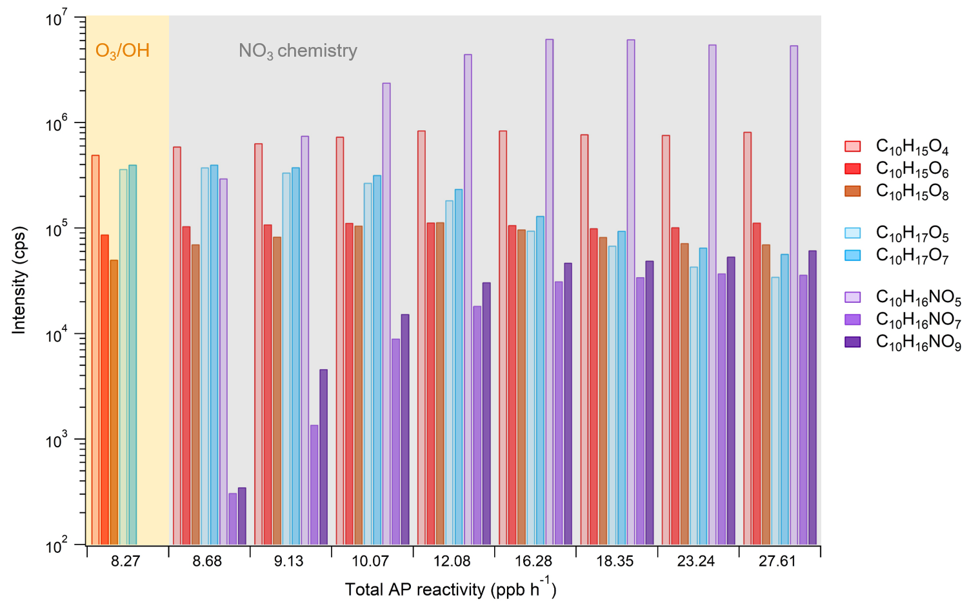
Supplementary Figure 13. Distribution of peroxy radicals measured by CI-(NH₄⁺)-Orbitrap in OFR experiments. Intensity of peroxy radicals C₁₀H₁₅O_{x} from O₃, C₁₀H₁₇O_{x} from OH and C₁₀H₁₆NO_{x} from NO₃ reaction distributed by total α-pinene reactivity. Results from O₃/OH chemistry are shaded in yellow and those from NO₃ chemistry in gray.
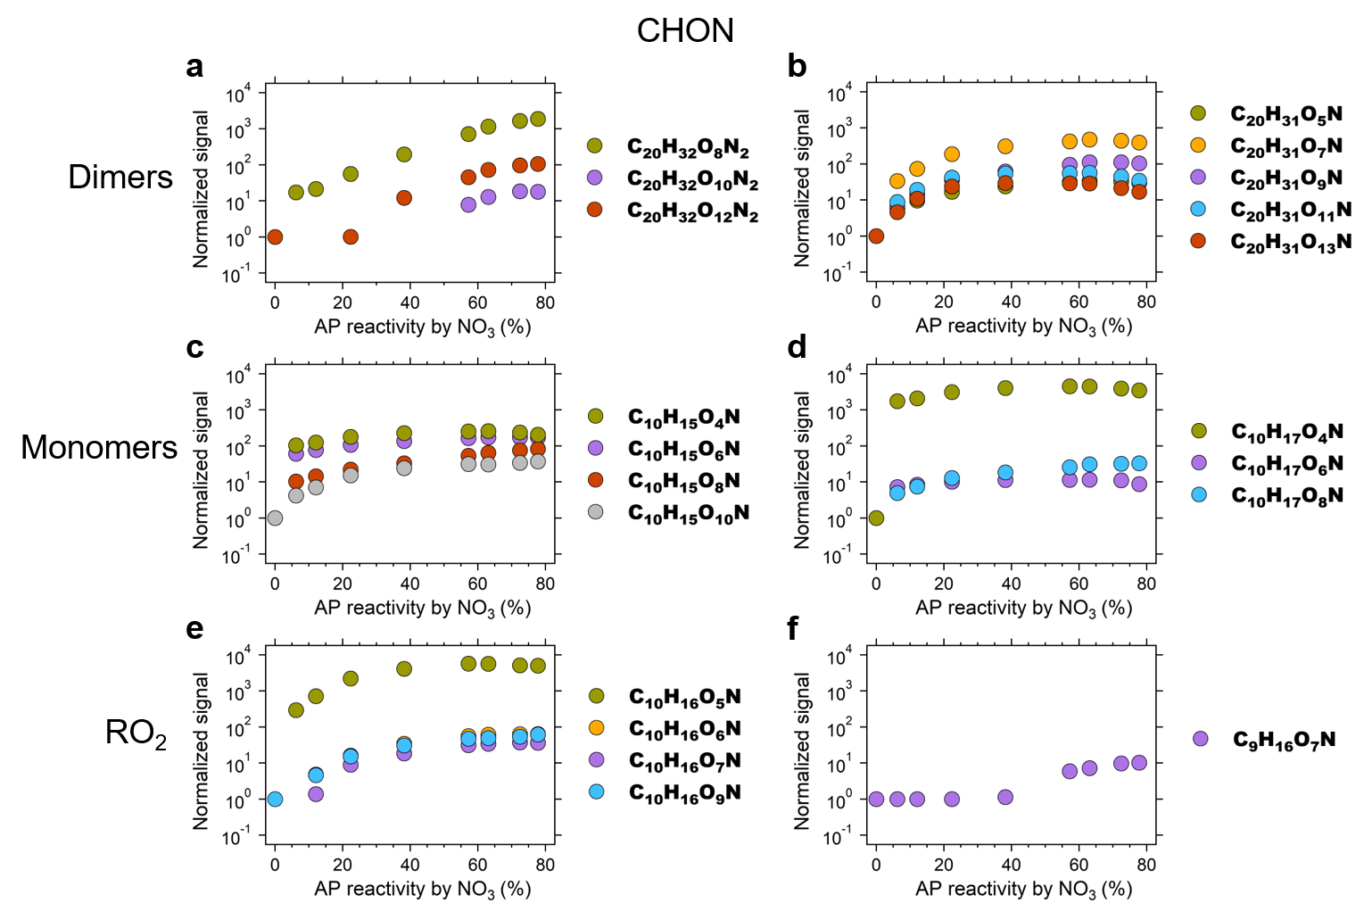
Supplementary Figure 14. CHON in OFR experiments measured by CI-(NH₄⁺)-Orbitrap. Normalized signals of dinitroxy dimers C₂₀H₃₂O_{x}N₂ (a) and nitroxy dimers C₂₀H₃₁O_{x}N (b), organic nitrates C₁₀H₁₅O_{x}N (c) and C₁₀H₁₇O_{x}N (d), peroxy radicals C₁₀H₁₆O_{x}N (e) and C₉H₁₆O_{x}N (f) derived from NO₃ chemistry as a function of α-pinene reactivity by NO₃ radicals.
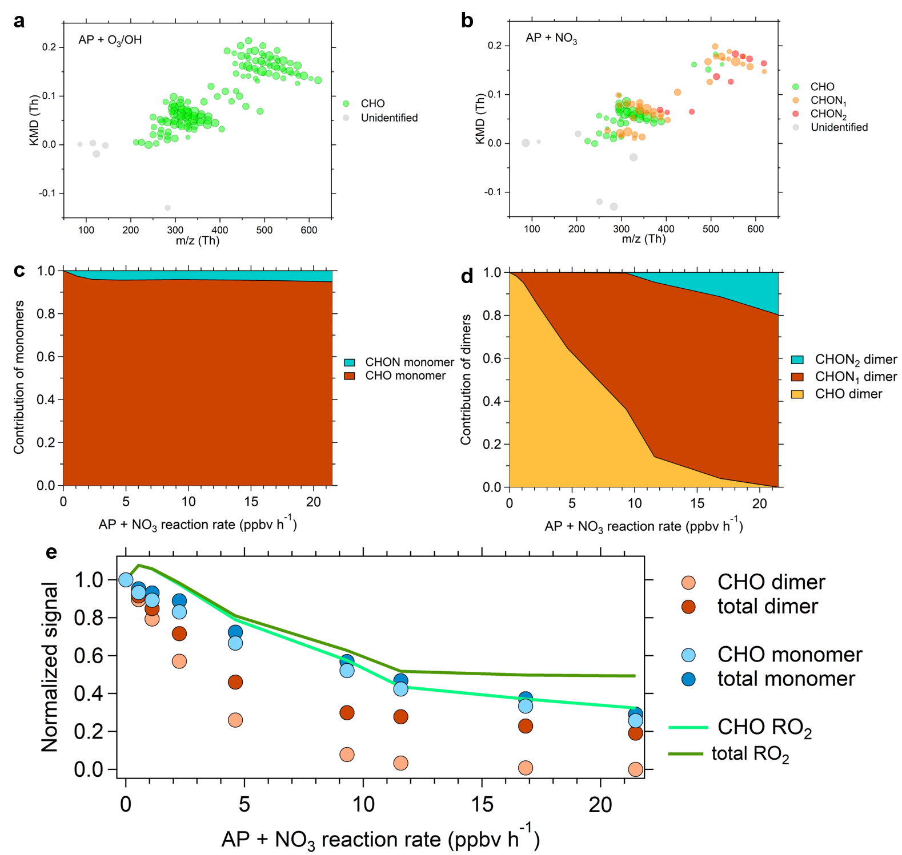
Supplementary Figure 15. Sensitivity of NO₃ radicals to the formation of OVOCs in OFR experiments measured by CI-(NO₃–)-Orbitrap. (a and b) Kendrick mass defect plots of gaseous compounds observed in the reaction of α-pinene with O₃/OH (a) and NO₃ radical (b). The circles are the measured ions colored by groups: CHO, CHON₁, CHON₂, and unidentified compounds, the sizes of which correspond to their logarithmic intensities. The unidentified compounds represent products with apparent evolution but unassigned molecular formulae. (c and d) Contribution of CHO monomers and CHON monomers to total monomers (c), CHO dimers, CHON₁ dimers, and CHON₂ dimers to total dimers (d) plotted against α-pinene oxidation rate by NO₃ radicals. (e) Normalized signals of CHO monomers, CHO dimers, and CHO RO₂ as a function of α-pinene oxidation rate by NO₃ radicals. Ion signals are normalized to the signal in O₃/OH chemistry for comparison.
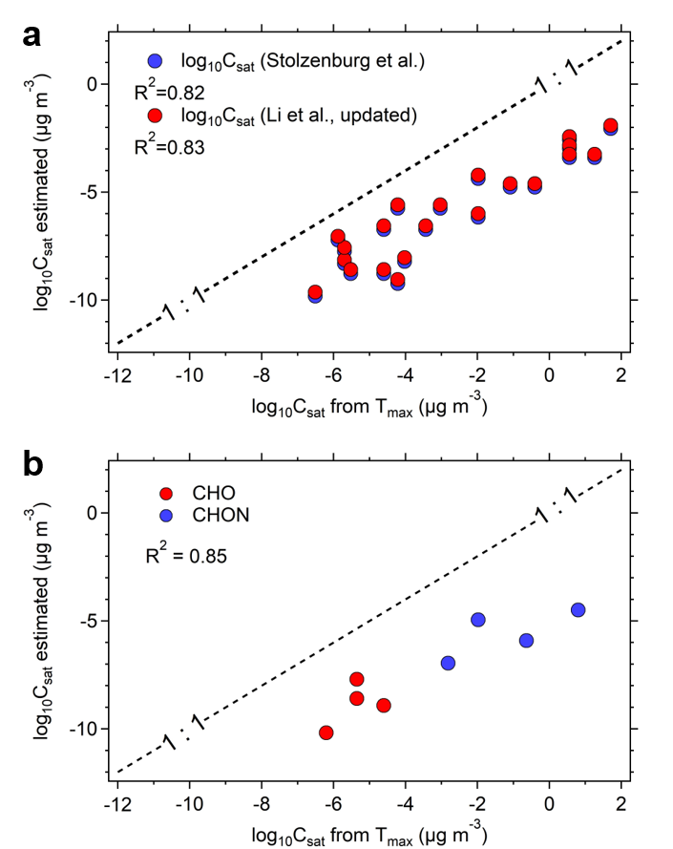
Supplementary Figure 16. Volatility of CHO in the particle phase measured by FIGAERO-CIMS vs. estimated by the VBS parameterizations in the CLOUD chamber. (a) Saturation vapor concentrations (log₁₀C_{sat}) of CHO species formed from α-pinene ozonolysis in the particle phase are predicted by two parameterizations of Stolzenburg et al.¹ (colored in blue) and Li et al. (updated by Isaacman-VanWertz and Aumont)² (colored in red). The measured log₁₀C_{sat} are calculated using the thermal-desorption volatility calibration curve obtained by calibrants correlating their log₁₀C_{sat} with 1/T_{max} using FIGAERO-CIMS³. The gas phase parameterizations are applied assuming compounds with same molecular formulae to have the same structure as in the particle phase. (b) Saturation vapor concentrations of selected CHO dimers and CHON dimers in the particle phase measured versus predicted by modified Li et al. approach. A good correlation R² of 0.85 validates the consistency between direct FIGAERO volatility measurements and VBS parameterizations.
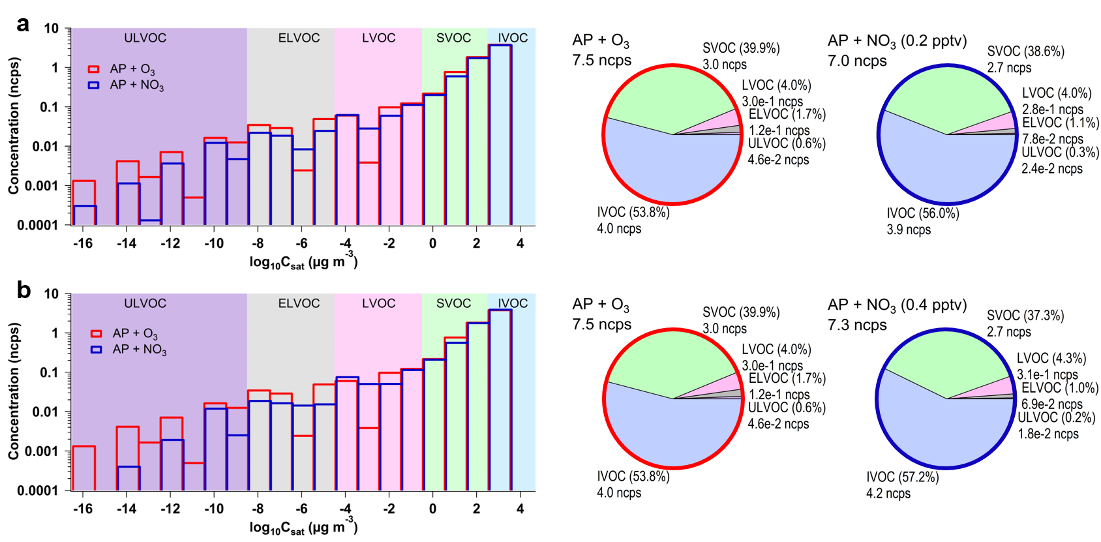
Supplementary Figure 17. Volatility distribution of OVOCs measured by CI-(NH₄⁺)-Orbitrap in the CLOUD chamber. Monomers C₉₋₁₀ and dimers C₁₈₋₂₀ binned to a volatility distribution showing the measured relative abundance in pure O₃ and NO₃ chemistry, respectively; simulated NO₃ concentration was ~0.2 pptv (a) and ~0.4 pptv (b). The background colors represent the saturation concentration (C_{sat}) in the range of ultra-low volatility (ULVOCs, purple), extremely low volatility (ELVOCs, gray), low volatility (LVOCs, pink), semi-volatile (SVOCs, green) and intermediate volatility (IVOCs, blue) organic compounds.
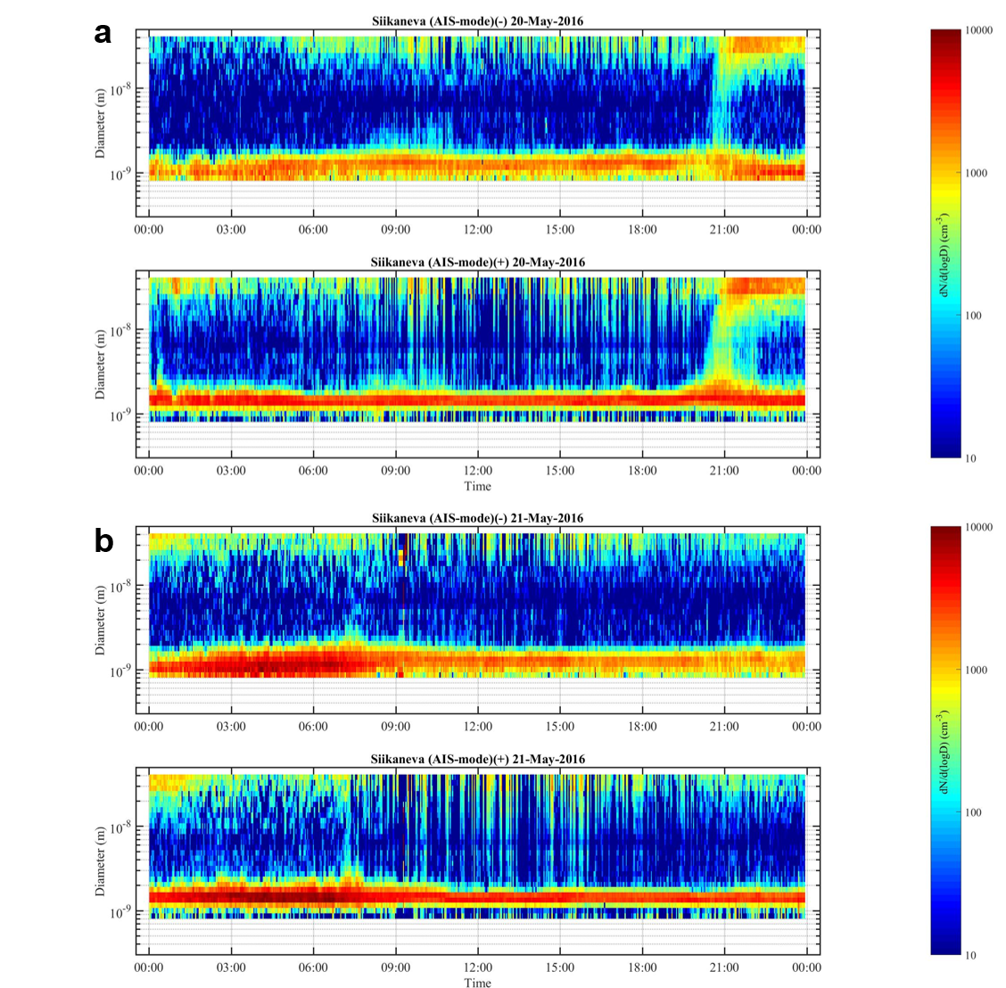
Supplementary Figure 18. Nocturnal NPF event and nonevent measured by AIS during Siikaneva campaign. Example of a nucleation event (a) and non-nucleation event (b) at night showing the size evolution of positive and negative ions. The color scale shows the number concentration of ions.
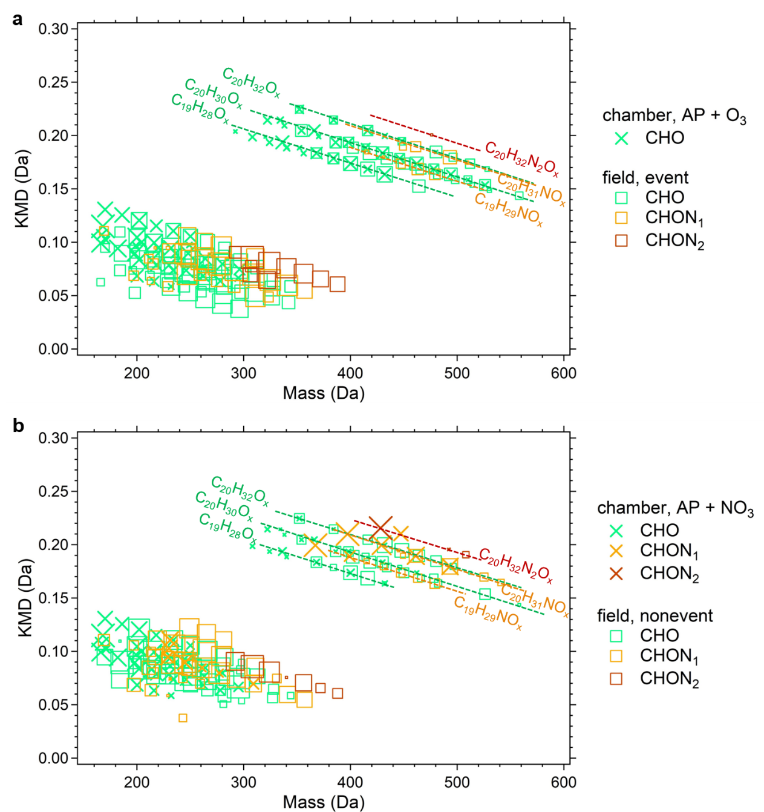
Supplementary Figure 19. Kendrick mass defect plots of oxygenated compounds observed in the CLOUD chamber and wetland. Mass defect plots for C₉₋₁₀ monomers and C₁₉₋₂₀ dimers in O₃ stage of chamber versus a nocturnal NPF event (a) and in NO₃ stage of chamber versus a nonevent (b). The circles are the measured molecules colored by groups: CHO, CHON₁, and CHON₂, the sizes of which correspond to their logarithmic intensities. Cross and square markers correspond to chamber and campaign data measured by CI-(NH₄⁺)-Orbitrap and CI-(NO₃–)-APi-TOF, respectively. The abscissa represents the measured mass of the compounds which has subtracted the reagent ions.
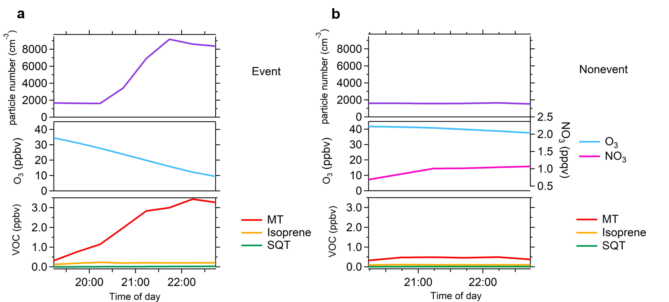
Supplementary Figure 20. Time evolution of particle number, VOC, O₃ and estimated NO₃ in a nocturnal NPF event and nonevent during Siikaneva campaign. (a) Concentration evolution of particle number, monoterpene (MT), isoprene, sesquiterpenes (SQT), and O₃ in the NPF event. (b) Concentration evolution of particle number, monoterpene (MT), isoprene, sesquiterpenes (SQT), O₃ and estimated NO₃ in the non-nucleation event. Unfortunately, NO_{x} measurement was not available in Siikaneva, in particular for event night with decoupling process. Concentration of NO₃ in nonevent (no decoupling process occurred) was estimated from the NO_{x} concentration measured at Hyytiälä in a boreal forest, ~5 km east of Siikaneva.
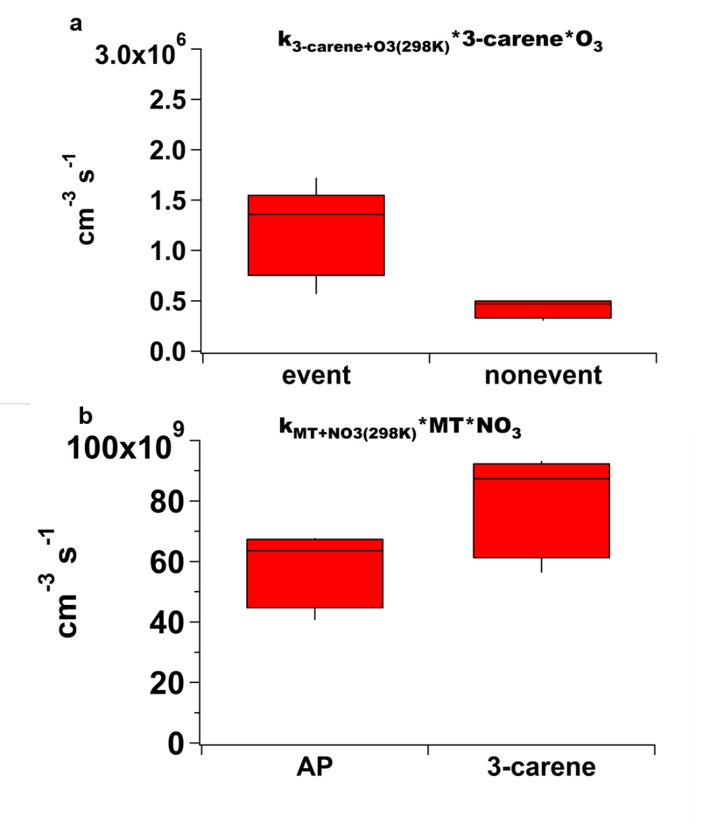
Supplementary Figure 21. Monoterpene reaction rate in a nocturnal NPF event and nonevent during Siikaneva campaign. (a) Ozonolysis rate of Δ³-carene in the NPF event and nonevent. (b) Reactivity of α-pinene and Δ³-carene by NO₃ radical in the nonevent. Concentration of monoterpenes were measured, but the composition could not be classified due to the instrumental limitation during the campaign. α-Pinene is the most abundant monoterpene in May at Hyytiälä, followed by Δ³-carene⁴. Hence, reactivities of α-pinene and Δ³-carene are calculated and represent the reactivity range by assuming the total monoterpene concentration is that of one monoterpene. The reaction rate of these monoterpenes with estimated NO₃ radical in the nonevent are also assessed at 298 K, given that the most reaction rate constants are only available at room temperature from International Union of Pure and Applied Chemistry (IUPAC, https://iupac.aeris-data.fr/en/home/). Considering the Δ³-carene concentration being a factor of ~2 lower than that of α-pinene⁴, the dominating monoterpene reactivity by O₃ and by NO₃ radical in Siikaneva are both from α-pinene.
Supplementary References
1 Stolzenburg, D. et al. Rapid growth of organic aerosol nanoparticles over a wide tropospheric temperature range. Proceedings of the National Academy of Sciences 115, 9122-9127 (2018). https://doi.org:doi:10.1073/pnas.1807604115
2 Isaacman-VanWertz, G. & Aumont, B. Impact of organic molecular structure on the estimation of atmospherically relevant physicochemical parameters. Atmospheric Chemistry and Physics 21, 6541-6563 (2021). https://doi.org:10.5194/acp-21-6541-2021
3 Wang, M. et al. Photo-oxidation of Aromatic Hydrocarbons Produces Low-Volatility Organic Compounds. Environmental science & technology 54, 7911-7921 (2020). https://doi.org:10.1021/acs.est.0c02100
4 Vettikkat, L. et al. High emission rates and strong temperature response make boreal wetlands a large source of isoprene and terpenes. Atmospheric Chemistry and Physics 23, 2683-2698 (2023). https://doi.org:10.5194/acp-23-2683-2023

