Supplementary Materials for

•Specific gut microbiome signature predicts hepatitis B virus-related hepatocellular carcinoma patients with microvascular invasion
Yu-Chong Peng et al.

*Corresponding author:Dr. Lu-Nan Qi Email: qilunan_gxmu@163.com

This PDF file includes:

Supplementary Text
Figs. S1 to S2#
Tables S1

Supplementary Text
Supplementary explanation of some results.

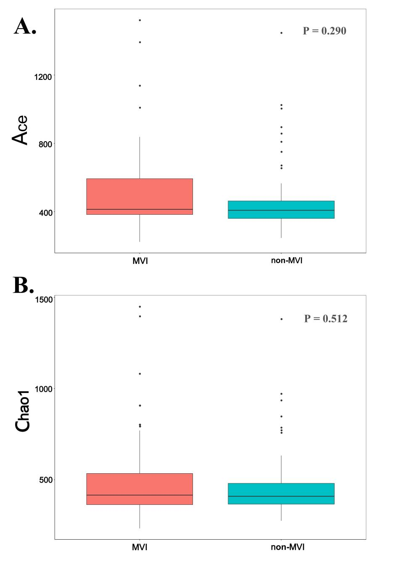

Fig. S1.
MVI Group and non-MVI Group comparison of α-diversity using ACE, Chao1 revealed A-B. *, 0.01<P≤0.05. OTUs, operational taxonomic units; MVI Group, microvascular invasion Group; non-MVI Group, non-microvascular invasion Group.

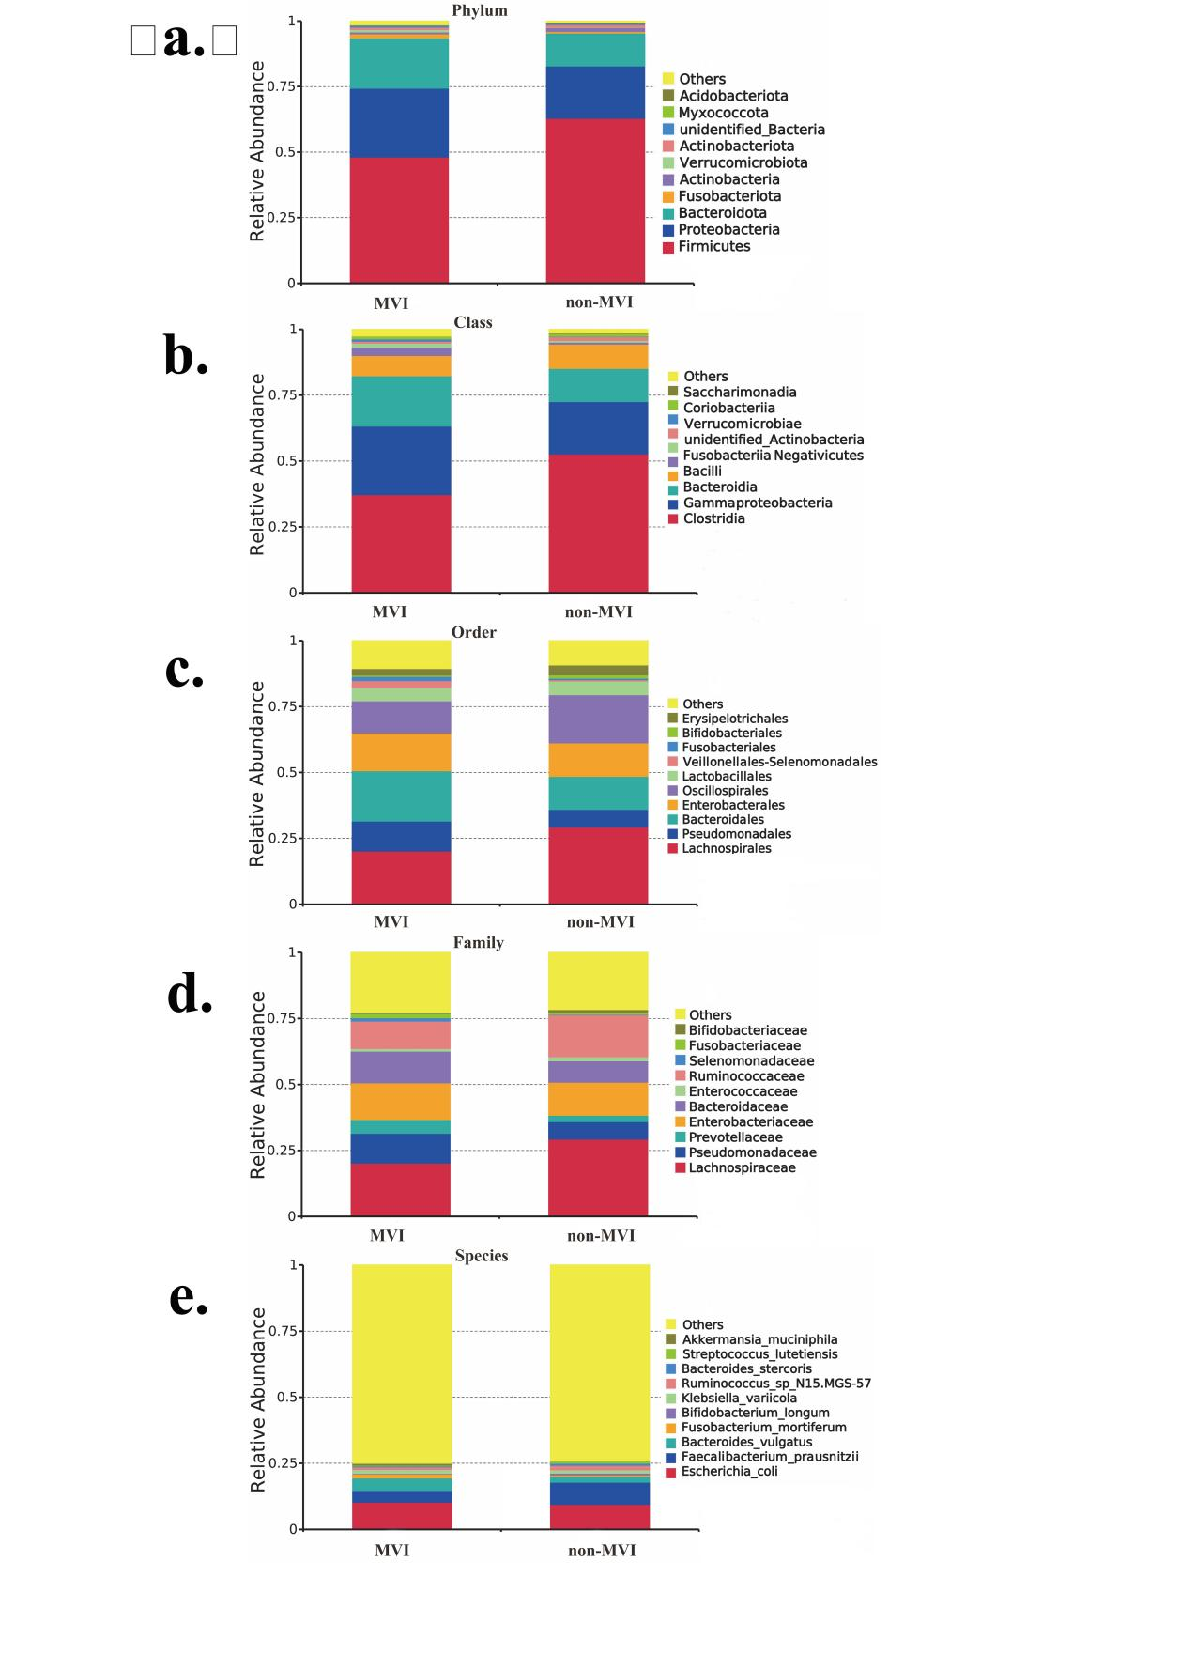

Fig. S2.
Relative abundance of the top 10 gut microbiome among groups MVI and non-MVI.(a)phylum level,(b)class level,(c)order level,(d)family level,(e)species level

Table S1.
Baseline characteristics of the validationg cohort
Characteristic | MVI (n=17) | Non-MVI(n=15) | P-value
Age(year) |  |  | 0.668
<45 | 9 (52.9%) | 10 (66.7%)
≥45 | 8 (47.1%) | 5 (33.3%)
Sex |  |  | 0.234
Female | 3 (29.4%) | 1 (6.7%)
Male | 12 (70.6%) | 14 (93.3%)
BMI | 23.73 (21.30-25.39) | 23.73 (20.81-25.19) | 0.763
PLT |  |  | >0.999
100-300 | 15 (88.2%) | 13 (86.7%)
<100 or >300 | 2 (11.8%) | 2 (13.3%)
RBP | 25.30 (19.80-29.90) | 27.50 (24.10-31.80) | 0.395
TBIL |  |  | >0.999
≤17.1 | 11 (64.7%) | 9 (60.0%)
>17.1 | 6 (35.3%) | 6 (40.0%)
ALB |  |  | >0.999
<35 | 2 (11.8%) | 2 (13.3%)
≥35 | 15 (88.2%) | 13 (86.7%)
PA | 200.60 (173.70-226.60) | 218.60 (201.25-246.25) | 0.079
ALT |  |  | 0.306
≤40 | 11 (64.7%) | 13 (86.7%)
>40 | 6 (35.3%) | 2 (13.3%)
AST |  |  | 0.022*
≤40 | 7 (41.2%) | 13 (86.7%)
>40 | 10 (58.8%) | 2 (13.3%)
HBsAg（ng/ml） | 447.69 (276.59-689.11) | 606.77 (447.03-912.29) | 0.157
PLR | 104.13 (94.40-168.60) | 117.07 (76.24-135.38) | 0.61
NLR | 2.09 (1.84-3.31) | 1.95 (1.74-2.91) | 0.955
MLR | 0.23 (0.20-0.28) | 0.24 (0.22-0.44) | 0.485
PT |  |  | 0.083
≤13 | 13 (76.5%) | 6 (40.0%)
>13 | 4 (23.5%) | 9 (60.0%)
INR |  |  | 0.909
≤1.2 | 16 (93.5%) | 13 (98.2%)
>1.2 | 1 (5.9%) | 2 (13.3%)
AFP |  |  | >0.999
≤400 | 7 (41.2%) | 6 (40.0%)
>400 | 10 (58.8%) | 9 (60.0%)
γ-GGT | 57.00 (33.00-87.00) | 52.00(35.50-81.00) | 0.610
TCH | 4.37 (3.63-5.62) | 4.89 (4.12-5.29) | 0.895
Ascites |  |  | 0.522
No | 15 (88,2%) | 15 (100%)
Yes | 2 (11.8%) | 0 (0.0%)
Th/Ts | 1.70 (1.30-2.60) | 1.50 (1.30-2.35) | 0.776
Smoking |  |  | 0.503
No | 11(64.5%) | 7 (46.7%)
Yes | 6 (35.3%) | 8 (53.3%)
Drinking |  |  | 0.141
No | 13 (76.5%) | 15 (100%)
Yes | 4 (23.5%) | 0 (0.0%)
Portal hypertension |  |  | 0.503
No | 12 (70.6%) | 11 (86.7%)
Yes | 5 (29.4%) | 2 (13.3%)
With or without envelope |  |  | 0.777
No | 4 (23.5%) | 11 (13.3%)
Yes | 13 (76.5%) | 13 (86.7%)
Is the envelope intact |  |  | >0.999
No | 9 (52.9%) | 6 (53.3%)
Yes | 8 (47.1%) | 7 (46.7%)
Tumor size(CT) |  |  | 0.931
1 | 8 (47.1%) | 7 (46.7%)
2 | 6 (35.3%) | 6 (40.0%)
3 | 3 (17.6%) | 2 (13.3%)
Liver Cirrhosis |  |  | 0.522
No | 12 (70.6%) | 8 (53.3%)
Yes | 5 (29.4%) | 7 (46.7%)
Tumor Number (CT) |  |  | 0.062
1 | 14 (82.4%) | 10 (66.7%)
2 | 3 (17.6%) | 1 (6.7%)
3 | 0 (0.0%) | 4 (26.7%)
BCLC stage |  |  | 0.567
A | 10 (58.8%) | 6 (40.0%)
B | 3 (17.6%) | 4 (26.7%)
C | 4 (23.5%) | 5 (33.3%)
Ki67 | 0.30 (0.20-0.40) | 0.30 (0.20-0.42) | 0.834
The P value was based on Wilcoxon Rank sum test, Fisher Exact test and Chi-square test.MVI Group, microvascular invasion Group; non-MVI Group, non-microvascular invasion Group; BMI, body mass index; PLT, platelet; RBP, retinol blinding protein; TBIL, total bilirubin; ALB, albumin; PA, prealbumin; ALT, alanine aminotransferase; AST, aspartate aminotransferase; HBsAg, hepatitis B surface antigen; PLR, platelet-to-lymphocyte ratio; NLR, neutrophil-to-lymphocyte ratio; MLR, monocyte-to-lymphocyte ratio; PT, prothrombin time; INR, international normalized ratio; AFP, alpha fetoprotein; γ-GGT, gamma-glutamyl transferase; TCH, total cholesterol; Th/Ts, helper T cell/suppressor T cell;BCLC stage, Barcelona Clinic Liver Cancer stage; Ki67, Ki-67

