Overcoming multidrug resistance by reversan and exterminating glioblastoma and glioblastoma stem cells by delivering drug loaded nanostructure hybrid lipid capsules (nHLCs)

Uzma Hasan^{1,2}, Meenakshi Chauhan², Suparna Mercy Basu², Jayakumar R² and Jyotsnendu Giri²*
¹Department of Biotechnology, Indian Institute of technology, Hyderabad India
²Department of Biomedical Engineering, Indian Institute of Technology, Hyderabad, India

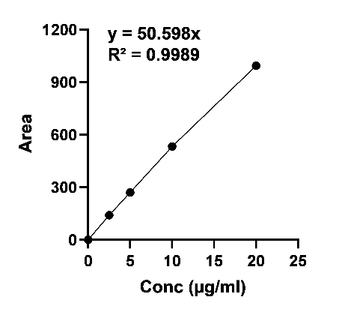
Figure SI 1: Standard plot of RF

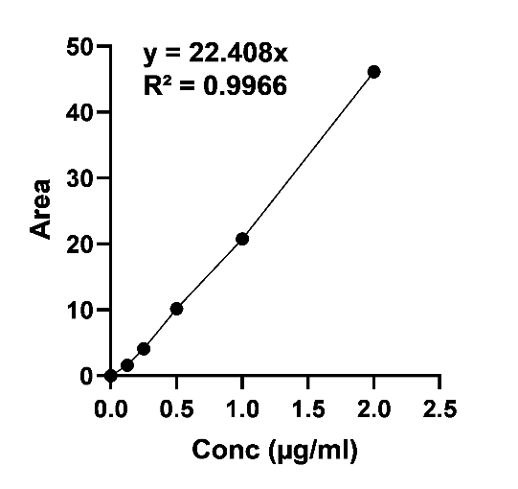
Figure SI 2: Standard plot of CMN

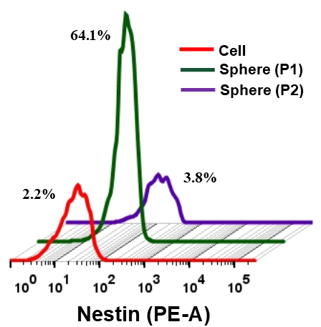

Figure SI 3: Histogram showing expression levels of Nestin in P1 and P2 spheres compared to GBM cells.

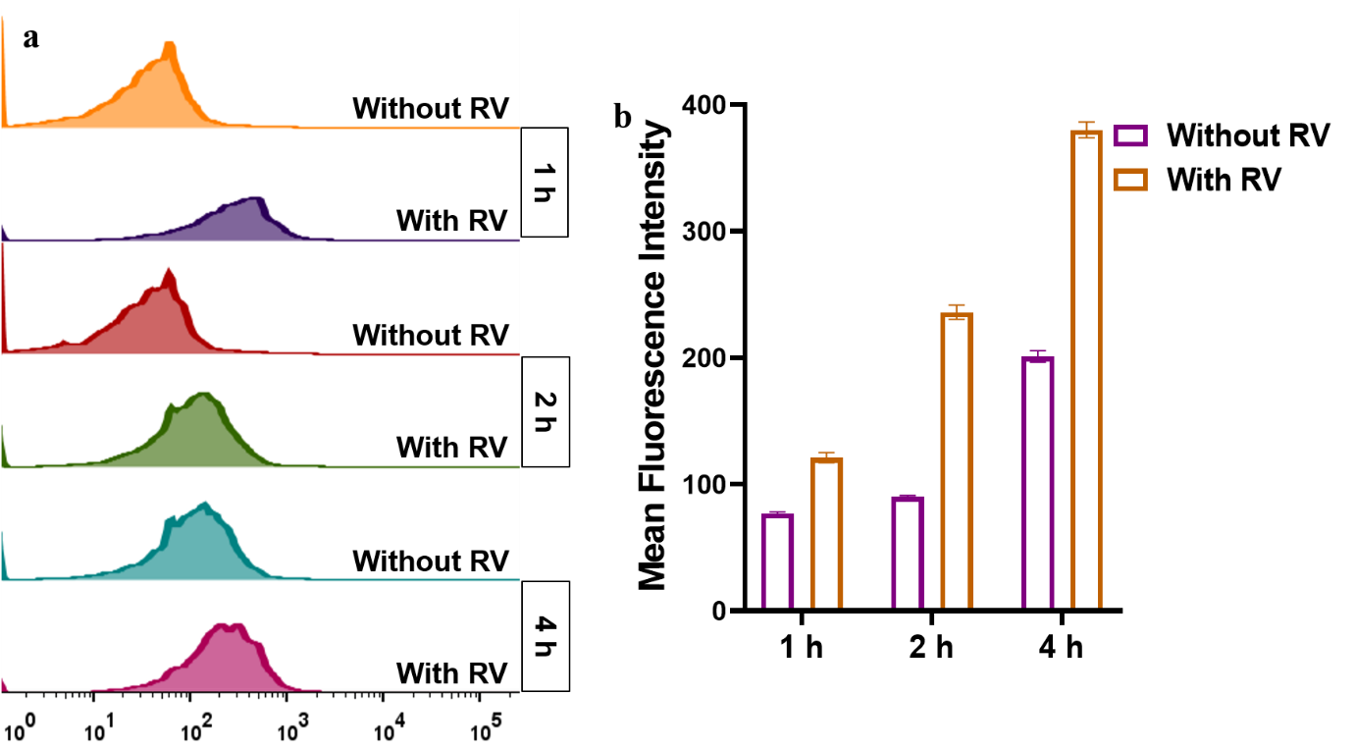

Figure SI 4: (a) Histogram and (b) mean fluorescence intensity by flow cytometry analysis showing cellular retention of nHLC-Dil in U251MG cells (at time point 1, 2 and 4 h) treated with RV for 4 h.

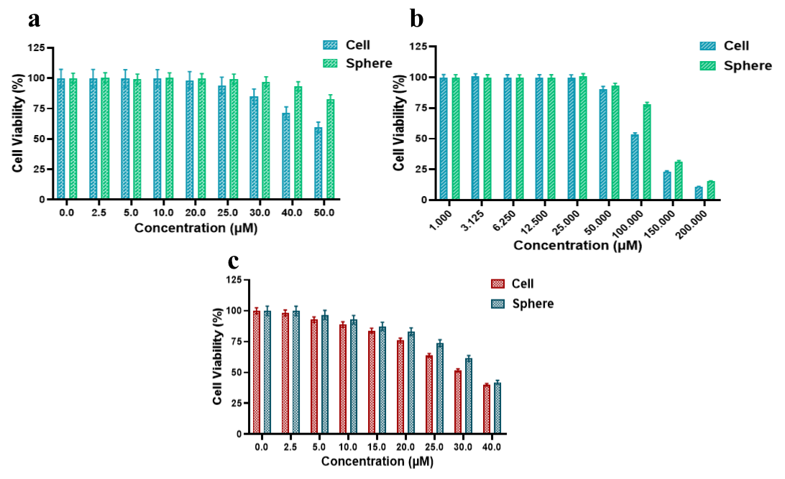

Figure SI 5: Cell viability of U251MG cells and spheres (a) Percentage viability (%) of GBM and GSCs treated with blank nHLC equivalent to RF concentration for 72 h. (b) Percentage viability (%) of GBM and GSCs treated with blank nHLC equivalent to CMN concentration for 72 h. (c) Percentage viability (%) of GBM and GSCs treated with different concentrations of RV for 72 h

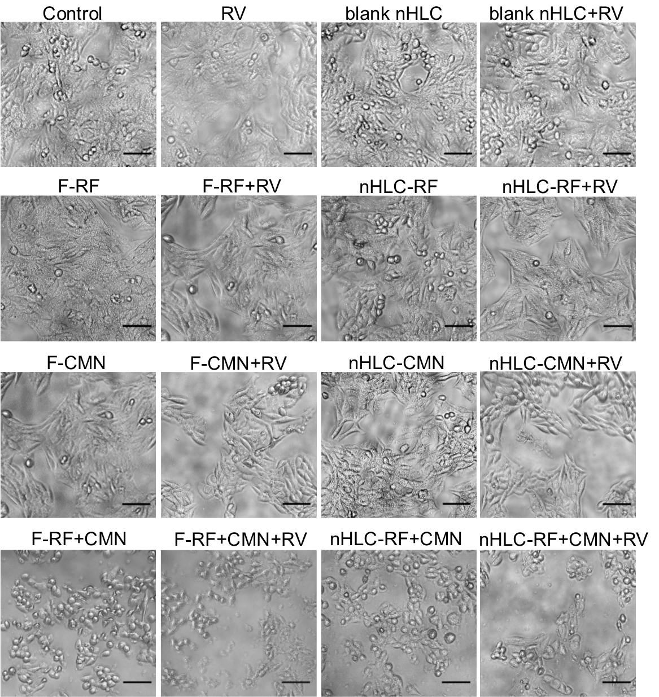

Figure SI 6: Bright field images of U251MG cells pre-treated with RV for 7 h followed by treatment with free and nHLC loaded drugs for 48 h. (Scale= 100 µm)

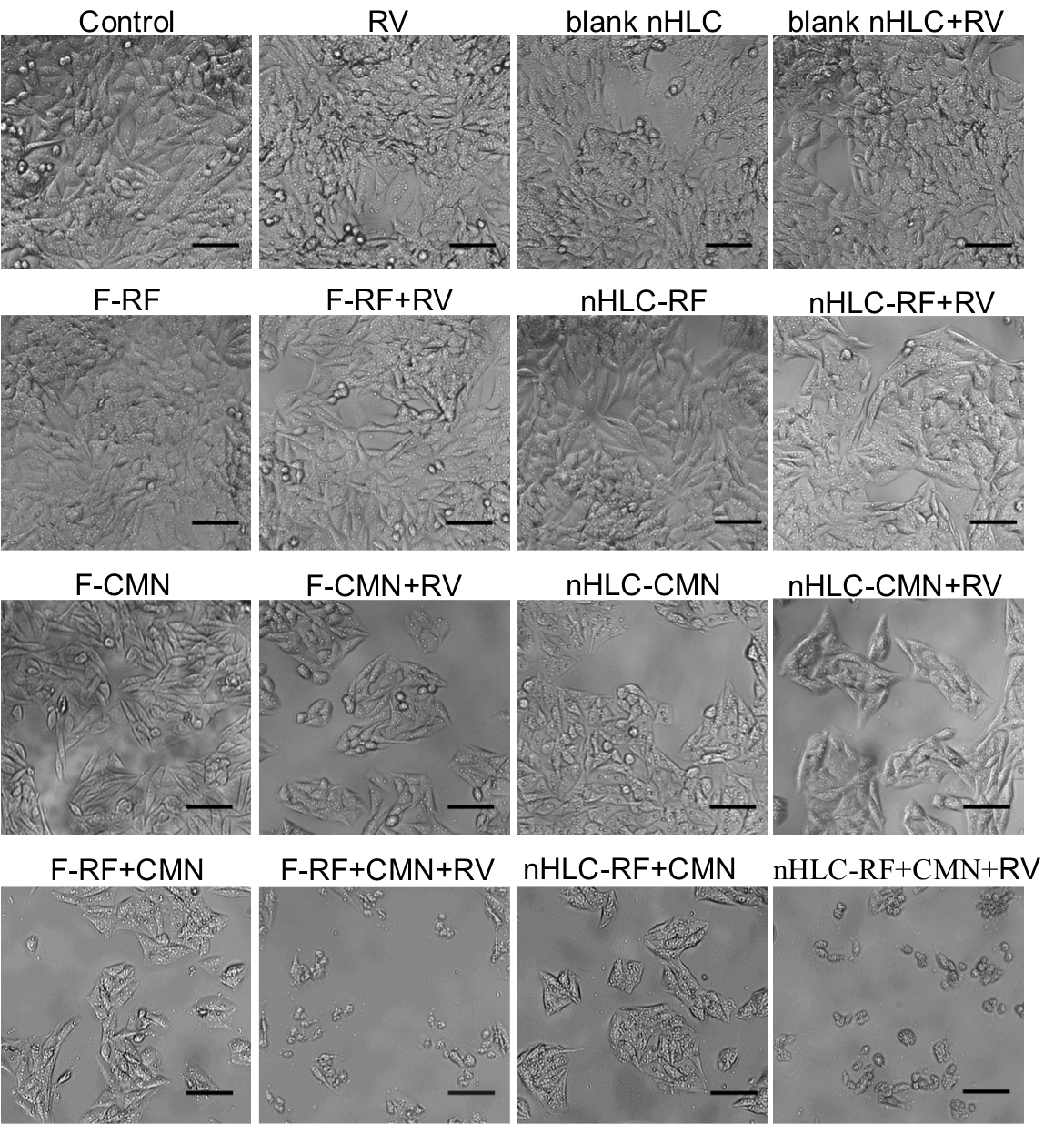

Figure SI 7: Bright field images of U251MG stem cells pre-treated with RV for 7 h followed by treatment with free and nHLC loaded drugs for 48 h. (Scale=100 µm)

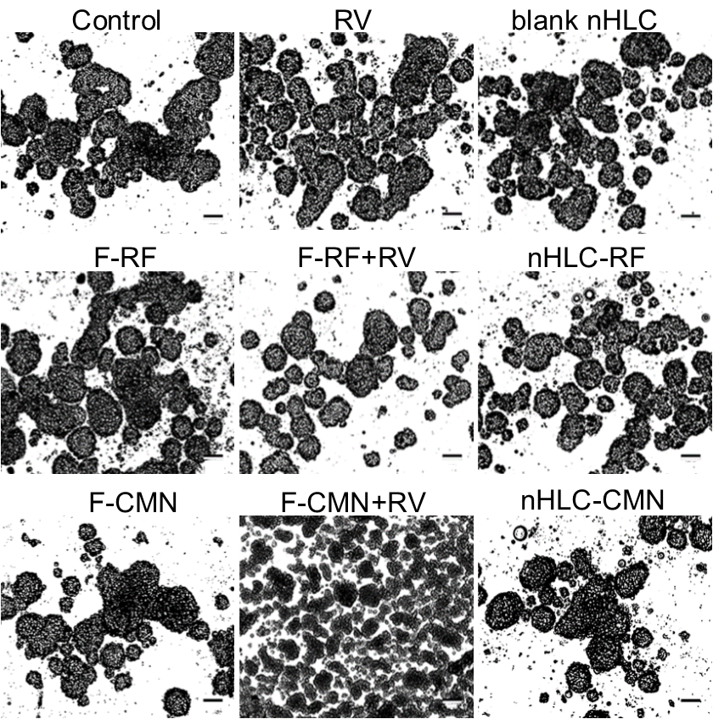

Figure SI 8: Bright field images of U251MG derived sphere inhibition assay post 48 h treatment with free and nHLC loaded drugs (RF and CMN). Spheres were pre-treated with 20 µM RV for 7 h. (Scale=100 µm)

