Rhodanine composite fluorescence probes to detect amyloid-beta aggregated species in Alzheimer's disease models
Table of Contents
1. General information 3
2. NMR spectra and HRMS: 4
3. Spectroscopic data 37
4. Effect of polarity on the fluorescence intensity of tested probe (19): 44
5. Characterization of Aβ₁₋₄₂ fibril: 45
6. Fluorescence Spectral Assessment of all the developed probes against monomeric Aβ₁₋₄₂ (monomers), Aβ₁₋₄₂ (aggregates) or fibrillar species, and BSA (Bovine serum albumin) 45
7. pH stability study of probe 18, 19 and 22 in physiological buffers. 47
8. HPLC purity profile of the leading probes 19 and 22. 47
9. Stability study in the ICR mice plasma 48
10. Assessment of BBB penetration using HPLC: 49
11. Cell internalization experiment: 50
12. Fluorescence Spectra of probes 18, 19, and 22 on Brain Tissue Samples 51
14. Computational studies: 55

General information
Materials and reagents:
Unless otherwise stated, commercially available reagents and solvents were used without purification to develop novel NIRF probes. The reagents and solvents were purchased from Sigma Aldrich, TCI chemicals, Merck, BLD Pharmatech, etc. the reaction progress was monitored using TLC chromatography on precoated silica gel 60 F254 (Merck KGaA). All air or moisture-sensitive reactions were performed under a nitrogen (inert) environment. Column chromatographic purifications were done using silica gel 60-120 mesh size (Avra synthesis, India).

Instruments:
Nuclear magnetic resonance (NMR) spectral analysis of the developed intermediates and the designed probes were performed using Bruker 500 MHz to record ¹H and ¹³C- NMR spectra in deuterated solvents like chloroform (CDCl₃) or d₆-dimethyl sulfoxide (d₆-DMSO) as indicated. The peak splitting patterns were assigned as d = doublet, t = triplet, q = quartet, m = multiplet, dd = doublet of doublet, brs = broad singlet. High-resolution mass spectra (HRMS) were obtained by HRMS-6540-UHD using electrospray ionization (HRMS/ESI) at the Banaras Hindu University, Varanasi, India. The photophysical properties, especially absorbance, fluorescence excitation, and emission maxima of the developed probes, were determined using a fluorescence Microplate reader (Spectramax Paradigm, Molecular devices, America) in DMSO. The purity of the leading compounds was determined using HPLC and was in a range of ≈ 95%. The purity, BBB assay, and plasma stability assay of the developed probes were performed on HPLC chromatography.
Biological reagents:
The Aβ₁₋₄₂ peptides, tau proteins, and bovine serum albumin (BSA) for in-vitro fluorescence studies were purchased from rPeptide, Denovo, and Sigma Aldrich, respectively.
Solvents used in the different assays:
The stock solutions (2.5 mM) of all the tested probes were prepared in DMSO, and various in-vitro optical studies were performed in a mixture of 2% DMSO with 98% PBS buffer (10 mM, pH 7.4); Binding affinity assay: PBS buffer (DMSO: <0.2%); MTT assay: DMEM (DMSO: <0.1%); Cell imaging: PBS buffer (DMSO: <0.1%); For in-vivo imaging and biodistribution assay: 4 mg/kg dose of probes in 0.8 mg/kg, 15 % of DMSO, 5% of Cremophor® EL, and 80% of PBS and BBB permeability assay: 4 mg/kg dose of probes in 30 % DMSO in 70% propylene glycol.
Brain autopsy samples for neuropathological staining:
For performing in-vitro fluorescence imaging against amyloid beta oligomer antibodies, the autopsy brain tissues from 5 subjects (aged 68-78 years) were obtained from the Department of Forensic Medicine and Toxicology, All India Institute of Medical Sciences, New Delhi, India. To carry out neuropathological fluorescence assay against ThT, formalin-fixed autopsy brain tissue slides of the hippocampal region from AD patients (92 years old female) and control group (92 years old female) were received from Human Brain Bank, NBRI, Gurugram, Haryana, India. All the experimental studies were performed after getting approval from institutional ethical committee, AIIMS, New Delhi and Institute of medical science, BHU, Varanasi.

Mice used in animal studies:
For in-vivo imaging in live animal for BBB permeability and biodistribution studies, 13-month-old and weighing 30 ± 2 g of APP/PS1 [B6C3-Tg (APPswe/PSEN1dE9) 85Dbo/Mmjax] double transgenic male mice, and aged matched normal C57BL/6 counterparts were provided by National Institute of Immunology, New Delhi. These Tg-AD mice expresses a chimeric mouse/human amyloid precursor protein (Mo/HuAPP695swe) and a mutant human presenilin 1 (PS1-dE9) both directly to CNS neurons. For HPLC analysis, adult male Swiss albino mice, 6 weeks old and weighing 28 ± 2 g were obtained from the animal house facility, Department of Pharmaceutical Engineering & Technology, Indian Institute of Technology (Banaras Hindu University). In all the animal experiments, mice were kept in a 12h light/dark cycle with free access to food and water ad libitum. All animal experiments were performed according to ARRIVE (Animal Research Reporting of In-Vivo Experiments) guidelines, as well as in compliance with institutional guidelines and were approved by the Institutional Animal Ethical Committee.

NMR spectra and HRMS:
¹H NMR spectra of coumarin intermediates:
Fig S1: ¹H NMR of 4-(dimethylamino)-2-hydroxybenzaldehyde (2)

Fig S2: ¹H NMR of ethyl 7-(dimethylamino)-2-oxo-2H-chromene-3-carboxylate (3)
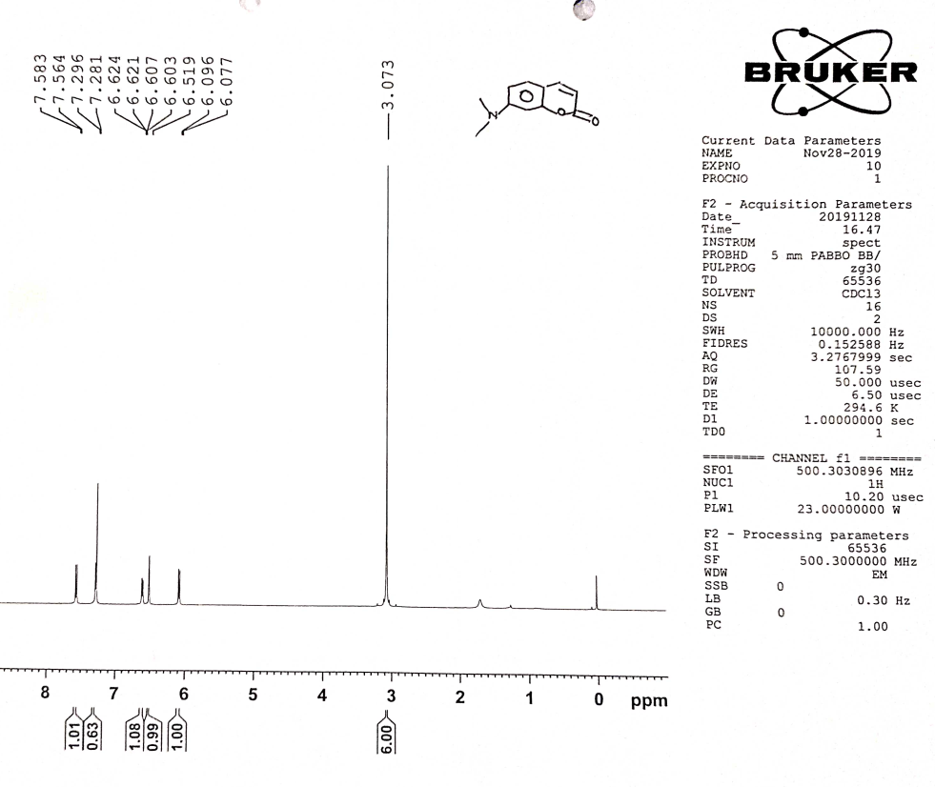
Fig S3: ¹H NMR of 7-(dimethylamino)-2H-chromen-2-one (4)

Fig S4: ¹H NMR of 7-(dimethylamino)-2-oxo-2H-chromene-3-carbaldehyde (5)

¹H NMR spectra of carbostyril intermediates:
Fig S5: ¹H NMR of 2-chloro-7-fluoroquinoline-3-carbaldehyde (8)

Fig S6: ¹H NMR of 7-fluoro-2-oxo-1,2-dihydroquinoline-3-carbaldehyde (9)

Fig S7: ¹H NMR of 7-(dimethylamino)-2-oxo-1,2-dihydroquinoline-3-carbaldehyde (10)

¹H NMR spectra of Rhodanine intermediates:
Fig S8: ¹H NMR of 2-(4-oxo-2-thioxothiazolidin-3-yl) acetic acid (13)

Fig S9: ¹H NMR of 3-(4-oxo-2-thioxothiazolidin-3-yl) propanoic acid (14)

Fig S10: ¹H NMR of 4-(4-oxo-2-thioxothiazolidin-3-yl)butanoic acid (15)

Fig S11: ¹H NMR of 5-(4-oxo-2-thioxothiazolidin-3-yl)pentanoic acid (16)

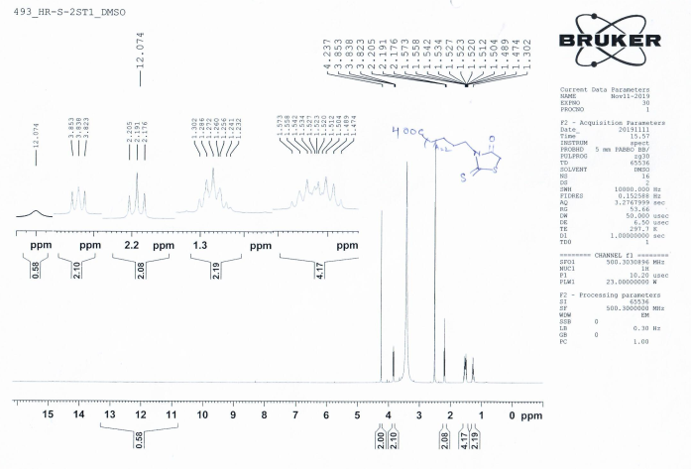
Fig S12: ¹H NMR of 6-(4-oxo-2-thioxothiazolidin-3-yl) hexanoic acid (17)

¹H NMR spectra of coumarin-based probes:
Fig S13: ¹H NMR of (Z)-2-(5-((7-(dimethylamino)-2-oxo-2H-chromen-3-yl)methylene)-4-oxo-2-thioxothiazolidin-3-yl)acetic acid (I-16, 18)

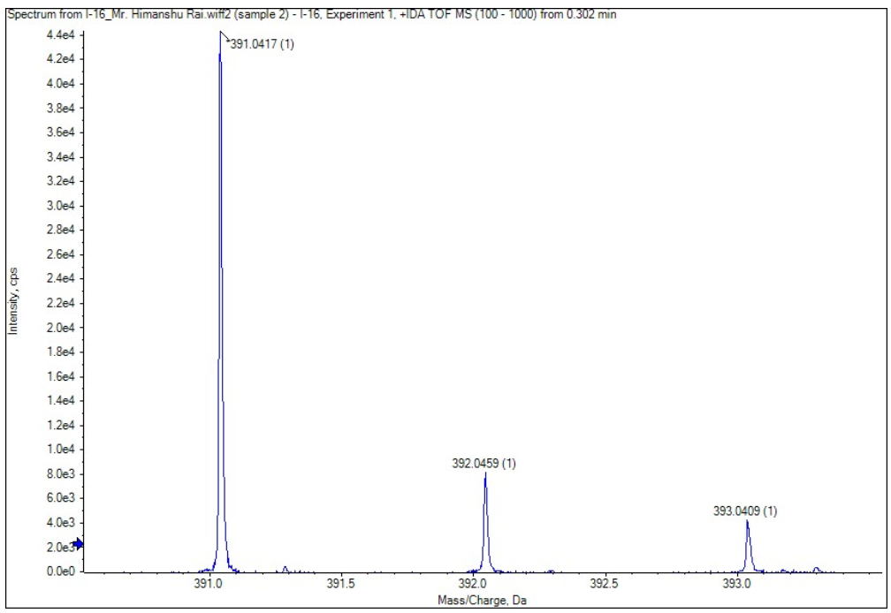
Fig S14: HRMS spectra of (Z)-2-(5-((7-(dimethylamino)-2-oxo-2H-chromen-3-yl)methylene)-4-oxo-2-thioxothiazolidin-3-yl)acetic acid (I-16, 18)

Fig S15: ¹H NMR of (Z)-3-(5-((7-(dimethylamino)-2-oxo-2H-chromen-3-yl) methylene)-4-oxo-2-thioxothiazolidin-3-yl)propanoic acid (I-8, 19)
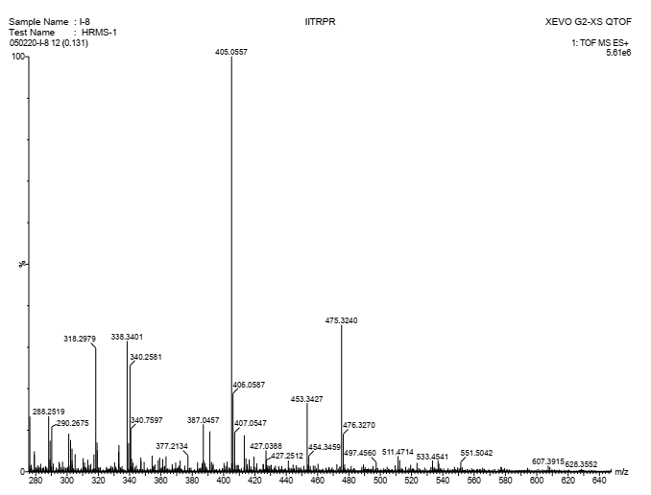
Fig S16: HRMS spectra of (Z)-3-(5-((7-(dimethylamino)-2-oxo-2H-chromen-3-yl) methylene)-4-oxo-2-thioxothiazolidin-3-yl)propanoic acid (I-8, 19)

Fig S17: ¹H NMR of (Z)-4-(5-((7-(dimethylamino)-2-oxo-2H-chromen-3-yl)methylene)-4-oxo-2-thioxothiazolidin-3-yl)butanoic acid (I-17, 20) with traceable piperidine (peaks at 1.5 and 2.82) impurities.

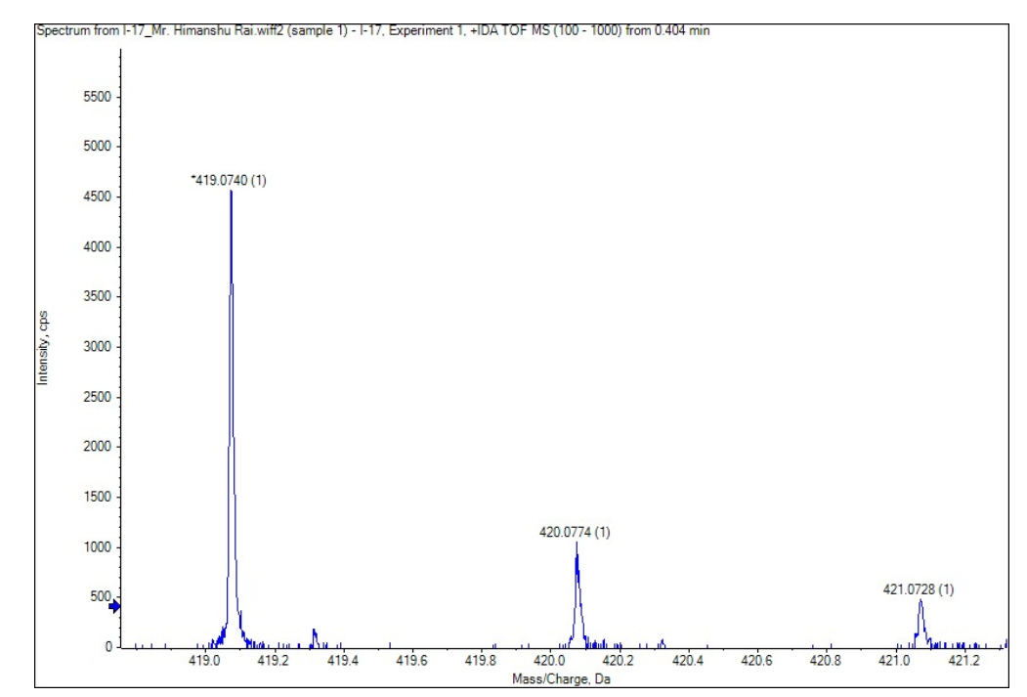
Fig S18: HRMS spectra of (Z)-4-(5-((7-(dimethylamino)-2-oxo-2H-chromen-3-yl)methylene)-4-oxo-2-thioxothiazolidin-3-yl)butanoic acid (I-17, 20)
Fig S19: ¹H NMR of (Z)-5-(5-((7-(dimethylamino)-2-oxo-2H-chromen-3-yl)methylene)-4-oxo-2-thioxothiazolidin-3-yl)pentanoic acid (I-18, 21)
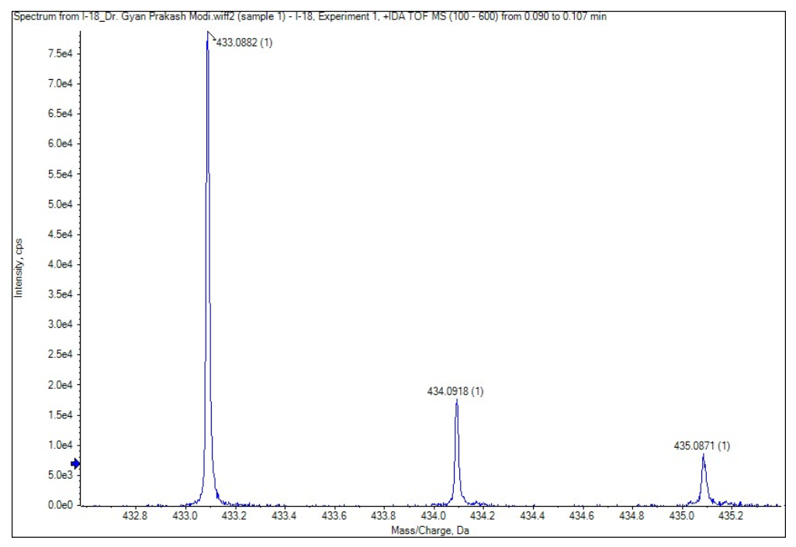
Fig S20: HRMS spectra of (Z)-5-(5-((7-(dimethylamino)-2-oxo-2H-chromen-3-yl)methylene)-4-oxo-2-thioxothiazolidin-3-yl)pentanoic acid (I-18, 21)

Fig S21: ¹H NMR of (Z)-6-(5-((7-(dimethylamino)-2-oxo-2H-chromen-3-yl) methylene)-4-oxo-2-thioxothiazolidin-3-yl)hexanoic acid (I-3, 22)
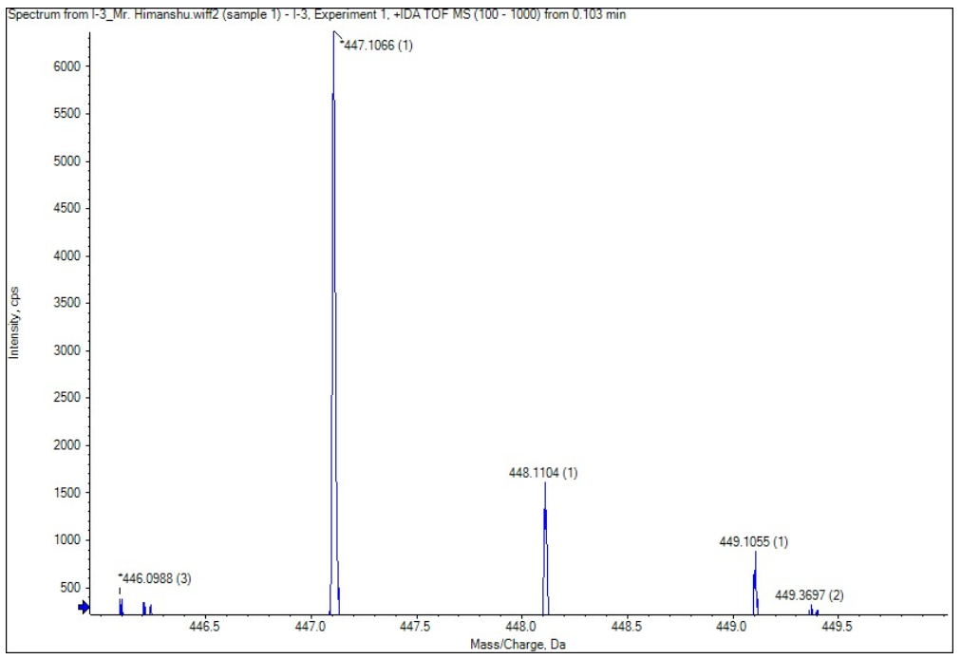

Fig S22: HRMS spectra of (Z)-6-(5-((7-(dimethylamino)-2-oxo-2H-chromen-3-yl) methylene)-4-oxo-2-thioxothiazolidin-3-yl)hexanoic acid (I-3, 22)

¹H NMR spectra of carbostyril based probes:
Fig S23: ¹H NMR of (Z)-2-(5-((7-(dimethylamino)-2-oxo-1,2-dihydroquinolin-3-yl)methylene)-4-oxo-2-thioxothiazolidin-3-yl)acetic acid (I-22, 23)
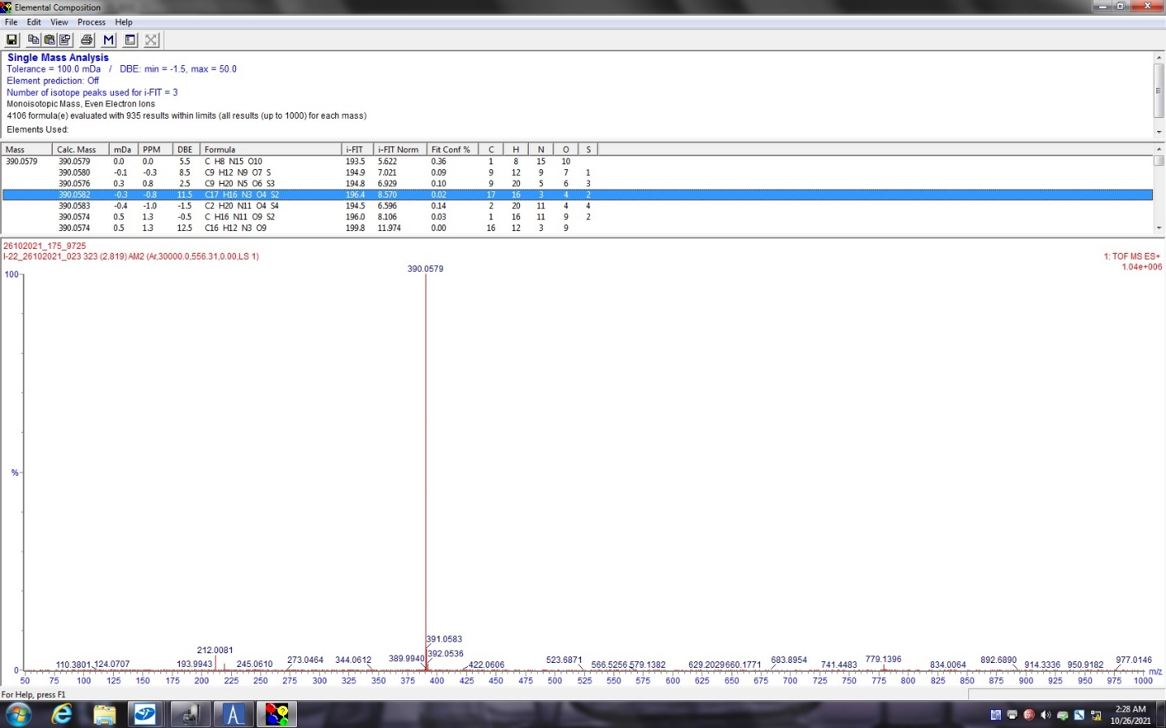
Fig S24: HRMS spectra of (Z)-2-(5-((7-(dimethylamino)-2-oxo-1,2-dihydroquinolin-3-yl)methylene)-4-oxo-2-thioxothiazolidin-3-yl)acetic acid (I-22, 23)

Fig S25: ¹H NMR of (Z)-3-(5-((7-(dimethylamino)-2-oxo-1,2-dihydroquinolin-3-yl)methylene)-4-oxo-2-thioxothiazolidin-3-yl)propanoic acid (I-20, 24) with traceable piperidine (peaks at 1.52 and 2.82) impurities.

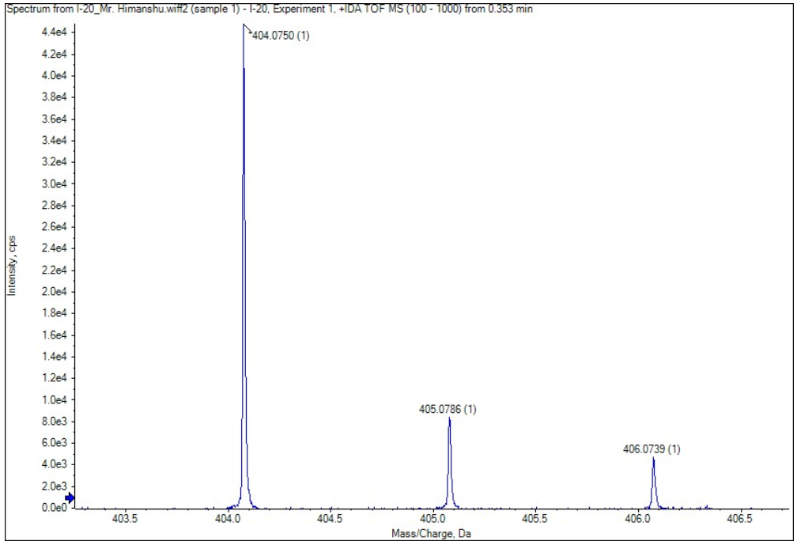
Fig S26: HRMS spectra of (Z)-3-(5-((7-(dimethylamino)-2-oxo-1,2-dihydroquinolin-3-yl)methylene)-4-oxo-2-thioxothiazolidin-3-yl)propanoic acid (I-20, 24).

Fig S27: ¹H NMR of (Z)-4-(5-((7-(dimethylamino)-2-oxo-1,2-dihydroquinolin-3-yl)methylene)-4-oxo-2-thioxothiazolidin-3-yl)butanoic acid (I-12, 25)
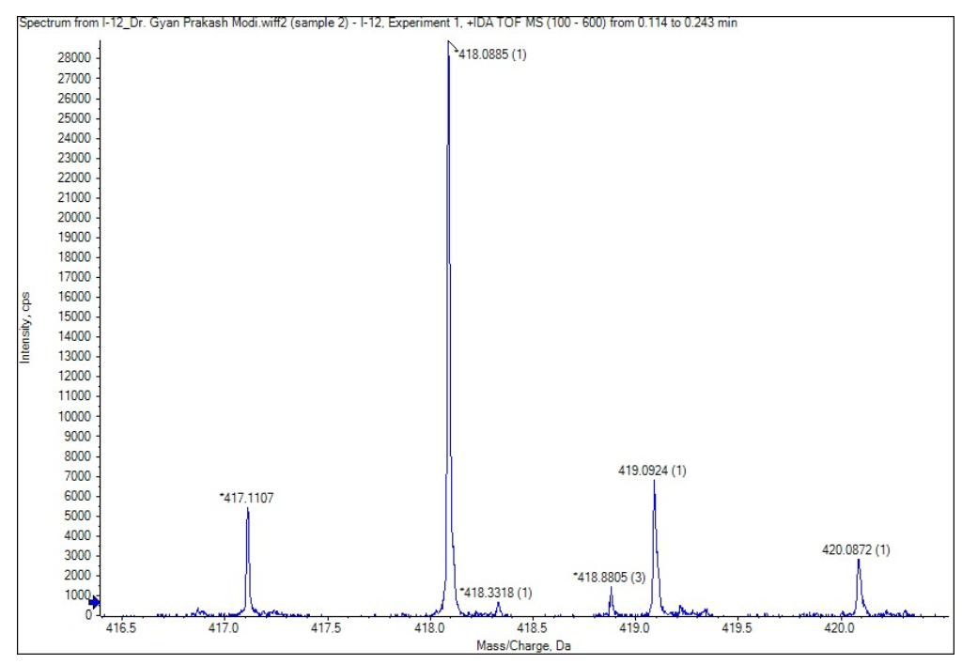
Fig S28: HRMS spectra of (Z)-4-(5-((7-(dimethylamino)-2-oxo-1,2-dihydroquinolin-3-yl)methylene)-4-oxo-2-thioxothiazolidin-3-yl)butanoic acid (I-12, 25)

Fig S29: ¹H NMR of (Z)-5-(5-((7-(dimethylamino)-2-oxo-1,2-dihydroquinolin-3-yl)methylene)-4-oxo-2-thioxothiazolidin-3-yl)pentanoic acid (I-21, 26)

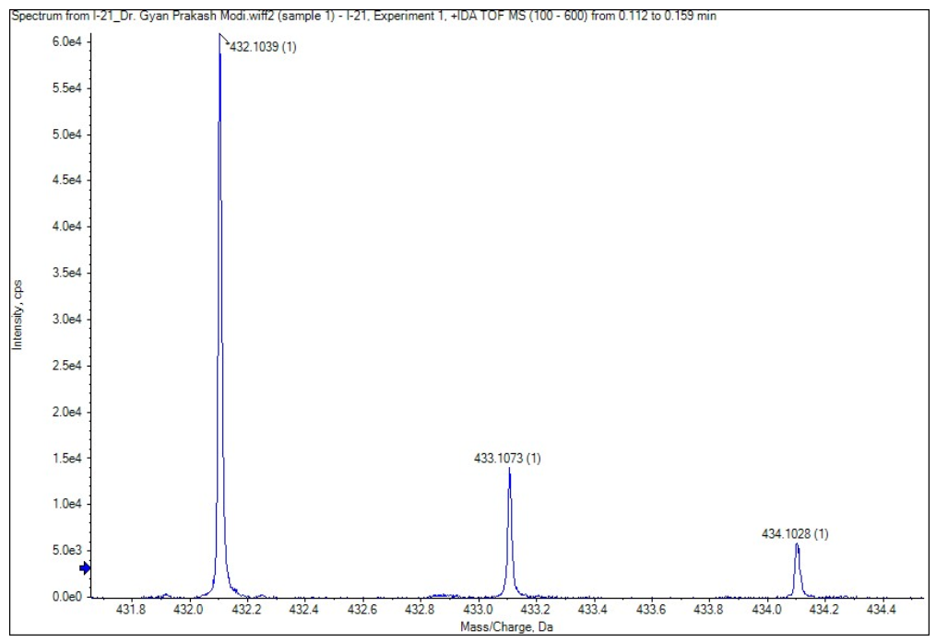
Fig S30: HRMS spectra of (Z)-5-(5-((7-(dimethylamino)-2-oxo-1,2-dihydroquinolin-3-yl)methylene)-4-oxo-2-thioxothiazolidin-3-yl)pentanoic acid (I-21, 26)

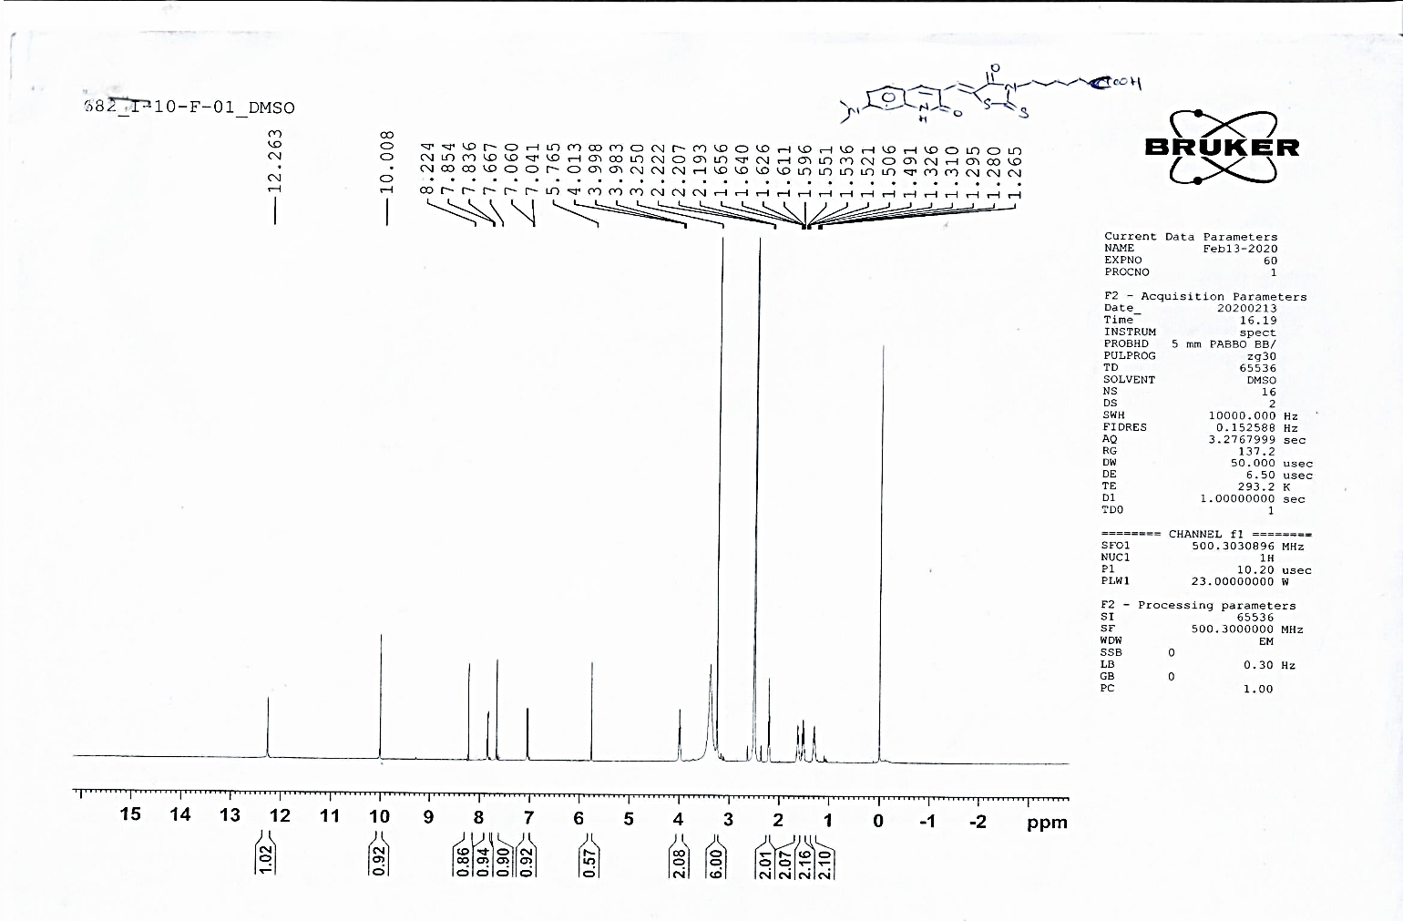Fig S31: ¹H NMR of (Z)-6-(5-((7-(dimethylamino)-2-oxo-1,2-dihydroquinolin-3-yl)methylene)-4-oxo-2-thioxothiazolidin-3-yl)hexanoic acid (I-10, 27)
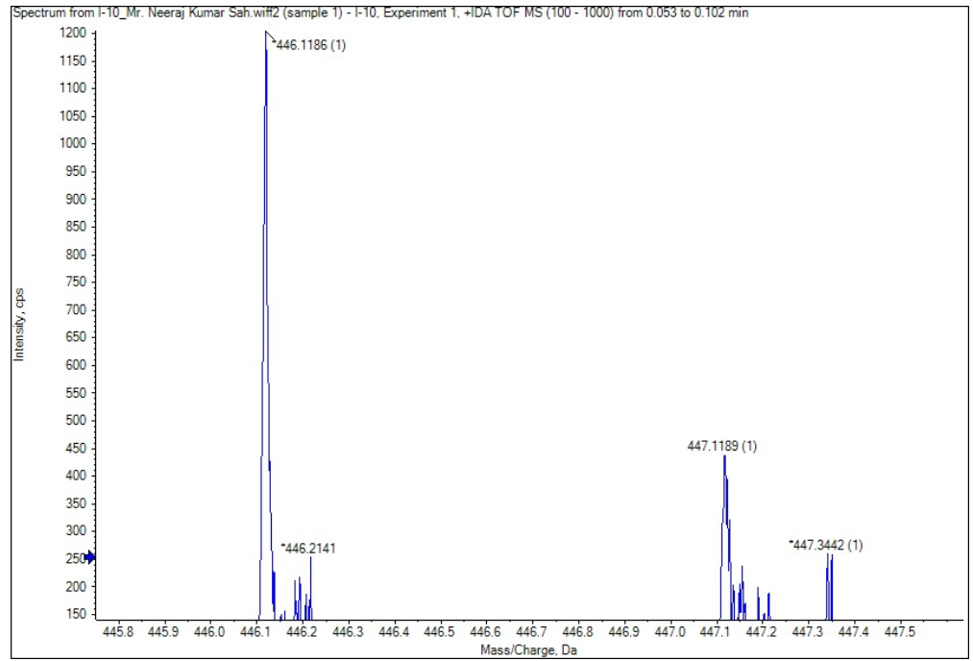
Fig S32: HRMS spectra of (Z)-6-(5-((7-(dimethylamino)-2-oxo-1,2-dihydroquinolin-3-yl)methylene)-4-oxo-2-thioxothiazolidin-3-yl)hexanoic acid (I-10, 27)

Table S1: HRMS table of developed probes:
Sr. No. | Probe ID | Mol. Wt. | Chemical Formula | [M + H] +  Calculated | [M + H] ⁺  Observed | (±) ΔPPM error*  X 10⁶
 | 18 | 390.43 | C₁₇H₁₄N₂O₅S₂ | 391.0417 | 391.0417 | 0.00
 | 19 | 404.46 | C₁₈H₁₆N₂O₅S₂ | 405.0573 | 405.0557 | 3.95
 | 20 | 418.48 | C₁₉H₁₈N₂O₅S₂ | 419.0730 | 419.0740 | 2.14
 | 21 | 432.51 | C₂₀H₂₀N₂O₅S₂ | 433.0886 | 433.0882 | 0.92
 | 22 | 446.54 | C₂₁H₂₂N₂O₅S₂ | 447.1043 | 447.1066 | 5.10
 | 23 | 389.44 | C₁₇H₁₅N₃O₄S₂ | 390.0577 | 390.0579 | 0.51
 | 24 | 403.47 | C₁₈H₁₇N₃O₄S₂ | 404.0733 | 404.0750 | 4.21
 | 25 | 418.48 | C₁₉H₁₈N₂O₅S₂ | 418.0889 | 418.0885 | 1.42
 | 26 | 431.53 | C₂₀H₂₁N₃O₄S₂ | 432.1046 | 432.1039 | 1.61
 | 27 | 445.55 | C₂₁H₂₃N₃O₄S₂ | 446.1203 | 446.1186 | 3.81
*ΔPPM error = [(calculated Mass- Observed Mass)/calculated Mass] X 10⁶

Spectroscopic data
The UV-Vis and fluorescence spectroscopic determination were carried out in DMSO and PBS (at physiological pH 7.4). To assess the sensitivity of D-π-A structure to the surrounding environmental polarity, fluorescence spectra of promising lead (19) was recorded in different solvents with diverse polarities (Toluene, 1,4 Dioxane, THF, MeOH, DMF, and DMSO). The spectroscopic data are shown in Fig. S33-39 and Table S2.
  - UV-Vis and fluorescence spectroscopic data of coumarin-based probes:

Fig. S33: Measurement of absorption spectra (left panel) and linear fitting curve between absorbance and concentration (right panel) of the probe 18, 19, 20, 21 and 22 in DMSO, molar absorption coefficients (ε) of each probe were calculated from the equation Y = ε*X + C from the graph.

Fig. S34: The emission spectra of the 18, 19, 20, 21 and 22 in DMSO.

  - UV-Vis and fluorescence spectroscopic data of carbostyril-based probes:

Fig. S35: Measurement of absorption spectra (left panel) and linear fitting curve between absorbance and concentration (right panel) of the 23, 24, 25, 26, and 27 in DMSO, molar absorption coefficients (ε) of each probe were calculated from the equation Y = ε*X + C from the graph.
Fig. S36: The emission spectra of the 23, 24, 25, 26, and 27 in DMSO. The solutions were excited at their absorption maxima in order to record the emission spectra.
  - UV-Vis and fluorescence spectroscopic data of coumarin and carbostyril-based probes in PBS (pH 7.4):
Fig. S37: Absorbance spectra (left panel) and emission spectra (right panel) of coumarin derivatives (top row) and carbostyril derivatives (bottom row) in PBS (pH 7.4). The solutions were excited at their absorption maxima to record the emission spectra.

  - Molecular rotor framework for "Turn-on" fluorescence phenomena of tested probe (19):
(A)
(B)
Fig. S38 (A-B): Variation in the relative fluorescence intensity (A) and Normalized F.I. (I/I₀) (B) at 600 nm of I-8 in 0-100% (v:v) percentages of glycerol in MeOH.

Effect of polarity on the fluorescence intensity of tested probe (19):

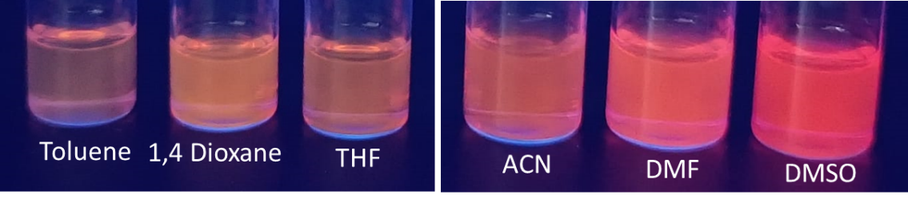
(A)
(solvent Polarity)
7.2
6.4
5.8
4.0
4.8
2.4
(B)
(C)
Fig. S39(A-C): (A) Images of probe 19 (50 µM) dilutions in different solvents (Toluene, 1,4 Dioxane, THF, ACN, DMF, and DMSO) illuminating at 365 nm in (long wavelength) UV light. (B) Total fluorescence emission spectra of probe 19 (1 µM). (C) Plots and linear fitting diagram of emission maxima of probe 19 and corresponding fluorescence intensity w.r.t polarity of different solvents showed good linear correlation values (R²) of 0.9646 and 0.9027, respectively.

Characterization of Aβ₁₋₄₂ fibril:
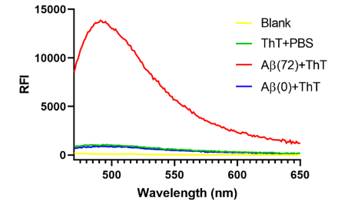
Fig. S40: ThT fluorescence assay to asses aggregation of Aβ monomers [Aβ(0)] to Aβ aggregates [Aβ(72)].

Fluorescence Spectral Assessment of all the developed probes against monomeric Aβ₁₋₄₂ (monomers), Aβ₁₋₄₂ (aggregates) or fibrillar species, and BSA (Bovine serum albumin)

Fig. S41-a: Representative spectral graphs of synthesized probes (18-27) upon incubation with various Aβs and BSA in in-vitro fluorescence assay. Probes (18, 19, 22, and 23; spectral data) having interesting results are added to the main manuscript.
Fig. S41-b. The change in the fluorescence intensity of the promising probes (19 and 22 at 10 µM) upon incubation with various Tau species [here Blank represents 2% DMSO in 10 mM Tris-HEPES assembly buffer, Tau (monomers; 10 µM), and Tau (aggregates; 10 µM) fibrils] in in-vitro fluorescence assay.

pH stability study of probe 18, 19 and 22 in physiological buffers.
Fig. S42. Three-way correlation graphs of probe 18, 19 and 22 at 50 µM upon incubation with at a various pH buffers (pH = 6, 6.7, 7.0, and 7.4 and 10% DMSO as a cosolvent). A, B, C and D in each graph representing signals at pH = 6, 6.7, 7.0 and 7.4, respectively.

HPLC purity profile of the leading probes 19 and 22.
HPLC purity of probe 19 was performed on (Shimadzu, Japan) equipped with a reverse column (Shimadzu Shim-pack GIST C18, 5.0 μm, 4.6 mm×250 mm, Japan). Conditions: acetonitrile/water (85/15, v/v) at a flow rate of 1.0 mL/min.
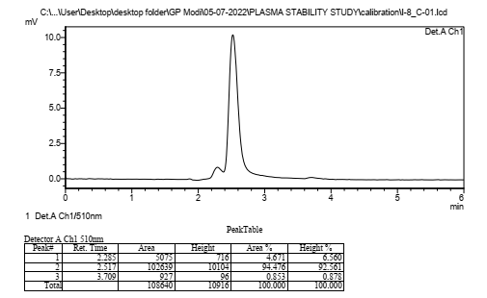
Fig. S43: HPLC performance of the probe 19 showed 94.5 % peak purity at 2.517 retention time.
Whereas, High-Performance Liquid Chromatography purity of probe 22 was performed on (Hitachi Primaide, Japan) equipped with a reverse column (Venusil MP C18, 5.0 μm, 4.6 mm×250 mm, Bonna-Agela Technologies, China). Conditions: acetonitrile/water (85/15, v/v) at a flow rate of 1.0 mL/min.
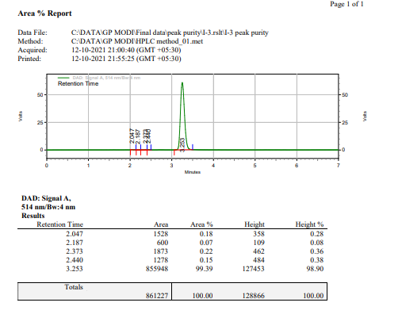
Fig. S44: HPLC performance of the probe 22 showed 98.90 % peak purity at 3.253 retention time.

Stability study in the ICR mice plasma

Fig. S45: HPLC chromatograms of the probe 19 (A) and quantitative analysis to determine the % plasma stability on time scale via bar graph (B).

Assessment of BBB penetration using HPLC:
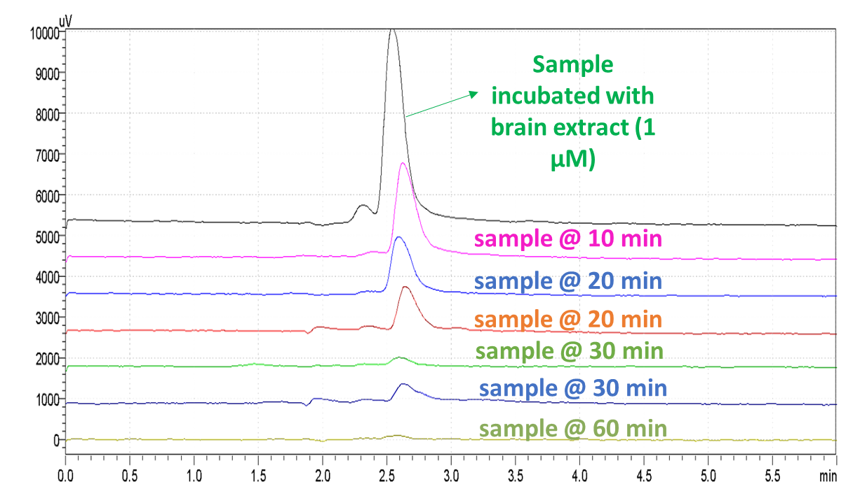
Fig. S46: HPLC chromatograms a) superposed sample of probe 19 (sample) with brain homogenate extract at 10, 20, 30 and 60 min.

Cell internalization experiment:
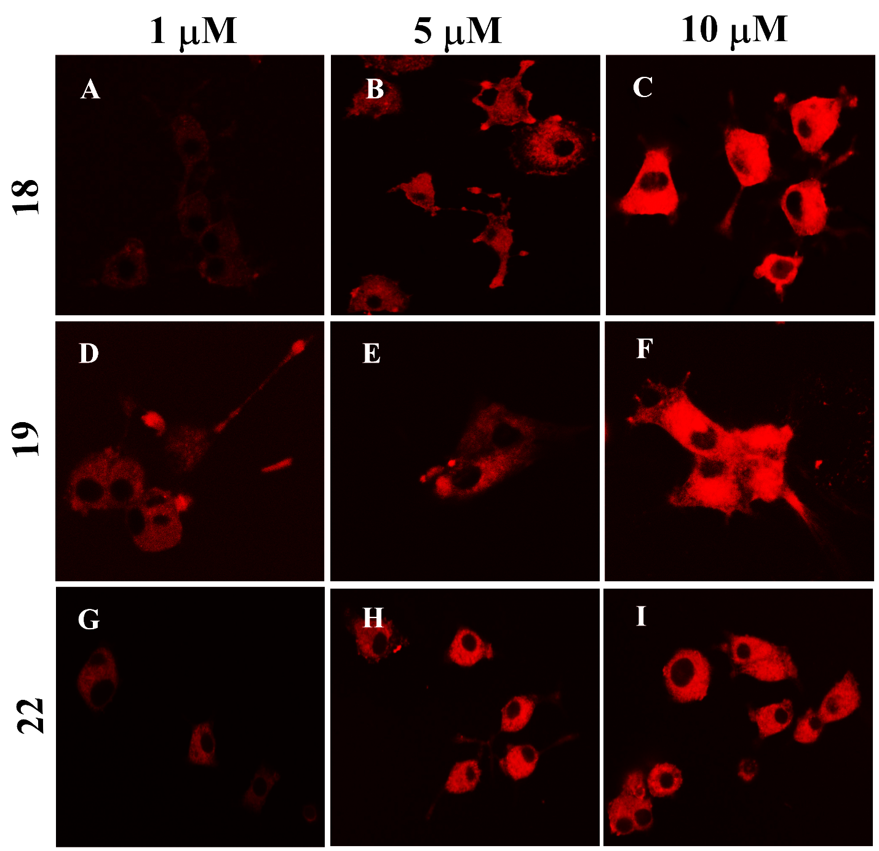
Fig. S47: Concentration-dependent fluorescence microscope images visualizing probe 18 (A, B, and C), 19 (D, E, and F), and 22 (G, H, and I) dyes (at 1, 5, and 10µM respectively) internalization in PC12 cells under 40X magnification.

Fluorescence Spectra of probes 18, 19, and 22 on Brain Tissue Samples

Fig. S48: Probe 18 neuropathological staining of human autopsy brain slides. The amyloid beta binding is shown as arrows, and nonspecific bindings are shown as arrowheads. A & D are DAPI counterstaining for the nucleus, B & E are probe 18 staining observed with green filter, and C & F are probe 18 staining observed with red filter (resolution 20X; scale bare 50 µm).

Fig. S49: Probe 19 neuropathological staining of human autopsy brain slide. The amyloid beta binding is shown as arrows. A & C are DAPI counterstaining for the nucleus, and B & D is probe 19 staining was observed with red filter (resolution 20X; scale bare 50 µm).

Fig. S50: Probe 22 neuropathological staining of autopsy brain slides. The amyloid beta binding is shown as arrows, and nonspecific bindings are shown as arrowheads. A & D are DAPI counterstaining for the nucleus, B & E are 22 staining observed with green filter, and C & F are probe 22 staining observed with red filter (resolution 20X; scale bare 50 µm).

- In-vitro confocal fluorescence imaging of leader probe I-8 using ThT as reference dye:
Fig. S51: Probe 19 Staining. The amyloid beta staining in the control patient's brain autopsy slide. A, D, and G are ThT stained to confirm Aβs. B, E & H are probe 19 counterstaining slide images at 594 nm to confirm Aβs. C, F & H have merged images that show that ThT and probe 19 colocalized showing a high signal-to-noise ratio and similar affinity for Aβs. (resolution 63X; scale bar 10 µm).

Computational studies:
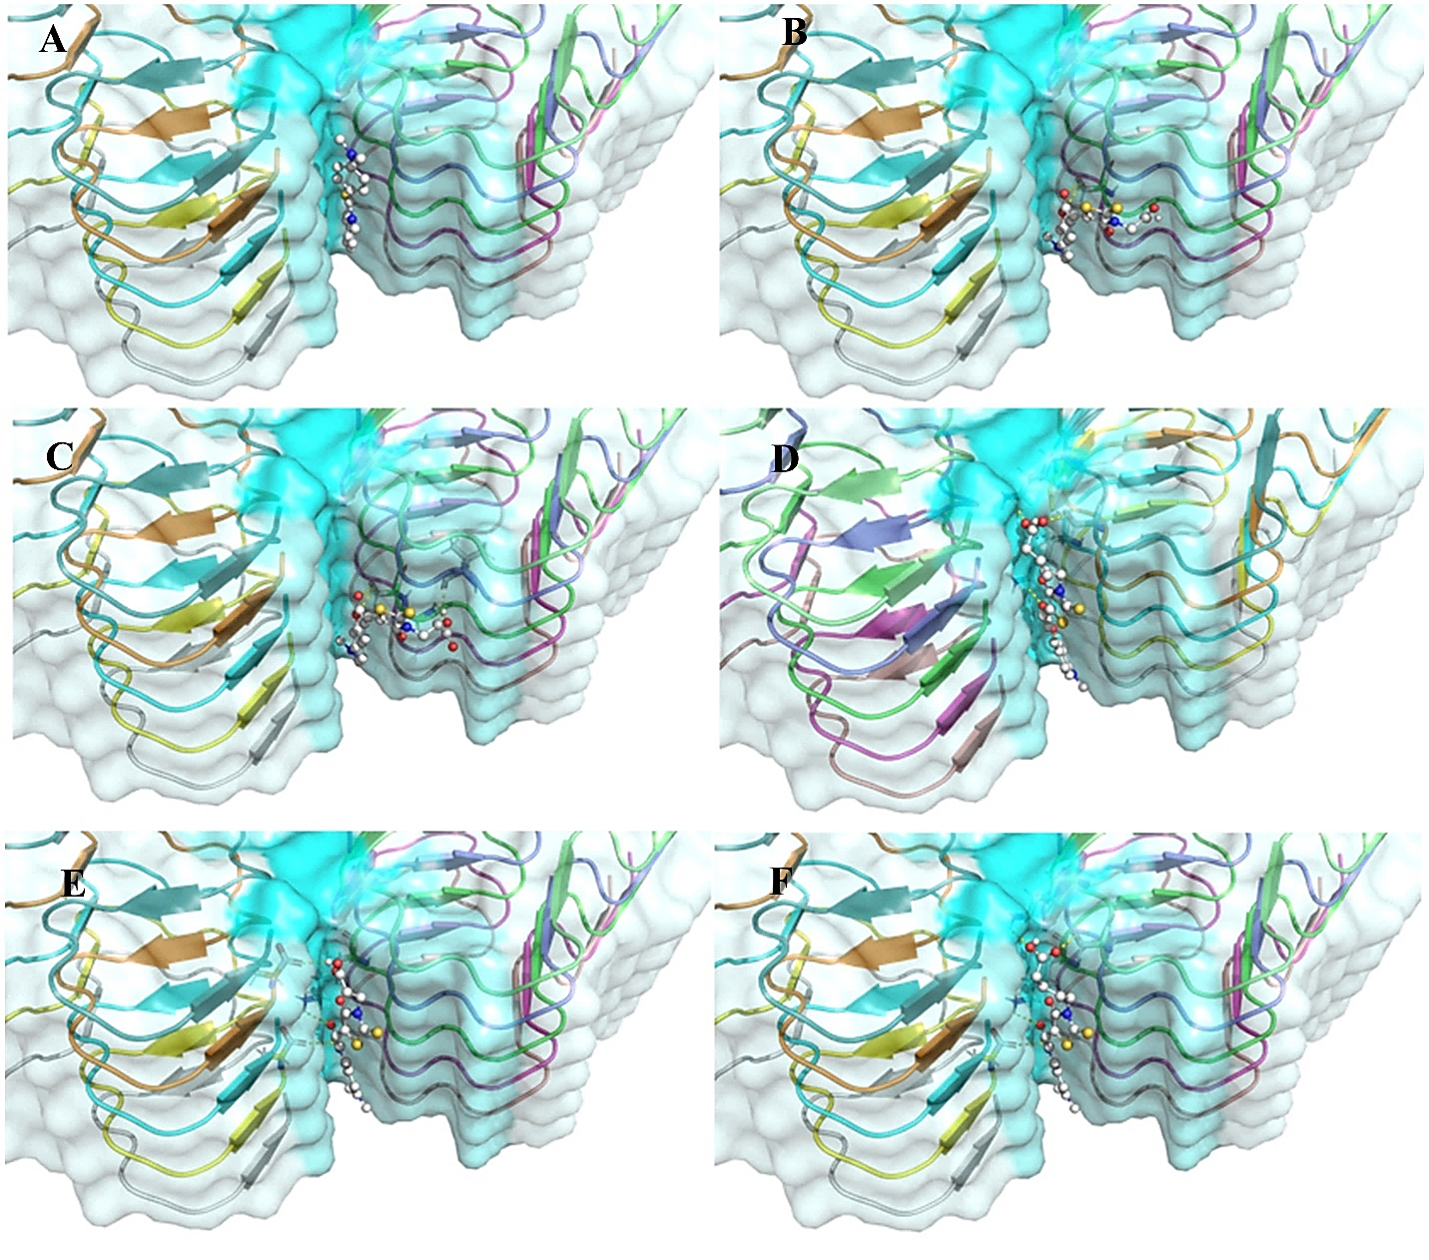
Figure S52. 3D surface representation of the ThT, 18, 19, 22, 24 and 26 (A, B, C, D, E, and F, respectively; ball and stick mode, and color by molecule mode) within the binding pocket of Aβ fibril (PDB ID: 7Q4M)
Fig. S53: Hydrogen bond and nonbonded interactions of probes with Aβ fibril. A, B and C are probe 18, 24 and 26 respectively. The Green dashed line represents the hydrogen bond with distance.

