Additional file 1 It was involved experiments animal, quality control of analysis by PCA chart, volcano charts and a table of the distribution of the sequences.

- Experiment animals.

Cow ID | Year | Time(THI) | Breed | Weigh | BCS | Location
80/53 | 4 | 6:00(HIT77) | Jersey | 341 | 3 | Chongqing
80/53 | 4 | 10:00(THI82) | Jersey | 341 | 3 | Chongqing
80/53 | 4 | 14:00(THI88) | Jersey | 341 | 3 | Chongqing
28/51 | 5 | 6:00(HIT77) | Jersey | 352 | 4 | Chongqing
28/51 | 5 | 10:00(THI82) | Jersey | 352 | 4 | Chongqing
28/51 | 5 | 14:00(THI88) | Jersey | 352 | 4 | Chongqing
30/51 | 4 | 6:00(HIT77) | Jersey | 348 | 3.5 | Chongqing
30/51 | 4 | 10:00(THI82) | Jersey | 348 | 3.5 | Chongqing
30/51 | 4 | 14:00(THI88) | Jersey | 348 | 3.5 | Chongqing
18/51 | 4 | 6:00(HIT77) | Jersey | 347 | 4 | Chongqing
18/51 | 4 | 10:00(THI82) | Jersey | 347 | 4 | Chongqing
18/51 | 4 | 14:00(THI88) | Jersey | 347 | 4 | Chongqing
18/50 | 4 | 6:00(HIT77) | Jersey | 344 | 3 | Chongqing
18/50 | 4 | 10:00(THI82) | Jersey | 344 | 3 | Chongqing
18/50 | 4 | 14:00(THI88) | Jersey | 344 | 3 | Chongqing

（2）data PCA analysis effected by different THI involved THI77, THI82 and THI88

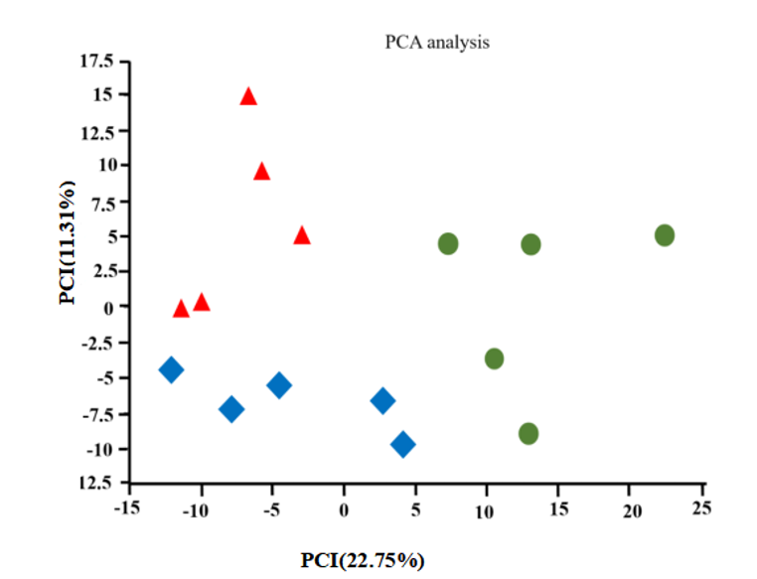

（3）Volcano charts to show different expression gene effected by different weather temperatures involved 25℃(THI77), 30℃(THI82) and 35℃(THI88)

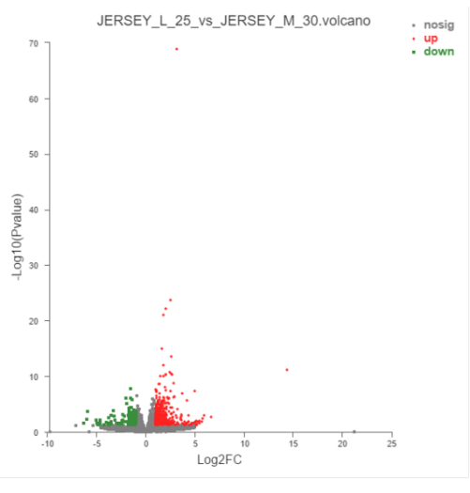
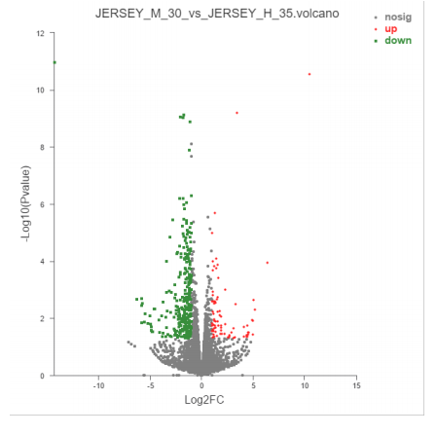
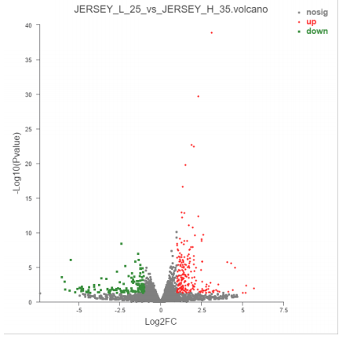

（4）Distribution of sequencing in different regions of the Bos taurus transcriptome.

Sample | Introns (%) | 3'UTR (%) | CDS (%) | 5'UTR (%) | Intergenic (%)
THI=77_1 | 15.23 | 7.71 | 65.04 | 2.81 | 9.22
THI=77_2 | 11.99 | 8.21 | 68.37 | 2.51 | 8.91
THI=77_3 | 10.8 | 8.8 | 68.19 | 3.03 | 9.18
THI=77_4 | 15.49 | 8.03 | 64.41 | 2.61 | 9.46
THI=77_5 | 13.25 | 8.61 | 68.32 | 2.54 | 8.88
THI=82_1 | 17.21 | 7.88 | 62.49 | 2.73 | 9.69
THI=82_2 | 13.34 | 9.88 | 64.7 | 2.93 | 9.15
THI=82_3 | 13.38 | 9.71 | 65.14 | 2.8 | 8.97
THI=82_4 | 16.03 | 8.15 | 62.28 | 2.8 | 10.2
THI=82_5 | 14.19 | 8.3 | 66.22 | 2.9 | 8.39
THI=88_1 | 17.41 | 7.98 | 62.85 | 2.82 | 8.94
THI=88_2 | 14.21 | 8.26 | 66.06 | 3.06 | 8.41
THI=88_3 | 16.13 | 8.11 | 64.16 | 2.88 | 8.72
THI=88_4 | 14.99 | 8.46 | 65.81 | 2.37 | 8.37
THI=88_5 | 14.63 | 7.9 | 66.44 | 2.78 | 8.25

Additional file 2 It shows the original analysis using normalized read counts effected by THI of 77(25℃), 82(30℃) and 88(35℃) within different expressed genes (DEGs) involved total DEGs, up-regulated DEGs and down-regulated DEGs, ,the 16 heat DEGs screened and showed its heatmap with data.
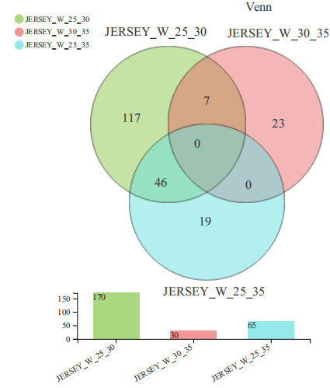

(A) Venn statistics shown total DEGs effected by each pair of THI group of pair of groups involved THI77 vs THI82, THI82 vs THI88 and THI77 vs THI88 ;
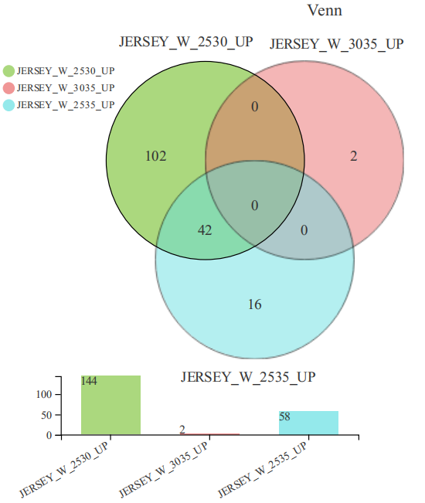

(B)Venn statistics shown up-regulated DEGs effected by each pair of THI involved THI77 vs THI82,THI82 vs THI88 and THI77 vs THI88;
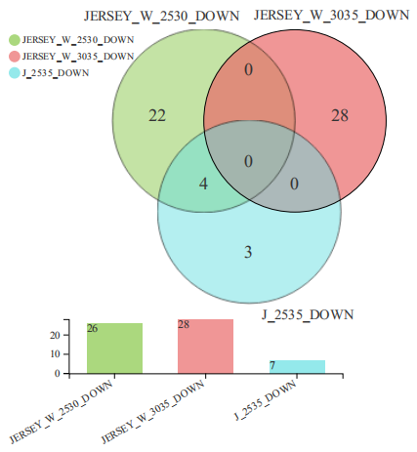

(C)Venn statistics shown down-regulated genes DEGs effected by each pair of THI group involved THI77 vs THI82, THI82 vs THI88 and THI77 vs THI88.

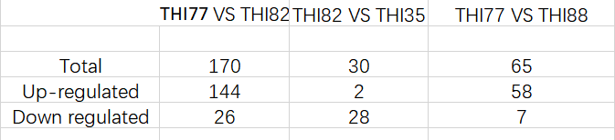

- Statistic of the different expressed genes (DEGs) involved total DEGs, up-regulated DEGs and down-regulated DEGs.
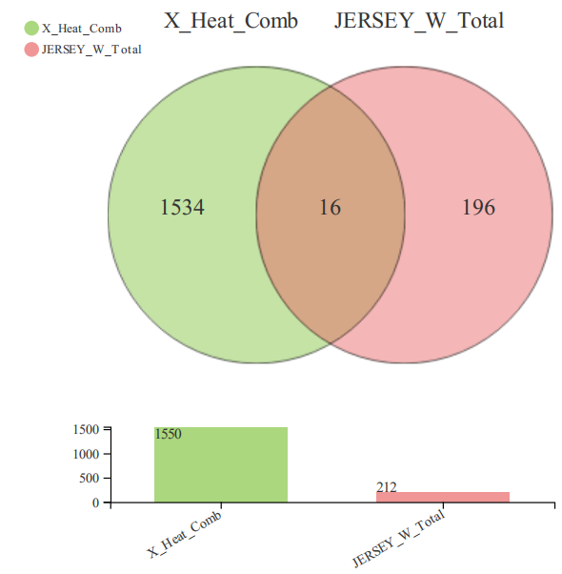

(E)The 16 heat DEGs was screened between heat genes and DEGs.
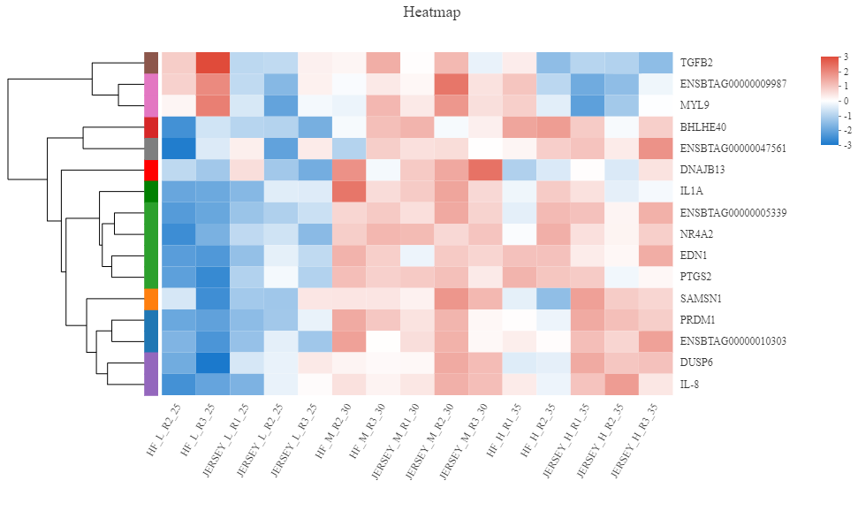
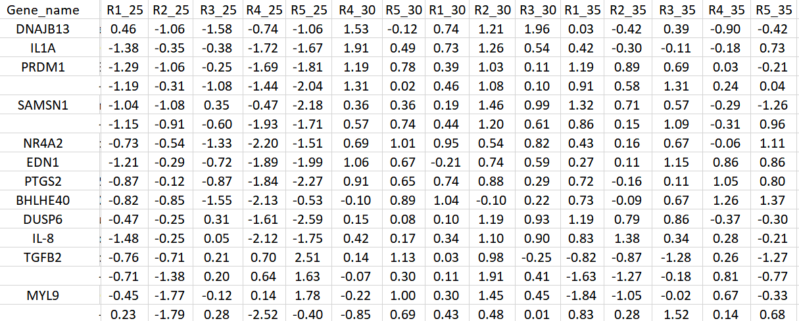
(F)There was shown Original heatmap and its data.

Additional file 3 The histogram of KEGG shows findings of genes in detail annotated at (a) signal transduction, (b) endocrine system, and (c)immune system.
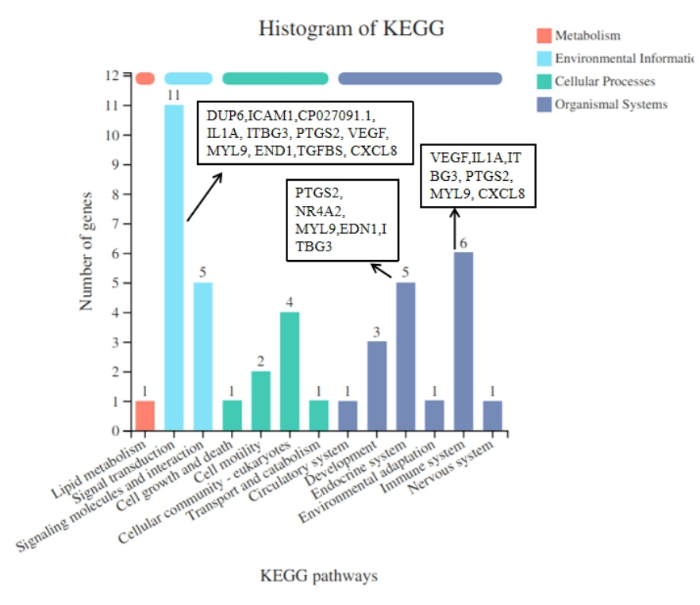
(a)
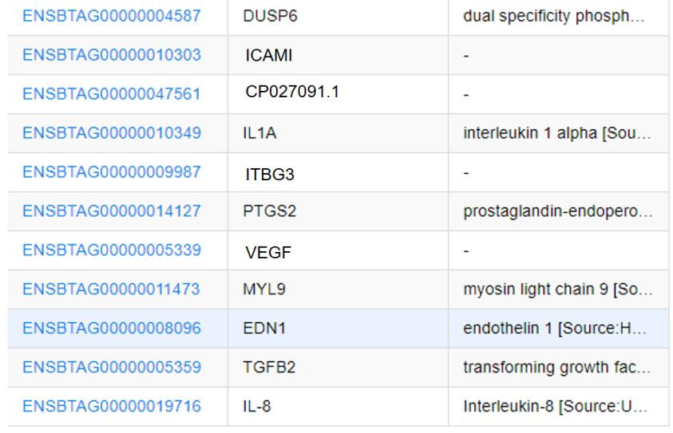

(b)
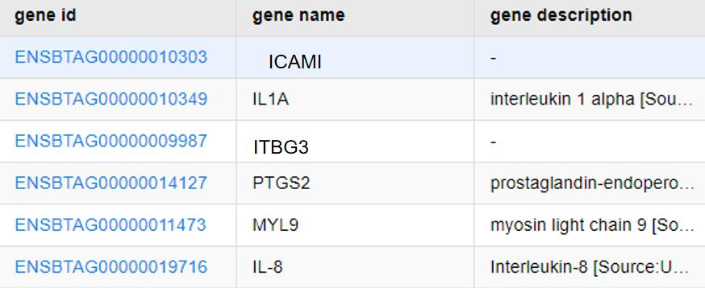

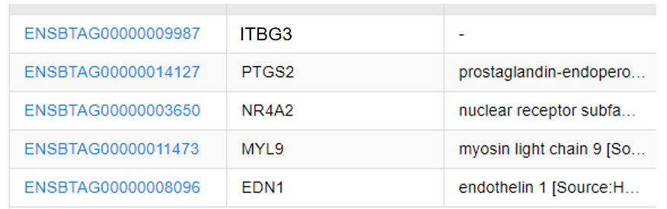
(c)

Additional file 4 The Data supports heat DEGs expression between RNA-seq and Q-PCR.
Gene | RNA-seq | Q-PCR
VEGF | 3.116245633 | 5.171634024
PRDM1 | 1.054091055 | 4.891134068
SAMSN1 | 1.222218258 | 1.68605799
BHLHE40 | 1.031179246 | 3.245455242
NR4A2 | 1.523615429 | 1.959605925
DUSP6 | 1.068648487 | 1.831203613
EDN1 | 1.428660769 | 0.892913323
MYL9 | 1.115241045 | 0.969697781
PTGS2 | 1.581002521 | 0.730693962
CXCL8 | 1.320893774 | 1.328946152
TGFB2 | -1.117683905 | -0.459178681
IL1A | -1.0851836 | -3.542810826

Additional 5 Tables shows (1) raw data of gas exchanged at the fifth day ; (2) Raw data of physiological responses from day 1 to day 5.

Cow ID | Year | Time(THI) | Day | pH | Pco₂
80/53 | 4 | 6:00(HIT77) | 5 | 7.41 | 45
80/53 | 4 | 10:00(THI82) | 5 | 7.4 | 40.2
80/53 | 4 | 14:00(THI88) | 5 | 7.48 | 35
28/51 | 5 | 6:00(HIT77) | 5 | 7.44 | 37
28/51 | 5 | 10:00(THI82) | 5 | 7.45 | 39.6
28/51 | 5 | 14:00(THI88) | 5 | 7.44 | 31
30/51 | 4 | 6:00(HIT77) | 5 | 7.4 | 43
30/51 | 4 | 10:00(THI82) | 5 | 7.45 | 39.8
30/51 | 4 | 14:00(THI88) | 5 | 7.46 | 30
18/51 | 4 | 6:00(HIT77) | 5 | 7.42 | 38
18/51 | 4 | 10:00(THI82) | 5 | 7.5 | 39.9
18/51 | 4 | 14:00(THI88) | 5 | 7.49 | 33
18/50 | 4 | 6:00(HIT77) | 5 | 7.38 | 41
18/50 | 4 | 10:00(THI82) | 5 | 7.45 | 40.1
18/50 | 4 | 14:00(THI88) | 5 | 7.43 | 36
Cow ID | day | Time(THI) | Ambient temp (°C) | Humidity |  | Skin temperature | Retcal temp （°C) | Respiration rate
 |  |  |  | Dry bulb | Wet bulb | Skin temperature | Retcal temp （°C) | Respiration rate
80/53 | 1 | 6:00(HIT77) | 26.4 | 26.1 | 25 | 36 | 38.5 | 51
80/53 | 1 | 10:00(THI82) | 29.3 | 30 | 27 | 38 | 38.8 | 77
80/53 | 1 | 14:00(THI88) | 36 | 35 | 35.1 | 39.6 | 39.5 | 121
28/51 | 1 | 6:00(HIT77) | 26.4 | 26.1 | 25 | 37.5 | 38.9 | 53
28/51 | 1 | 10:00(THI82) | 29.3 | 30 | 27 | 38.4 | 38.4 | 74
28/51 | 1 | 14:00(THI88) | 36 | 35 | 35.1 | 39.5 | 39.6 | 123
30/51 | 1 | 6:00(HIT77) | 26.4 | 26.1 | 25 | 35.5 | 38.1 | 49
30/51 | 1 | 10:00(THI82) | 29.3 | 30 | 27 | 38.6 | 38.8 | 78
30/51 | 1 | 14:00(THI88) | 36 | 35 | 35.1 | 39.3 | 39.8 | 119
18/51 | 1 | 6:00(HIT77) | 26.4 | 26.1 | 25 | 36.2 | 38.7 | 54
18/51 | 1 | 10:00(THI82) | 29.3 | 30 | 27 | 38 | 38.6 | 76
18/51 | 1 | 14:00(THI88) | 36 | 35 | 35.1 | 39.4 | 39.3 | 124
46/50 | 1 | 6:00(HIT77) | 26.4 | 26.1 | 25 | 35.8 | 38.3 | 48
46/50 | 1 | 10:00(THI82) | 29.3 | 30 | 27 | 38.2 | 38.7 | 75
46/50 | 1 | 14:00(THI88) | 36 | 35 | 35.1 | 39.6 | 39.6 | 164
80/53 | 2 | 6:00(HIT77) | 26.9 | 26.4 | 26 | 36 | 38.5 | 51
80/53 | 2 | 10:00(THI82) | 30.2 | 29 | 26.5 | 38 | 38.8 | 77
80/53 | 2 | 14:00(THI88) | 35.5 | 36 | 35.4 | 39.6 | 39.5 | 121
28/51 | 2 | 6:00(HIT77) | 26.9 | 26.4 | 26 | 37.5 | 38.9 | 53
28/51 | 2 | 10:00(THI82) | 30.2 | 29 | 26.5 | 38.4 | 38.4 | 74
28/51 | 2 | 14:00(THI88) | 35.5 | 36 | 35.4 | 39.5 | 39.6 | 123
30/51 | 2 | 6:00(HIT77) | 26.9 | 26.4 | 26 | 35.5 | 38.1 | 49
30/51 | 2 | 10:00(THI82) | 30.2 | 29 | 26.5 | 38.6 | 38.8 | 78
30/51 | 2 | 14:00(THI88) | 35.5 | 36 | 35.4 | 39.3 | 39.8 | 119
18/51 | 2 | 6:00(HIT77) | 26.9 | 26.4 | 26 | 36.2 | 38.8 | 55
18/51 | 2 | 10:00(THI82) | 30.2 | 29 | 26.5 | 38 | 38.6 | 76
18/51 | 2 | 14:00(THI88) | 35.5 | 36 | 35.4 | 39.4 | 39.3 | 132
46/50 | 2 | 6:00(HIT77) | 26.9 | 26.4 | 26 | 35.8 | 38.3 | 48
46/50 | 2 | 10:00(THI82) | 30.2 | 29 | 26.5 | 38.2 | 38.6 | 75
46/50 | 2 | 14:00(THI88) | 35.5 | 36 | 35.4 | 39.6 | 39.6 | 164
80/53 | 3 | 6:00(HIT77) | 26.6 | 25.7 | 25.2 | 36 | 38.5 | 51
80/53 | 3 | 10:00(THI82) | 28 | 29.5 | 26.5 | 38 | 38.8 | 77
80/53 | 3 | 14:00(THI88) | 36.5 | 35.5 | 35.3 | 39.6 | 39.5 | 121
28/51 | 3 | 6:00(HIT77) | 26.6 | 25.7 | 25.2 | 37.5 | 38.9 | 53
28/51 | 3 | 10:00(THI82) | 28 | 29.5 | 26.5 | 38.4 | 38.4 | 73
28/51 | 3 | 14:00(THI88) | 36.5 | 35.5 | 35.3 | 39.5 | 39.6 | 123
30/51 | 3 | 6:00(HIT77) | 26.6 | 25.7 | 25.2 | 35.5 | 38.1 | 49
30/51 | 3 | 10:00(THI82) | 28 | 29.5 | 26.5 | 38.6 | 38.8 | 78
30/51 | 3 | 14:00(THI88) | 36.5 | 35.5 | 35.3 | 39.3 | 39.8 | 119
18/51 | 3 | 6:00(HIT77) | 26.6 | 25.7 | 25.2 | 36.2 | 38.5 | 54
18/51 | 3 | 10:00(THI82) | 28 | 29.5 | 26.5 | 38 | 38.6 | 76
18/51 | 3 | 14:00(THI88) | 36.5 | 35.5 | 35.3 | 39.4 | 39.3 | 131
46/50 | 3 | 6:00(HIT77) | 26.6 | 25.7 | 25.2 | 35.8 | 38.3 | 48
46/50 | 3 | 10:00(THI82) | 28 | 29.5 | 26.5 | 38.2 | 38.9 | 75
46/50 | 3 | 14:00(THI88) | 36.5 | 35.5 | 35.3 | 39.6 | 39.6 | 164
80/53 | 4 | 6:00(HIT77) | 26.8 | 26 | 25.4 | 36 | 38.5 | 51
80/53 | 4 | 10:00(THI82) | 32.2 | 30 | 26.5 | 38 | 38.8 | 77
80/53 | 4 | 14:00(THI88) | 36.2 | 36 | 35.2 | 39.6 | 39.5 | 121
28/51 | 4 | 6:00(HIT77) | 26.8 | 26 | 25.4 | 37.5 | 38.9 | 53
28/51 | 4 | 10:00(THI82) | 32.2 | 30 | 26.5 | 38.4 | 38.4 | 76
28/51 | 4 | 14:00(THI88) | 36.2 | 36 | 35.2 | 39.5 | 39.6 | 123
30/51 | 4 | 6:00(HIT77) | 26.8 | 26 | 25.4 | 35.5 | 38.1 | 49
30/51 | 4 | 10:00(THI82) | 32.2 | 30 | 26.5 | 38.6 | 38.8 | 78
30/51 | 4 | 14:00(THI88) | 36.2 | 36 | 35.2 | 39.3 | 39.8 | 119
18/51 | 4 | 6:00(HIT77) | 26.8 | 26 | 25.4 | 36.2 | 38.5 | 54
18/51 | 4 | 10:00(THI82) | 32.2 | 30 | 26.5 | 38 | 38.6 | 76
18/51 | 4 | 14:00(THI88) | 36.2 | 36 | 35.2 | 39.4 | 39.3 | 126
46/50 | 4 | 6:00(HIT77) | 26.8 | 26 | 25.4 | 35.8 | 38.3 | 48
46/50 | 4 | 10:00(THI82) | 32.2 | 30 | 26.5 | 38.2 | 38.7 | 71
46/50 | 4 | 14:00(THI88) | 36.2 | 36 | 35.2 | 39.6 | 39.6 | 164
80/53 | 5 | 6:00(HIT77) | 26.7 | 26 | 24.4 | 36 | 38.5 | 51
80/53 | 5 | 10:00(THI82) | 30.2 | 29 | 26 | 38 | 38.8 | 77
80/53 | 5 | 14:00(THI88) | 35.8 | 35.5 | 35.4 | 39.6 | 39.5 | 121
28/51 | 5 | 6:00(HIT77) | 26.7 | 26 | 24.4 | 37.5 | 38.9 | 53
28/51 | 5 | 10:00(THI82) | 30.2 | 29 | 26 | 38.4 | 38.4 | 74
28/51 | 5 | 14:00(THI88) | 35.8 | 35.5 | 35.4 | 39.5 | 39.6 | 131
30/51 | 5 | 6:00(HIT77) | 26.7 | 26 | 24.4 | 35.5 | 38.1 | 49
30/51 | 5 | 10:00(THI82) | 30.2 | 29 | 26 | 38.6 | 38.8 | 78
30/51 | 5 | 14:00(THI88) | 35.8 | 35.5 | 35.4 | 39.3 | 39.8 | 119
18/51 | 5 | 6:00(HIT77) | 26.7 | 26 | 24.4 | 36.2 | 38.7 | 54
18/51 | 5 | 10:00(THI82) | 30.2 | 29 | 26 | 38 | 38.6 | 76
18/51 | 5 | 14:00(THI88) | 35.8 | 35.5 | 35.4 | 39.4 | 39.3 | 125
46/50 | 5 | 6:00(HIT77) | 26.7 | 26 | 24.4 | 35.8 | 38.3 | 48
46/50 | 5 | 10:00(THI82) | 30.2 | 29 | 26 | 38.2 | 38.4 | 75
46/50 | 5 | 14:00(THI88) | 35.8 | 35.5 | 35.4 | 39.6 | 39.6 | 164

gene name  Additional 6 The 16 genes enriched at GO and KEGG related to immunosuppression, oxidative stress, and endocrine disorder in lymphocytes under heat stress. | GO_id | GO_term | KO_id | KO_name | Pathway_id | Pathway_definition
TGFB2 | GO:0001666  GO:0010629 | BP: response to hypoxia  BP: negative regulation of gene expression | K13376 | TGFB2 | map04060  Map04350 | Cytokine-cytokine receptor interaction  TGF-beta signaling pathway
ITBG3 | GO:0004872  GO:0019899 | MF::receptor activity  MF:enzyme biinding | K06493 | ITGB3,CD61 | map04919  map04151 | Thyroid hormone signaling pathway  PI3K-Akt signaling pathway
DNAJB13 | GO:0006457  GO:0051082 | BP:protein folding  MF:unfolded protein binding | K09519 | DNAJB13 | ------ | ------
IL1A | GO:0006955  GO:0019221  GO:0034605  GO:0035234  GO:0050715  GO:0005125  GO:0005149 | BP:immune response  BP:cytokine-mediated signaling pathway  BP:cellular response to heat  BP:ectopic germ cell programmed cell death  BP:positive regulation of cytokine secretion  MF:cytokine activity  MF:interleukin-1 receptor binding | K04383 | IL1A | map04933  map04010  map04060 | AGE-RAGE signaling pathway in diabetic complications;  MAPK signaling pathway;  Cytokine-cytokine receptor interaction.
PRDM1 | GO:0000122  GO:0010628 | BP:Negative regulation of transcription from RNA polymerase II promoter  BP:positive regulation of gene expression | ------ | ------ | ------ | ------
SAMSN1 | GO:0002820  GO:0050732  GO:0050869  GO:0005634  GO:0005829  GO:0001784 | BP:Negative regulation of adaptive immune response  BP:Negative regulation of peptidyl-tyrosine phosphorylation  BP:Negative regulation of B cell activation  CC:Nucleus  CC:Cytosol  MP:Phosphotyrosine binding | ------ | ------ | ------ | ------
VEGFA | GO:0007595  GO:0032147  GO:0038033  GO:0038091  GO:0038190  GO:0043117  GO:0050927  GO:0050930  GO:0060749 | BP:Lactation  BP:Activation of protein kinase activity  BP:Positive regulation of endothelial cell chemotaxis by VEGF-activated vascular endothelial growth factor receptor signaling  BP:Positive regulation of cell proliferation by VEGF-activated platelet derived growth factor receptor signaling pathway  BP:VEGF-activated neurophil signaling pathway  BP:Positive regulation of vascular permeability  BP:Positive regulation of positive chemotaxis  BP:Induction of positive chemotaxis  BP:Mammary gland alveolus development  BP:Cellular response to hypoxia  MF:Cytokine activity | K05448 | VEGFA | map04015  map04014  map04933  map04370  map04060  map04151  map04066 | Rap1 signaling pathway  Ras signaling pathway  AGE-RAGE signaling pathway in diabetic complications  VEGF signaling pathway  Cytokine-cytokine receptor interaction  PI3K-Akt signaling pathway  HIF-1 signaling pathway
EDN1 | GO:0001569  GO:0001666  GO:0007585  GO:0007589  GO:0014065  GO:0019229  GO:0030072  GO:0035815  GO:0005125  GO:0005179 | BP:Patterning of blood vessels  BP:Response to hypoxia  BP:Regulation of pH  BP:Body fluid secretion  BP:Phosphatidylinositol 3-kinase signaling  BP:Regulation of vasoconstriction  BP:Peptide hormone secretion  BP:Positive regulation of renal sodium excretion  MF:Cytokine activity  MF:Hormone activity | K16366 | EDN1 | map04270  map04668  map04066  map04933  map05410 | Vascular smooth muscle contraction  TNF signaling pathway  HIF-1 signaling pathway  AGE-RAGE signaling pathway in diabetic complications  Hypertrophic cardiomyopathy (HCM)
ICAM1 | GO:0016337  GO:0005887  GO:0016021  GO:0005178 | BP:Single organismal cell-cell adhesion  CC:Integral component of plasma membrane  CC:Integral component of membrane  MF:Integrin binding | K06490 | ICAM1 CD54 | map04514  map04650  map04668  map04670  map04064  map04933 | Cell adhesion molecules (CAMs)  Natural killer cell mediated cytotoxicity  TNF signaling pathway  Leukocyte transendothelial migration  NF-kappa B signaling pathway  AGE-RAGE signaling pathway in diabetic complications
BHLHE40 | GO:0000122 GO:0032922 | BP:circadian regulation of gene expression  BP:negative regulation of transcription from RNA polymerase II promoter | K03729 | BHLHB2, DEC1 | map04710 | Circadian rhythm
NR4A2 | GO:0001666 GO:0006367 GO:0034599 GO:0043576 | BP:Response to hypoxia  BP:Transcription initiation from RNA polymerase II promoter  BP:Cellular response to oxidative stress  BP:Regulation of respiratory gaseous exchange | K08558 | NR4A2, NURR1 | map04925 | Aldosterone synthesis and secretion
DUSP6 | GO:0000188  GO:0043065  GO:0070373 GO:0004725 | BP:Inactivation of MAPK activity  BP:Positive regulation of apoptotic process  BP:Negative regulation of ERK1 and ERK2 cascade  MF:Protein tyrosine phosphatase activity | K04459 | DUSP, MKP | map04010 | MAPK signaling pathway
MYL9 | GO:0070527  GO:0001725  GO:0016460  GO:0030018  GO:0005509  GO:0032036 | BP：Platelet aggregation  CC：Stress fiber  CC：Myosin II complex  CC：Z disc  MF：Calcium ion binding  MF：Myosin heavy chain binding | K12755 | MYL9 | map04921  map04510  map04810  map04270  map04024  map04022  map04670 | Oxytocin signaling pathway  Focal adhesion  Regulation of actin cytoskeleton  Vascular smooth muscle contraction  cAMP signaling pathway  cGMP-PKG signaling pathway  Leukocyte transendothelial migration
PTGS2 | GO:0001934  GO:0006954  GO:0006979  GO:0055114  GO:0071347  GO:0098869  GO:0004601  GO:0004666 | BP:Inflammatory response  BP:Response to oxidative stress  BP:Oxidation-reduction process  BP:Cellular response to interleukin-1  BP:Cellular oxidant detoxification  MF:Peroxidase activity  MF:Prostaglandin-endoperoxide synthase activity  MF:Dioxygenase activity | K11987 | PTGS2, COX2 | map04657  map04064  map04668  map04921  map04370  map04726  map04913 | IL-17 signaling pathway  NF-kappa B signaling pathway  TNF signaling pathway  Oxytocin signaling pathway  VEGF signaling pathway  Serotonergic synapse  Ovarian steroidogenesis
CXCL8 | GO:0006954  GO:0006955  GO:0030593  GO:0050930  GO:0070098  GO:0071347  GO:0090023  GO:0005153  GO:0008009 | BP:Inflammatory response  BP:Immune response  BP:Neutrophil chemotaxis  BP:Induction of positive chemotaxis  BP:Chemokine-mediated signaling pathway  BP:Cellular response to interleukin-1  BP:Positive regulation of neutrophil chemotaxis  MF:Interleukin-8 receptor binding  MF:Chemokine activity | K10030 | IL8, CXCL8 | map04657  map04622  map04620  map04621  map04060  map04062  map04064 | IL-17 signaling pathway  RIG-I-like receptor signaling pathway  Toll-like receptor signaling pathway  NOD-like receptor signaling pathway  Cytokine-cytokine receptor interaction  Chemokine signaling pathway  NF-kappa B signaling pathway
CP027091.1 | GO:0038033  GO:0038091  GO:0045944  GO:0050731  GO:0071456 | BP：Positive regulation of endothelial cell chemotaxis by VEGF-activated vascular endothelial growth factor receptor signaling pathway  BP：Positive regulation of cell proliferation by VEGF-activated platelet derived growth factor receptor signaling pathway  BP：Positive regulation of transcription from RNA polymerase II promoter  BP：Positive regulation of peptidyl-tyrosine phosphorylation  BP：Positive regulation of positive chemotaxis  BP：Cellular response to hypoxia  MF: Cytokine activity | K05448 | VEGFA | map04933  map04370  map04060  map01521  map04151  map04066 | AGE-RAGE signaling pathway in diabetic complications  VEGF signaling pathway  Cytokine-cytokine receptor interaction  EGFR tyrosine kinase inhibitor resistance  PI3K-Akt signaling pathway  HIF-1 signaling pathway

Additional 7 It shows （A）Co-expression network diagram of the 16 heat DEG and (B) the diagram of VEGF signaling pathway.
(A)
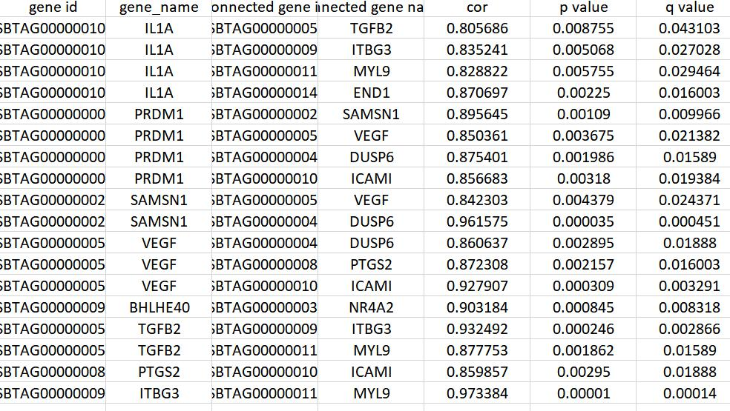

(B)
