Supplementary file
Figure A. Distribution of responses regarding climate anxiety and behavioural engagement
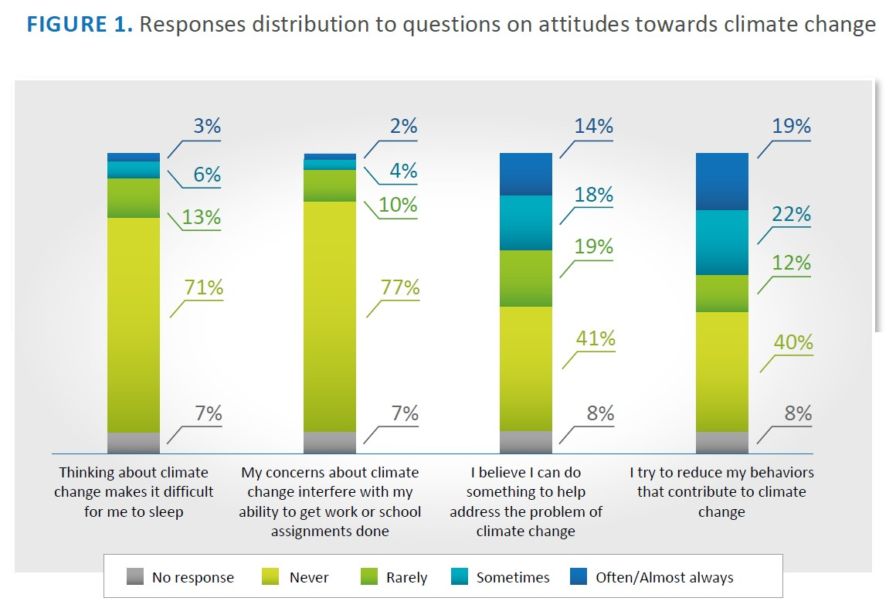
*These proportions include the missing data

