How to improve mRNA-based CAR-T cell generation and functionality? A lab-scale comparison
Nadine von Auw¹, Robert Serfling¹, Reni Kitte¹, Nadja Hilger¹, Chengkang Zhang², Stephan Fricke^{1,3}, U. Sandy Tretbar^{1,3*}
¹Fraunhofer Institute for Cell Therapy and Immunology (IZI), Department for Cell and Gene Therapy Development, Perlickstr. 1, 04103 Leipzig, Germany
²Lonza, 9900 Medical Center Drive, Rockville, MD 20850, USA
³Fraunhofer Cluster of Excellence Immune-Mediated Diseases CIMD, Leipzig, Germany
*corresponding author

Supplemental Information
Supplemental Figures:
Figure S1. Days six to ten after T cell stimulation are the most suitable days for T cell transfection with mRNA. (A) The expansion of T cells from two healthy donors was compared when cultured directly after isolation or expanded after thawing from frozen culture. (B) Primary T cells of four healthy donors were cultured according to protocol A and monitored for cell expansion over 14 days. (C/D) 14 different T cell cultures were checked for viability, T cell subtypes, and activation and available data points were plotted. (E/F) The transfection efficiency of CAR-GFP-mRNA electroporated T cells was determined at day four (E) and day ten (F) post-isolation. H₂O-transfected T cells served as negative control, and EGFP-mRNA transfected T cells as a positive control. Values are displayed as one biological experiment with two replicates (n =1).
Figure S2: Quality control of T cell isolation. Since the frequency of lymphocytes varies across individuals, the quality of T cell separation was assessed on the day of isolation (day -X) by an immune cell phenotyping using flow cytometry. After the Ficoll gradient, immune phenotyping of the obtained peripheral blood mononuclear cells (PBMCs, day -X) showed an adequate composition of 70-85 % T cells (CD3+), 5-10 % B cells (CD19+), 5-10 % monocytes (CD14+), and 5-30 % NK cells (CD56+). CD3+ T cells were composed of CD4+ and CD8+ cells, roughly in a 2:1 ratio. After T cell isolation, naïve T cells were analyzed using the same antibody panel for immune phenotyping, indicating high purity of the T cell population by CD3+/CD4+/CD8+ cells. References for cell numbers: Kleiveland 2015; Miltenyi Biotec.
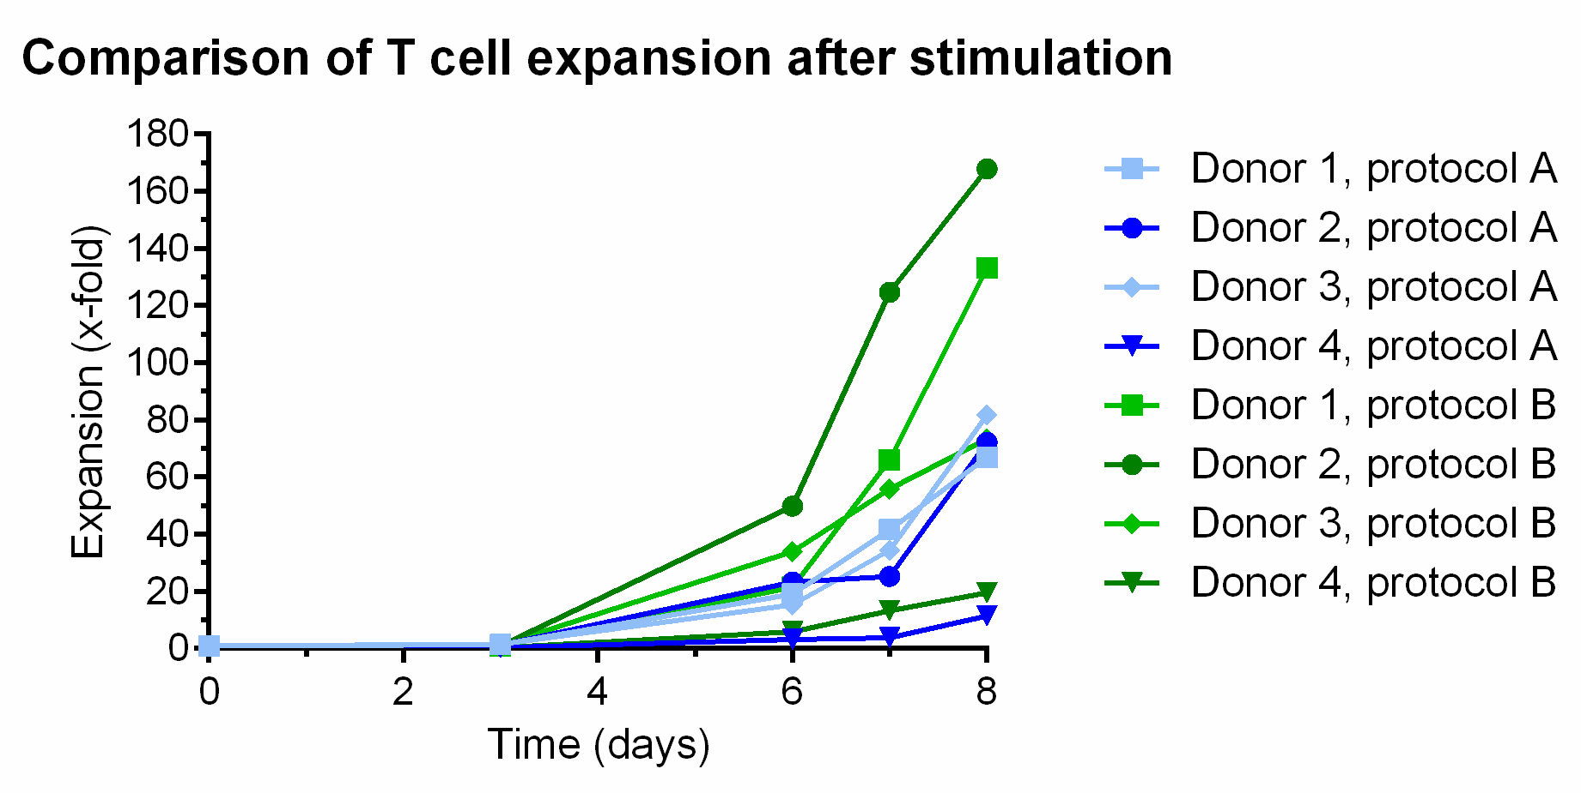
Figure S3: T cell expansion rates of four individual donors in two different media. Primary T cells of four healthy donors were monitored for cell expansion over eight days. Cells were either cultured according to protocol A (blue) or protocol B (green). T cells were cultured at 37 °C and 37 % CO₂ for up to eight days. Values are displayed as one biological experiment (n =1).

Figure S4: Electroporation of primary T cells with EGFP-mRNA using different electroporation parameters (pulse codes). Freshly prepared T cells were stimulated and cultured according to protocol A up to seven days before electroporation with commercially available EGFP-mRNA (TriLink). A total of nine different pulse codes were tested. The transfection efficiency (percentage of EGFP-positive cells (GFP⁺)) and viability (percentage of 7-AAD-negative cells (7-AAD⁻)) were measured via flow cytometry 24 h (A) and 48 h (B) after transfection. Untransfected cells mixed with mRNA were used as control (NPC). Data represent the means (±SEM) of two replicates from one donor, each measured as technical duplicates.
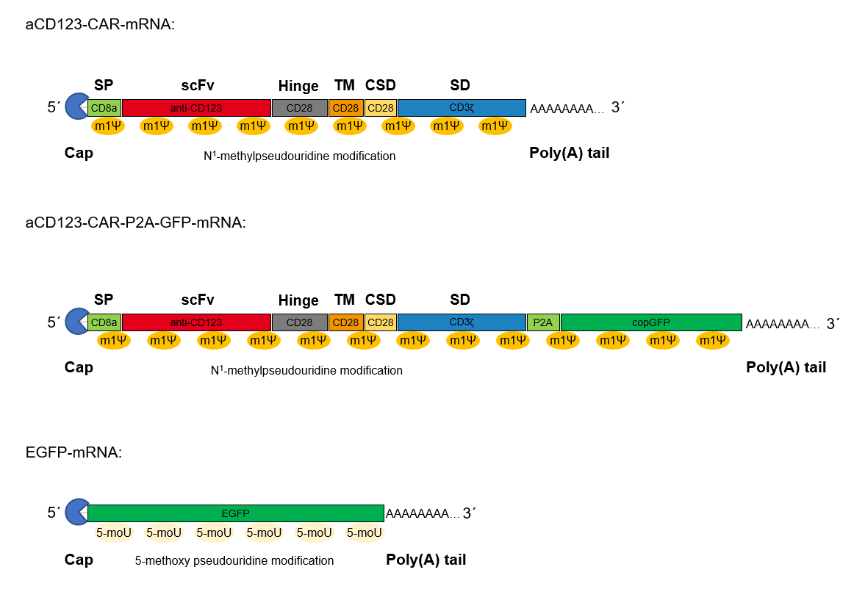
Figure S5: Schematic of the mRNA constructs used in this study. For transient transfection, an anti-CD123-CAR-mRNA and a reporter EGFP mRNA were used. Both were capped, poly(A)-tailed, and modified with pseudouridine variants instead of uridine 5’-triphosphate (UTP). The CAR-encoding sequence consists of signal peptide (SP), CD123-directed single chain variable fragment (scFv), CD28 hinge, CD28 transmembrane domain (TM), CD28 co-stimulatory domain (CSD), and a CD3ζ signaling domain (SD). The reporter EGFP mRNA was only used for pulse code testing for optimal electroporation setting determination.
Figure S6: Electroporation of primary T cells with aCD123-CAR-P2A-GFP model mRNA using three pre-selected pulse codes. Freshly prepared T cells were stimulated and cultured for up to 10 days before electroporation with CAR-mRNA. Untransfected cells mixed with mRNA were used as control (NPC). Data represent the means (±SEM) of two replicates from one donor, each measured as technical duplicates. The transfection efficiency (percentage of EGFP-positive cells (GFP⁺)) and CAR expression was measured via flow cytometry 24 h (A) and 48 h (B) after transfection. (C) The viability was determined 24 h after transfection as a percentage of 7-AAD-negative (7-AAD⁻) cells.

References:

Kleiveland, Charlotte R. (2015): The Impact of Food Bioactives on Health: in vitro and ex vivo models. Peripheral Blood Mononuclear Cells. Hg. v. Kitty Verhoeckx, Paul Cotter, Iván López-Expósito, Charlotte Kleiveland, Tor Lea, Alan Mackie, et al. Cham (CH).

Miltenyi Biotec: Blood. Subtypes of PBMCs. Online verfügbar unter https://www.miltenyibiotec.com/DE-en/resources/macs-handbook/human-cells-and-organs/human-cell-sources/blood-human.html#gref.

