Table 1. Psidium guajava compounds
No | Compounds | Structure
1 | 1,2-benzenedicarboxylic-acid | 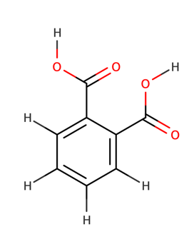
2 | 2-cyclohexene-1-carboxylic-acid-1-methyl-4-oxo-ethyl-ester | 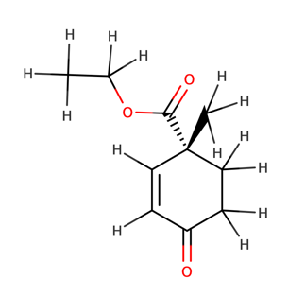
3 | 2-Furancarboxaldehyde, 5-hydroxymethyl | 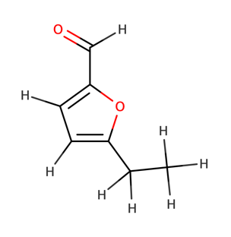
4 | 2-methyl-Z,Z-3,13-octadecadienol | 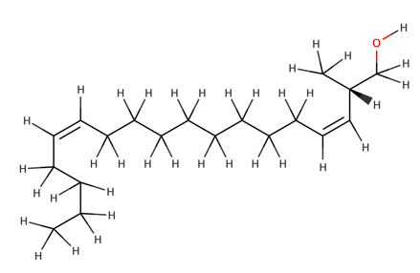
5 | 3-methyl mannoside | 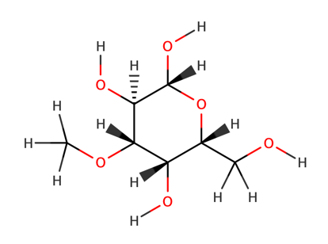
6 | 14-methyl-8-hexadecyn-1-ol | 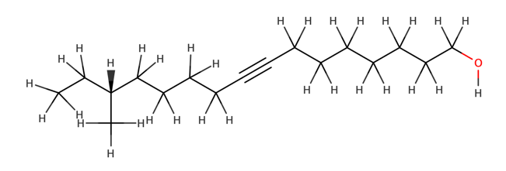
7 | gamma sitosterol | 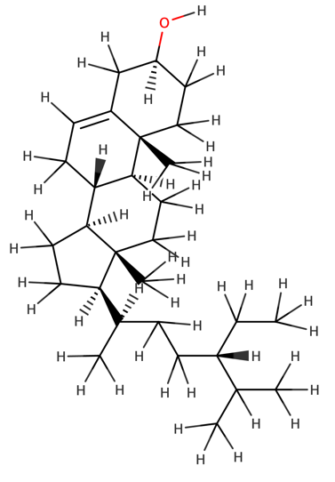
8 | geranyl acetate | 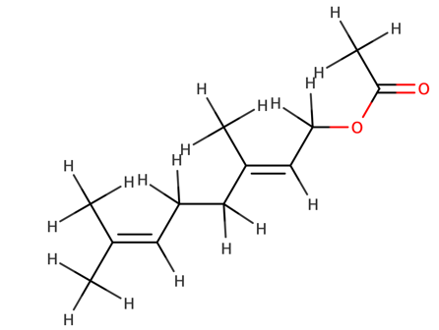
9 | hexadenoic acid | 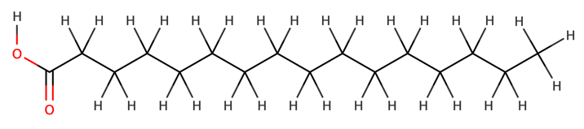
10 | hexadenoic acid ethyl ester | 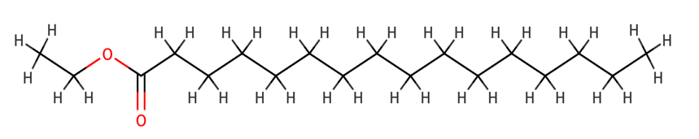
11 | hexadenoic acid methyl ester | 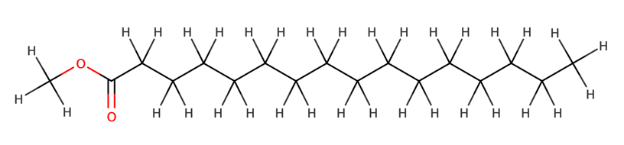
12 | methyl-(8E,11E)-octadeca-8,11-dienoate | 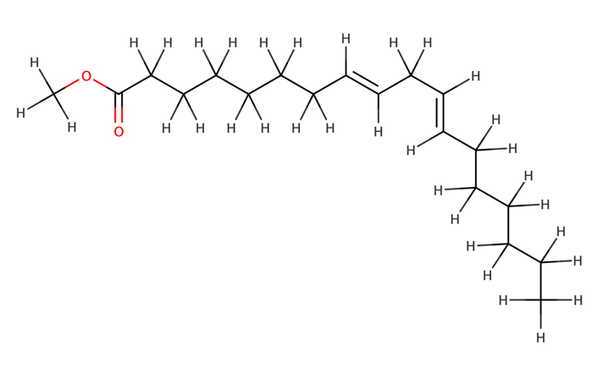
13 | peri-xanthenoxanthene-4,10-dione,2,8-bis (1-methylethyl) | 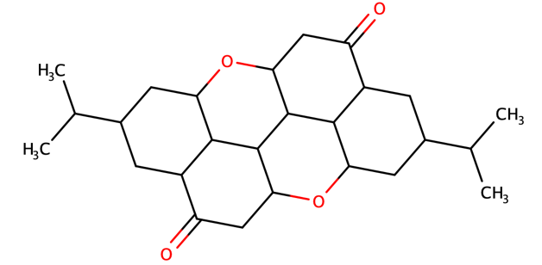
14 | (R)-(-)-14-methyl-8-hexadecyn-1-ol | 