Supplementary Material

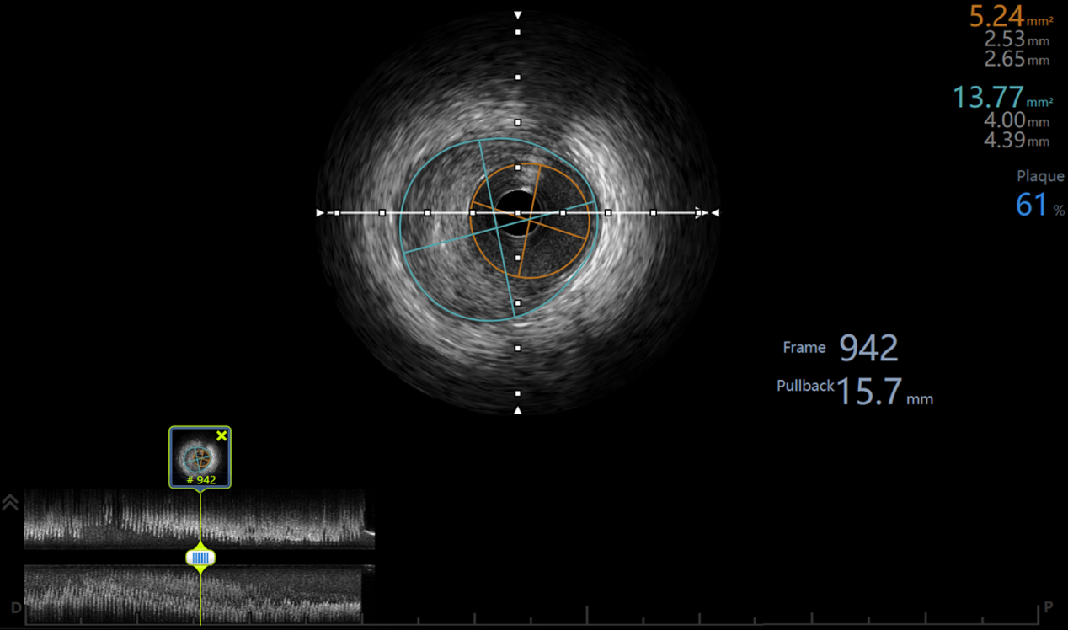
Fig. S1 Schematic diagram of plaque measurement by IVUS.
The lower left part is the long-axis image of the coronary. The upper left part is a cross-sectional image of the narrowest part of the lumen, in which the part surrounded by the purple ring line is the external elastic membrane area (MLA-EEM), the part surrounded by the orange ring line is the lumen area (MLA-LA), and the area between the two is Plaque area (MLA-PA). The upper right corner is the corresponding area (mm²), minimal diameter (mm), and maximum diameter (mm), and the blue (plaque: 61) represents the plaque burden. Frame and pullback are location of the current slice.

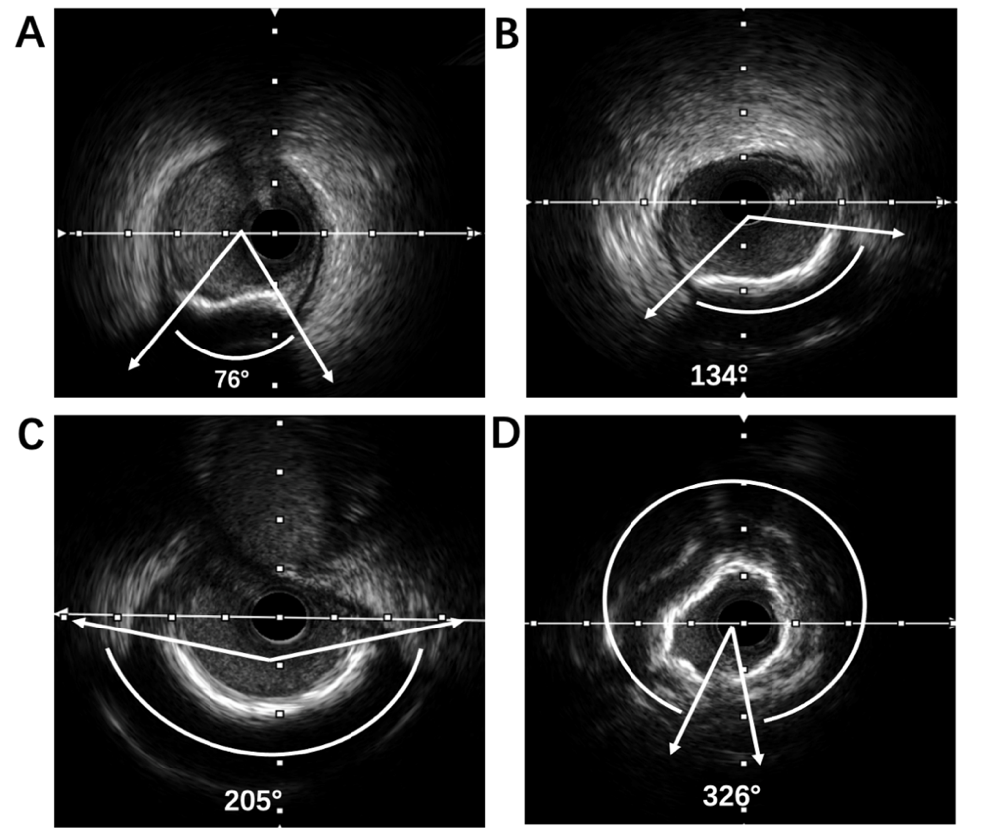
Fig. S2 Schematic diagram of CAC measurement by IVUS.
The white part with opaque sound and shadow is the calcified part. The two arrow lines start from the center of the lumen, and the enclosed angle is the calcified angle (Arc). CAC grouping：A: Grade I CAC; B: Grade II CAC; C: Grade III CAC; D: Grade IV CAC.

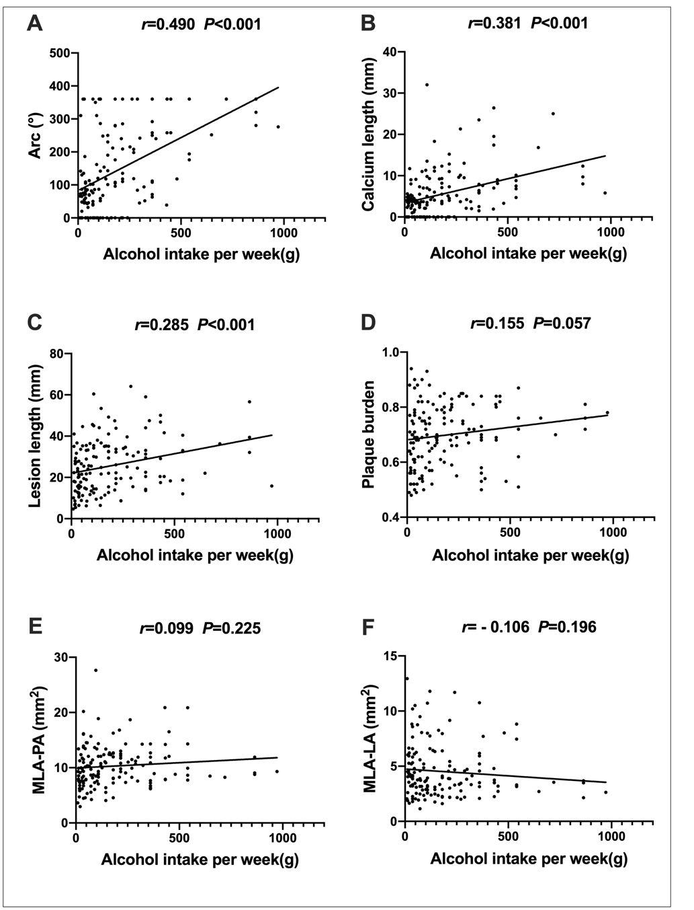
Fig. S3 Correlations between weekly alcohol intake and CAC & plaque parameters.

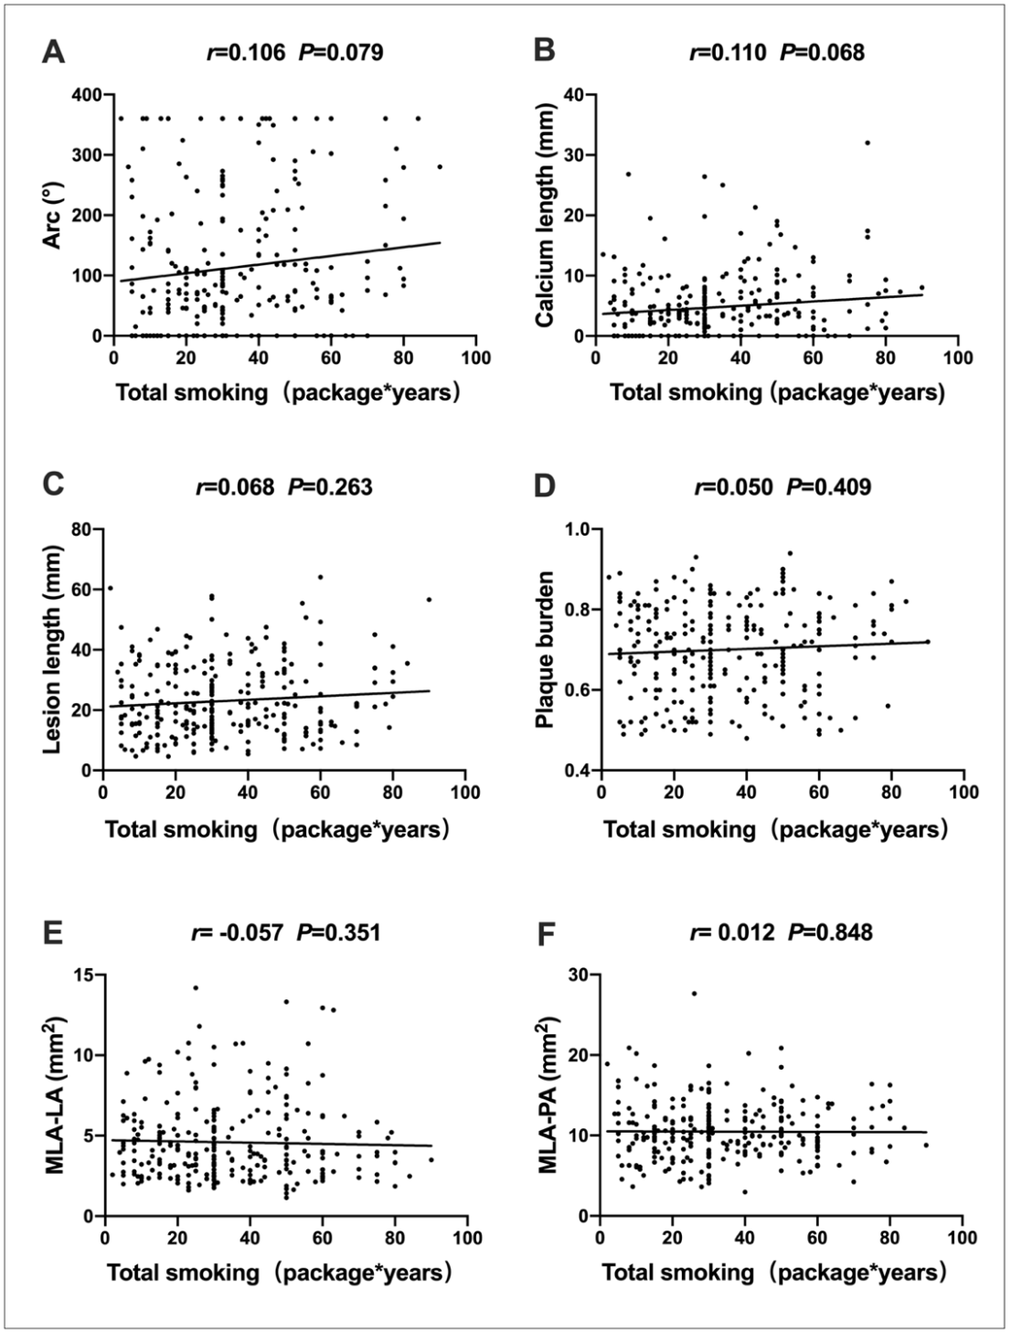
Fig. S4 Correlations between total smoking and CAC & plaque parameters.

Table S1 Uni- and multivariate analysis of SCAC in the whole population(n=536).

Factors | Univariate |  |  | Multivariate
Factors | OR | 95% CI | P value | OR | 95% CI | P value
Age | 1.072 | 1.049-1.097 | <0.001 | 1.059 | 1.029-1.089 | <0.001
PP | 1.061 | 1.045-1.078 | <0.001 | 1.042 | 1.023-1.060 | <0.001
FFAs | 1.517 | 1.350-1.705 | <0.001 | 1.388 | 1.210-1.593 | <0.001
DM duration grade | 1.820 | 1.410-2.350 | <0.001 | 1.508 | 1.108-2.052 | 0.009
Drinking level
None | 1.0 |  |  | 1.0
Light | 0.484 | 0.223-1.053 | 0.067 | 0.540 | 0.206-1.414 | 0.209
Moderate | 2.747 | 1.461-5.164 | 0.002 | 5.179 | 2.254-11.898 | <0.001
Heavy | 9.091 | 4.345-19.020 | <0.001 | 13.975 | 5.427-35.985 | <0.001
Smoking level
None | 1.0 |  |  | 1.0
Light | 0.680 | 0.373-1.239 | 0.208 | 0.904 | 0.371-2.204 | 0.824
Moderate | 0.652 | 0.363-1.170 | 0.152 | 0.740 | 0.309-1.770 | 0.499
Heavy | 1.379 | 0.847-2.246 | 0.197 | 0.919 | 0.406-2.081 | 0.840
Sex | 0.850 | 0.567-1.274 | 0.431 | 0.938 | 0.466-1.889 | 0.857

