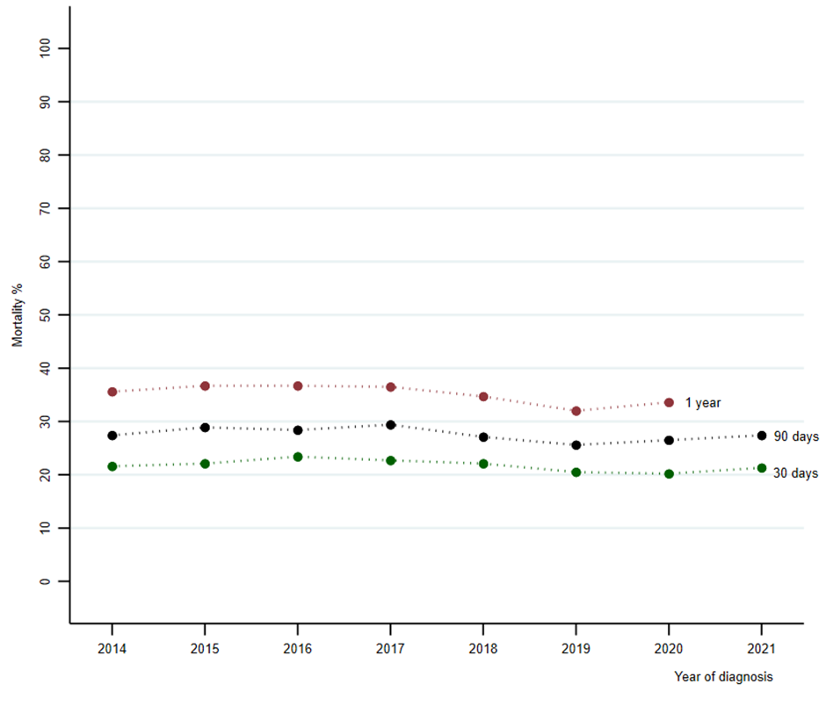
Supplementary Figure 1 Age-standardized mortality at 30- and 90-day and 1-year for patients with sepsis receiving intensive care treatment

Supplementary Table 1 Hazard ratio for death from Cox regression by sepsis characteristics during follow-up of sepsis patients.
Variable | No. of patients | Person year at risk | Deaths | Mortality  per 100 person year | Crude HR | Adjusted HRª (95% CI)
Sepsis subgroup^{b}
Implicit | 17 315 | 11 079 | 5 598 | 50.5 | 1.00 | 1.000 (Reference)
Explicit | 8 258 | 5 526 | 2 660 | 48.1 | 0.99 | 1.09 (1.04–1.14)
COVID-19-related | 2 845 | 1 841 | 490 | 26.6 | 0.53 | 0.85 (0.77–0.93)
Abbrevation: HR=Hazard Ratio, CI= Confidence Interval.
ª Cox regression with time to death as dependent variable, the listed variable as covariate, adjusted for indicator covariate for the year 2020, sex and age.
^{b} All patients entered after 27th February 2020

