Title: The Importance of Decreased Expression Levels of BAT5 and IL21R-AS1 in Circulating Leukocytes of Patients with Acute Myocardial Infarction

Table S1: Gene informations of lncRNAs in public databases
 | IL21R-AS1 | BAT5
GENCODE Gene Name | IL21R-AS1 | BAT5, ABHD16A
GENCODE Gene | ENSG00000259954 | ENSG00000204427 and ENSG00000204422
LncBook Gene ID | HSALNG0110450 | HSALNG0149398
LncExpDB Transcript ID and chromosomal localisation | HSALNT0385140, HSALNT0229266, HSALNT0229267 (hg38: chr16:27447669-27453393) | HSALNT0333720 (hg38: chr6:31737432-31739943)

Table S2: The primers used in qRT-PCR experiments
Primer pairs
BAT5 | Forward: 5’-ATTCCAGCTCCTGGGTTACTTG-3’  Reverse: 5’-TCCGATGTGTTGCTTCCAAGA-3’
IL21R-AS1 | Forward: 5’-CTGGTTCTTGTAGCTCCGTG-3’  Reverse: 5’-CTCACCTTACCCTCATCCTGTG-3’
ACTB | Forward: 5’-GACCCAGATCATGTTTGAGACC-3’  Reverse: 5’-TGGTGGTGAAGCTGTAGCC-3’

Table S3: N6-methyladenosine (m⁶A) modification sites of BAT5
# | Position | Sequence context | Structural context | Local structure visualization | Score  (binary) | Score  (knn) | Score  (spectrum) | Score  (combined) | Decision
1 | 12 | ----- ----- -AAGT  TACAG AGACA ACATG  CTGAG AGAGC AGAGG | N/A | N/A | 0.565 | 0.409 | 0.498 | 0.530 | m⁶A site (Low confidence)
2 | 709 | GCCGT TTTCT CACTA  TGCTG GGACA TTGCT  GCTAC TTCTG GCAGG | N/A | N/A | 0.566 | 0.323 | 0.514 | 0.533 | m⁶A site (Low confidence)
3 | 763 | CCTCC GAGGC ATTGG  CCGCT GGACC AACCC  CCAGT ACCGG CAGTT | N/A | N/A | 0.558 | 0.569 | 0.651 | 0.595 | m⁶A site (Moderate confidence)
4 | 860 | CAGCT TGCCA ACTAC  AACTT TGACT TCCGG  AGCTG GCCAG TCGAC | N/A | N/A | 0.512 | 0.795 | 0.779 | 0.633 | m⁶A site (High confidence)
5 | 897 | CAGTC GACTT CCACT  GGGAA GAACC CAGCA  GCCGG AAGGA GTCTC | N/A | N/A | 0.377 | 0.532 | 0.742 | 0.531 | m⁶A site (Low confidence)
6 | 979 | CCCAG AGCCC CTGCA  CCGGG GGACA GCAGA  CACCC TCCTC AACCG | N/A | N/A | 0.632 | 0.673 | 0.701 | 0.661 | m⁶A site (High confidence)
7 | 1211 | GAGAT TGACA CCATG  TTTGT GGACC GGCGG  GGGAC AGCTG AGCCC | N/A | N/A | 0.576 | 0.703 | 0.485 | 0.546 | m⁶A site (Low confidence)
8 | 1222 | CATGT TTGTG GACCG  GCGGG GGACA GCTGA  GCCCC AGGGA CAGAA | N/A | N/A | 0.597 | 0.435 | 0.454 | 0.532 | m⁶A site (Low confidence)
9 | 1239 | GGGGG ACAGC TGAGC  CCCAG GGACA GAAGC  TGGTG ATCTG CTGTG | N/A | N/A | 0.656 | 0.467 | 0.448 | 0.563 | m⁶A site (Moderate confidence)
10 | 1448 | CGCCT AGGCT TCCAG  CCCCA GGACA TCATC  ATCTA CGCCT GGTCC | N/A | N/A | 0.663 | 0.85 | 0.502 | 0.608 | m⁶A site (High confidence)
11 | 1609 | CTGGA GGGGC CTGGT  GACCA GGACC GTGAG  GCAGC ATCTC AATCT | N/A | N/A | 0.561 | 0.690 | 0.611 | 0.587 | m⁶A site (Moderate confidence)
12 | 1724 | ATCAC CACCA CGGTT  CCTGA GGACA TCATG  TCCAA CCGAG GCAAT | N/A | N/A | 0.642 | 0.692 | 0.569 | 0.615 | m⁶A site (High confidence)
13 | 1886 | AGCCG ATGGG AGGTG  GAAGA GGACT GGTGT  CTGTC TGTCC TCCGC | N/A | N/A | 0.691 | 0.721 | 0.418 | 0.583 | m⁶A site (Moderate confidence)
14 | 1958 | TTCCC CTGGA GCGTG  GGGGA GGACA TGAGT  GCAGA TGGAC GGCGG | N/A | N/A | 0.605 | 0.741 | 0.758 | 0.673 | m⁶A site (Very high confidence)
15 | 2057 | TGCAC CCCAC TCCCA  GCCCA GAACT TCCAG  ATGCC CTGGC ACCTC | N/A | N/A | 0.677 | 0.816 | 0.723 | 0.702 | m⁶A site (Very high confidence)
16 | 2085 | AGATG CCCTG GCACC  TCTAG GGACC AACTG  GGACT CATTA TGGAA | N/A | N/A | 0.596 | 0.718 | 0.676 | 0.634 | m⁶A site (High confidence)
17 | 2095 | GCACC TCTAG GGACC  AACTG GGACT CATTA  TGGAA GAATG GGGTG | N/A | N/A | 0.693 | 0.630 | 0.667 | 0.680 | m⁶A site (Very high confidence)

Table S4: N6-methyladenosine (m⁶A) modification sites of IL21R-AS1
# | Position | Sequence context | Structural context | Local structure visualization | Score(binary) | Score(knn) | Score(spectrum) | Score(combined) | Decision
1 | 288 | TCCCA GCAGA AAGAG  AGCAT GGACC AGCTA  GGGTA CGTTC CAGCA | N/A | N/A | 0.601 | 0.635 | 0.454 | 0.544 | m⁶A site (Low confidence)
2 | 447 | CATTT CATCT GTCAG  ACGGA TGACT CTGCC  CCTCA GAGCT TGCAG | N/A | N/A | 0.516 | 0.573 | 0.663 | 0.577 | m⁶A site (Moderate confidence)
3 | 488 | GCAGA CGGCA AGGTG  ATAAG GAACA ATATG  GACTT CTTGC AGCTC | N/A | N/A | 0.535 | 0.582 | 0.755 | 0.626 | m⁶A site (High confidence)
4 | 497 | AAGGT GATAA GGAAC  AATAT GGACT TCTTG  CAGCT CCTGG AGGCA | N/A | N/A | 0.792 | 0.805 | 0.777 | 0.787 | m⁶A site (Very high confidence)
5 | 593 | CAAAG CCCCG GAGAT  GCTGT GGACC AACTT  GCAAC ACAAG ACCCT | N/A | N/A | 0.580 | 0.695 | 0.688 | 0.629 | m⁶A site (High confidence)
6 | 786 | GTGCA ATCAC ACACA  CACGT GGACA TGCCA  CTGCG CACCT AAGAC | N/A | N/A | 0.689 | 0.728 | 0.357 | 0.558 | m⁶A site (Moderate confidence)
7 | 984 | CCAGT GGCCT GGCCA  GCTCT GGACA TCCAG  TCAGC CTCAT TAGCT | N/A | N/A | 0.604 | 0.582 | 0.555 | 0.583 | m⁶A site (Moderate confidence)
8 | 1339 | CCAGC TGAGA CACAG  CCACA GGACA GGACT  GTGGT CCCTG CATCC | N/A | N/A | 0.658 | 0.715 | 0.529 | 0.609 | m⁶A site (High confidence)
9 | 1344 | TGAGA CACAG CCACA  GGACA GGACT GTGGT  CCCTG CATCC AAGAG | N/A | N/A | 0.757 | 0.804 | 0.518 | 0.663 | m⁶A site (High confidence)
10 | 1495 | AGCAC AGTCA CTGTG  TCAAT GGACA CCAGG  CCGTA TGGCC GATCC | N/A | N/A | 0.608 | 0.656 | 0.497 | 0.566 | m⁶A site (Moderate confidence)

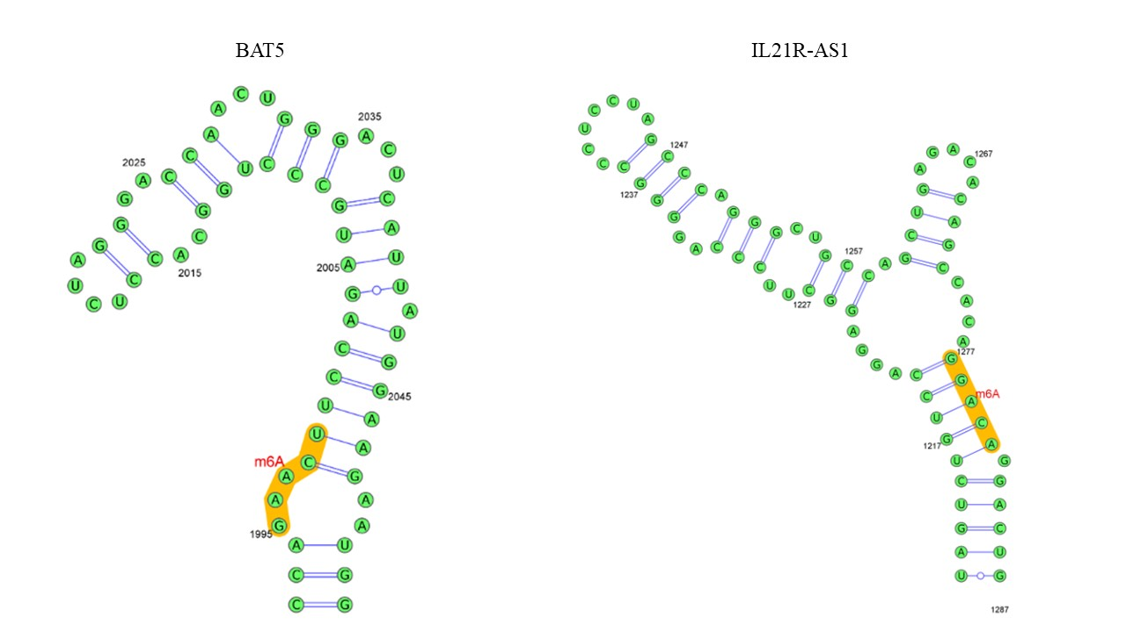
Figure S1: The m⁶A modification site of BAT5 and IL21R-AS1

