Supplementary Materials for

Acute isolation is associated with increased reward responsiveness in human adolescents
L. Tomova^{1,2}*, E. Towner¹, K. Thomas^{1,3}, S-J Blakemore^{1,3}*
¹ Department of Psychology, University of Cambridge
² Hughes Hall, University of Cambridge
³ Institute of Cognitive Neuroscience, University College London

*Corresponding authors. Emails: S-J Blakemore: sblakemore@ucl.ac.uk;
L. Tomova: lt503@cam.ac.uk

This document includes:

Supplementary Materials
Figures S1 to S5
Tables S1 to S11

Supplementary Materials
Analyses for final rating at the end of isolation (T4; 3h 30min to 4h of isolation, varying between participants)
At the end of social isolation (T4), participants reported significantly increased loneliness compared with at the start of the session, in both isolation sessions (iso total: t(38)=5.88, P< 0.001, Cohen’s d=0.99; iso media: t(39) =4.92, P<0.001, Cohen’s d=0.71) and decreased positive mood (iso total: t(38)=−6.18, P<0.001, Cohen’s d=0.79; iso media: (t(39)=−6.31, P<0.001, Cohen’s d=0.76). Figure S2 shows plots including T4 measures.
We analysed changes in social craving over the duration of isolation (for iso total and iso media) but found no increase in social craving either at T4 or T3 compared to baseline in either session (all ps > 0.25).

Effects of session on state anxiety
To assess whether state anxiety was affected by isolation, we added session (baseline, iso total, iso media) and trait anxiety as predictors of self-reported state anxiety levels. We found no main effect of session or interaction of session and trait anxiety predicting state anxiety (p-values > 0.18).

Pairwise comparisons reward seeking
To further interrogate the 4-way interaction for RTs from the mixed effects model (reported in main text), we calculated pairwise comparisons between each level for the 3 factors in the EBDM task: reward (high/low) effort (high/low) and context (social/non-social) resulting in 8 tests (Bonferroni corrected p<0.0063 (0.05/8)). Table S3 shows the results for each paired t-test.

Sensitivity analyses reward seeking: Effects of gender, session number, session order and days between sessions
We performed sensitivity analyses to assess whether gender, session number, session order and days between sessions interacted with the effects of session on response times. There were three sessions (baseline, iso total and iso media), and the order of the iso total and iso media session was counterbalanced between sessions 2 and 3 across participants. Thus, iso total was session 2 for half the participants and session 3 for the other half (and vice versa for iso media). First, to assess whether gender, session order or days between sessions interacted with the effects of isolation on reward seeking in the EBDM task (using RTs from high effort + high reward trials as the dependent variable), we ran a sensitivity analysis in which we added session (baseline, iso total, iso media), context (social, non-social), calibration (i.e., the maximum number of button presses performed in 10 s), gender (male, female), session order (iso total first, iso media first) and days between sessions (number of days between the iso total / iso media session and the previous session; baseline coded as zero) as predictors in our linear mixed model. The command for this model was:
fitlme(Data,’Response ~ (session * context) + Calibration + gender + session_order + days_between_sessions + (session * context|subjectID)’).
We did not find any effects of gender, session order, or days between sessions, while the main effect of session for the total isolation session remained significant (Table S4).
We then compared response times in each condition between session number (1, 2, 3) regardless of session type (baseline, iso total, iso media). We calculated the same linear mixed model as reported in the main text for the session type but replaced session type with session number, resulting in the following predictors: session_nr (1, 2, 3), reward (high/low), effort (high/low) and context (social/non-social). We found a 3-way interaction between session_nr, reward and effort (b=-0.62, t=-2.22, CI=-1.16, -0.07, P=0.027). Response times when deciding to play high effort and high reward trials did not differ between session 1 and session 2 but decreased between session 1 and session 3, irrespective of session type (i.e., iso media or iso total). However, as reported above, adding session order as a control variable into the model did not change the original results. This suggests that, while there were some order effects in our study, they did not drive the main finding of decreased response times to high rewards after total isolation.

Sensitivity analyses reward learning: Effects of gender, session number, session order and days between sessions
To assess whether gender, session number, session order and days between sessions interacted with the effects of session on reward learning in the RL task, we ran sensitivity analyses in which we added session (baseline, iso total, iso media), condition (social, non-social), gender (male, female), session order (iso total first, iso media first) and days between sessions (number of days between the iso total session / iso media session and the previous session; baseline coded as zero) as predictors in our linear mixed model. We ran this model for each parameter from the reward learning task (learning_pos, learning_neg and beta).
The command for this model was:
fitlme(Data,'Parameter ~ (session * condition) + gender + session_order + days_between_sessions + (session * condition | subjectID)').

Learning_pos. We did not find any main effect or interaction with any of the control variables. As in the main analysis, we found a significant interaction of session and condition on learning_pos rates (Table S8), driven by increase learning rates in the iso total session (compared to baseline) for learning from social feedback, and decreased learning rates in the iso media session (compared to baseline) for learning from social feedback.
Learning_neg. We found an effect of gender in that males showed a lower learning rate from negative prediction errors than did females. As in the main analysis, we found a main effect of social feedback, indicating that participants showed a higher learning rate from negative social feedback compared to negative non-social feedback in each session (Table S9).
Beta. We found an effect of gender with lower beta values (indicating higher exploration) for males. In addition, we found an effect of session order in that overall beta values were higher (indicating lower exploration) when iso total was the first isolation session (rather than iso media). We also found a negative effect of number of days between sessions, meaning that when the session followed shortly after a previous session beta rates were higher, indicating lower exploration (Table S10). Furthermore, in contrast to the main analysis, we found a significant positive effect of both isolation sessions (iso total and iso media) on beta compared to baseline (indicating lower exploration following isolation).
To further assess whether order effects could have contributed to the changes in parameters between sessions, we compared each parameter for each condition between session number regardless of session type (as described above for the EBDM task). We calculated the same linear mixed model as reported in the main text for the session type, but replaced session type with session number, resulting in the following predictors: session_number (1, 2, 3), condition (social/non-social). For learning_pos rates, we found a 2-way interaction between session_number and condition (b=0.04, t=3.19, CI=0.02, 0.07, P=0.002). Pairwise comparisons (uncorrected for multiple comparisons) showed a higher learning_pos rate in session 2 t(40)=3.87, P<0.001, d=0.83) and session 3 t(39)= 4.47, P<0.001, d=0.97) compared to session 1 for social feedback and a higher learning_pos rate in session 3 t(39)= 2.08, P=0.044, d=0.16) compared to session 1 for non-social feedback. Note that this pattern of results is different to the main results of session type (baseline, iso media and iso total). In addition, as reported above, adding session order as a control variable into the model did not change the original results. This suggests that, while there were order effects in our study, they did not drive the main results of changes in learning_pos rates after either isolation session. In addition, note that the direct comparison between learning_pos rates in the iso total and iso media session is unaffected by order effects as those two sessions were counterbalanced across participants.
For learning_neg rates, we found a main effect of session number (b=0.03, t=2.16, CI=0.003, 0.06, P=0.032) indicating that overall participants showed higher learning_neg rates with increasing number of sessions. However, for learning_neg rates we did not find a main effect of session type in our main analysis, so again the order effects likely did not drive any reported main findings.
Finally, for beta, we found a main effect of session number (b=0.13, t=2.55, CI=0.03, 0.23, P=0.011), indicating that overall participants showed higher beta (indicating less exploration) with increasing number of sessions. Thus, contrary to the finding for learning_pos rates, exploration was affected by session number / session order with participants showing decreasing exploration with increasing number of sessions. Given that the sensitivity analysis reported above also showed that controlling for session order did affect results in beta, order effects might have – at least partially – influenced the results of the main analysis for beta.

Exploratory analyses: Effects of chronic loneliness, depression, trait anxiety and boredom on isolation effects
We explored whether trait differences in chronic loneliness (UCLA loneliness scale), depression (CESD scale), trait anxiety (STAI scale) or self-reported current boredom levels during each session interacted with the effects of isolation. We ran separate models for each of these variables (4 analyses for each task) to explore main effects and interactions with session and condition by adding them as a predictor in a linear mixed model for the EBDM task (RTs on high effort and high reward trials as dependent variable; other predictors: session (baseline, iso total, iso media) and context (social, non-social) and for the RL task (learning_pos rates as dependent variable; other predictors: session (baseline, iso total, iso media) and condition (social, non-social)). We report results as significant at p < 0.0125 (0.05 / 4).
We found no effects of any exploratory variable on learning_pos rates in the RL task (all p-values > 0.10). We found that chronic loneliness interacted with RTs in the EBDM task in that participants who reported higher loneliness showed faster responses in the social context trials in the iso total session (b=-0.07, t=-2.58, CI=-0.12,-0.02, P=0.011). A similar trend effect in the iso media session did not survive correction for multiple comparisons (b=-0.06, t=-2.32, CI=-0.12,-0.01, P=0.021). We found no effects of any other exploratory variable on RTs in the EBDM task (all p-values > 0.08).

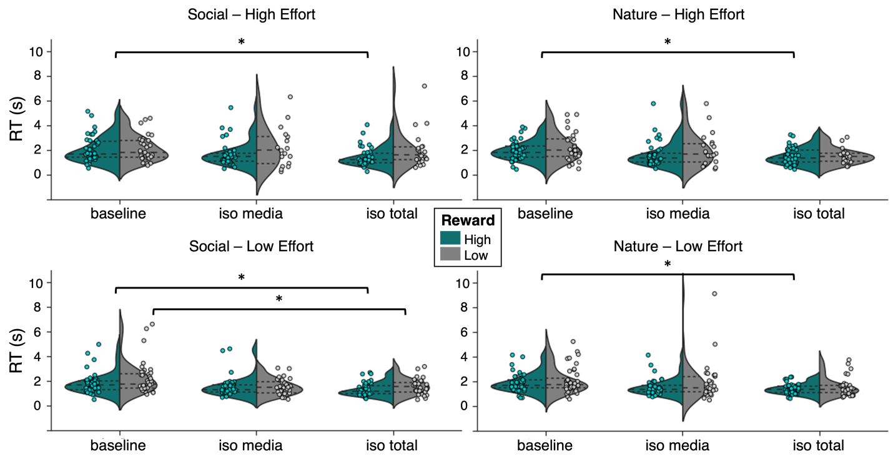

FIG. S1. Full figure EBDM task showing 4-way interaction.
Violin plots depict response times (RTs) during the EBDM task for high effort trials (upper panel) and low effort trials (lower panel) in the social context (left) and non-social context (right) in each session plotted separately for high rewards (green) and low rewards (grey). The violin plots illustrate the distribution of the data, the long-dashed lines indicate the median, the short-dashed lines the interquartile range with individual data points shown overlayed. The asterisk indicates significance at a Bonferroni-corrected p value < 0.0063. This plot illustrates the 4-way interaction reported in the main text showing that participants show faster RTs after iso total compared to baseline in the low effort, low reward condition in the social context but not in the nature context. The results remain unchanged when the outlier in the low effort / low reward / nature context data is removed.

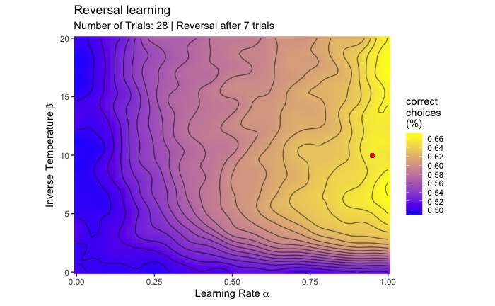
FIG. S2. Simulations of optimal parameters RL task.
The figure shows the optimal combination of learning rate and inverse temperature predicting highest choice accuracy for the task setup used in this study. The values are obtained from data simulations based on the assigned reward probabilities, task length and frequency of reversals. Bright yellow colouring depicts high choice accuracy while purple colouring indicates low choice accuracy (50% equals chance performance). The red dot indicates the optimal combination of learning rate and inverse temperature predicting the highest choice accuracy for the present task setup.

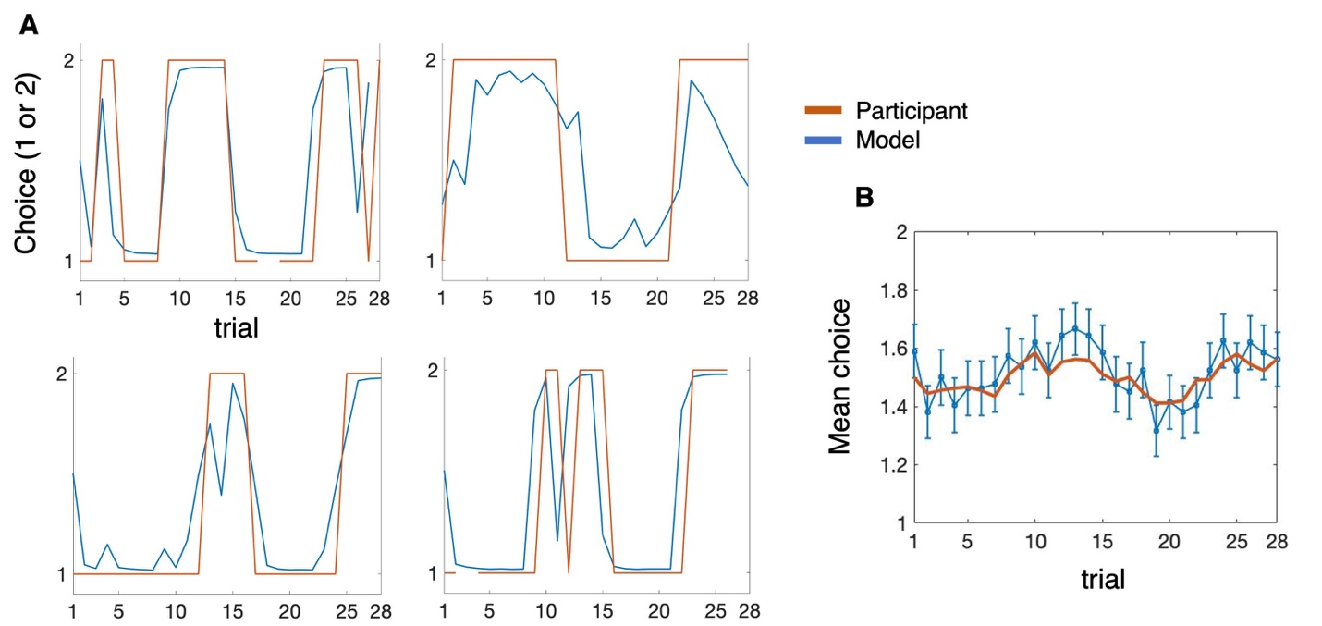
FIG. S3. Posterior predictive checks RL task.
A. True data and simulated choice estimate data from the fictitious update model for four exemplar participants. Red lines represent the true data, and blue lines represent the simulated data from the model. B. Mean participant choice across all participants (+- SEM; in blue) and mean simulated choice estimates (in red) for each trial. The plots illustrate how well the model captures the pattern seen in the data.

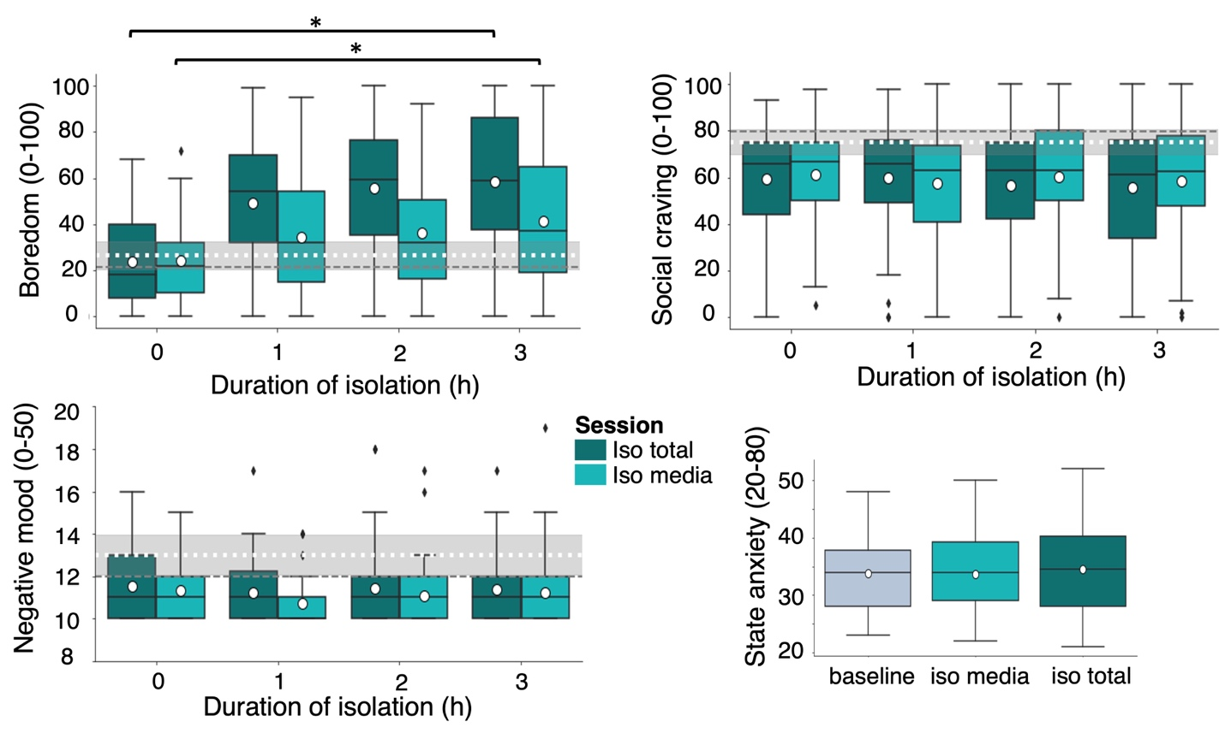

FIG. S4. Effects of isolation on boredom, social craving, negative mood and state anxiety.
Changes in self-reported boredom (upper, left), social craving (upper, right) and negative mood (lower, left) over time during isolation. Dark green = iso total session; turquoise = iso media session. State anxiety (lower, right) measures for each session. The boxplots indicate the median (black centre line), mean (white circle), the interquartile range (IQR; box) and the 1.5 x IQR minima and maxima (whiskers). The black rhombi indicate outliers (values outside of 1.5 x IQR). The dashed lines across the plots indicate the mean (white) and median (grey) ratings during baseline and their 95% confidence interval (grey area). The asterisk indicates significance at p < 0.001.

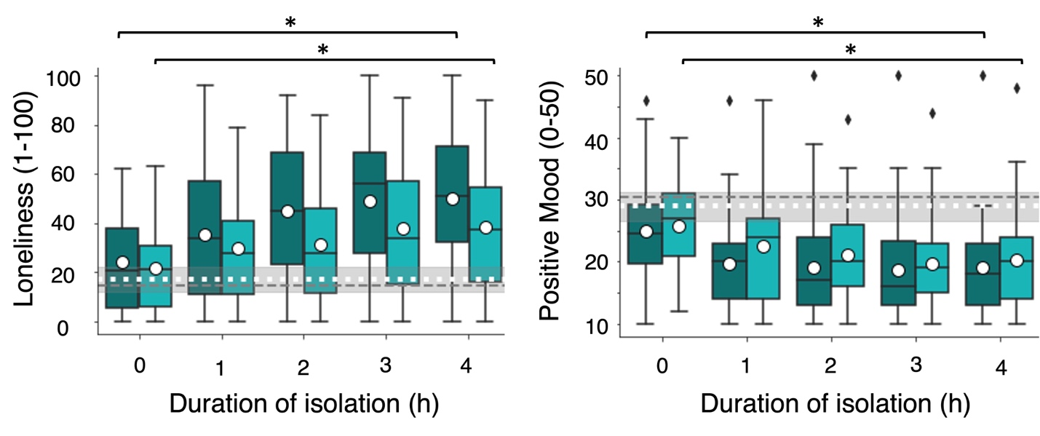
FIG. S5. Effects of isolation on loneliness and mood including T4.
Changes in self-reported loneliness (left) and positive mood (right) over time during isolation. Dark green = iso total session; turquoise = iso media session. The boxplots indicate the median (black centre line), mean (white circle), the interquartile range (IQR; box) and the 1.5 x IQR minima and maxima (whiskers). The black rhombi indicate outliers (values outside of 1.5 x IQR). The dashed lines across the plots indicate the mean (white) and median (grey) ratings during baseline and their 95% confidence interval (grey area). The asterisk indicates significance at p < 0.001.

Predictors | Estimates | t | p
Session: Iso Total | -1.236 | -1.2 | 0.216
Session: Iso Media | -1.897 | -1.4 | 0.171
Context: Nature | -0.048 | -0.5 | 0.637
Reward: Low | -2.810 | -7.6 | 6.49e-14
Effort: Low | 0.310 | 1.9 | 0.053
Interaction: Effort (Low) – Reward (Low) | 1.429 | 4.0 | 8.12e-05
Interaction: Session (Iso total) – Context (Nature) | 0.587 | 0.8 | 0.448
Interaction: Session (Iso media)– Context (Nature) | -0.471 | -0.8 | 0.406
Interaction: Session (Iso total) – Reward (Low) | -0.075 | -0.2 | 0.857
Interaction: Session (Iso media) – Reward (Low) | 0.231 | 0.4 | 0.682
Interaction: Session (Iso total) – Effort (Low) | 1.303 | 1.1 | 0.280
Interaction: Session (Iso media) – Effort (Low) | 2.003 | 1.3 | 0.205
Interaction: Session (Iso total) – Context (Nature) – Reward (Low) – Effort (Low) | 0.967 | 1.2 | 0.232
Interaction: Session (Iso media) – Context (Nature) – Reward (Low) –Effort (Low) | -1.114 | -0.8 | 0.452

Table S1.
Full output linear mixed effects model for EBDM task - choice data.

Predictors | Estimates | t | p
Session: Iso Total | -0.616 | -3.8 | 0.0001
Session: Iso Media | -0.413 | -2.6 | 0.010
Context: Nature | -0.111 | -0.9 | 0.382
Reward: Low | 0.445 | 2.2 | 0.025
Effort: Low | -0.246 | -1.9 | 0.063
Interaction: Effort (Low) – Reward (Low) | -0.041 | -0.2 | 0.813
Interaction: Session (Iso total) – Context (Nature) | 0.125 | 0.9 | 0.375
Interaction: Session (Iso media)– Context (Nature) | 0.200 | 1.3 | 0.192
Interaction: Session (Iso total) – Reward (Low) | 0.305 | 1.0 | 0.313
Interaction: Session (Iso media) – Reward (Low) | 0.643 | 3.2 | 0.002
Interaction: Session (Iso total) – Effort (Low) | 0.113 | 0.8 | 0.422
Interaction: Session (Iso media) – Effort (Low) | 0.112 | 0.7 | 0.519
Interaction: Session (Iso total) – Context (Nature) – Reward (Low) – Effort (Low) | 0.836 | 2.5 | 0.015
Interaction: Session (Iso media) – Context (Nature) – Reward (Low) –Effort (Low) | 0.904 | 1.9 | 0.054

Table S2.
Full output linear mixed effects model for EBDM task - response time data.
Variable | df | t | p | Cohen’s d
Baseline vs Iso total – Social Context
High Reward + High Effort | 38 | 3.3 | 0.002* | 0.64
High Reward + Low Effort | 39 | 3.0 | 0.005* | 0.67
Low Reward + High Effort | 18 | 1.2 | 0.232 | 0.34
Low Reward + Low Effort | 28 | 3.5 | 0.002* | 0.71
Baseline vs Iso total – Non-social Context
High Reward + High Effort | 37 | 3.2 | 0.003* | 0.60
High Reward + Low Effort | 39 | 3.8 | 0.0005* | 0.82
Low Reward + High Effort | 17 | 2.5 | 0.022 | 0.66
Low Reward + Low Effort | 31 | 2.0 | 0.051 | 0.47
Baseline vs Iso media – Social Context
High Reward + High Effort | 36 | 2.1 | 0.044 | 0.34
High Reward + Low Effort | 38 | 1.7 | 0.108 | 0.38
Low Reward + High Effort | 18 | 1.2 | 0.861 | 0.05
Low Reward + Low Effort | 28 | 2.7 | 0.012 | 0.61
Baseline vs Iso media – Non-social Context
High Reward + High Effort | 36 | 1.9 | 0.063 | 0.40
High Reward + Low Effort | 39 | 2.8 | 0.008 | 0.53
Low Reward + High Effort | 19 | 0.8 | 0.461 | 0.20
Low Reward + Low Effort | 28 | 0.3 | 0.745 | 0.08

Table S3.
Pairwise comparisons EBDM task. Asterisks indicate significance at the Bonferroni corrected p<0.0063 (0.05/8) level.

Predictors | Estimates | t | p
Session: Iso Total | -0.450 | -3.1 | 0.002
Session: Iso Media | -0.223 | -1.0 | 0.317
Context: Social | 0.119 | 0.8 | 0.428
Gender (Male) | 0.063 | 0.4 | 0.728
Session order (Iso total first) | -0.170 | -1.0 | 0.331
Calibration | 0.001 | 0.2 | 0.873
Days between sessions | 0.002 | 0.6 | 0.542
Interaction: Session (Iso total) – Condition (Social) | -0.167 | -1.0 | 0.321
Interaction: Session (Iso media) – Condition (Social) | -0.151 | -0.8 | 0.340

Table S4.
Sensitivity Analysis EBDM task. Output linear mixed effects model for effects of session (baseline, iso total, iso media) and context (social, non-social) on response time data (on high effort / high reward trials) from the EBDM task including control variables gender (male, female), calibration (number of pumps managed in 10 s during initial calibration at the start of each session), session order (iso total first, iso media first) and days between sessions.

Model | LOOIC | Bayesian stacking | Pseudo-BMA | WAIC
Baseline – Non-social
RP | 1265.006 | 0.006 | 0.00 | 1240.133
EWA | 1281.956 | 0.007 | 0.356 | 1267.682
FICTU | 1239.735 | 0.987 | 0.644 | 1210.22
Baseline - Social
RP | 1280.810 | 0.228 | 0.150 | 1262.007
EWA | 1284.998 | 0.199 | 0.078 | 1266.486
FICTU | 1269.207 | 0.573 | 0.772 | 1210.222
Iso Total – Non-social
RP | 1112.041 | 0.00 | 0.333 | 1095.814
EWA | 1127.211 | 0.523 | 0.078 | 1100.757
FICTU | 1107.958 | 0.477 | 0.588 | 1070.517
Iso Total – Social
RP | 1156.312 | 0.375 | 0.219 | 1127.814
EWA | 1140.289 | 0.000 | 0.304 | 1111.910
FICTU | 1140.721 | 0.625 | 0.477 | 1113.125
Iso Media – Non-social
RP | 1096.862 | 0.000 | 0.000 | 1065.532
EWA | 1125.190 | 0.236 | 0.000 | 1181.415
FICTU | 1021.003 | 0.764 | 1.000 | 983.643
Iso Media – Social
RP | 1037.255 | 0.000 | 0.004 | 1012.743
EWA | 1036.196 | 0.267 | 0.007 | 1017.891
FICTU | 977.097 | 0.733 | 0.989 | 938.433

Table S5.
Results of model comparison for RL task. We report the following model fit parameters: LOOIC = Leave-One-Out Information Criterion; Bayesian Stacking = stacking of means¹; Pseudo-BMA = Pseudo Bayesian Model Averaging¹; WAIC = Widely Applicable Information Criterion
RP = Reward-Punishment Model; EWA = Experience-Weighted Attraction Model; FICTU = Fictitious Update Model. For LOOIC and WAIC, lower values indicate better model fit. For Stacking and Pseudo-BMA higher values indicate better model fit. The Fictitious Update Model is marked grey in each section as it shows the best model fit across the different parameters for each data set. ¹Yao, Y., Vehtari, A., Simpson, D. & Gelman, A. Using Stacking to Average Bayesian Predictive Distribution (with Discussion). Bayesian Anal. 13, 917–1007 (2018).

Predictors | Estimates | t | p
Session: Iso Total | 0.025 | 5.2 | 3.78e-07
Session: Iso Media | -0.004 | -0.9 | 0.389
Condition: Social | -0.062 | -11.6 | 7.87e-25
Interaction: Session (Iso total) - Condition (Social) | 0.195 | 31.9 | 2.30e-88
Interaction: Session (Iso media) - Condition (Social) | -0.043 | -7.1 | 1.23e-11

Table S6.
Full output linear mixed effects model for RL task - learning_pos rate parameter.

Predictors | Estimates | t | p
Session: Iso Total | 0.038 | 1.4 | 0.168
Session: Iso Media | 0.054 | 1.8 | 0.070
Condition: Social | 0.061 | 2.3 | 0.025
Interaction: Session (Iso total) - Condition (Social) | 0.045 | 1.3 | 0.197
Interaction: Session (Iso media) - Condition (Social) | 0.012 | 0.3 | 0.751

Table S7.
Full output linear mixed effects model for RL task - learning_neg rate parameter.

Predictors | Estimates | t | p
Session: Iso Total | 0.150 | 1.9 | 0.061
Session: Iso Media | 0.264 | 2.6 | 0.009
Condition: Social | -0.065 | -0.6 | 0.584
Interaction: Session (Iso total) - Condition (Social) | -0.072 | -0.5 | 0.179
Interaction: Session (Iso media) - Condition (Social) | 0.194 | 1.4 | 0.612

Table S8.
Full output linear mixed effects model for RL task – beta parameter.

Predictors | Estimates | t | p
Session: Iso Total | 0.026 | 5.2 | 3.50e-7
Session: Iso Media | -0.003 | -0.6 | 0.550
Condition: Social | -0.063 | -11.4 | 2.39e-24
Gender (male) | -0.004 | -1.9 | 0.063
Session order (iso total first) | 0.002 | 0.8 | 0.446
Days between sessions | -6.06e-5 | -1.4 | 0.179
Interaction: session (iso total) – condition (social) | 0.195 | 31.5 | 3.13e-86
Interaction: session (iso media) – condition (social) | -0.043 | -6.9 | 4.19e-11

Table S9.
Sensitivity Analysis RL task – learning_pos. Output linear mixed effects model for effects of session (baseline, iso total, iso media) and condition (social, non-social) on learning_pos rates including control variables gender (male, female), session order (iso total first, iso media first) and days between sessions.

Predictors | Estimates | t | p
Session: Iso Total | 0.032 | 1.0 | 0.307
Session: Iso Media | 0.049 | 1.6 | 0.146
Condition: Social | 0.060 | 2.2 | 0.031
Gender (male) | -0.081 | -2.0 | 0.047
Session order (iso total first) | -0.007 | -0.2 | 0.873
Days between sessions | 0.0002 | 0.4 | 0.728
Interaction: session (iso total) – condition (social) | 0.045 | 1.3 | 0.196
Interaction: session (iso media) – condition (social) | 0.012 | 0.3 | 0.735

Table S10.
Sensitivity Analysis RL task – learning_neg. Output linear mixed effects model for effects of session (baseline, iso total, iso media) and condition (social, non-social) on learning_neg rates including control variables gender (male, female), session order (iso total first, iso media first) and days between sessions.

Predictors | Estimates | t | p
Session: Iso Total | 0.257 | 2.8 | 0.005
Session: Iso Media | 0.368 | 3.4 | 0.0008
Condition: Social | -0.065 | -0.5 | 0.589
Gender (male) | -0.286 | -3.2 | 0.002
Session order (iso total first) | 0.176 | 2.0 | 0.047
Days between sessions | -0.003 | -2.6 | 0.009
Interaction: session (iso total) – condition (social) | -0.073 | -0.5 | 0.610
Interaction: session (iso media) – condition (social) | 0.195 | 1.3 | 0.185

Table S11.
Sensitivity Analysis RL task – beta. Output linear mixed effects model for effects of session (baseline, iso total, iso media) and condition (social, non-social) on beta rates including control variables gender (male, female), session order (iso total first, iso media first) and days between sessions.

