Supplementary Information for
Thin-film thermal system for nucleic acid amplification in digital microfluidics

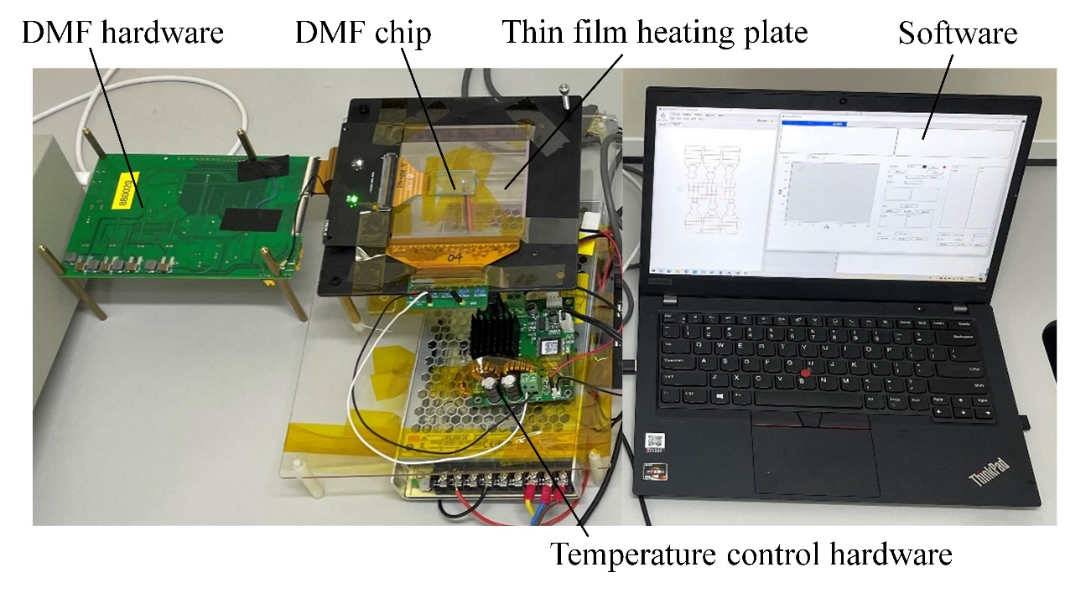
Fig S1 The software and hardware system.

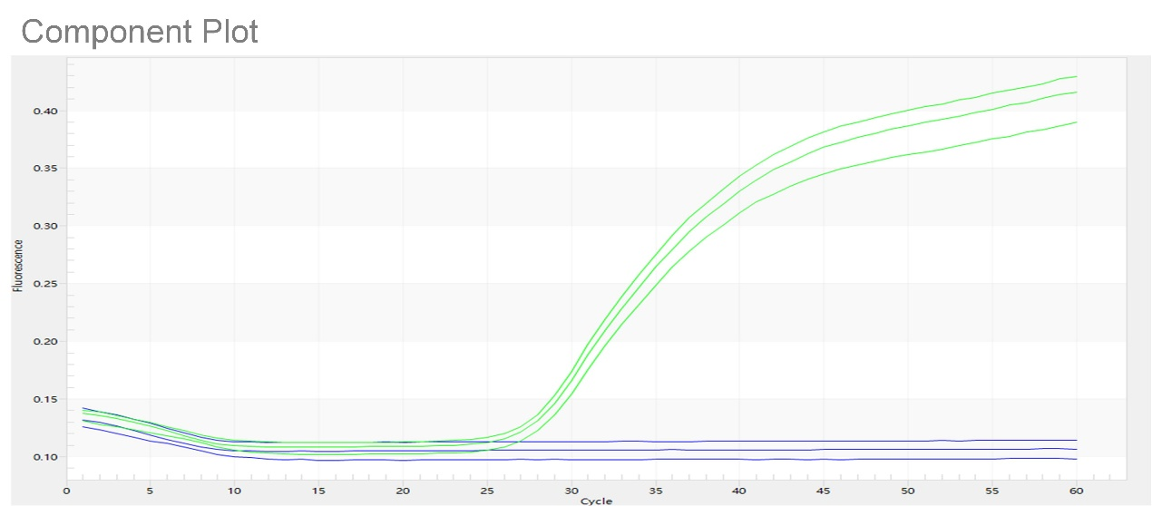
Fig S2 PCR off-chip validation. Green date lines are positive and blue lines are negative. The fluorescence of positive samples increases with the number of cycles

Voltage（V） | 6 | 8 | 10 | 12 | 14 | 16 | 18 | 20 | 22 | 24
Current（A） | 0.489 | 0.633 | 0.76 | 0.882 | 0.987 | 1.081 | 1.171 | 1.256 | 1.321 | 1.39
Power（W） | 2.942 | 5.066 | 7.603 | 10.588 | 13.822 | 17.3 | 21.081 | 25.128 | 29.071 | 33.37
Average temperature（℃） | 37.94 | 47.35 | 59.20 | 71.24 | 85.60 | 99.56 | 115.17 | 128.00 | 145.07 | 159.20
std（℃） | 1.08 | 2.02 | 3.14 | 4.18 | 5.50 | 6.40 | 7.67 | 8.52 | 9.95 | 11.02
Table1. First set of test data for thin film heating plate, average temperature and STD values for 36 test points at 6-24V.

Voltage（V） | 6 | 8 | 10 | 12 | 14 | 16 | 18 | 20 | 22 | 24
Current（A） | 0.484 | 0.627 | 0.721 | 0.835 | 0.941 | 1.037 | 1.123 | 1.264 | 1.338 | 1.347
Power（W） | 2.906 | 5.018 | 7.214 | 10.024 | 13.178 | 16.597 | 20.217 | 25.288 | 29.466 | 32.337
Average temperature（℃） | 41.50 | 51.17 | 62.161 | 75.30 | 88.92 | 104.24 | 119.34 | 134.65 | 150.10 | 165.19
std（℃） | 0.69 | 1.05 | 1.43 | 1.91 | 2.35 | 3.04 | 3.54 | 3.96 | 4.65 | 5.19
Table2. Second set of test data for thin film heating plate, average temperature and STD values for 36 test points at 6-24V.

