SUPPLEMENTARY INFORMATION
Supplementary Table 1. Literature sources of species images used for quantifying colour lightness.

Literature | Year | Region/Country | Continent | species
Dodd Jr, C. K., Frogs of the United States and Canada - 2 volumes Johns Hopkins University Press, Baltimore | 2013 | Canada and USA | North America | 105
Speybroeck, J. B. B., Beukema, W., Bok, B., & van der Voort, J., Field Guide to the Amphibians and Reptiles of Britain and Europe. Bloomsbury Wildlife, London. | 2018 | Europe | Europe | 46
Channing, A., & Rödel, M.-O., Field guide to the frogs & other amphibians of Africa Struik Nature, Cape Town. | 2019 | Africa | Africa | 788
Glaw, F., & Vences, M. A., Field Guide to the amphibians and reptiles of Madagascar. 3rd ed., Vences & Glaw Verlag, Cologne. | 2007 | Madagascar | Africa | 239
Gururaja, K., Pictorial guide to frogs and toads of the Western Ghats. Gubbi Labs, Karnataka. | 2012 | Western Ghats, India | Asia | 73
Gururaja, K., & Ramachandra, T., Anuran diversity and distribution in Dandeli Anshi Tiger Reserve. Energy & Wetlands. Research Group Centre for Ecological Sciences Indian Institute of Science Bangalore. | 2012 | Anshi Tiger Reserve, India | Asia | 2
Fei, L., Atlas of amphibians of China (field edition). Zhongyuan Publishing and Media Group, Henan Science and Technology Press. | 2020 | China | Asia | 357
Alhadi, F., Kaprawi, F., Hamidy, A., & Kirschey, T., Amfibi Pulau Jawa - Panduan Bergambar dan Identifikasi. Perkumpulan Amfibi Reptil Sumatera & NABU, Jakarta. | 2021 | Jawa, Indonesia | Asia | 32
Inger, R. F., Stuebing, R. B., Grafe, U., & Dehling, M. A., Field guide to the frogs of Borneo. 3rd ed., Natural History Publications (Borneo), Kota Kinabalu. | 2017 | Borneo, Indonesia  Malaysia, Brunei | Asia | 160
Tyler, M. J., & Knight, F., Field guide to the frogs of Australia. 2nd ed., CSIRO Publishing, Clayton South. | 2020 | Australia | Australia | 263
McCranie, J. R., & Wilson, L. D., The amphibians of Honduras. Society for the Study of Amphibians and Reptiles, Ithaca. | 2002 | Honduras | South America | 47
Leenders, T., Amphibians of Costa Rica: A field guide. Zona Tropical Publication, Comstock Publishing Association, Ithaca. | 2016 | Costa Rica | Central America | 146
Lescure, J., & Marty, C., Atlas des amphibiens de Guyane. Muséum national d’Histoire naturelle, Patrimoines naturels. | 2000 | Guyana | South America | 19
Ouboter, P. E., & Jairam, R., Amphibians of Suriname. Brill, Leiden. | 2012 | Suriname | South America | 46
Ron, S. R., Merino-Viteri, A., & Ortiz, D., Anfibios del Ecuador - guía dinámica de especies Versión 2020.0. Museo de Zoología, Pontificia Universidad Católica del Ecuador. | 2021 | Ecuador | South America | 607
Kahn, T. R., la Marca, E., Lötters, S., Brown, J. L., Twomey, E., & Amézquita, A., Aposematic Poison Frogs (Dendrobatidae) of the Andean Countries: Colombia, Bolivia, Ecuador, Peru and Venezuela. Conservation International, Arlington. | 2016 | Andean Countries | South America | 52
Bartlett, R. D., & Bartlett, P., Reptiles and amphibians of the Amazon: An ecotourist’s guide. University Press of Florida, Gainsville | 2003 | Amazon | South America | 27
Lima, A. P., Magnusson, W. E., Menin, M., Erdtmann, L. K., Rodrigues, D. de J., Keller, C. K., & Hödl, W., Guia de Sapos da Reserva Adolpho Ducke: Amazônia Central. Attema Design Editorial, Manaus. | 2005 | Amazon, Reserva Adolpho Ducke, Brazil | South America | 4
Freitas, M. A., Herpetofauna no nordeste Brasileiro - guia de Campo. Technical Books Editora, Rio de Janeiro. | 2015 | northeast Brazil | South America | 80
Ávila, R. W., Morais, D. H., Maffei, F., Pansonato, A., Kawashita-Ribeiro, R. A., Rodrigues, D. J., & Strüssmann, C., Herpetofauna de Mato Grosso Vol. I - Anfíbios. Editora CRV, Curitiba | 2021 | Mato Grosso, Brazil | South America | 74
Maffei, F., Ubaid, F., & Jim, J., Anfíbios - Fazenda Rio Claro, Lençóis Paulista, SP. Canal 6 editora, Bauru. | 2011 | Rio Claro, Brazil | South America | 3
Haddad, C. F. B., Toledo, L. F., Prado, C. P. A., Loebmann, D., Gasparini, J. L., & Sazima, I., Guia dos Anfíbios da Mata Atlântica - Diversidade e Biologia. Anolis Books, São Paulo. | 2013 | Mata Atlantica, Brazil | South America | 451
Maneyro, R., Loebmann, D., Tozetti, A., & Fonte, L. F. M., Anfíbios das planícies costeiras do extremo sul do Brasil e Uruguai.Anolis Books, São Paulo. | 2017 | southern Brazil, Uruguay | South America | 10
Uetanabaro, M., Prado, C. P. de A., Rodrigues, D. de J., Gordo, M., & Campos, Z., Guia de campo dos anuros do Pantanal e planaltos de entorno. Editora UFMS, Campo Grande. | 2008 | Pantanal, Brazil | South America | 20
Charrier, A., Guía de Campo Anfibios de los Bosques de la Zona Centro Sur y Patagonia de Chile. Corma Chile. | 2019 | Chile | South America | 43
Cei, J. M., Batracios de Chile. Ediciones de la Universidad de Chile, Santiago de Chile. | 1962 | Chile | South America | 2
Cei, J. M., Amphibians of Argentina. Monitore zoologico italiano (N.S.), Monografia 2. | 1980 | Argentina | South America | 49

Supplementary Table 2. RGB values of the colour wheel.
Colour | R | G | B
Algaegreen10 | 205 | 204 | 184
Algaegreen100 | 127 | 123 | 0
Algaegreen40 | 177 | 177 | 107
Algaegreen70 | 154 | 153 | 45
Black10 | 255 | 255 | 255
Black100 | 24 | 24 | 24
Black40 | 177 | 177 | 177
Black70 | 102 | 102 | 102
Blue10 | 230 | 230 | 254
Blue100 | 0 | 0 | 254
Blue40 | 154 | 153 | 255
Blue70 | 77 | 76 | 255
Brown10 | 204 | 194 | 184
Brown100 | 123 | 61 | 0
Brown40 | 176 | 142 | 107
Brown70 | 152 | 99 | 45
Burgundy10 | 203 | 184 | 204
Burgundy100 | 126 | 0 | 126
Burgundy40 | 177 | 107 | 177
Burgundy70 | 153 | 45 | 154
Cyan10 | 231 | 255 | 255
Cyan100 | 1 | 255 | 255
Cyan40 | 153 | 255 | 255
Cyan70 | 77 | 255 | 255
Darkblue10 | 183 | 184 | 204
Darkblue100 | 0 | 0 | 126
Darkblue40 | 107 | 107 | 177
Darkblue70 | 44 | 45 | 153
Darkcyan10 | 159 | 177 | 177
Darkcyan100 | 0 | 126 | 125
Darkcyan40 | 107 | 177 | 177
Darkcyan70 | 45 | 153 | 153
Darkgreen10 | 183 | 200 | 181
Darkgreen100 | 0 | 126 | 0
Darkgreen40 | 107 | 177 | 107
Darkgreen70 | 45 | 153 | 44
Darkred10 | 204 | 184 | 185
Darkred100 | 128 | 0 | 1
Darkred40 | 177 | 107 | 107
Darkred70 | 153 | 45 | 45
Elder10 | 250 | 230 | 255
Elder100 | 210 | 0 | 255
Elder40 | 235 | 153 | 255
Elder70 | 224 | 77 | 254
Green10 | 233 | 255 | 234
Green100 | 0 | 255 | 1
Green40 | 153 | 255 | 153
Green70 | 76 | 255 | 76
Magenta10 | 255 | 230 | 254
Magenta100 | 255 | 0 | 254
Magenta40 | 255 | 153 | 255
Magenta70 | 255 | 77 | 255
Orange10 | 255 | 244 | 230
Orange100 | 254 | 153 | 0
Orange40 | 255 | 210 | 153
Orange70 | 255 | 177 | 77
Red10 | 255 | 230 | 230
Red100 | 255 | 0 | 0
Red40 | 255 | 152 | 153
Red70 | 255 | 77 | 77
Sky10 | 230 | 255 | 251
Sky100 | 0 | 255 | 211
Sky40 | 152 | 255 | 236
Sky70 | 77 | 254 | 225
Warmgrey10 | 205 | 192 | 184
Warmgrey100 | 51 | 47 | 44
Warmgrey40 | 153 | 144 | 137
Warmgrey70 | 103 | 95 | 92
Yellow10 | 255 | 255 | 229
Yellow100 | 255 | 255 | 1
Yellow40 | 255 | 251 | 152
Yellow70 | 255 | 255 | 77

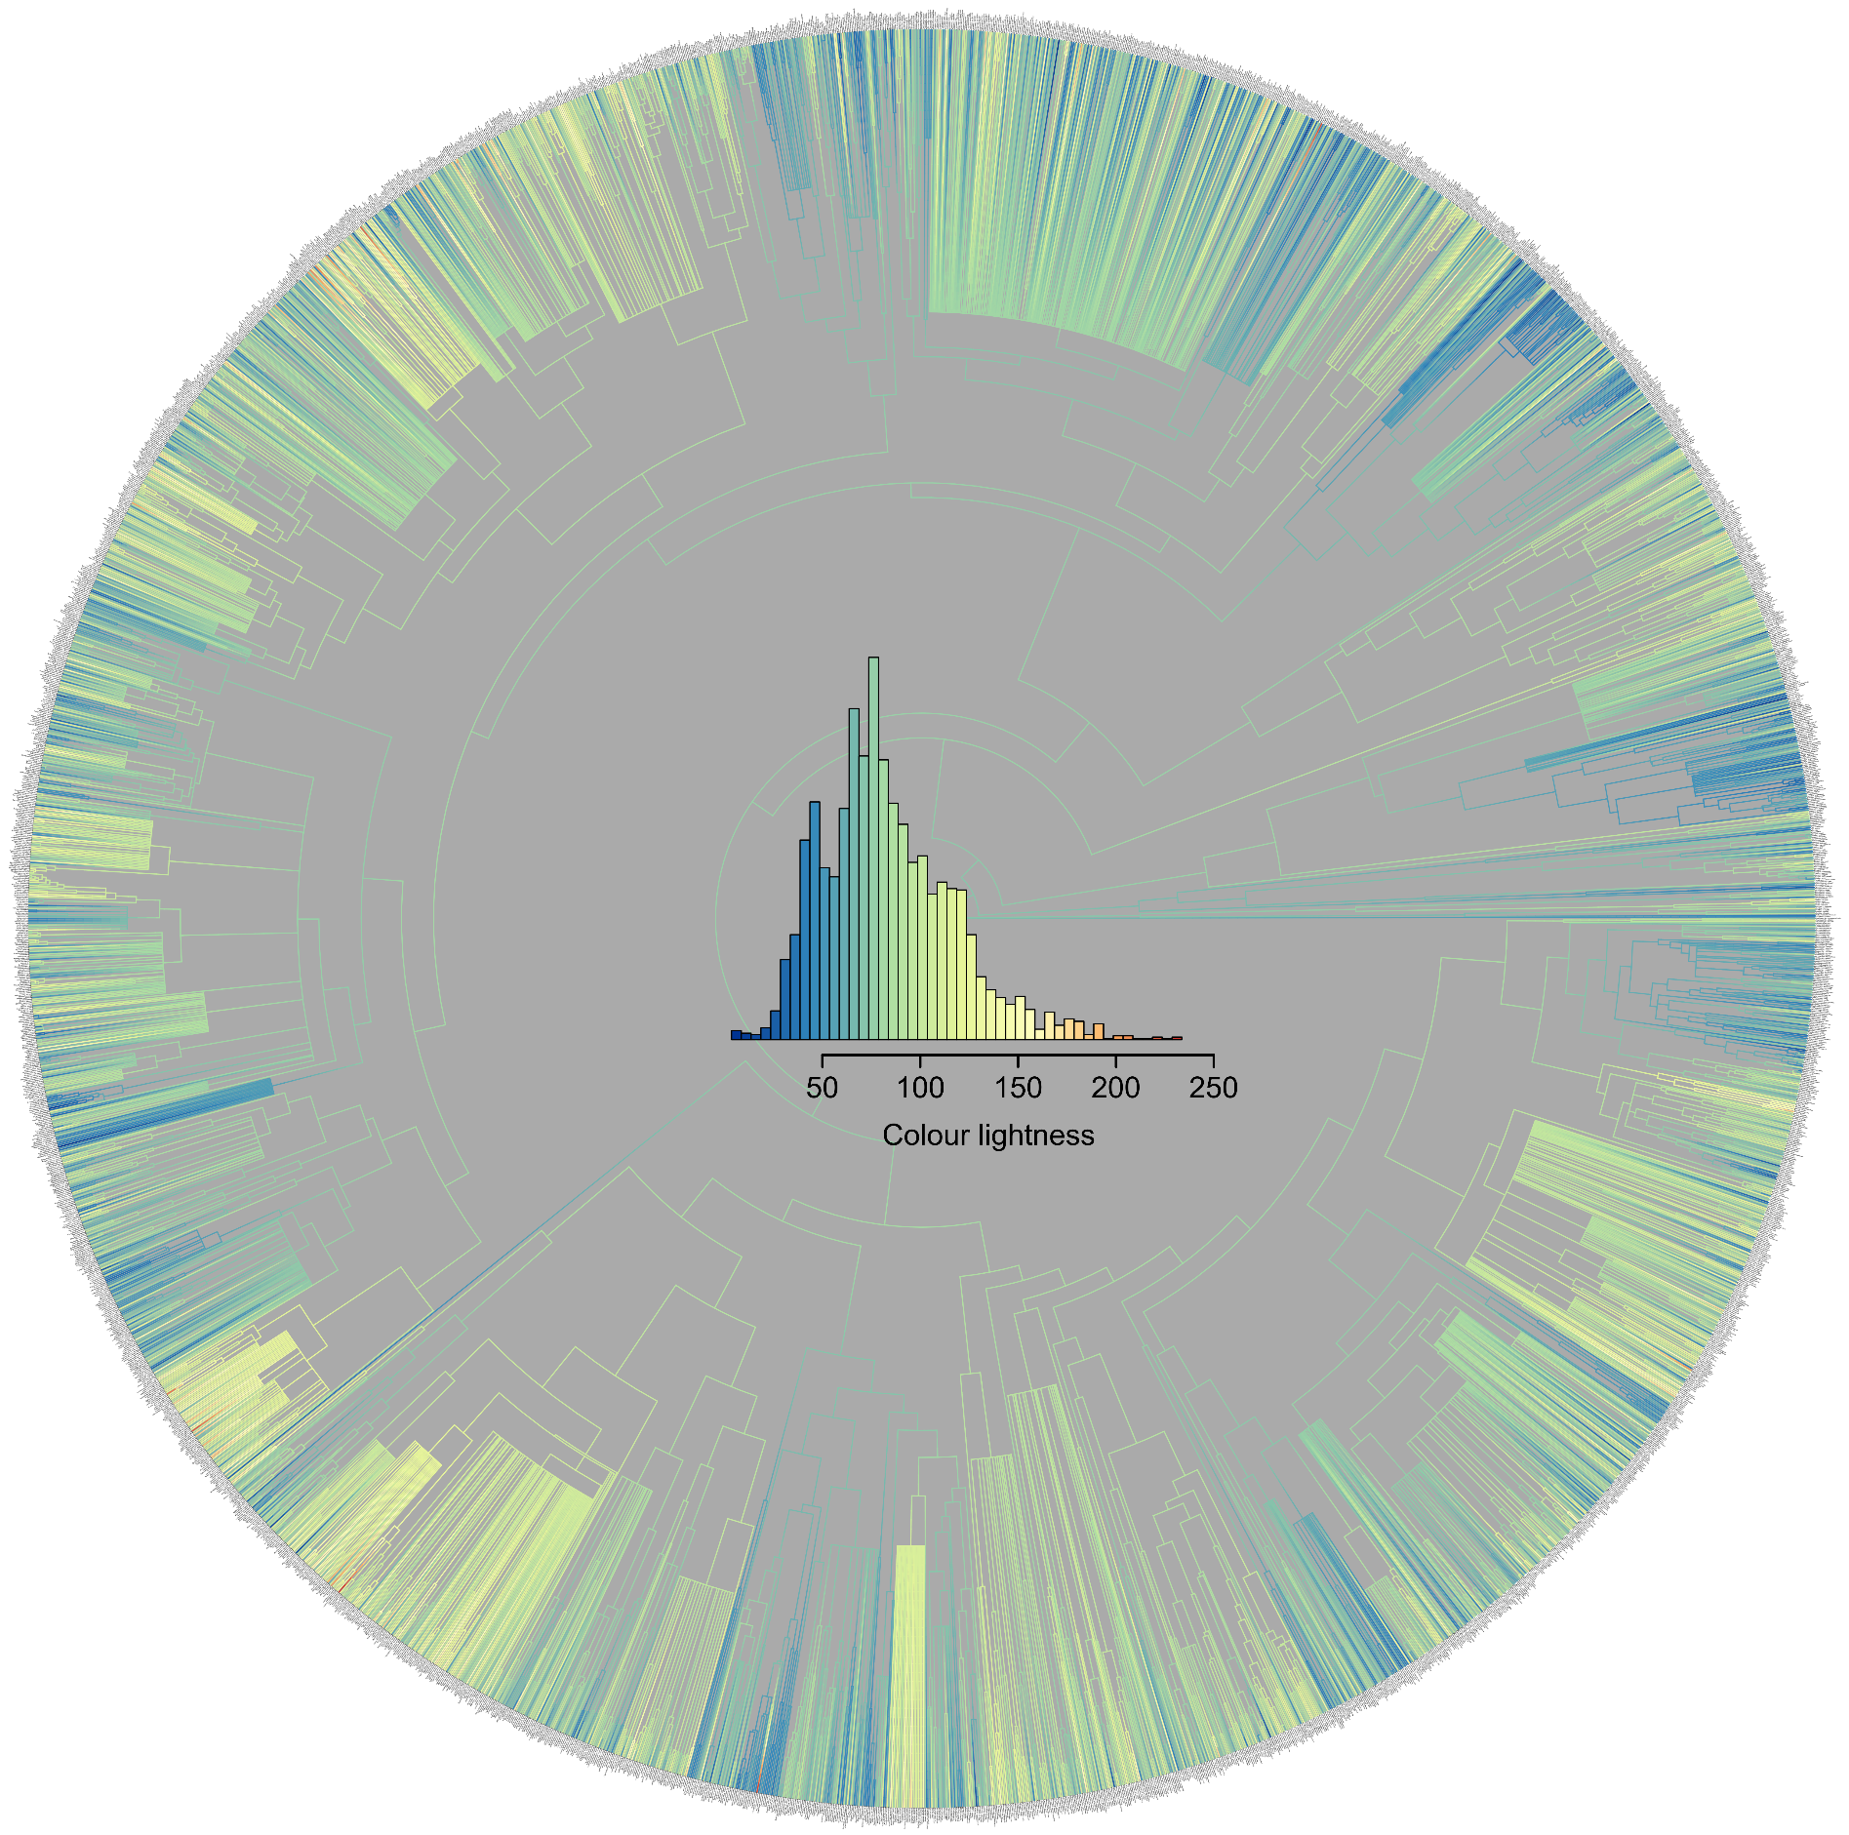

Supplementary Fig. 1. Ancestral reconstruction of colour lightness variation across the phylogeny of 3,059 anuran species. Blue values indicate low colour lightness and red colours indicate high colour lightness of anuran species.

