EXTENDED DATA
Extended Data Table 1. Colour lightness–environment relationships of diurnal and nocturnal anurans. Multiple linear regressions of colour lightness and interactions of EVI, mean annual temperature, elevation and annual UVB separated with activity time (D = diurnal, N = nocturnal, D/N = diurnal and nocturnal).
Interaction |  | slope±SE | t | P | R²
Mean annual EVI | D | –5.50±8.74 | –0.63 | 0.529 | 0.05
Mean annual EVI | N | –4.91±2.93 | –1.68 | 0.094 | 0.05
Mean annual EVI | D/N | –11.00±3.37 | –3.26 | 0.001 | 0.05
Mean annual temperature | D | 11.41±22.02 | 0.52 | 0.605 | 0.05
Mean annual temperature | N | 26.78±11.53 | 2.32 | 0.021 | 0.05
Mean annual temperature | D/N | 26.98±12.70 | 2.13 | 0.034 | 0.05
Elevation | D | –0.23±5.27 | –0.04 | 0.965 | 0.05
Elevation | N | 3.82±3.17 | 1.20 | 0.229 | 0.05
Elevation | D/N | 3.66±3.86 | 0.95 | 0.343 | 0.05
Mean annual UVB | D | –2.04±12.62 | –0.16 | 0.872 | 0.05
Mean annual UVB | N | –6.30±6.71 | –0.94 | 0.348 | 0.05
Mean annual UVB | D/N | –10.04±8.04 | –1.25 | 0.212 | 0.05

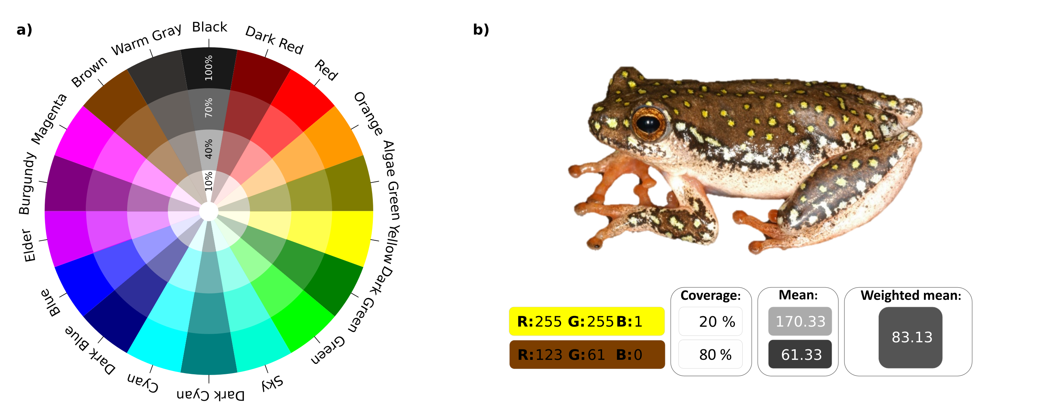
Extended Data Fig. 1. Colour wheel and example of the procedure for estimating colour lightness. a, The wheel comprises 18 rays, each consisting of four colours with different ‘Saturation’ levels (S: 10, 40, 70, 100%). Six rays are based on colours that divide the ‘Hue’ range into equally wide classes (H: 60, 120, 180, 240, 300, 360°). Another six rays are based on the same colours with a ‘Value’ of 50 instead of 100 (e.g., dark green instead of green). Three rays are based on the complementary colours cyan, yellow, and magenta; and finally, three rays are based on black, warm grey and brown. The corresponding RGB values for each colour shown in the colour wheel are provided in Supplementary Table 2. The selection of colours is representative for the colour of the spectrum of light visual to humans but needed to incorporate narrow-ranging yet clearly distinguishable colours such as yellow and mixed colours such as brown and black. b, Example calculation of dorsal coverage weighted mean colour lightness for Hyperolius viridiflavus (copyrights for the image are held by Alan Channing).
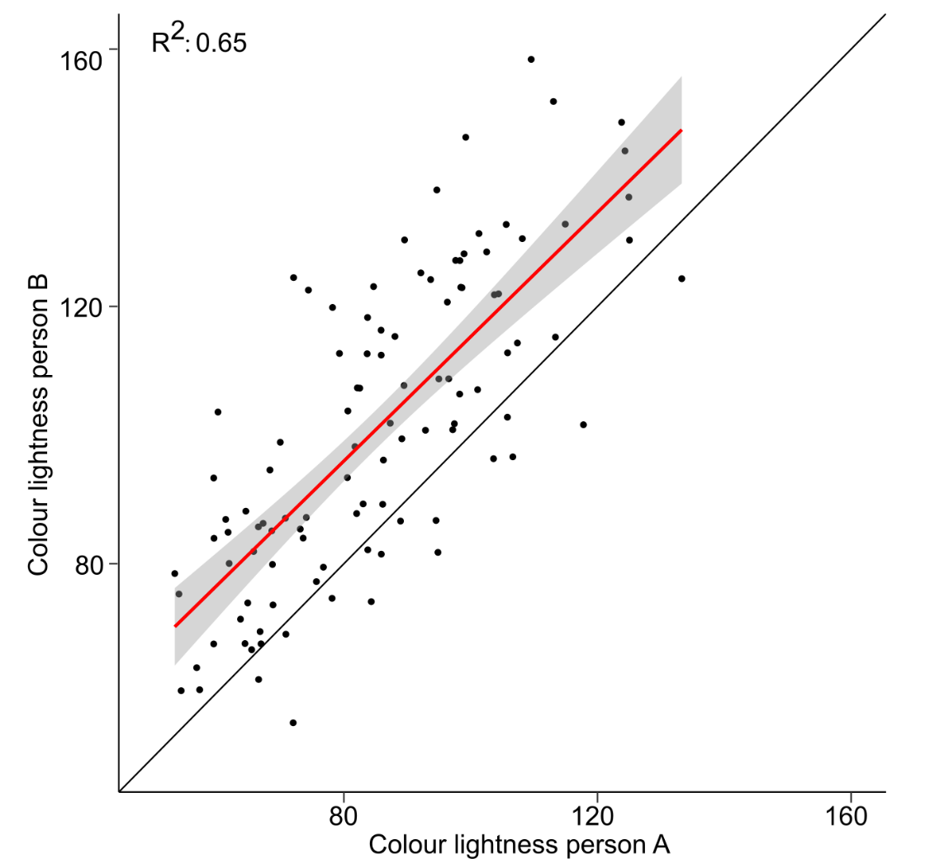
Extended Data Fig. 2. Colour lightness estimates from two different persons. Single linear regressions of the colour lightness of Australian frogs and toads assessed by two persons based on photos of species (n = 107). High values of colour lightness indicate lighter coloured species. Red and grey shaded lines indicate the regression and confidence interval, respectively (slope±SE = 0.60±0.04, intercept = 24.45).
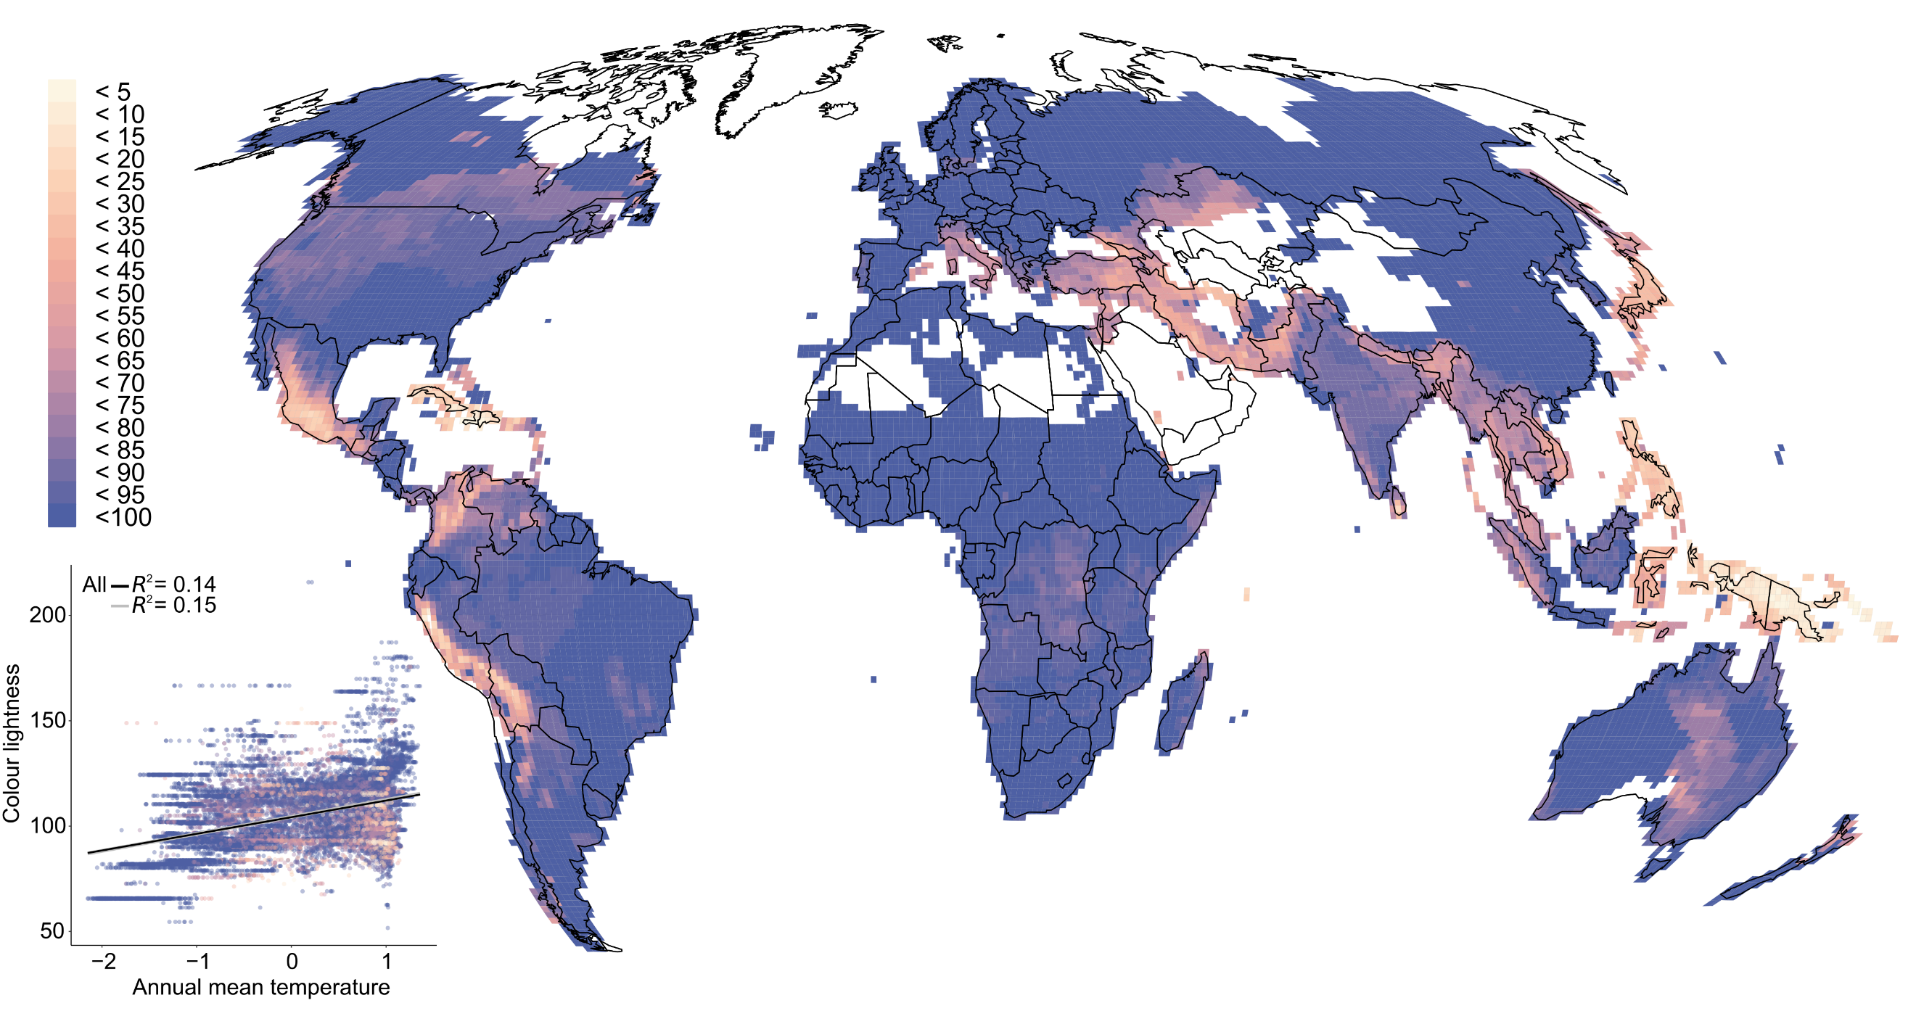
Extended Data Fig. 3. Spatial coverage of colour lightness data for anuran assemblages. Colours in the scatterplot and map indicate the percentage of species per assemblage for which colour lightness data were available relative to the total number of species (n = 17,170; map in Mollweide projection). Note that our decision to remove assemblages with a colour data coverage of less than 33% did not change the overall trends, for instance, in the relationship between colour lightness and annual mean temperature, but slightly reduced the scatter, as indicated by a higher coefficient of determination (all: slope±SE = 7.89±0.15; >33%: slope±SE = 8.08±0.15). Colour scale intervals follow an equal-distance classification ranging from high (plum) to low (light beige).
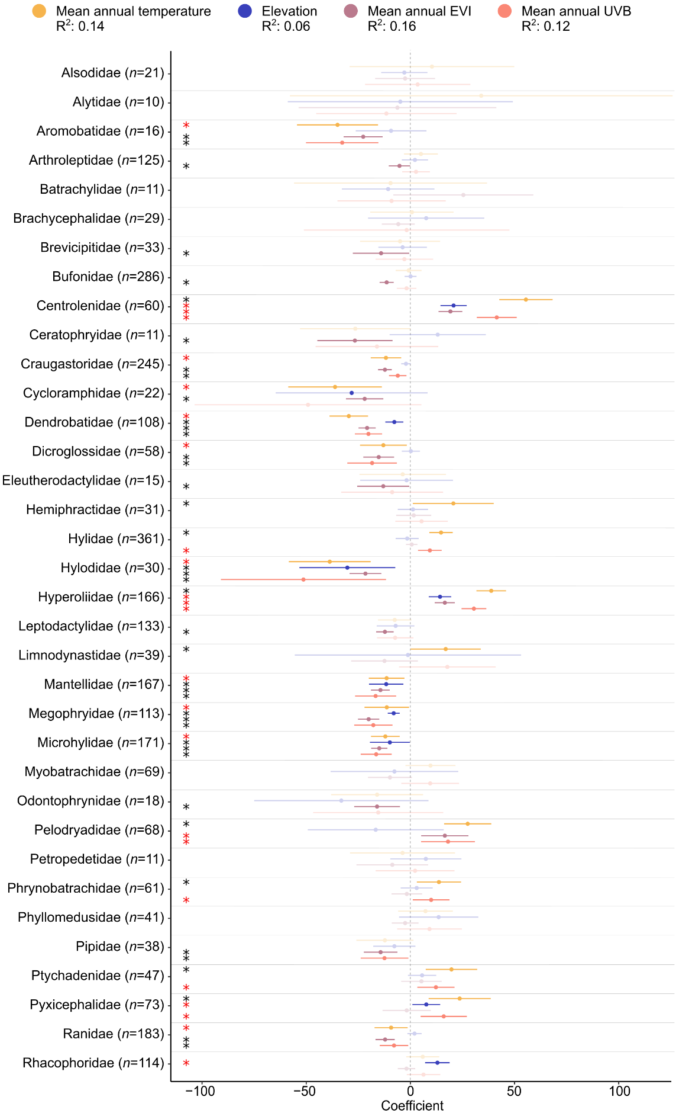
Extended Data Fig. 4. Coefficient plot of single linear regression models of colour lightness and environmental variables at the species level (n = 2,984). Coloured bars indicate the 95% confidence interval, and dots indicate the mean standardized effect size of interactions of mean annual temperature, elevation, productivity (i.e., mean annual enhanced vegetation index, EVI) and mean annual UVB radiation for the families of anuran species. Bars that do not overlap with zero (dashed line) indicate significant effects. Black asterisks indicate support for colour-based thermoregulation, pathogen resistance or UVB protection, whereas red asterisks indicate a converse trend. Shaded colours show non-significant correlations.
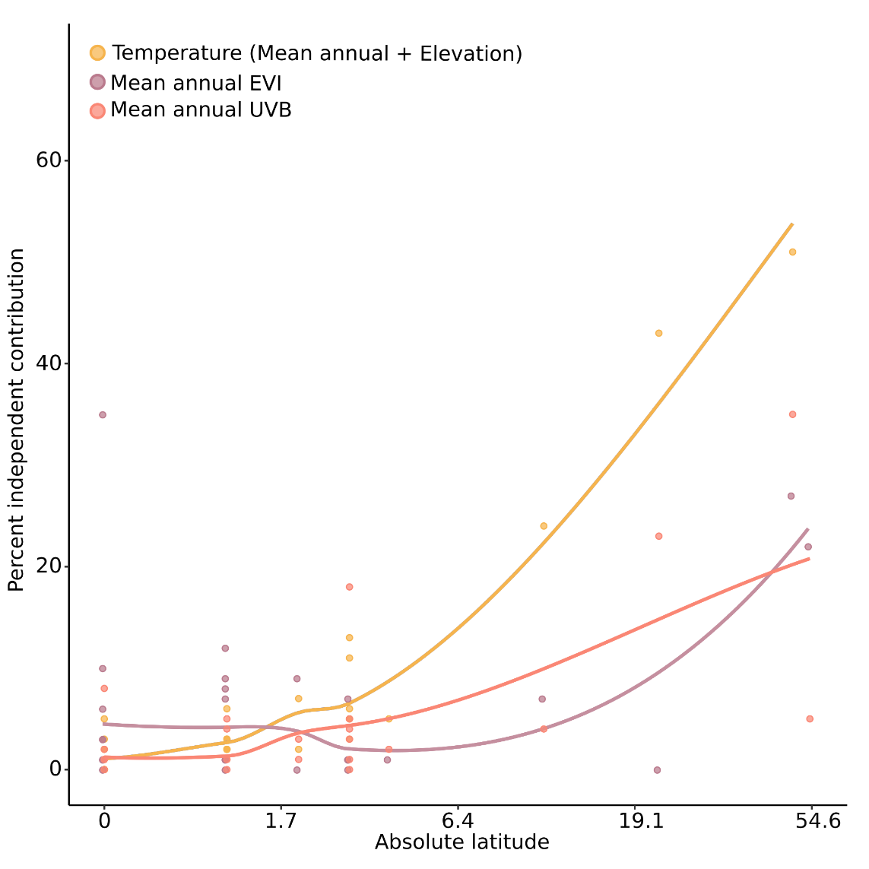
Extended Data Fig. 5. Independent contribution of environmental variables. The percentage of the total explained variance in mean annual temperature, mean annual EVI (productivity) and mean annual UVB and the log +1 transformed latitudinal distribution centre of each family (absolute values averaged across all species) (n = 35 families). X-axis labels provide original values.

