Supporting Information
Construction of Interface-Engineered Coral-like Ni₂P@CeO₂ Hybrid Nanoarrays to Boost Electrocatalytic Hydrogen Evolution Performance in alkaline water/seawater electrolytes

Chaojie Lyu^{1,2} · Jiarun Cheng¹ · Huichao Wang¹ · Yuquan Yang¹ · Kaili Wu^{1,2} ·Peng Song³ · Woon-Ming Lau^{1,2} · Jinlong Zheng^{1,2} · Xixi Zhu³ · Hui Ying Yang⁴

¹ Beijing Advanced Innovation Center for Materials Genome Engineering
Center for Green Innovation, School of Mathematics and Physics
University of Science and Technology Beijing,
Beijing 100083, P. R. China
² Shunde Graduate School, University of Science and Technology Beijing
Foshan, Guangdong 528399, P. R. China
³ College of Chemical and Biological Engineering
Shandong University of Science and Technology
Qingdao 266590, P. R. China
⁴ Pillar of Engineering Product Development
Singapore University of Technology and Design
487372, Singapore

Material
Nickel nitrate hexahydrate (Ni(NO₃)₂⋅6H₂O, 99%), Cerium nitrate hexahydrate (Ce(NO₃)₃⋅6H₂O, 99%), urea (CO(NH₂)₂, 99%), potassium hydroxide (KOH, 85%), platinum-carbon (commercial 20% Pt/C), sodium hypophosphite (NaH₂PO₂, 95%), sodium chloride (NaCl, 90%) were produced by Sigma-Aldrich. The Teflon autoclave (50 ml) was produced by Anhui Chem-n Instrument Co., Ltd. The ultrapure water (18.2 MΩ) was used for samples preparation and washing.

Structure and characterization:
The crystal structure and composition of the sample was identified by X-ray diffractometer (XRD, Rigaku Dmax 2200, CuKa radiation). Morphology and microstructure were further characterized by scanning electron microscopy (SEM, Hitachi 7500) and high-resolution transmission electron microscopy (TEM, JOEL JEM-2200FS). The high-angle annular dark-field scanning TEM (HAADF-STEM) and Energy-dispersive spectroscopy (EDS) mapping were characterized by JOEL JEM-2200FS operating at 200 kV. The chemical and valence state were investigated by X-ray photoelectron spectroscopy (XPS) by PHI 5000 Versaprobe with an Al Kα X-ray source. The Brunauer-Emmett-Teller (BET) specific surface area and pore size distribution was determined by ASAP 2460, Micromeritics, USA. The electron paramagnetic resonance (EPR) characterization was performed on Bruker EMXplus-6/1, Germany.

Fig. S1. X-ray diffraction of Ni(OH)₂@CeO₂ nanoarrays.

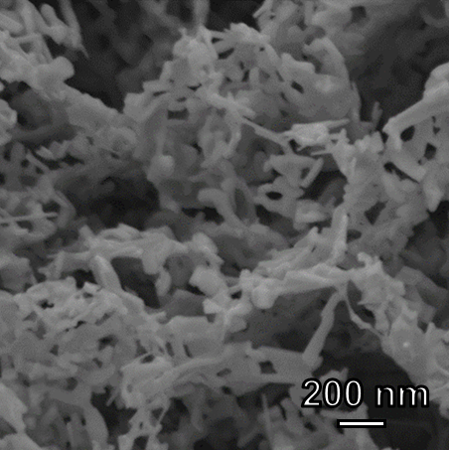
Fig. S2. Scanning electron microscopy (SEM) image of Ni₂P/NF.

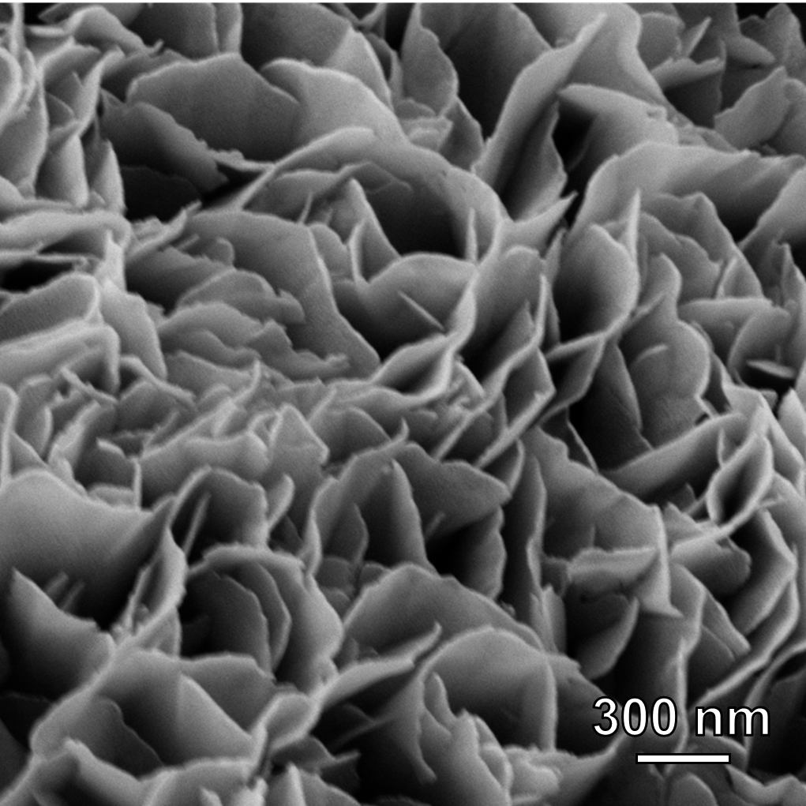
Fig. S3. Scanning electron microscopy (SEM) image of CeO₂/NF.

Table. S1. The overpotentials at current densities of 10, 50 and 100 mA/cm² of Ni₂P@CeO₂/NF, Ni₂P/NF, CeO₂/NF and Pt/C/NF electrodes for HER.
Catalysts | Overpotential (mV)  at 10 mA/cm² | Overpotential (mV)  at 50 mA/cm² | Overpotential (mV)  at 100 mA/cm²
Ni₂P@CeO₂/NF | 62 | 128 | 174
Ni₂P/NF | 108 | 198 | 257
CeO₂/NF | 161 | 275 | 361
Pt/C/NF | 42 | 85 | 120

Table. S2. Performance comparisons of Ni₂P@CeO₂/NF electrode with recently reported HER electrocatalysts.
Catalysts | Overpotential (mV)  at 10 mA/cm² | Tafel slope  (mV/dec) | Reference
Ni₂P@CeO₂/NF | 62 | 57.8 | This work
NiP₂/NiSe₂/CFC | 89 | 65.7 | [1]
CoSe₂-MoSe₂(1–1)/rGO | 107 | 56 | [2]
Ni₂P@C NAs/NF | 122 | 102 | [3]
Fe,Ce-Ni_{x}S_{y} | 125 | 63 | [4]
15:MoCo-VS₂/CC | 140 | 75 | [5]
Ni₂P-Fe₂P-Ru₂P/NF | 78.6 | 85.1 | [6]
Fe_{0.9}Ni_{2.1}S₂@NF | 72 | 71 | [7]
B-CoSe₂@CoNi LDH | 100 | 101 | [8]
NiMo@ZnO/NF | 110 | 131.2 | [9]

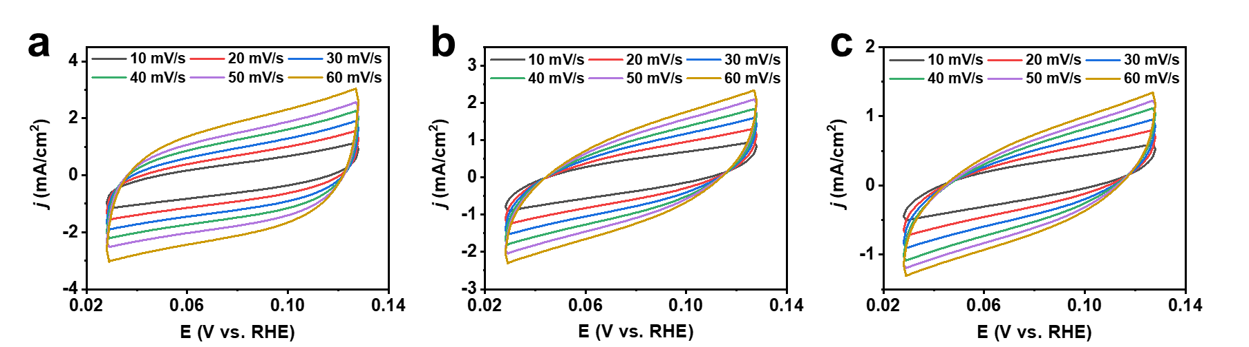
Fig. S4. Cyclic voltammograms of (a) Ni₂P@CeO₂/NF, (b) Ni₂P/NF, and (c) CeO₂/NF obtained in 0.03~0.13 V vs. RHE region at scan rates of 10, 20, 30, 40, 50 and 60 mV/s, respectively.

Fig. S5. I-t curve of Ni₂P /NF electrode recorded at -0.26 V vs. RHE for 100 h in 1 M KOH.

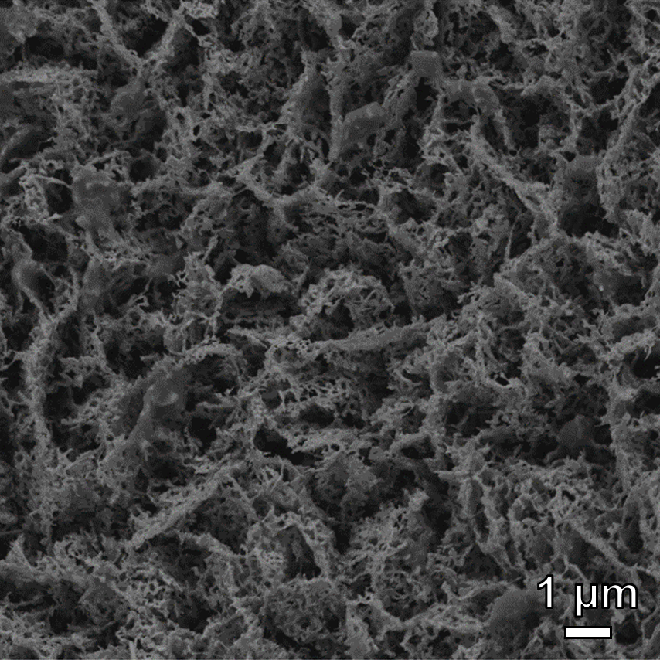
Fig. S6. SEM image of Ni₂P@CeO₂/NF after HER tests.

Fig. S7. XRD pattern of Ni₂P@CeO₂ nanoarrays after HER tests.

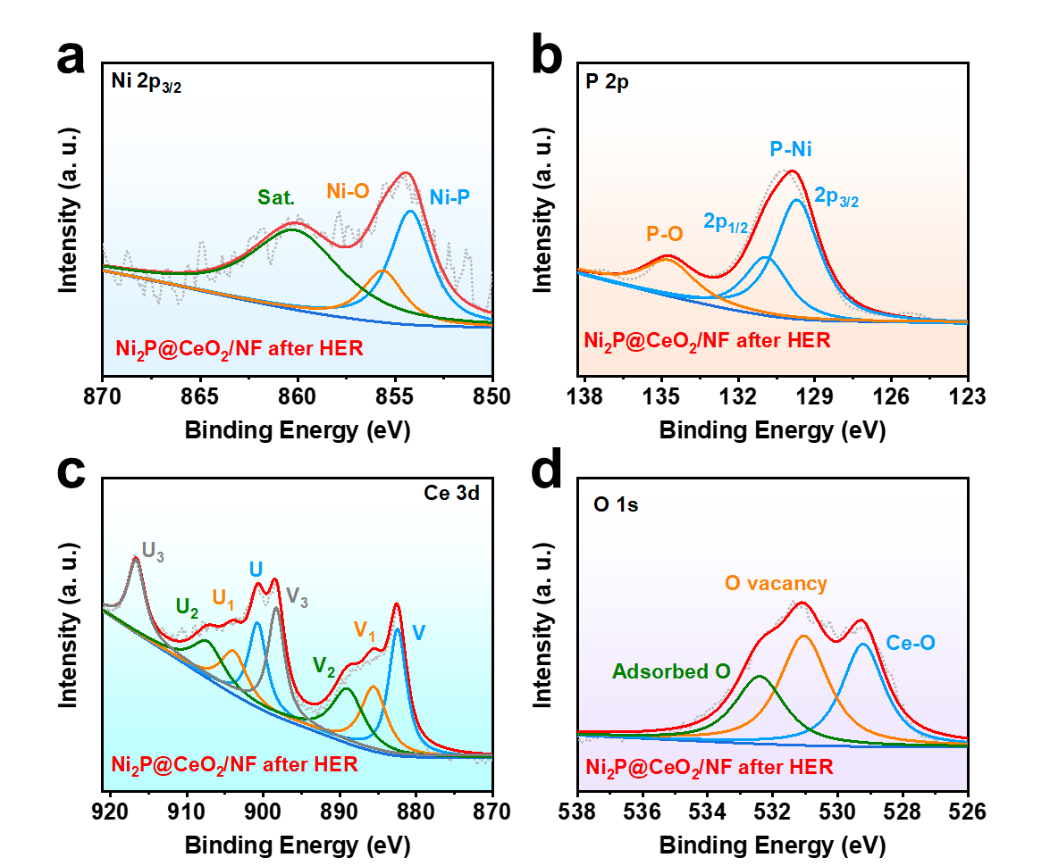
Fig. S8. XPS spectrum of Ni₂P@CeO₂ nanoarrays after HER tests.

Table. S3. Performance comparisons of Ni(OH)₂@CeO₂/NF electrode with recently reported transition-metal-based OER electrocatalysts.
Catalysts | Overpotential (mV)  at 10 mA/cm² | Tafel slope  (mV/dec) | Reference
Ni(OH)₂@CeO₂/NF | 229 | 86.5 | This work
NiMoNS | 260 | 54.7 | [10]
Cu-CoP | 252 | 89.1 | [11]
CeO₂@CoS/MoS₂ | 247 | 64 | [12]
NC-FeCoNiMg | 290 | 34.6 | [13]
NiFe-MOF-BF4-0.3 NSs | 237 | 41 | [14]
NCF-C3 | 273 | 63 | [15]
NCFPO-350 | 278 | 58.92 | [16]
M-PCBN/CC | 232 | 32 | [17]
single-facet CoSe₂(001) | 240 | 75.8 | [18]
Co-Ni-Fe-P HNBs | 249 | 59.19 | [19]

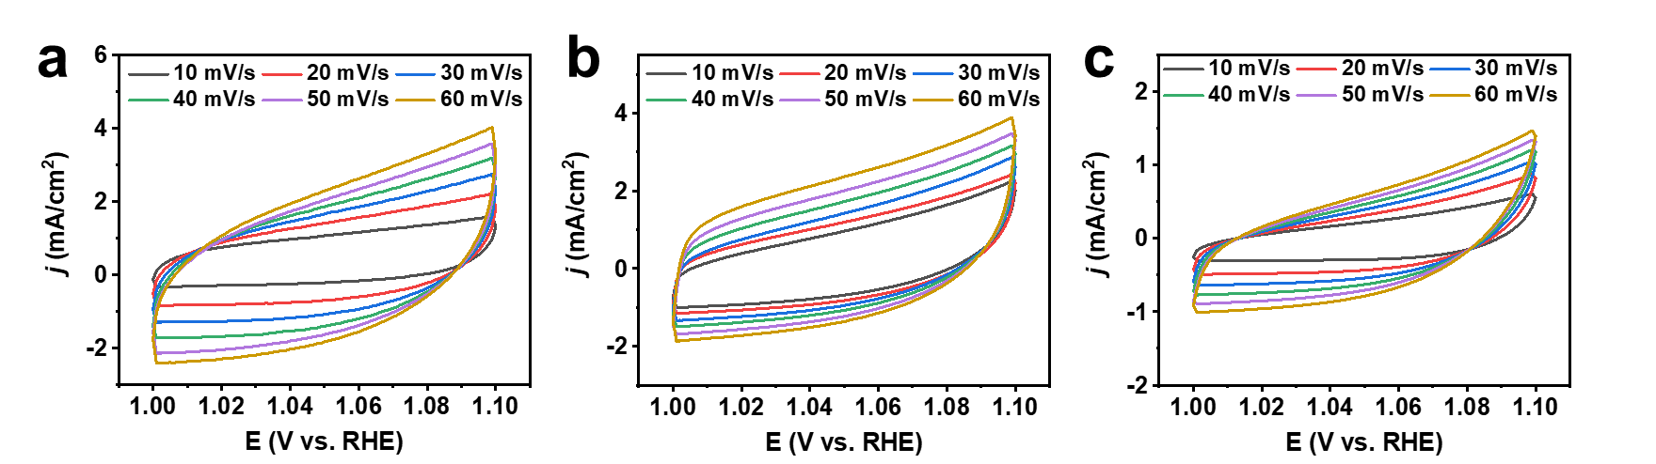
Fig. S9. Cyclic voltammograms of (a) Ni(OH)₂@CeO₂/NF, (b) Ni(OH)₂/NF, and (c) CeO₂/NF obtained in 1.00~1.10 V vs. RHE region at scan rates of 10, 20, 30, 40, 50 and 60 mV/s, respectively.

Fig. S10. OER polarization curves of Ni(OH)₂@CeO₂/NF electrode before and after i-t test.

Table. S4. Performance comparison of Ni(OH)₂@CeO₂/NF||Ni₂P@CeO₂/NF electrolyzer with the recently reported two-electrode electrolyzer.
Electrolyzer | Voltages (V)  at 10 mA/cm² | Reference
Ni(OH)₂@CeO₂/NF‖Ni₂P@CeO₂/NF | 1.53 | This work
Ni-CoP/Co₂P@NC||Ni-CoP/Co₂P@NC | 1.59 | [20]
Ru₁Co₂ NPs||Ru₁Co₂ NPs | 1.59 | [21]
NiFe-LDH/Ni(OH)₂||NiFe-LDH/Ni(OH)₂ | 1.6 | [22]
Co-Ni-P/MoS₂||Co-Ni-P/MoS₂ | 1.53 | [23]
CuO@CoZn-LDH||CuO@CoZn-LDH | 1.55 | [24]
Ru-NiSe₂/NF||Ru-NiSe₂/NF | 1.537 | [25]
MoCo-VS₂||MoCo-VS₂ | 1.54 | [5]
La-doped RuO₂||La-doped RuO₂ | 1.53 | [26]
N-NiCo-LDH‖N-NiCo-LDH | 1.55 | [27]
Co/Mo₂C@C|| Co/Mo₂C@C | 1.59 | [28]
Ni₃S₂@NGCLs/NF||Ni₃S₂@NGCLs/NF | 1.55 | [29]

Fig. S11. Polarization curves of Ni(OH)₂@CeO₂/NF||Ni₂P@CeO₂/NF electrolyzer before and after i-t tests in 1 M KOH.

Fig. S12. Faradic efficiencies of Ni(OH)₂@CeO₂/NF||Ni₂P@CeO₂/NF electrolyzer under 100 mA/cm² in 1 M KOH solution.

Table. S5. The voltages of Ni(OH)₂@CeO₂/NF||Ni₂P@CeO₂/NF electrolyzer in 1 M KOH, 1 M KOH + NaCl and 1 M KOH + seawater electrolytes at current densities of 10, 50 and 100 mA/cm².
Electrolytes | voltage (V)  at 10 mA/cm² | voltage (V)  at 50 mA/cm² | voltage (V)  at 100 mA/cm²
1 M KOH | 1.53 | 1.63 | 1.72
1 M KOH + NaCl | 1.54 | 1.65 | 1.75
1 M KOH + seawater | 1.55 | 1.68 | 1.78

Fig. S13. Polarization curves of Ni(OH)₂@CeO₂/NF||Ni₂P@CeO₂/NF electrolyzer before and after i-t tests in 1 M KOH + seawater electrolyte.

Fig. S14. Faradic efficiencies of Ni(OH)₂@CeO₂/NF||Ni₂P@CeO₂/NF electrolyzer under 100 mA/cm² in 1 M KOH + seawater electrolyte.

Notes and reference
[1] Yang L, Huang L, Yao Y, Jiao L (2021) In-situ construction of lattice-matching NiP₂/NiSe₂ heterointerfaces with electron redistribution for boosting overall water splitting. Appl Catal B-Environ 282:119584.
[2] Zhu M, Yan Q, Bai X, Cai H, Zhao J, Yan Y, Zhu K, Ye K, Yan J, Cao D, Wang G (2022) Construction of reduced graphene oxide coupled with CoSe₂-MoSe₂ heterostructure for enhanced electrocatalytic hydrogen production. J Colloid Interface Sci 608:922-930.
[3] Ma M, Zheng Z, Song Z, Zhang X, Han X, Chen H, Xie Z, Kuang Q, Zheng L (2020) In situ construction and post-electrolysis structural study of porous Ni₂P@C nanosheet arrays for efficient water splitting. Inorg. Chem. Front. 7:2960-2968.
[4] Zhang X, Qiu Y, Li Q, Ji X, Liu J (2022) Fe-atom-implantation induced regional phase reconstruction for high-entropy Ni_{x}S_{y} construction with diversified crystallographic orientations towards accelerated water splitting. J Power Sources 522:231004.
[5] Singh V, Nakate U, Bhuyan P, Chen J, Duy Thanh T, Park S (2022) Mo/Co doped 1T-VS₂ nanostructures as a superior bifunctional electrocatalyst for overall water splitting in alkaline media. J. Mater. Chem. A 10:9067-9079.
[6] Cai S, Chen X, Huang M, Han J, Zhou Y, Li J (2022) Interfacial engineering of nickel/iron/ruthenium phosphides for efficient overall water splitting powered by solar energy. J. Mater. Chem. A 10:772-778.
[7] Fei B, Chen Z, Liu J, Xu H, Yan X, Qing H, Chen M, Wu R (2020) Ultrathinning Nickel Sulfide with Modulated Electron Density for Efficient Water Splitting. Adv Energy Mater 10:2001963.
[8] Song J, Chen Y, Huang H, Wang J, Huang S, Liao Y, Fetohi A, Hu F, Chen H, Li L, Han X, El-Khatib K, Peng S (2022) Heterointerface Engineering of Hierarchically Assembling Layered Double Hydroxides on Cobalt Selenide as Efficient Trifunctional Electrocatalysts for Water Splitting and Zinc-Air Battery. Adv Sci 9:2104522.
[9] Cao J, Li H, Zhu R, Ma L, Zhou K, Wei Q, Luo F (2020) Improved hydrogen generation via a urea-assisted method over 3D hierarchical NiMo-based composite microrod arrays. J. Alloy. Compd. 844:155382.
[10] Liu Y, Liu P, Men Y, Li Y, Peng C, Xi S, Pan Y (2021) Incorporating MoO₃ Patches into a Ni Oxyhydroxide Nanosheet Boosts the Electrocatalytic Oxygen Evolution Reaction. ACS Appl Mater Interfaces 13:26064-26073.
[11] Thiyagarajan D, Gao M, Sun L, Dong X, Zheng D, Abdul Wahab M, Will G, Lin J (2022) Nanoarchitectured porous Cu-CoP nanoplates as electrocatalysts for efficient oxygen evolution reaction. Chem Eng J 432:134303.
[12] Huang W, Li X, Yang X, Zhang H, Liu P, Ma Y, Lu X (2021) CeO₂-embedded mesoporous CoS/MoS₂ as highly efficient and robust oxygen evolution electrocatalyst. Chem Eng J 420:127595.
[13] Huang Y, Pei F, Ma G, Ye Z, Peng X, Li D, Jin Z (2022) Bicontinuous Nanoporous Nitrogen/Carbon-Codoped FeCoNiMg Alloy as a High-Performance Electrode for the Oxygen Evolution Reaction. ACS Appl Mater Interfaces 14:784-793.
[14] Zhao Z, Sun X, Gu H, Niu Z, Braunstein P, Lang J (2022) Engineering the Electronic Structures of Metal-Organic Framework Nanosheets via Synergistic Doping of Metal Ions and Counteranions for Efficient Water Oxidation. ACS Appl Mater Interfaces 14:15133-15140.
[15] Zheng H, Wang Y, Zhang P, Ma F, Gao P, Guo W, Qin H, Liu X, Xiao H (2021) Multiple effects driven by AC magnetic field for enhanced electrocatalytic oxygen evolution in alkaline electrolyte. Chem Eng J 426:130785.
[16] Pan D, Chen P, Zhou L, Liu J, Guo Z, Song J (2021) Self-template construction of 2D amorphous N-doped CoFe-mesoporous phosphate microsheets for zinc-air batteries. J Power Sources 498:229859.
[17] Zhang W, Wang Y, Zheng H, Li R, Tang Y, Li B, Zhu C, You L, Gao M, Liu Z, Yu S, Zhou K (2020) Embedding Ultrafine Metal Oxide Nanoparticles in Monolayered Metal-Organic Framework Nanosheets Enables Efficient Electrocatalytic Oxygen Evolution. ACS Nano 14:1971-1981.
[18] Dang K, Zhang S, Wang X, Sun W, Wang L, Tian Y, Zhan S (2021) Cobalt diselenide (001) surface with short-range Co-Co interaction triggering high-performance electrocatalytic oxygen evolution. Nano Res 14:4848-4856.
[19] Wang Y, Sun L, Lu L, Xu D, Hao Q, Liu B (2021) A sequential template strategy toward hierarchical hetero-metal phosphide hollow nanoboxes for electrocatalytic oxygen evolution. J Mater Chem A 9:3482-3491.
[20] Chu H, Feng P, Jin B, Ye G, Cui S, Zheng M, Zhang G, Yang M (2022) In-situ release of phosphorus combined with rapid surface reconstruction for Co-Ni bimetallic phosphides boosting efficient overall water splitting. Chem Eng J 433:133523.
[21] Bao Y, Dai J, Zhao J, Wu Y, Li C, Ji L, Zhang X, Yang F (2020) Modulation in Ruthenium-Cobalt Electronic Structure for Highly Efficient Overall Water Splitting. ACS Appl Energ Mater 3:1869-1874.
[22] Gultom N, Abdullah H, Hsu C, Kuo D (2021) Activating nickel iron layer double hydroxide for alkaline hydrogen evolution reaction and overall water splitting by electrodepositing nickel hydroxide. Chem Eng J 419:129608.
[23] Bao J, Zhou Y, Zhang Y, Sheng X, Wang Y, Liang S, Guo C, Yang W, Zhuang T, Hu Y (2020) Engineering water splitting sites in three-dimensional flower-like Co-Ni-P/MoS₂ heterostructural hybrid spheres for accelerating electrocatalytic oxygen and hydrogen evolution. J Mater Chem A 8:22181-22190.
[24] Yin L, Du X, Di C, Wang M, Su K, Li Z (2021) In-situ transformation obtained defect-rich porous hollow CuO@CoZn-LDH nanoarrays as self-supported electrode for highly efficient overall water splitting. Chem Eng J 414:128809.
[25] Qin R, Wang P, Li Z, Zhu J, Cao F, Xu H, Ma Q, Zhang J, Yu J, Mu S (2022) Ru-Incorporated Nickel Diselenide Nanosheet Arrays with Accelerated Adsorption Kinetics toward Overall Water Splitting. Small 18:2105305.
[26] Wu Y, Yao R, Zhao Q, Li J, Liu G (2022) La-RuO₂ nanocrystals with efficient electrocatalytic activity for overall water splitting in acidic media: Synergistic effect of La doping and oxygen vacancy. Chem Eng J 439:135699.
[27] Wen Y, Qi J, Wei P, Kang X, Li X (2021) Design of Ni₃N/Co₂N heterojunctions for boosting electrocatalytic alkaline overall water splitting. J Mater Chem A 9:10260-10269.
[28] Yuan S, Xia M, Liu Z, Wang K, Xiang L, Huang G, Zhang J, Li N (2022) Dual synergistic effects between Co and Mo₂C in Co/Mo₂C heterostructure for electrocatalytic overall water splitting. Chem Eng J 430:132697.
[29] Li B, Li Z, Pang Q, Zhang J (2020) Core/shell cable-like Ni₃S₂ nanowires/N-doped graphene-like carbon layers as composite electrocatalyst for overall electrocatalytic water splitting. Chem Eng J 401:126045.

