Interface Engineering induced NiFe/Ni-Mo-S@CC Heterostructure as Enhanced Bifunctional Electrocatalysts for Overall Water Splitting
Zhangquan Gong, Wentao Cheng, Zheng Fang, Na Li, Yanmin Qin, Xing Wang*, Haifeng Bao*
School of Materials Science and Engineering, Key Laboratory for New Textile Materials and Applications of Hubei Province, State Key Laboratory of New Textile Materials and Advanced Processing Technologies, Wuhan Textile University, 430200 Wuhan, China
*Corresponding author E-mail: wx@wtu.edu.cn, baohaifeng@wtu.edu.cn

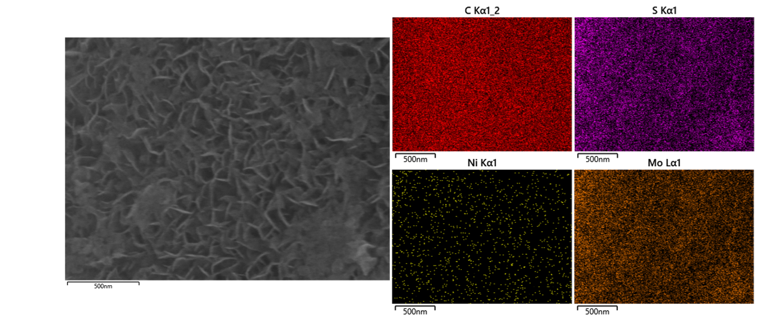
Fig. S1. EDS elemental mapping images of Ni-Mo-S@CC.

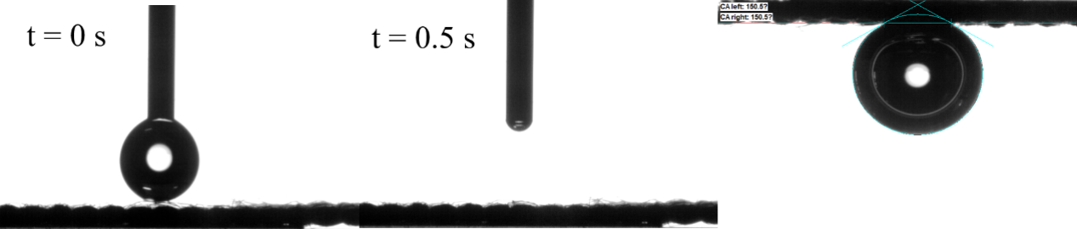
Fig. S2. The water and bubble contact angle of NiFe/Ni-Mo-S@CC.

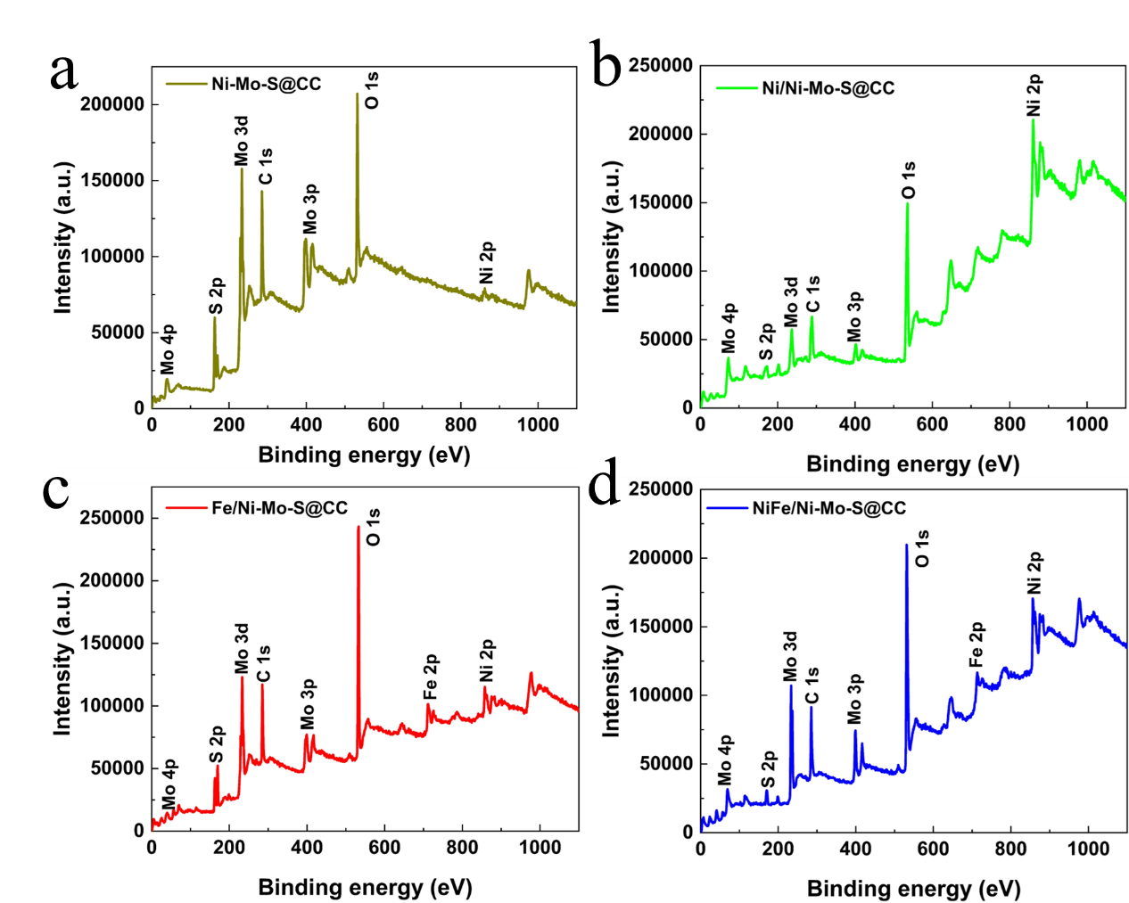
Fig. S3. XPS full spectrum of (a) Ni-Mo-S@CC, (b) Ni/Ni-Mo-S@CC,
(c) Fe/Ni-Mo-S@CC samples, (d) NiFe/Ni-Mo-S@CC,.
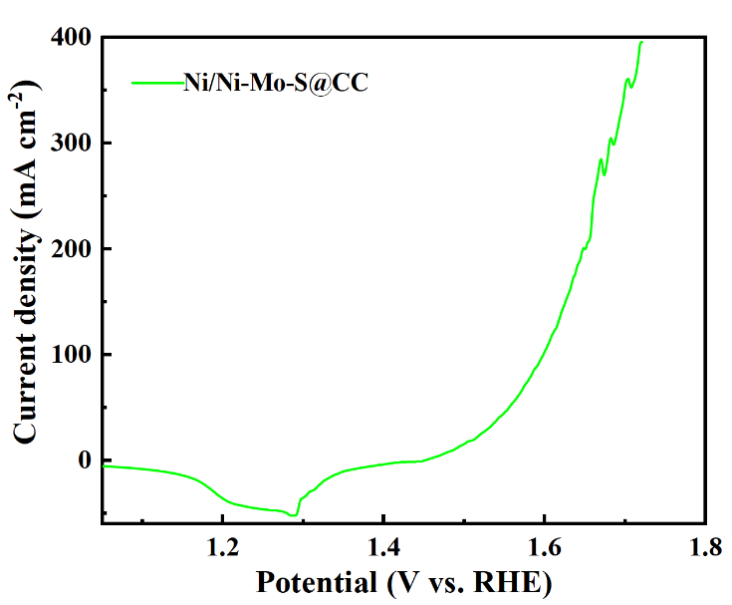
Fig. S4. LSV curve of Ni/Ni-Mo-S@CC under reverse scan.
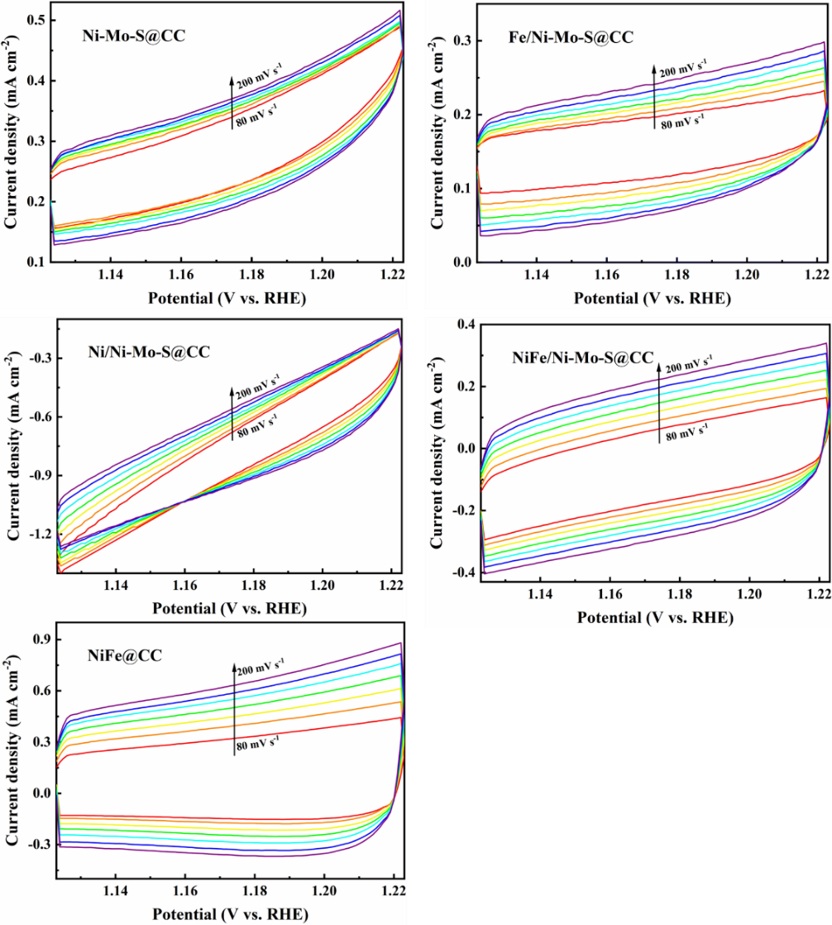
Fig. S5. CV curves of (a) Ni-Mo-S@CC, (b) Fe/Ni-Mo-S@CC, (c) Ni/Ni-Mo-S@CC, (d) NiFe/Ni-Mo-S@CC, (e) NiFe@CC taken at various scan rates of 80, 100, 120, 140, 160, 180 and 200 mV/s.
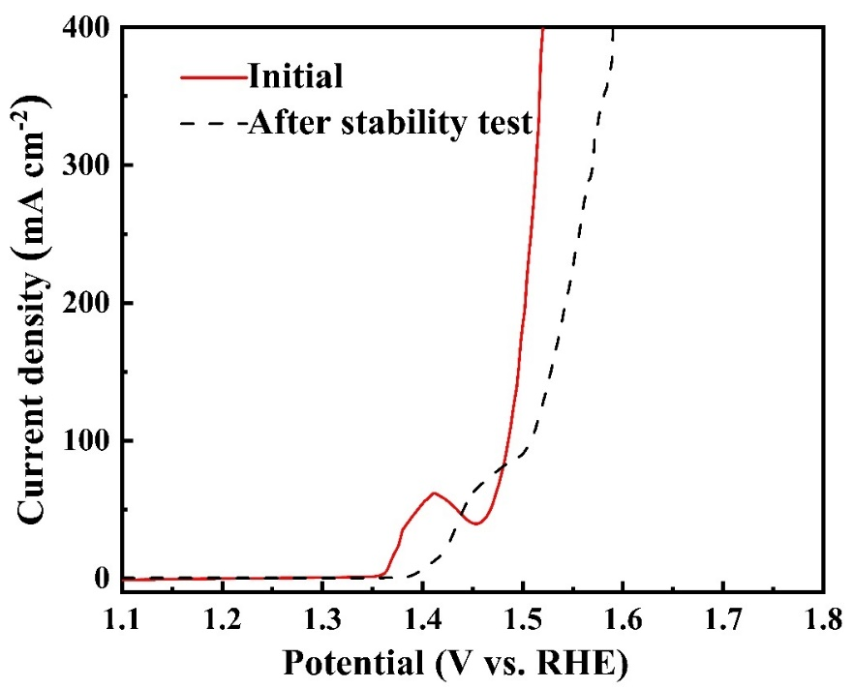
Fig. S6. LSV curves of NiFe/Ni-Mo-S@CC before and after 24 h stability test.
Potential change from 1.47 to 1.50 V at 100 mA cm⁻²
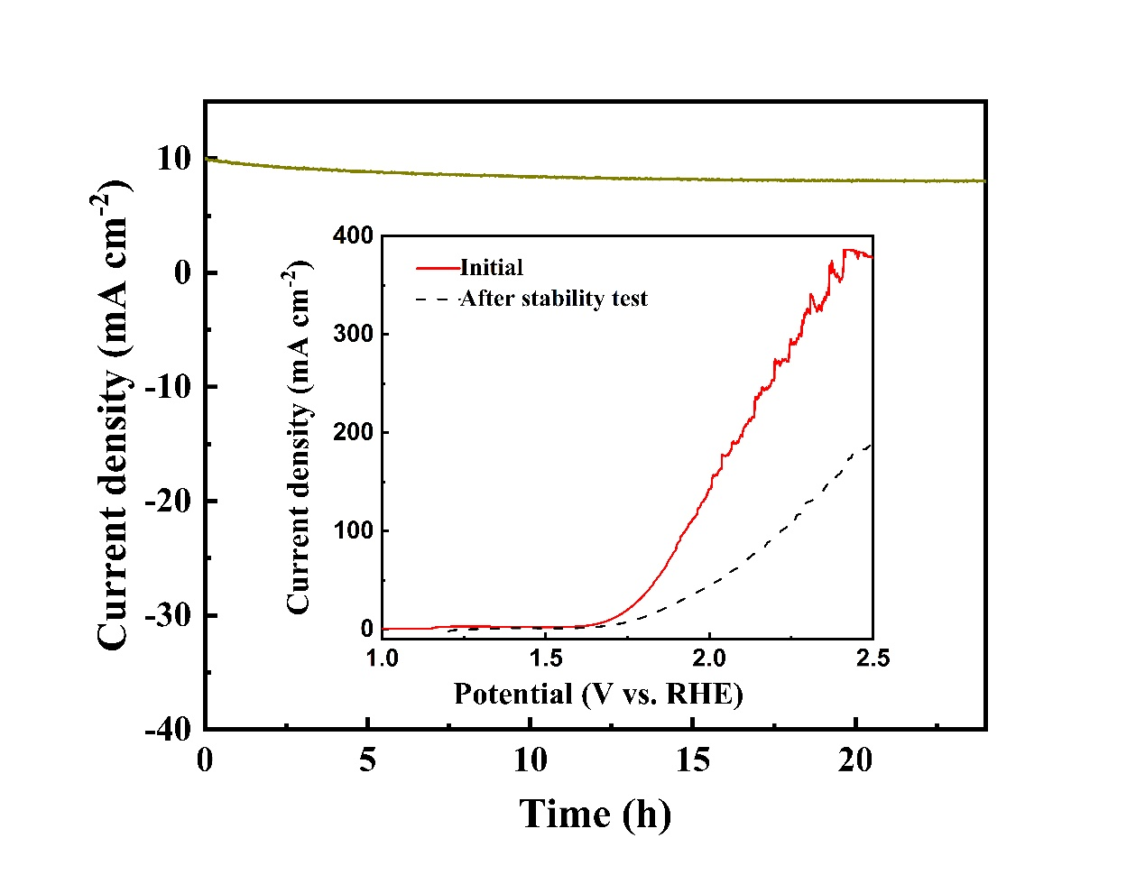
Fig. S7. Time-dependent current density curves for Ni-Mo-S@CC‖Ni-Mo-S@CC cell and corresponding polarization curves before and after stability test.

Table S1. The comparison of OER activity data for various catalysts.
Catalyst electrodes | Support | η (mV) | Durability (h) | Reference
NiFe/Ni-Mo-S@CC | CC | 161 (η₁₀) | 24 | This work
CoFeN_{x} HNAs/NF | Ni foam | 256 (η₁₀) | 40 | [1]
S-doped Ni₄Mo/CF | Cu foam | 140 (η₁₀) | 60 | [2]
Co-Ni₃S₂ | Ni foam | 228 (η₁₀) | / | [3]
Co(OH)₂/NiMo CA@CC | CC | 267 (η₁₀) | 24 | [4]
Co-W-B-P/CF | Cu foam | 280 (η₁₀) | / | [5]
CNTs@NiP₂/NbP | Ni foam | 248.2 (η₂₀) | 32 | [6]
MoS₂/Co₉S₈/Ni₃S₂/Ni | Ni foam | 166 (η₁₀) | / | [7]
MoO₃/Ni–NiO | CC | 347 (η₁₀₀) | 10 | [8]
Au/Ni₃S₂/NF | Ni foam | 230 (η₁₀) | 60 | [9]
Co₂P/CoP@Co@NCNT | NCNT | 256 (η₁₀) | 50 | [10]
CoFe₂O₄/CoO | / | 246 (η₁₀) | / | [11]
CC/MOF-CoSe₂@MoSe₂ | CC | 183.8 (η₁₀) | 24 | [12]

Table S2. The comparison of HER activity data for various catalysts.
Catalyst electrodes | Support | η (mV) | Durability (h) |  | Reference
NiFe/Ni-Mo-S@CC | CC | 72 (η₁₀) | 24 | This work
CoFeN_{x} HNAs/NF | Ni foam | 200 (η₁₀) | 40 | [1]
S-doped Ni₄Mo/CF | Cu foam | 128 (η₁₀) | 60 | [2]
Co-Ni₃S₂ | Ni foam | 102 (η₂₀) | / | [3]
Co(OH)₂/NiMo CA@CC | CC | 30 (η₁₀) | 24 | [4]
Co-W-B-P/CF | Cu foam | 65 (η₁₀) | / | [5]
CNTs@NiP₂/NbP | Ni foam | 137 (η₂₀) | 32 | [6]
MoS₂/Co₉S₈/Ni₃S₂/Ni | Ni foam | 113 (η₁₀) | / | [7]
MoO₃/Ni–NiO | CC | 62 (η₁₀) | 20 | [8]
Au/Ni₃S₂/NF | Ni foam | 97 (η₁₀) | 60 | [9]
Co₂P/CoP@Co@NCNT | NCNT | 118 (η₁₀) | 50 | [10]
CoFe₂O₄/CoO | / | 164 (η₁₀) | / | [11]
CC/MOF-CoSe₂@MoSe₂ | CC | 109.9 (η₁₀) | 24 | [12]

Table S3. The comparison for overall water splitting of NiFe/Ni-Mo-S@CC with the electrocatalysts reported in 1 M KOH (V₁₀-cell voltage at 10 mA cm⁻²).
Catalyst electrodes | Support | V₁₀ (V) | Durability (h) | Reference
NiFe/Ni-Mo-S@CC | CC | 1.50 | 24 | This work
CoFeN_{x} HNAs/NF | Ni foam | 1.592 | 40 | [1]
S-doped Ni₄Mo/CF | Cu foam | 1.595 | 60 | [2]
Co-Ni₃S₂ | Ni foam | 1.54 | 25 | [3]
Co(OH)₂/NiMo CA@CC | CC | 1.52 | 30 | [4]
Co-W-B-P/CF | Cu foam | 1.57 | 48 | [5]
CNTs@NiP₂/NbP | Ni foam | 1.51 | 50 | [6]
MoS₂/Co₉S₈/Ni₃S₂/Ni | Ni foam | 1.54 | 24 | [7]
MoO₃/Ni–NiO | CC | 1.55 | 20 | [8]
Au/Ni₃S₂/NF | Ni foam | 1.52 | 60 | [9]
Co₂P/CoP@Co@NCNT | NCNT | 1.60 | 12 | [10]
CoFe₂O₄/CoO | / | 1.614 | ∼60 | [11]
CC/MOF-CoSe₂@MoSe₂ | CC | 1.53 | 24 | [12]

References
[1] D. Li, Y. Xing, R. Yang, T. Wen, D. Jiang, W. Shi, S. Yuan, Holey Cobalt-Iron Nitride Nanosheet Arrays as High-Performance Bifunctional Electrocatalysts for Overall Water Splitting, ACS Appl Mater Interfaces, 12 (2020) 29253-29263.
[2] S. Feng, J. Wang, W. Wang, X. Wang, Y. Zhang, Chenchen, A. Ju, J. Pan, R. Xu, The Ni‐Mo‐S Catalyst @Copper Foams with Excellent Stability and 1.5 V Drive Electrolytic Water, Advanced Materials Interfaces, 8 (2021) 2100500.
[3] C. Jin, P. Zhai, Y. Wei, Q. Chen, X. Wang, W. Yang, J. Xiao, Q. He, Q. Liu, Y. Gong, Ni(OH)₂ Templated Synthesis of Ultrathin Ni₃S₂ Nanosheets as Bifunctional Electrocatalyst for Overall Water Splitting, Small, 17 (2021) 2102097.
[4] Q. Zhang, W. Xiao, W.H. Guo, Y.X. Yang, J.L. Lei, H.Q. Luo, N.B. Li, Macroporous Array Induced Multiscale Modulation at the Surface/Interface of Co(OH)₂/NiMo Self‐Supporting Electrode for Effective Overall Water Splitting, Advanced Functional Materials, 31 (2021) 2102117.
[5] G. Hu, W. Fu, Y. Lin, Y. Yue, M. Wang, P. Liu, Y. Li, J. Li, L. Wei, X. Zhao, Y. Wei, Highly Efficient Nanoflower-like Bifunctional Electrocatalyst Co-W-B-P/CF for Overall Water Splitting, ACS Applied Energy Materials, 5 (2022) 4259-4269.
[6] S. Singh, D.C. Nguyen, N.H. Kim, J.H. Lee, Interface engineering induced electrocatalytic behavior in core-shelled CNTs@NiP₂/NbP heterostructure for highly efficient overall water splitting, Chemical Engineering Journal, 442 (2022) 136120.
[7] Y. Yang, H. Yao, Z. Yu, S.M. Islam, H. He, M. Yuan, Y. Yue, K. Xu, W. Hao, G. Sun, H. Li, S. Ma, P. Zapol, M.G. Kanatzidis, Hierarchical Nanoassembly of MoS₂/Co₉S₈/Ni₃S₂/Ni as a Highly Efficient Electrocatalyst for Overall Water Splitting in a Wide pH Range, J Am Chem Soc, 141 (2019) 10417-10430.
[8] X. Li, Y. Wang, J. Wang, Y. Da, J. Zhang, L. Li, C. Zhong, Y. Deng, X. Han, W. Hu, Sequential Electrodeposition of Bifunctional Catalytically Active Structures in MoO₃/Ni-NiO Composite Electrocatalysts for Selective Hydrogen and Oxygen Evolution, Adv Mater, 32 (2020) 2003414.
[9] H. Liu, J. Cheng, W. He, Y. Li, J. Mao, X. Zheng, C. Chen, C. Cui, Q. Hao, Interfacial electronic modulation of Ni₃S₂ nanosheet arrays decorated with Au nanoparticles boosts overall water splitting, Applied Catalysis B: Environmental, 304 (2022) 120935.
[10] Z. Lu, Y. Cao, J. Xie, J. Hu, K. Wang, D. Jia, Construction of Co₂P/CoP@Co@NCNT rich-interface to synergistically promote overall water splitting, Chemical Engineering Journal, 430 (2022) 132877.
[11] K. Srinivas, Y. Chen, Z. Su, B. Yu, M. Karpuraranjith, F. Ma, X. Wang, W. Zhang, D. Yang, Heterostructural CoFe₂O₄/CoO nanoparticles-embedded carbon nanotubes network for boosted overall water-splitting performance, Electrochimica Acta, 404 (2022) 139745.
[12] S.J. Patil, N.R. Chodankar, S.K. Hwang, P.A. Shinde, G. Seeta Rama Raju, K. Shanmugam Ranjith, Y.S. Huh, Y.K. Han, Co-metal–organic framework derived CoSe₂@MoSe₂ core–shell structure on carbon cloth as an efficient bifunctional catalyst for overall water splitting, Chemical Engineering Journal, 429 (2022) 132379.

