Traditional Alcoholic Beverages of Bonda Tribe in Odisha, India: Evidences from the Field
Photos
Photo 1: Specific Steps and Processes Followed to Produce Traditional Alcohol
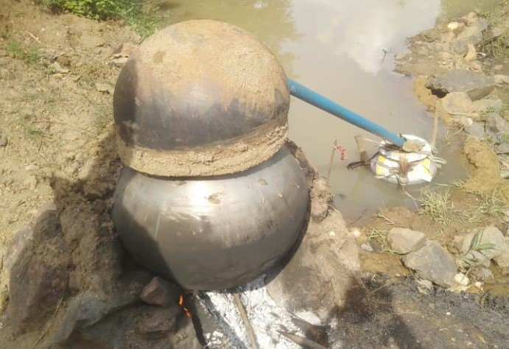 | 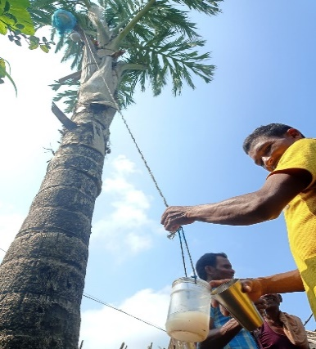 | 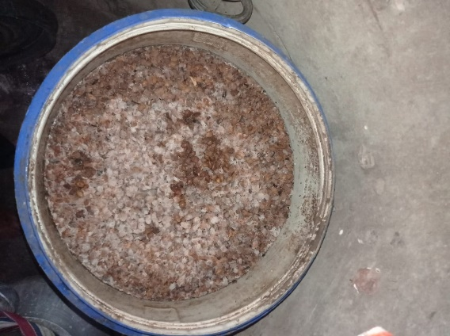
Alcohol distillation process | Salap juice Collection | Fermentation of Mahua flower
Photo Courtesy: Second author of the article
Photo 1: Broadly the production of traditional alcoholic beverages of Bonda are classified under three categories i.e., sap collection from tree, fermentation of food-fruit-cereal-vegetable-nuts, etc. and alcohol production through distillation. While the first photo shows the distillation of alcohol, second shows sap collection from Fishtail palm tree and the third one shows fermentation of mahua flower.

Photo 2: Drinking of different Alcohol
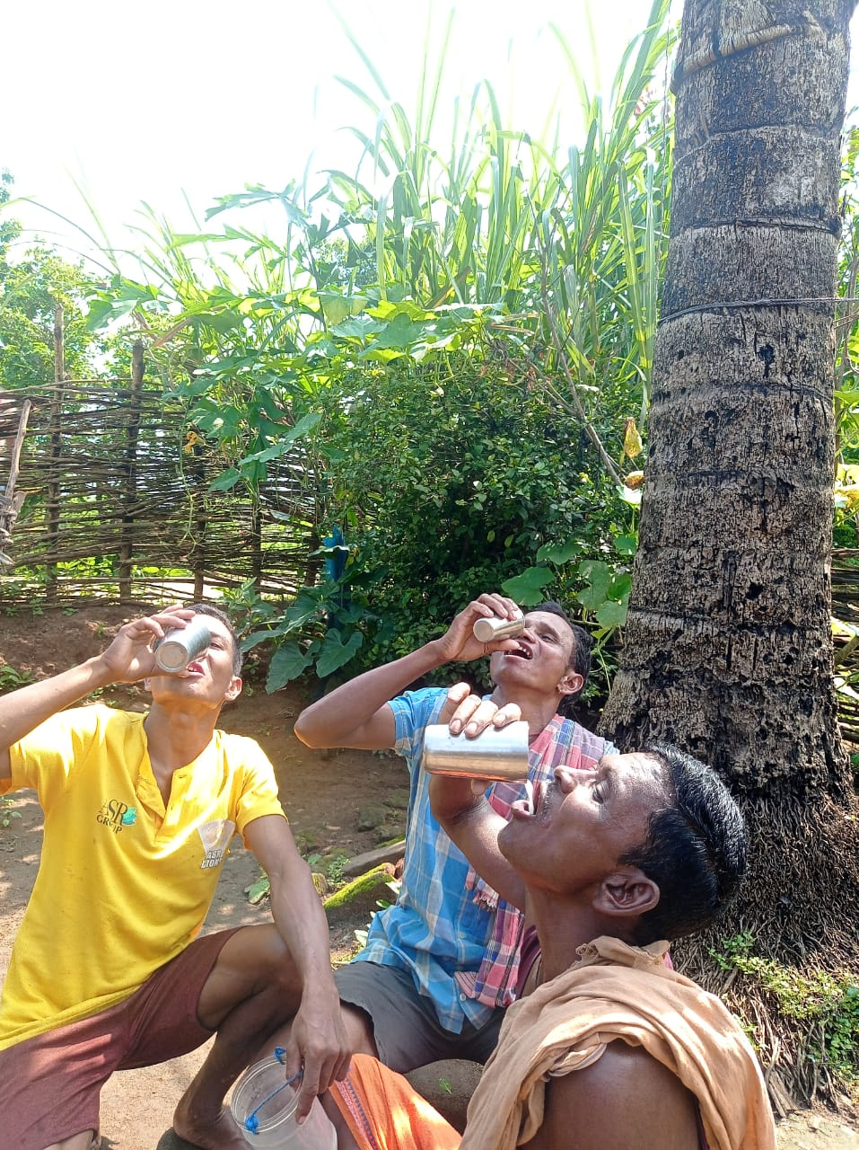 | 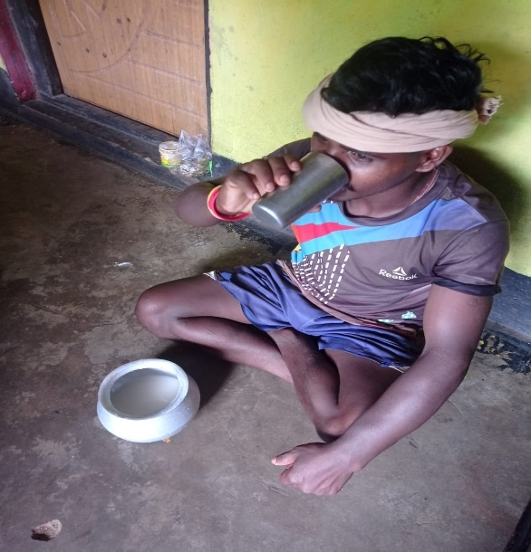
Drinking of Salap (Fishtail palm Juice) | Drinking of Rice beer (Handia/Pendom)
Photo Courtesy: Second author of the article
Photo 2: Consumption of alcohol by Bonda are either done alone or in group. However, consumption of alcohol in group is a common practice, which is basically performed in socio-cultural celebration both for merry marking and symbolic culture.

