Supplementary materials

1. Construction of ETV6::PDGFRB, SP-△(77-136), SP-△(71-79) or SP-△(166-183) retroviral expression vectors.

To generate the full-length ETV6::PDGFRB expression plasmid, the CDS region of exon 1-4 of ETV6 cDNA sequences were excised from the pCDH-MCS1-EF1-ETV6::ABL1-flag-copGFP plasmid (provided by Dr.Meizhen Xu, Institute of Hematology, China) and the CDS region of exon 11-23 of PDGFRB cDNA sequences from a STRN3::PDGFRB retroviral vector in the MSCV retroviral backbone containing both the STRN3::PDGFRB and eGFP cDNA with an IRES.

The ETV6 fragment was amplifed by: EP-F1 (5’-GAATTAGATCTCTCGAGGCCACCATGTCTGAGACTCCTGCTCAGT-3’), EP-R1 (5’- CACCTTAAAGGGCAAGGCTTCTTCATGGTTCTGATGCAG -3’）.
The PDGFRB fragment was amplifed by: EP-F2 (5’-TCAGAACCATGAAGAAGCCTTGCCCTTTAAGGTGGTGGT-3’), EP-R2 (5’-AGGGGGGGGGGGCGGAATTCCTACTTGTCATCGTCGTCCTTG-3’)

The amplified fragments were purified using the TaKaRa MiniBEST Agarose Gel DNA Extraction Kit Ver.4.0 (Takara, Dalian, China) and subsequently mixed as the template for PCR using primers EP-F1 and EP-R2 to obtain full-length cDNA. The 2.2-kb ETV6::PDGFRB (EP) with a Flag tag was cloned into pMSCV-IRES-eGFP (pMIG, between XholI abd EcoRI) using EasyGeno Assembly Cloning Kit (Tiangen, Beijing, China), to yield pMSCV-EP-IRES-eGFP.

For SP-△(77-136) cloning, SP-CF1 (5’-TAGGCGCCGGAATTAGCCACCATGGACGAGCTTGCCG-3’) and SP-CR1 (5’-GTTCCGTGCCATACCACTCGTGCTGGATGTAGTGC-3’) were used for PCR to produce fragment 1. For fragment 2, SP-CF2 (5’-CGAGTGGTATGGCACGGAACTGAACCAAGG-3’) and SP-CR2 (5’-CGTCCTTGTAATCCAGGAAGC-3’) were used. The pMSCV-IRES-eGFP was digested with EcoR I and Xhol I. The amplified fragments and linearized pMIG were purified, and ligated by using EasyGeno Assembly Cloning Kit (Tiangen, Beijing, China), to yield pMSCV- SP-△(77-136) -IRES-eGFP.

For SP-△(71-79) cloning, pMSCV-SP-IRES-eGFP was linearized by PCR, using SP-CavF1 (5’- GGATACTGCACGAGATGGAGCGGGCGCACTGGGAGGTGGAA-3’) and SP-CavR1 (5’- CCGCTCCATCTCGTGCAGTATCCCCGGGATAGTGTACTGCTG-3’), and then ligated by using EasyGeno Assembly Cloning Kit, to yield pMSCV-SP-△(71-79)-IRES-eGFP.

For SP-△(166-183) cloning, pMSCV-SP-IRES-eGFP was linearized by PCR, using SP-CalF1 (5’- CCACAGCACCTCAGGAAGTAGGTTATACAGATACAATATTAGATGTAC-3’) and SP-CalR1 (5’- CCTACTTCCTGAGGTGCTGTGGGAGCCTCTGTGTCTTTGGTTTCT-3’), and then ligated by using EasyGeno Assembly Cloning Kit, to yield pMSCV-SP-△(166-183)-IRES-eGFP.

Supplementary Figure 1
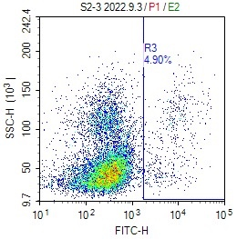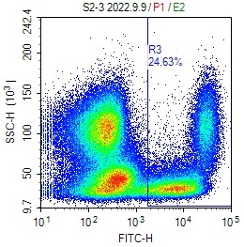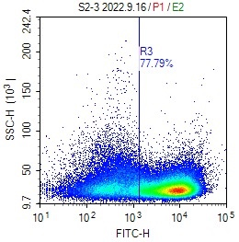
The flow cytometry analysis of peripheral blood from S7-F1 group mice showed that Gr-1/ CD11b positive cells disappeared gradually after transplant, but CD3/CD4/CD8 positive T cells gradually become dominant clone

Supplementary Figure 2
Western blot of spleen cells from different mice confirmed the expression of the STRN3::PDGFRB fusion protein.

Supplementary Figure 3
B
Cartoon showing disease development in recipients of cells from serial passage. Secondary recipients (A1 through 5) received 5×10⁵ spleen from mouse S7. Spleen cells were transferred to tertiary recipients. All mice receiving bone marrow cells developed T-cell lymphomas with characteristics similar to S7A4.

Supplementary Figure 4
B
A

Gross images of the gastrointestinal (GI) tract in mice that treated selinexor. Images are of mice at 10 days post-treatment. GI tract dissected from mice in A.

Supplementary Figure 5

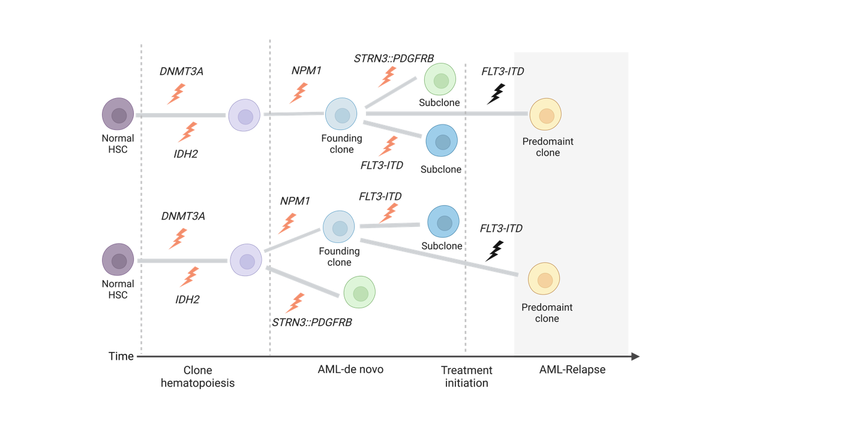
There are two possibilities of the clonal architecture of this patient: 1, DNMT3A and IDH2 mutations are early genetic events that are responsible for the generation of a clonal hematopoiesis. NPM1 mutations are gatekeepers for AML, whereas FLT3-ITD and STRN3::PDGFRB mutations are late events; 2, Under earlier mutations (such as DNMT3A and IDH2), NPM1 and STRN3::PDGFRB subclones appeared simultaneously, in which NPM1 was the predominant clone and FLT3-ITD subclone appeared.

