Supplementary Figure S1: Molecular docking conformation on key targets.

(A) Molecular conformation of AKT1-gamma tocopherol.
(B) Molecular conformation of ESR1-campesterol.
(C) Molecular conformation of ESR2- campesterol.
(D) Molecular conformation of PPARA-fucosterol.
(E) Molecular conformation of PPARD-stigmasterol.
(F) Molecular conformation of PPARG-stigmasterol.
(G) Molecular conformation of NR1H3-campesterol.
(H) Molecular conformation of ILK-alpha- tocopherol.

Supplementary Figure S1

(A)
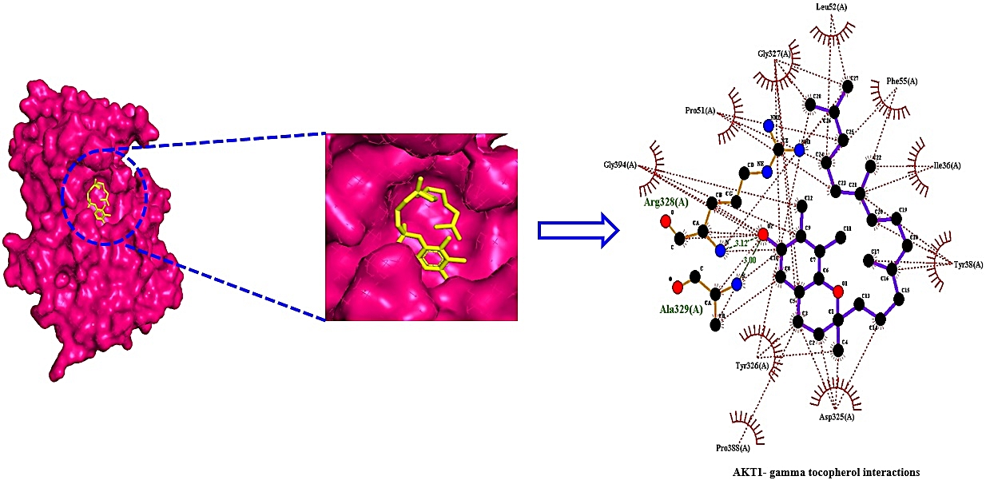
(B)
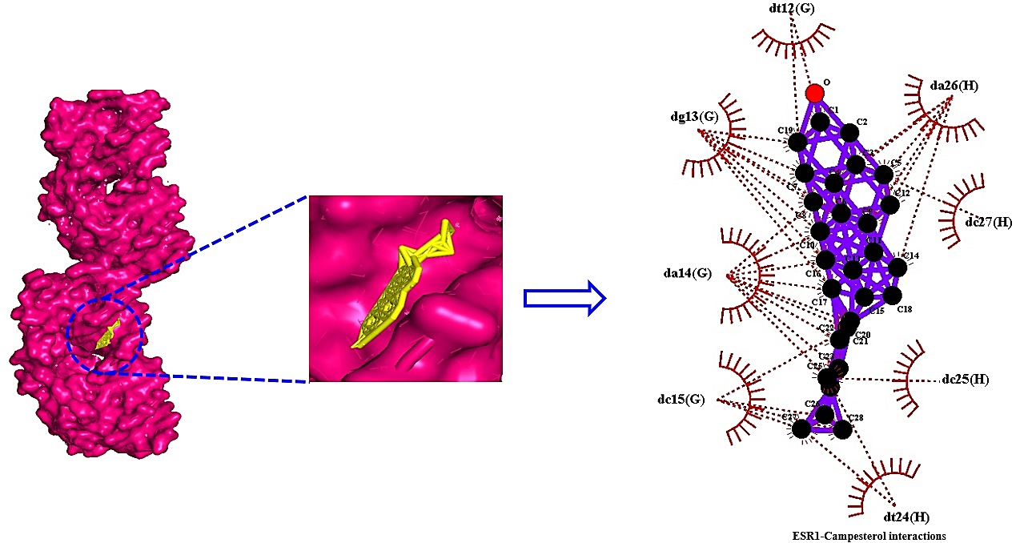

(C)

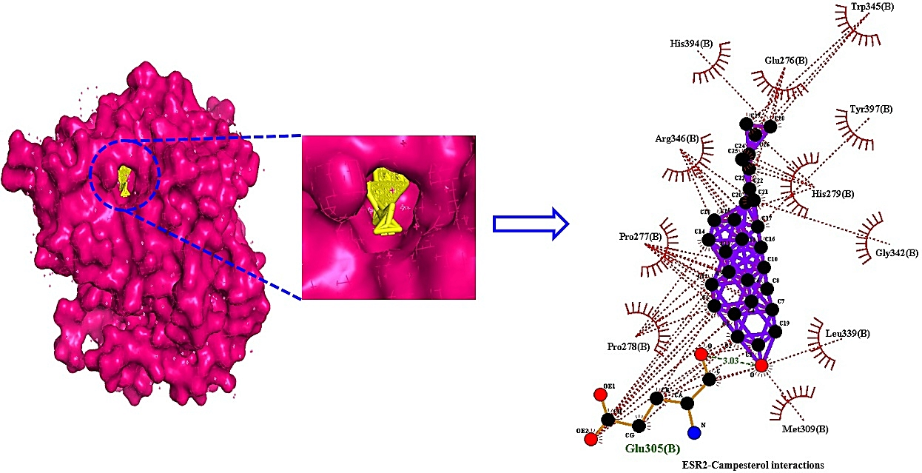

(D)

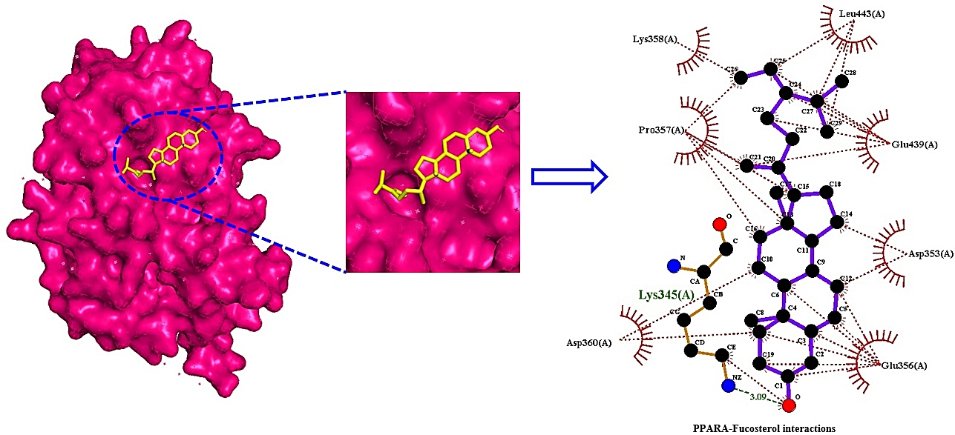

(E)
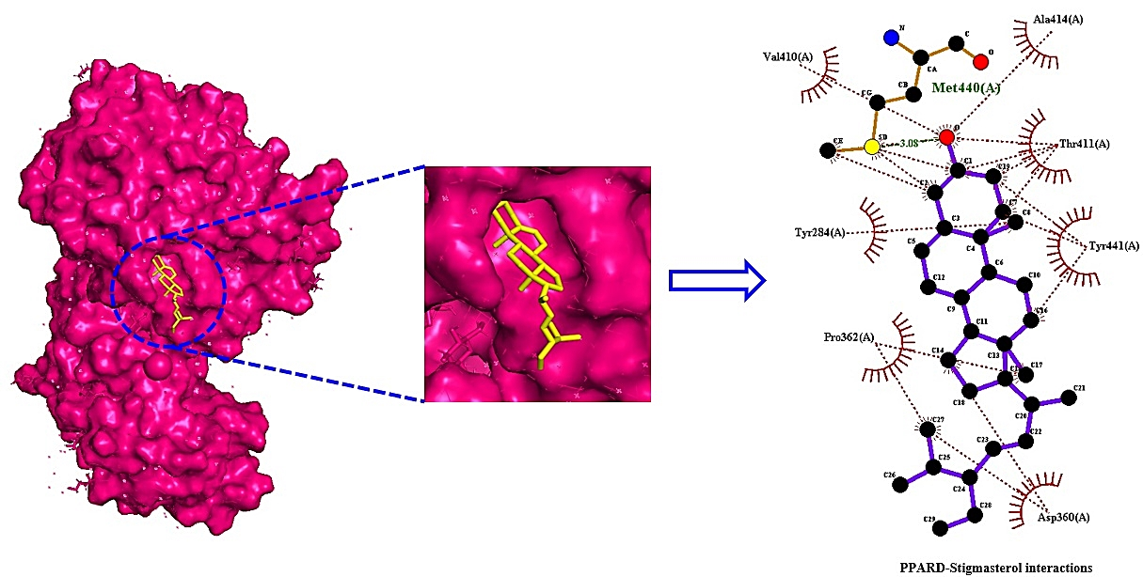

(F)

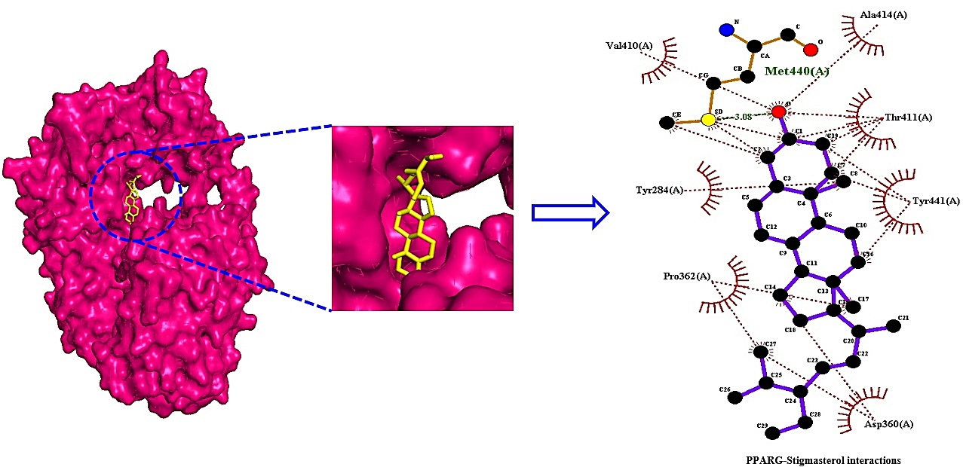

(G)

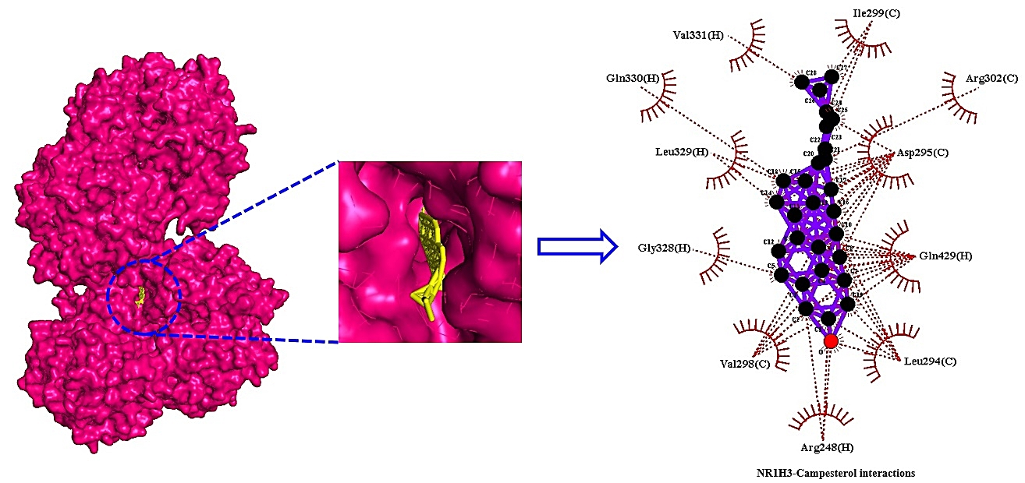

(H)

