ANO7 African-Ancestral Genomic Diversity and Advanced Prostate Cancer

Jue Jiang, Pamela Soh, Shingai B.A. Mutambirwa, M.S. Riana Bornman, Christopher A. Haiman, Vanessa M. Hayes and Weerachai Jaratlerdsiri

Supplementary File

Supplementary Methods

Ethnic approvals and data preparation for the Exome array case-control study
The investigation of African-related Prostate cancer (PCa) causal variants was conducted on a case-control study of 798 South Africans, recruited as part of the Southern African Prostate Cancer Study (SAPCS) and both population and ancestrally matched to the African whole genome sequencing (WGS) data. Men were consented under the University of Pretoria Faculty of Health Sciences Research Ethics Committee (HREC) SAPCS approval #43/2010 (with US Federal wide assurance FWA00002567 and IRB00002235 IORG0001762). Genomic DNA was extracted from whole blood (Qiagen) and shipped to Australia under Republic of South Africa Department of Health Export Permit (National Health Act 2003; J1/2/4/2 #1/12) and University of Pretoria and University of Sydney Material Transfer Agreement (MTA). Genomic interrogation was performed under the St. Vincent’s Sydney HREC study approval #SVH/15/227.

Annotation of short variants
The annotation of short variants was processed with the online tool SNPnexus (https://www.snp-nexus.org/v4/) (1). SNPnexus provides multiple tools and datasets using the publicly accessible Ensembl gene annotation system (Ensembl Variation 95). The database includes HapMap (Nov 2018 updated), 1000 Genomes (Nov 2018 updated), and gnomad v2.1(Mar 2019 updated). Predicted effects of SNVs were merged from two annotation tools, including Sorting Intolerant From Tolerant (SIFT, Jan 2019 updated) (2) and Polymorphism Phenotype (PolyPhen, Jan 2019 updated) (3). Predicted deleterious variants (PDVs) of the main transcript of ANO7 ENST00000274979 included deleterious variants predicted by SIFT and probably/possibly damaging variants predicted by PolyPhen, as well as indels with stop-gain/frameshift effects predicted with cancer genome interpreter (CGI) (4). Minor allele frequency (MAF) of PDVs in African and European populations were obtained from online Allele Frequency Aggregator (ALFA) (5).

Sequence analysis
The sequence and phylogenetics analyses were processed using MEGA (v11) (1) where multiple algorithms and methods are available for each step. A total of 45 unique sequences of amino acid sequences was obtained by replacing the original transcript (ENST00000274979) with respectively germline missense variants for each of the 166 patients. Multiple sequence alignment of the 45 sequences was made using MUSCLE in MEGA (2). The best protein model estimated by PhyML (v 3.0) (3) was Jones-Taylor-Thornton (JTT) with evolutionary rates among sites invariable and following discrete Gamma distribution, which in turn was used for the construction of phylogenetic trees and estimation of pairwise genetic distance in MEGA. We used the neighbour-joining statistical method and bootstrap values equal to 1,000 to construct the phylogenetic tree, which was only assessed for groupings due to low branch support.

Pairs of correlated variants and haplotype block analysis
Correlations between ANO7 PDVs and other important variants, including germline SVs and previously reported PCa causal SNVs, were accessed using Spearman’s rank correlation coefficient (ρ) from Stats package in R, which assumes no frequency distribution. Significantly correlated pairs were those with FDR<0.05 after p-value adjustment by multiple hypothesis correction using Rstatix package (v 0.7.0) (4).
Haplotype block analysis of SNVs within ANO7 was conducted with Haploview (v 4.1) (5). Input data was prepared using VCFtools (v 0.1.14) (6) excluding multi-allelic variants, insertions, or deletions. Haploview calculated pairwise measures of LD between SNVs with MAF>0.001, and defined LD blocks under default confidence intervals where 95% of the SNVs were considered in strong LD (5). The strong LD of a pair was defined if the one-sided lower and upper 95% confidence bounds on D-prime were above 0.7 and 0.98, respectively (7).

Age at diagnosis and ANO7 variants
The associations between age at diagnosis and selected ANO7 variants was investigated with linear regression models using Stats package in R. Variables were examined using t-test with a threshold of significance at a P-value of 0.05. An indicator was made to indicate whether a patient carried more than two variants of PDVs and/or germline SVs. One African patient was filtered out for lacking age information and all the European patients were excluded as none presented with more than two selected variants. The analysis cohort (n=108, all African) consisted of 93 patients with <3 selected variants and 15 patients with $≥$3 selected variants. As the linear regression model allows assessment of effects of multiple variables simultaneously, the best model was determined by the fitness of the model estimated by Akaike’s Information Criterion (AIC) in stepwise selection. Variables in the best model included the indicator of whether having more than two selected variants, the total count of genome-wide short germline variants and PCa risk levels. Genome-wide tumour mutational burden (TMB) was tested but was not selected.

ANO7 variants prevalence in ethnic groups
The difference of allele frequency in different ethnic groups (African, n=109 and European, n=57) was compared for 13 PDVs using logistic regression models from Stats package in R. The logistic regression analyses model the probability of a binary discrete variable, so the genotype information was transformed into a binary variable where “0” means no alternate alleles and “1” means otherwise. The significant level was tested using t-test, and corrected by false discovery rate (FDR) using Rstatix package (v 0.7.0) in R (v 4.1.3;). Significantly differential MAFs were defined by FDR<0.05.

Pores identified in all the sequences containing PDV p.Ile740Leu
Ten unique sequences across the study cohort contain p.Ile740Leu and other missense variants if co-occur in a patient. Identified pores in the ten sequenced were classified into Pores 1-2 if showing the same placement of pores identified in the original protein, and into two new pores named as Pores 3-4, listed in Table S4 and presented in Figure S12-S15.
Pores 1-2 with normal radius were both identified in Seq 39 that contains p.Ile740Leu and p.Asp156Glu while Pore 2 with normal radius was found in Seq 43 that contains p.Ile740Leu and p.Asp70Asn. Save for the above two altered proteins, Pores 1-2 with narrower bottlenecks were observed in altered proteins (Seq 28 for narrower Pore 1, and Seqs 9, 28, and 31 for narrower Pore 2), while neither of the Pores 1-2 were identified in the other four altered proteins (Seqs 18-20, 22).
Two new pores were identified repeatedly in altered proteins and both bypassed the putative Ca2+ binding sites. Pore 3 is the one with one end among at helices α1-2, 9 and the other end among α5-9 (Figure S10a), identified in two proteins (Seqs 12 and 18). Pore 4 is among helices α 5,7, 9 for one end and among α 5-7, 9 for the other end (Figure S10b), reported in three proteins (Seqs 20, 22, and 28). Protein predicted with Seq 19 only showed a broken pore.
References
1. Stecher G, Tamura K, Kumar S. Molecular evolutionary genetics analysis (MEGA) for macOS. Molecular biology and evolution. 2020;37(4):1237-9.
2. Edgar RC. MUSCLE: a multiple sequence alignment method with reduced time and space complexity. BMC bioinformatics. 2004;5(1):1-19.
3. Guindon S, Dufayard J-F, Lefort V, Anisimova M, Hordijk W, Gascuel O. New algorithms and methods to estimate maximum-likelihood phylogenies: assessing the performance of PhyML 3.0. Systematic biology. 2010;59(3):307-21.
4. Kassambara A. rstatix: Pipe-friendly framework for basic statistical tests. Accessed: Feb. 09, 2022. 2021.
5. Barrett JC, Fry B, Maller J, Daly MJ. Haploview: analysis and visualization of LD and haplotype maps. Bioinformatics. 2005;21(2):263-5.
6. Danecek P, Auton A, Abecasis G, Albers CA, Banks E, DePristo MA, et al. The variant call format and VCFtools. Bioinformatics. 2011;27(15):2156-8.
7. Gabriel SB, Schaffner SF, Nguyen H, Moore JM, Roy J, Blumenstiel B, et al. The structure of haplotype blocks in the human genome. science. 2002;296(5576):2225-9.

Supplementary Tables
Table S1. Demographic and clinical information for the sequencing cohort studied
Ancestry | Sample size (n) | Country (n) |  | Median age (years, range) | Risk level (n)ª
Ancestry | Sample size (n) | South Africa | Australia | Median age (years, range) | Low-risk | High-risk
African | 109 | 109 | 0 | 68.00 (45-99) | 27 | 82
European | 57 | 4 | 53 | 63 (46-72) | 7 | 50
Total | 166 | 113 | 53 | 65.50 (45-99) | 34 | 132
ªLow-risk, Gleason score <4+3; High-risk, Gleason score ≥ 4+3

Table S2. Intercorrelation between germline SVs and risk variants.
Ethnicity | Paris of correlated variants |  | ρª | FDR | IC^{b} | Distance (kb)
African | g.29592_29657del^{c} | g.34404_34664del | 0.39 | 9.44E-04 | N | 4.7
African | g.29592_29657del | rs62187431 | 1 | 0 | Y | 0.7
African | g.34404_34664del | rs62187431 | 0.39 | 9.44E-04 | N | 5.5
ªrho, Spearman’s correlation coefficient.
^{b}Y is for inclusive correlated pairs and N is for non-inclusive correlated pairs.
^{c}Genomic changes compared to NG029845.

Table S3. Alpha helixes and residues of protein ANO7
Alpha $α$ helixes | Residue start | Residue end
1 | 343 | 375
2 | 407 | 450
3 | 492 | 530
4 | 537 | 573
5 | 581 | 610
6 | 636 | 669
7 | 705 | 721
8 | 727 | 747
9 | 764 | 784
9 extend | 790 | 796
10 | 842 | 869
10 extend | 879 | 896

Table S4. Ten sequences that contains I740L and pores identified in the respective predicted proteins
No. Sequence | Missenses contained | Pore identification | Condition of the pore
Seq 9 | p.Ile740Leu, p.Arg578Cys, | Pore 2 | Narrower bottleneck (0.4Å, Figure S12c)
Seq 12 | p.Ile740Leu, p.Val604Ile | Pore 3 | Normal (Figure S13a)
Seq 18 | p.Ile740Leu | Pore 3 | Normal (Figure S13b)
Seq 19 | p.Ile740Leu, p.Glu912Lys | A unique pore | Broken (Figure S15a)
Seq 20 | p.Ile740Leu, p.Asp789Val | Pore 4 | Normal (Figure S14a)
Seq 20 | p.Ile740Leu, p.Asp789Val | Pore 4 alike | Broken (Figure S15b)
Seq 20 | p.Ile740Leu, p.Asp789Val | A unique pore | Broken (Figure S15c)
Seq 22 | p.Ile740Leu, p.Ala632Val | Pore4 | Normal (Figure S14b)
Seq 22 | p.Ile740Leu, p.Ala632Val | A unique pore | Broken (Figure S15d)
Seq 28 | p.Ile740Leu, p.Ala494Val | Pore 4 | Normal (Figure S14c)
Seq 28 | p.Ile740Leu, p.Ala494Val | Pore 4 alike | Broken (Figure S15e)
Seq 28 | p.Ile740Leu, p.Ala494Val | Pore 1 | Narrower bottleneck (0.5Å) (Figure S11b)
Seq 28 | p.Ile740Leu, p.Ala494Val | Pore 2 | Narrower bottleneck (0.1Å, Figure S12d)
Seq 31 | p.Ile740Leu, p.Ala470Val | Pore 2 | Narrower bottleneck (0.4Å, Figure S12e)
Seq 39 | p.Ile740Leu, p.Asp156Glu | pore 1 | Normal (Figure S11a)
Seq 39 | p.Ile740Leu, p.Asp156Glu | pore 2 | Normal (Figure S12a)
Seq 43 | p.Ile740Leu, p.Asp70Asn | pore 2 | Normal (Figure S12b)

Supplementary Figures

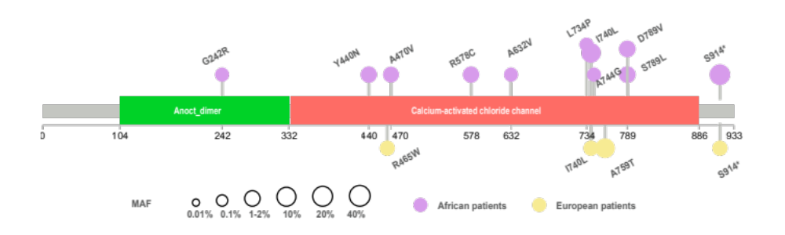
Figure S1. MAFs of ANO7 PDVs in African (n=109) and European (n=57) PCa patients. purple circles represent MAF of PDVs in African patients while yellow circles represent MAF in European patients.

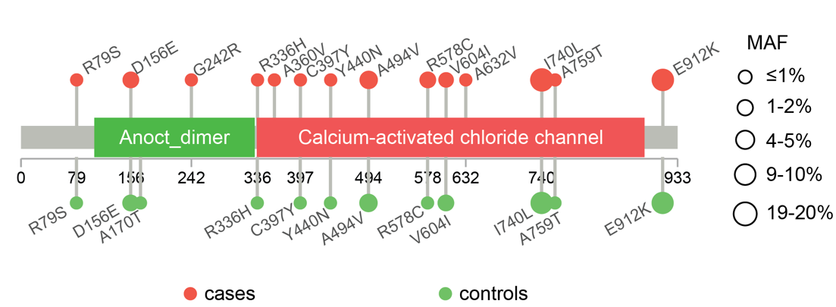

Figure S2. MAFs of ANO7 PDVs in cancer cases (n=473) and controls (n=307). Red circles represent MAF of PDVs in cases while green circles represent MAF in controls.

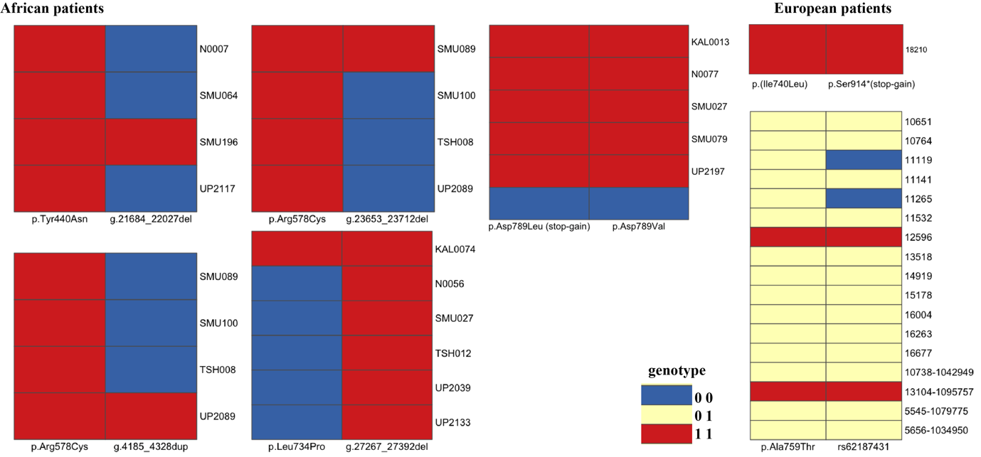

Figure S3. Genotypes of six inclusive correlated pairs in African and European patients. Rows are for the carriers of variants with sample IDs listed, and columns are for the two correlated variant. Colours represent genotypes of variants. Patients carrying no selected variants are in blue, carrying heterozygous variants are in red, and carrying homozygous variants are in red.

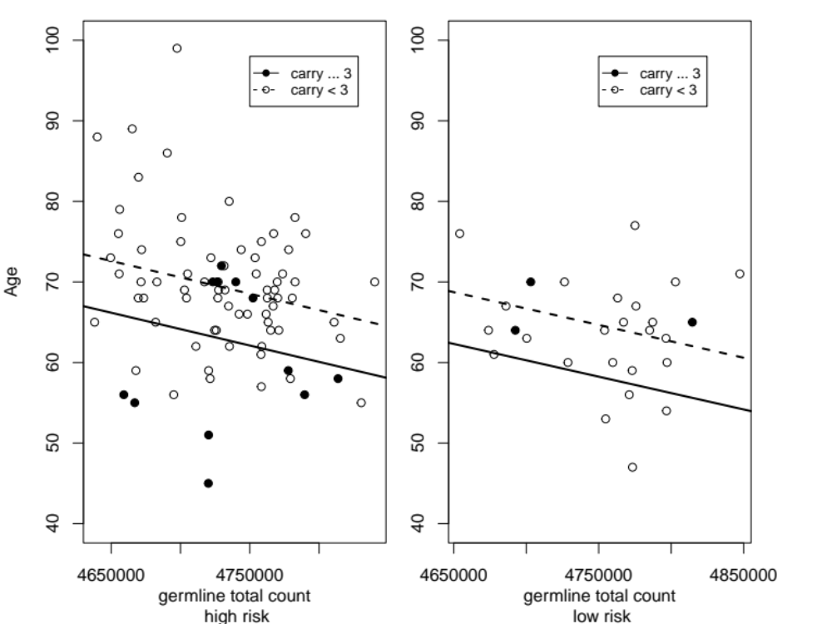

Figure S4. Age and total number of genome-wide germline short variants within African patients. The black dots represent African patients who had more than two selected variants (germline SVs and PDVs, n=15) and the white dots represent African patients with zero or one selected variant (n=93). ANO7 germline SVs were counted when spanning part of or the whole region of ANO7 gene. The effect of ANO7 selected variants was adjusted with two confounding factors, including total number of genome-wide short germline variants (-4.07e-5, 95% CI=-7.21e-5 – -9.23e-6, P-value=0.01) and the risk of prostate cancer (-3.87, 95% CI=-7.34 – -0.4, P-value=0.03).

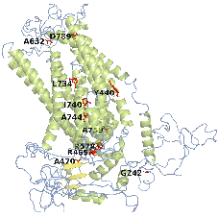

Figure S5. Distribution of PDVs (red) on tertiary structure of Anoctamin 7 protein. The $α$helices are in green and $β$sheets are in yellow.

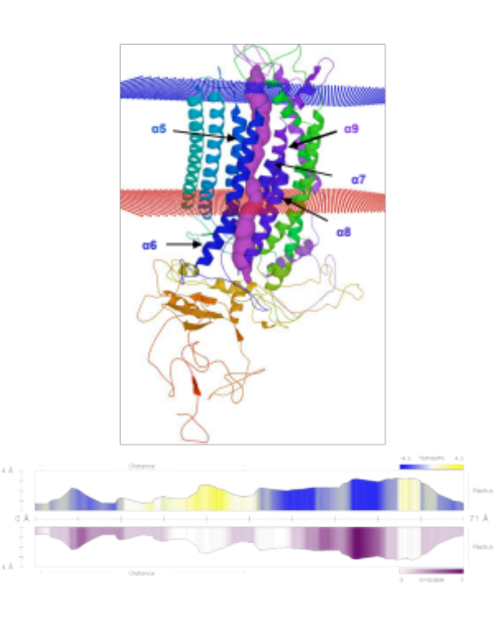

Figure S6. Ion conduction Pore 1 predicted in Anoctamin 7 protein. The top part shows placement of Pore 1 is among helices α5-9. Transmembrane domains were between blue and red nets. The bottom part shows the properties of Pore 1. The Y values of bar plots indicate radii of the pore. The top bar plot shows hydropathy with colours where blue indicates hydrophilicity and yellow indicates hydrophobicity. The bottom bar shows ionisable capability, where the darker the purple, the easier to be ionisable.

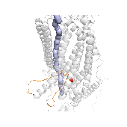
Figure S7. Alteration of Pore 2 identified in altered Anoctamin 7 with p.Ala470Val and p.Ile740Leu. Residues 673-694 are in orange. Pore 2 is in purple. PDVs are in red.

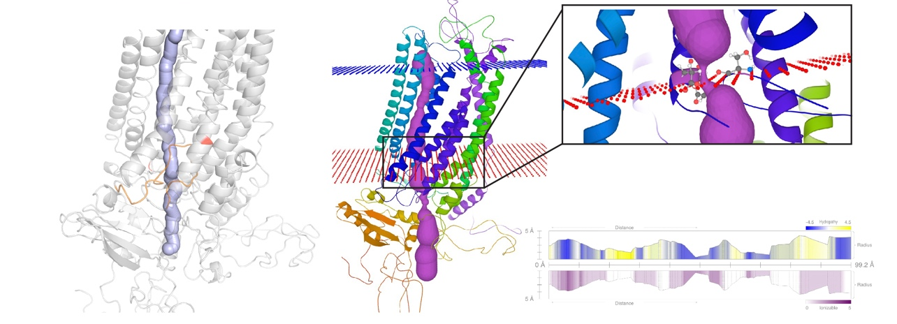
Figure S8. Alteration of Pore 2 in altered Anoctamin 7 with p.Ile740Leu and p.Arg578Cys.
Left, residues 673-694 are in orange. Pore 2 is in purple. PDVs are in red. Middle and right top, reduced bottleneck is observed. Right bottom, properties predicted for the Pore 2 in altered protein. More detailed configurations are described in Figure S6.

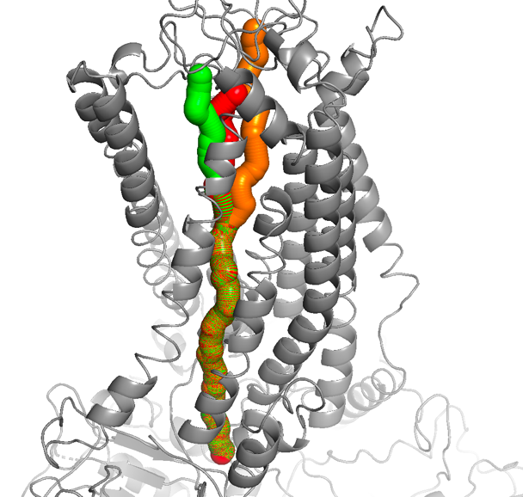

Figure S9 An example of a reproducible model of Pore 1. Three pores in green, red and orange colours are placed in the same group of helices $α$5-9, but divergent to each other within the top compartment of the model.

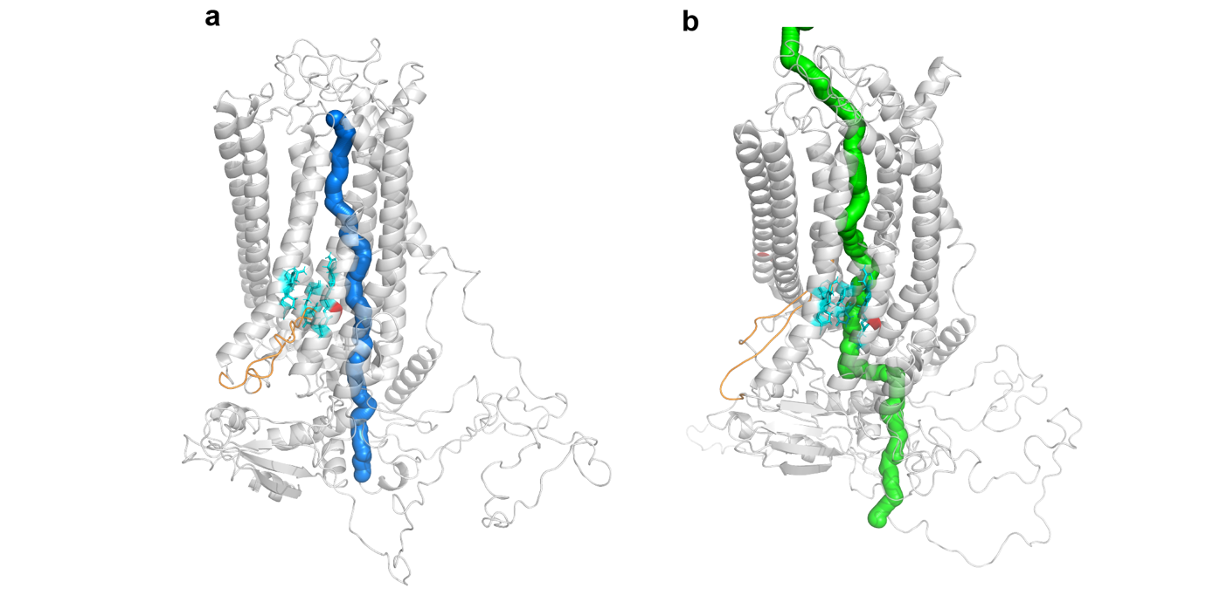

Figure S10. Pores that are commonly identified in altered proteins. a. Pore 3 in marine is shown in an altered protein that contains a PDV p.Ile740Leu in red and b Pore 4 in green is shown in an altered protein that contains PDVs p.Ile740Leu and p.Ala494Val in red. Putative Ca²⁺ binding sites are in cyan, shown as sticks. Residues 673-694 that change positions are in orange.

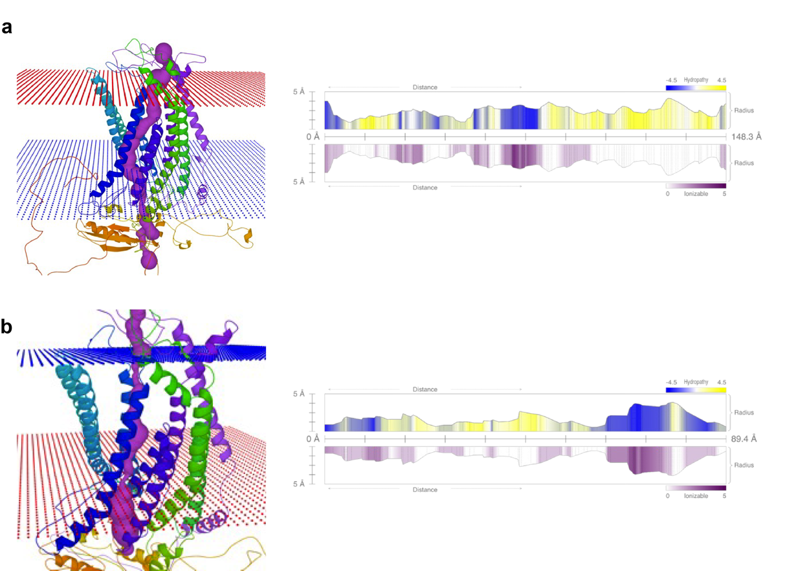

Figure S11. Pore1 identified in altered proteins. a, a normal Pore 1 in Seq 39. b, a narrower Pore 1 (0.5Å) in Seq 28. The properties of respective pores are on the right plots. More detailed configurations are described in Figure S6.

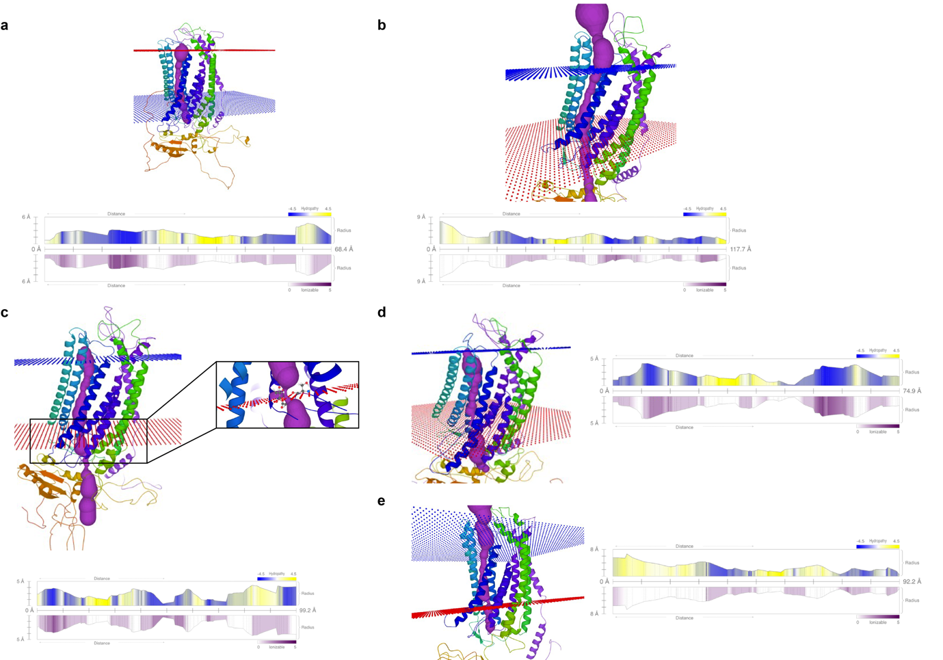

Figure S12 Pore2 identified in altered proteins. normal Pore 2 identified in a. Seq 39 and b. Seq 43. Narrower Pore 2 identified in c. Seq 9 (0.4Å), d Seq 28 (0.1Å) and e Seq 31 (0.4Å). More detailed configurations are described in Figure S6.

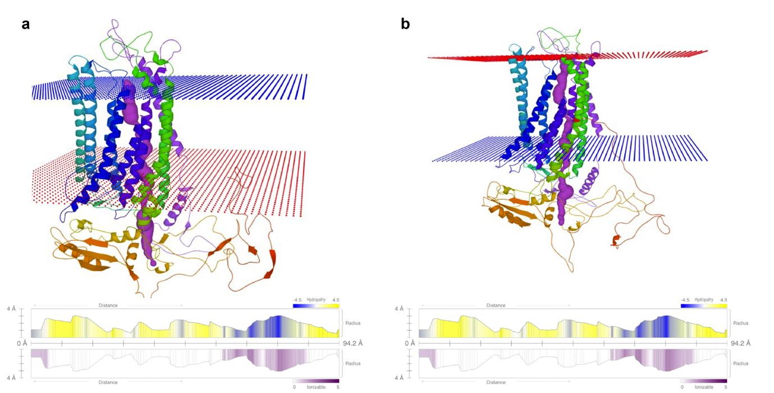

Figure S13. Pore 3 identified in proteins. a. Pore 3 in Seq 12 and b. Seq 18. More detailed configurations are described in Figure S6.

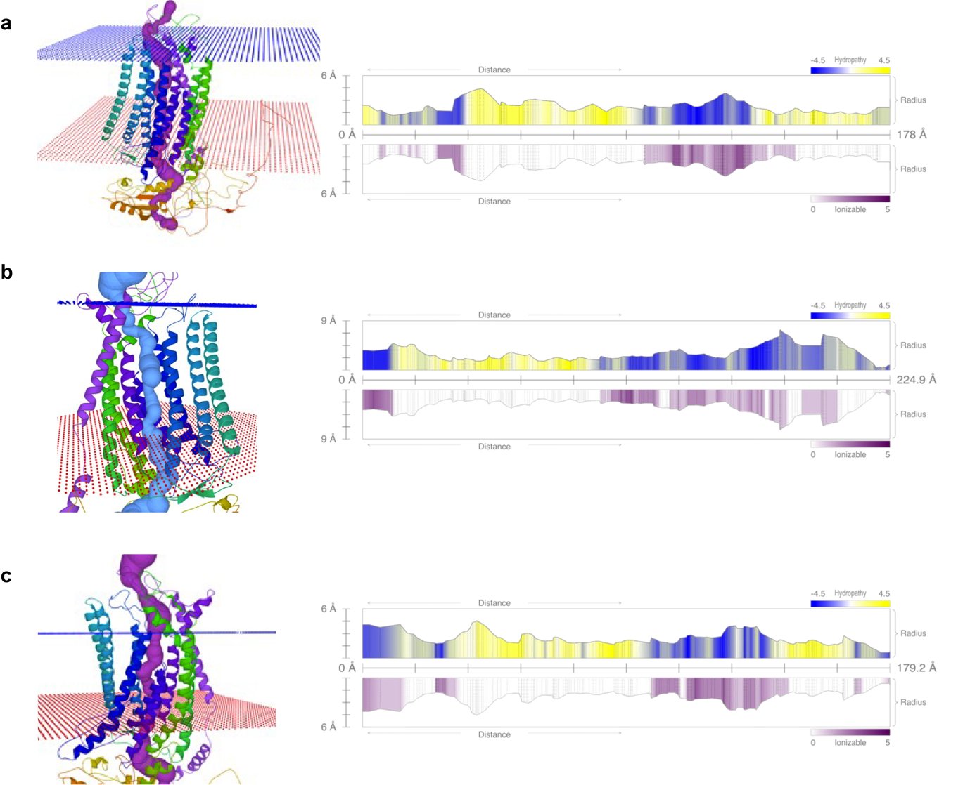

Figure S14. Pore 4 identified in proteins. a. Pore 4 in Seq 20, b. Seq 22 and c. Seq 28. More detailed configurations are described in Figure S6.

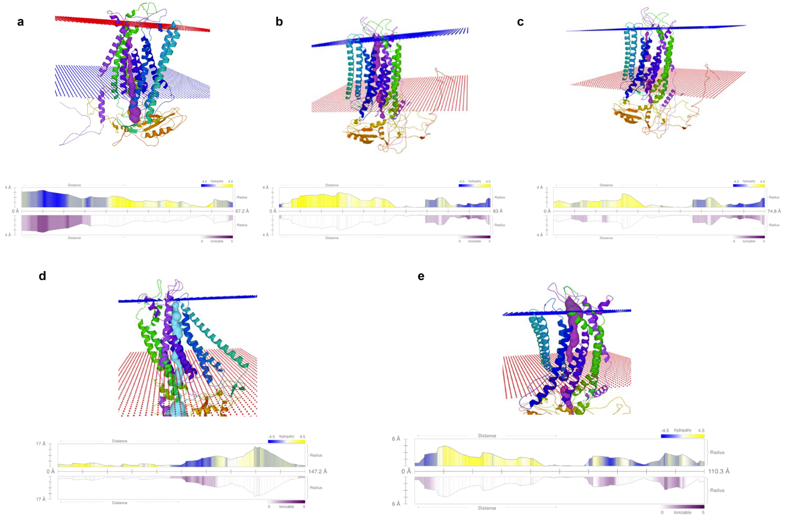

Figure S15. Positions and properties of broken pores. a, a broken pore in Seq 19. b, a Pore 4 alike pore identified in Seq 20, broken when passing through helix α7. c, another broken pore identified in Seq 20. d, a broken pore identified in Seq 22. e, a Pore 4 alike pore identified in Seq 28, broken when passing through helix α7. More detailed configurations are described in Figure S6.

