Supporting information
Limitation of molecular twisting: Upgrading a donor-acceptor dye
to drive H₂ evolution
Kaijian Zhu,¹ Ainoa Paradelo Rodríguez,¹ Maria B. Brands,² Titus de Haas,³ Francesco Buda,³ Joost N. H. Reek,² Guido Mul,¹ Annemarie Huijser ¹*

¹ PhotoCatalytic Synthesis Group, MESA⁺ Institute for Nanotechnology, University of Twente, P.O. Box 217, 7500 AE Enschede, the Netherlands.
² Van 't Hoff Institute for Molecular Sciences, Universiteit van Amsterdam, Science Park 904, 1098 XH Amsterdam, the Netherlands.

³ Leiden Institute of Chemistry, Leiden University, P. O. Box 9502, 2300 RA Leiden, the Netherlands.

Experimental
Preparation of P1 sensitized NiO films
The NiO films were prepared by a chemical bath deposition method, followed by annealing. The 0.075 M Ni(NO₃)₂•6H₂O (Sigma-Aldrich, 99.999%), 0.2 M urea (Sigma-Aldrich, >99%) and 0.75 M ethanolamine (Sigma-Aldrich, >99%) precursors were sequentially dissolved into Milli-Q water. Cleaned fluorine-doped tin oxide (FTO) substrates purchased from Sigma-Aldrich were put into the solution, and films were grown on the FTO for 3 hours at 90 °C and washed by water. Finally, the NiO films were obtained by annealing at 450 °C for 1 hour in air. The NiO films were immersed into 0.3 mM P1 dye solution (4-(bis-4-[5-(2,2-dicyano-vinyl)-thiophene-2-yl]-phenyl-amino)-benzoic acid, Dyenamo, Sweden) in ethanol (Supelco, >99.9 %) with different concentrations of myristic acid (MA, Sigma-Aldrich, >98%, 0 mM, 3 mM, 15 mM and 40 mM) in the dark for ca. 16 hours.
ZrO₂ deposition
The cleaned FTO plates were treated in a UV-ozone photoreactor (UVP PR-100) for 30 min, after they were cut up in 20 × 20 mm pieces. Two sides of the plates were covered along the full length with adhesive tape (Scotch® MagicTM tape 8-1933R8), and ZrO₂ nanoparticle paste (Solaronix, ZT/SP Ref 46411) was applied on the top of the plate with a glass rod. The paste was then smeared from top to bottom using the edge of a glass plate, which was held at an acute angle (< 30°). This process was repeated until a homogeneous layer of the paste was obtained. The tape was removed and the plates were thermally annealed at 500 °C for 30 min (with a temperature ramp of 20 °C/min). The plates were taken out of the oven immediately after the program finished.
Characterization
X-ray diffraction (XRD, Bruker D2, Cu Kα source) and Scanning Electron Microscope (SEM, Zeiss MERLIN ) were used to characterize the crystal structures, nanomorphology and thickness of the films. The valence states of the surface were characterized by X-ray Photoelectron Spectroscopy (XPS, PHI Quantera SXM). The UV-Vis absorbance spectra of the films were recorded using a ThermoSci EVO600 spectrometer.
The light absorption efficiency (F_{A}) is calculated according to the equation, with A the absorbance in optical density (OD):
$$F_{A}=\left(1-{10}^{-A}\right)×100 \%$$
Time resolved photoluminescence (TRPL)
The setup used for time-resolved photoluminescence has been described in detail in the previous work.¹⁻² Briefly, a Fianium laser (FP-532-1-s, center wavelength 532 nm, pulse duration of 300 fs, 80.37 MHz repetition rate) was used as a light souse. For experiments with UV excitation (267 nm), the output was focused into a 3 mm β-BaB₂O₄ crystal (Newlight Photonics). The residual 532 nm output was removed by three dichroic mirrors (Thorlabs, MBI-K04) and a FGUV11-UV filter (Thorlabs). The sample was kept in a quartz cuvette (Hellma, 10 mm optical path length) as the working electrode with 0.1 M phosphate buffer solution (PBS, pH=7) as the electrolyte, a Pt counter electrode and an Ag/AgCl reference electrode. The applied potential was controlled by a Emstat3 potentiostat (PalmSens). The spectral calibration was checked and adapted if necessary using a Hg/Ar calibration lamp (Oriel, LSP035).The spectral sensitivity of the PL spectra was corrected by the equation below, which was determined by measuring the spectrum of a black body lamp (Ocean Optics, HL-2000) with a calibrated spectrum:
$$Real PL spectrum=\frac{measured PL spectrum}{Y}$$
$$Y={110-0.0012 \left(wavelength in nm-600\right)}^{2}$$
The setup used for transient absorption experiments has been described in detail in our previous work.¹⁻²
TDDFT calculations
All calculations were performed within the AMS2022.103 software package developed by SCM.³ The P1 ground state geometry was optimized using the CAM-B3LYP functional⁴ in an all-electron triple-ζ polarized (TZP) Slater-type basis set including relativistic effects by means of the scalar zeroth order regular approximation (ZORA).⁵ The water solvation environment was accounted for by the implicit conductor like screening model (COSMO)⁶⁻⁸ and dispersion corrections (D3) were included with Becke-Johnson damping.⁹⁻¹¹ The integration quality was improved over the default option by setting the numerical quality to ‘good’ and the SCF convergence criterium was tightened to 10e-8 Hartree/cycle. The optimized structure was verified to be a local minimum on the potential energy surface by performing a Hessian calculation (no imaginary frequencies). The excited state geometry optimization was performed within the framework of time-dependent density functional theory, using the Tamm-Dancoff approximation, at the same settings as the ground state optimization.¹² Each optimization step included four excitations from the ground state, while the P1 structure was minimized on the potential energy surface of the first excited state.
Photoelectrochemical (PEC) measurements
A VersaSTAT 3 Potentiostat was used to measure the photoelectrochemical (PEC) properties in a three-electrode cell under the illumination of a solar simulator with an AM 1.5G filter (Newport, 1 sun intensity) and a filter blocking UV light below 400 nm. An Ag/AgCl electrode and gold wire were used as the reference electrode and counter electrode. Prior to the measurements, the PBS (0.1 M)-citric acid (0.09 M) buffer electrolyte (pH around 3.8) was degassed by N₂ for more than 20 min. With a 5 mV/s scan rate, scans from high to low potential were carried out.
Operando photo-electrochemistry/mass-spectrometry (PEC/MS) measurements
The EC/MS equipment from SpectroInlets (Copenhagen, Denmark) and a 460 nm LED lamp (around 70 mW/cm²) were used to conduct the PEC/MS measurements. The He was used as the carrier gas. Different m/z signals were recorded over time. A three-electrodes photoelectrochemical cell was used with Ag/AgCl (saturated reference electrode and Pt mesh counter electrode. A nafion membrane was used to separate the reduction and oxidation reaction chambers. The electrolyte continues flow through the working electrode chamber and to the MS with the flow rate of 0.85 mL/min. Bio-Logic VSP potentiostat was used to applied the potential.
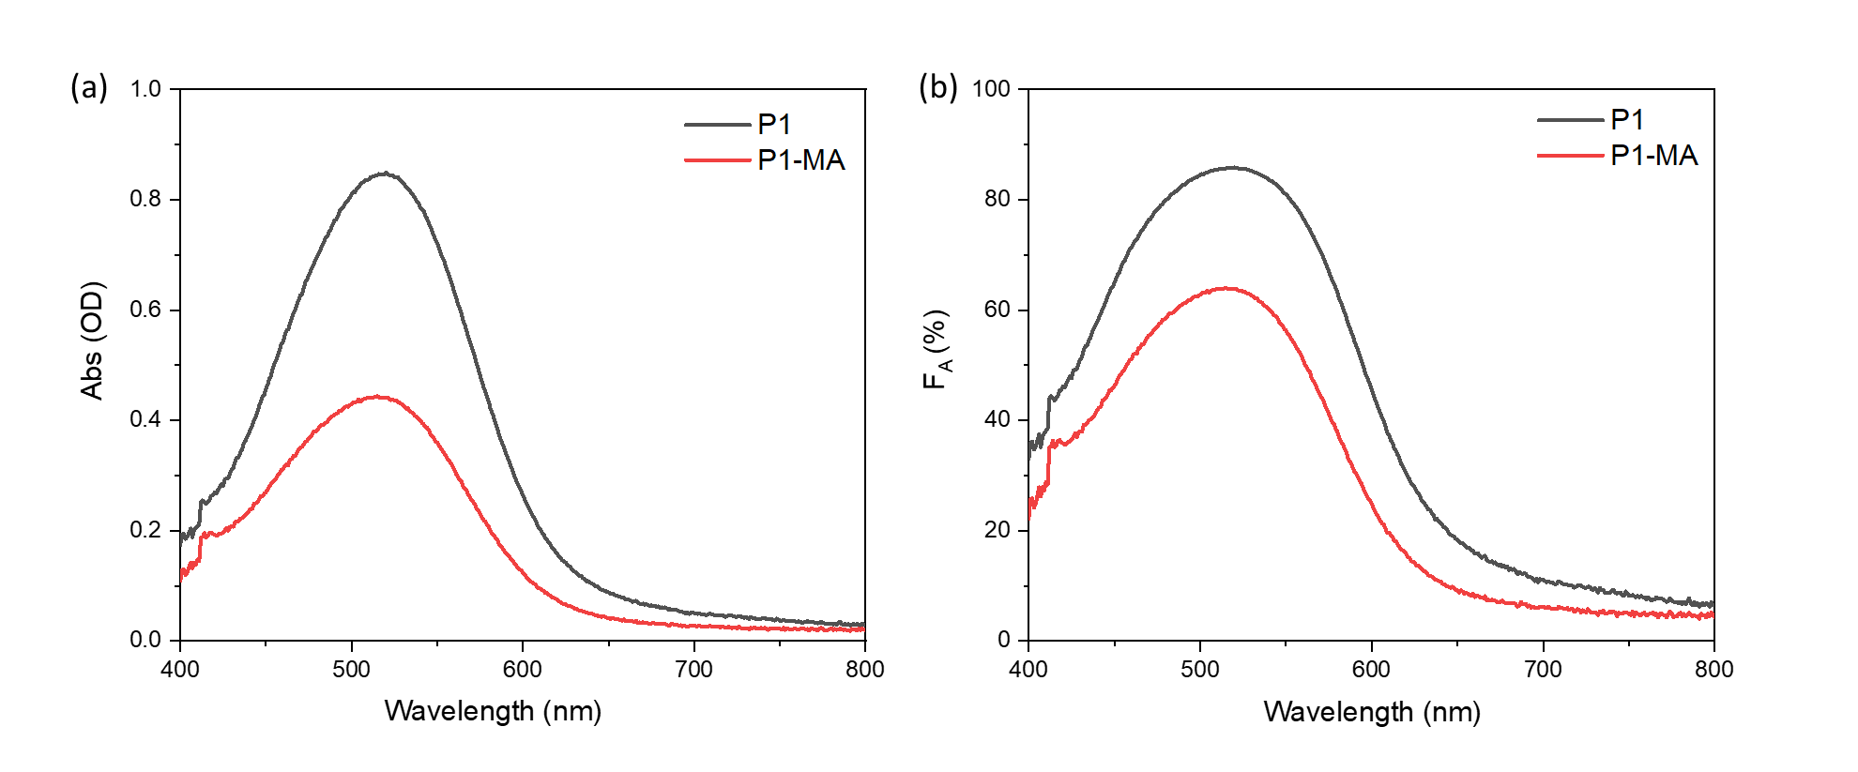
Figure S1. UV-Vis absorbance spectra (a) and light absorption efficiency (F_{A}) as function of wavelength (b) of NiO/P1 and NiO/P1-MA after subtracting the NiO signals.
Table S1. The ground state and excited state energy computed in the ground state and excited state optimized geometries. The ground state energy of the ground state relaxed structure is taken as reference for all the other values.
Structure | Ground state energy (eV) | Excited state energy (eV)
Ground state optimized | 0 | 2.87
Excited state optimized | 0.25 | 2.51

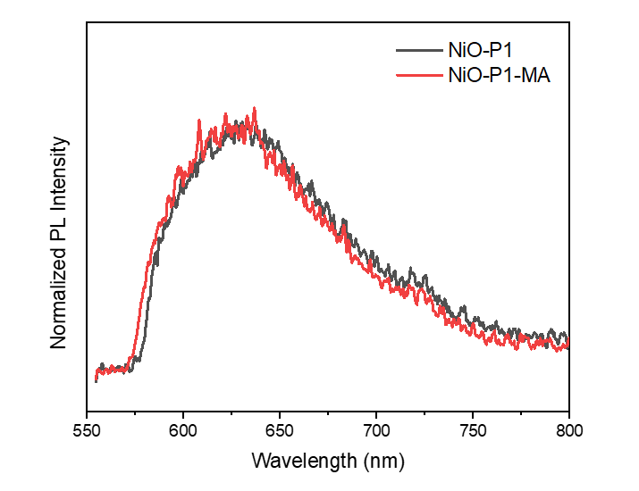
Figure S2. Steady-state photoluminescence spectra of NiO/P1 and NiO/P1-MA recorded by 532 nm excitation in air, detected using a 580 nm long-pass filter to block residual excitation light.
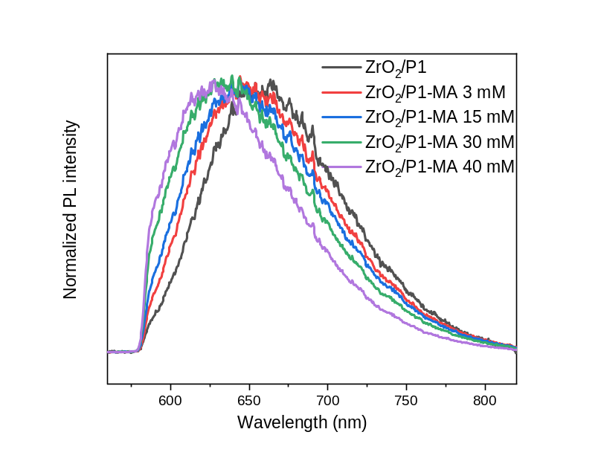
Figure S3. Steady-state photoluminescence spectra of ZrO₂/P1 prepared using different MA concentrations in the solution used for photosensitization.
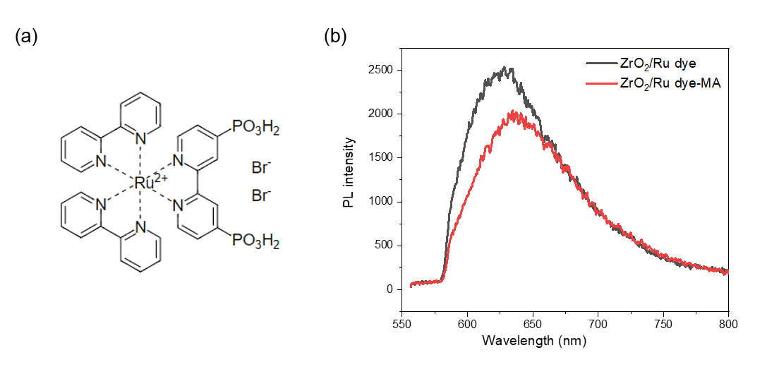
Figure S4. Ru dye molecular structure (a) and steady-state photoluminescence spectra of ZrO₂/Ru dye with and without co-adsorbed MA (40 mM in dipping solution) (b).
Figure S3 shows the steady-state photoluminescence spectra of ZrO₂/P1 and ZrO₂/P1-MA, showing a gradual blue-shift with increasing MA quantity. Figure S4 shows the steady-state photoluminescence spectra of a Ru dye without D-π-A structure on ZrO₂ in the absence and presence of MA, not showing a blue-shift induced by MA alike observed for P1.
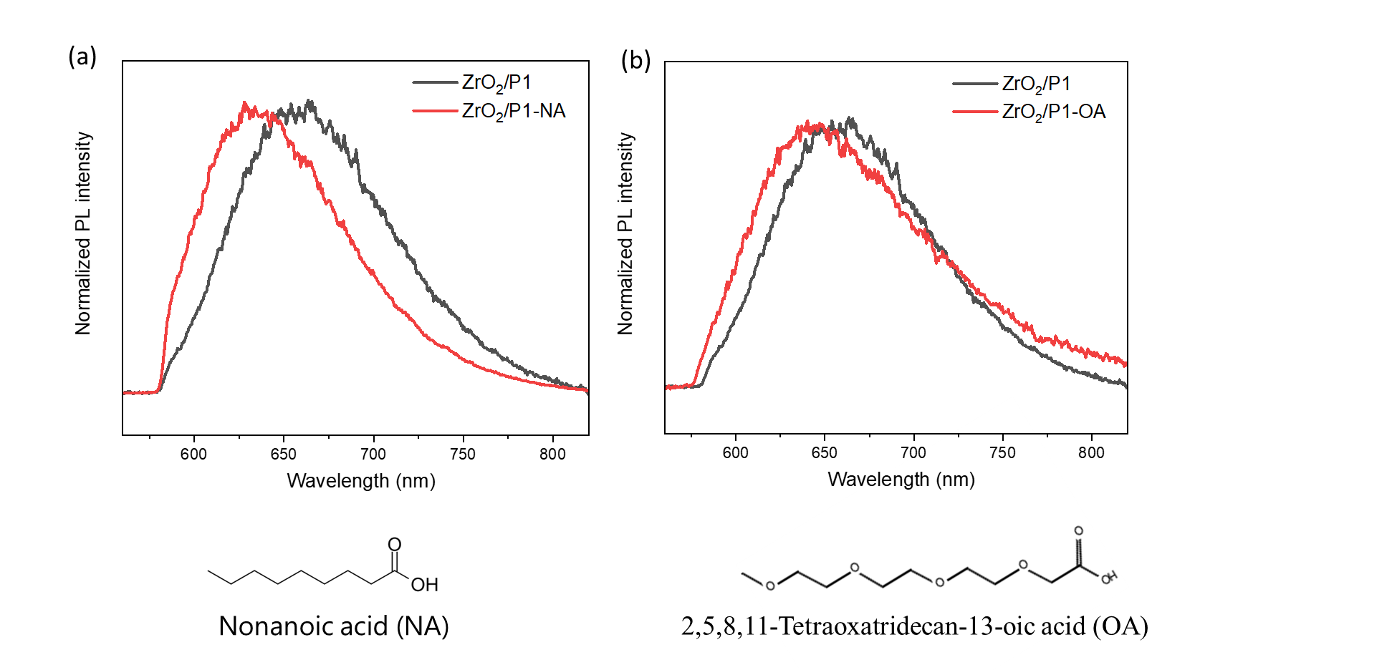
Figure S5. Steady-state photoluminescence spectra of ZrO₂/P1 prepared with 40 mM NA (a) and OA (b) in the solution used for photosensitization.

Figure S5 shows the steady-state photoluminescence spectra of ZrO₂/P1 prepared with 40 mM NA (a) and OA (b) present in the solution used for photosensitization. Co-adsorption of NA also induces a blue-shift, albeit less than MA, while the blue-shift due to OA is very small.

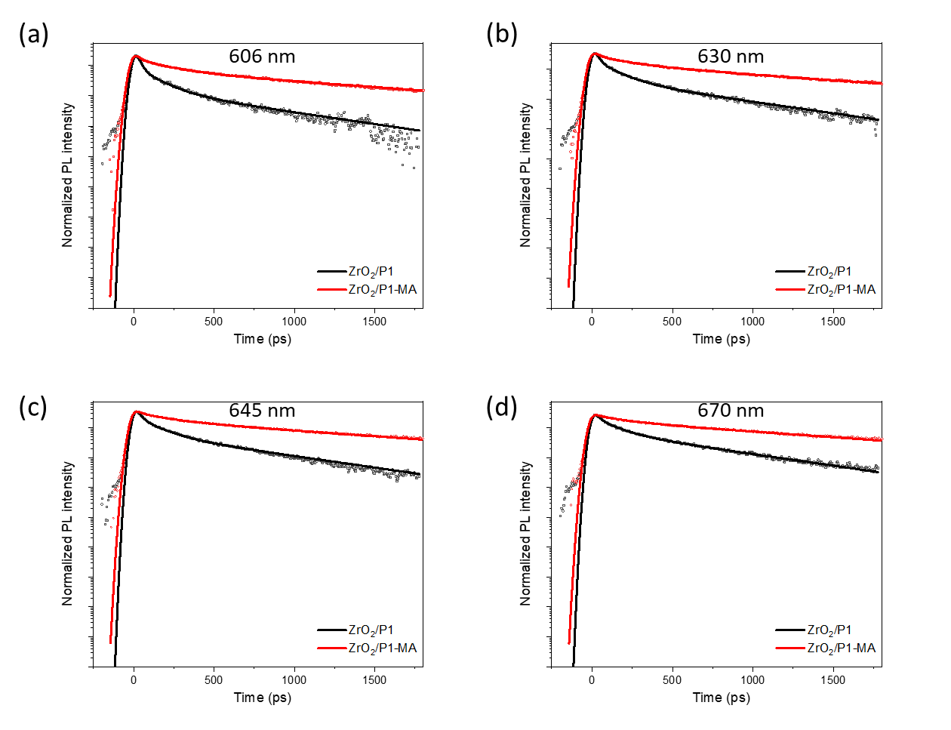
Figure S6. Photoluminescence decay at 606 nm (a), 630 nm (b), 645 nm (c) and 670 nm (d) of ZrO₂/P1 and ZrO₂/P1-MA. In all cases the sample was excited at 532 nm. The solid lines indicate fits from global analysis.

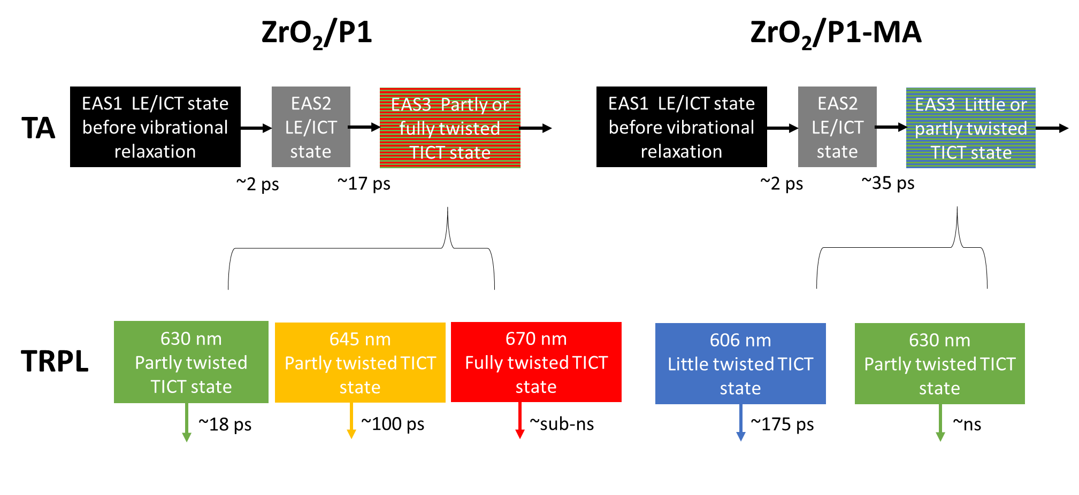
Figure S7. Photophysical models used for global analysis of the TA and TRPL data of ZrO₂/P1 and ZrO₂/P1-MA.
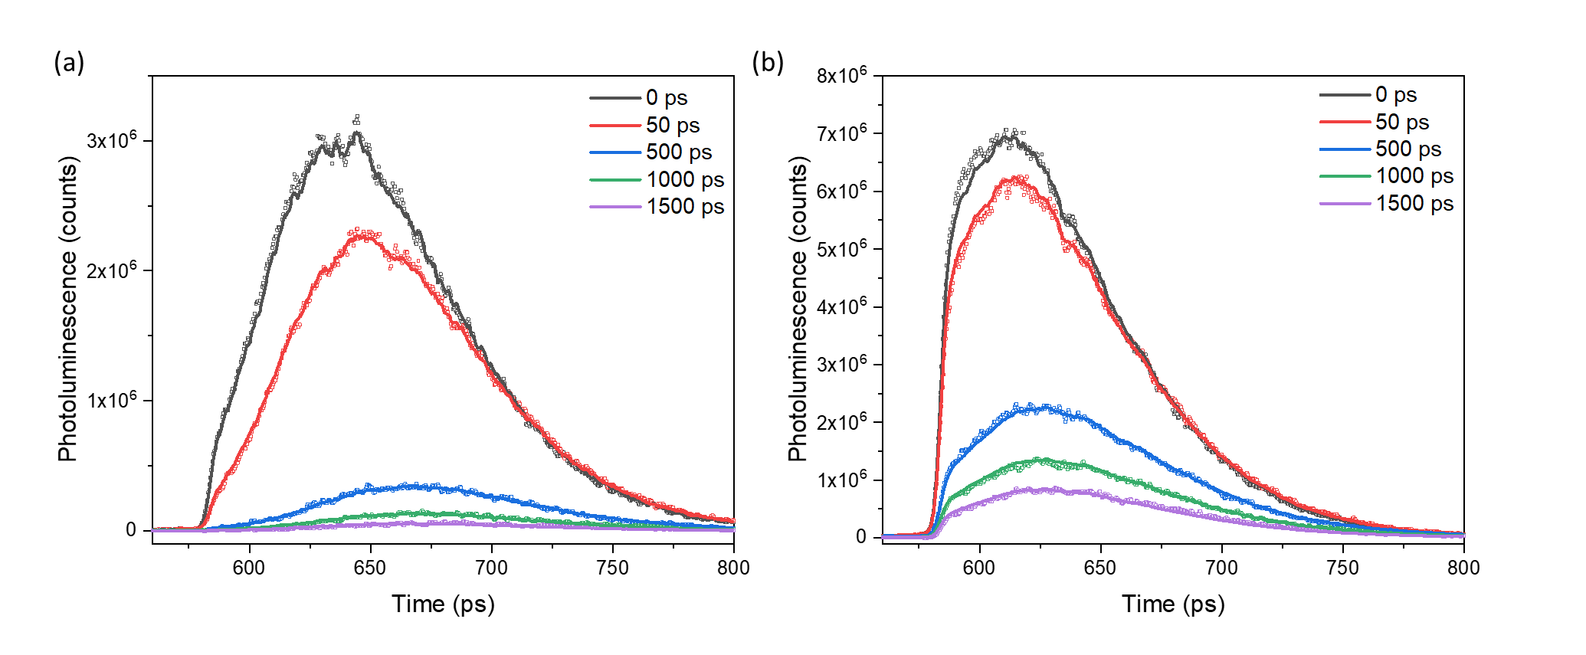
Figure S8. PL spectra of ZrO₂/P1 (a) and ZrO₂/P1-MA after 532 nm excitation in air. The solid lines indicate fits from global analysis. The most intense spectrum is defined as time 0.

Figure S7 shows the photophysical models used for global analysis of the TA and TRPL data of ZrO₂/P1 and ZrO₂/P1-MA. The spectra and fitting results are shown in Figure S8. The data fits well by using the model in Figure S7. The evolution associated spectra (EAS) and associated time scales obtained from global analysis of the TA data are shown in Figure S9. EAS1 likely presents the LE/ICT state before vibrational relaxation occurring in ca. 2 ps, EAS2 the LE/ICT state after vibrational relaxation and EAS3 the (to some degree) twisted TICT state. We assign the PL bands centered at 606 nm, 630 nm and 665 nm to a little, partly and fully twisted TICT state, with the first only observed in presence of MA and the latter only in absence of MA. Figure S10 indicate the model fits data well.
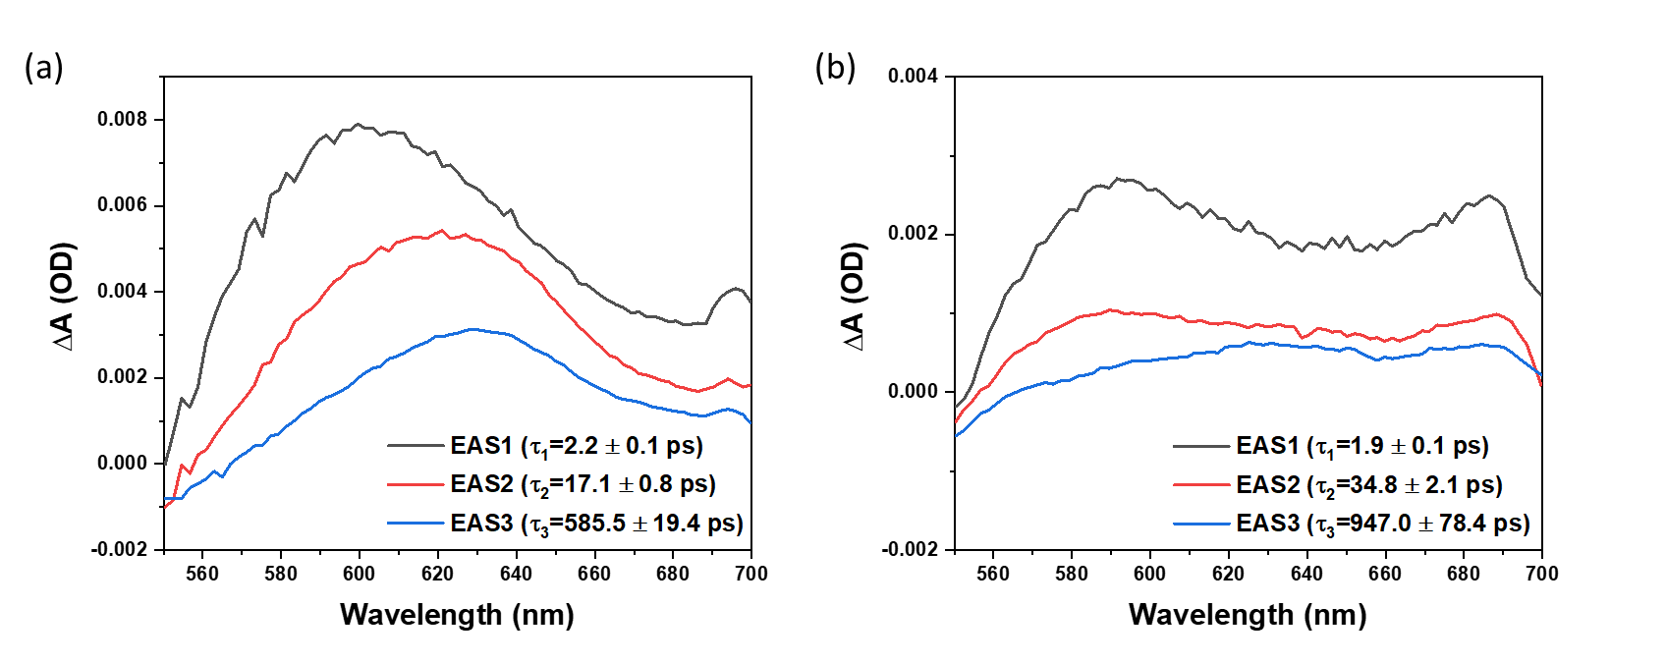
Figure S9. Evolution associated spectra (EAS) and corresponding lifetimes of ZrO₂/P1 (a) and ZrO₂/P1-MA (b), obtained from global analysis of the TA data using a sequential model.
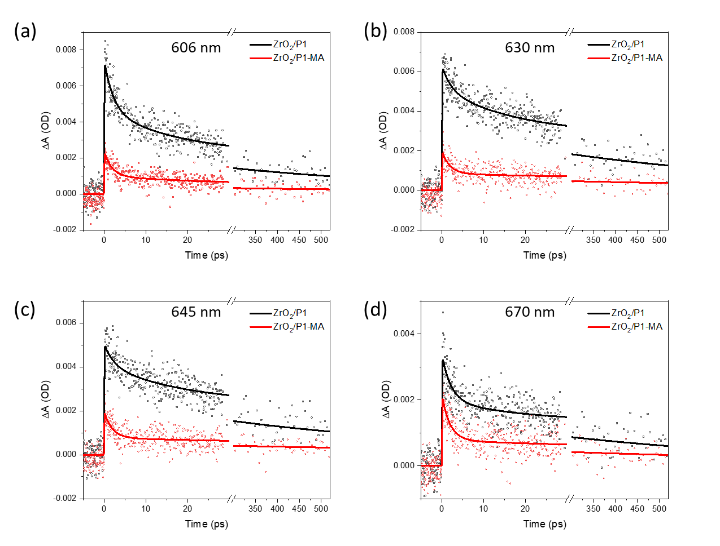
Figure S10. Kinetic traces at 606 nm (a), 630 nm (b), 645 nm (c) and 670 nm (d) of ZrO₂/P1 and ZrO₂/P1-MA . The solid lines indicate fits from global analysis.
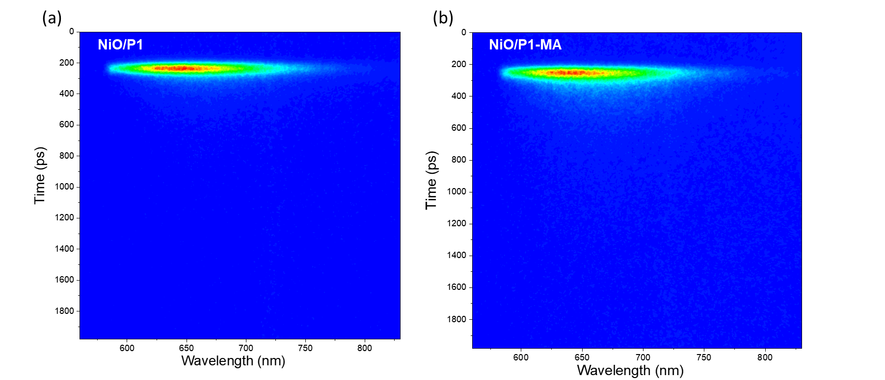
Figure S11. Time-resolved fluorescence spectral decay profiles of NiO/P1 (a) and NiO/P1-MA (b) in 0.1 M citrate-phosphate buffer electrolyte (pH = 3.8), obtained using 532 nm excitation.
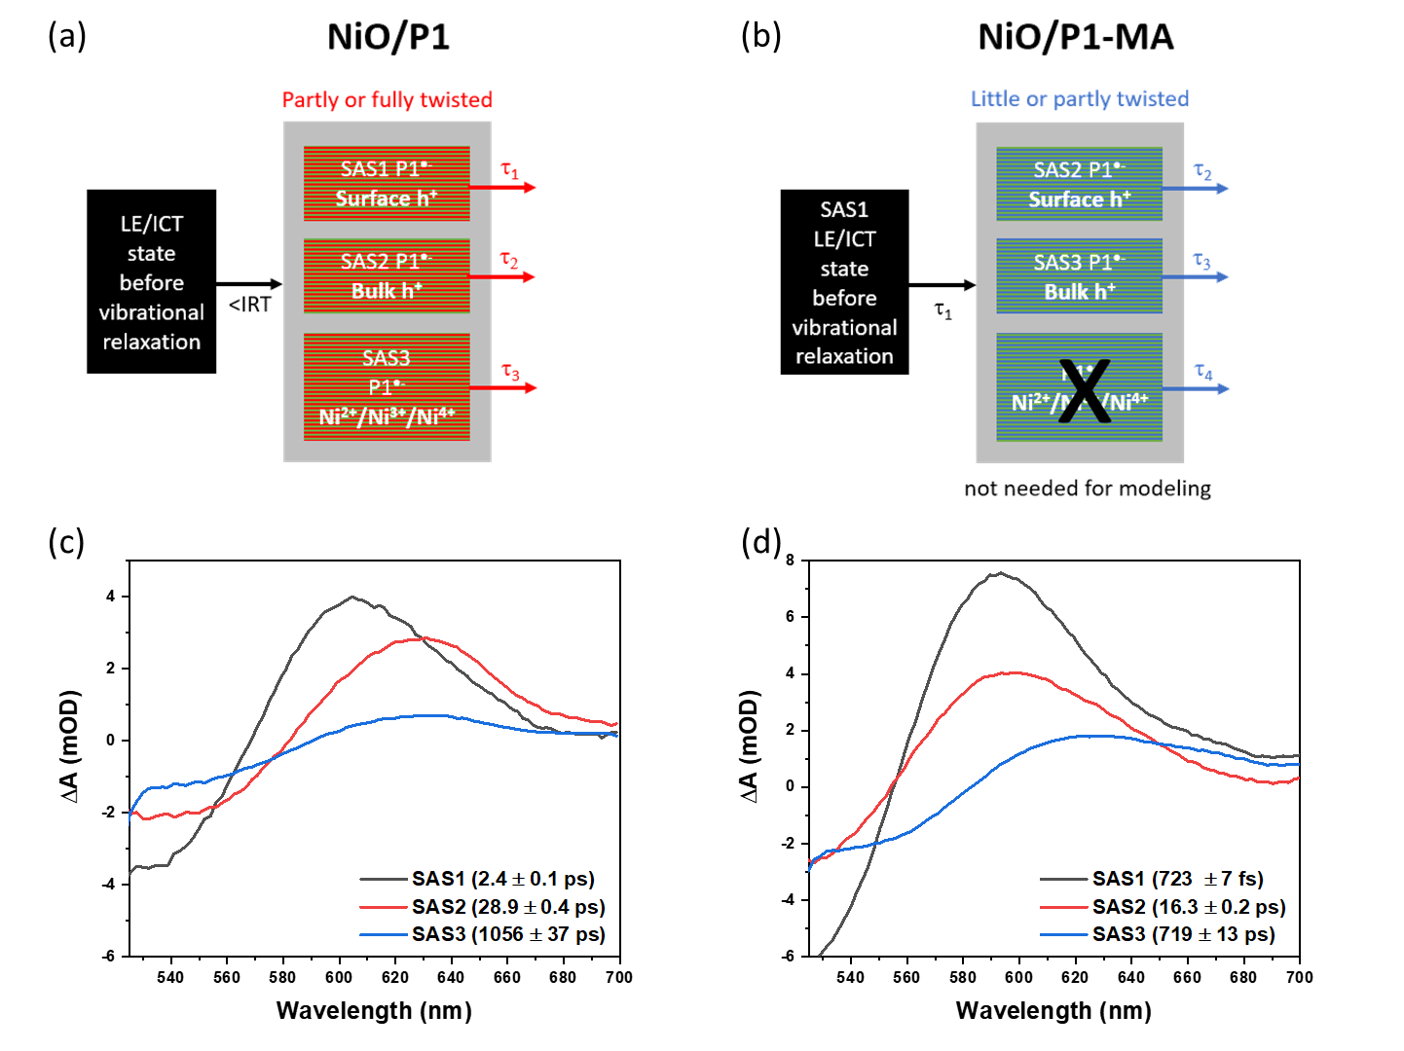
Figure S12. Photophysical models used for target analysis of the TA data of NiO/P1 (a) and NiO/P1-MA (b), taking into account different hole injection rates. IRT = instrumental response time (100-150 fs). Species associated spectra (SAS) and corresponding lifetimes obtained from target analysis for NiO/P1 (c) and NiO/P1-MA (d).
Figure S11 shows the time-resolved photoluminescence profiles of NiO/P1 and NiO/P1-MA, obtained using 532 nm excitation. Figure S12 shows the photophysical models introduced in our earlier work² used for target analysis of the TA data of NiO/P1 and NiO/P1-MA and the obtained species associated spectra and corresponding lifetimes. The models assumes hole injection from P1* into NiO to occur either within the instrumental response time (<IRT, 100-150 fs, for NiO/P1) or in several ps (for NiO/P1-MA, causing a blue-shifted TA spectrum compared to NiO/P1 at e.g. 250 fs, see Figs. 6a and 6b and main text), as the presence of MA clearly slows down hole injection as evident from the gap in signals at 527 nm and 560 nm (Figures 6c and 6d main text). Hole injection hence likely occurs prior to vibrational relaxation in ca. 2 ps (Fig. S7), as also reported by Gustavsson and co-workers.¹³ Several charge recombination rates are observed, which we assigned earlier to charge recombination between P1^{•-} and h⁺ trapped at the NiO surface (the fastest recombination process) or more mobile h⁺ capable to reach the NiO bulk (slower recombination). Also Ni²⁺, Ni³⁺ and Ni⁴⁺ trap states may contribute to the signal.¹⁴ Light-induced P1 twisting and the suppression thereof by MA may influence the TA spectrotemporal dynamics as well. The observation that after hole injection the TA spectrum of NiO/P1-MA is still blue-shifted relative to that of NiO/P1 (ca. 15 nm at 5 ps, Figs. 6 and 6b main text) may suggest that P1 twisting on NiO occurs faster than on ZrO₂ (Figure S9) due to charge separation with the NiO. Twisting has not been included in the modeling to avoid overfitting. Though these models are likely a simplification of the reality, they describe the TA data well.
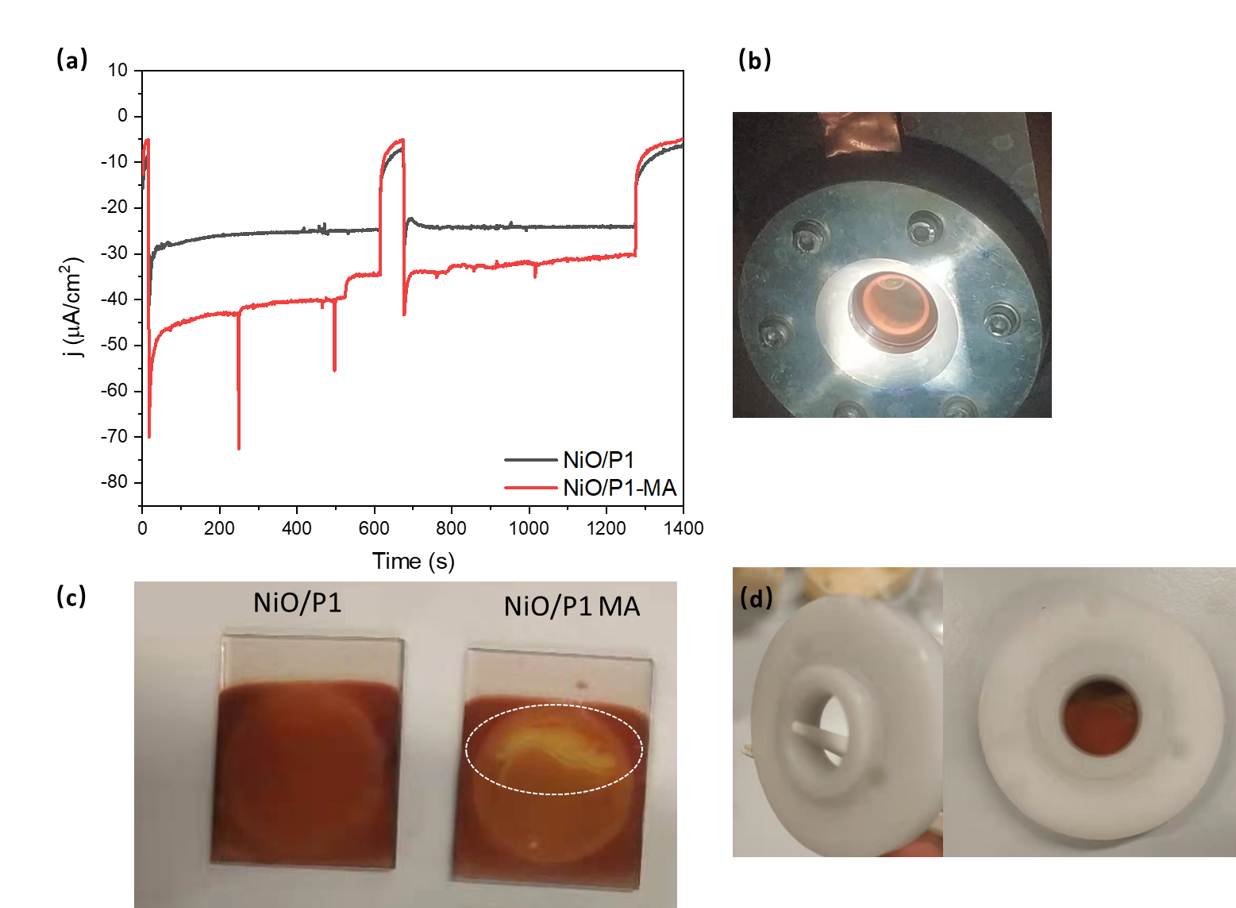
Figure S13. I-t curves at -0.35 V vs. Ag/AgCl of NiO/P1 and NiO/P1-MA in citric acid-phosphate buffer solution (pH = 3.8) with chopped illumination with 1 sun (AM 1.5G, >400 nm) (a); the cell used (b); digital photographs of NiO/P1 and NiO/P1-MA after the measurements (c); the sample holder (d).
Figure S13 shows the i-t curves of NiO/P1 and NiO/P1-MA measured in the cell shown in Figure S13b. The generation of bubbles causes dye and possibly also MA losses (Figure S13c), as the bubbles could not easily escape (Figure S13d shows the sample holder), likely also giving rise to the spikes in photocurrent observed in the presence of MA and the decrease in photocurrent (Figure S13a). However, it is obvious that the photocurrent density for NiO/P1-MA is higher than for NiO/P1, in agreement with the linear sweep voltammetry results shown in Figure 7a in the main text. To further investigate the stability of NiO/P1-MA, the i-t curves were measured in a cell not blocking the bubbles (Figure S14), showing a stable photocurrent and without obvious dye losses even after long measurement time.

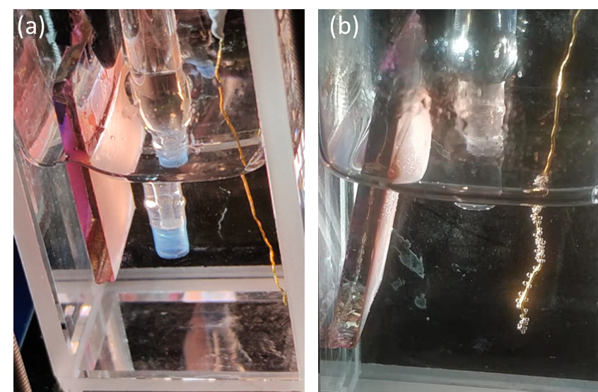
Figure S14. Digital photographs of NiO/P1 (a) and NiO/P1-MA (b) during the i-t measurement at -0.35 V vs. Ag/AgCl in 0.1 M citrate-phosphate buffer solution at pH = 3.8 with chopped illumination with 1 sun (AM 1.5G, >400 nm).

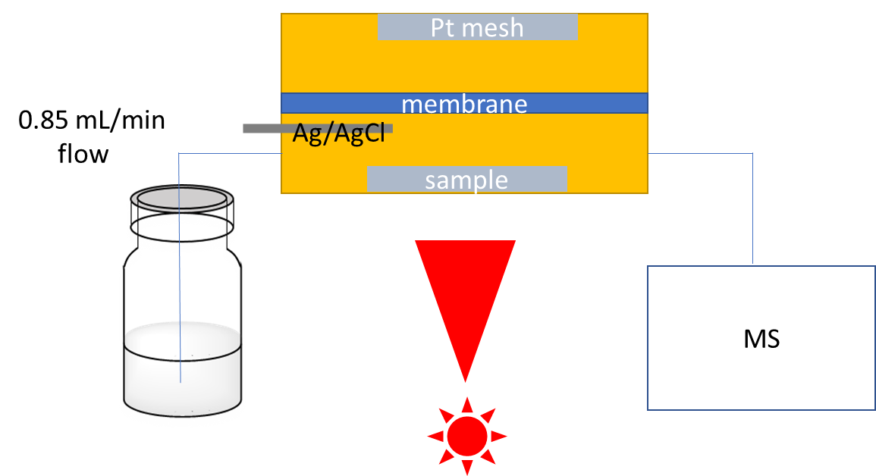Figure S15. Schematic diagram of the home-assembled light source combined with electrochemical mass spectrometry (EC-MS) experiments.
Figure S15 shows a schematic diagram of the setup used for EC-MS experiments. The setup was stabilized by using a continuous He flow through the electrolyte. The home-designed three electrodes cell was put in the position where the sample is faced up to prevent bubble accumulation at the surface and dye losses. The electrolyte flow was kept as low as possible and the rate is around 0.85 mL/min.
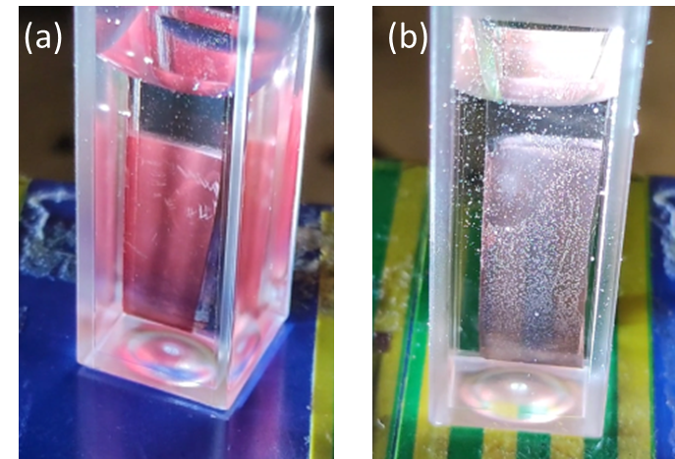
Figure S16. Digital photographs of NiO/P1 (a) and NiO/P1-MA (b) in 0.1 M citrate-phosphate buffer solution (pH = 3.8) with 15 vol% triethanolamine (TEOA) hole scavenger under illumination with 1 sun (AM 1.5G, >400 nm).
Figure S16 presents digital photographs of NiO/P1 (a) and NiO/P1-MA (b) in 0.1 M citrate-phosphate buffer solution (pH = 3.8) with 15 vol% triethanolamine (TEOA) hole scavenger under illumination with 1 sun (AM 1.5G, >400 nm), clearly showing bubble generation for the latter. Figure S17 shows the Ni 2p_{3/2} XPS spectra of NiO/P1 (a, c) and NiO/P1-MA (b, d) before and after the photoelectrochemical measurement, demonstrating no significant changes in Ni oxidation states. Figure S18 presents a digital photograph of CuGaO₂/P1-MA (b) in 0.1 M citrate-phosphate buffer solution with 15 vol% triethanolamine (TEOA) hole scavenger under illumination with 1 sun (AM 1.5G, >400 nm), also showing bubble formation.
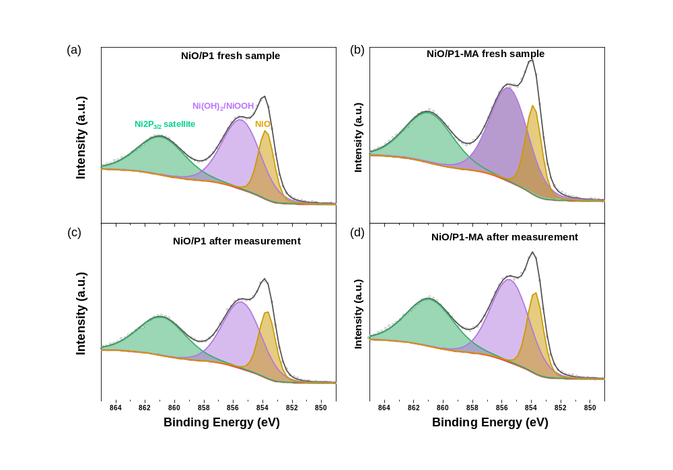
Figure S17. Ni 2p_{3/2} XPS spectra of NiO/P1 (a, c) and NiO/P1-MA (b, d) before and after the photoelectrochemical measurement.

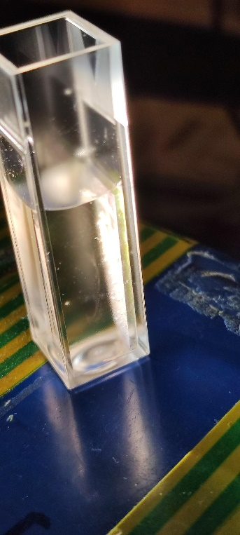
Figure S18. Digital photograph of CuGaO₂/P1-MA (b) in 0.1 M citrate-phosphate buffer solution with 15 vol% triethanolamine (TEOA) hole scavenger under illumination with 1 sun (AM 1.5G, >400 nm).
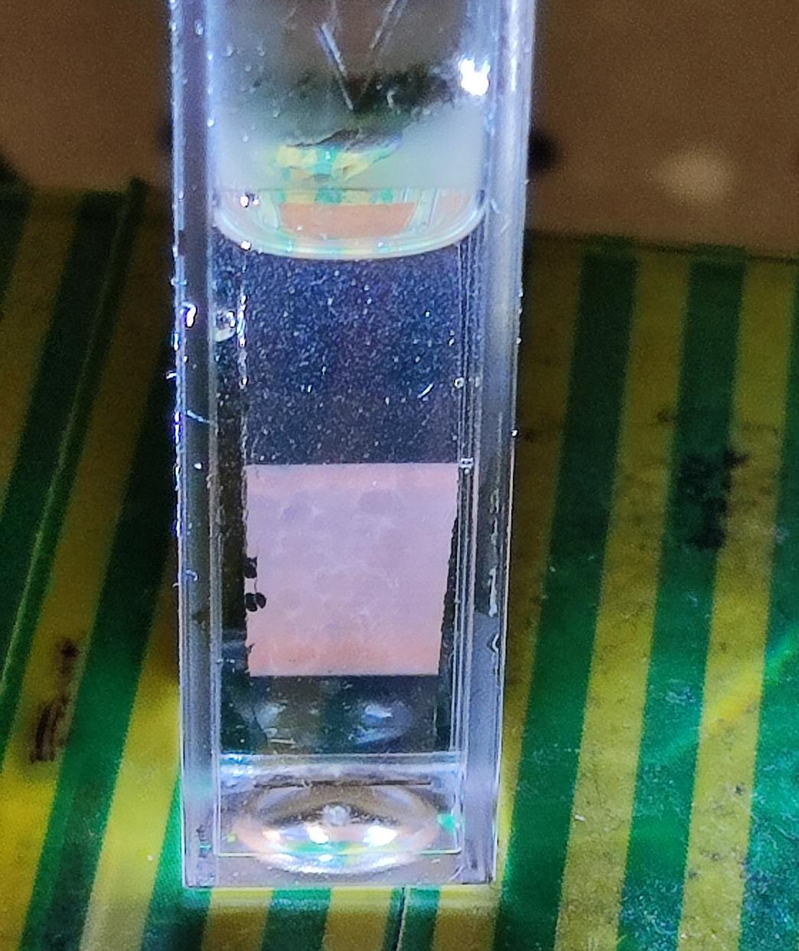
Figure S19. Digital photograph of ZrO₂/P1-MA (b) in 0.1 M citrate-phosphate buffer solution with 15 vol% triethanolamine (TEOA) hole scavenger under illumination with 1 sun (AM 1.5G, >400 nm).
References
1. Zhu, K. et al. Unraveling the Mechanisms of Beneficial Cu-Doping of NiO-Based Photocathodes. J. Phys. Chem. C, 125, 16049-16058 (2021).
2. Zhu, K.; Frehan, S. K.; Mul, G. & Huijser, A. Dual Role of Surface Hydroxyl Groups in the Photodynamics and Performance of NiO-Based Photocathodes. J. Am. Chem. Soc. 44, 11010-1018 (2022).
3. Rüger, R. et.al. AMS 2021.1 AMS 2021.1, SCM, Theor. Chem. 2021.
4. Yanai, T.; Tew, D. P. & Handy, N. C. A new hybrid exchange–correlation functional using the Coulomb-attenuating method (CAM-B3LYP). Chem. Phys. Lett. 393, 51-57 (2004).
5. Van Lenthe, E.; Ehlers, A. & Baerends, E.-J. Geometry optimizations in the zero order regular approximation for relativistic effects. J. Chem. Phys.110, 8943-8953 (1999).
6. Klamt, A. Conductor-like screening model for real solvents: a new approach to the quantitative calculation of solvation phenomena. . J. Phys. Chem. 99, 2224-2235 (1995).
7. Klamt, A. & Jonas, V. Treatment of the outlying charge in continuum solvation models. J. Chem. Phys. 105, 9972-9981 (1996).
8. Pye, C. C.; Ziegler, T.; Van Lenthe, E. & Louwen, J. N. An implementation of the conductor-like screening model of solvation within the Amsterdam density functional package—Part II. COSMO for real solvents. Can. J. Chem. 87, 790-797 (2009).
9. Grimme, S. Accurate description of van der Waals complexes by density functional theory including empirical corrections. J. Comput. Chem. 25, 1463-1473 (2004).
10. Grimme, S.; Antony, J.; Ehrlich, S. & Krieg, H. A consistent and accurate ab initio parametrization of density functional dispersion correction (DFT-D) for the 94 elements H-Pu. J. Chem. Phys. 132, 154104 (2010).
11. Grimme, S.; Ehrlich, S. & Goerigk, L. Effect of the damping function in dispersion corrected density functional theory. J. Comput. Chem. 32, 1456-1465 (2011).
12. Hirata, S. & Head-Gordon, M. Time-dependent density functional theory within the Tamm–Dancoff approximation. Chem. Phys. Lett. 314, 291-299 (1999).
13. Maffeis, V.; Jousselme, B. & Gustavsson, T. Hole injection from P1 dye hot-excited states in p-type dye-sensitized films: a fluorescence study. Photoch. Photobio. Sci. 20, 1257-1271 (2021).
14. D'Amario, L.; Föhlinger, J.; Boschloo, G. & Hammarström, L. Unveiling hole trapping and surface dynamics of NiO nanoparticles. Chem. Sci. 9, 223-230 (2018).

