Supplementary Information
Heterogeneity governs 3D-cultures of clinically relevant microbial communities
Daniela Peneda Pacheco¹, Federico Bertoglio^{2,6#}, Cosmin Butnarasu³, Natalia Suarez Vargas¹, Giuseppe Guagliano¹, Anna Ziccarelli¹, Francesco Briatico‐Vangosa¹, Vincenzo Ruzzi¹, Stefano Buzzaccaro¹, Roberto Piazza¹, Sebastião van Uden¹, Elena Crotti⁴, Sonja Visentin³*, Livia Visai^{2,5}* and Paola Petrini¹*
¹Department of Chemistry, Materials and Chemical Engineering "Giulio Natta" at Politecnico di Milano, Milan, Italy
²Molecular Medicine Department (DMM), Center for Health Technologies (CHT), UdR INSTM, University of Pavia, Pavia, Italy
³Molecular Biotechnology and Health Sciences Department, University of Torino, Torino, Italy
⁴Department of Food, Environmental and Nutritional Sciences (DeFENS), University of Milan, Milan, Italy
⁵Medicina Clinica-Specialistica, UOR5 Laboratorio di Nanotecnologie, ICS Maugeri, IRCCS, 27100 Pavia, Italy
⁶School of Advanced Studies IUSS Pavia, Pavia, Italy
*Corresponding authors. These authors equally contributed to the work.
Prof. Paola Petrini. e-mail: paola.petrini@polimi.it
Prof. Livia Visai. e-mail: livia.visai@unipv.it
Prof. Sonja Visentin. e-mail: sonja.visentin@unito.it

#Current affiliation: Choose Life Biotech SA, Bellinzona, Switzerland.

Supplementary Figure 1. The stability was assessed by immersing CF-Mu³Gel in different media: same salt content (7.07 mg.ml⁻¹ NaCl) - isotonic; 0 mg.ml⁻¹ NaCl - hypotonic -; 14.0 mg.ml⁻¹ NaCl – hypertonic; and bacterial culture media – MHB (Muller Hinton broth). Stability assessment was conducted up to 72h to include the period of bacterial inoculation, antimicrobial treatment, and CFU counting. CF-Mu³Gel immersed in isotonic, hypertonic, and MHB presented similar weight and thickness variation of up to 20 and 68.5%, respectively. CF-Mu³Gel immersed in hypotonic media experienced a pronounced impact on both weight and thickness variation, which continuously increased through the examined period of time. This may be associated with continuous water uptake.
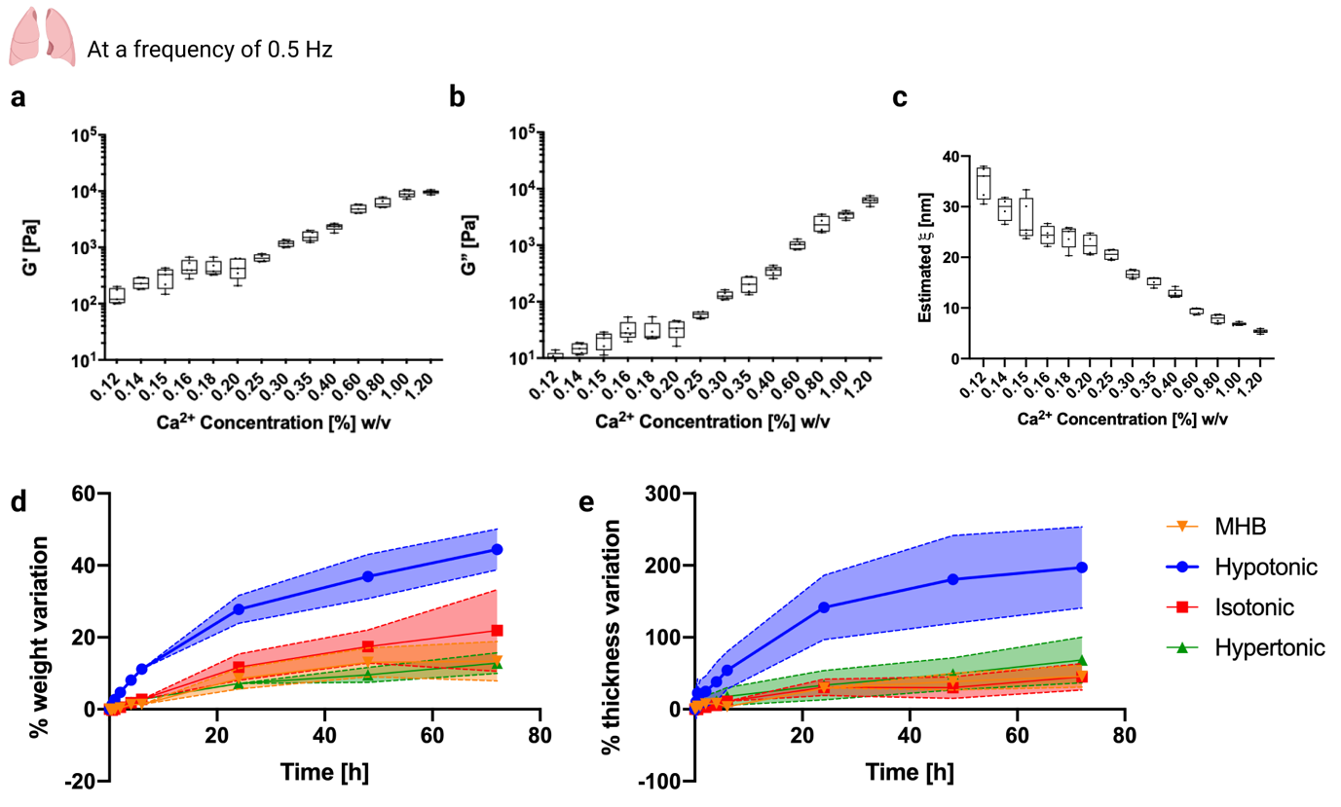
Supplementary Fig. 1 | Stability assessment of CF-Mu³Gel in different media: MHB; hypotonic - 0 mg.ml⁻¹ NaCl; isotonic – 7.07 mg.ml⁻¹ NaCl; and hypertonic – 14.0 mg.ml⁻¹ NaCl. a, Percentage of weight variation; and b, Percentage of thickness variation. CF-Mu³Gel immersed in MHB (orange), hypotonic (blue), isotonic (red), and hypertonic media (green). The area over the lines in a and b represents the standard deviation (n=9).

Supplementary Figure 2. Interlaboratory reproducibility was analysed by comparing cell viability results obtained in the Department of Molecular Medicine of the University of Pavia - Italy and Bac³Gel Lda, at TagusPark - Portugal. The viability of S. aureus and P. aeruginosa monocultured grown in CF-Mu³Gel were comparable between both institutions with no statistical differences detected, which supports interlaboratory reproducibility of microbiological experiments performed on CF-Mu³Gel.
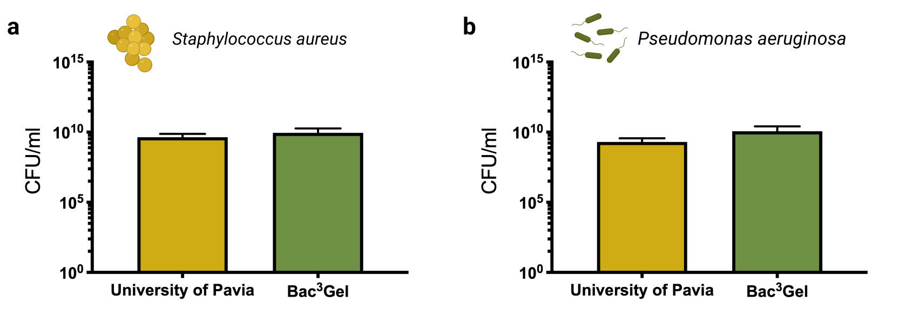
Supplementary Fig. 2 | Interlaboratory study of bacterial viability in CF-Mu³Gel. a, S. aureus; and b, P. aeruginosa were grown in CF-Mu³Gel, which production and microbiological experiments were performed by different operators at both the University of Pavia - Italy (yellow) and Bac³Gel Lda – Portugal (green). The values represent the mean of at least 9 samples, and the bars indicate the standard deviation.

Supplementary Figure 3. Distribution and colonisation of S. aureus within CF-Mu³Gel was investigated by culturing DsRed-fluorescent S. aureus for 12, 24, and 48 h. An increase in the intensity of red with the time of culture was observed especially at the top and bottom.
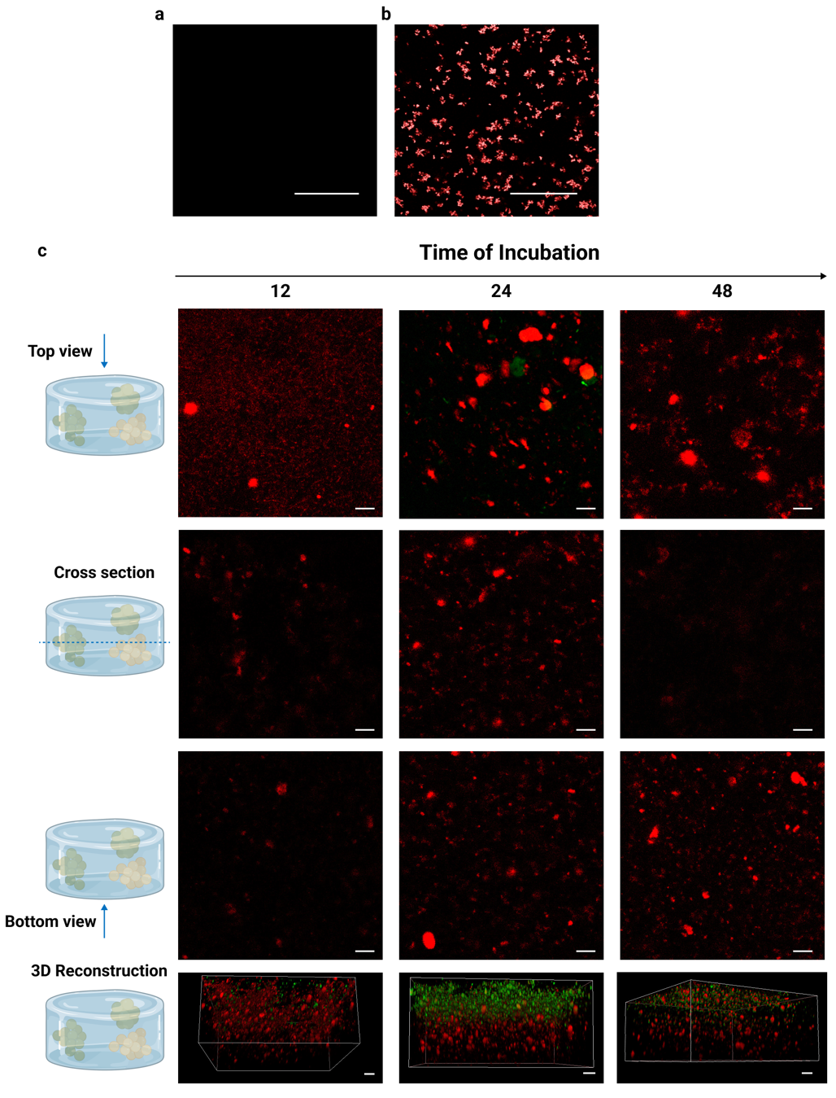
Supplementary Fig. 3 | Mono-cultures of CF-Mu³Gel with DsRed-fluorescent S. aureus. Confocal microscopy analyses of a, sterile CF-Mu³Gel (scale bar = 50 μm); b, DsRed-fluorescent S. aureus (scale bar = 50 μm); c, CF-Mu³Gel colonised with DsRed-fluorescent S. aureus for 12, 24, and 48 h visualised from the: top; cross-section; and bottom perspectives; as well as 3D reconstruction. SYTO9 staining (green) was performed to visualise viable bacteria. The scale bar corresponds to 10 μm.

Supplementary Figure 4. Distribution and colonisation of P. aeruginosa within CF-Mu³Gel was investigated by culturing GFP-fluorescent P. aeruginosa for 12, 24, and 48 h. A consistent increase in the intensity of green with the time of culture was observed throughout the whole structure.
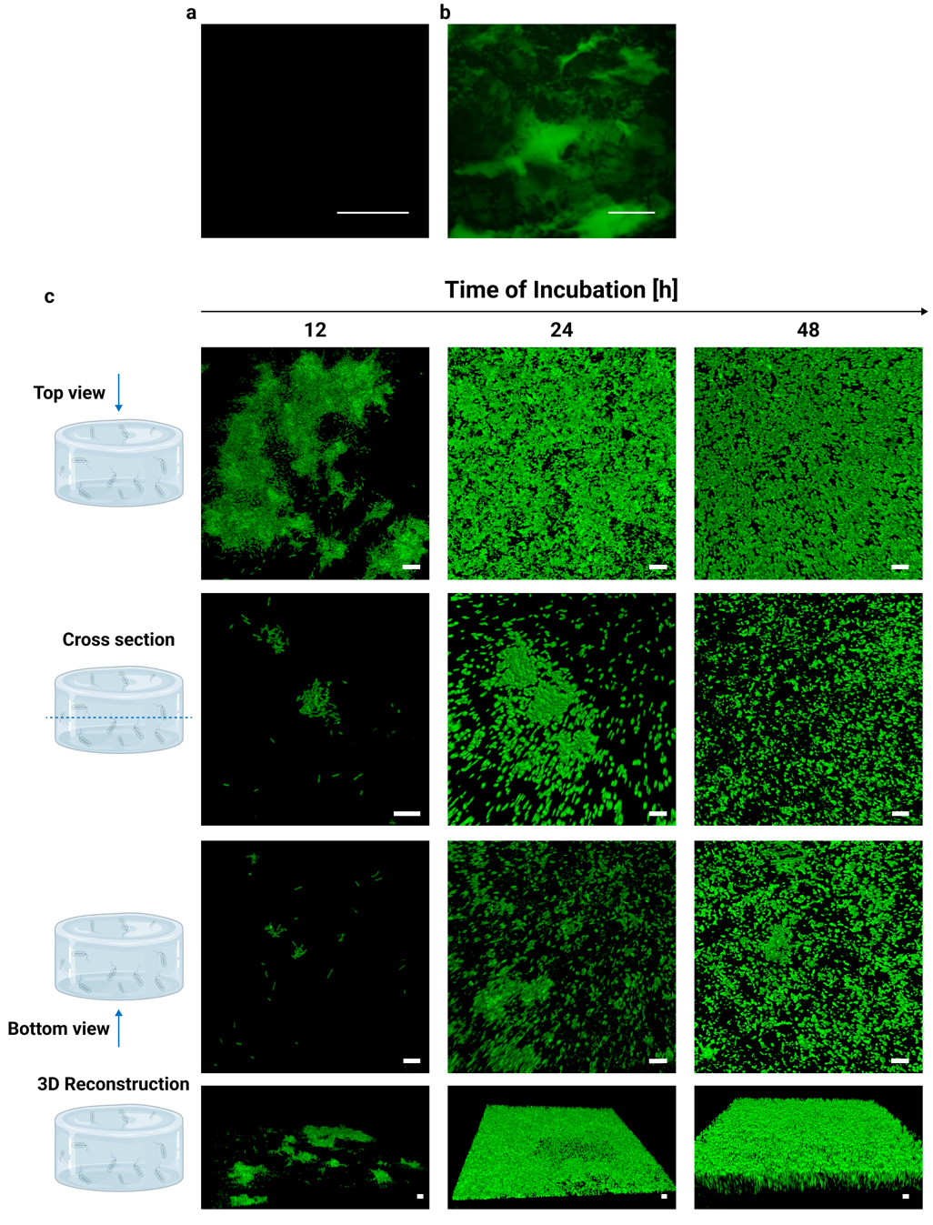
Supplementary Fig. 4 | Mono-cultures of CF-Mu³Gel with GFP-fluorescent P. aeruginosa. a, sterile CF-Mu³Gel (scale bar = 50 μm); b, GFP-fluorescent P. aeruginosa (scale bar = 100 μm); and c, Confocal microscopy analyses of CF-Mu³Gel colonised with GFP-fluorescent P. aeruginosa for 12, 24, and 48 h visualised from the: top; cross-section; and bottom perspectives; as well as 3D reconstruction. The scale bar corresponds to 10 μm.

Supplementary Figure 5. Aggregates of P. aeruginosa inside CF-Mu³Gel after 24 h of colonisation.
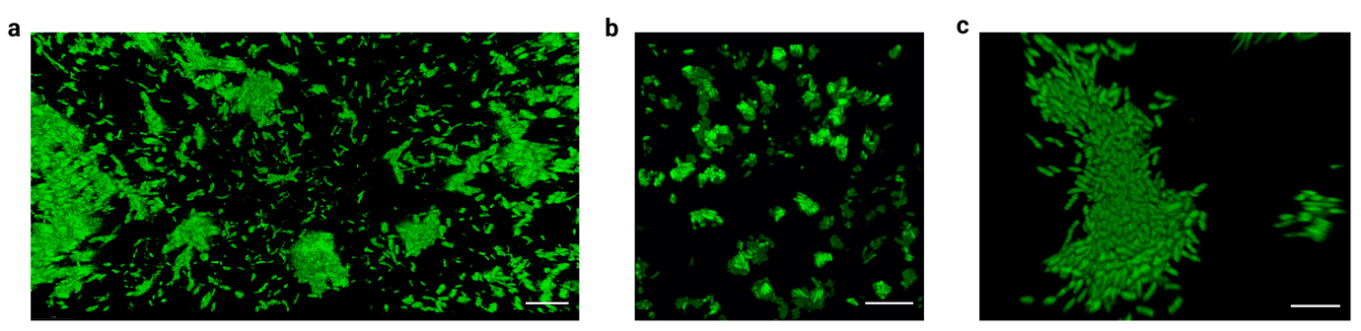Supplementary Fig. 5 | Confocal microscopy imaging of aggregates of P. aeruginosa after 24h of culture in CF-Mu³Gel a, scale bar = 20 μm; b and c, scale bar = 10 μm.

Supplementary Figure 6. Three antimicrobial agents were selected based on antimicrobial treatment routinely administered to CF patients and against infections where S. aureus and P. aeruginosa are present or co-present. The minimal inhibitory concentration was determined to establish the concentration at which the antimicrobial agent prevents the visible growth of a microorganism, so the concentration that the absorbance is close to zero.⁷⁷ A MIC of ciprofloxacin of 0.5 mg l⁻¹ was determined against S. aureus, which is in agreement with previous studies.^{78,79} P. aeruginosa also showed a MIC for ciprofloxacin of 0.5 mg l⁻¹, in accordance with the MIC breakpoint to which P. aeruginosa is reported sensitive by EUCAST.⁸⁰ For tobramycin, the MIC for P. aeruginosa was 8 mg l⁻¹, which, following the MIC breakpoints reported by EUCAST, is considered as resistant.⁸⁰ Instead, colistin is commonly used as the last weapon against Gram-negative cultures, such as pneumonia caused by P. aeruginosa and the determined MIC was 8 mg l⁻¹.
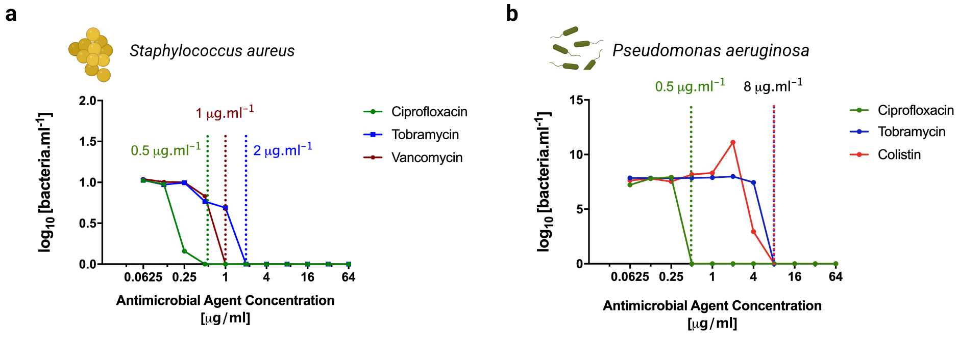
Supplementary Fig. 6 | Minimal inhibitory concentration for different antimicrobial agents a, Minimal inhibitory concentration of ciprofloxacin, tobramycin, and vancomycin against S. aureus; and b, Minimal inhibitory concentration of ciprofloxacin, tobramycin, and colistin against P. aeruginosa by the broth microdilution method using Muller Hinton broth (MHB) according to The European Committee on Antimicrobial Susceptibility Testing (EUCAST) guidelines.

Supplementary Figure 7. Co-cultures of S. aureus and P. aeruginosa in CF-Mu³Gel following three different settings: (a) contemporary co-culture of both S. aureus and P. aeruginosa for 24h; (b) culture with S. aureus first, followed by P. aeruginosa culture for another 24h of incubation; and finally (c) culture with P. aeruginosa first, after which S. aureus was added and incubated for further 24h. To observe bacteria distribution and co-colonisation both DsRed-fluorescent S. aureus (fluorescent red) and GFP-fluorescent P. aeruginosa (fluorescent green) were adopted.
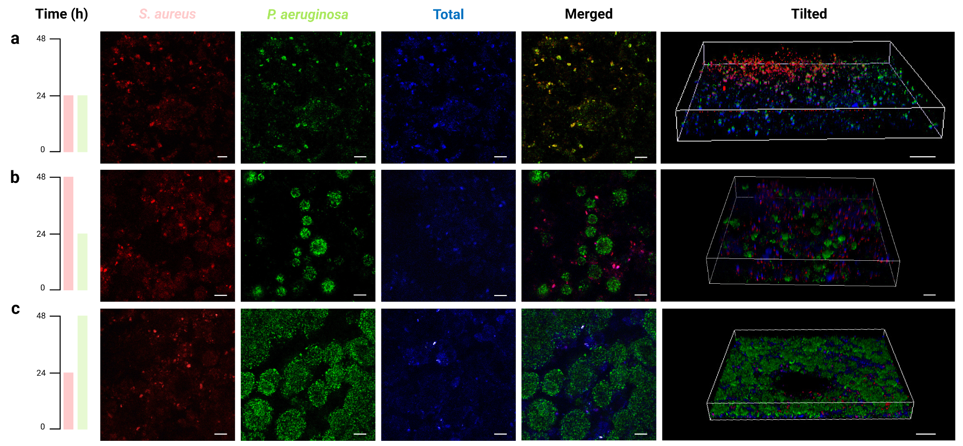
Supplementary Fig. 7 | Co-cultures of DsRed-fluorescent S. aureus and GFP-fluorescent P. aeruginosa in CF-Mu³Gel. Confocal microscopy analyses of CF-Mu³Gel colonised with both DsRed-fluorescent S. aureus (fluorescent red) and GFP-fluorescent P. aeruginosa (fluorescent green) following different experimental settings: a, contemporary culture with both S. aureus and P. aeruginosa for 24 h; b, culturing S. aureus first for 24 h followed by P. aeruginosa culture for another 24 h; and finally, c, culture with P. aeruginosa first for 24 h, after which S. aureus was added and incubated for further 24 h. Co-colonised CF-Mu³Gel was further stained with Hoechst 33342 to depict total bacteria (in blue). Deconstructed microscopical images are provided to better understand the organisation of S. aureus (fluorescent red) and P. aeruginosa (fluorescent green) during co-culture in CF-Mu³Gel, as well as the 3D reconstruction of the different experimental set-ups. The scale bar corresponds to 10 μm.

Supplementary Figure 8. Co-cultures of S. aureus and P. aeruginosa were further treated with ciprofloxacin to understand how the co-existence of these bacteria would impact their susceptibility to antimicrobial treatment. To do so, S. aureus was first cultured for 24 h followed by P. aeruginosa culture for further 24 h (experimental setting b). This experimental setting was chosen because it closely recapitulates infection evolution in CF patients, as first S. aureus infections are occurring, followed by P. aeruginosa colonisation. Upon ciprofloxacin treatment, no differences in the number of P. aeruginosa were found when this was co-cultured in CF-Mu³Gel among the tested MIC. In CF-Mu³Gel, S. aureus was only susceptible to 10 MIC ciprofloxacin treatment with a one-log 10 reduction in comparison to MIC and no antimicrobial treatment. In planktonic conditions, the number of P. aeruginosa gradually decreased with increased concentration of ciprofloxacin. A reduction of two-log 10, four-log10, and five-log10 of the number of P. aeruginosa was determined after treating with 0.1, 1, and 10 MIC, respectively, in comparison to P. aeruginosa co-cultured under planktonic conditions with no antimicrobial treatment.
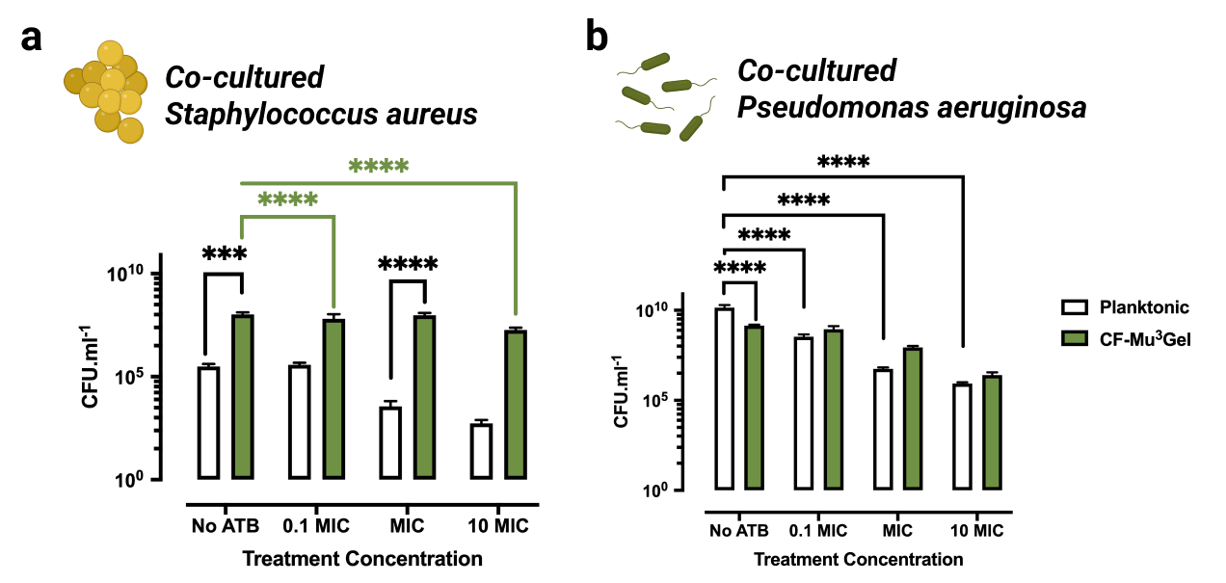
Supplementary Fig. 8 | Antimicrobial treatment of CF-Mu³Gel co-colonised with both S. aureus and P. aeruginosa followed by antimicrobial treatment with ciprofloxacin. 0.1, 1 and 10 MIC correspond to 0.05, 0.5, and 5 mg.l⁻¹, respectively, while No ATB means that ciprofloxacin was absent. a, Proportion of S. aureus: P. aeruginosa after antimicrobial treatment; Quantification of co-cultured: b, S. aureus; and c, P. aeruginosa grown after treatment using selective medium, mannitol and cetrimide agar, respectively. The results obtained with CF-Mu³Gel (green) were further compared with planktonic cultures (white). All data were analysed using two‐way ANOVA. Significant differences were set for *p < 0.05; **p < 0.01; ***p < 0.001; ****p < 0.0001. A minimum of five independent samples were analysed per bacterium (n ≧ 5).

Supplementary Table 1. Mass Spectroscopy analytical conditions.

Compound | Parent ion | Fragment ion | Collision Energy (V)
Ciprofloxacin | 331.9 | 230.8 | -38.5
Tobramycin | 468.0 | 324.0 | -13.0
Colistin | 386.0 | 100.9 | -13.5

