The X-ray machine was transported in small vehicles or boats to reach communities. It was tramnpsorted in two protective suitcases.
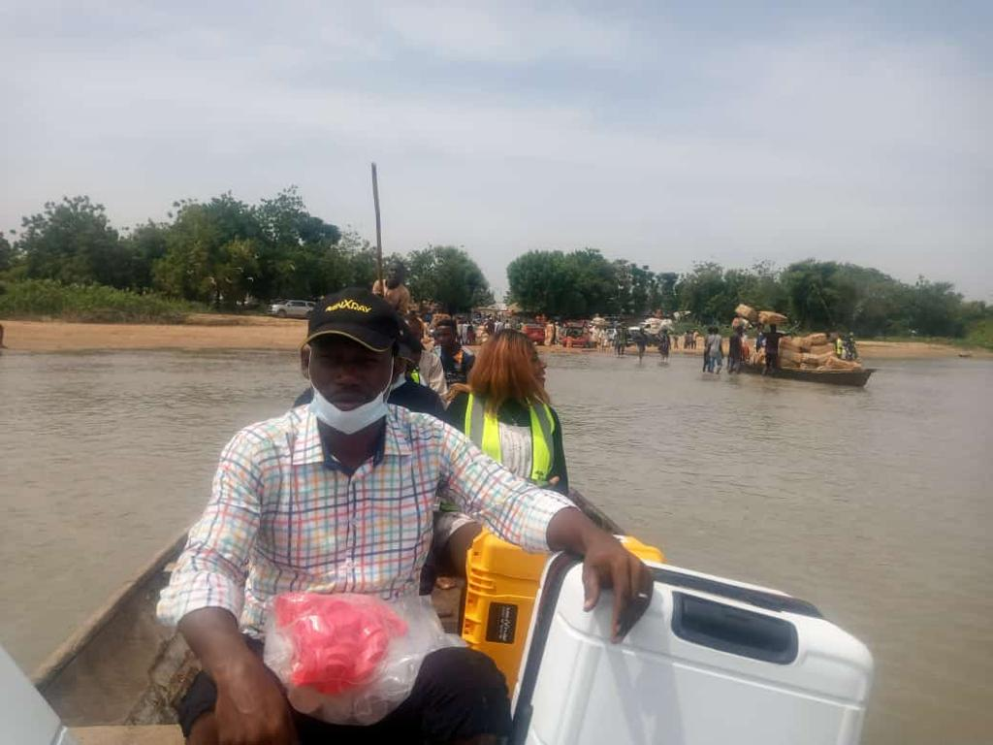
The setup in communities could be done in the midle of fields without need for electricity and several hours of use.
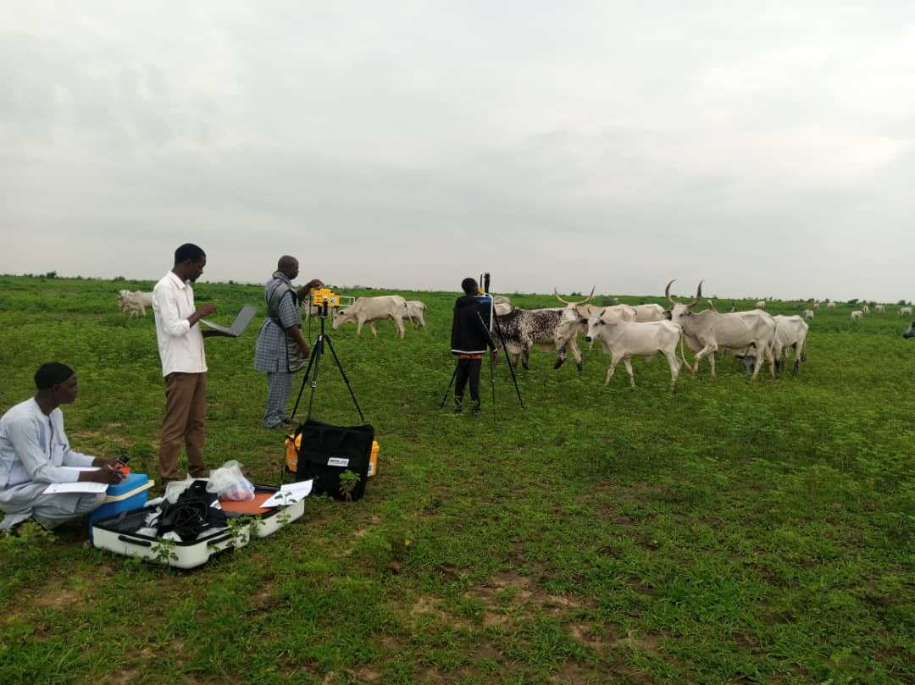
Screening camps were conducted in communities and health facilities, usually without electricity. In this picture the person reviewing the AI processing on the laptop can be seen in the foreground.
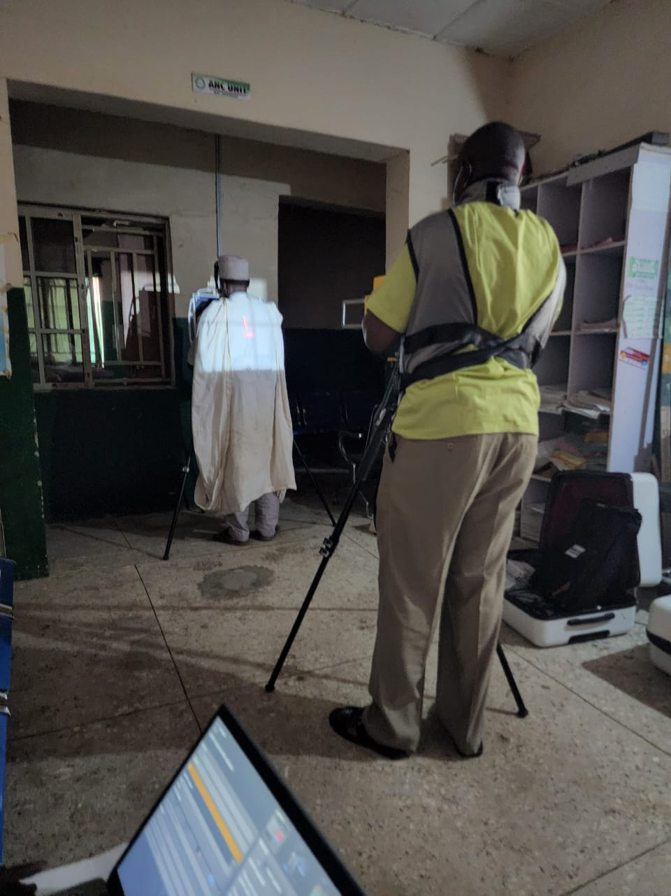

The suitcases were used as makeshift desks in the communities and the x-ray machines were a populatar attraction.
