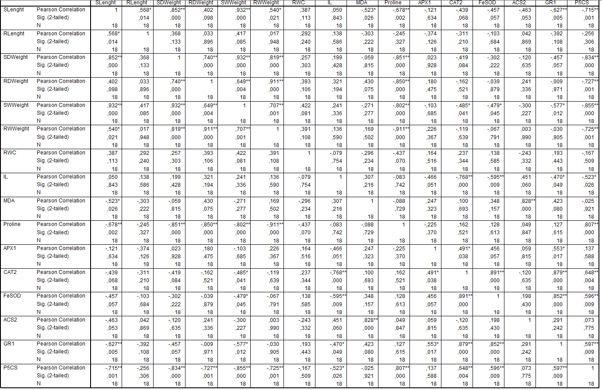
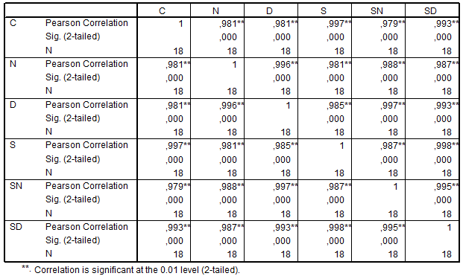
Table 1. Correlations among different experimental finding. S stands for shoot, R; root, SD; shoot dry, RD; root dry, SW; shoot wet, RW; root wet, RWC; relative water content, IL; ion leakage, MDA; malondialdehyde and oxidative stress related gene expressions. * and ** Indicates significance at the 0.05 and 0.01 level, respectively.
CORRELATION TABLES OF INVESTIGATED PARAMETERS

Table 2. Correlations among different treatments in terms of morphological parameters.

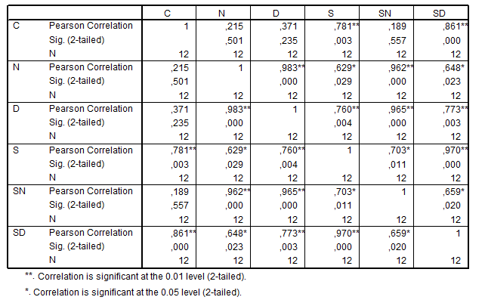
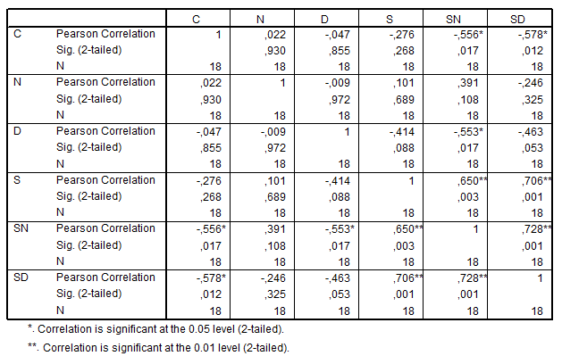
Table 3. Correlations among different treatments in terms of physiological parameters.

Table 4. Correlations among different treatments in terms of abiotic stress related gene expressions.

