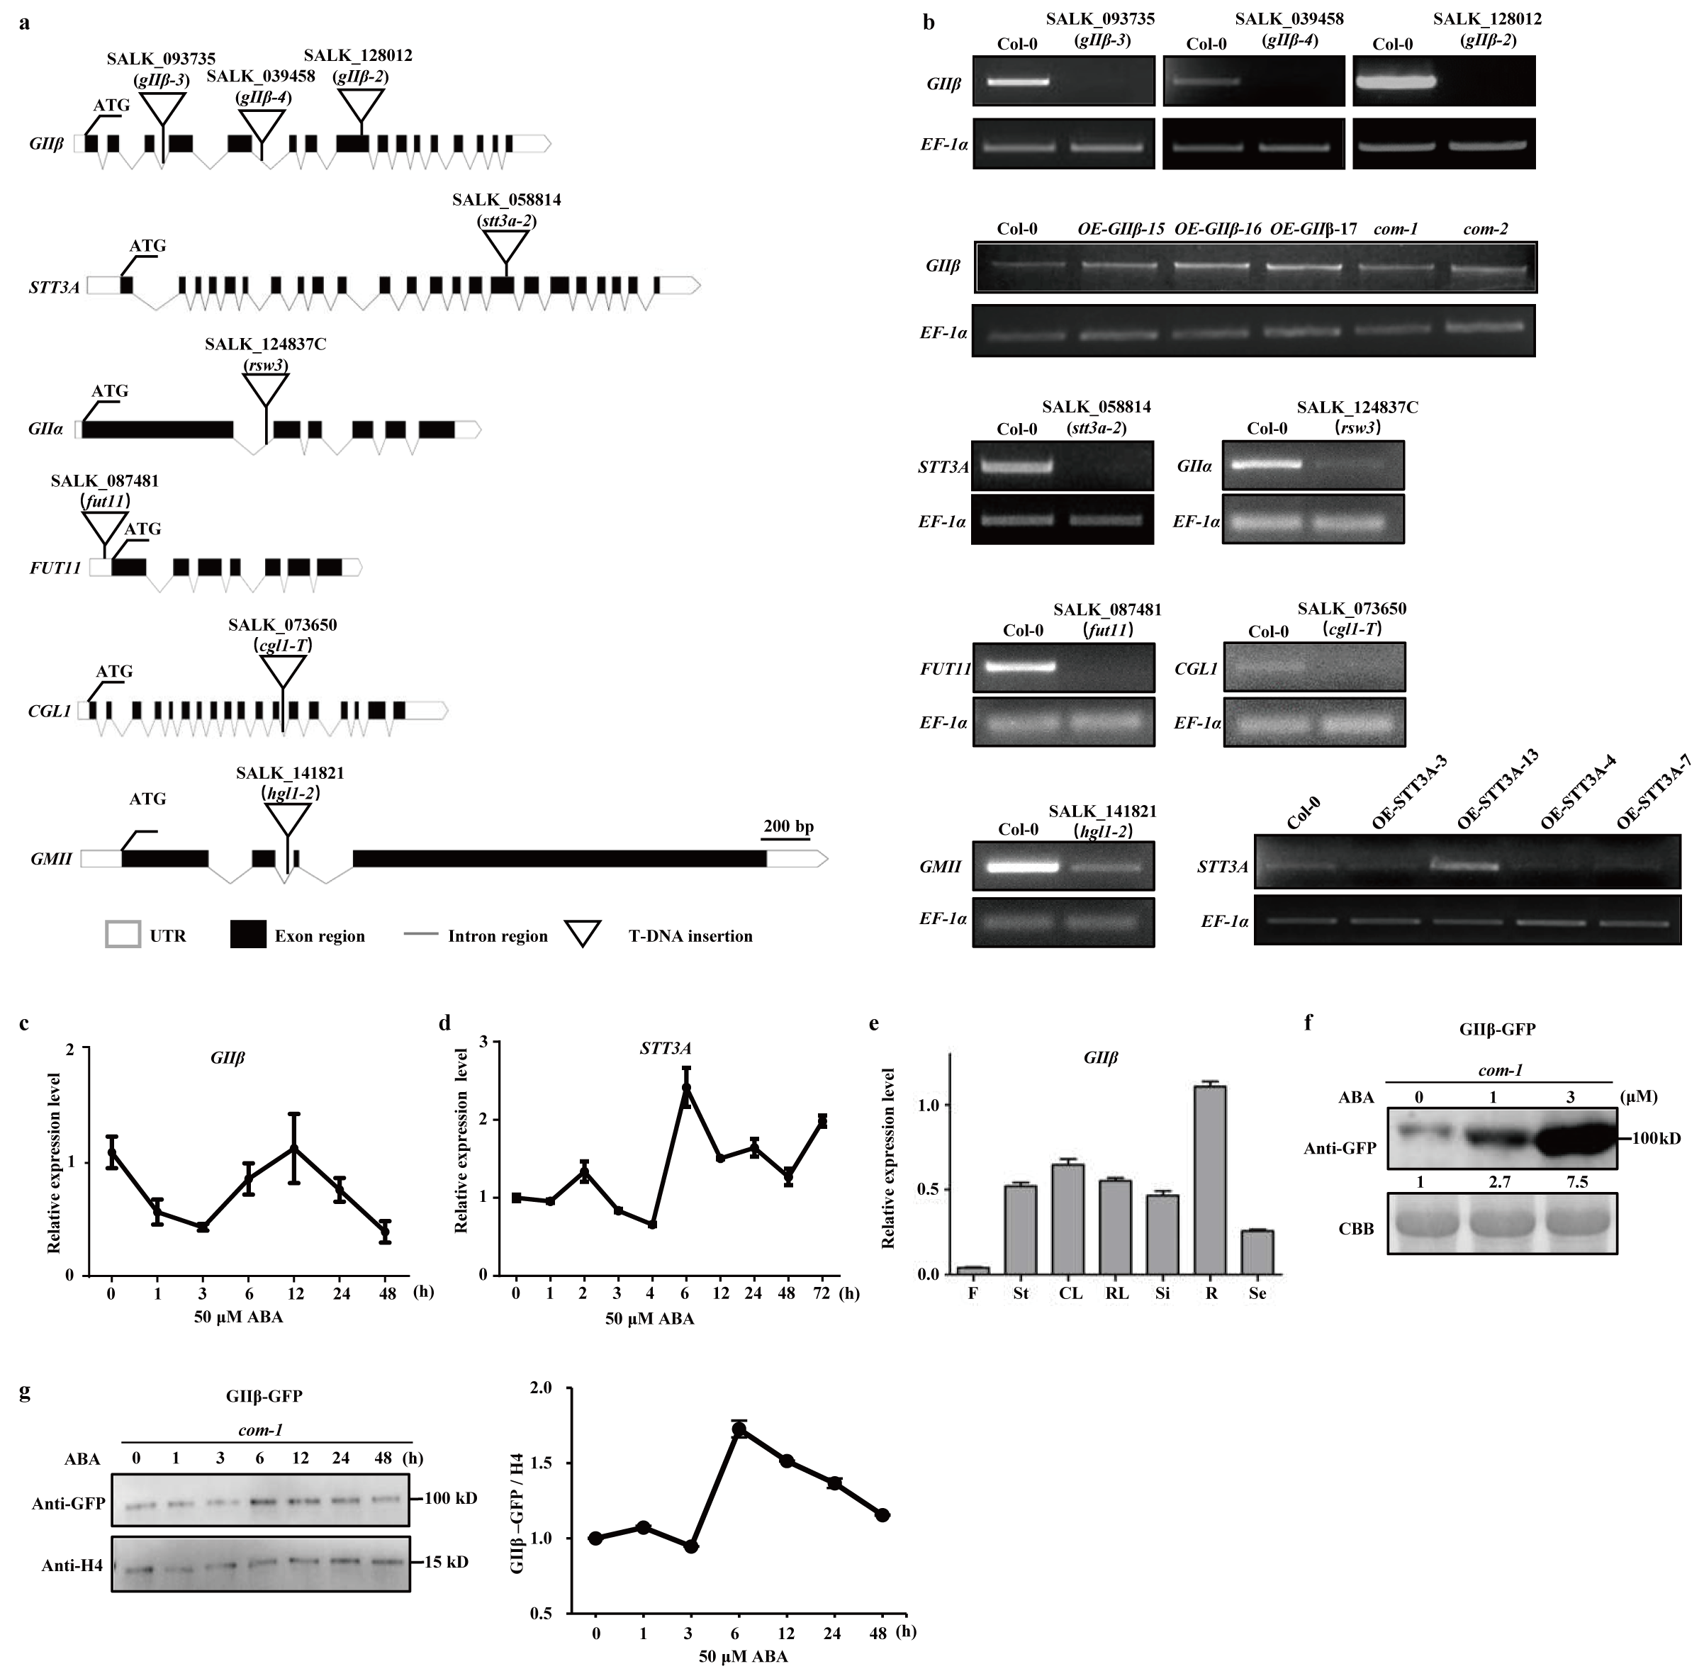 Extended Data Fig. 1 | npe mutants and transgenic Arabidopsis used in this study.
a, Schematic presentation of gene structures of GⅡβ, STT3A, GⅡα, FUT11, CGL1 and GMII with T-DNA insertion shown as triangles. b, The expression level of GⅡβ, STT3A, GⅡα, FUT11, CGL1 and GMII in diverse genotypes determined by RT-PCR. Elongation factor 1 α (EF-1α) was used as a loading control. c, d, The temporal expression pattern of GⅡβ and STT3A during prolonged ABA application. RNA samples were extracted from 7-day-old seedlings after treatment with 50 μM ABA for different time periods. The qRT-PCR data were normalized against Actin7 or ubiquitin 10 (UBQ10). n=3 biological replicates. e, Tissue-specific expression pattern of GⅡβ determined by qRT-PCR. F, flower; St, stem; CL, cauline leaf; RL, rosette leaf; Si, silique; R, root; Se, seed. The means were calculated from three independent replicates. f, GIIβ protein level was induced by ABA in a dose-dependent manner. g, The temporal expression pattern of GIIβ protein during prolonged ABA treatments. Quantification of band intensity in (f). Total protein samples as shown in (f) and (g) were extracted from 7-day-old seedlings after ABA treatment.
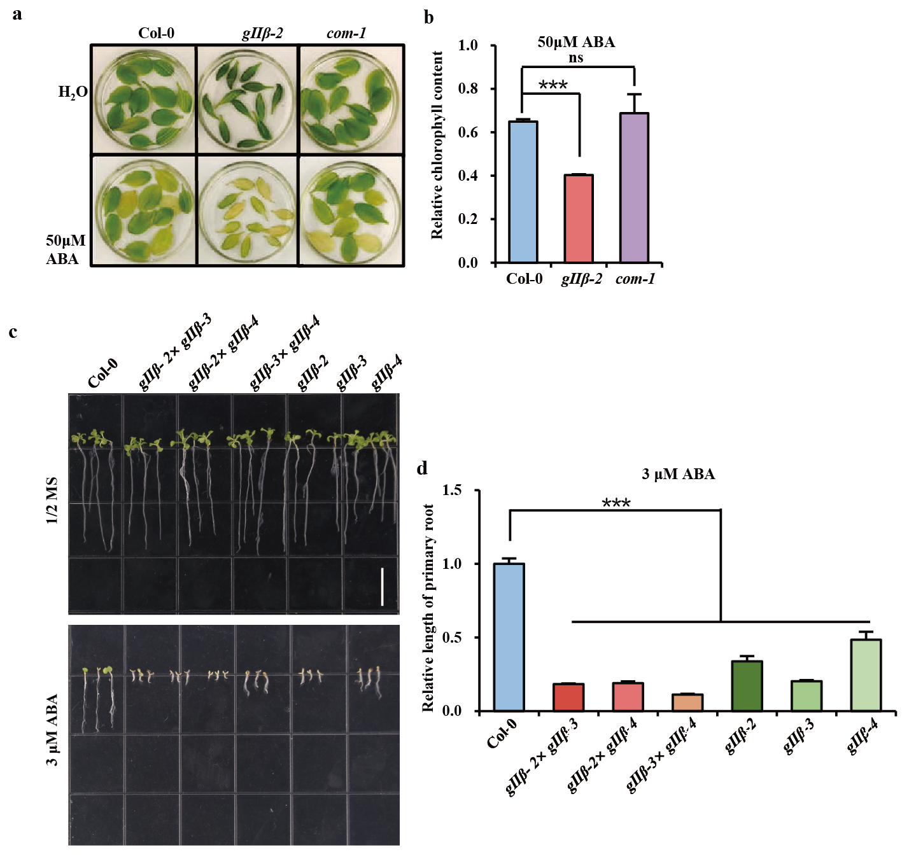
Extended Data Fig. 2 | Morphological analyses showed that NPEs negatively regulate ABA signalling.
a, Detached leaf senescence and measurement of chlorophyll content in gIIβ-2 and complement line 1. Detached rosette leaves of 3-week-old Arabidopsis were soaked in water containing 50 μM ABA for 3 days, then were placed in a glass petri dish for photography and Chlorophyll measurement. b, Quantification of chlorophyll concentration as shown in (a). The ratio of ABA-treated leaves by no ABA-treated leaves (ABA+/-) relative root length was calculated. Data are means ± s.d. from 3 biological replicates (n > 10 leaves for each replicate). c, Three GIIβ mutants and their F1 hybrids exhibited hypersensitivity to ABA in terms of primary root length. 10-day-old Arabidopsis seedlings were grown on 1/2×MS medium or supplemented with 3 μM ABA. d, Quantification of the length of primary roots in (c). The relative root length was calculated as (ABA+/-). The ratio was designated as 1 in Col-0. Data are means ± s.d.n=3 plants. Asterisks indicate significant differences (*P-value < 0.05, **P-value < 0.01, ***P-value < 0.001), as determined by two-tailed paired t-tests. “ns” means no significant difference.

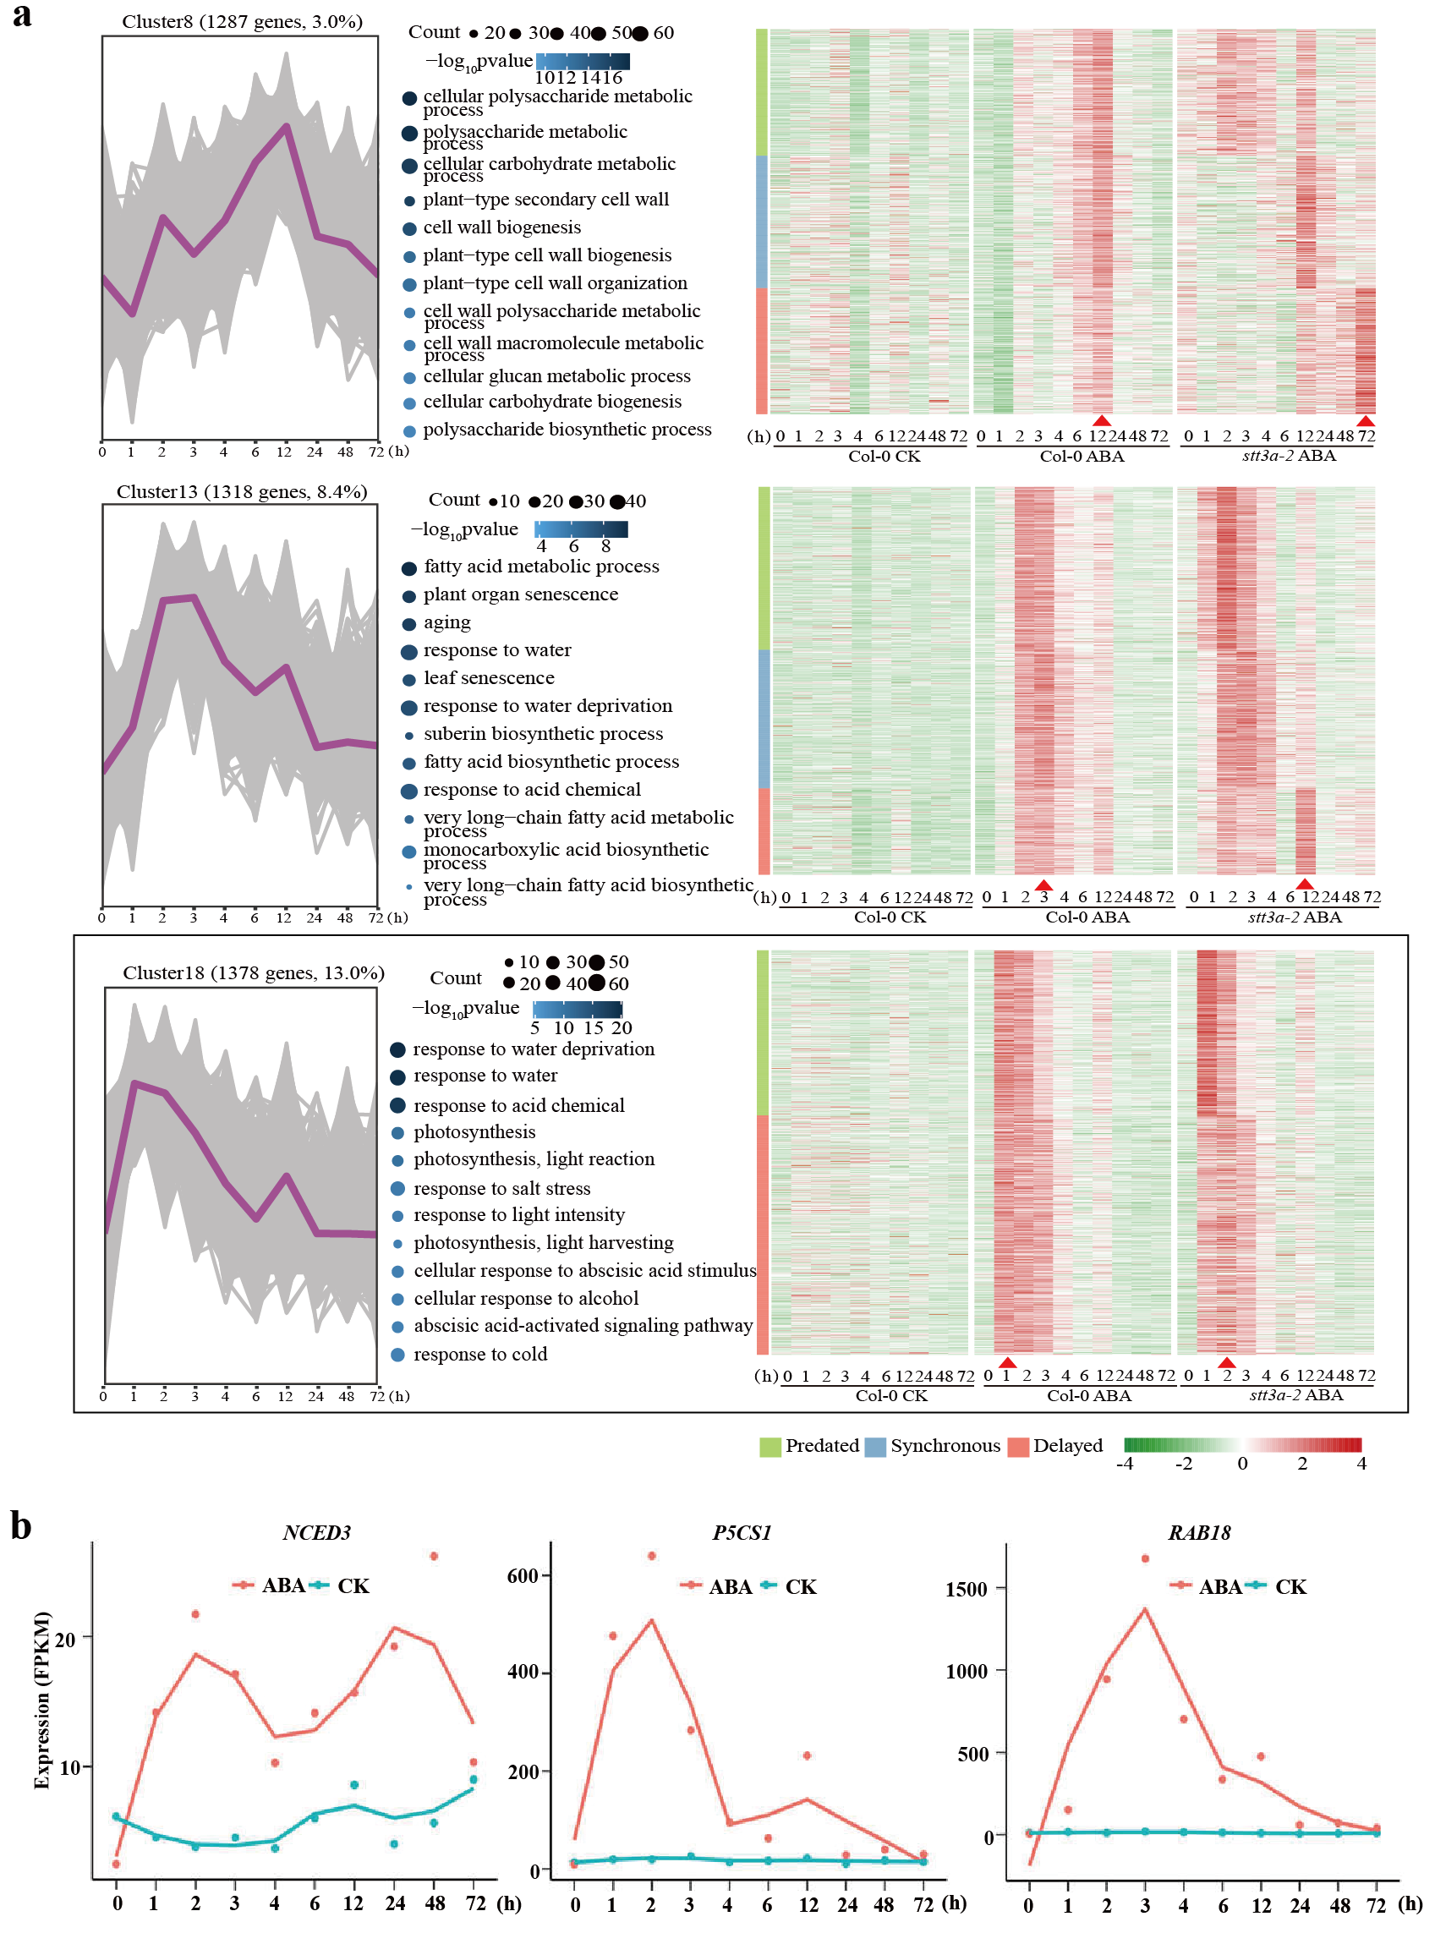
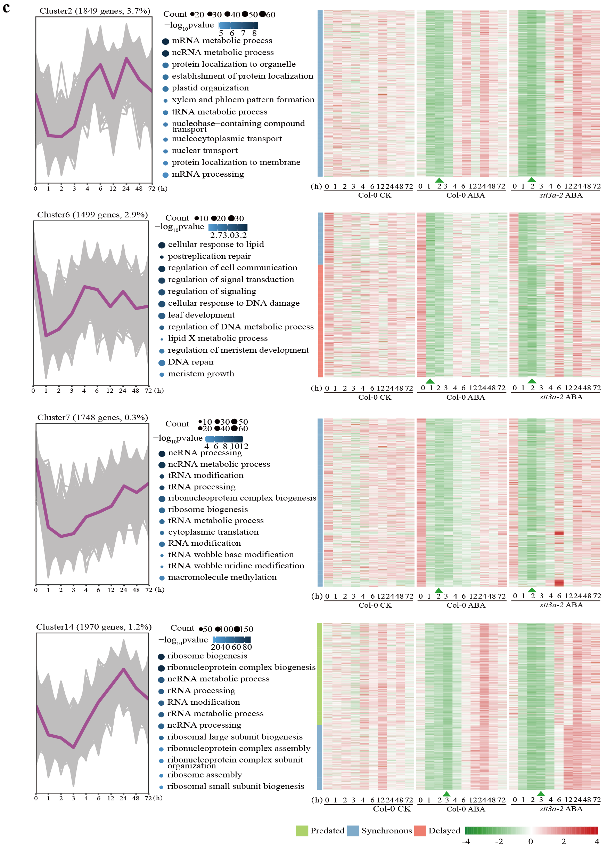
Extended Data Fig. 3 | Genome-wide desensitization of ABA-transcriptional response during pronged ABA signalling.
a, c, left, The temporal expression patterns from time-course RNA-seq data sets for ABA-upregulated genes in cluster 8, 13, and 18 (a), and for ABA-downregulated genes in cluster 2, 6, 7, 14 (c). a, c, middle, The associated GO terms of these ABA-responsive genes are listed. a, c, right, Heatmaps showed the comparative expression analyses of ABA responsive genes in Col-0 and stt3a-2 backgrounds with no ABA-treated Col-0 as controls. The arrowheads denote the biphasic inflection point from sensitization to desensitization during prolonged ABA signalling. b, The temporal expression pattern of ABA responsive genes NCED3, P5CS1, RAB18 from RNA-seq data sets in (a).
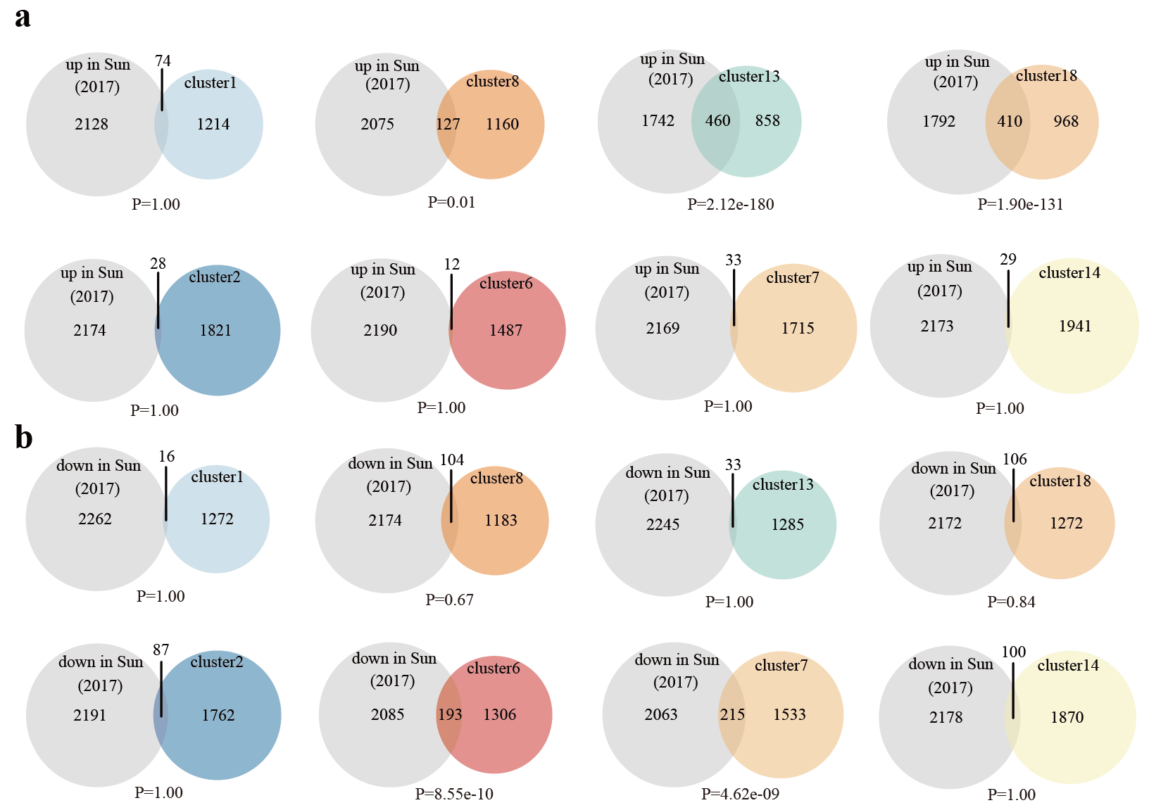
Extended Data Fig. 4 | Venn diagram depicting the significant overlap with previously published ABA responsive genes.
a, RNA-seq data sets overlap with previously reported ABA-induced genes. b, RNA-seq data sets overlap with previously reported ABA-downregulated genes. The hypergeometric test was used to calculate the P value between each cluster (right) with previous data (left). False discovery rate corrected P-value < 0.05.

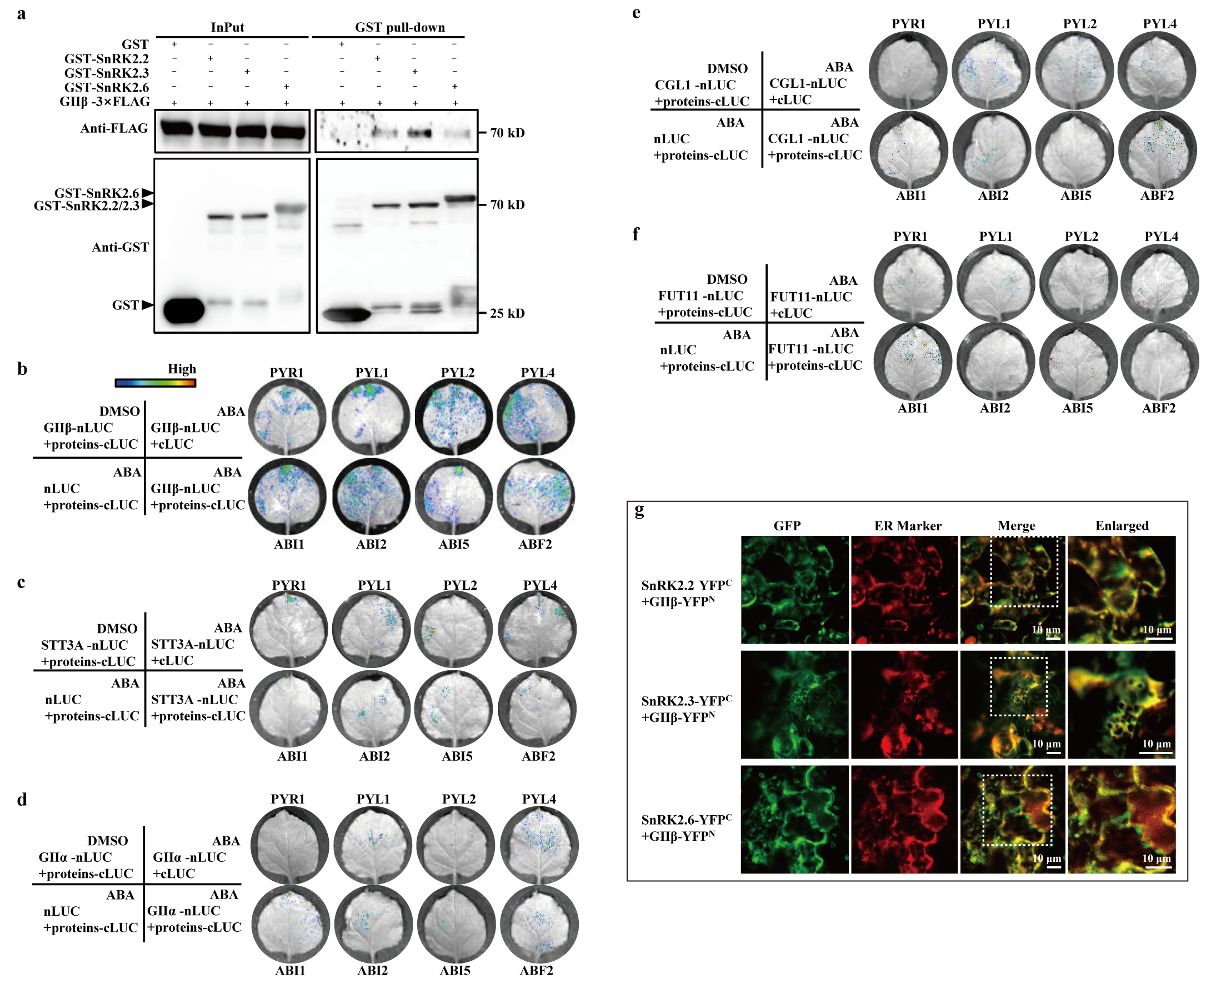
Extended Data Fig. 5 | The proteins interactions between NPEs and core components of ABA signaling.
a, Pull-down assay showed the direct interaction between SnRK2.2/2.3/2.6 and GIIβ. GST-SnRK2s and GⅡβ-3×FLAG are mixed and incubated for 4 h, followed by Western blot analysis using indicated antibodies. b-f, LCI assays showed the interactions between NPEs (GIIβ, STT3A, GIIα, CGL1 and FUT11) and the components of ABA core-signalling (PYLs, PP2C (ABI1 and ABI2), and ABF2). For ABA treatment, 50 μM ABA was injected into tobacco leaves (0.05% DMSO as control) after 12 h of GV3101 infection. g, BiFC assays demonstrated the interactions between GⅡβ and SnRK2s take place in the ER. mCherry was used as ER marker (CD3-959). Scale bars, 10 μm.
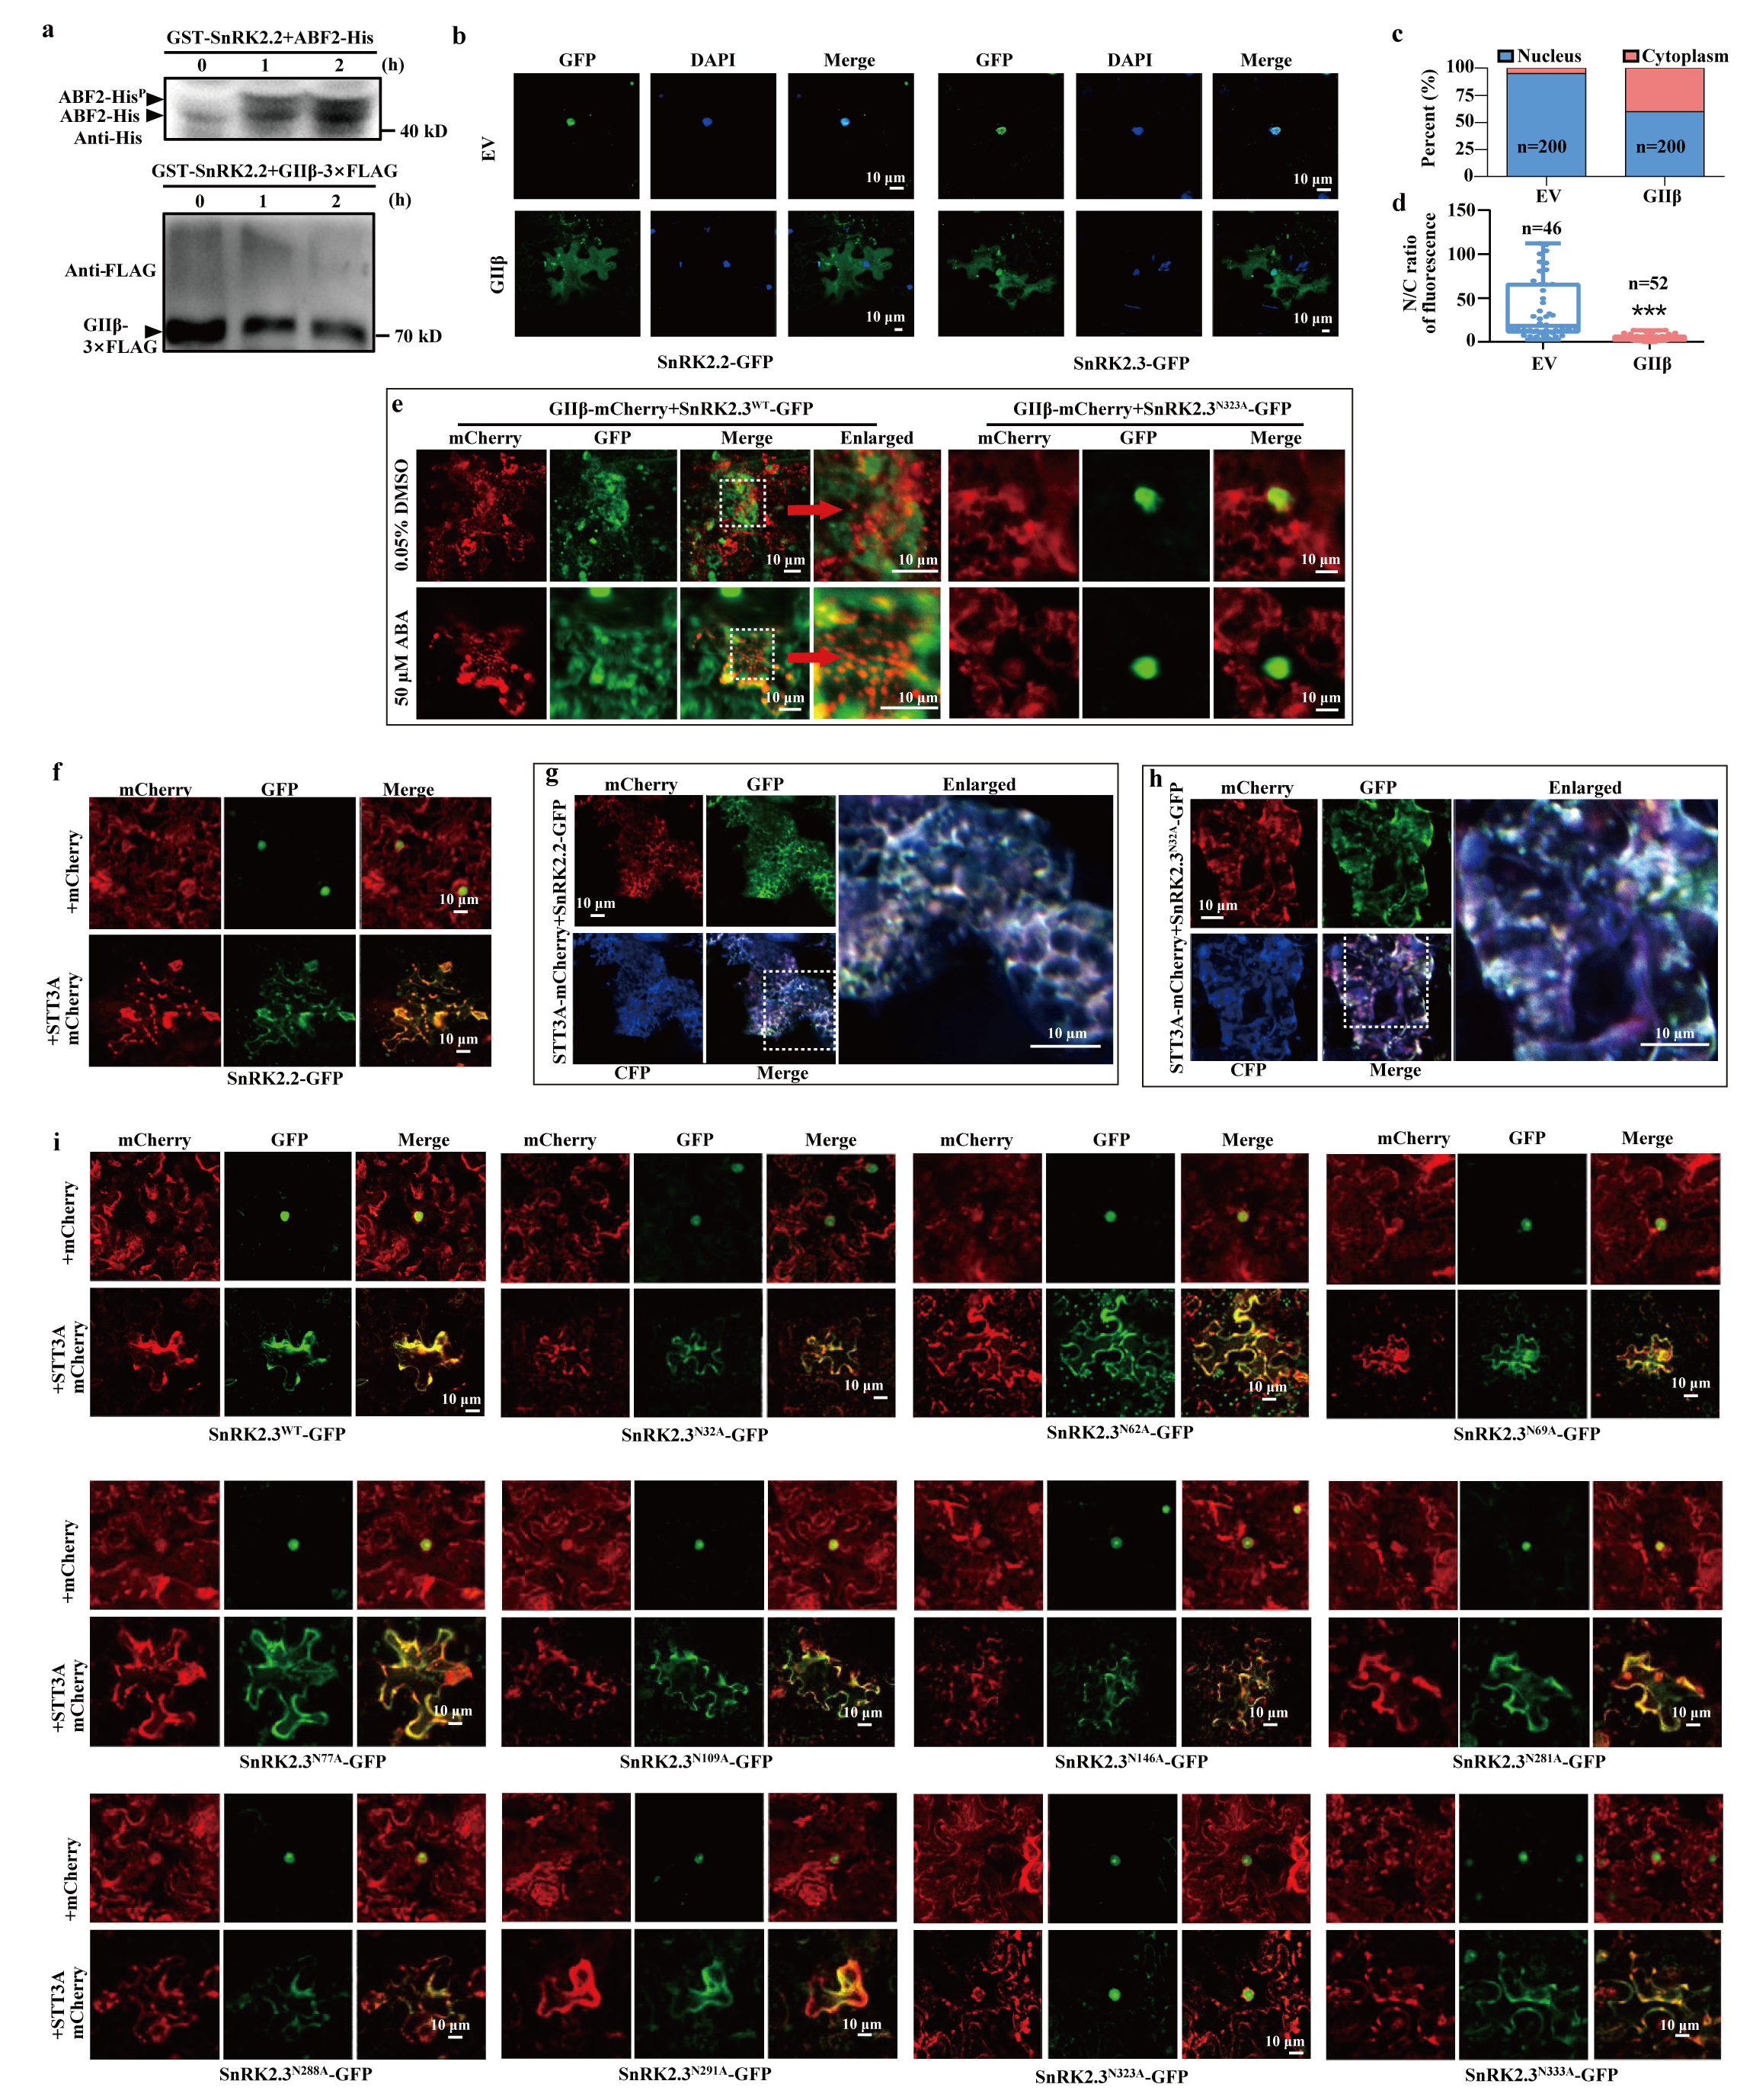Extended Data Fig. 6 | N-glycosylation of SnRK2s promotes its subcellular change when transiently expressed in N. benthamiana leaves.
a, Detection of GⅡβ Phosphorylation with ABF2-His as a positive control. GⅡβ-3×Flag and ABF2-His proteins were incubated with purified GST-SnRK2.2 in phosphorylation buffer, followed by SDS–PAGE separation with phos-tag and detection with the indicated antibodies. b, GIIβ-coexpression induces nuclear export of SnRK2.2/2.3. GIIβ was coexpressed with SnRK2.2-GFP and SnRK2.3-GFP respectively in N. benthamiana leaves. DAPI is a nuclear dye. EV, empty vector used as a negative control. c, Quantification of subcellular localization of SnRK2.2-GFP as shown in (b). n=200 tobacco cells. d, Quantification of the ratio of cytoplasmic to nuclear SnRK2.2-GFP fluorescent intensity (N/C). The whiskers indicate the minimum and maximum values. Asterisks indicate significant differences (***P-value < 0.001), as determined by two-tailed paired t-tests. n≥46 tobacco cells. e, GIIβ-mCherry was coexpressed with SnRK2.3^{WT}-GFP and SnRK2.3^{N323A}-GFP respectively in N. benthamiana leaves. f and g, STT3A-coexpression regulates localization of SnRK2.2-GFP. Scale bars, 10 μm. CFP was as ER marker (CFP-HDEL). h and i, STT3A-coexpression regulates localization of SnRK2.3-GFP, and mutations of total 10 N sites (N32A, N62A, N69A, N77A, N109A, N146A, N281A, N288A, N291A, N333A) of SnRK2.3 disrupt the regulation of STT3A . Scale bars, 10 μm. CFP was as ER marker (CFP-HDEL).
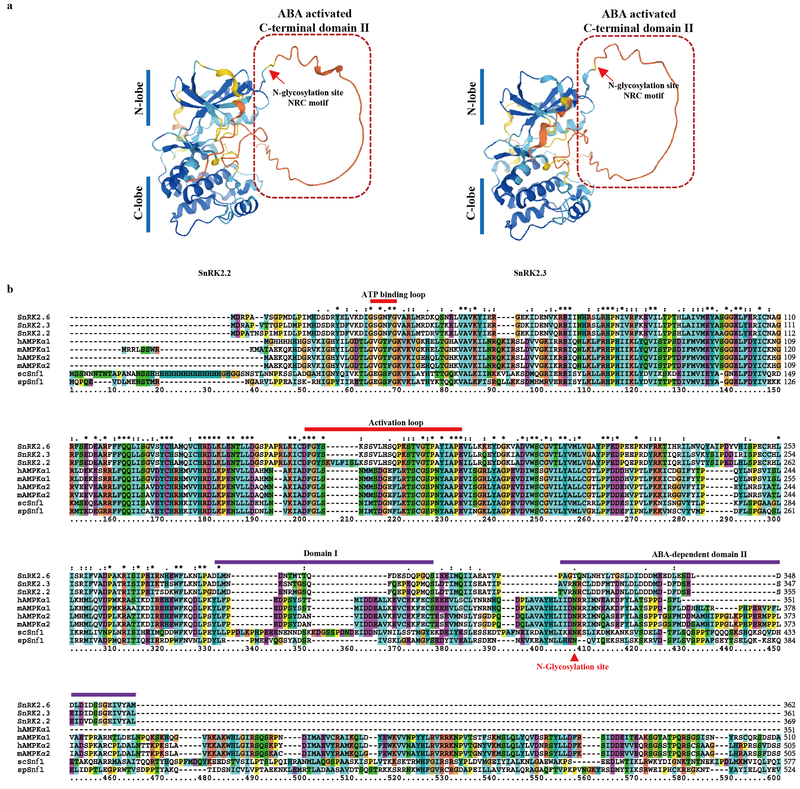Extended Data Fig. 7 | Structural model for SnRK2.2/2.3 and protein sequence alignment.
a, Structural model for SnRK2.2/2.3 created by AlphaFold2 (www.alphafold.ebi.ac.uk). Arrows indicate the N-glycosylation sites. b, Protein sequence alignment of SnRK2 homologous protein. Red arrow indicates the N-glycosylation site.
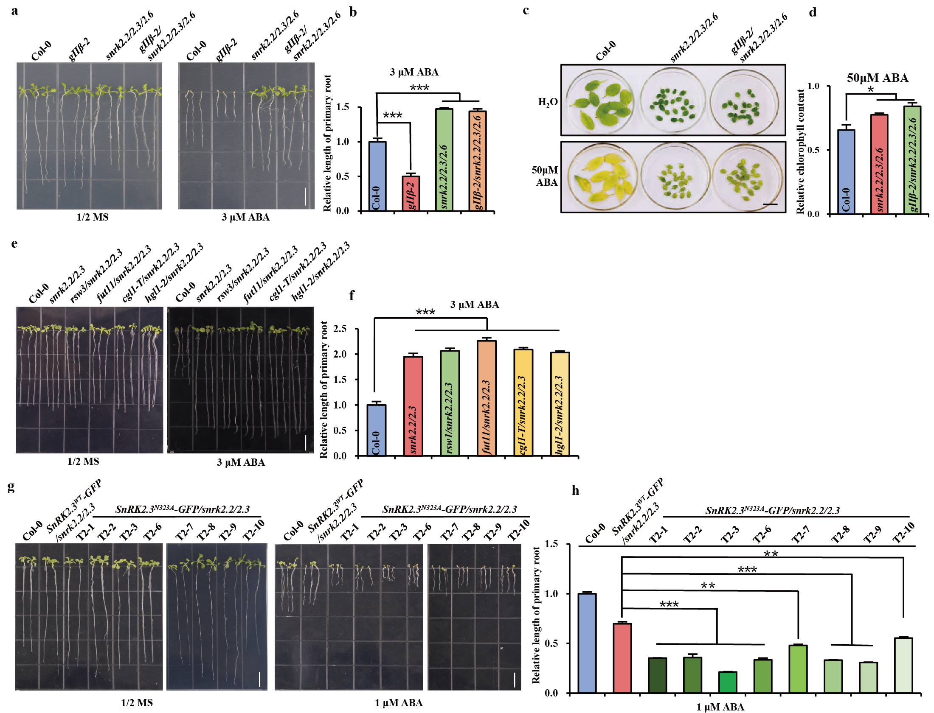
Extended Data Fig. 8 | SnRK2s are epistatic to NPEs in ABA signalling.
a, b, Root phenotypes of Col-0, gⅡβ-2, snrk2.2/2.3/2.6 and gⅡβ-2/snrk2.2/2.3/2.6 grown on 1/2×MS medium either lacking or supplemented with 3 μM ABA. The ratio (ABA+/-) of WT was designated as 1, and the relative ratio to WT was shown for mutants. c, d, Senescence phenotypes of Col-0, snrk2.2/2.3/2.6 and gⅡβ-2/snrk2.2/2.3/2.6. Rosette leaves of 3-week-old plants are soaked in water with or without 50 μM ABA. After 3 days (22℃, Dark), the rosette leaves are photographed. Scale bars, 1 cm. e, f, Root phenotypes of Col-0, snrk2.2/2.3/2.6, rsw3/snrk2.2/2.3, fut11/snrk2.2/2.3, cgl1-T/snrk2.2/2.3, and hgl1-2/snrk2.2/2.3 grown on 1/2×MS medium either lacking or supplemented with 3 μM ABA. n=10 plants. g, h, Root phenotypes of Col-0, SnRK2.3^{WT}-GFP/snrk2.2/2.3 and SnRK2.3^{N323A}-GFP/snrk2.2/2.3 lines. Both SnRK2.3-GFP and SnRK2.3^{N323A}-GFP are driven by 35S promoter. The plants were grown on 1/2×MS medium either lacking or supplemented with 1 μM ABA. n=3-6 plants. Scale bars, 1 cm. Graph shows the relative length of primary root (ABA/MS) of seedlings grown for 14 days. The ratio (ABA+/-) of WT was designated as 1, and the relative ratio to WT was shown for transgenic plants. Data are presented as means ± s.d. and asterisks indicate significant differences (*P-value < 0.05, **P-value < 0.01, ***P-value < 0.001), as determined by two-tailed paired t-tests.
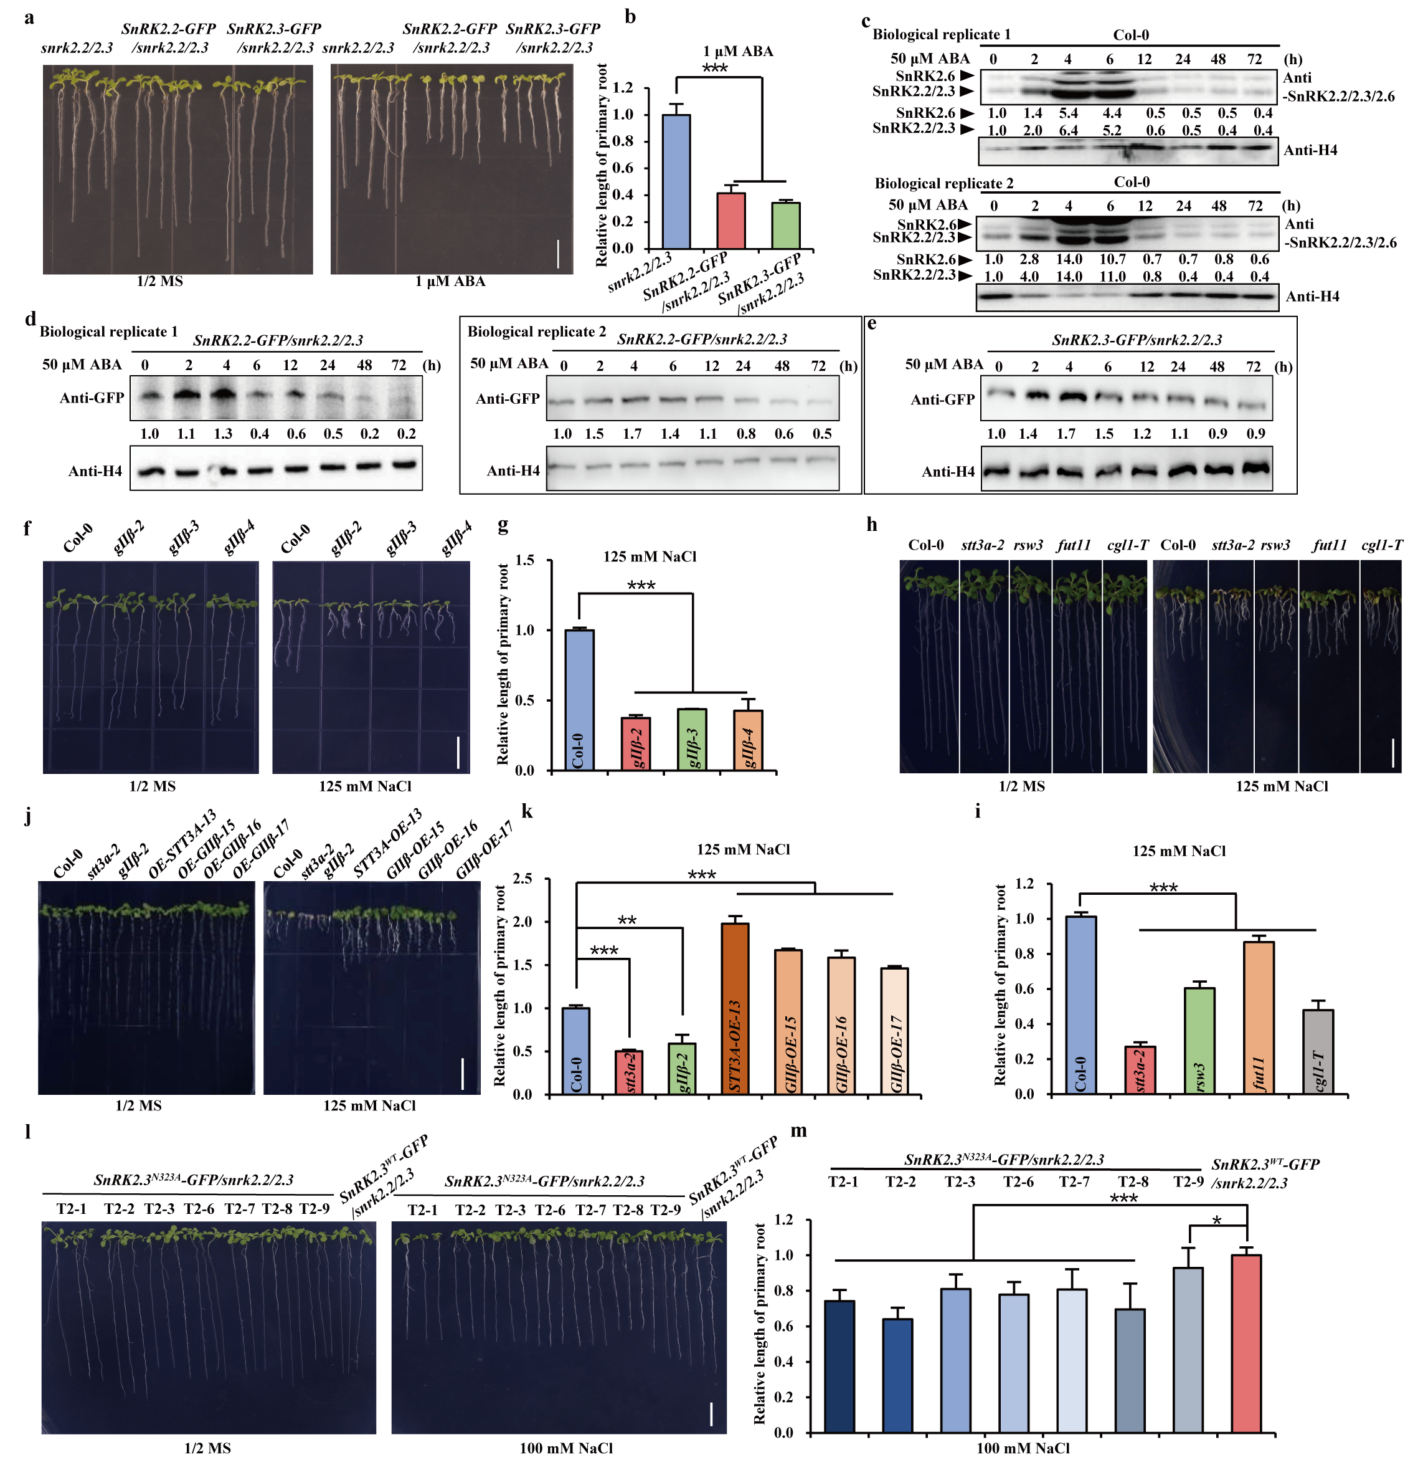 Extended Data Fig. 9 | The temporal express pattern of SnRK2 proteins and morphological analyses of transgenic Arabidopsis.
a, Root phenotypes of snrk2.2/2.3, SnRK2.2-GFP/snrk2.2/2.3 and SnRK2.3-GFP/snrk2.2/2.3. Both SnRK2.2-GFP and SnRK2.3-GFP are driven by 35S promoter. The plants were grown on 1/2×MS medium with or without 1 μM ABA. Scale bars, 1 cm. b, Histogram shows the relative length of primary root, n=5 plants. The ratio (ABA+/-) of snrk2.3/2.3 was designated as 1, and the relative ratio to snrk2.3/2.3 was shown for transgenic plants. c-e, The time-course expression pattern of SnRK2.2/2.3/2.6 (c, two biological replicates), SnRK2.2-GFP (d, two biological replicates) and SnRK2.3-GFP (e). Total proteins are extracted from the 4-day-young seedling treated with 50 μM ABA over time, followed by immunoblotting analysis with the anti-SnRK2.2/2.3/2.6 antibodies (c) and the anti-GFP antibodies (d, e). H4 is used as control. f-m, Root phenotypes of Col-0, mutants and transgenic lines under salt stress. Scale bars, 1 cm. Graph shows the relative length of primary root (NaCl/MS). The ratio (NaCl+/-) of WT (Col-0, SnRK2.3^{WT}-GFP/snrk2.2/2.3) was designated as 1, and the relative ratio to WT was shown for mutants and transgenic plants. Data are presented as means ± s.d. n=15 plants in (g), (k), (i), and (m). Asterisks indicate significant differences (*P-value < 0.05, **P-value < 0.01, ***P-value < 0.001), as determined by two-tailed paired t-tests.
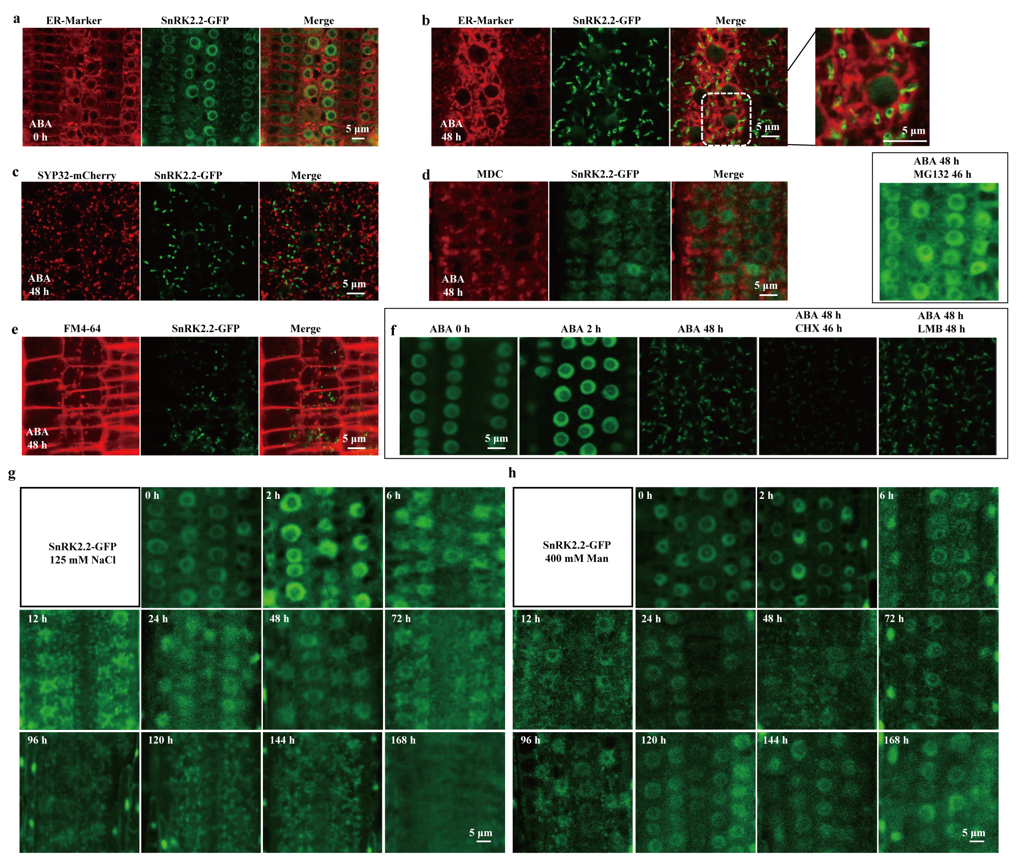 Extended Data Fig. 10 | Subcellular localization assays of SnRK2-GFP
a-e, Subcellular localization assays of SnRK2.2-GFP. SnRK2.2-GFP is driven by 35S promoter. The SnRK2.2-GFP transgenic plant was treated with 50 μM ABA for different time periods. The red channel shows the ER signal (CD3-959, a, b), SYP32-mCherry as Golgi apparatus marker (c), MDC as autophagosome marker (d), and FM4-64 as endocytic tracer dye (e). The green channel shows the SnRK2.2-GFP signal. f, SnRK2.2-GFP transgenic plants are treated with 50 μM ABA for different time periods. 50 μM CHX and 50 μM MG132 are added after 2 h of 50 μM ABA treatment and plants are treated with 5 μM LMB and 50 μM ABA simultaneously for 48 h. g, h, Subcellular localization assays of SnRK2.2-GFP under abiotic stress. SnRK2.2-GFP transgenic plants are treated with 125 mM NaCl (g) or 400 mM Man (h) for different time periods after grown for 4 days.
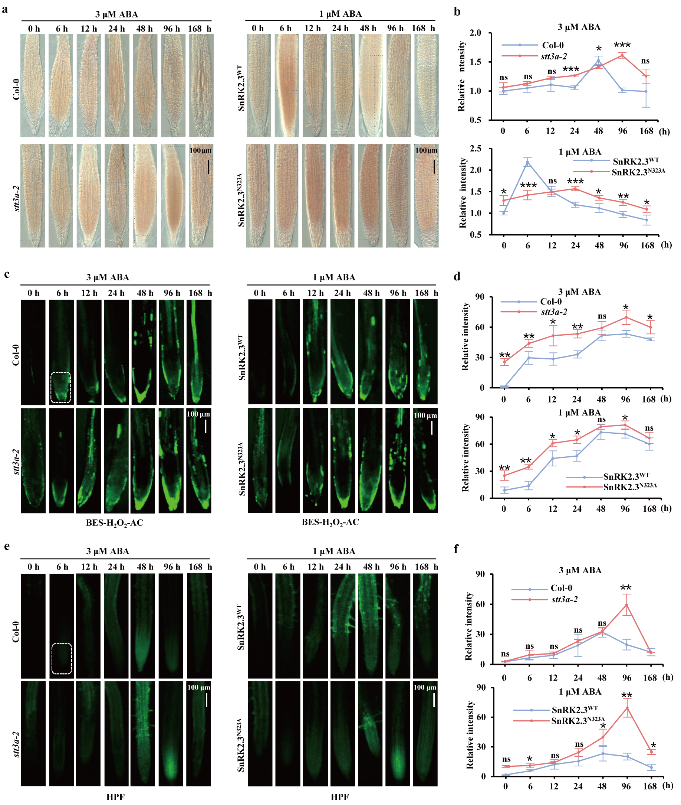
Extended Data Fig. 11 | Detection of H₂O₂.
a, b, Detection of H₂O₂ with DAB staining. (a) Col-0 and stt3a-2 are transferred to the 1/2×MS with 3 μM ABA after germination, and DAB staining is performed after growing for different periods of time. Differently, SnRK2.3^{WT}/snrk2.2/2.3 (SnRK2.3^{WT}) and SnRK2.3^{N323A}/snrk2.2/2.3 (SnRK2.3^{N323A}) are transferred to the 1/2×MS with 1 μM ABA. Scale bars, 1 cm. b, Line charts are the quantification of fig. a. n=3 plants. c-f, Roots are stained with BES- H₂O₂-Ac and 3’- (p-hydroxyphenyl) fluorescein (HPF). Col-0 and stt3a-2 are treated with 3 μM ABA. Additionally, SnRK2.3^{WT}/snrk2.2/2.3(SnRK2.3^{WT}) and SnRK2.3^{N323A}/snrk2.2/2.3 (SnRK2.3^{N323A}) are treated with 1 μM ABA. Quantification of BES- H₂O₂-Ac (d) (n=4-7 plants) and HPF (f) (n=4-7 plants) fluorescent intensity is shown. Staining intensity and fluorescent intensity are determined by ImageJ. The signal intensity at the root tip is detected within the region bordered by white dashed line. Scale bars, 1 cm. Data are presented as means ± s.d. and asterisks indicate significant differences (*P-value < 0.05, **P-value < 0.01, ***P-value < 0.001), as determined by two-tailed paired t-tests. “ns” means no significant difference.
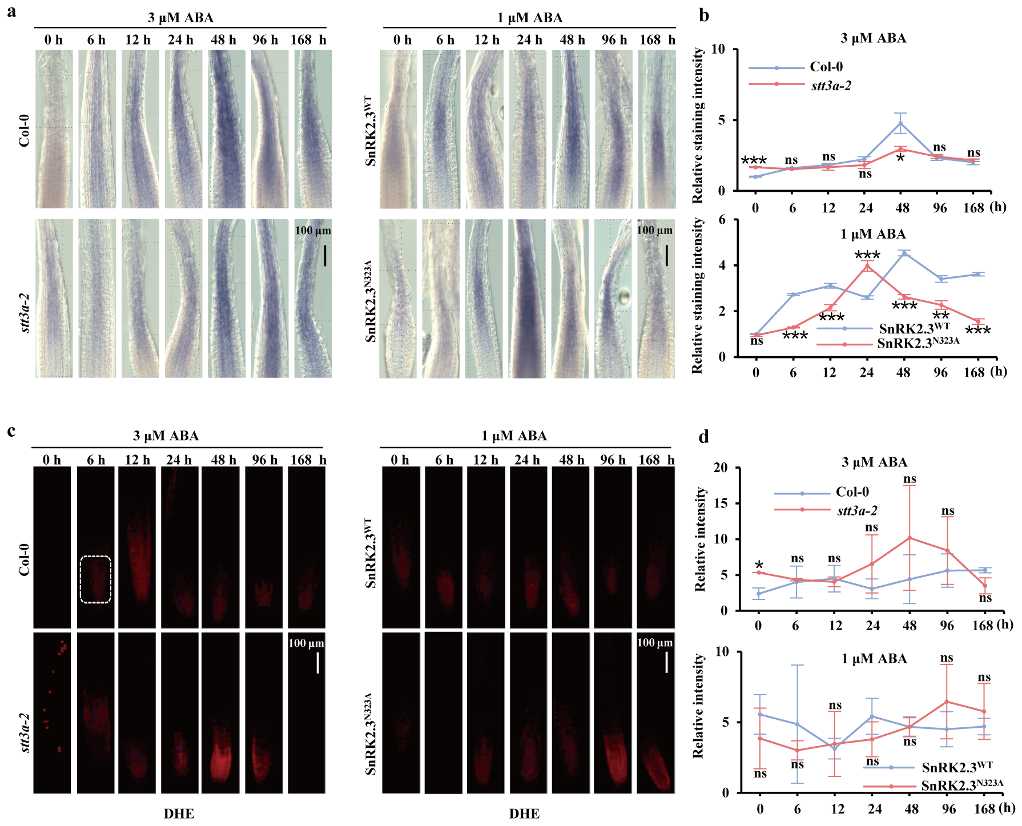
Extended Data Fig. 12 | Detection of superoxide.
a, b, Detection of superoxide (O₂^{.-}) with NBT staining. (a) Col-0 and stt3a-2 are transferred to the 1/2×MS with 3 μM ABA after germination, and NBT staining is performed after growing for different periods of time. Differently, SnRK2.3^{WT}/snrk2.2/2.3 (SnRK2.3^{WT}) and SnRK2.3^{N323A}/snrk2.2/2.3 (SnRK2.3^{N323A}) are transferred to the 1/2×MS with 1 μM ABA. (b) Graphs are the quantification of fig. a. n=3 plants. c, d, Roots are stained with dihydroethidium (DHE). Col-0 and stt3a-2 are treated with 3 μM ABA. Additionally, SnRK2.3^{WT} and SnRK2.3^{N323A} are treated with 1 μM ABA. Quantification of fluorescent intensity is shown in (d), n=4-7 plants. Staining intensity and fluorescent intensity are determined by ImageJ. Data are presented as means ± s.d. and asterisks indicate significant differences (*P-value < 0.05, **P-value < 0.01, ***P-value < 0.001), as determined by two-tailed paired t-tests. “ns” means no significant difference.
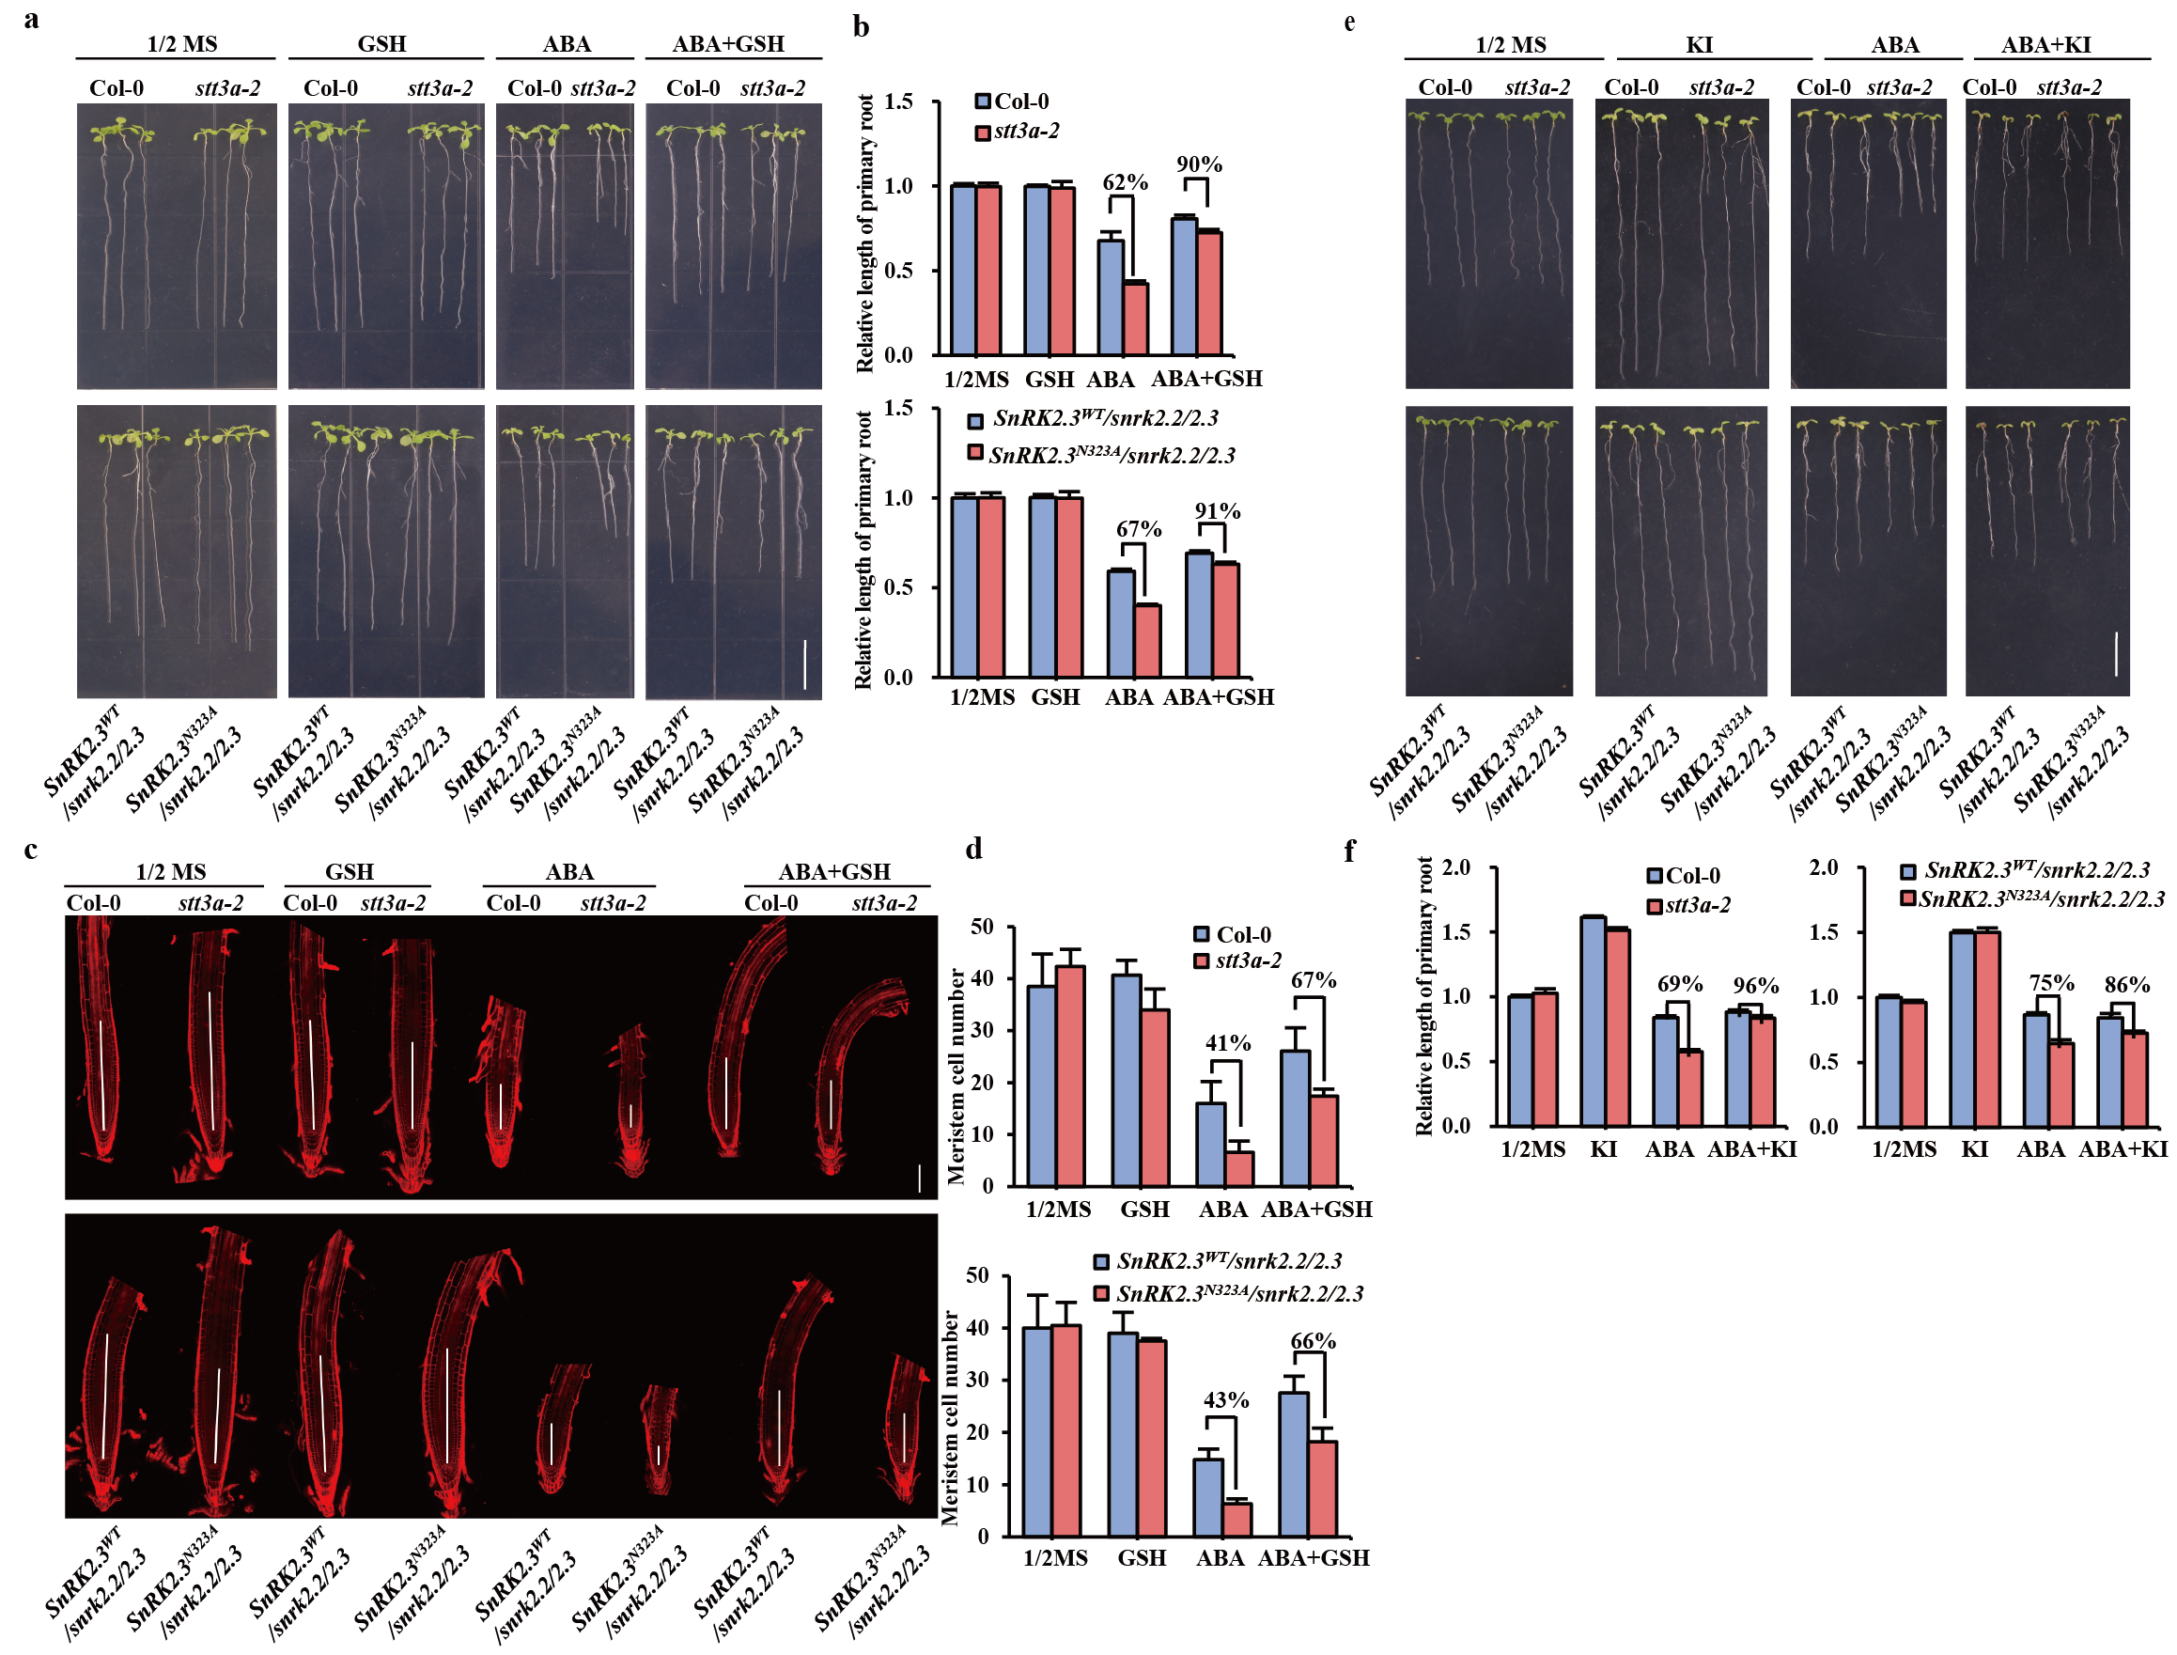Extended Data Fig. 13 | N-glycosylation SnRK2s alleviates ABA-induced growth inhibition through H₂O₂ modulation.
a, b, Root phenotypes of Col-0 and stt3a-2. Col-0 and stt3a-2 grown on 1/2×MS medium either lacking or supplemented with 3 μM ABA or 200 μM GSH. SnRK2.3^{WT}/snrk2.2/2.3 (SnRK2.3^{WT}) and SnRK2.3^{N323A}/snrk2.2/2.3 (SnRK2.3^{N323A}) grown on 1 μM ABA. Scale bars, 1 cm. b, Quantification of relative length of primary root associated with (a), n=11 plants. The length of primary root of WT (Col-0, SnRK2.3^{WT}-GFP/snrk2.2/2.3 grown on 1/2MS) was designated as 1, and the relative ratio to WT was shown for mutants and transgenic plants. c, The meristem zone (white line) with different treatment. Each root is made by joining several photographs of the same root. Scale bars =100 μm. d, Histograms show quantification of meristem cell number associated with (c), n=3-15 plants. e, Root phenotypes of Col-0 and stt3a-2 grown on 1/2×MS medium either lacking or supplemented with 3 μM ABA or 1 mM potassium iodide (KI). SnRK2.3^{WT}/snrk2.2/2.3 (SnRK2.3^{WT}) and SnRK2.3^{N323A}/snrk2.2/2.3 (SnRK2.3^{N323A}) grown on 1 μM ABA. Scale bars, 1 cm. Both SnRK2.3^{WT} and SnRK2.3^{N323A} are driven by 35S promoter. f, Quantification of relative length of primary root associated with (e), n=10 plants. Data are presented as means ± s.d. The length of primary root of WT (Col-0, SnRK2.3^{WT}-GFP/snrk2.2/2.3 grown on 1/2MS) was designated as 1, and the relative ratio to WT was shown for mutants and transgenic plants.

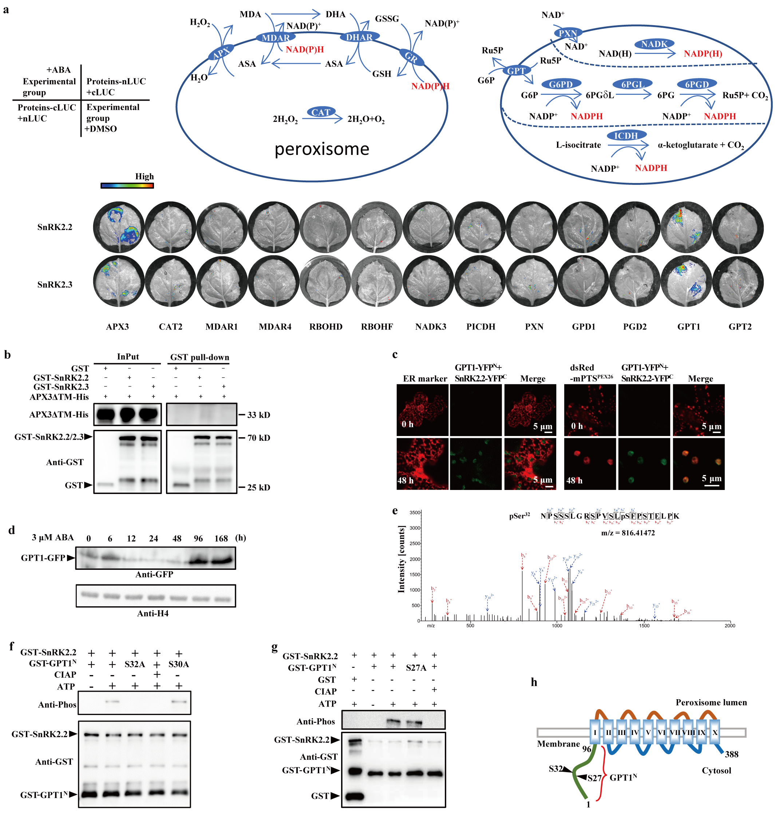
Extended Data Fig. 14 | SnRK2s interact with GPT1.
a, The interactions between peroxisomal isozymes and SnRK2s. The H₂O₂ scavenging pathway (upper, left) and NADPH generation pathway (upper, right) are shown. LCI assays showed the binding activities between peroxisomal isozymes and SnRK2s with or without ABA treatment.50 μM ABA was injected into leaves (0.05% DMSO as control) after 12 hours of GV3101 infection. b, Pull-down assay using recombinant GST-SnRK2s and APX3ΔTM-His. GST-SnRK2s and APX3ΔTM-His are mixed and incubated for 4 hours, followed by Western blot analysis using indicated antibodies. c, BiFC assays demonstrated the interactions between GPT1 and SnRK2.2 on the peroxisomal membrane. CD3-959 was used as ER marker and dsRed-mPTS^{PEX26} was used as a peroxisome membrane marker. 50 μM ABA was used. Scale bars, 5 μm. d, The time-course expression pattern of GPT1 protein. Total proteins were extracted from the 4-day-old seeding treated with 3 μM ABA over time, followed by immunoblotting analysis with the anti-GFP antibodies. e, Identification of SnRK2.2 phosphorylation sites on GPT1 by LC-MS/MS. Ser32 was identified as a potential phosphorylation site of GPT1. f, g, Phosphorylation analysis of GPT1. GST-SnRK2.2 and GST-GPT1^{N} (or S32A, S30A, S27A) proteins were incubated with purified GST-SnRK2.2 in phosphorylation buffer, followed by SDS–PAGE separation detection with the indicated antibodies. h, Topology model of GPT1 with the N-terminal (green) and arrows indicate positions of serine residues, Ser (S27) and Ser (S32). The membrane domains are depicted as barrels (Roman numerals) connected by hinge regions (brown, blue). The N-terminal end (1-96 AA) of GPT1 (GPT1^{N}) was used for phosphorylation assay in (f) and (g).
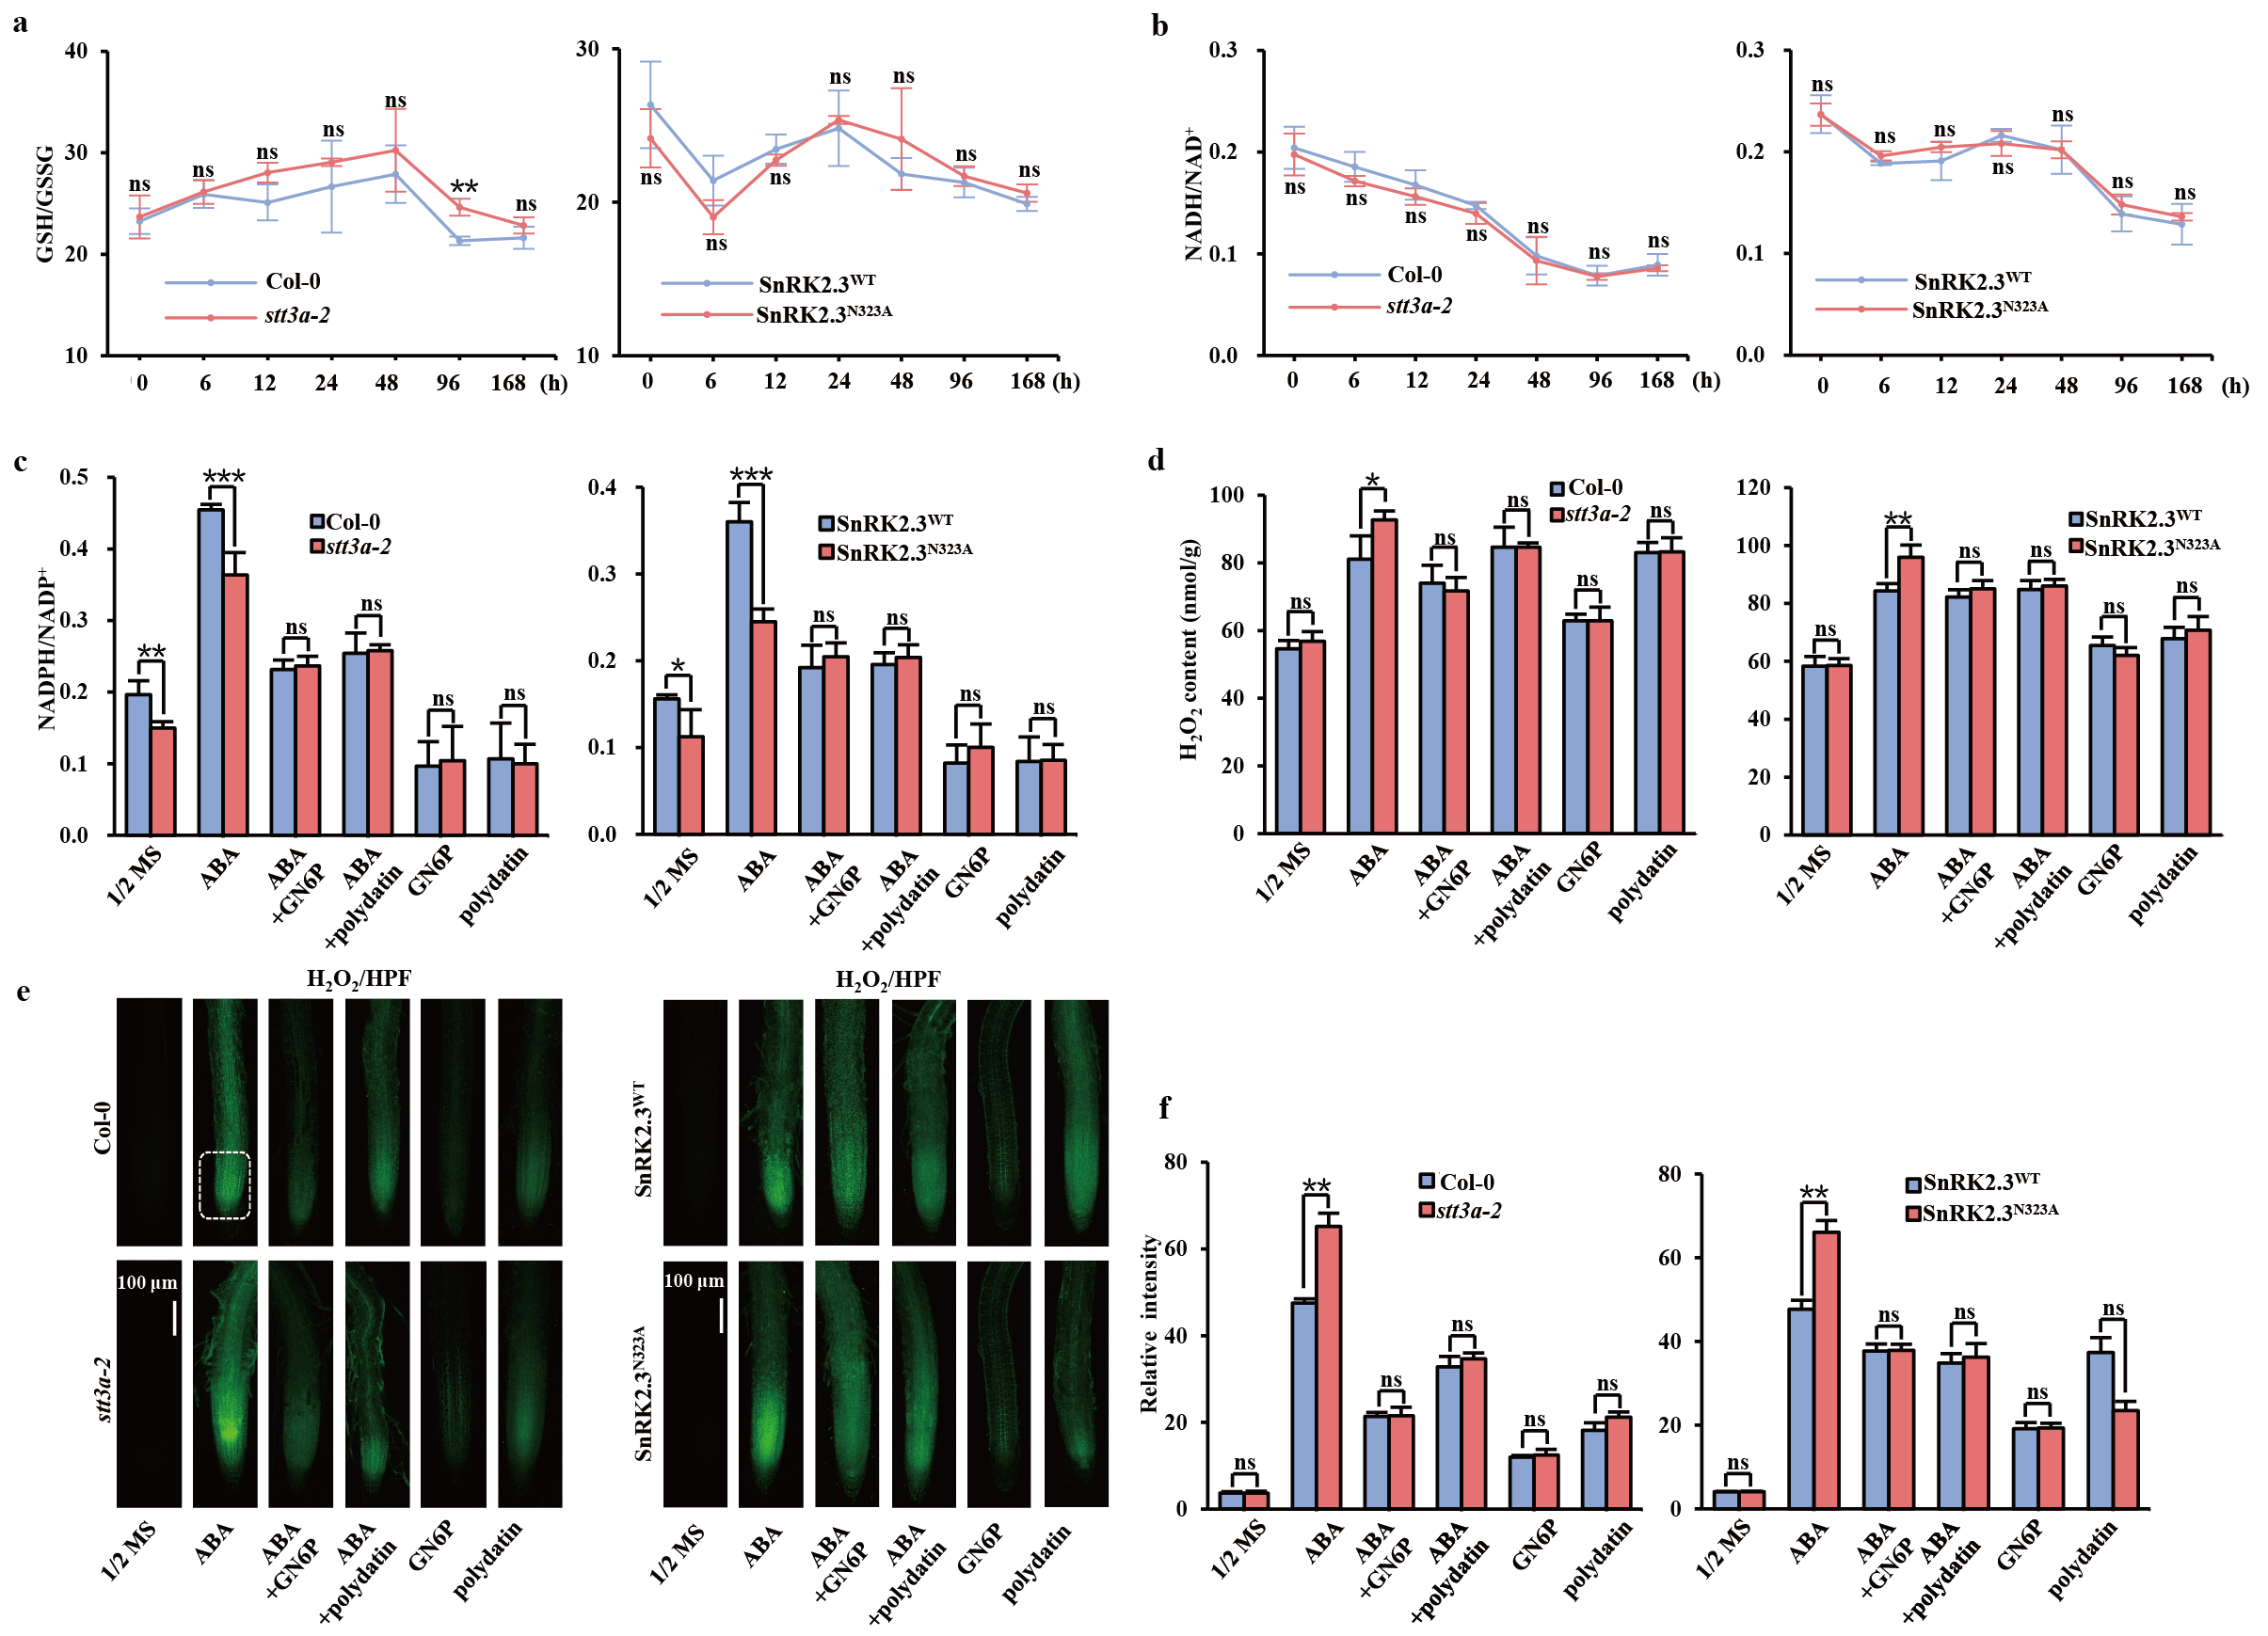Extended Data Fig. 15 | N-glycosylation of SnRK2s regulate NADPH accumulation through OPPP activity.
a, b, Measurement of GSH/GSSG and NADH/NAD⁺. After 4 days of growth, the Col-0 and stt3a-2 are treated with 3 μM ABA for the corresponding time periods, and the SnRK2.3^{WT} and SnRK2.3^{N323A} transgenic plants ware treated with 1 μM ABA. After 7 days, roots ware collected for quantification of levels of H₂O₂ and NADPH/NADP⁺. c, d, Measurement of NADPH/NADP⁺and H₂O₂. Col-0, stt3a-2, SnRK2.3^{WT} and SnRK2.3^{N323A} ware grown on the 1/2 MS medium with pentose phosphate pathway inhibitors (3 μM GN6P, 10 μM polydatin). After 7-days-treatment, roots ware collected for measurement of H₂O₂ and NADPH/NADP⁺. e, f, HPF staining for H₂O₂ quantification. Fluorescent intensity was determined by ImageJ. Data are presented as means ± s.d. n=10-20 plants. Asterisks indicate significant differences (*P-value < 0.05, **P-value < 0.01, ***P-value < 0.001), as determined by two-tailed paired t-tests. “ns” means no significant difference.
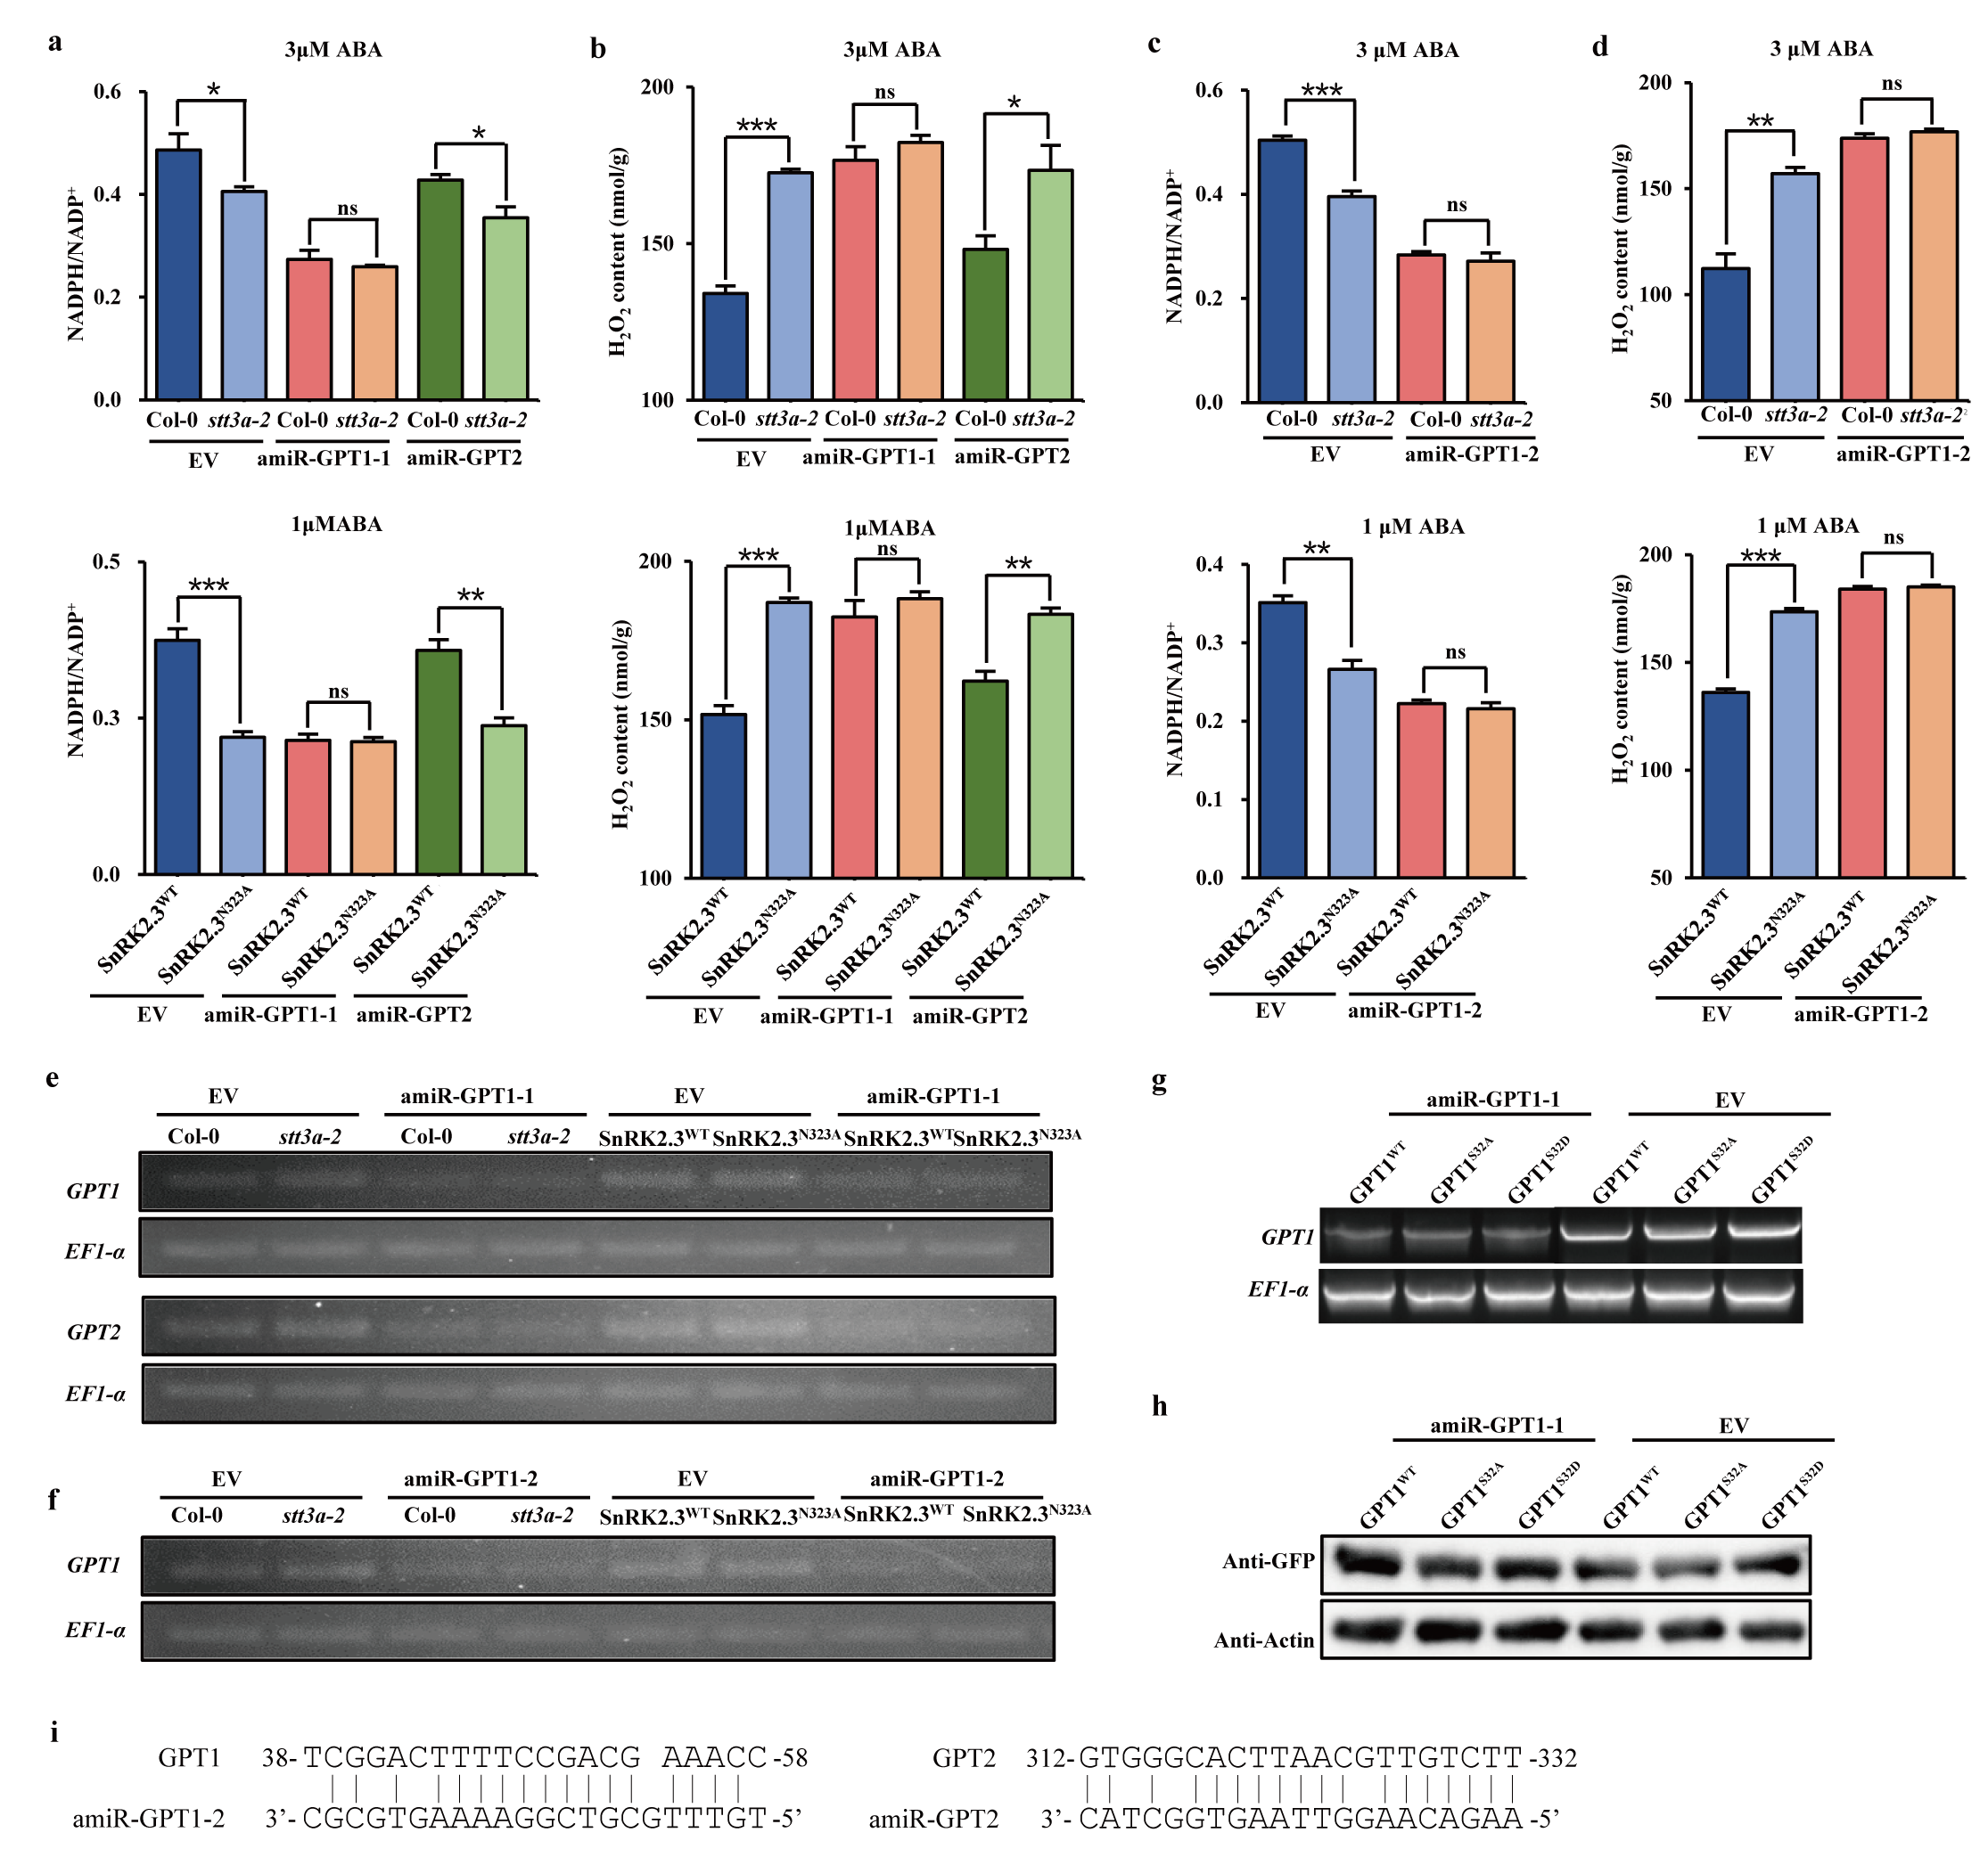
Extended Data Fig. 16| SnRK2-GPT1 controls NADPH accumulation during prolonged ABA signalling.
a-d, Measurement of H₂O₂ and NADPH/NADP⁺. amiR-GPT1 (artificial miRNA for endogenous GPT1 silencing) was expressed in hairy roots of Col-0, stt3a-2, SnRK2.3^{WT}/snrk2.2/2.3 (SnRK2.3^{WT}) and SnRK2.3^{N323A}/snrk2.2/2.3 (SnRK2.3^{N323A}). After ABA treatment, hairy roots ware collected for measurement of H₂O₂ and NADPH/NADP⁺. Artificial miRNA Expression Vector (EV) and amiR-GPT2 ware used as negative controls. Data are presented as means ± s.d. and asterisks indicate significant differences (*P-value < 0.05, **P-value < 0.01, ***P-value < 0.001), as determined by two-tailed paired t-tests. “ns” means no significant difference. e-g, RT-PCR analysis of the gene (GPT1 and GPT2) transcripts in hairy roots. EF-1α was used as a loading control. h, Detection the protein quality of GPT1^{mutant}-GFP. Total proteins ware extracted from hairy roots, followed by immunoblotting analysis with the anti-GFP antibodies. Actin was used as control. i, Target sites of amiR-GPT1-2 and amiR-GPT2.
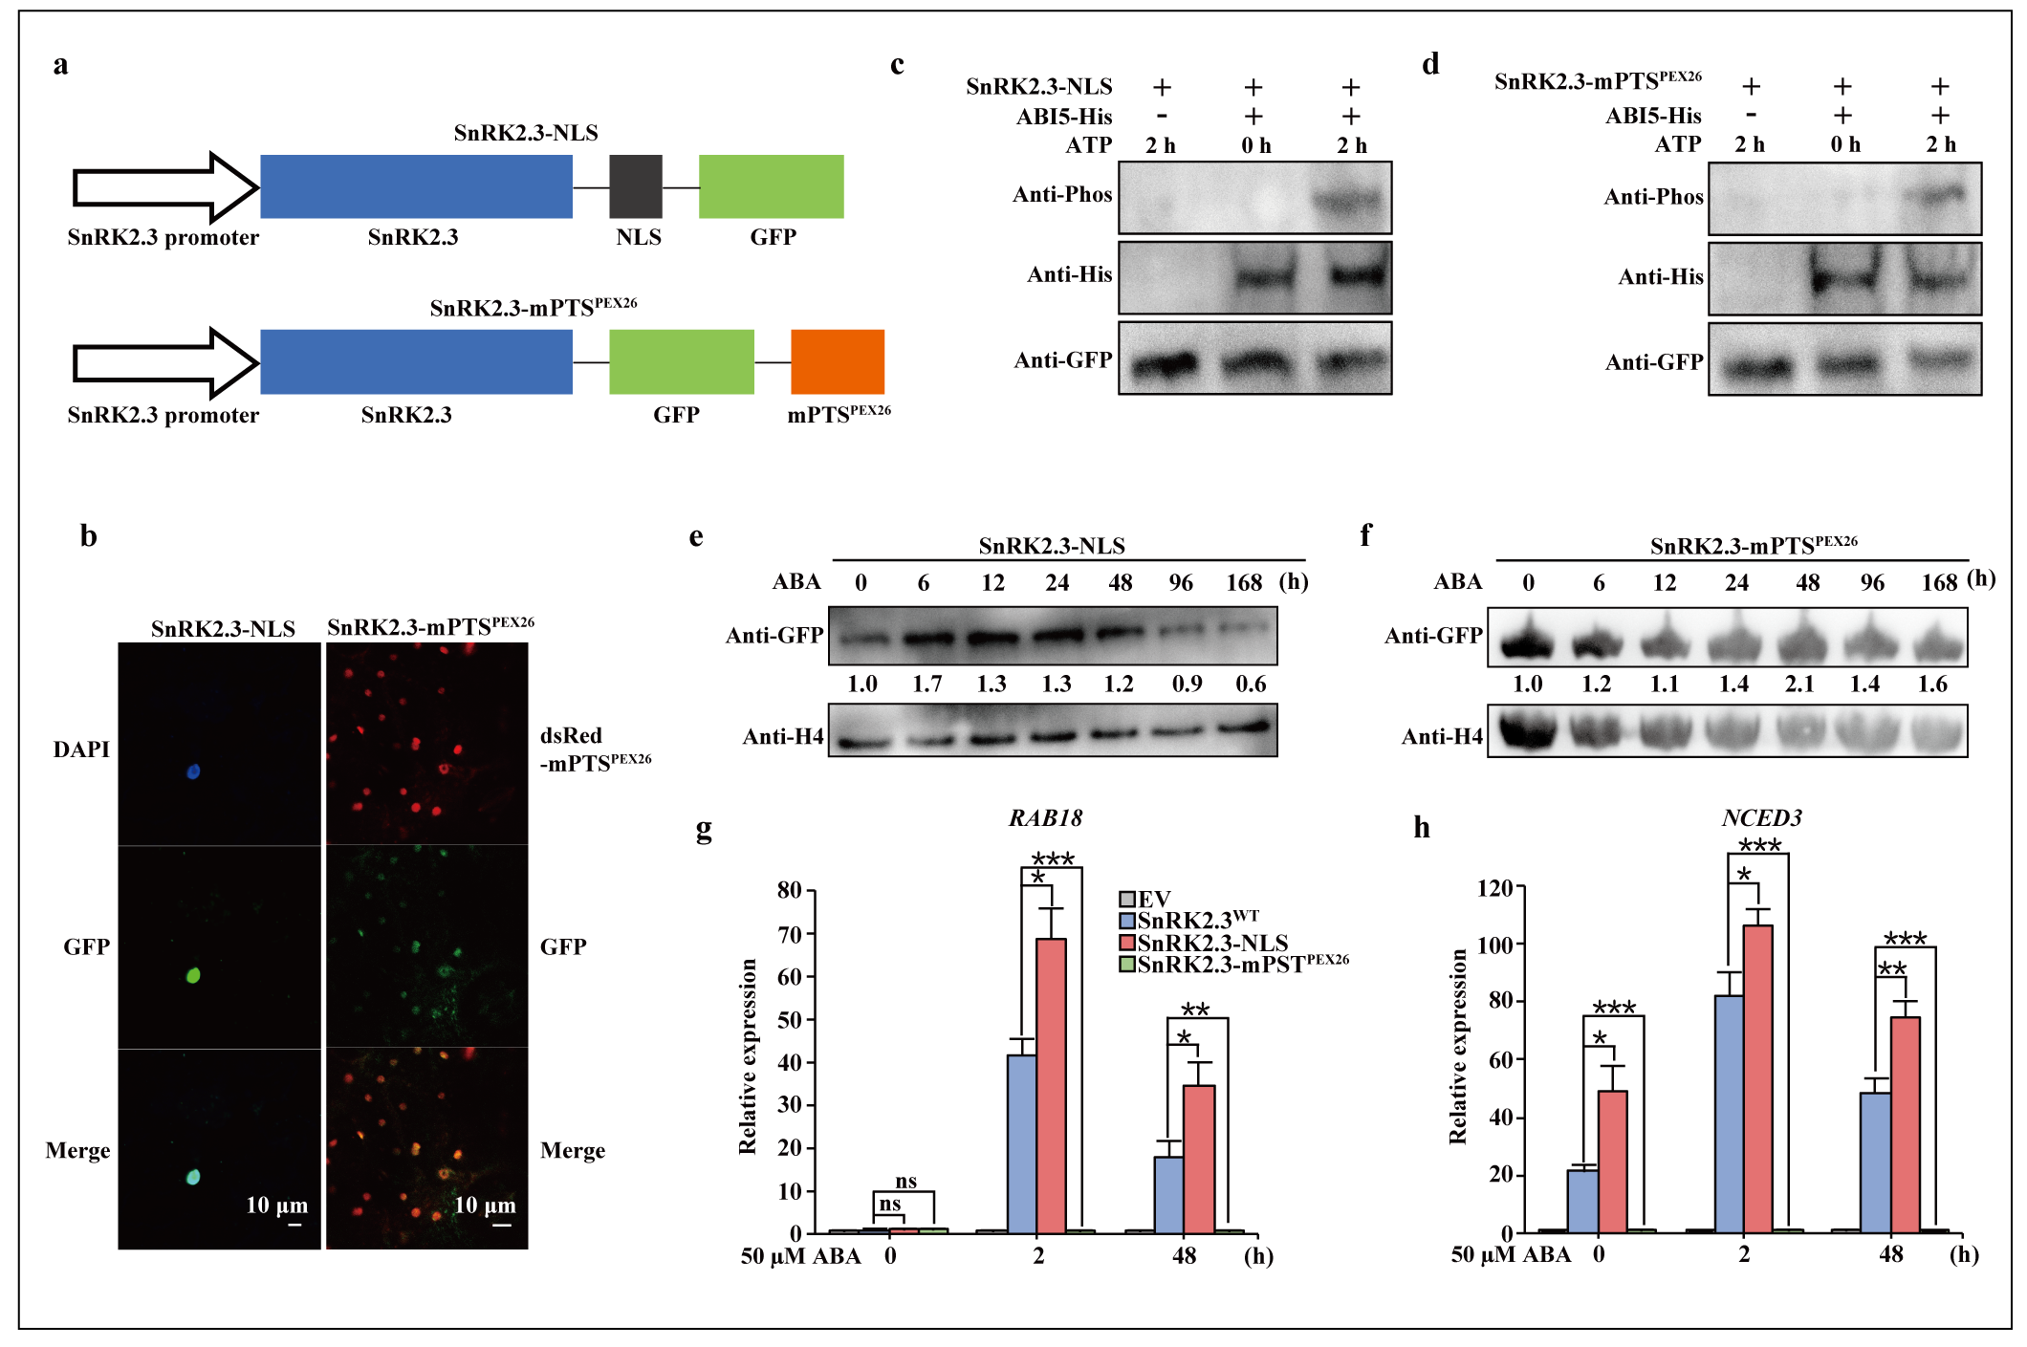
Extended Data Fig. 17 | The nuclear SnRK2.3-NLS and peroxisomal SnRK2.3-mPTS^{PEX26}.
a, Schematic presentation of structures of SnRK2.3-NLS and SnRK2.3-mPTS^{PEX26}. b, Subcellular localization of SnRK2.3-NLS-GFP and SnRK2.3-mPTS^{PEX26} in tobacco leaves. After 48 h of 50 μM ABA treatment, the subcellular localization of the protein was observed. DAPI was used to indicate the cell nucleus and dsRed-PEX26 was used as peroxisomal marker. Scale bars, 10 μm. c, d, Detection of protein kinase activity. SnRK2.3-NLS and SnRK2.3-mPTS^{PEX26} were expressed in snrk2.2/2.3 hairy roots, respectively. Proteins were extracted from hairy root treated with 50 μM ABA for 2 h and followed by immunoprecipitation with GFP-Trap agarose. ABI5-His were incubated with SnRK2.3-NLS (c) and SnRK2.3-mPTS^{PEX26} (d) in phosphorylation buffer, followed by SDS–PAGE separation detection with the indicated antibodies. e, f, The time-course expression pattern of SnRK2.3-NLS (d) and SnRK2.3-mPTS^{PEX26} (e). Total proteins were extracted from snrk2.2/2.3 hairy roots treated with 1 μM ABA over time, followed by immunoblotting analysis with the anti-GFP antibodies. g, h, The expression levels of RAB18 and NCED3. SnRK2.3^{WT}, SnRK2.3-NLS, SnRK2.3-mPTS^{PEX26} were expressed in snrk2.2/2.3 hairy roots, respectively. Both SnRK2.3^{WT}, SnRK2.3-NLS and SnRK2.3-mPTS^{PEX26} were driven by native promoter (2020 bp upstream sequences of the SnRK2.3 coding region). After ABA treatment, hairy roots ware collected for RNA extraction. EV (pMDC107 vector) was used as negative controls. Data are presented as means ± s.d. and asterisks indicate significant differences (*P-value < 0.05, **P-value < 0.01, ***P-value < 0.001), as determined by two-tailed paired t-tests. “ns” means no significant difference.
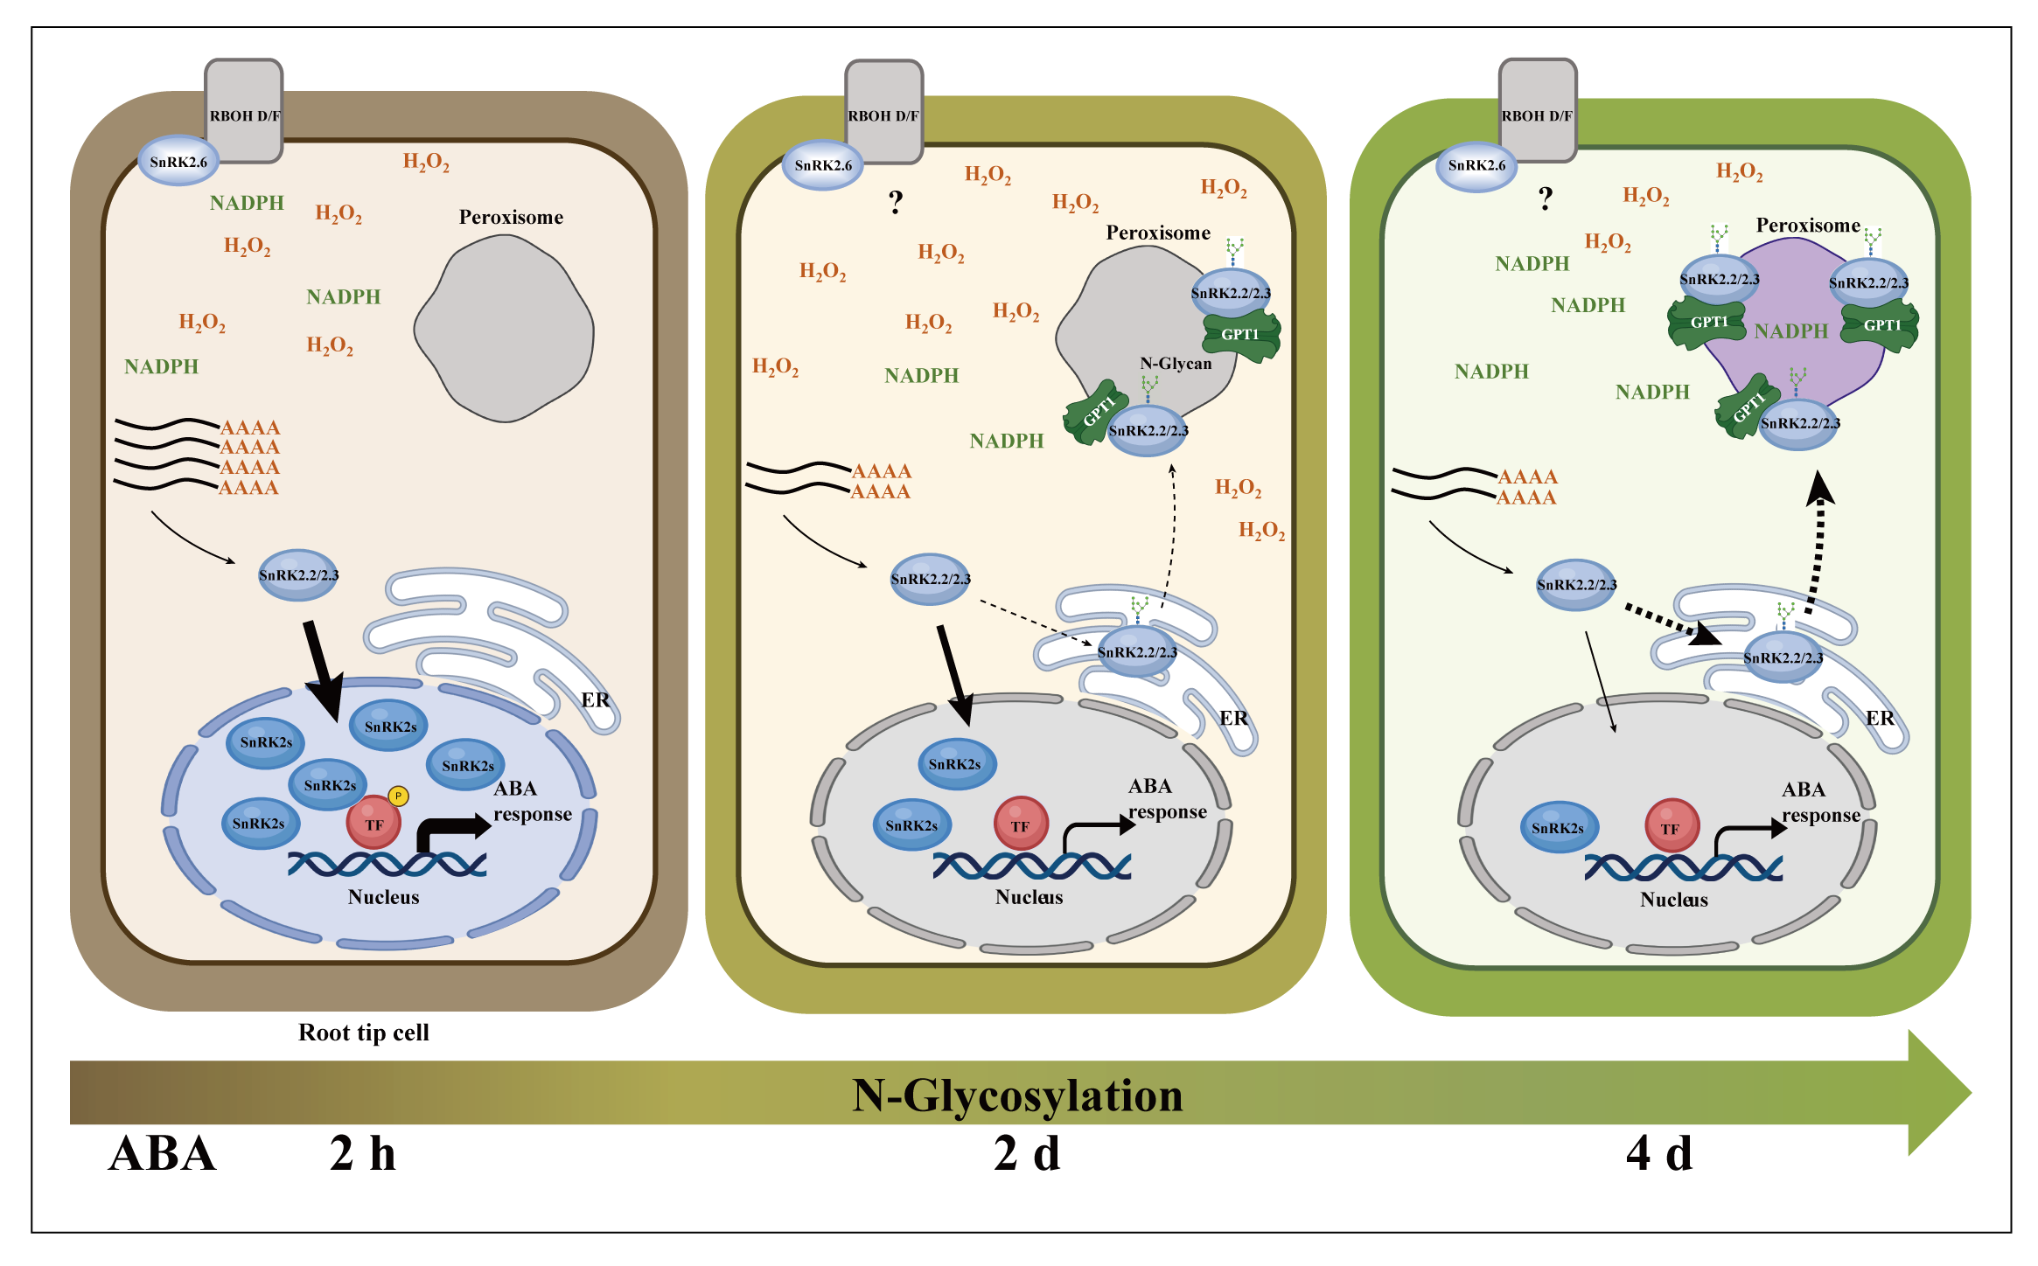Extended Data Fig. 18 | N-glycosylation of SnRK2s controls the switch from transcriptional regulation to NADPH maintenance during prolonged ABA signalling.
A working model for N-glycosylation of SnRK2s regulating NADPH maintenance in Arabidopsis root tip cells. Under short-term ABA treatment (such as 2 h), SnRK2.2/2.3/2.6 (SnRK2s) are translated in cytoplasm, then they are distributed into the nucleus to activate ABA response by phosphorylating transcription factors, which may also activate the first phase of NADPH accumulation (Fig. 4d) in an unknown mechanism. SnRK2.6 is also distributed on the plasma membrane and interacts with NADPH oxidases RBOH D/F to activate H₂O₂ signalling. Under long-term ABA treatment (such as 2 d, 4 d), Synthesised SnRK2.2/2.3 are N-glycosylated in the ER during prolonged ABA signalling, which orchestrates the gradual redistribution of SnRK2.2/2.3 onto the peroxisomal membrane, indirectly leading to less nuclear SnRK2.2/2.3 distribution and desensitization of the transcriptional response in the nucleus. Peroxisomal SnRK2.2/2.3 interact with GPT1 to enhance OPPP activity in control of NADPH maintenance in the peroxisomes (the second phase of NADPH accumulation in Fig. 4d), which rebalances the redox in the cell to improve plant survival under long-term stress.

