Metal(loid) pollution of agricultural soils downstream of a lead-zinc mine in southwest China: comprehensive evaluation of risks to food production and human health

Peiyu Zhang ^{a, b}, Wenyong Wang ^{b}, Xingyang Li ^{b}, Ting Gao ^{b}, Benle Liu ^{b}, LonghuaWu ^{b}, Changyin Tan ^{a,∗}, Peter Christie ª

ª College of Geographical Sciences, Hunan Normal University, Changsha 410081, China
^{b} CAS Key Laboratory of Soil Environment and Pollution Remediation, Institute of Soil Science, Chinese Academy of Sciences, Nanjing 210008, China
* Corresponding author.
E-mail address: chytan@hunnu.edu.cn (Changyin Tan)

1. Evaluation Index

1.1 Contamination factor
The Contamination factor (CF) was proposed by Hakanson (Hakanson, 1980; Rehman, et al., 2018). This is the ratio of the concentration of a specific metal(loid) in the soil to its background value. According to the value of the pollution index, the pollution types are classified into: CF < 1 (low contamination), 1 < CF < 3 (moderate contamination), 3 < CF < 6 (considerable contamination) and CF > 6 (very high contamination). The calculation formula is as follows:
$CF=\frac{C_{(metal(loid))}}{C_{(bacground)}}$ （1）

1.2 Geo-accumulation index
According to Muller (Rehman, et al., 2018) the index of geo-accumulation (Igeo) can be calculated by the following Eq：
$Igeo=\log_{2}(\frac{C_{n}/C_{Fe}}{{1.5∗B}_{n}/C_{Fe}})$ （2）
where, $C_{n}$ and $B_{n}$ respectively represent the calculated concentration of the element and the geochemical background concentration of the corresponding element. Different researchers have used various conservative elements such as aluminum (Al), silicon (Si), and iron(Fe) (Nazeer, Hashmi, & Malik, 2014). However, here, in order to normalize the metal(loid)s, Fe was used as a reference element. According to the index the pollution levels were divided into seven grades: Igeo ≤ 0 (Unpolluted), 0 < Igeo ≤ 1 (Unpolluted to moderately polluted), 1 < Igeo ≤ 2 (Moderately polluted), 2 < Igeo ≤ 3 (Moderately to heavily polluted), 3 < Igeo ≤ 4 (Heavily polluted), 4 < Igeo ≤ 5 (Heavily to extremely polluted), Igeo > 5 (Extremely polluted).

1.3 Agricultural Product Safety Index (APSI)
Here, the agricultural product index (APSI) - hereinafter referred to as Index (I) - was used to evaluate the safety of regional agricultural production. The index can be calculated as follows Eq:
$APSI_{ij}=C_{ij}/C_{Bij}$ (3)
Where j is the metal(loid), i represents the type of plant (agricultural production), $APSI_{ij}$ represent the agricultural product safety index of the metal(loid) element j for plant i, $C_{ij}$ is the content value (mg kg⁻¹) of the metal(loid) element j in the plant i and $C_{bij}$ is the contaminant limit value (mg kg⁻¹) of the metal(loid) element j in agricultural production i. The contaminant limit values are from the Chinese National Food Safety Standards (GB2762-2017), the values are shown in Table 1. In this study the average metals Cd and Pb within agricultural production were used to calculate the corresponding APSI. If the index of $C_{ij}$ > 1, it means that the metal(loid) content exceeds the limit value in food, and there is a food safety risk.
Enrichment Factor (EF) is the ratio of the concentration of a pollutant in an organism to its living environment.
${EF}_{i}=C_{P}/C_{b}$ (4)
Where i is the metal(loid) element, $C_{p}$ represents the content of i in plant (agricultural production), $C_{b}$ represent the content of i in soil.
Transport Coefficient (TC) refers to the ratio of the metal(loid) content in the aboveground parts of the plant to the underground parts.
${TC}_{i}=C_{G}/C_{B}$ (5)
Where i is the metal(loid) element, $C_{G}$ represents the content of i in the aboveground parts of the plant, $C_{B}$ represents the underground parts of the plant.

1.4 Potential ecological risk index
This ecological risk model was proposed by Hakanson (1980) and Wu et al. (2015) to assess pollution categories in soil based on metal(loid) toxicity and environmental response. Its main function was to identify the types of pollutants and prioritize research on pollution. In the current study, soil potential ecological risk index (PERI) has been assessed based on the total content of metal(loid)s that have been selected (Huang, et al., 2018; Sharifinia, Taherizadeh, Namin, & Kamrani, 2018).
$PERI=\sum_{i=1}^{n}{Eri}$ （6）
$Eri=Tr∗CF$ （7）
When PERI was determined as "the sum of all the risk values of all metal(loid)s in the soil and $E_{ri}$ was regarded as the "single element ecological risk value, CF was regarded as a contamination factor, and $T_{r}$ is called a toxic/lethal response value. It calculates the potential threats caused by metal(loid) pollution by expressing the deadline for specific metal(loid)s and the sensitivity of the environment to pollutants. According to Rehman (Rehman, et al., 2018) and Hakanson (Hakanson, 1980; Xiaoqing Kan, 2021), $T_{r}$ (toxic/lethal response values) of Cd, Cr, Cu, Ni, Zn, Pb and As were 30, 2, 5, 5, 1, 5 and 10 respectively. The pollution grades corresponding to the different values of the index are shown in Table 2.

1.5 Human health risk assessment

1.5.1 Human exposure and health risk assessment
The non-cancer and cancer risks caused by soil metal(loid) pollution exposure were calculated based on the total content of selected metal(loid) (Cheng, et al., 2018; Shi, et al., 2020; Zhang, O'Connor, Xu, & Hou, 2020). The formulas used here to evaluate the interaction between humans and metals are based on the literature and programs/strategies developed by USEPA (Kan, et al., 2021). Metal(loid) contact may occur in three main ways: (a) breathing air particles inward through the nose and mouth; (b) through the skin attaching elemental particles of exposed areas, called "skin absorption", and (c) ingesting deposited particles. Here, three exposure routes related to soil metal(loid)s were explored: oral, skin contact and inhalation. The research subjects were divided into children (age 0-18 years) and adults (age > 18 years). The average daily intake of metal(loid)s (ADI) was calculated using the following formulas.
${ADI}_{ing}=\frac{C∗IngR∗ED∗EF∗FI}{BW∗AT}$ *10⁻⁶ （8）
${ADI}_{dermal}=\frac{C∗SA∗AF∗ABF∗ED∗EF}{BW∗AT}$ *10⁻⁶ （9）
${ADI}_{inh}=\frac{C∗ET∗EF∗ED}{PEF∗BW∗AT}$ （10）
According to USEPA (USEPA, 1989, 2009，2011), where IngR is ingestion rate of soil, C is the value (mg kg⁻¹) of each toxic metal(loid), and EF and ED are exposure frequency and exposure duration, respectively. FI is the factor ingested from the contamination source, PEF is the particle emission factor, BW is the average body weight, AT is the average time of exposure to contaminated soil, SA is the exposed skin area, AF is the adherence factor, ABF is the dermal adsorption factor, and ET is the exposure time. The values of these parameters are shown in Table $3$.

1.5.2 Non-carcinogenic and carcinogenic risk assessment
Soil intake was selected as the priority exposure route for potentially toxic elements to the human body. By comparing the exposure (oral soil/dust intake) of a period with the reference dose (${RfDi}_{i}$) in a similar exposure period, assessing the potential non-carcinogenic of a certain metal(loid). This ratio is called the hazard quotient (HQ) (Li, Lin, Cheng, Duan, & Lei, 2015; Kan, et al., 2021).
${HQ}_{i}=\sum{\frac{{ADD}_{i}}{{RfD}_{i}}}$ （11）
where, ${RfD}_{i}$ is the reference dose of each metal(loid) under different exposure routes (mg kg⁻¹ day⁻¹; Table $4$). In order to assess the overall non-carcinogenic risk of multiple substances and multiple exposure routes, the hazard index (HI) was calculated by formula (10).
$HI=\sum{{HQ}_{i}}$ （12）
When HI < 1, there may not be a non-carcinogenic risk, and a HI value ≥ 1 indicates a potential non-carcinogenic effect (Xiao, et al., 2020).
In addition, due to the contact and absorption of metal(loid)s in the human body and the environment, metal(loid)s in the environment also have a carcinogenic risk to the human body. The risk of cancer is considered to be the possibility of cancer in life (Li, et al., 2015). The following equation was used to calculate the carcinogenic risk of toxic metal(loid)s in a lifetime
$CR=\sum{{ADD}_{i}∗{SF}_{i}}$ （13）
${SF}_{i}$ is the carcinogenic slope factor of a certain metal(loid) elements (unit mg kg⁻¹ day⁻¹; Table $4$). This value transfers the estimated daily intake of pollutants throughout the life cycle to the individual’s increased risk of cancer. A risk higher than 1 × 10⁻⁴ is considered unacceptable, a risk value < 1 × 10⁻⁶ indicates no significant health hazards, and a value between 1 × 10⁻⁴ and 1 ×1 0⁻⁶ is regarded as an acceptable or tolerable carcinogenic risk (Xiao, et al., 2020).

Table 1 The contaminant limits values of the Chinese National Food Safety Standards (GB2762-2017) in different agricultural products.
Table 2 Ecological Risk Grades according to the Ecological Risk Index (Eri) and Potential Ecological Risk Index (PERI).
Table 3 Parameters used in the health risk assessment.
Table 4 Reference dose (RfD) and slope factor (SF) of metal(loid)s for health risk assessment.

Table S₁ contaminant limits values of the Chinese National Food Safety Standards (GB2762-2017) in different agricultural products
Agricultural product | Element
Agricultural product | Cd (mg kg⁻¹) | Pb (mg kg⁻¹) | Zn (mg kg⁻¹)
Banana | 0.05 | 0.1 | —
Tangerine | 0.05 | 0.1 | —
Peanut | 0.5 | 0.2 | —
Bean | 0.2 | 0.2 | —
Ginger | 0.1 | 3 | —
Garlic | 0.1 | 3 | —
Mango | 0.05 | 0.1 | —
Sweet potato | 0.1 | 0.2 | —
Corn | 0.1 | 0.2 | —
Grapefruit | 0.05 | 0.1 | —
Loquat | 0.05 | 0.1 | —

Table S2 Ecological Risk grades according to the Eri and PER
Grade | Value of Eri | Potential Ecological Risk | Grade | Value of PERI | Soil contamination degree
1 | Eri < 40 | Low ecological risk | 1 | PERI < 95 | Low ecological risk
2 | 40 ≤ Eri < 80 | Moderate ecological risk | 2 | 95 ≤ PERI < 190 | Moderate ecological risk
3 | 80 ≤ Eri < 160 | Considerable ecological risk | 3 | 190 ≤ PERI < 380 | Considerable ecological risk
4 | 160 ≤ Eri < 320 | High ecological risk | 4 | PERI > 380 | Very high ecological risk
5 | Eri ≥ 320 | Very serious ecological risk

Table S₃ Parameters used in the health risk assessment
Parameter | Description | Unit | Value | Reference
EF | exposure frequency | day/year | 350 | (Chen et al., 2019; Xiaoqing Kan, 2021)
IngR | ingestion rate of soil | Mg/day | 200 for children  100 for adults | (Xiaoqing Kan, 2021; Yang et al., 2019)
ED | exposure duration | years | 6 for children  24 for adults | (MEP, 2014)
FI | factor ingested from contamination source | unitless | 1 | (Xiaoqing Kan, 2021)
PEF | particle emission factor | m³/kg | 1.36×10⁹ | (USEPA, 2011)
BW | average body weight | kg | 29 for children  70 for adults | SEPAC (2013)
AT | average time of exposure to contaminated soils | day | 365×ED（non-carcinogenic）  365×76.6（carcinogenic） | (MEP, 2013; Xiaoqing Kan, 2021)
SA | exposed skin area | m² | 2800 for children  5700 for adults | (Huang et al., 2020)
AF | adherence factor | mg/cm² h | 0.2 for children  0.07 for adults | (Xiaoqing Kan, 2021)
ABF | dermal adsorption factor | - | 0.001（non-carcinogenic）  0.01（carcinogenic） | (USEPA, 2011)
ET | exposure time | h/day | 8 | (Xiaoqing Kan, 2021)

Table S4 Reference dose (RfD) and slope factor (SF) of metal(loid)s in health risk assessment
Element | Ing RfD | Dermal RfD | Inhalation  RfD | Ing SF | Dermal SF | Inhalation  SF | Reference
As | 0.0003 | 0.000123 | 0.0003 | 1.5 | 3.66 | 15.1 | USEPA(2001)
Cd | 0.001 | 0.00001 | 0.00001 | 6.1 | 6.1 | 6.3 | USEPA(2011)
Cr | 0.003 | 0.00006 | 0.0000286 | 0.5 | 20 | 42 | Huang (2020)
Cu | 0.04 | 0.012 | 0.0402 | 1.7 | 42.5 | — | USEPA(2001)
Hg | 0.0003 | 0.000021 | 0.0000857 | — | — | — | USEPA(2001)
Ni | 0.02 | 0.0054 | 0.00009 | 1.7 | 42.5 | 0.84 | USEPA(2001)
Pb | 0.0035 | 0.000525 | 0.00352 | — | — | — | USEPA(2001)
Zn | 0.3 | 0.06 | 0.3 | — | — | — | USEPA(2001)

2. Supplementary figure and table
Table S1. Environmental survey data in 1998 and 2011
SF.1 Evaluation index and evaluation system.
SF.2 Boxplots of the surface soil metal(loid) concentrations (mg kg⁻¹) in different regions.
SF.3 Distribution of different Contamination Factor grades (%).
SF.4 Distribution of different ecological risk index and potential ecological risk index grades (%).
SF.5 The mean values of the non-carcinogenic hazard index (HI: Tal) and Hazard quotient (HQ) in different regions.
SF.6 The mean of Carcinogenic Risk (CR) in different regions.

Table S1. Environmental survey data in 1998 and 2011
 | investigation of 1998 |  | investigation of 2011
Elements | Water of Daqiao reiver | Regional soil | Fluvial sediment
Cd | 32.0-76.2 | 0.93-6.67 | 0.53
Pb | 2.97-33.8 | 63.0-178 | 5.99
Zn | 1.22-3.35 | —— | 23.9
Hg | —— | —— | 2.15
As | —— | —— | 5.01
Note: display with multiples of the national Standard Value.

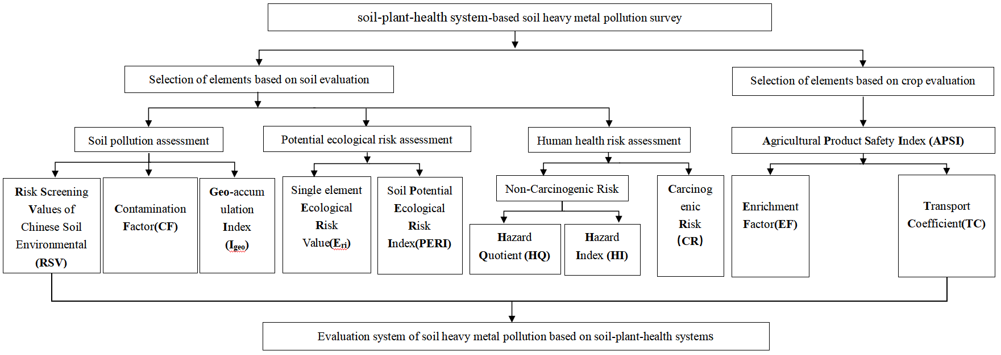
SF. 1 Evaluation index and evaluation system

SF.2 Boxplots of the surface soil metal(loid) concentrations (mg kg⁻¹) in different regions.

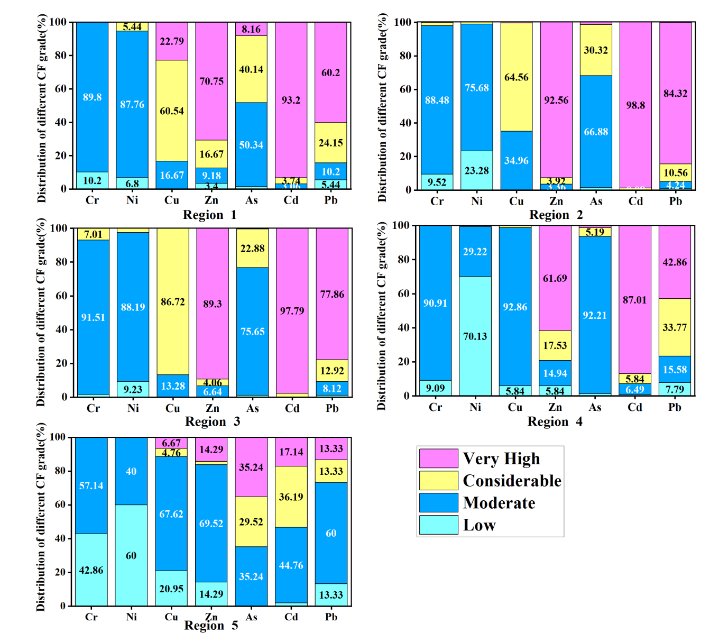
SF. 3 Distribution of different Contamination Factor grades (%).
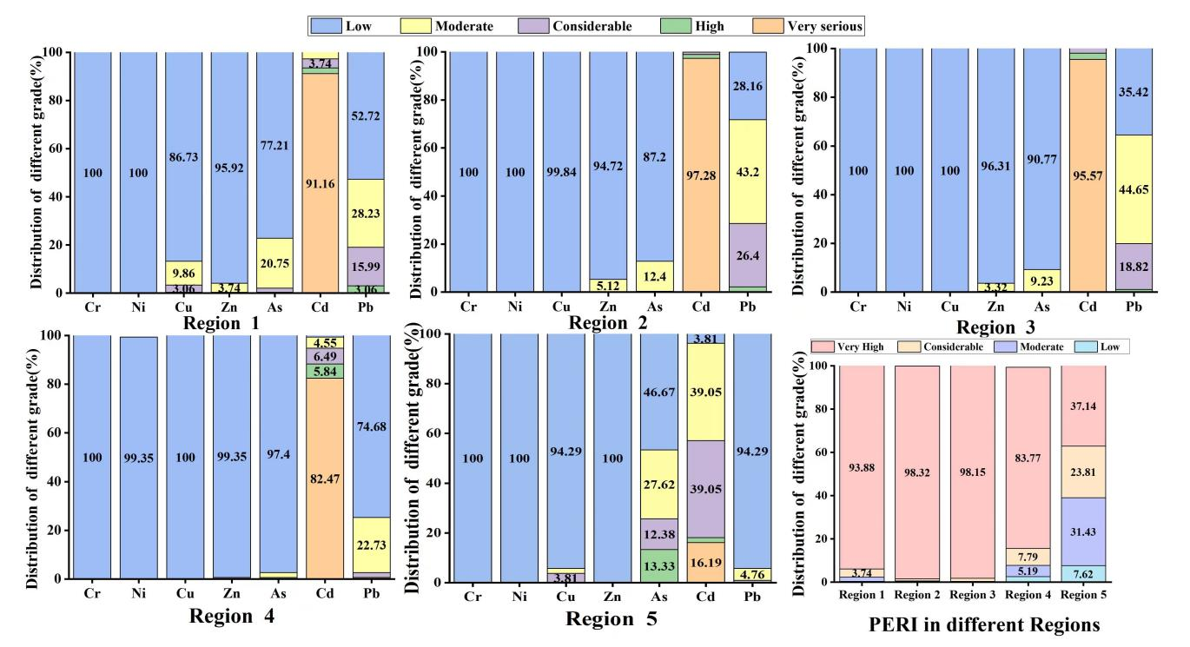
SF. 4 Distribution of different ecological risk index and potential ecological risk index grades (%).
SF. 5 Mean non-carcinogenic hazard index (HI: Tal) and Hazard quotient (HQ) in different regions.
SF.6 Mean Carcinogenic Risk (CR) in different region

References
Cheng, Z., Chen, L.J., Li, H.H., Lin, J.Q., Yang, Z.B., Yang, Y.X., et al. (2018). Characteristics and health risk assessment of heavy metals exposure via household dust from urban area in Chengdu, China. Sci Total Environ, 619-620, 621-629, doi:10.1016/j.scitotenv.2017.11.144.
Hakanson, L. (1980). An ecological risk index for aquatic pollution control.a sedimentological approach. Water Research, 14(8), 975-1001.
Huang, Y., Chen, Q., Deng, M., Japenga, J., Li, T., Yang, X., et al. (2018). Heavy metal pollution and health risk assessment of agricultural soils in a typical peri-urban area in southeast China. J Environ Manage, 207, 159-168, doi:10.1016/j.jenvman.2017.10.072.
Li, P., Lin, C., Cheng, H., Duan, X., & Lei, K. (2015). Contamination and health risks of soil heavy metals around a lead/zinc smelter in southwestern China. Ecotoxicol Environ Saf, 113, 391-399, doi:10.1016/j.ecoenv.2014.12.025.
MEP, 2013. Soil and sediment - Determination of mercury, arsenic, selenium, bismuth, antimony - Microwave dissolution/Atomic Fluorescence Spectrometry. Ministry of Environmental Protection of China.
Nazeer, S., Hashmi, M.Z., & Malik, R.N. (2014). Heavy metals distribution, risk assessment and water quality characterization by water quality index of the River Soan, Pakistan. Ecological Indicators, 43, 262-270, doi:10.1016/j.ecolind.2014.03.010.
Rehman, I.U., Ishaq, M., Ali, L., Khan, S., Ahmad, I., Din, I.U., et al. (2018). Enrichment, spatial distribution of potential ecological and human health risk assessment via toxic metals in soil and surface water ingestion in the vicinity of Sewakht mines, district Chitral, Northern Pakistan. Ecotoxicol Environ Saf, 154, 127-136, doi:10.1016/j.ecoenv.2018.02.033.
Sharifinia, M., Taherizadeh, M., Namin, J.I., & Kamrani, E. (2018). Ecological risk assessment of trace metals in the surface sediments of the Persian Gulf and Gulf of Oman: Evidence from subtropical estuaries of the Iranian coastal waters. Chemosphere, 191, 485-493, doi:10.1016/j.chemosphere.2017.10.077.
Shi, H., Wang, J., Yuan, J., Tan, X., Wang, X., Chen, C., et al. (2020). Biomonitoring human urinary levels of 26 metal elements in multi-race coexistence region of Xinjiang, China. Sci Total Environ, 711, 134752, doi:10.1016/j.scitotenv.2019.134752.
USEPA, 1989. Risk Assessment Guidance for Superfund Volume I: Human Health Evaluation Manual (Part A). U.S. Environment Protection Agency (Washington DC).
USEPA, 2009. Risk Assessment Guidance for Superfund (RAGS). U.S. Environment Protection Agency (Washington DC).
USEPA, 2011. Exposure Factors Handbook, Final ed. U.S. Environment Protection Agency (Washington DC).
Wu, S., Peng, S., Zhang, X., Wu, D., Luo, W., Zhang, T., et al. (2015). Levels and health risk assessments of heavy metals in urban soils in Dongguan, China. Journal of Geochemical Exploration, 148, 71-78, doi:10.1016/j.gexplo.2014.08.009.
Xiao, X., Zhang, J., Wang, H., Han, X., Ma, J., Ma, Y., et al. (2020). Distribution and health risk assessment of potentially toxic elements in soils around coal industrial areas: A global meta-analysis. Science of the Total Environment, 713, doi:10.1016/j.scitotenv.2019.135292.
Xiaoqing Kan, Y.D., Lu Feng, Min Zhou, Haobo Hou, . (2021). Contamination and health risk assessment of heavy metals in China’s leadezinc mine tailings: A metaeanalysis. Chemosphere, 267.
Zhang, Y., O'Connor, D., Xu, W., & Hou, D. (2020). Blood lead levels among Chinese children: The shifting influence of industry, traffic, and e-waste over three decades. Environ Int, 135, 105379, doi:10.1016/j.envint.2019.105379.

