Table S2: Mixed effects model predicting the effect of severity of herd mortalities to all causes on farmer wellbeing adjusting for other covariates
Parameter | Estimate | 95% CI | p-value
Fixed effects
Proportion of herd mortality * | -8.05 | -13.29 – -2.80 | 0.003
Satisfaction with health | 0.28 | 0.23 – 0.32 | <0.001
Social support received | 0.82 | 0.44 – 1.19 | <0.001
Perception of disease risk to herd | 0.40 | 0.01 – 0.79 | 0.04
Age (years) | -0.09 | -0.17 – -0.01 | 0.02
Farm size (acres) | 0.05 | -0.03 – 0.13 | 0.23
Sex [ref = female]
Male | 1.39 | -0.81 – 3.60 | 0.21
Education level [ref = no formal education]
Up to 12 years | 0.00 | -2.35 – 2.34 | 0.99
Higher education | 2.00 | -0.79 – 4.78 | 0.16
Wealth index [ref = poorest]
Below average | 0.05 | -2.95 – 3.06 | 0.97
Average | 2.77 | -0.37 – 5.90 | 0.08
Above average | 3.25 | -0.03 – 6.52 | 0.05
Least poor | 3.31 | -0.09 – 6.71 | 0.06
History of disease outbreak [ref = No]
Yes | 0.01 | -2.18 – 2.20 | 0.99
Random effects
Within cluster standard deviation | 8.79 | 8.08 – 9.50 | …
Between cluster standard deviation | 1.76 | 0.00 – 3.07 | …
Marginal R² / Conditional R² | 0.48 / 0.50
* Proportion of herd mortality refers to total livestock mortalities relative to herd size, standardized in tropical livestock units. Estimates are the changes in overall wellbeing scores of ruminant livestock farmers attributable to changes in parameters, with their corresponding 95% confidence intervals (95% CI) and p-values. Overall wellbeing is the average of scores in all the wellbeing dimensions including physical, psychological, social and environmental wellbeing assessed using the WHO Quality of life – BREF tool. “ref” denotes the reference level for categorical variables in the model. Marginal and conditional R² are the model variance explained by the fixed effect, and both fixed and random effects respectively.

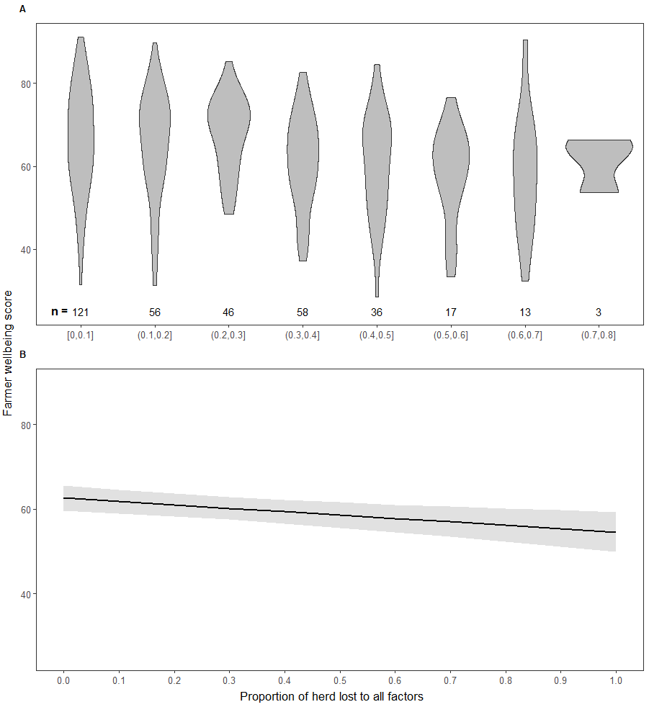
S2 Figure: Effect of the severity of herd mortalities suffered on farmers’ wellbeing
The figure shows the actual and predicted relationship between the severity of animal mortalities to all causes and farmers’ overall wellbeing. The overall wellbeing is the average score of wellbeing scores in physical, psychological, social, and environmental domains. Panel A shows the relationship between 10 percentage increments in relative herd mortalities to all causes and farmers overall wellbeing without accounting for the potential confounding effect of other covariates. Panel B presents the estimated marginal effect at different levels of livestock mortalities experienced, conditional on the other co-variates in the pre-specified linear mixed effect model. The slope of the marginal effect line with confidence intervals around the point estimates shows the extent and direction of the relationship between the levels of herd mortalities to all causes and livestock farmers’ overall wellbeing.

