Supplementary Materials

Listed in the order of appearance
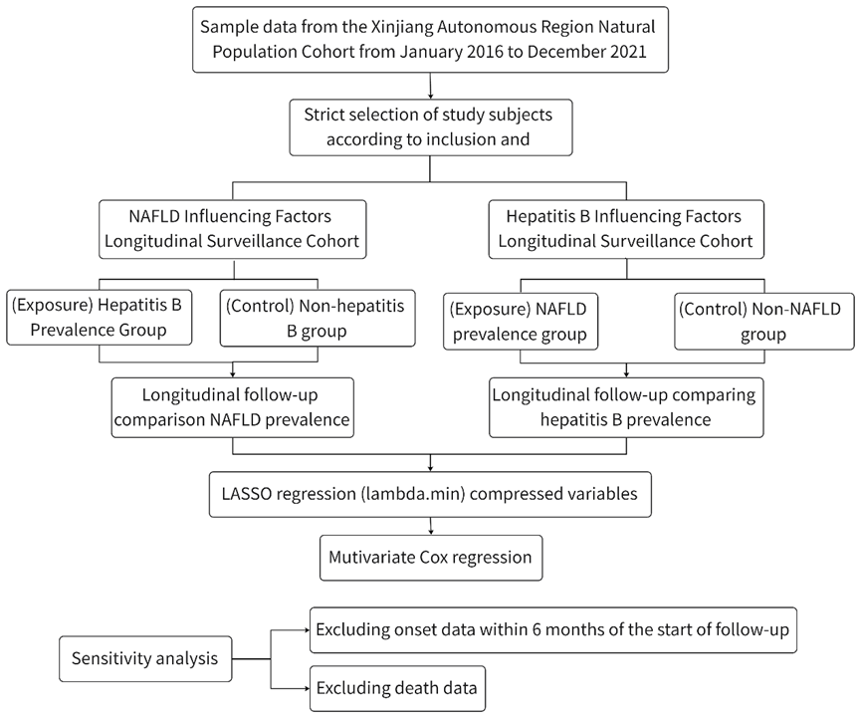
Supplementary Fig 1. Flow chart for cohort establishment and study design

