Supplemental Table1. One portion size of FFQ item list
 | The name of dishes or foods | 1 portion  (g) | Reference
1 | Ugali | 150 | Half serve
2 | Bread | 25 | 1 slice
3 | Mandazi | 50 | 1 piece
4 | Chapati / Pancake | 80 | 1 slice
5 | Boiled rice | 150 | Half serve
6 | Muthokoi / Githeri | 200 | Half serve
7 | Pilau | 150 | Half serve
8 | Spaghetti | 150 | Half serve
9 | Maize | 80 | 1 small size
10 | Cooked banana | 150 | 2 small size or 1 big size
11 | Boiled cassava | 100 | 1 cut
12 | Boiled sweetpotato | 100 | 1 cut
13 | Boiled yam | 100 | 1 cut
14 | Cooked potato | 100 | 1 medium size
15 | Cocoyam (Arrow root) | 100 | 1 cut
16 | Greengrams stew | 200 | Half serve
17 | Pigeon peas stew | 200 | Half serve
18 | Cowpeas stew | 200 | Half serve
19 | Soybeans stew | 200 | Half serve
20 | Kidney beans stew | 200 | Half serve
21 | Lentil stew | 200 | Half serve
22 | Stir-fried cabbage | 80 | 1 serve
23 | Stir-fried sukumawiki | 80 | 1 serve
24 | Stir-fried spinach | 80 | 1 serve
25 | Boiled pumpkin | 100 | 1/8 cut
26 | Black nightshade | 80 | 1 serve
27 | Amaranth leaves | 80 | 1 serve
28 | Cowpea leaves | 80 | 1 serve
29 | Pumpkin leaves | 80 | 1 serve
30 | Murenda | 80 | 1 serve
31 | Crotalaria leaves | 80 | 1 serve
32 | Spider plant | 80 | 1 serve
33 | Avocado | 50 | 1 cut
34 | Sweet banana | 60 | 1 small size
35 | Guava | 60 | 1 small size
36 | Mango | 50 | 1 small size
37 | Papaya | 60 | 1 cut
38 | Chicken | 60 | 1 wings (including bone)
39 | Egg dish | 50 | 1 egg
40 | Beef stew | 60 | 1 serve
41 | Goat stew | 60 | 1 serve
42 | Pork stew | 60 | 1 serve
43 | Omena stew | 50 | 1 serve
44 | Tilapia stew | 80 | 1 serve
45 | Groundnuts | 25 | 1 palmful
46 | Tea, Coffee, and Milk | 300 | 1 cup
47 | Porridge | 350 | 1 cup
48 | Soda | 300 | 1 bottle
49 | Alcohol (beer) | 300 | 1 bottle

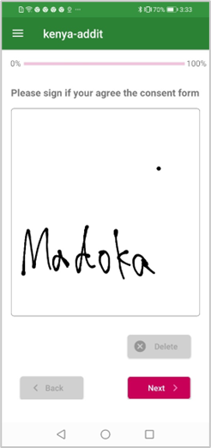 | 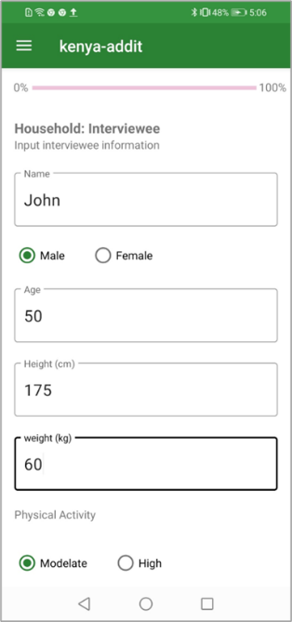 | 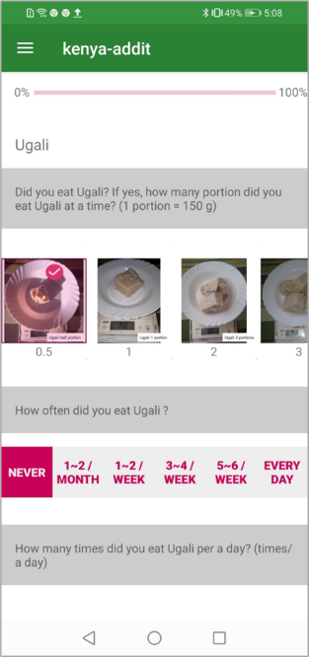 | 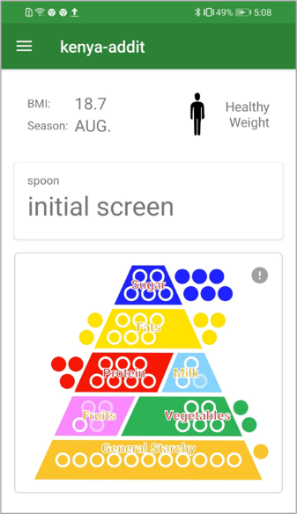
Consent form | Registration form | FFQ input form | Feedback example
Supplemental Figure 1 Example of ADD-IT application form

