Supplementary

Table S1. Definitions of variables.
Variables | Definitions
Age | In years
Gender | Male or female
smoking | Patients’ smoking habit was collected by personal history in the database.
Body mass index | BMI, is a patient's weight in kilograms divided by the square of height in meters.
Hypertension | History of hypertension requiring anti-hypertensive medication recorded in the medical chart or Patients’ diagnosis with ICD code I10, I11, E10.722, E10.723, E11.722, E11.723, E14.722, E14.723, E16.8x101, E16.8x102, N28.917, O10.001, O10.101, O10.201, O10.301, O10.401, O10.901, O10.902, O11xx01, O13xx01, O16xx01, O99.415, P29.201, T70.202 were defined as hypertension.
Diabetes mellitus | A diagnosis of diabetes requiring oral medication or insulin or Patients’ diagnosis with ICD code E10, E11, E12, E13, E14 were defined as diabetes.
Heart insufficiency | Documented in the patient’s chart within 30 days before surgery. A diagnosis of congestive heart failure requiring diuretics or Patients’ diagnosis with ICD code I50, I97.104, T81.810, I11.001, I13.201, I97.106, N18.820, O29.102, O74.202, O75.402, O89.102, O99.408, O99.423. Alternatively, max preoperative BNP more than 400 pg/ml with signs and symptoms.
ASA-PS | 1 /2/3/4 or 5, recorded in the electronic database
Complexity of surgery | The modified John Hopkins Hospital criteria (MJHSC) were used for categorizing the surgical complexity.
Intraoperative blood loss | In mL, extracted from the electronic database
Intraoperative red blood cell transfusion | Administration of red blood cells or plasma during surgery
Intraoperative hypotension | intraoperative systolic blood pressure below 70 mmHg or diastolic blood pressure below 30 mmHg or mean blood pressure below 49 mmHg for more than or equal to 5 minutes, or mean blood pressure below decreases to more than 30% from baseline for more than or equal to 5 min. extracted and calculated from database.
Intraperitoneal operation | Operations intraperitoneally. Was defined by ICD codes. Such as lower esophagus, gastric, colon, appendix,rectus and bile and common duct surgeries.
Intraoperative mean HR | Intraoperative heart rate was collected and calculated by mean, and analyzed by IQR.
AKI | Acute kidney injury, and was defined by the patient’s postoperative serum creatinine increase to not less than 26.5 μmol/l within 48 hours, or 1.5 times from the baseline within 7 days after surgery, or initialization of blood dialysis. As the serum creatinine level fluctuates much postoperatively and could cause an inaccurate estimate of Glomerular Filtration Rate (eGFR), creatinine this study did not define AKI based on the GFR value or urine output.
Postoperative length of stay | Number of days from the surgery to discharge from the hospital
In-hospital mortality | Death during the hospital stay for the surgery
ASA-PS, the American Society of Anaesthesiologists physical status;
ICD: The International Statistical Classification of Diseases;

Table S2. Postoperative events
Items | ALL  (n=55,439) | D-dimer ≤ 0.38 µg/mL (n=48,284) | D-dimer > 0.38  µg/mL (n=7155) | P value
AKI | 2779(5.0%) | 0(0.0%) | 2779(100.0%) | <0.001
Grade 1 | 2101(3.8%) | 1421(2.9%) | 680(9.5%) | <0.001
Grade 2 | 140(0.3%) | 77(0.2%) | 63(0.9%) | <0.001
Grade 3 | 570(1.0%) | 415(0.9%) | 155(2.2%) | <0.001
ICU admission | 2801(5.1%) | 2187(4.2%) | 614(22.1%) | <0.001
Postoperative hospital stay (days) | 4(1-7) | 3(1-7) | 6(3-11) | <0.001
In-hospital 7-day mortality | 69(0.1%) | 46(0.1%) | 23(0.8%) | <0.001
Data are presented as n (%) or median (95% CI).
AKI: acute kidney injury.
ICU: intensive care unit

Table S3. Patient characteristics and operative variables stratified by D-dimer cut-off point (mini-P value approach) after propensity score weighting.
characteristic | D-dimer ≤ 0.38  µg/mL (n=55284.1) | D-dimer > 0.38  µg/mL (n=52722.8) | SMD, %
Age [yr; median (IQR)] years old |  |  | 5.4
< 40 | 9230.5 (16.7) | 8382.1 (15.9)
40 - 50 | 8465.4 (15.3) | 7397.0 (14.0)
50 - 60 | 12318.6 (22.3) | 11661.8 (22.1)
60 - 70 | 13212.1 (23.9) | 12873.1 (24.4)
>70 | 12057.6 (21.8) | 12408.7 (23.5)
male gender, [n (%)] | 28227.2(51.1%) | 26486.5(50.2%) | 1.6
Body mass index, kg/m² [mean(SD) |  |  | 4.4
<18.5 | 17012(30.8%) | 16801.6(31.9%)
18.5-25.0 | 2324.8(4.2%) | 2558(4.9%)
25.0-29.9 | 25530.4(46.2%) | 23906.9(45.3%)
>29.9 | 10416.9(18.8%) | 9456.2(17.9%)
smoking, [n (%)] | 7109.2(12.9%) | 6454.2(12.2%) | 1.9
drinking, [n (%)] | 5955.4(10.8%) | 5627.1(10.7%) | 0.3
Preoperative hemoglobin, [n (%)] |  |  | 5.1
<100 g/L | 5190.6(9.4%) | 5084.3(9.6%)
100-110 g/L | 2459.5(4.4%) | 2598(4.9%)
110-120 g/L | 4306.7(7.8%) | 4716.4(8.9%)
>120 g/L | 43327.4(78.4%) | 40324(76.5%)
Preoperative creatinine, [n (%)] (<133 mmol/L) | 1492(2.7%) | 2194.3(4.2%) | 8.0
Preoperative albumin, [n (%)] (>40 g/L) | 39614.5(71.7%) | 37209.1(70.6%) | 2.4
Co-existing disease
hypertension | 19119.1(34.6%) | 18401.1(34.9%) | 0.7
Coronary artery disease | 8045.1(14.6%) | 7886.3(15%) | 1.1
Heart failure | 672.3(1.2%) | 681.7(1.3%) | 0.7
Arrhythmia | 1590.7(2.9%) | 1806.8(3.4%) | 3.1
Peripheral arterial disease | 952.8(1.7%) | 953.5(1.8%) | 0.6
Stroke | 4471.1(8.1%) | 4557.8(8.6%) | 2.0
diabetes mellitus | 37336.8(67.5%) | 35618.9(67.6%) | 0
Renal insufficiency | 976.3(1.8%) | 1027.6(1.9%) | 1.4
Dyslipidemia | 2365.2(4.3%) | 2019.2(3.8%) | 2.3
COPD | 972.6(1.8%) | 918.4(1.7%) | 0.1
Anemia | 2116.6(3.8%) | 2173.7(4.1%) | 1.5
ASA-PS |  |  | 3.6
I | 12331.5(22.3%) | 11287.3(21.4%)
II | 37837.3(68.4%) | 36059.7(68.4%)
III | 4932.3(8.9%) | 5167.9(9.8%)
IV or more | 183.1(0.3%) | 207.9(0.4%)
Surgery type |  |  | 7.7
Eye/ear | 1484.9(2.7%) | 1329.3(2.5%)
Integumentary | 2200.6(4%) | 1985.7(3.8%)
Genital/urinary | 13157.6(23.8%) | 12532.5(23.8%)
Musculoskeletal | 6187.9(11.2%) | 6004.4(11.4%)
Nervous | 2369.3(4.3%) | 2198.9(4.2%)
Vascular | 1534.8(2.8%) | 1681.2(3.2%)
Digestive | 21782.3(39.4%) | 20864.9(39.6%)
Respiratory | 3592.4(6.5%) | 3970.8(7.5%)
Other | 2974.4(5.4%) | 2155.1(4.1%)
Surgery time, [min; median (IQR)] | 91 [51-163] | 97 [53-168] | 5.4
Anesthesia duration, [min; median (IQR)] | 157 [107-246] | 166 [112-253] | 4.3
Intraoperative ﬂuid administration
Crystal | 1100 [600-1600] | 1100 [700-1600] | 6.8
colloid | 0 [0-500] | 0 [0-500] | 0.7
Estimated blood loss, [ml; median (IQR)] | 0 [0-100] | 0 [0-100] | 3.9
Intraoperative blood infusion | 5701.4(10.3%) | 5262.9(10%) | 1.1
Urine, [ml; median (IQR)] | 0 [0-350] | 0 [0-300] | 0.5
Intraoperative hypotension | 541.6(1%) | 562(1.1%) | 0.9
Intraoperative mean HR, bpm |  |  | 23.5
60-65 | 12248(22.5%) | 10492(20.2%)
<60 | 16501(30.3%) | 12447.5(24%)
65-75 | 15997.8(29.4%) | 14955(28.9%)
>75 | 9645.8(17.7%) | 13918.1(26.9%)
a: All values are reported as No. (%) unless otherwise specified.
SMD：Standard mean difference, less than 15 is considered well balanced.

Table S4. Patient characteristics and operative variables stratified by D-dimer cut-off point (ROC approach) after propensity score weighting.
characteristic | D-dimer ≤ 0.165  µg/mL (n=55284.1) | D-dimer > 0.165  µg/mL (n=52722.8) | SMD, %
Age [yr; median (IQR)] years old |  |  | 2.7
< 40 | 9227.7(16.8%) | 8886.9(16.3%)
40 - 50 | 8433.4(15.4%) | 8078.1(14.8%)
50 - 60 | 12275.3(22.4%) | 12066.1(22.1%)
60 - 70 | 13240(24.1%) | 13378.8(24.6%)
>70 | 11715(21.3%) | 12068.6(22.2%)
male gender, [n (%)] | 27943.3(50.9%) | 27265.5(50%) | 1.7
Body mass index, kg/m² [mean(SD) |  |  | 1.9
<18.5 | 16860.5(30.7%) | 16977.1(31.2%)
18.5-25.0 | 2214.7(4%) | 2357.4(4.3%)
25.0-29.9 | 25432.5(46.3%) | 25014.5(45.9%)
>29.9 | 10383.7(18.9%) | 10129.6(18.6%)
smoking, [n (%)] | 7004.6(12.8%) | 6823.7(12.5%) | 0.7
drinking, [n (%)] | 5891.1(10.7%) | 5747.5(10.5%) | 0.6
Preoperative hemoglobin, [n (%)] |  |  | 1.8
<100 g/L | 4979.9(9.1%) | 5067.8(9.3%)
100-110 g/L | 2428.4(4.4%) | 2579.5(4.7%)
110-120 g/L | 4330.7(7.9%) | 4319.8(7.9%)
>120 g/L | 43152.5(78.6%) | 42511.4(78%)
Preoperative creatinine, [n (%)] (<133 mmol/L) | 1285(2.3%) | 1962.2(3.6%) | 7.4
Preoperative albumin, [n (%)] (>40 g/L) | 39565.4(72.1%) | 38909(71.4%) | 1.5
Co-existing disease
hypertension | 18912.2(34.5%) | 18937.9(34.8%) | 0.6
Coronary artery disease | 7851.4(14.3%) | 8045.8(14.8%) | 1.3
Heart failure | 623.8(1.1%) | 652.4(1.2%) | 0.6
Arrhythmia | 1449.4(2.6%) | 1736.8(3.2%) | 3.3
Peripheral arterial disease | 871.5(1.6%) | 981.8(1.8%) | 1.7
Stroke | 4322.2(7.9%) | 4483(8.2%) | 1.3
diabetes mellitus | 37102(67.6%) | 36812.3(67.6%) | 0
Renal insufficiency | 944.2(1.7%) | 993.6(1.8%) | 0.8
Dyslipidemia | 2384.2(4.3%) | 2012.3(3.7%) | 3.3
COPD | 922.5(1.7%) | 957.9(1.8%) | 0.6
Anemia | 2095.6(3.8%) | 2095.6(3.8%) | 0.2
ASA-PS |  |  | 2.9
I | 12330.5(22.5%) | 11898.1(21.8%)
II | 37717.4(68.7%) | 37520.1(68.9%)
III | 4704.6(8.6%) | 4852(8.9%)
IV or more | 138.9(0.3%) | 208.3(0.4%)
Surgery type |  |  | 2.9
Eye/ear | 1485.5(2.7%) | 1403.4(2.6%)
Integumentary | 2182.9(4%) | 2270.5(4.2%)
Genital/urinary | 13210.4(24.1%) | 12968(23.8%)
Musculoskeletal | 6016.1(11%) | 6149(11.3%)
Nervous | 2365.3(4.3%) | 2251.8(4.1%)
Vascular | 1483.3(2.7%) | 1609.3(3%)
Digestive | 21592(39.3%) | 21308.4(39.1%)
Respiratory | 3595.3(6.5%) | 3729.6(6.8%)
Other | 2960.6(5.4%) | 2788.4(5.1%)
Surgery time, [min; median (IQR)] | 91 [51-162] | 94 [52-166] | 3.4
Anesthesia duration, [min; median (IQR)] | 156 [106-242] | 162 [109-251] | 3.6
Intraoperative ﬂuid administration
Crystal | 1100 [600-1600] | 1100 [600-1600] | 6.2
colloid | 0 [0-500] | 0 [0-500] | 1.8
Estimated blood loss, [ml; median (IQR)] | 0 [0-50] | 0 [0-100] | 5.4
Intraoperative blood infusion | 5573(10.2%) | 5596.9(10.3%) | 0.4
Urine, [ml; median (IQR)] | 0 [0-350] | 0 [0-300] | 0.2
Intraoperative hypotension | 464.7(0.8%) | 632(1.2%) | 3.1
Intraoperative mean HR, bpm |  |  | 18.2
60-65 | 12409(23%) | 11160.6(20.8%)
<60 | 16830.7(31.2%) | 14083.5(26.3%)
65-75 | 15789(29.2%) | 15872.3(29.6%)
>75 | 8955.5(16.6%) | 12476.7(23.3%)
a: All values are reported as No. (%) unless otherwise specified.
SMD：Standard mean difference, less than 15 is considered well balanced.

Figure S1 ROC curve of preoperative D-dimer on postoperative acute kidney injury.
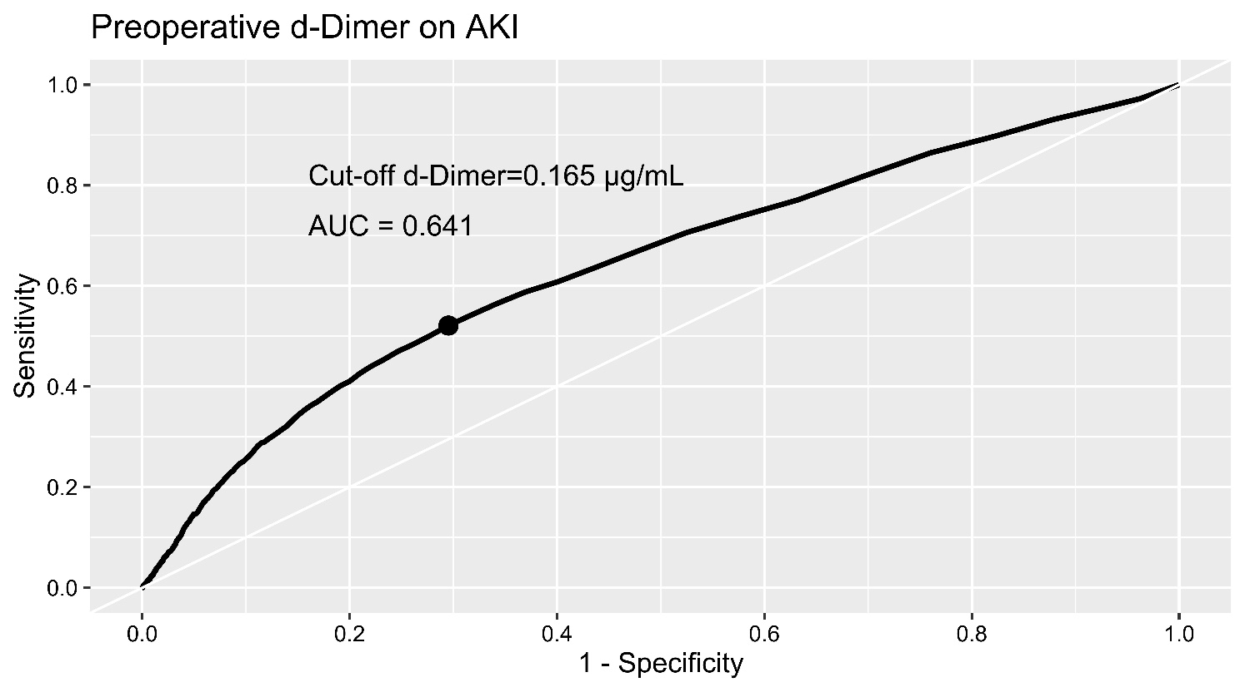

Figure S2. Subgroup analyses stratiﬁed by patient and operative variables. (ROC approach)

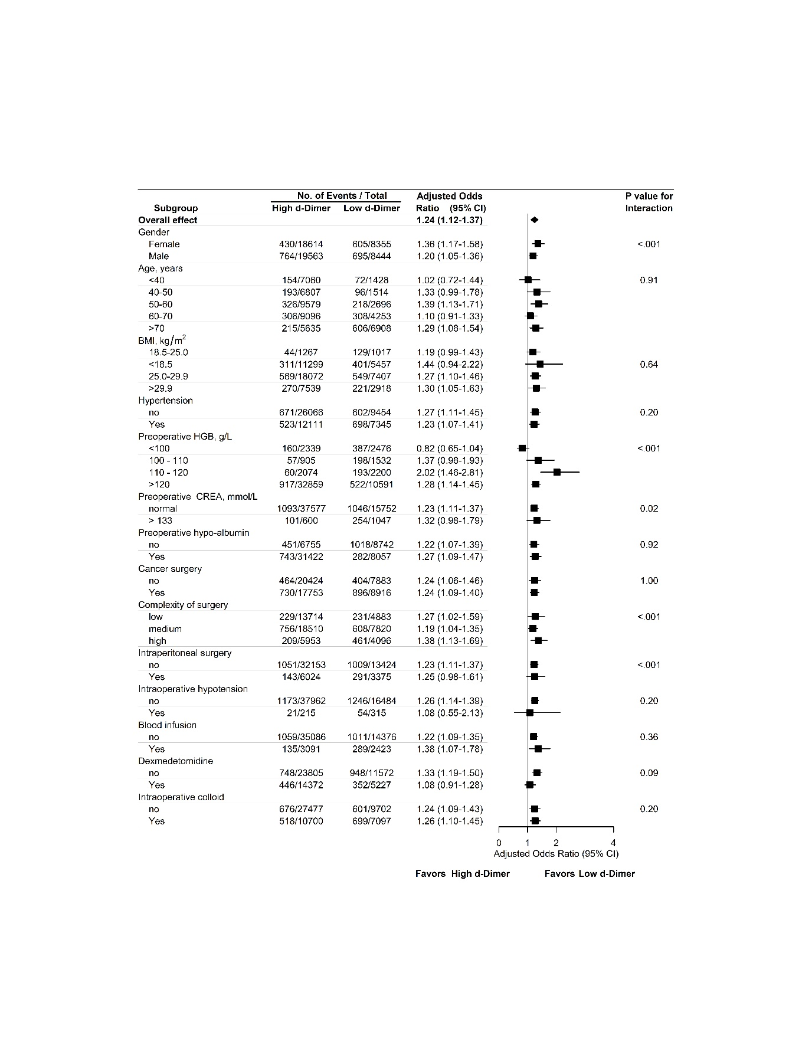
The adjusted covariates included: gender, age, BMI, hypertension, preoperative hemoglobin, creatinine and albumin level, cancer surgery, surgical complexity, intraperitoneal surgery, intraoperative blood transfusion, intraoperative hypotension, intraoperative dexmedetomidine, and colloid use.
BMI: body mass index
HGB: hemoglobin
CREA: creatinine

