Supplementary Table 1.
Descriptive Statistics of Personality Traits Used in This Study and Correlation with Beauty of Haiku at the TP 3
 |  | Mean | (SD) | Correlation with Beauty TP 3 (r) | p value
Age |  | 20.93 | (2.56) | -.17 | .08
Sex |  | 1.53 | (.50) | -.01 | .95
Haiku Familiarity |  | 1.35 | (.57) | .17 | .08
Haiku Experience |  | 1.16 | (.53) | -.09 | .33
Art Experience |  | 1.32 | (.68) | .07 | .44
Openness |  | 3.71 | (.50) | .14 | .14
Multidimensional Ambiguity Attitude Scale
 | Discomfort with Ambiguity | 4.56 | (.92) | .01 | .90
 | Moral Absolutism | 2.92 | (.86) | .02 | .87
 | Need for Complexity | 4.30 | (1.02) | .06 | .53
Interpersonal Reactivity Index
 | Personal Distress | 3.39 | (.65) | .14 | .14
 | Empathic Concern | 3.34 | (.41) | .12 | .22
 | Perspective Taking | 3.08 | (.56) | .03 | .75
 | Fantasy | 3.50 | (.72) | .09 | .36
Profile of Emotional Competence
 | Self | 2.89 | (.58) | -.18 | .06
 | Other | 2.85 | (.62) | -.18 | .06
Trait Awe |  | 4.13 | (.90) | .20 | .04
Trait Nostalgia |  | 3.88 | (1.26) | .26 | .01
Analysis-Holism Scale
 | Causality | 5.12 | (.71) | .34 | .00
 | Contradiction | 4.61 | (.73) | .14 | .13
 | Change | 4.85 | (.72) | .12 | .20
 | Attention | 5.02 | (.67) | .16 | .09

Note. The average score of negative and positive haiku was used to score the beauty.

Supplementary Table 2.
Correlation Matrix for All Personality Traits
Correlation Coefficient |  |  | 1 | 2 | 3 | 4 | 5 | 6 | 7 | 8 | 9 | 10 | 11 | 12 | 13 | 14 | 15 | 16 | 17 | 18 | 19 | 20 | 21 | 22
1 | Age |  | 1.00
2 | Sex |  | -.06 | 1.00
3 | Haiku Familiarity |  | .08 | .13 | 1.00
4 | Haiku Experience |  | .07 | -.09 | .11 | 1.00
5 | Art Experience |  | .14 | -.04 | .07 | .13 | 1.00
6 | Openness |  | -.18 | .18 | .00 | -.05 | .14 | 1.00
 | Multidimensional Ambiguity Attitude Scale
7 |  | Discomfort with Ambiguity | .01 | -.04 | .07 | -.02 | .03 | .19 | 1.00
8 |  | Moral Absolutism | .18 | -.06 | -.04 | .21 | .20 | .01 | -.23 | 1.00
9 |  | Need for Complexity | .13 | .00 | .03 | .23 | .17 | -.17 | -.38 | .55 | 1.00
 | Interpersonal Reactivity Index
10 |  | Personal Distress | -.17 | .20 | .09 | .03 | -.01 | .40 | -.01 | -.04 | -.06 | 1.00
11 |  | Empathic Concern | -.14 | .11 | -.02 | .04 | -.01 | .20 | -.07 | .14 | .16 | .31 | 1.00
12 |  | Perspective Taking | .25 | .09 | -.03 | .12 | .07 | -.23 | -.03 | .35 | .33 | -.16 | .04 | 1.00
13 |  | Fantasy | .00 | .10 | .13 | .07 | .06 | -.06 | -.24 | .28 | .42 | .16 | .23 | .19 | 1.00
14 | Profile of Emotional Competence |  | .33 | .09 | -.13 | .01 | .02 | -.29 | -.01 | .17 | .23 | -.36 | -.05 | .53 | .14 | 1.00
15 |  | Self | .29 | -.01 | -.12 | -.01 | .02 | -.29 | -.03 | .07 | .24 | -.42 | -.13 | .37 | .02 | .88 | 1.00
16 |  | Other | .29 | .16 | -.11 | .03 | .02 | -.23 | .01 | .24 | .17 | -.21 | .04 | .56 | .22 | .89 | .57 | 1.00
17 | Trait Awe |  | .12 | .06 | .01 | .01 | .11 | .01 | -.07 | .43 | .55 | .01 | .09 | .38 | .34 | .25 | .27 | .18 | 1.00
18 | Trait Nostalgia |  | -.02 | -.03 | .02 | -.01 | -.05 | .01 | -.17 | .27 | .34 | .08 | .16 | .11 | .28 | .06 | .06 | .05 | .43 | 1.00
 | Analysis-Holism Scale
19 |  | Causality | -.19 | .13 | .12 | -.02 | .06 | .06 | .00 | .20 | .26 | -.01 | -.03 | .14 | .15 | -.11 | -.11 | -.08 | .27 | .18 | 1.00
20 |  | Contradiction | -.06 | .12 | .02 | -.14 | -.03 | .08 | .12 | -.13 | -.13 | -.10 | -.02 | .25 | .00 | .02 | .02 | .01 | -.04 | -.12 | .11 | 1.00
21 |  | Change | -.14 | -.02 | .00 | .06 | .11 | .08 | -.46 | .07 | .24 | .13 | .08 | -.16 | .12 | -.26 | -.22 | -.25 | .06 | .08 | .13 | -.11 | 1.00
22 |  | Attention | .02 | .04 | -.18 | -.30 | -.06 | .13 | -.01 | .09 | -.01 | .02 | .09 | .19 | .16 | .18 | .11 | .21 | .16 | .24 | .14 | .29 | .02 | 1.00
P value |  |  | 1 | 2 | 3 | 4 | 5 | 6 | 7 | 8 | 9 | 10 | 11 | 12 | 13 | 14 | 15 | 16 | 17 | 18 | 19 | 20 | 21 | 22
1 | Age |  | .00
2 | Sex |  | .52 | .00
3 | Haiku Familiarity |  | .42 | .18 | .00
4 | Haiku Experience |  | .44 | .38 | .23 | .00
5 | Art Experience |  | .14 | .68 | .47 | .16 | .00
6 | Openness |  | .06 | .06 | 1.00 | .64 | .14 | .00
 | Multidimensional Ambiguity Attitude Scale
7 |  | Discomfort with Ambiguity | .91 | .71 | .48 | .87 | .77 | .05 | .00
8 |  | Moral Absolutism | .06 | .51 | .69 | .03 | .03 | .95 | .01 | .00
9 |  | Need for Complexity | .18 | .99 | .75 | .02 | .08 | .07 | .00 | .00 | .00
 | Interpersonal Reactivity Index
10 |  | Personal Distress | .07 | .03 | .34 | .78 | .91 | .00 | .90 | .67 | .50 | .00
11 |  | Empathic Concern | .15 | .26 | .84 | .70 | .91 | .03 | .45 | .15 | .10 | .00 | .00
12 |  | Perspective Taking | .01 | .34 | .76 | .22 | .44 | .02 | .79 | .00 | .00 | .10 | .67 | .00
13 |  | Fantasy | 1.00 | .28 | .19 | .47 | .55 | .51 | .01 | .00 | .00 | .10 | .01 | .04 | .00
14 | Profile of Emotional Competence |  | .00 | .36 | .19 | .91 | .84 | .00 | .88 | .07 | .01 | .00 | .59 | .00 | .14 | .00
15 |  | Self | .00 | .93 | .22 | .88 | .88 | .00 | .72 | .50 | .01 | .00 | .16 | .00 | .82 | .00 | .00
16 |  | Other | .00 | .10 | .27 | .74 | .85 | .02 | .94 | .01 | .07 | .02 | .70 | .00 | .02 | .00 | .00 | .00
17 | Trait Awe |  | .22 | .54 | .95 | .91 | .27 | .91 | .45 | .00 | .00 | .95 | .35 | .00 | .00 | .01 | .00 | .06 | .00
18 | Trait Nostalgia |  | .82 | .77 | .85 | .89 | .61 | .89 | .07 | .00 | .00 | .39 | .09 | .27 | .00 | .54 | .54 | .63 | .00 | .00
 | Analysis-Holism Scale
19 |  | Causality | .04 | .17 | .21 | .85 | .54 | .55 | .97 | .04 | .01 | .95 | .79 | .14 | .11 | .26 | .26 | .38 | .00 | .07 | .00
20 |  | Contradiction | .55 | .22 | .82 | .15 | .72 | .41 | .23 | .19 | .18 | .31 | .86 | .01 | 1.00 | .84 | .81 | .91 | .66 | .19 | .25 | .00
21 |  | Change | .14 | .86 | .97 | .50 | .26 | .38 | .00 | .47 | .01 | .17 | .42 | .10 | .21 | .01 | .02 | .01 | .54 | .40 | .19 | .26 | .00
22 |  | Attention | .80 | .65 | .06 | .00 | .56 | .18 | .95 | .34 | .92 | .86 | .36 | .05 | .10 | .06 | .26 | .03 | .09 | .01 | .14 | .00 | .83 | .00

Supplementary Table 3.
Multilevel Correlation of All Subjective Rating Variables
A |  | bty | pstv |  |  | ngtv |  |  | arsl |  |  | Eamb |  |  | Camb |  |  | awe | nstlg | bty |  | Jvlnc |  |  | Jarsl
 | TP | 3 | 1 | 2 | 3 | 1 | 2 | 3 | 1 | 2 | 3 | 1 | 2 | 3 | 1 | 2 | 3 | 3 | 3 | 1 | 2 | 3 | 1 | 2 | 3 | 1 | 2
bty | 3 | .19 | .06 | .22 | .32 | -.04 | -.09 | -.10 | .05 | .21 | .39 | -.05 | -.15 | -.16 | -.05 | -.18 | -.22 | .40 | .36 | .27 | .50 | .09 | .17 | .25 | .05 | .14 | .38
pstv | 1 | .34 | .27 | .46 | .27 | -.58 | -.32 | -.25 | .36 | .15 | .06 | -.25 | -.11 | -.03 | -.21 | -.04 | -.03 | -.02 | .02 | .33 | .19 | .68 | .51 | .28 | .23 | .15 | .00
 | 2 | .39 | .92 | .18 | .62 | -.34 | -.69 | -.52 | .15 | .20 | .15 | -.12 | -.16 | -.10 | -.13 | -.20 | -.12 | .03 | .13 | .21 | .36 | .44 | .71 | .59 | .10 | .10 | .10
 | 3 | .52 | .80 | .96 | .11 | -.25 | -.49 | -.72 | .04 | .11 | .24 | -.04 | -.11 | -.19 | -.07 | -.16 | -.23 | .04 | .21 | .13 | .19 | .30 | .54 | .82 | .01 | .04 | .17
ngtv | 1 | .24 | .76 | .66 | .53 | .32 | .47 | .34 | -.01 | .06 | .02 | .15 | .04 | .02 | .12 | .00 | .04 | .07 | -.04 | -.14 | -.08 | -.61 | -.49 | -.30 | -.08 | .01 | .05
 | 2 | .31 | .78 | .61 | .50 | .93 | .23 | .64 | -.02 | .09 | .02 | .13 | .06 | .03 | .11 | .10 | .07 | .04 | -.05 | -.11 | -.16 | -.41 | -.67 | -.58 | -.04 | .04 | .04
 | 3 | .32 | .67 | .55 | .48 | .89 | .98 | .16 | .01 | .09 | .06 | .05 | .05 | .11 | .07 | .08 | .13 | .07 | -.06 | -.06 | -.06 | -.29 | -.53 | -.78 | .02 | .05 | .07
arsl | 1 | .33 | .80 | .83 | .71 | .54 | .52 | .46 | .34 | .37 | .20 | -.43 | -.20 | -.06 | -.29 | -.09 | -.04 | .06 | .02 | .34 | .19 | .19 | .09 | .00 | .39 | .38 | .14
 | 2 | .43 | .78 | .79 | .73 | .46 | .53 | .49 | .93 | .33 | .47 | -.16 | -.44 | -.24 | -.11 | -.30 | -.16 | .13 | .14 | .15 | .29 | .07 | .05 | .02 | .21 | .43 | .38
 | 3 | .62 | .67 | .74 | .79 | .34 | .43 | .41 | .80 | .92 | .25 | -.11 | -.31 | -.45 | -.08 | -.25 | -.38 | .24 | .28 | .06 | .19 | .05 | .08 | .11 | .12 | .29 | .60
Eamb | 1 | .10 | -.07 | -.20 | -.21 | .10 | .12 | .18 | -.25 | -.31 | -.21 | .26 | .29 | .15 | .49 | .19 | .10 | -.03 | -.02 | -.15 | -.11 | -.19 | -.10 | -.05 | -.25 | -.22 | -.09
 | 2 | .14 | .02 | .02 | .00 | .21 | .14 | .21 | -.10 | -.14 | -.10 | .91 | .21 | .45 | .19 | .51 | .30 | -.08 | -.09 | -.09 | -.16 | -.09 | -.12 | -.07 | -.11 | -.28 | -.29
 | 3 | .02 | .06 | .06 | .01 | .22 | .15 | .23 | -.01 | -.06 | -.14 | .71 | .92 | .18 | .12 | .33 | .57 | -.07 | -.17 | -.01 | -.07 | -.04 | -.08 | -.14 | -.04 | -.15 | -.37
Camb | 1 | .28 | .15 | .08 | .17 | .09 | .10 | .02 | .04 | .01 | .14 | .50 | .48 | .23 | .37 | .33 | .21 | .00 | -.04 | -.14 | -.11 | -.17 | -.13 | -.08 | -.19 | -.18 | -.08
 | 2 | .32 | .22 | .28 | .31 | .23 | .14 | .13 | .18 | .12 | .22 | .54 | .65 | .50 | .88 | .22 | .45 | -.03 | -.14 | -.06 | -.21 | -.05 | -.13 | -.11 | -.03 | -.18 | -.25
 | 3 | .24 | .28 | .27 | .18 | .27 | .24 | .24 | .19 | .15 | .11 | .43 | .60 | .66 | .43 | .72 | .12 | -.03 | -.24 | -.03 | -.11 | -.04 | -.11 | -.18 | -.01 | -.10 | -.35
awe | 4 | .64 | .47 | .40 | .42 | .42 | .49 | .52 | .42 | .37 | .41 | .18 | .26 | .25 | .11 | .24 | .28 | .36 | .14 | .13 | .27 | -.02 | -.01 | .02 | .05 | .13 | .24
nstlg | 4 | .53 | .47 | .37 | .40 | .43 | .56 | .53 | .53 | .45 | .49 | .06 | .07 | .02 | .22 | .27 | .20 | .65 | .21 | .02 | .18 | .04 | .08 | .15 | -.02 | .06 | .27
bty | 1 | .72 | .57 | .60 | .58 | .66 | .60 | .58 | .66 | .57 | .58 | .09 | .16 | .11 | .25 | .35 | .32 | .61 | .71 | .28 | .53 | .28 | .22 | .12 | .20 | .16 | .05
 | 2 | .88 | .49 | .56 | .61 | .52 | .50 | .52 | .58 | .56 | .63 | .04 | .14 | .10 | .17 | .30 | .30 | .63 | .64 | .93 | .24 | .17 | .25 | .14 | .11 | .19 | .19
Jvlnc | 1 | .23 | .06 | .13 | .22 | -.36 | -.19 | -.25 | .02 | .24 | .23 | -.09 | -.07 | -.03 | .09 | .03 | .21 | .04 | -.12 | -.26 | -.06 | .04 | .69 | .36 | .18 | .08 | .00
 | 2 | .11 | -.10 | .17 | .34 | -.42 | -.46 | -.54 | .04 | .08 | .15 | -.20 | .03 | -.02 | .18 | .21 | .07 | -.13 | -.22 | -.16 | -.02 | .70 | .04 | .65 | .10 | .08 | .03
 | 3 | .19 | -.04 | .21 | .31 | -.32 | -.46 | -.48 | .05 | .08 | .23 | -.24 | -.12 | -.24 | .15 | .08 | -.17 | -.13 | -.14 | -.10 | .03 | .50 | .89 | .04 | .01 | .00 | .07
Jarsl | 1 | -.01 | .15 | .06 | -.07 | .24 | .18 | .10 | .37 | .26 | .10 | -.07 | -.11 | -.07 | .07 | .00 | .00 | -.01 | .27 | .33 | .19 | -.42 | -.29 | -.20 | .36 | .66 | .16
 | 2 | .20 | .22 | .18 | .14 | .19 | .19 | .16 | .45 | .44 | .35 | -.21 | -.17 | -.10 | .02 | .04 | .05 | .14 | .36 | .31 | .28 | -.11 | -.15 | -.07 | .78 | .23 | .44
 | 3 | .41 | .19 | .22 | .34 | -.01 | .07 | .06 | .34 | .46 | .58 | -.24 | -.21 | -.27 | .05 | .03 | -.15 | .19 | .28 | .24 | .33 | .15 | .09 | .27 | .34 | .69 | .16
B |  | bty | pstv |  |  | ngtv |  |  | arsl |  |  | Eamb |  |  | Camb |  |  | awe | nstlg | bty |  | Jvlnc |  |  | Jarsl
 | TP | 3 | 1 | 2 | 3 | 1 | 2 | 3 | 1 | 2 | 3 | 1 | 2 | 3 | 1 | 2 | 3 | 3 | 3 | 1 | 2 | 3 | 1 | 2 | 3 | 1 | 2
bty | 3 | .00 | .01 | .00 | .00 | .04 | .00 | .00 | .02 | .00 | .00 | .01 | .00 | .00 | .01 | .00 | .00 | .00 | .00 | .00 | .00 | .00 | .00 | .00 | .01 | .00 | .00
pstv | 1 | .00 | .00 | .00 | .00 | .00 | .00 | .00 | .00 | .00 | .00 | .00 | .00 | .12 | .00 | .02 | .14 | .22 | .24 | .00 | .00 | .00 | .00 | .00 | .00 | .00 | .81
 | 2 | .00 | .00 | .00 | .00 | .00 | .00 | .00 | .00 | .00 | .00 | .00 | .00 | .00 | .00 | .00 | .00 | .08 | .00 | .00 | .00 | .00 | .00 | .00 | .00 | .00 | .00
 | 3 | .00 | .00 | .00 | .00 | .00 | .00 | .00 | .04 | .00 | .00 | .03 | .00 | .00 | .00 | .00 | .00 | .02 | .00 | .00 | .00 | .00 | .00 | .00 | .48 | .03 | .00
ngtv | 1 | .03 | .00 | .00 | .00 | .00 | .00 | .00 | .54 | .00 | .43 | .00 | .02 | .25 | .00 | .81 | .04 | .00 | .05 | .00 | .00 | .00 | .00 | .00 | .00 | .64 | .01
 | 2 | .01 | .00 | .00 | .00 | .00 | .00 | .00 | .41 | .00 | .25 | .00 | .00 | .14 | .00 | .00 | .00 | .07 | .02 | .00 | .00 | .00 | .00 | .00 | .06 | .05 | .03
 | 3 | .01 | .00 | .00 | .00 | .00 | .00 | .00 | .47 | .00 | .00 | .02 | .01 | .00 | .00 | .00 | .00 | .00 | .00 | .00 | .01 | .00 | .00 | .00 | .32 | .01 | .00
arsl | 1 | .00 | .00 | .00 | .00 | .00 | .00 | .00 | .00 | .00 | .00 | .00 | .00 | .00 | .00 | .00 | .05 | .00 | .25 | .00 | .00 | .00 | .00 | .94 | .00 | .00 | .00
 | 2 | .00 | .00 | .00 | .00 | .00 | .00 | .00 | .00 | .00 | .00 | .00 | .00 | .00 | .00 | .00 | .00 | .00 | .00 | .00 | .00 | .00 | .02 | .41 | .00 | .00 | .00
 | 3 | .00 | .00 | .00 | .00 | .00 | .00 | .00 | .00 | .00 | .00 | .00 | .00 | .00 | .00 | .00 | .00 | .00 | .00 | .00 | .00 | .01 | .00 | .00 | .00 | .00 | .00
Eamb | 1 | .38 | .54 | .07 | .08 | .35 | .26 | .11 | .02 | .00 | .06 | .00 | .00 | .00 | .00 | .00 | .00 | .19 | .22 | .00 | .00 | .00 | .00 | .02 | .00 | .00 | .00
 | 2 | .23 | .83 | .87 | .98 | .06 | .22 | .06 | .37 | .19 | .36 | .00 | .00 | .00 | .00 | .00 | .00 | .00 | .00 | .00 | .00 | .00 | .00 | .00 | .00 | .00 | .00
 | 3 | .84 | .58 | .57 | .94 | .04 | .19 | .05 | .95 | .60 | .21 | .00 | .00 | .00 | .00 | .00 | .00 | .00 | .00 | .73 | .00 | .07 | .00 | .00 | .03 | .00 | .00
Camb | 1 | .01 | .16 | .43 | .14 | .36 | .35 | .85 | .68 | .91 | .18 | .00 | .00 | .04 | .00 | .00 | .00 | .83 | .05 | .00 | .00 | .00 | .00 | .00 | .00 | .00 | .00
 | 2 | .01 | .04 | .01 | .01 | .04 | .20 | .25 | .09 | .25 | .04 | .00 | .00 | .00 | .00 | .00 | .00 | .12 | .00 | .00 | .00 | .01 | .00 | .00 | .13 | .00 | .00
 | 3 | .05 | .02 | .03 | .15 | .02 | .04 | .05 | .10 | .18 | .33 | .00 | .00 | .00 | .00 | .00 | .00 | .13 | .00 | .11 | .00 | .03 | .00 | .00 | .70 | .00 | .00
awe | 4 | .00 | .00 | .00 | .00 | .00 | .00 | .00 | .00 | .00 | .00 | .08 | .02 | .03 | .27 | .03 | .02 | .00 | .00 | .00 | .00 | .35 | .63 | .38 | .01 | .00 | .00
nstlg | 4 | .00 | .00 | .00 | .00 | .00 | .00 | .00 | .00 | .00 | .00 | .60 | .54 | .86 | .04 | .02 | .09 | .00 | .00 | .34 | .00 | .05 | .00 | .00 | .38 | .00 | .00
bty | 1 | .00 | .00 | .00 | .00 | .00 | .00 | .00 | .00 | .00 | .00 | .37 | .14 | .33 | .02 | .00 | .01 | .00 | .00 | .00 | .00 | .00 | .00 | .00 | .00 | .00 | .01
 | 2 | .00 | .00 | .00 | .00 | .00 | .00 | .00 | .00 | .00 | .00 | .73 | .19 | .37 | .11 | .01 | .01 | .00 | .00 | .00 | .00 | .00 | .00 | .00 | .00 | .00 | .00
Jvlnc | 1 | .12 | .67 | .38 | .17 | .02 | .19 | .10 | .86 | .09 | .11 | .55 | .62 | .83 | .51 | .81 | .17 | .78 | .41 | .06 | .67 | .00 | .00 | .00 | .00 | .00 | .99
 | 2 | .45 | .49 | .28 | .04 | .01 | .00 | .00 | .76 | .56 | .31 | .18 | .83 | .87 | .21 | .15 | .67 | .37 | .14 | .25 | .89 | .00 | .00 | .00 | .00 | .00 | .17
 | 3 | .21 | .78 | .19 | .08 | .03 | .00 | .00 | .72 | .56 | .11 | .10 | .42 | .12 | .30 | .57 | .28 | .36 | .34 | .49 | .82 | .02 | .00 | .00 | .49 | .98 | .00
Jarsl | 1 | .94 | .16 | .57 | .54 | .02 | .08 | .37 | .00 | .02 | .33 | .50 | .29 | .52 | .48 | .97 | 1.00 | .95 | .01 | .00 | .07 | .00 | .04 | .15 | .00 | .00 | .00
 | 2 | .07 | .05 | .11 | .22 | .08 | .08 | .16 | .00 | .00 | .00 | .06 | .13 | .39 | .84 | .70 | .64 | .20 | .00 | .00 | .01 | .45 | .30 | .63 | .00 | .00 | .00
 | 3 | .00 | .09 | .07 | .01 | .94 | .55 | .60 | .00 | .00 | .00 | .03 | .06 | .03 | .68 | .76 | .23 | .09 | .02 | .03 | .00 | .30 | .57 | .08 | .00 | .00 | .00
Note. Upper triangle represents haiku-level correlation and lower triangle represents participant-level correlation. Bold figure represents intra-class correlation coefficient.
Abbreviations. bty, beauty; pstv, positive emotion; ngtv, negative emotion; arsl, arousal; Eamb, emotional ambiguity; Camb, cognitive ambiguity; nstlg, nostalgia; Jvlnc, joystick valence, Jarsl, joystick arousal; TP, Time Point
Supplementary Table 4.
Results of Linear Mixed Models Showing that Changes in Positive Emotion, Negative Emotion, Arousal, Emotional Ambiguity, and Cognitive Ambiguity Explain Beauty of Haiku at Timepoint 3 (Separate models for each factor)
Fixed Effects |  | Estimate | SE | df | t value | p value
Positive Emotion
 | Intercept | 58.68 | 5.24 | 50.03 | 11.19 | .00
 | TP 2-1 | .05 | .08 | 62.40 | .58 | .57
 | TP 3-2 | .05 | .09 | 53.69 | .63 | .53
 | Haiku Valence | -1.97 | 3.25 | 46.37 | -.61 | .55
 | TP 2-1 * TP 3-2 | -.01 | .00 | 987.28 | -1.83 | .07
 | TP 2-1 * Haiku Valence | .12 | .05 | 65.16 | 2.15 | .03
 | TP 3-2 * Haiku Valence | .14 | .05 | 46.74 | 2.70 | .01
 | TP 2-1 * TP 3-2 * Haiku Valence | .00 | .00 | 877.73 | 1.86 | .06
Negative Emotion
 | Intercept | 55.87 | 1.89 | 83.85 | 29.54 | .00
 | TP 2-1 | -.08 | .03 | 68.27 | -2.42 | .02
 | TP 3-2 | -.09 | .03 | 53.89 | -2.89 | .01
 | Haiku Valence | .93 | 3.20 | 46.78 | .29 | .77
 | TP 2-1 * TP 3-2 | .00 | .00 | 211.60 | -1.23 | .22
 | TP 2-1 * Haiku Valence | -.12 | .06 | 59.03 | -1.93 | .06
 | TP 3-2 * Haiku Valence | -.15 | .05 | 43.26 | -2.85 | .01
 | TP 2-1 * TP 3-2 * Haiku Valence | .00 | .00 | 205.20 | .80 | .43
Arousal
 | Intercept | 56.61 | 1.86 | 85.36 | 30.42 | .00
 | TP 2-1 | .20 | .02 | 96.80 | 8.63 | .00
 | TP 3-2 | .30 | .03 | 109.60 | 10.39 | .00
 | Haiku Valence | 1.56 | 3.08 | 44.43 | .51 | .62
 | TP 2-1 * TP 3-2 | .00 | .00 | 2428.00 | 1.63 | .10
 | TP 2-1 * Haiku Valence | .07 | .04 | 968.40 | 1.63 | .10
 | TP 3-2 * Haiku Valence | .12 | .04 | 430.10 | 2.73 | .01
 | TP 2-1 * TP 3-2 * Haiku Valence | .00 | .00 | 1769.00 | 1.97 | .05
Emotional Ambiguity
 | Intercept | 56.86 | 1.88 | 81.84 | 30.21 | .00
 | TP 2-1 | -.09 | .02 | 50.32 | -4.04 | .00
 | TP 3-2 | -.07 | .02 | 91.62 | -3.24 | .00
 | Haiku Valence | 1.68 | 3.15 | 43.96 | .53 | .60
 | TP 2-1 * TP 3-2 | .00 | .00 | 1633.00 | 2.34 | .02
 | TP 2-1 * Haiku Valence | -.09 | .04 | 44.47 | -2.22 | .03
 | TP 3-2 * Haiku Valence | -.04 | .03 | 132.40 | -1.23 | .22
 | TP 2-1 * TP 3-2 * Haiku Valence | .00 | .00 | 1518.00 | .05 | .96
Cognitive Ambiguity
 | Intercept | 57.19 | 1.89 | 82.02 | 30.25 | .00
 | TP 2-1 | -.11 | .02 | 48.18 | -4.79 | .00
 | TP 3-2 | -.11 | .03 | 60.55 | -4.07 | .00
 | Haiku Valence | 1.39 | 3.19 | 44.98 | .44 | .67
 | TP 2-1 * TP 3-2 | .00 | .00 | 1483.00 | 3.08 | .00
 | TP 2-1 * Haiku Valence | .00 | .04 | 49.08 | -.03 | .98
 | TP 3-2 * Haiku Valence | -.03 | .05 | 45.35 | -.70 | .49
 | TP 2-1 * TP 3-2 * Haiku Valence | .00 | .00 | 1072.00 | .87 | .38

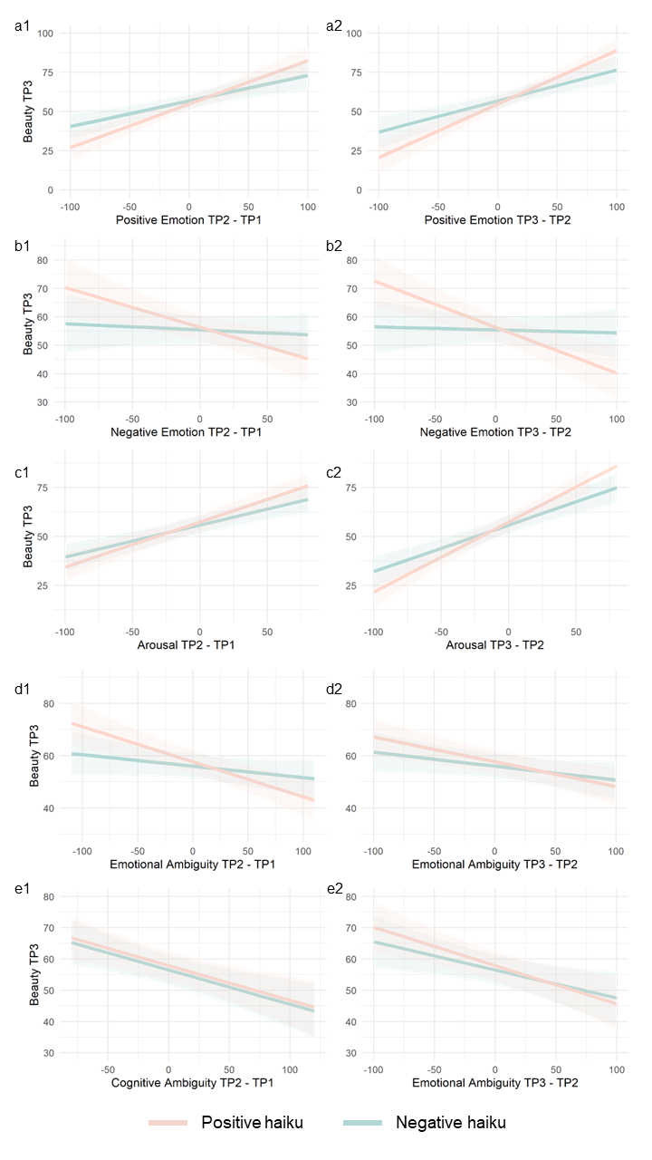
Supplementary Figure 1.
Interaction of linear mixed model of positive emotion, negative emotion, arousal, emotional ambiguity, and cognitive ambiguity explaining beauty of timepoint 3

Supplementary Table 5.
Results of a Hierarchical Bayesian Analysis Showing that Changes in Positive Emotion, Negative Emotion, Arousal, Emotional Ambiguity, and Cognitive Ambiguity Explain the Beauty of Haiku at TP3 (One model for all factors)
Fixed Effects | TP | Estimate | Est.Error | l-95% CI | u-95% CI | R-hat | Bulk ESS | Tail ESS
Intercept |  | 56.59 | 1.95 | 52.74 | 60.36 | 1.00 | 2133 | 4167
Positive Emotion | 2-1 | .18 | .03 | .12 | .24 | 1.00 | 10837 | 10964
 | 3-2 | .21 | .03 | .15 | .28 | 1.00 | 9206 | 10674
Negative Emotion | 2-1 | .00 | .03 | -.07 | .06 | 1.00 | 11229 | 10991
 | 3-2 | .00 | .03 | -.05 | .06 | 1.00 | 12772 | 12304
Arousal | 2-1 | .13 | .02 | .08 | .17 | 1.00 | 13532 | 12808
 | 3-2 | .22 | .03 | .17 | .28 | 1.00 | 13209 | 11618
Emotional Ambiguity | 2-1 | .00 | .02 | -.03 | .04 | 1.00 | 13936 | 11968
 | 3-2 | .04 | .02 | .00 | .08 | 1.00 | 13791 | 11632
Cognitive Ambiguity | 2-1 | -.06 | .02 | -.11 | -.02 | 1.00 | 11673 | 10496
 | 3-2 | -.06 | .02 | -.10 | -.01 | 1.00 | 12061 | 12244

Supplementary Table 6.
Results of Linear Mixed Model Showing that All Subjective Variables Explaining Beauty TP3
Fixed Effects | TP | Estimate | SE | df | t value | p value
Intercept |  | 56.73 | 3.52 | 472.30 | 16.10 | .00
Positive Emotion | 2-1 | .19 | .03 | 66.00 | 6.69 | .00
 | 3-2 | .21 | .04 | 33.70 | 5.31 | .00
Negative Emotion | 2-1 | .00 | .03 | 60.52 | -.03 | .98
 | 3-2 | .00 | .03 | 40.71 | .11 | .91
Arousal | 2-1 | .12 | .03 | 51.66 | 4.30 | .00
 | 3-2 | .22 | .03 | 42.25 | 6.65 | .00
Emotional Ambiguity | 2-1 | .00 | .02 | 33.02 | -.03 | .98
 | 3-2 | .03 | .02 | 57.78 | 1.42 | .16
Cognitive Ambiguity | 2-1 | -.07 | .03 | 55.27 | -2.80 | .01
 | 3-2 | -.06 | .02 | 49.84 | -2.39 | .02

Supplementary Table 7.
Each Parameter of the Trend Smoothing Model of Valence and Arousal as Measured by the Joystick
Valence
Haiku Type | Value | Mean | SE Mean | SD | 2.50% | 50% | 97.50% | n_eff | Rhat
Positive | Drift change | 0 | 0 | 0 | 0 | 0 | 0 | 1128 | 1
Positive | Observation error | 0.06 | 0 | 0 | 0.06 | 0.06 | 0.07 | 3594 | 1
Negative | Drift change | 0 | 0 | 0 | 0 | 0 | 0 | 1376 | 1
Negative | Observation error | 0.07 | 0 | 0 | 0.07 | 0.07 | 0.08 | 3500 | 1
 | Log posterior probability | 60087.36 | 1.19 | 40.72 | 60005.67 | 60088.17 | 60165.03 | 1162 | 1
Arousal
Haiku Type | Value | Mean | SE Mean | SD | 2.50% | 50% | 97.50% | n_eff | Rhat
Positive | Drift change | 0 | 0 | 0 | 0 | 0 | 0 | 1311 | 1
Positive | Observation error | 0.14 | 0 | 0 | 0.14 | 0.14 | 0.14 | 3628 | 1
Negative | Drift change | 0 | 0 | 0 | 0 | 0 | 0 | 1348 | 1
Negative | Observation error | 0.15 | 0 | 0 | 0.14 | 0.15 | 0.15 | 3478 | 1
 | Log posterior probability | 40073.98 | 1.07 | 38.88 | 39995.42 | 40074.23 | 40148.11 | 1322 | 1
Note. The settings of model estimation are: 4 chains, each with iteration = 10000; warmup = 1000; thin = 10; post-warmup draws per chain = 900, total post-warmup draws = 3600. Drift change represent fluctuations in the amount of change. Log posterior probability is the value used during the calculation.

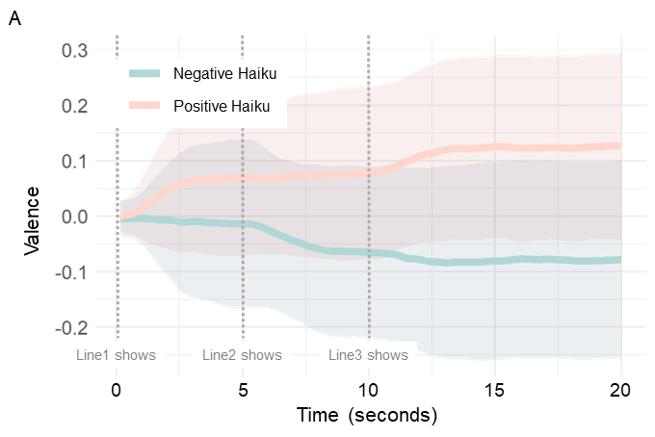
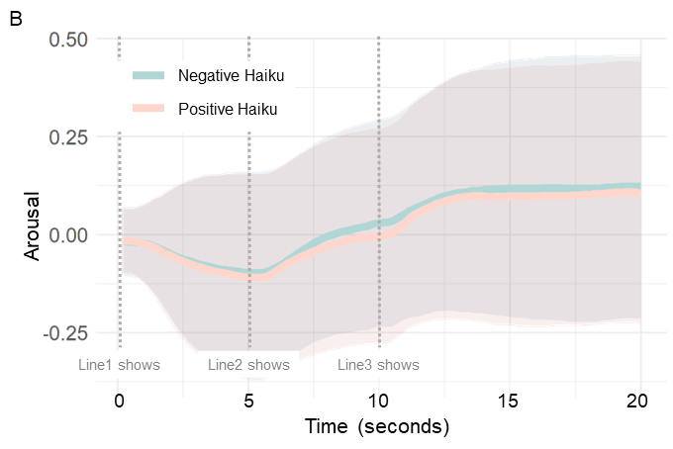
Supplementary Figure 2.
Time-series Changes of Valence (A) and Arousal (B) by Joystick Operation (Observed Data)

Supplementary Table 8.
Descriptive Statistics of Pupil Diameter
 |  | Negative Haiku |  | Positive Haiku
 | TP | Mean | (SD) | Mean | (SD) | t value | p value | d
Pupil Diameter
 | 1 | 37.27 | (6.37) | 37.47 | (6.62) | -.72 | .47 | -.03
 | 2 | 36.66 | (6.49) | 36.67 | (6.49) | .00 | 1.00 | .00
 | 3 | 36.42 | (6.52) | 36.17 | (6.42) | .92 | .36 | .04

Supplementary Table 9.
Multilevel correlation of all variables with pupil diameter

 |  | Correlation with PD TP1 (p) |  |  |  | Correlation with PD TP2 (p) |  |  |  | Correlation with PD TP3 (p)
 |  | Haiku Level |  | Participant Level |  | Haiku Level |  | Participant Level |  | Haiku Level |  | Participant Level
Pupil Diameter
 | 1 | - | - | - | - | .98 | (.00) | .69 | (.00) | .96 | (.00) | .47 | (.00)
 | 2 | .69 | (.00) | .98 | (.00) | - | - | - | - | .99 | (.00) | .63 | (.00)
 | 3 | .47 | (.00) | .96 | (.00) | .63 | (.00) | .99 | (.00) | - | - | - | -
Positive Emotion
 | 1 | .00 | (.83) | -.18 | (.11) | -.01 | (.81) | -.18 | (.11) | .03 | (.10) | -.18 | (.10)
 | 2 | .00 | (1.00) | -.22 | (.06) | -.05 | (.03) | -.24 | (.04) | -.02 | (.29) | -.24 | (.04)
 | 3 | .00 | (.96) | -.26 | (.03) | -.03 | (.13) | -.28 | (.02) | -.04 | (.05) | -.29 | (.02)
Negative Emotion
 | 1 | .04 | (.10) | -.10 | (.36) | .04 | (.08) | -.10 | (.34) | .02 | (.36) | -.13 | (.26)
 | 2 | .03 | (.16) | -.04 | (.75) | .08 | (.00) | -.02 | (.84) | .06 | (.01) | -.03 | (.77)
 | 3 | .01 | (.79) | -.05 | (.67) | .05 | (.03) | -.03 | (.82) | .07 | (.00) | -.04 | (.76)
Arousal
 | 1 | .01 | (.71) | -.07 | (.51) | .02 | (.46) | -.09 | (.40) | .03 | (.17) | -.11 | (.33)
 | 2 | .00 | (1.00) | -.02 | (.84) | .03 | (.19) | -.03 | (.80) | .04 | (.09) | -.04 | (.73)
 | 3 | .00 | (.98) | -.07 | (.52) | .01 | (.62) | -.07 | (.51) | .03 | (.13) | -.08 | (.47)
Emotional Ambiguity
 | 1 | .01 | (.55) | -.01 | (.93) | .01 | (.71) | -.02 | (.89) | .03 | (.16) | .00 | (.97)
 | 2 | -.02 | (.42) | -.02 | (.88) | -.02 | (.31) | -.03 | (.82) | .01 | (.53) | -.01 | (.92)
 | 3 | -.01 | (.75) | -.02 | (.88) | -.02 | (.45) | -.02 | (.87) | .04 | (.08) | .00 | (1.00)
Cognitive Ambiguity
 | 1 | -.02 | (.39) | -.11 | (.30) | -.02 | (.43) | -.09 | (.39) | -.01 | (.55) | -.10 | (.37)
 | 2 | -.03 | (.13) | -.09 | (.43) | -.04 | (.04) | -.08 | (.47) | -.03 | (.23) | -.10 | (.38)
 | 3 | .00 | (.85) | .03 | (.77) | -.02 | (.36) | .05 | (.66) | -.02 | (.48) | .03 | (.77)
Beauty
 | 1 | .01 | (.51) | -.13 | (.22) | .01 | (.54) | -.13 | (.26) | .04 | (.04) | -.14 | (.21)
 | 2 | .05 | (.03) | -.08 | (.50) | .03 | (.11) | -.06 | (.60) | .04 | (.05) | -.06 | (.57)
 | 3 | .01 | (.72) | -.12 | (.28) | .02 | (.26) | -.09 | (.43) | .03 | (.13) | -.09 | (.44)
Awe | 3 | -.02 | (.36) | -.14 | (.20) | -.02 | (.29) | -.12 | (.29) | -.01 | (.79) | -.13 | (.23)
Nostalgia | 3 | .00 | (.84) | -.03 | (.77) | .01 | (.51) | -.03 | (.81) | .03 | (.18) | -.04 | (.74)
Joystick Valence
 | 1 | -.05 | (.02) | -.17 | (.25) | -.04 | (.09) | -.15 | (.34) | -.02 | (.42) | -.10 | (.49)
 | 2 | -.03 | (.17) | -.28 | (.09) | -.06 | (.01) | -.32 | (.06) | -.03 | (.14) | -.28 | (.09)
 | 3 | -.01 | (.75) | -.31 | (.04) | -.03 | (.12) | -.35 | (.02) | -.05 | (.01) | -.35 | (.02)
Joystick Arousal
 | 1 | -.01 | (.64) | .00 | (1.00) | .03 | (.16) | .00 | (.98) | .06 | (.01) | -.02 | (.88)
 | 2 | .00 | (.86) | -.05 | (.68) | .05 | (.02) | -.05 | (.67) | .05 | (.01) | -.07 | (.54)
 | 3 | .01 | (.68) | -.04 | (.74) | .03 | (.11) | -.02 | (.87) | .07 | (.00) | -.02 | (.87)

Supplementary Table 10.
Result of linear mixed model showing that changes in pupil diameter explain the beauty of haiku
Fixed Effects |  | Estimate | SE | df | t value | p value
Pupil Diameter
 | Intercept | 55.58 | 1.98 | 85.14 | 28.11 | .00
 | TP 2-1 | .66 | .23 | 40.69 | 2.85 | .01
 | TP 3-2 | .09 | .24 | 31.24 | .37 | .71
 | Haiku Valence | 1.83 | 3.28 | 45.64 | .56 | .58
 | TP 2-1 * TP 3-2 | -.12 | .05 | 697.01 | -2.56 | .01
 | TP 2-1 * Haiku Valence | -.32 | .48 | 45.75 | -.67 | .50
 | TP 3-2 * Haiku Valence | -.10 | .40 | 53.67 | -.26 | .80
 | TP 2-1 * TP 3-2 * Haiku Valence | .19 | .10 | 348.05 | 1.93 | .05
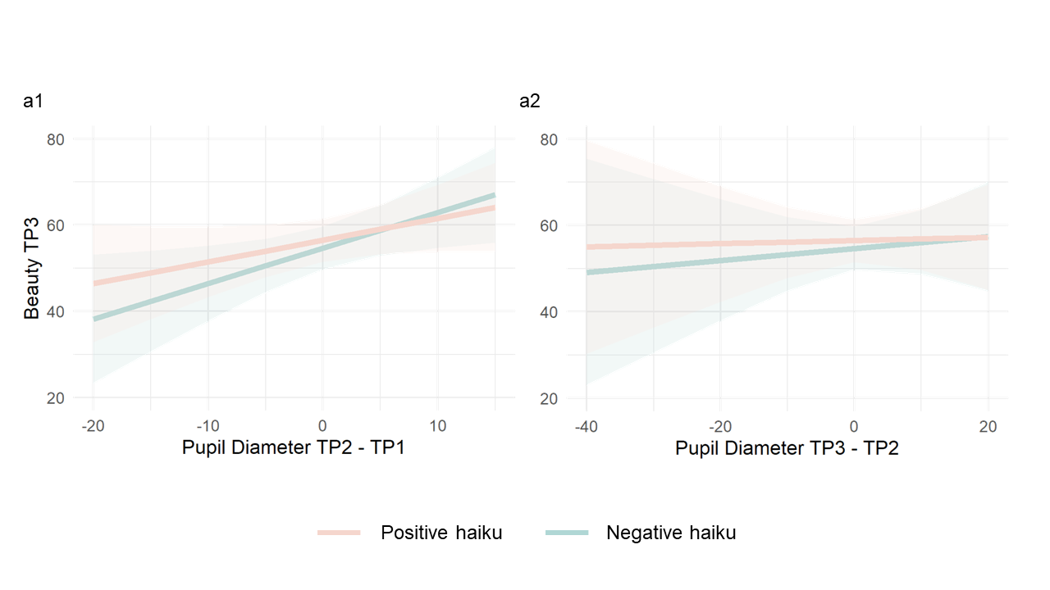
Supplementary Figure 3.
Interaction of Linear Mixed Model of Pupil Diameter Explaining Beauty TP3

Supplementary Table 11.
Each Parameter of the Trend Smoothing Model of Pupil Diameter
Pupil Diameter
Haiku Type | Value | Mean | SE Mean | SD | 2.50% | 50% | 97.50% | n_eff | Rhat
Positive | Drift change | 0.01 | 0 | 0.01 | 0 | 0 | 0.02 | 66 | 1.08
Positive | Observation error | 6.18 | 0 | 0.04 | 6.1 | 6.18 | 6.26 | 4301 | 1
Negative | Drift change | 0.01 | 0 | 0.01 | 0 | 0 | 0.02 | 82 | 1.04
Negative | Observation error | 6.06 | 0 | 0.04 | 5.99 | 6.06 | 6.14 | 5234 | 1
 | Log posterior probability | -51523.67 | 23.53 | 165.4 | -51821.92 | -51537.87 | -51176.86 | 49 | 1.08
Note. The settings of model estimation are: 4 chains, each with iteration = 20000; warmup = 1000; thin = 10; post-warmup draws per chain = 1900, total post-warmup draws = 7600. Drift change represent fluctuations in the amount of change. Log posterior probability is the value used during the calculation.

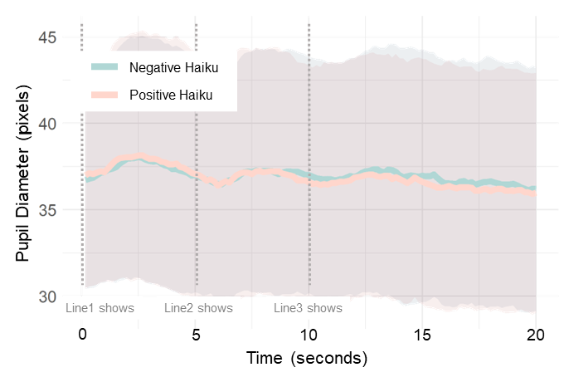Supplementary Figure 4.
Time-series changes of pupil diameter (observed data)

