Supporting Information
A spatiotemporal release platform based on pH/Enzyme Dual Responsive PMB Release Hydrogel with polymer PMB conjugates in Chronic Wound RepairLanlan Dong ^{1, 2}, Can Huang², Baohua Zhao², Guangyun Hu², Wei Qian^{2*}, Gaoxing Luo^{2*}
¹College of Bioengineering, Chongqing University, No. 174 Shazheng Road, Chongqing, 400044 P. R. China.
² Institute of Burn Research, Southwest Hospital, Third Military Medical University (Army Medical University), Chongqing, 400038 P. R. China.
*Corresponding authors. E-mail address: weiqian87@tmmu. edu.cn; logxw@tmmu.edu.cn;

Figures

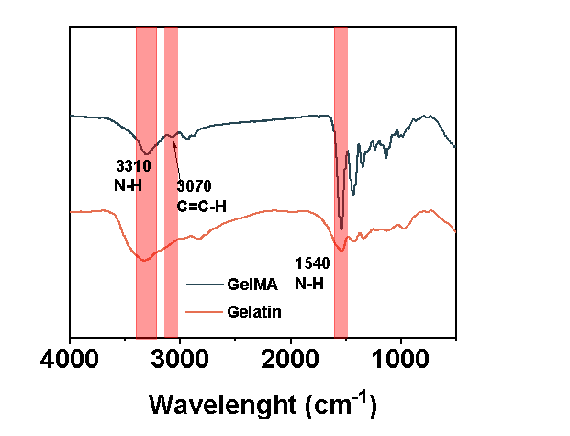
b
a
Figure S1. (a) FT-IR of gelatin and GelMA. (b) FT-IR of PMB, SA, OSSA, OSA+PMB and OSSA+PMB

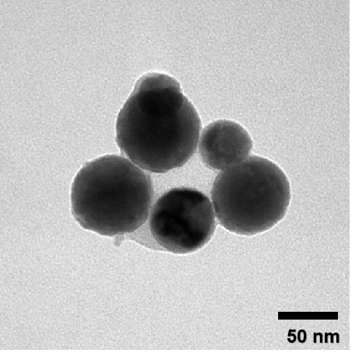
Figure S2. TEM of conjugates in GelMA/OSSA/PMB.
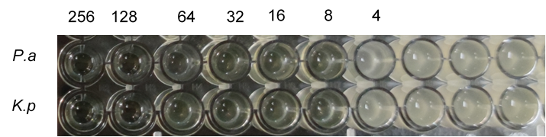
Figure S3. MIC of PMB to MDR-P.a.
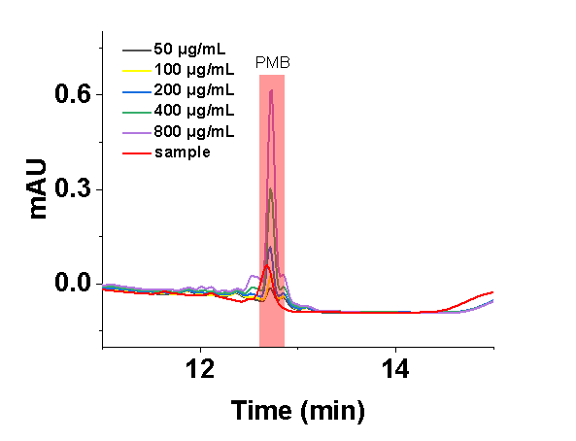
a
b

Figure S4. (a) HPLC of samples with various concentrations of PMB ranging from 50 to 800 µg/mL. (b) the corresponding calibration curves.
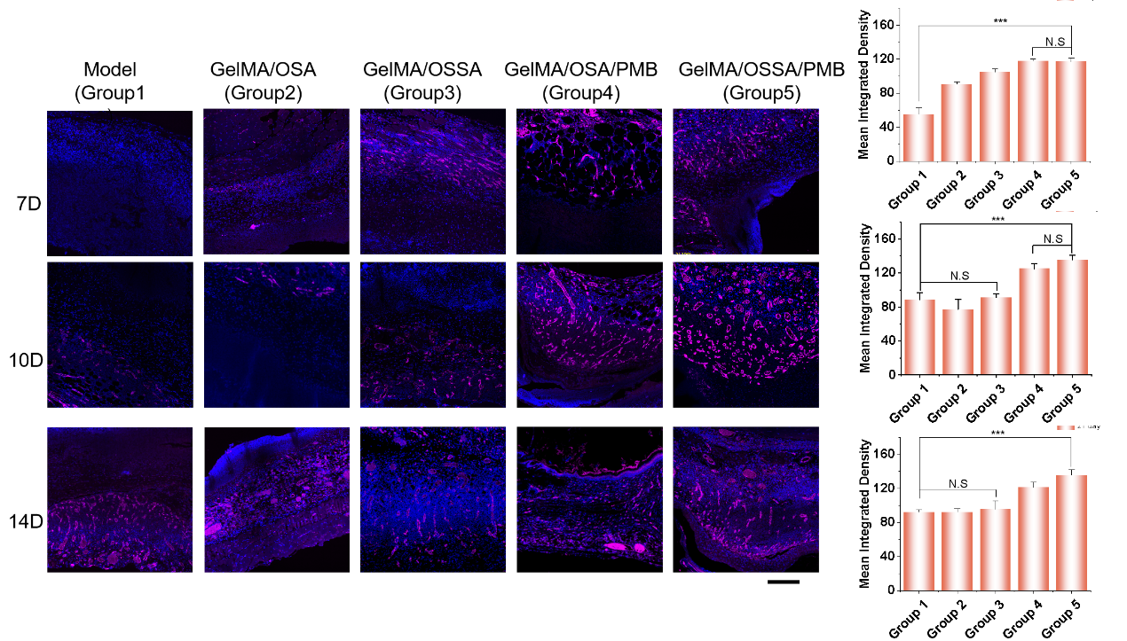
Figure S5. CD31 at different time points. Bar graphs represent mean + SD. NS, not significant; ***, p < 0.001.

Figure S6. Statistical analysis of collagen deposition at day10 (n = 6). Bar graphs represent mean + SD. NS, not significant; ***, p < 0.001.

a
Figure S7. (a) Principal component analysis (PCA) was performed based on differentially expressed genes (DEGs) in the wound tissue of the two groups. (b) MA plots displaying differentially expressed genes after treatment with GelMA/OSSA/PMB Hydrogel group and PBS group.

