Electronic Supplementary Information (ESI)
18-Crown-6 based supramolecular structure, hydrogen bonding behaviour and its nonlinear optical properties
Chellakarungu Balakrishnan^{1,2} • Muniyasamy Manonmani¹ • Govindarajan Vinitha³ •
Subbiah Meenakshisundaram^{1*}
¹ Department of Chemistry, Annamalai University, Annamalainagar - 608002, Tamil Nadu, India
² Department of Chemistry, Erode Sengunthar Engineering College, Erode - 638057, Tamil Nadu, India.
³ Division of Physics, School of Advanced Science, VIT Chennai, Chennai - 600127, Tamil Nadu, India

Title | Figure
FT-IR spectrum of (18C6).2(5ATIPA).2(H₂O) | S1
Percentage contributions to the Hirshfeld surface areas for the various close intermolecular contacts | S2

Title | Table
Selected bond lengths [Å], angles [°] and torsion angles [°] for (18C6).2(5ATIPA).2(H₂O) | S1

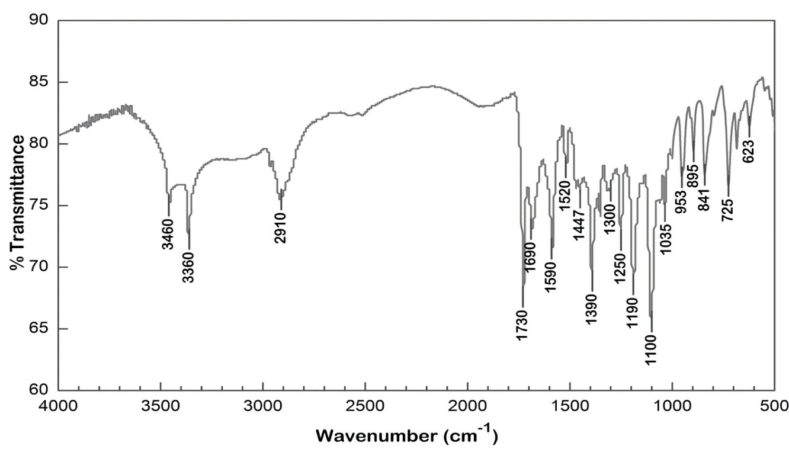
Fig. S1 FT-IR spectrum of (18C6).2(5ATIPA).2(H₂O)

Fig. S2 Percentage contributions to the Hirshfeld surface areas for the various close intermolecular contacts.

Table S1. Selected bond lengths [Å], angles [°] and torsion angles [°] for (18C6).2(5ATIPA).2(H₂O)
Bond length [Å]
C(1)-C(2) | 1.41(5) | C(5)-C(6) | 1.34(5) | C(10)-O(7) |  | 1.45(6)
C(1)-C(6) | 1.52(5) | C(5)-I(2) | 2.15(4) | C(10)-C(11) |  | 1.51(2)
C(1)-I(3) | 2.07(4) | C(6)-C(7) | 1.49(5) | C(11)-O(6) |  | 1.34(6)
C(2)-N(1) | 1.34(5) | C(7)-O(4) | 1.16(4) | C(12)-O(6) |  | 1.41(6)
C(2)-C(3) | 1.43(5) | C(7)-O(3) | 1.38(4) | C(12)-C(13) |  | 1.51(2)
C(3)-C(4) | 1.34(5) | C(8)-O(2) | 1.11(4) | C(13)-O(5) |  | 1.44(2)
C(3)-I(1) | 2.15(3) | C(8)-O(1) | 1.39(4) | C(14)-O(5) |  | 1.44(2)
C(4)-C(5) | 1.36(5) | C(9)-C(14)#1 | 1.46(8) | - |  | -
C(4)-C(8) | 1.55(5) | C(9)-O(7) | 1.47(6) | - |  | -
Bond Angles [°]
C(2)-C(1)-C(6) | 120(4) | C(5)-C(4)-C(8) | 123(3) | O(2)-C(8)-C(4) |  | 126(4)
C(2)-C(1)-I(3) | 120(3) | C(6)-C(5)-C(4) | 126(4) | O(1)-C(8)-C(4) |  | 113(3)
C(6)-C(1)-I(3) | 119(3) | C(6)-C(5)-I(2) | 117(3) | C(14)#1-C(9)-O(7) |  | 114(5)
N(1)-C(2)-C(1) | 118(3) | C(4)-C(5)-I(2) | 116(3) | O(7)-C(10)-C(11) |  | 105(4)
N(1)-C(2)-C(3) | 127(3) | C(5)-C(6)-C(7) | 128(3) | O(6)-C(11)-C(10) |  | 109(4)
C(1)-C(2)-C(3) | 114(3) | C(5)-C(6)-C(1) | 115(3) | O(6)-C(12)-C(13) |  | 128(5)
C(4)-C(3)-C(2) | 126(3) | C(7)-C(6)-C(1) | 117(3) | O(5)-C(13)-C(12) |  | 97(4)
C(4)-C(3)-I(1) | 120(3) | O(4)-C(7)-O(3) | 124(3) | O(5)-C(14)-C(9)#1 |  | 105(5)
C(2)-C(3)-I(1) | 112(2) | O(4)-C(7)-C(6) | 124(3) | C(13)-O(5)-C(14) |  | 102(4)
C(3)-C(4)-C(5) | 117(3) | O(3)-C(7)-C(6) | 112(3) | C(11)-O(6)-C(12) |  | 111(4)
C(3)-C(4)-C(8) | 119(3) | O(2)-C(8)-O(1) | 121(3) | C(10)-O(7)-C(9) |  | 114(4)
Torsion Angles (°)
C(6)-C(1)-C(2)-N(1) |  | 178(4) | C(2)-C(1)-C(6)-C(5) |  | 9(6)
I(3)-C(1)-C(2)-N(1) |  | 2(6) | I(3)-C(1)-C(6)-C(5) |  | -175(3)
C(6)-C(1)-C(2)-C(3) |  | -10(6) | C(2)-C(1)-C(6)-C(7) |  | -178(4)
I(3)-C(1)-C(2)-C(3) |  | 173(3) | I(3)-C(1)-C(6)-C(7) |  | -1(4)
N(1)-C(2)-C(3)-C(4) |  | -177(4) | C(5)-C(6)-C(7)-O(4) |  | 67(5)
C(1)-C(2)-C(3)-C(4) |  | 12(6) | C(1)-C(6)-C(7)-O(4) |  | -106(4)
N(1)-C(2)-C(3)-I(1) |  | -11(5) | C(5)-C(6)-C(7)-O(3) |  | -111(4)
C(1)-C(2)-C(3)-I(1) |  | 178(3) | C(1)-C(6)-C(7)-O(3) |  | 76(4)
C(2)-C(3)-C(4)-C(5) |  | -11(6) | C(3)-C(4)-C(8)-O(2) |  | 74(5)
I(1)-C(3)-C(4)-C(5) |  | -176(3) | C(5)-C(4)-C(8)-O(2) |  | -96(5)
C(2)-C(3)-C(4)-C(8) |  | 179(4) | C(3)-C(4)-C(8)-O(1) |  | -98(4)
I(1)-C(3)-C(4)-C(8) |  | 14(5) | C(5)-C(4)-C(8)-O(1) |  | 92(4)
C(3)-C(4)-C(5)-C(6) |  | 9(6) | O(7)-C(10)-C(11)-O(6) |  | 68(6)
C(8)-C(4)-C(5)-C(6) |  | 179(4) | O(6)-C(12)-C(13)-O(5) |  | -58(8)
C(3)-C(4)-C(5)-I(2) |  | 178(3) | C(12)-C(13)-O(5)-C(14) |  | -104(5)
C(8)-C(4)-C(5)-I(2) |  | -12(5) | C(9)#1-C(14)-O(5)-C(13) |  | -163(4)
C(4)-C(5)-C(6)-C(7) |  | 179(4) | C(10)-C(11)-O(6)-C(12) |  | -170(4)
I(2)-C(5)-C(6)-C(7) |  | 10(5) | C(13)-C(12)-O(6)-C(11) |  | 167(6)
C(4)-C(5)-C(6)-C(1) |  | -8(6) | C(11)-C(10)-O(7)-C(9) |  | 171(5)
I(2)-C(5)-C(6)-C(1) |  | -177(3) | C(14)#1-C(9)-O(7)-C(10) |  | 172(5)
Symmetry transformations used to generate equivalent atoms: #1 -x+1,-y+1,-z+1

