Supporting Information
Monitoring crystallite fusion of nanocellulose during colloid condensation

Yoshinori Doi¹, Kazuho Daicho^{1,}*, Noriyuki Isobe^{2,1}, Reina Tanaka^{3,1}, Satoshi Kimura¹, Shuji Fujisawa¹, Tsuguyuki Saito^{1,}*

¹Department of Biomaterial Sciences, Graduate School of Agricultural and Life Sciences, The University of Tokyo, 1-1-1 Yayoi, Bunkyo-ku, Tokyo 113-8657, Japan
²Biogeochemistry Research Center, Research Institute for Marine Resources Utilization (MRU), Japan Agency for Marine-Earth Science and Technology (JAMSTEC), 2-15 Natsushima-cho, Yokosuka, Kanagawa 237-0061, Japan
³Department of Forest Resource Chemistry, Forestry and Forest Products Research Institute, 1 Matsunosato, Tsukuba, Ibaraki 305-8687, Japan

* Corresponding Author:
E-mail: daichok@g.ecc.u-tokyo.ac.jp (Kazuho Daicho)
saitot@g.ecc.u-tokyo.ac.jp (Tsuguyuki Saito)

This file includes Supporting Figures S1–S5.

Fig. S1 Peak deconvolution of the WAXD profiles of the samples. The curved lines in black represent the experimental data after subtracting a linear background, and the dotted lines represent the fitting results

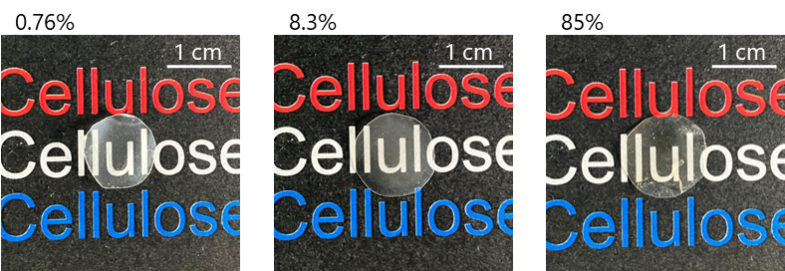

Fig. S2 Appearances of pelletized aerogel samples

Fig. S3 NMR spectra of an aerogel sample prepared at a 0.2% concentration before and after the compression

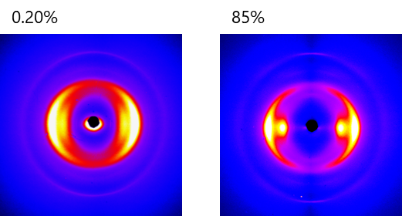

Fig. S4 On-edge transmission 2D WAXD profiles of the pellets. The 2D profiles were obtained using a Rigaku MicroMax-007 HF system in transmission mode with a Cu Kα beam (λ = 0.1542 nm) at 40 kV and 30 mA. The pellets were placed parallel to the beam. The recorded patterns were obtained using a Rigaku RAXIA-Di system

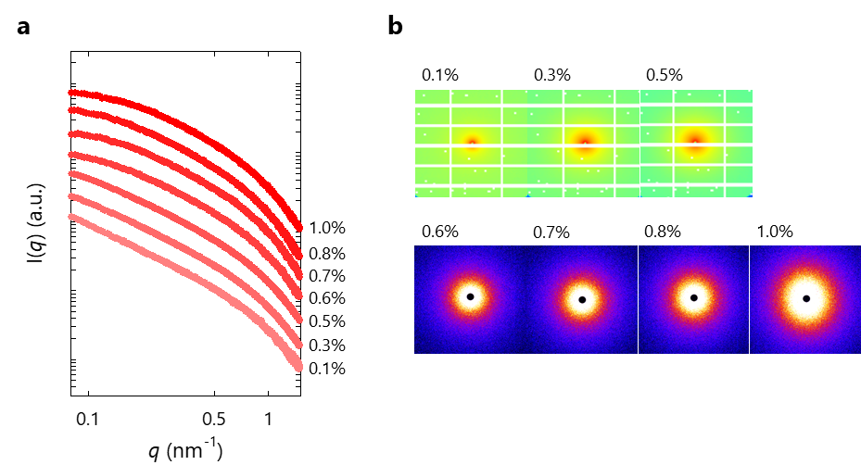

Fig. S5 a 1D and b 2D SAXS profiles of wet CNF samples with solid contents of 0.1–1.0%

